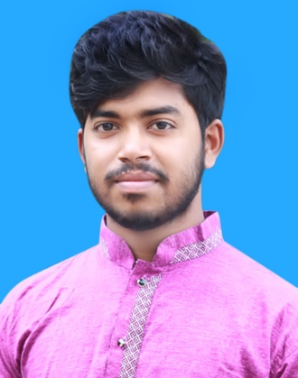CURRICULUM VITAE OF

**Morsed Khan**

**+8801884007704**

**Emil:- info.morshad@gmail.com**

**Career Objectives:**

To make an excellent career on Computer Technology based job. I would like to build an excellent career which has a challenging position, where my Achievement, Education, Knowledge, and my strong capabilities will be most fully engaged. And which is rapidly expanding.

**Educational Qualification:**

* ***Diploma In Engineering ( Computer ): -***
* Name of the institution : Dhaka Polytechnic Institute, Dhaka-1208 

|  |  |  |
| --- | --- | --- |
| ▪ | Technology | : Computer Technology   |
| ▪ | Session | : 2016-2017  |
| ▪ | C.G.P. A | : 3.44  |
| ▪ | Board | : Bangladesh Technical Education Board (BTEB)  |

* ***Secondary School Certificate (S.S.C): -***

|  |  |  |
| --- | --- | --- |
| ▪ | Name of the institution | : Dhamgor sk alim madrsha  |
| ▪ | Subject | : General  |
| ▪ | Passing year | 2016  |
| ▪ | Result G.P. A | : 4.31(Scale of 5)  |
|  | Board | : Madrasha |



**Computer skills:**

1: MS Office, Internet Browsing & Email  

2: Java Programming

3: HTML, CSS3, JAVASCRIPT, BOOSTRAB, PSD TO HTML

**Specialization:**

* Have good efficiency in English written & speaking. 
* Bengali is mother tongue, excellent fluency in speaking and has better efficiency in writing. 

**Permanent Address:**

o Village : : Poramtala

o Post Office: : Poramtola

1. Police Station : Muradnahor

o District : Comilla

**Present Address :**

o Post Office : Dhaka-1208

1. Police Station : Tejgaon Industrial Thana

o District : Dhaka

**Declaration:**

“I do here by declare and certify that all the information stated above in this curriculum vitae are true and complete to the best of my knowledge and belief”.

Morsed khan

 

 