use case Animal Horror story.

The following game will contain the steps underneath this description. The Animal horror story is based on 2 animals, a snake and a rabbit. The point is to have the snake eat the rabbit.
1. Create x,y axis by 10.
2. Nice Rabbit is created on any of the following boxes. This rabbit will be moveable
3. Evil Snake is created as well in any of these boxes the snake will be moveable aswell
4. Program will be able to identify Snake and Rabbits position when nessesary
5. Snake will be able to kill the Rabbit if they happen to step on the same block.
6. system will outprint ''i am a nice rabbit standing on x,x-block or evil snake standing on x,x block'' every time one of the following characters move to another block
7. system wil out.println a message where the rabbit will ask for mercy before death
8. System.out.println will not react on the snakes feast.
9. When rabbit is killed program/game will end.
Version 1: Domain diagram
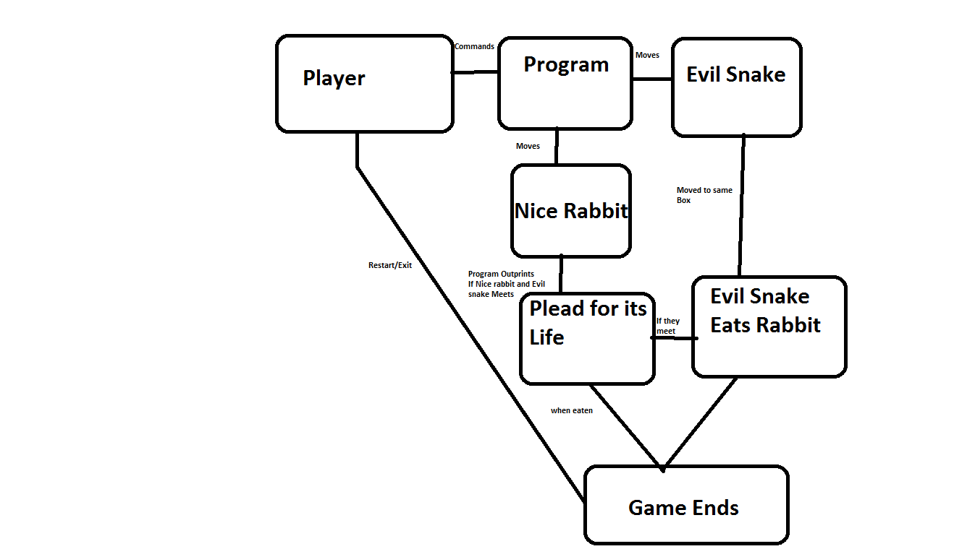
Version 2:

Class Diagram: Little Animal Horror Zoo

Snake
-species: String
-x : int
-y : int
+move(); void
+speak(); void
+tellPosition() : String
+kill() : void

Rabbit
-species: String
-x : int
-y : int
+move(); void
+speak(); void
+tellPosition() : String
+beeg() : void

Game
+Main(String [])
+actions
+dialog

