Computers Networking: A Top Down Approach

Chapter 1

Exercise 1.1
Design and describe an application-level protocol to be used between an automatic teller machine and a bank’s centralized computer. Your protocol should allow a user’s card and password to be verified, the account balance (which is maintained at the centralized computer) to be queried, and an account withdrawal to be made (that is, money disbursed to the user). Your protocol entities should be able to handle the all-too-common case in which there is not enough money in the account to cover the withdrawal. Specify your protocol by listing the messages exchanged and the action taken by the automatic teller machine or the bank’s centralized computer on transmission and receipt of messages. Sketch the operation of your protocol for the case of a simple withdrawal with no errors, using a diagram similar to that in Figure 1.2. Explicitly state the assumptions made by your protocol about the underlying end-to-end transport service.
Solution
Steps | ATM | Message | Bank
1 | Wakes up | >>> Are you there?
2 |  | <<< Yes
3 | Ask for credential to the user or card | >>> Want to Log
4 | Block ATM until answer or connection is dropped | >>> Here’s my user and password | Find user and try to authenticate
5 | Unblocks only when authenticated and load session. Try again if not | <<< I authenticated you. Your sessions is active / Your authentication Failed
6 |  | >>> I want to know my account balance | Find actual amount in database
7 | Amount is displayed and allow to user do actions | <<< You have $$$
8 |  | >>> Want to withdrawal $$$ amount | Verify if the amount to withdraw is lesser than the balance. If it is then subtract the withdrawal of the balance
9 | If it is approved then cash is out. Display result in any case | <<< Yes, you can withdraw this amount of money / Denied founds are insufficient
10 |  | >>> Cash is out | Register a complete transaction
11 |  | >>> Okay. Log out | Closing session and send to ATM to log out and remain idle
12 | Session over and remain idle | <<< Your session is dismissed

Exercise 1.2
Equation 1.1 gives a formula for the end-to-end delay of sending one packet of length L over N links of transmission rate R. Generalize this formula for sending P such packets back-to-back over the N links.
Solution
If you can send a packets back to back that mean one packet can be immediately sent into once it received by one link so the first package acts like in our normal case. However the remaining packages jumps without delay between links so it only applies the transmission delay.

Exercise 1.3
Consider an application that transmits data at a steady rate (for example, the sender generates an N-bit unit of data every k time units, where k is small and fixed). Also, when such an application starts, it will continue running for a relatively long period of time. Answer the following questions, briefly justifying your answer:
- Would a packet-switched network or a circuit-switched network be more appropriate for this application? Why?
- Suppose that a packet-switched network is used and the only traffic in this network comes from such applications as described above. Furthermore, assume that the sum of the application data rates is less than the capacities of each and every link. Is some form of congestion control needed? Why?
Solution
- A circuit-switched is more appropriate because a steady rate can be easily and efficiently multiplexed into the common signal allowing low latency communications (because you avoid queue, and processing latency). Also if it going to connect long periods of time then it can help to justify a circuit because the line is going to be used most of the time.
- No. There’s no need of a congestion control because you wont saturate the switches. No matter the path the packet chose will arrive.

Exercise 1.4
Consider the circuit-switched network in Figure 1.13. Recall that there are four circuits on each link. Label the four switches A, B, C, and D, going in the clockwise direction.
- What is the maximum number of simultaneous connections that can be in progress at any one time in this network?
- Suppose that all connections are between switches A and C. What is the maximum number of simultaneous connections that can be in progress?
- Suppose we want to make four connections between switches A and C, and another four connections between switches B and D. Can we route these calls through the four links to accommodate all eight connections?
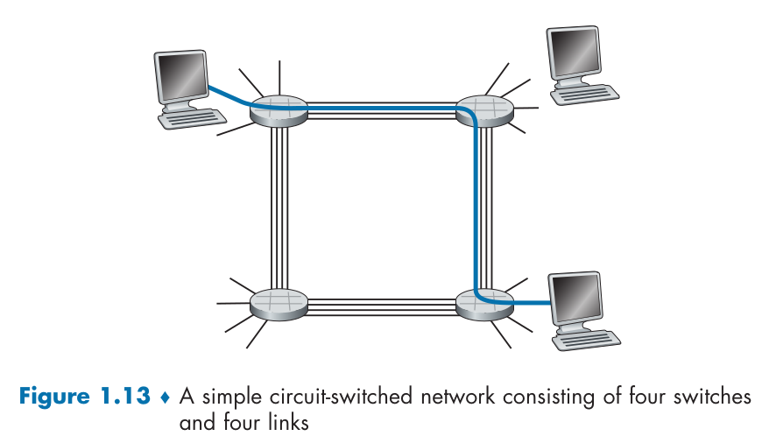
Solution
- There’s 16 links between all 4 switches and it can connect all 16 computers simultaneously.
- It can happen 8 simultaneous connections between A and C. Four of them has to pass through B and the remaining four has to pass through D.
- It is possible but you have to coordinate the connections so in case you want to connect A to C half of the connections send through B and the remaining half through D. With this move you leave 2 free links in B and D so now you can send 2 connections that passes through C and 2 that passes through D.

Exercise 1.5
Review the car-caravan analogy in Section 1.4. Assume a propagation speed of 100 km/hour.
- Suppose the caravan travels 175 km, beginning in front of one tollbooth, passing through a second tollbooth, and finishing just after a third toll booth. What is the end-to-end delay?
- Repeat (a), now assuming that there are eight cars in the caravan instead of ten.
Solution
In this scenario is important to know some parameters of the exercise. The caravan is composed of 10 cars and when it arrive to a tollbooth it has to wait 12 seconds to be processed. So in case that all caravan remain together the queue delay will be 10 cars * 12 seconds per car=120 seconds until all cars payed.
- In that case the propagation delay will be of 175 km / 100 km per hour = 1.75h = 105 min. If we are going to ignore what happen anything before the first tollbooth and after the last tollbooth then the queue delay only apply 2 times making a total of 105 min + 120 sec * 2 = 109 min
- In that case the queue delay is about 8 cars * 12 sec per car = 96 sec. Then it makes a total of 105 min + 96 sec * 2 = 108.2 min

Exercise 1.6
This elementary problem begins to explore propagation delay and transmission delay, two central concepts in data networking. Consider two hosts, A and B, connected by a single link of rate R bps. Suppose that the two hosts are separated by m meters, and suppose the propagation speed along the link is s meters/sec. Host A is to send a packet of size L bits to Host B.
- Express the propagation delay, d_{prop}, in terms of m and s.
- Determine the transmission time of the packet, d_{trans}, in terms of L and R.
- Ignoring processing and queuing delays, obtain an expression for the end-to-end delay.
- Suppose Host A begins to transmit the packet at time t = 0. At time t = d_{trans}, where is the last bit of the packet?
- Suppose d_{prop} is greater than d_{trans}. At time t = d_{trans}, where is the first bit of the packet?
- Suppose d_{prop} is less than d_{trans}. At time t = d_{trans}, where is the first bit of the packet?
- Suppose s = 2.5 * 10⁸, L = 1500 bytes, and R = 10 Mbps. Find the distance m so that d_{prop} equals d_{trans}.
Solution
- It will be of m/s seconds
- It will be of L/R seconds

- it is still transmitting into the medium and will reach at time t = d_{trans} + (L-1)/R
- If the delay of propagate is greater than transmission then the first bit will still travelling the medium at t = d_{trans}
- In this case the first bit has already reached their destination at t = d_{trans}

Exercise 1.7
In this problem, we consider sending real-time voice from Host A to Host B over a packet-switched network (VoIP). Host A converts analog voice to a digital 64 kbps bit stream on the fly. Host A then groups the bits into 56-byte packets. There is one link between Hosts A and B; its transmission rate is 10 Mbps and its propagation delay is 10 msec. As soon as Host A gathers a packet, it sends it to Host B. As soon as Host B receives an entire packet, it converts the packet’s bits to an analog signal. How much time elapses from the time a bit is created (from the original analog signal at Host A) until the bit is decoded (as part of the analog signal at Host B)?
Solution

Exercise 1.8
Suppose users share a 10 Mbps link. Also suppose each user requires 200 kbps when transmitting, but each user transmits only 10 percent of the time. (See the discussion of packet switching versus circuit switching in Section 1.3.)
- When circuit switching is used, how many users can be supported?
- For the remainder of this problem, suppose packet switching is used. Find the probability that a given user is transmitting.
- Suppose there are 120 users. Find the probability that at any given time, exactly n users are transmitting simultaneously. (Hint: Use the binomial distribution.)
- Find the probability that there are 51 or more users transmitting simultaneously.
Solution
- You can have 10Mbps/200Kbps = 50 connections at the same time in circuit switching
- It will be of 0.1

- Because I’m lazy I calculated using a program and the probability is technically 0. The most probably outcome is 12 simultaneous connections (which seem has sense because 120 users by 10% connection time)

Exercise 1.9
Consider the discussion in Section 1.3 of packet switching versus circuit switching in which an example is provided with a 1 Mbps link. Users are generating data at a rate of 100 kbps when busy, but are busy generating data only with probability p = 0.1. Suppose that the 1 Mbps link is replaced by a 1 Gbps link.
- What is N, the maximum number of users that can be supported simultaneously under circuit switching?
- Now consider packet switching and a user population of M users. Give a formula (in terms of p, M, N) for the probability that more than N users are sending data.
Solution
- Is about 1Gbps/100kbps = 10,000 simultaneous users
- Well, as the before exercise can be calculated as

Exercise 1.10
Consider a packet of length L that begins at end system A and travels over three links to a destination end system. These three links are connected by two packet switches. Let d_{i}, s_{i}, and R_{i} denote the length, propagation speed, and the transmission rate of link i, for i = 1, 2, 3. The packet switch delays each packet by d_{proc}. Assuming no queuing delays, in terms of d_{i}, s_{i}, R_{i}, (i = 1, 2, 3), and L, what is the total end-to-end delay for the packet? Suppose now the packet is 1,500 bytes, the propagation speed on all three links is 2.5 * 10⁸ m/s, the transmission rates of all three links are 2.5 Mbps, the packet switch processing delay is 3 msec, the length of the first link is 5,000 km, the length of the second link is 4,000 km, and the length of the last link is 1,000 km. For these values, what is the end-to-end delay?
Solution
The end to end delay can be expressed and is calculated as

Exercise 1.11
In the above problem, suppose R₁ = R₂ = R₃ = R and d_{proc} = 0. Further suppose that the packet switch does not store-and-forward packets but instead immediately transmits each bit it receives before waiting for the entire packet to arrive. What is the end-to-end delay?
Solution
In this scenario the whole 3 links behaves as a single one like if the switches weren’t there.

Exercise 1.12
A packet switch receives a packet and determines the outbound link to which the packet should be forwarded. When the packet arrives, one other packet is halfway done being transmitted on this outbound link and four other packets are waiting to be transmitted. Packets are transmitted in order of arrival. Suppose all packets are 1,500 bytes and the link rate is 2.5 Mbps. What is the queuing delay for the packet? More generally, what is the queuing delay when all packets have length L, the transmission rate is R, x bits of the currently-being-transmitted packet have been transmitted, and n packets are already in the queue?
Solution

Exercise 1.13
- Suppose N packets arrive simultaneously to a link at which no packets are currently being transmitted or queued. Each packet is of length L and the link has transmission rate R. What is the average queuing delay for the N packets?
- Now suppose that N such packets arrive to the link every LN/R seconds. What is the average queuing delay of a packet?
Solution
- In this scenario the packets follow his pattern of transmission of 0 + L/R + 2*L/R and so on until N-1*L/R. This progression is a sequential addition series which give us the total but the average has to take in count that is the total divided by every package

- If packets arrive every LN/R seconds then that mean the delay perceived by the sender and recipient are the same so it will take the same delay

Exercise 1.14
Consider the queuing delay in a router buffer. Let I denote traffic intensity; that is, I = La/R. Suppose that the queuing delay takes the form L/R*I/(1 – I) for I < 1.
- Provide a formula for the total delay, that is, the queuing delay plus the transmission delay.
- Plot the total delay as a function of L/R.
Solution

- The delay function seems as expected. A initial boundary of never get a delay smaller than L/R and as “a” comes closer to 1 reach a asymptote where delay times grows to infinite.
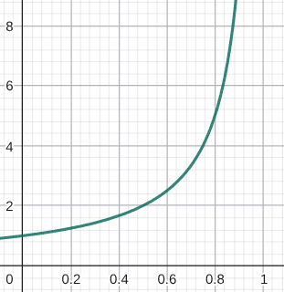

Exercise 1.15
Let a denote the rate of packets arriving at a link in packets/sec, and let μ denote the link’s transmission rate in packets/sec. Based on the formula for the total delay (i.e., the queuing delay plus the transmission delay) derived in the previous problem, derive a formula for the total delay in terms of a and μ.
Solution
Then μ will represent the inverse of transmission rate.

Exercise 1.16
Consider a router buffer preceding an outbound link. In this problem, you will use Little’s formula, a famous formula from queuing theory. Let N denote the average number of packets in the buffer plus the packet being transmitted. Let a denote the rate of packets arriving at the link. Let d denote the average total delay (i.e., the queuing delay plus the transmission delay) experienced by a packet. Little’s formula is N = a * d. Suppose that on average, the buffer contains 100 packets, and the average packet queuing delay is 20 msec. The link’s transmission rate is 100 packets/sec. Using Little’s formula, what is the average packet arrival rate, assuming there is no packet loss?
Solution

Exercise 1.17
- Generalize Equation 1.2 in Section 1.4.3 for heterogeneous processing rates, transmission rates, and propagation delays.
- Repeat (a), but now also suppose that there is an average queuing delay of d_{queue} at each node.
Solution

Exercise 1.18
Perform a Traceroute between source and destination on the same continent at three different hours of the day.
- Find the average and standard deviation of the round-trip delays at each of the three hours.
- Find the number of routers in the path at each of the three hours. Did the paths change during any of the hours?
- Try to identify the number of ISP networks that the Traceroute packets pass through from source to destination. Routers with similar names and/or similar IP addresses should be considered as part of the same ISP. In your experiments, do the largest delays occur at the peering interfaces between adjacent ISPs?
- Repeat the above for a source and destination on different continents. Compare the intra-continent and inter-continent results.
Solution
mortega@ASUS-TUF:~$ traceroute www.cic.ipn.mx
traceroute to www.cic.ipn.mx (148.204.63.1), 30 hops max, 60 byte packets
1 _gateway (192.168.1.1) 3.366 ms 3.180 ms 5.242 ms
2 dsl-servicio-l200.uninet.net.mx (200.38.193.226) 9.256 ms 9.742 ms 10.220 ms
3 itcam-nvl-triara-49-cge0-15-0-0.uninet.net.mx (189.246.101.145) 22.168 ms 22.142 ms 22.117 ms
4 ext-189-247-251-225.uninet.net.mx (189.247.251.225) 19.333 ms 19.160 ms 22.039 ms
5 8.243.220.41 (8.243.220.41) 28.147 ms 27.823 ms 27.940 ms
6 ae1.3502.edge2.mex1.ciriontechnologies.net (200.189.212.38) 42.765 ms 39.717 ms 154.088 ms
7 64-76-42-10.dynamic.impsat.net.ar (64.76.42.10) 36.957 ms 136.902 ms 136.758 ms
8 fixed-187-190-77-114.totalplay.net (187.190.77.114) 136.804 ms 136.784 ms 136.762 ms
9 sgz-n1-ext.gw-ipn.ipn.mx (148.204.1.3) 155.139 ms 155.004 ms 154.978 ms
10 * * *
11 cic-dcyc.gi-2-1.mmf1000.ipn.mx (148.204.0.62) 48.080 ms 51.476 ms 49.499 ms
12 pc-063-001.cic.ipn.mx (148.204.63.1) 46.494 ms !X 46.443 ms !X 46.419 ms !X

/*Pending*/

Exercise 1.19
Metcalfe’s law states the value of a computer network is proportional to the square of the number of connected users of the system. Let n denote the number of users in a computer network. Assuming each user sends one message to each of the other users, how many messages will be sent? Does your answer support Metcalfe’s law?
Solution
One single user can send messages to other n-1 users in the same network and this is true for every user. So the number of possible messages are n*n-1 now even if it is less or not exactly n^2 the size of the networks grows at power of 2 so because it is proportional to this value seems correct to see it that way.

Exercise 1.20
Consider the throughput example corresponding to Figure 1.20(b). Now suppose that there are M client-server pairs rather than 10. Denote R_{s}, R_{c}, and R for the rates of the server links, client links, and network link. Assume all other links have abundant capacity and that there is no other traffic in the network besides the traffic generated by the M client-server pairs. Derive a general expression for throughput in terms of R_{s}, R_{c}, R, and M.
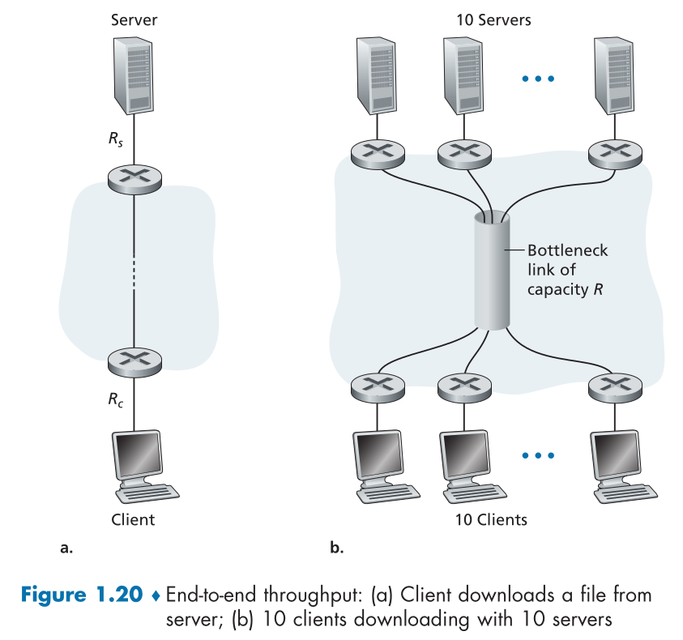
Solution
Well R link will be the bottleneck here. R_{c} and R_{s} will be limited as their max bandwidth to R/M. So the speed of the connection can be describes as

Exercise 1.21
Consider Figure 1.19(b). Now suppose that there are M paths between the server and the client. No two paths share any link. Path k (k = 1, ... , M) consists of N links with transmission rates R^{k}₁, R^{k}₂, ... , R^{k}_{N} . If the server can only use one path to send data to the client, what is the maximum throughput that the server can achieve? If the server can use all M paths to send data, what is the maximum throughput that the server can achieve?
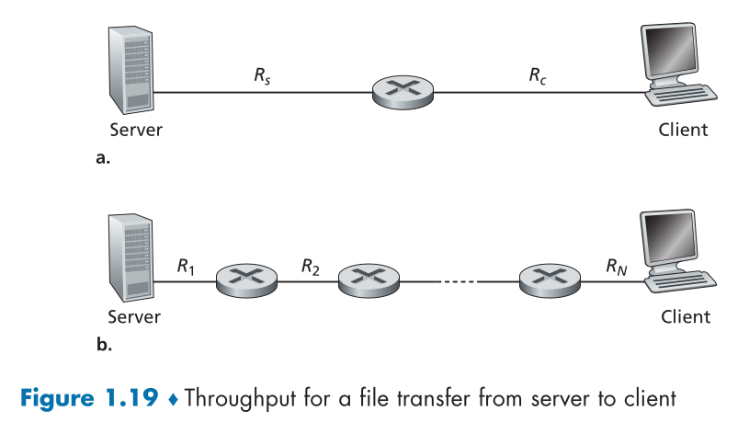
Solution
If you can only send data through a single path then the best choose can be described as:

In case that you can send data through all these links the easiest way (to not make individual calculations for load balancing) is to send data evenly taken reference the least throughput path

Exercise 1.22
Consider Figure 1.19(b). Suppose that each link between the server and the client has a packet loss probability p, and the packet loss probabilities for these links are independent. What is the probability that a packet (sent by the server) is successfully received by the receiver? If a packet is lost in the path from the server to the client, then the server will re-transmit the packet. On average, how many times will the server re-transmit the packet in order for the client to successfully receive the packet?
Solution
To get the probability for a packet to be successfully delivered is then a sequential probability of not losing the packet through the whole link. This can be described as:

From now I will call P(Y) as the probability of packet transmission succeed described before because this probability takes in count the dependency of the number of links so I mean Y depends from X₁ to X_{n}. In that case the mean number of packets needed is described as

Is worth to explain that P(Y) is the success event that should happen and happen only once. (1-P(Y)) represent any combination of failure transmission and it has to happen k-1 times before it can be successfully delivered. So k represent the number of attempts but also the number of packets delivered each iteration.

Exercise 1.23
Consider Figure 1.19(a). Assume that we know the bottleneck link along the path from the server to the client is the first link with rate R_{s} bits/sec. Suppose we send a pair of packets back to back from the server to the client, and there is no other traffic on this path. Assume each packet of size L bits, and both links have the same propagation delay d_{propa}.
- What is the packet inter-arrival time at the destination? That is, how much time elapses from when the last bit of the first packet arrives until the last bit of the second packet arrives?
- Now assume that the second link is the bottleneck link (i.e., R_{c} < R_{s}). Is it possible that the second packet queues at the input queue of the second link? Explain. Now suppose that the server sends the second packet T seconds after sending the first packet. How large must T be to ensure no queuing before the second link Explain.
Solution
- On this scenario the first packet delay to get at the switch will be of

Now because we know that R_{c} > R_{s} then no queue time is possible for the second packet to wait. In that case it only has to wait for the first packet for pass through the first link so the delay will be

So the difference between the arrival of the first packet and second packet is about L/R_{s}
- Yes actually a queue delay is expected because the secomd packet will arrive to the first switch and will find the first packet hasn’t finished yet. So in this scenario the calculation of delay of the first packet remains the same but the calculation of the delay of the second packet should be added the T delay.
T has to be the overhead difference between both links so

The order matters because if R_{c} is smaller than R_{s} that mean L/R_{c} is bigger than L/R_{s}

Exercise 1.24
Suppose you would like to urgently deliver 50 terabytes data from Boston to Los Angeles. You have available a 100 Mbps dedicated link for data transfer. Would you prefer to transmit the data via this link or instead use FedEx overnight delivery? Explain.
Solution
First we should calculate the time will require to transmit all this data through the network

This takes an enormous time. Actually take almost 46 days to accomplish so there’s no point to send it through the network if you can send it through FedEx because it will most likely to deliver the data in 3 days or less I don’t know.

Exercise 1.25
Suppose two hosts, A and B, are separated by 20,000 kilometers and are connected by a direct link of R = 5 Mbps. Suppose the propagation speed over the link is 2.5 * 10⁸ meters/sec.
- Calculate the bandwidth-delay product, R * d_{prop}.
- Consider sending a file of 800,000 bits from Host A to Host B. Suppose the file is sent continuously as one large message. What is the maximum number of bits that will be in the link at any given time?
- Provide an interpretation of the bandwidth-delay product.
- What is the width (in meters) of a bit in the link? Is it longer than a football field?
- Derive a general expression for the width of a bit in terms of the propagation speed s, the transmission rate R, and the length of the link m.
Solution

- Well once the whole link is filled after propagation delay the maximum number of bits inside this link will be of 400000 bits.
- It tells how many bits can travel inside a link before reach their destination

A football field could be around 100 metes so no. A bit travelling through this link is shorter than a football field.
- The general term will be

Exercise 1.26
Referring to problem P25, suppose we can modify R. For what value of R is the width of a bit as long as the length of the link?
Solution
In that case only one bit should travel inside the link. In other words

Exercise 1.27
Consider problem P25 but now with a link of R = 500 Mbps.
- Calculate the bandwidth-delay product, R * d_{prop}.
- Consider sending a file of 800,000 bits from Host A to Host B. Suppose the file is sent continuously as one big message. What is the maximum number of bits that will be in the link at any given time?
- What is the width (in meters) of a bit in the link?
Solution

- Because the bandwidth delay product is greater than the file which will be transmitted then the maximum number of bits inside the link will be of 800,000 bits.

Exercise 1.28
Refer again to problem P25.
- How long does it take to send the file, assuming it is sent continuously?
- Suppose now the file is broken up into 20 packets with each packet containing 40,000 bits. Suppose that each packet is acknowledged by the receiver and the transmission time of an acknowledgement packet is negligible. Finally, assume that the sender cannot send a packet until the preceding one is acknowledged. How long does it take to send the file?
- Compare the results from (a) and (b).
Solution

- In this scenario the acknowledgement packet will be small so the transmission time will be negligible however their propagation trough the link isn’t

- Well obviously send this data in packets is worse. This is because the transmission delay will happen for every packet and because there’s only one link there’s no gain in sending them into many routes.

Exercise 1.29
Suppose there is a 10 Mbps microwave link between a geostationary satellite and its base station on Earth. Every minute the satellite takes a digital photo and sends it to the base station. Assume a propagation speed of 2.4 * 10⁸ meters/sec.
- What is the propagation delay of the link?
- What is the bandwidth-delay product, R * d_{prop}?
- Let x denote the size of the photo. What is the minimum value of x for the microwave link to be continuously transmitting?
Solution
- In order to solve the questions of this exercise I will assume the distance between the geostationary satellite and the base station on Earth is about 36000km (based on empiric metrics). Then the propagation delay will be of

- If the satellite takes a photo every minute then we need to find the size of a photograph which keep the link busy so we can do the bandwidth delay product like but using a fixed delay instead propagation delay

If we assume the photo uses a raw RGB pixel structure (3 Bytes per pixel) and the photo is a square image then the size of the photo has to be 5000*5000 pixels.

Exercise 1.30
Consider the airline travel analogy in our discussion of layering in Section 1.5, and the addition of headers to protocol data units as they flow down the protocol stack. Is there an equivalent notion of header information that is added to passengers and baggage as they move down the airline protocol stack?
Solution
Yes in the analogy the passengers purchase a ticket which tells the sit number and also which kind of service it has like premium or economic. When it goes into the airport it has to register their baggage and this baggage has to be categorized and labelled depending of their dimensions to decide their best fit into the plane also to label whom is their owner. Then the passengers goes into the gates where depending of their ticket can have special services like VIP waiting rooms, prior boarding, best sits (the economic or plus header makes distinction in priority service in people). Then when arrives could have priority to get off the plane. Once they leave their gateway this distinctions disappears and their ticket is no use now. They go for their baggage and all this labels for packing are removed and disposed to their owner.

Exercise 1.31
In modern packet-switched networks, including the Internet, the source host segments long, application-layer messages (for example, an image or a music file) into smaller packets and sends the packets into the network. The receiver then reassembles the packets back into the original message. We refer to this process as message segmentation. Figure 1.27 illustrates the end-to-end transport of a message with and without message segmentation. Consider a message that is 10⁶ bits long that is to be sent from source to destination in Figure 1.27. Suppose each link in the figure is 5 Mbps. Ignore propagation, queuing, and processing delays.
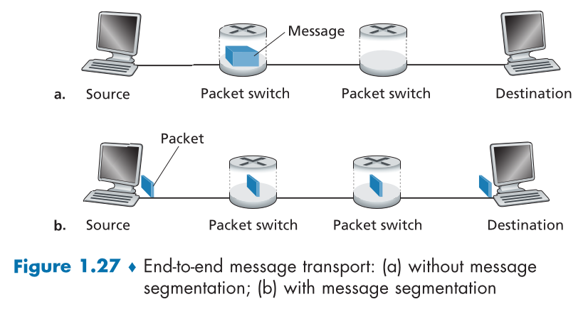
- Consider sending the message from source to destination without message segmentation. How long does it take to move the message from the source host to the first packet switch? Keeping in mind that each switch uses store-and-forward packet switching, what is the total time to move the message from source host to destination host?
- Now suppose that the message is segmented into 100 packets, with each packet being 10,000 bits long. How long does it take to move the first packet from source host to the first switch? When the first packet is being sent from the first switch to the second switch, the second packet is being sent from the source host to the first switch. At what time will the second packet be fully received at the first switch?
- How long does it take to move the file from source host to destination host when message segmentation is used? Compare this result with your answer in part (a) and comment.
- In addition to reducing delay, what are reasons to use message segmentation?
- Discuss the drawbacks of message segmentation.
Solution
- To send the data through the first switch will take the time of

and when it passes through the 2 switches (3 links to travel) then will require the following time

- If the data is segmented into 100 packets then the time to transmit these packets from the source to the first switch will be of

So then the second packet will arrive to the first switch at the same time as the first packet reach the second switch.

This compared to the non-packet transmission is faster. The segmentation reduce the impact of performance of not using the links as much as they can.
- It improve network traffic because it doesn’t congest a link to much because is waiting to transmit a big chunk of data and by trying to keep all link busy to transmit data. Also will help to fix errors earlier because is speedier and quicker to heck errors on small packets. Also the segmentation is more fair to multiple user usage
- Of course there are drawbacks. The segmentation reduces greatly the global transmission delay however make worse the propagation delay (when acknowledge is necessary), process delay (when many switches are in between) and even a little transmission delay of each packet (because headers needed).

Exercise 1.32
Experiment with the Message Segmentation interactive animation at the book’s Web site. Do the delays in the interactive animation correspond to the delays in the previous problem? How do link propagation delays affect the overall end-to-end delay for packet switching (with message segmentation) and for message switching?
Solution
Well not at all because in the animation you can decide if you ignore or not the other kind of delays. /*Pending*/

Exercise 1.33
Consider sending a large file of F bits from Host A to Host B. There are three links (and two switches) between A and B, and the links are uncongested (that is, no queuing delays). Host A segments the file into segments of S bits each and adds 80 bits of header to each segment, forming packets of L = 80 + S bits. Each link has a transmission rate of R bps. Find the value of S that minimizes the delay of moving the file from Host A to Host B. Disregard propagation delay
Solution
Well it seems like the delay to send this file will be of

Now to get the minimum value of S we can treat this equation as a function which depends of S. To solve continuity problems because S cannot be 0 we will define the function properties from S>0 to infinity (Also because it’s not natural any value of S less than 0). From there we take the first and second derivative

And from there taking their maximum and minimum possible values

Now we check the concativity of the function by checking the signs when we substitute the value of S inside the second derivative. However it seems clear that the calculation will throw a positive result if S is positive and negative if S is negative. So the minimum f''(S) > 0 only happen with a positive value of S (which in the real world is the only possible option). So the best value of S to minimize delay is

Exercise 1.34
Skype offers a service that allows you to make a phone call from a PC to an ordinary phone. This means that the voice call must pass through both the Internet and through a telephone network. Discuss how this might be done.
Solution
Well to be able to do that then Skype server should have some kind of decode. When the client send the data as VoIP into the server then the server analyze the data of the packets and transform the digital information to analog information so then the Skype use a calling centre to select a phone from where to call and ring to the target phone and send this analog data through a telephone line. The server should also try to intercept user actions and transform this actions as phone line actions too, like sending phone inputs through the line.

Chapter 2

Exercise 2.1
True or false?
- A user requests a Web page that consists of some text and three images. For this page, the client will send one request message and receive four response messages.
- Two distinct Web pages (for example, www.mit.edu/research.html and www.mit.edu/students.html) can be sent over the same persistent connection.
- With nonpersistent connections between browser and origin server, it is possible for a single TCP segment to carry two distinct HTTP request messages.
- The Date: header in the HTTP response message indicates when the object in the response was last modified.
- HTTP response messages never have an empty message body.
Solution
- False. It will request first the document page and then send a request for every image inside the page (this case 3). So it send 4 request and get 4 answers.
- True. It can be sent over the same persistent connection
- False. For every HTTP request has to be sent into individual TCP packets because the transport layer only create a wrap of the application message so isn’t possible for transport layer to decide sent mixed messages of application data through the same packet
- False. Because in non persistent connection the connection is closed when the message is sent so you cannot send 2 HTTP request. For persistent connection actually this is true because the HTTP request are sent like a stream inside the transport layer
- False. The HTTP responses can actually be empty. Actually when you sent a HEAD request it sent a response with only header data

Exercise 2.2
SMS, iMessage, Wechat, and WhatsApp are all smartphone real-time messaging systems. After doing some research on the Internet, for each of these systems write one paragraph about the protocols they use. Then write a paragraph explaining how they differ.
Solution
/*Pending*/

Exercise 2.3
Consider an HTTP client that wants to retrieve a Web document at a given URL. The IP address of the HTTP server is initially unknown. What transport and application-layer protocols besides HTTP are needed in this scenario?
Solution
Is needed a request of domain name translation using a DNS request which is sent through UDP. When an authoritative answer is given then the HTTP replaces the domain name into the IP.

Exercise 2.4
Consider the following string of ASCII characters that were captured by Wireshark when the browser sent an HTTP GET message (i.e., this is the actual content of an HTTP GET message). The characters <cr><lf> are carriage return and line-feed characters (that is, the italized character string <cr> in the text below represents the single carriage-return character that was contained at that point in the HTTP header). Answer the following questions, indicating where in the HTTP GET message below you find the answer.

GET /cs453/index.html HTTP/1.1
Host: gaia.cs.umass.edu
User-Agent: Mozilla/5.0 (Windows;U; Windows NT 5.1; en-US; rv:1.7.2) Gecko/20040804 Netscape/7.2 (ax)
Accept:ext/xml, application/xml, application/xhtml+xml, text/html;q=0.9, text/plain;q=0.8,image/png,*/*;q=0.5
Accept-Language: en-us,en;q=0.5
Accept-Encoding: zip,deflate
Accept-Charset: ISO-8859-1,utf-8;q=0.7,*;q=0.7
Keep-Alive: 300
Connection:keep-alive

- What is the URL of the document requested by the browser?
- What version of HTTP is the browser running?
- Does the browser request a non-persistent or a persistent connection?
- What is the IP address of the host on which the browser is running?
- What type of browser initiates this message? Why is the browser type needed in an HTTP request message?
Solution
- The original URL will be something like http://gaia.cs.umass.edu/cs453/index.html
- Is running HTTP 1.1
- A persistent connection
- Doesn’t tell
- Some based in Netscape. It can be important to tell which kind of browser to know which version of HTTP and which features are available

Exercise 2.5
The text below shows the reply sent from the server in response to the HTTP GET message in the question above. Answer the following questions, indicating where in the message below you find the answer.

HTTP/1.1 200 OK
Date: Tue, 07 Mar 2008 12:39:45GMT
Server: Apache/2.0.52 (Fedora)
Last-Modified: Sat, 10 Dec 2005 18:27:46 GMT
ETag: ”526c3-f22-a88a4c80”
Accept-Ranges: bytes
Content-Length: 3874
Keep-Alive: timeout=5, max=100
Connection: Keep-Alive
Content-Type: text/html; charset=ISO-8859-1

<!doctype html public ”-//w3c//dtd html 4.0transitional//en”>
<html>
<head>
<meta http-equiv=”Content-Type” content=”text/html; charset=iso-8859-1”>
<meta name=”GENERATOR” content=”Mozilla/4.79 [en] (Windows NT 5.0; U) Netscape]”>
<title>CMPSCI 453 / 591 /NTU-ST550ASpring 2005 homepage</title>
</head>

- Was the server able to successfully find the document or not? What time was the document reply provided?
- When was the document last modified?
- How many bytes are there in the document being returned?
- What are the first 5 bytes of the document being returned? Did the server agree to a persistent connection?
Solution
- Yes it found the document. The document was delivered on March 7th of 2008
- The page wasn’t modified since December 10th of 2005
- 3874 Bytes
- Well the message says the document is encoded in iso-8859-1 where every character uses 8 bits so the first 5 characters of the document are “<!doc”. Also the server did agree on have a persistent connection, this is defined by the “Keep-Alive” header when tells when idle it should close after 5 seconds and it allows a maximum of 100 before restart the connection

Exercise 2.6
Obtain the HTTP/1.1 specification (RFC 2616). Answer the following
questions:
- Explain the mechanism used for signalling between the client and server to indicate that a persistent connection is being closed. Can the client, the server, or both signal the close of a connection?
- What encryption services are provided by HTTP?
- Can a client open three or more simultaneous connections with a given server?
- Either a server or a client may close a transport connection between them if either one detects the connection has been idle for some time. Is it possible that one side starts closing a connection while the other side is transmitting data via this connection? Explain.
Solution
- Yes both ends can tell to the other end that want to close the connection using the header “Connection: close”. A persistent connection is default action however both client and server has to verify that both are HTTP/1.1 compatible
- HTTP can provide TLS and SSL encryption but only if use the HTTPS protocol which is an extension. By its own HTTP doesn’t provide any encryption.
- The specification says that client should limit the number of connections to less or equal to two and servers should limit their connections by 2*N where N is the number of different users
- /*Pending*/

Exercise 2.7
Suppose within your Web browser you click on a link to obtain a Web page. The IP address for the associated URL is not cached in your local host, so a DNS lookup is necessary to obtain the IP address. Suppose that n DNS servers are visited before your host receives the IP address from DNS; the successive visits incur an RTT of RTT₁, . . . , RTT_{n}. Further suppose that the Web page associated with the link contains exactly one object, consisting of a small amount of HTML text. Let RTT₀ denote the RTT between the local host and the server containing the object. Assuming zero transmission time of the object, how much time elapses from when the client clicks on the link until the client receives the object?
Solution
/*Pending*/

Exercise 2.8
Referring to Problem P7, suppose the HTML file references eight very small objects on the same server. Neglecting transmission times, how much time elapses with
- Non-persistent HTTP with no parallel TCP connections?
- Non-persistent HTTP with the browser configured for 6 parallel connections?
- Persistent HTTP?
Solution
/*Pending*/

Exercise 2.9
Consider Figure 2.12, for which there is an institutional network connected to the Internet. Suppose that the average object size is 1,000,000 bits and that the average request rate from the institution’s browsers to the origin servers is 16 requests per second. Also suppose that the amount of time it takes from when the router on the Internet side of the access link forwards an HTTP request until it receives the response is three seconds on average (see Section 2.2.5). Model the total average response time as the sum of the average access delay (that
is, the delay from Internet router to institution router) and the average Internet delay. For the average access delay, use Δ/(1 - Δb), where Δ is the average time required to send an object over the access link and b is the arrival rate of objects to the access link.
- Find the total average response time.
- Now suppose a cache is installed in the institutional LAN. Suppose the miss rate is 0.4. Find the total response time.
Solution
/*Pending*/

Exercise 2.10
Consider a short, 10-meter link, over which a sender can transmit at a rate of 150 bits/sec in both directions. Suppose that packets containing data are 100,000 bits long, and packets containing only control (e.g., ACK or handshaking) are 200 bits long. Assume that N parallel connections each get 1/N of the link bandwidth. Now consider the HTTP protocol, and suppose that each downloaded object is 100 Kbits long, and that the initial downloaded object contains 10 referenced objects from the same sender. Would parallel downloads via parallel instances of non-persistent HTTP make sense in this case? Now consider persistent HTTP. Do you expect significant gains over the non-persistent case? Justify and explain your answer.
Solution
/*Pending*/

Exercise 2.11
Consider the scenario introduced in the previous problem. Now suppose that the link is shared by Bob with four other users. Bob uses parallel instances of non-persistent HTTP, and the other four users use non-persistent HTTP without parallel downloads.
- Do Bob’s parallel connections help him get Web pages more quickly? Why or why not?
- If all five users open five parallel instances of non-persistent HTTP, then would Bob’s parallel connections still be beneficial? Why or why not?
Solution
/*Pending*/

Exercise 2.12
Write a simple TCP program for a server that accepts lines of input from a client and prints the lines onto the server’s standard output. (You can do this by modifying the TCPServer.py program in the text.) Compile and execute your program. On any other machine that contains a Web browser, set the proxy server in the browser to the host that is running your server program; also configure the port number appropriately. Your browser should now send its GET request messages to your server, and your server should display the messages on its standard output. Use this platform to determine whether your browser generates conditional GET messages for objects that are locally cached.
Solution
/*Pending*/

Exercise 2.13
Consider sending over HTTP/2 a Web page that consists of one video clip, and five images. Suppose that the video clip is transported as 2000 frames, and each image has three frames.
- If all the video frames are sent first without interleaving, how many “frame times” are needed until all five images are sent?
- If frames are interleaved, how many frame times are needed until all five images are sent.
Solution
/*Pending*/

Exercise 2.14
Consider the Web page in problem 13. Now HTTP/2 prioritization is employed. Suppose all the images are given priority over the video clip, and that the first image is given priority over the second image, the second image over the third image, and so on. How many frame times will be needed until the second image is sent?
Solution
/*Pending*/

Exercise 2.15
What is the difference between MAIL FROM: in SMTP and From: in the mail message itself?
Solution
/*Pending*/

Exercise 2.16
How does SMTP mark the end of a message body? How about HTTP? Can HTTP use the same method as SMTP to mark the end of a message body? Explain
Solution
/*Pending*/

Exercise 2.17
Read RFC 5321 for SMTP. What does MTA stand for? Consider the following received spam e-mail (modified from a real spam e-mail). Assuming only the originator of this spam e-mail is malicious and all other hosts are honest, identify the malicious host that has generated this spam e-mail.

From - Fri Nov 07 13:41:30 2008
Return-Path: <tennis5@pp33head.com>
Received: from barmail.cs.umass.edu (barmail.cs.umass.edu [128.119.240.3]) by cs.umass.edu (8.13.1/8.12.6) for <hg@cs.umass.edu>; Fri, 7 Nov 2008 13:27:10 -0500
Received: from asusus-4b96 (localhost [127.0.0.1]) by barmail.cs.umass.edu (Spam Firewall) for <hg@cs.umass.edu>; Fri, 7 Nov 2008 13:27:07 -0500 (EST)
Received: from asusus-4b96 ([58.88.21.177]) by barmail.cs.umass.edu for <hg@cs.umass.edu>; Fri, 07 Nov 2008 13:27:07 -0500 (EST)
Received: from [58.88.21.177] by inbnd55.exchangeddd.com; Sat, 8 Nov 2008 01:27:07 +0700
From: ”Jonny” <tennis5@pp33head.com>
To: <hg@cs.umass.edu>
Subject: How to secure your savings

Solution
/*Pending*/

Exercise 2.18
- What is a whois database?
- Use various whois databases on the Internet to obtain the names of two DNS servers. Indicate which whois databases you used.
- Use nslookup on your local host to send DNS queries to three DNS servers: your local DNS server and the two DNS servers you found in part (b). Try querying for Type A, NS, and MX reports. Summarize your findings.
- Use nslookup to find a Web server that has multiple IP addresses. Does the Web server of your institution (school or company) have multiple IP addresses?
- Use the ARIN whois database to determine the IP address range used by your university.
- Describe how an attacker can use whois databases and the nslookup tool to perform reconnaissance on an institution before launching an attack.
- Discuss why whois databases should be publicly available.
Solution
/*Pending*/

Exercise 2.19
In this problem, we use the useful dig tool available on Unix and Linux hosts to explore the hierarchy of DNS servers. Recall that in Figure 2.19, a DNS server in the DNS hierarchy delegates a DNS query to a DNS server lower in the hierarchy, by sending back to the DNS client the name of that lower-level DNS server. First read the man page for dig, and then answer the following questions.
- Starting with a root DNS server (from one of the root servers [a-m].root-servers.net), initiate a sequence of queries for the IP address for your department’s Web server by using dig. Show the list of the names of DNS servers in the delegation chain in answering your query.
- Repeat part (a) for several popular Web sites, such as google.com, yahoo.com, or amazon.com.
Solution
/*Pending*/

Exercise 2.20
Suppose you can access the caches in the local DNS servers of your department. Can you propose a way to roughly determine the Web servers (outside your department) that are most popular among the users in your department? Explain.
Solution
/*Pending*/

Exercise 2.21
Suppose that your department has a local DNS server for all computers in the department. You are an ordinary user (i.e., not a network/system administrator). Can you determine if an external Web site was likely accessed from a computer in your department a couple of seconds ago? Explain.
Solution
/*Pending*/

Exercise 2.22
Consider distributing a file of F = 20 Gbits to N peers. The server has an upload rate of u_{s} = 30 Mbps, and each peer has a download rate of d_{i} = 2 Mbps and an upload rate of u. For N = 10, 100, and 1,000 and u = 300 Kbps, 700 Kbps, and 2 Mbps, prepare a chart giving the minimum distribution time for each of the combinations of N and u for both client-server distribution and P2P distribution.
Solution
/*Pending*/

Exercise 2.23
Consider distributing a file of F bits to N peers using a client-server architecture. Assume a fluid model where the server can simultaneously transmit to multiple peers, transmitting to each peer at different rates, as long as the combined rate does not exceed us.
- Suppose that u_{s}/N≤d_{min}. Specify a distribution scheme that has a distribution time of NF/u_{s}.
- Suppose that u_{s}/N≥d_{min}. Specify a distribution scheme that has a distribution time of F/d_{min}.
- Conclude that the minimum distribution time is in general given by max{NF/u_{s}, F/d_{min}}.
Solution
/*Pending*/

Exercise 2.24
Consider distributing a file of F bits to N peers using a P2P architecture. Assume a fluid model. For simplicity assume that d_{min} is very large, so that peer download bandwidth is never a bottleneck.
- Suppose that u_{s}≤(u_{s} + u₁ + . . . + u_{N})/N. Specify a distribution scheme that has a distribution time of F/u_{s}.
- Suppose that u_{s}≥(u_{s} + u₁ + . . . + u_{N})/N. Specify a distribution scheme that has a distribution time of NF/(u_{s} + u₁ + . . . + u_{N}).
- Conclude that the minimum distribution time is in general given by max{F/u_{s}, NF/(u_{s} + u₁ + . . . + u_{N})}.
Solution
/*Pending*/

Exercise 2.25
Consider an overlay network with N active peers, with each pair of peers having an active TCP connection. Additionally, suppose that the TCP connections pass through a total of M routers. How many nodes and edges are there in the corresponding overlay network?
Solution
/*Pending*/

Exercise 2.26
Suppose Bob joins a BitTorrent torrent, but he does not want to upload any data to any other peers (so called free-riding).
- Bob claims that he can receive a complete copy of the file that is shared by the swarm. Is Bob’s claim possible? Why or why not?
- Bob further claims that he can further make his “free-riding” more efficient by using a collection of multiple computers (with distinct IP addresses) in the computer lab in his department. How can he do that?
Solution
/*Pending*/

Exercise 2.27
Consider a DASH system for which there are N video versions (at N different rates and qualities) and N audio versions (at N different rates and qualities). Suppose we want to allow the player to choose at any time any of the N video versions and any of the N audio versions.
- If we create files so that the audio is mixed in with the video, so server sends only one media stream at given time, how many files will the server need to store (each a different URL)?
- If the server instead sends the audio and video streams separately and has the client synchronize the streams, how many files will the server need to store?
Solution
/*Pending*/

Exercise 2.28
Install and compile the Python programs TCPClient and UDPClient on one host and TCPServer and UDPServer on another host.
- Suppose you run TCPClient before you run TCPServer. What happens? Why?
- Suppose you run UDPClient before you run UDPServer. What happens? Why?
- What happens if you use different port numbers for the client and server sides?
Solution
/*Pending*/

Exercise 2.29
Suppose that in UDPClient.py, after we create the socket, we add the line:
clientSocket.bind((’’, 5432))
Will it become necessary to change UDPServer.py? What are the port numbers for the sockets in UDPClient and UDPServer? What were they before making this change?
Solution
/*Pending*/

Exercise 2.30
Can you configure your browser to open multiple simultaneous connections to a Web site? What are the advantages and disadvantages of having a large number of simultaneous TCP connections?
Solution
/*Pending*/

Exercise 2.31
We have seen that Internet TCP sockets treat the data being sent as a byte stream but UDP sockets recognize message boundaries. What are one advantage and one disadvantage of byte-oriented API versus having the API explicitly recognize and preserve application-defined message boundaries?
Solution
/*Pending*/

Exercise 2.32
We have seen that Internet TCP sockets treat the data being sent as a byte stream but UDP sockets recognize message boundaries. What are one advantage and one disadvantage of byte-oriented API versus having the API explicitly recognize and preserve application-defined message boundaries?
Solution
/*Pending*/

