Modern Operating Systems

Chapter 1

Exercise 1.1
What are the two main functions of an operating system?
Solution
The two main function of a operating system is to manage hardware resources and provide a programming interface for users to consume this resources.

Exercise 1.2
In Section 1.4, nine different types of operating systems are described. Give a list of applications for each of these systems (one per operating systems type).
Solution
- Mainframe OS: A bank broker which handle millions of stock operations
- Server OS: A web page of a famous corporation
- Personal Computer OS: A video editor
- Handheld Computer OS: A social media app
- Internet of Things OS: A security camera systems
- Real Time OS: An automobile drive conduction system
- Smart Card OS: An encrypted key manager

Exercise 1.3
What is the difference between timesharing and multiprogramming systems?
Solution
Time sharing are systems that are meant to be used by many users. Multi programming systems are designed to be able to run different programs (that mean programs sharing the main memory at the same time and with some scheduler). Time sharing are actually multi programming by definition because it fetch different programs inside the memory executed by many users. But a multi programming system not necessarily is time sharing because cannot take into account the usage of many users but one.

Exercise 1.4
To use cache memory, main memory is divided into cache lines, typically 32 or 64 bytes long. An entire cache line is cached at once. What is the advantage of caching an entire line instead of a single byte or word at a time?
Solution
It exploit spatial locality reference of values near of the target value to get. So because if we know near values can be access soon then we can fetch a whole bunch of bytes like 32 and 64. However this principle has to balance a size which can provide spatial locality but with the flexibility to not occupy to much cache memory in one block to avoid compulsive misses.

Exercise 1.5
On early computers, every byte of data read or written was handled by the CPU (i.e., there was no DMA). What implications does this have for multiprogramming?
Solution
With DMA computer systems has the option for multiprogramming systems to do I/O operations with DMA without CPU intervention making CPU occupied always with some job to do (instead go idle waiting I/O interruption). Without DMA the performance would be greatly worse.

Exercise 1.6
Instructions related to accessing I/O devices are typically privileged instructions, that is, they can be executed in kernel mode but not in user mode. Give a reason why these instructions are privileged.
Solution
Because processes share I/Os. A program should not read other process operations and less to be able to change it behaviour. The only way to achieve that is for the operating system to ensure that only permitted memory are readable and writable for processes. That include I/Os

Exercise 1.7
The family-of-computers idea was introduced in the 1960s with the IBM System/360 mainframes. Is this idea now dead as a doornail or does it live on?
Solution
It still lives. It is actually a standard of the industry to adopt “family” architectures to ensure interoperability of systems Like the use of x86 for binary compatibility or PC motherboards for BIOS or Windows for OS applications dependent.

Exercise 1.8
One reason GUIs were initially slow to be adopted was the cost of the hardware needed to support them. How much video RAM is needed to support a 25-line × 80-row character monochrome text screen? How much for a 1200 × 900-pixel 24-bit color bit map? What was the cost of this RAM at 1980 prices ($5/KB)? How much is it now?
Solution
For a monochrome screen is needed

with a price of 2KB*$5=$10.
For a color screen is needed

The price of color screen in the 80s would be about $16,200 but now cost just cents

Exercise 1.9
There are several design goals in building an operating system, for example, resource utilization, timeliness, robustness, and so on. Give an example of two design goals that may contradict one another.
Solution
One can be time sharing vs real time. In time sharing systems the process execution time are scheduled by an algorithm to attempt a fair execution time so is not always predictable the time consumed by the process until it switch to another process. However real time process are meant to be always be on schedule. So the OS won’t allow for other process to complete if it compromise the deadline of a higher priority process that awaits.
Of course both example assume no system interrupts are used to change normal behaviour.

Exercise 1.10
What is the difference between kernel and user mode? Explain how having two distinct modes aids in designing an operating system.
Solution
Kernel mode is a execution context where all the code of the operating system run. Inside this context all the resources and hardware are totally visible. It prevent for the user mode to access these resources directly so the user mode has to use systemcalls, the parameters of the system calls are saved inside the CPU register and when it switch the context the OS first save the parameters into their memory and then load the kernel context allowing to kernel mode to know the wanted request to execute. Once it finish it save the state of their own kernel state and load the user state to continue normal execution. Then user mode never had access to raw resources but now it has permission of the kernel mode to use some part of it.

Exercise 1.11
A 255-GB disk has 65,536 cylinders with 255 sectors per track and 512 bytes per sector. How many platters and heads does this disk have? Assuming an average cylinder seek time of 11 ms, average rotational delay of 7 msec and reading rate of 100 MB/sec, calculate the average time it will take to read 400 KB from one sector.
Solution
With that numbers we get that

Exercise 1.12
Which of the following instructions should be allowed only in kernel mode?
- Disable all interrupts.
- Read the time-of-day clock.
- Set the time-of-day clock.
- Change the memory map.
Solution
- Be able to change other process execution should be kernel mode only
- Read a global value should be user and kernel mode available
- Modify a global value should be kernel mode only
- Modify memory mapping should be kernel mode only

Exercise 1.13
Consider a system that has two CPUs, each CPU having two threads (hyperthreading). Suppose three programs, P0, P1, and P2, are started with run times of 5, 10 and 20 msec, respectively. How long will it take to complete the execution of these programs? Assume that all three programs are 100% CPU bound, do not block during execution, and do not change CPUs once assigned.
Solution
It depend how the processes are scheduled. If P0 and P1 goes to the same CPU making 15 millisec so then P2 takes 20 millisec in the remaining core. If P1 and P2 share CPU the the total time goes to 30 millisec. If P0 and P2 share CPU then it takes 25 millisec.

Exercise 1.14
A computer has a pipeline with four stages. Each stage takes the same time to do its work, namely, 1 nsec. How many instructions per second can this machine execute?
Solution
The latency of the first instruction will take 4 nanoseconds but then will take 1 nanosec per instruction. So it can execute 10⁹ instructions per second (A billion of instructions)

Exercise 1.15
Consider a computer system that has cache memory, main memory (RAM) and disk, and an operating system that uses virtual memory. It takes 1 nsec to access a word from the cache, 10 nsec to access a word from the RAM, and 10 ms to access a word from the disk. If the cache hit rate is 95% and main memory hit rate (after a cache miss) is 99%, what is the average time to access a word?
Solution

Exercise 1.16
When a user program makes a system call to read or write a disk file, it provides an indication of which file it wants, a pointer to the data buffer, and the count. Control is then transferred to the operating system, which calls the appropriate driver. Suppose that the driver starts the disk and terminates until an interrupt occurs. In the case of reading from the disk, obviously the caller will have to be blocked (because there are no data for it). What about the case of writing to the disk? Need the caller be blocked awaiting completion of the disk transfer?
Solution
The operation of a read or write should be transactional. That mean that any state should be visible until the operation is complete and it should respect the order of previous transactions. For a read operation into a busy file should be blocked the access because it won’t had the most recent data. For a write into a busy file can be solved writing inside a buffer which eventually will move its content into the disk.

Exercise 1.17
What is a trap instruction? Explain its use in operating systems.
Solution
A trap instruction is a synchronous instruction which switch the executing context and the privilege mode of the context inside the CPU. Many architectures provide privileged modes and it provide special registers to assure that at least 2 modes to always be isolated. For example in RISC-V it provide 3 privileged modes M, S and U. M is the mode with most privileges and it has specific registers to check hardware status and interrupt control. S mode provide a certain registers and instructions to provide OS features like virtual memory and flush cache. Finally U mode which it only privilege is to switch to M or S mode with an ecall or a external triggered interruption. With these 3 modes it encourage to do specific and regular computer task with the right amount of privileges and assure that no less privileged mode can overrule a higher privilege mode.

Exercise 1.18
Why is the process table needed in a timesharing system? Is it also needed in personal computer systems running UNIX or Windows with a single user?
Solution
The process table is needed to link resources like memory mapping, privilege mode, process priority and much more. With a defined data structure like a table you can be sure which elements are tied to a process and make easier to manage it. Even if some properties is not necessary to track in single user mode like privilege mode it still provide a reliable way to manage processes. Also and more important it make possible multi programming in OS (that mean run many programs inside a computer) because you can associate a state to the active processes and make easier and fast to switch between them

Exercise 1.19
Is there any reason why you might want to mount a file system on a nonempty directory? If so, what is it?
Solution
When you mount a disk inside a non empty directory then all the files inside this directory become inaccessible until the disk is unmounted. The main reason you would like to mount into a non empty directory is because you probably want to overlay some files to change program data (probably for data restoring or change versions). For example in containers this action to save data into mutable disks because containers use immutable file system. When mounted then the data is preserved after container restart or delete. But if no mount volume is used to overlay the directory then data is written into a temporary overlay which it won’t be saved after reset or delete of the container.

Exercise 1.20
For each of the following system calls, give a condition that causes it to fail: fork, exec, and unlink.
Solution
The only reason I could think for fork() to fail is not enough memory space to create a new process. For exec() can be not enough memory space or permission denied for running that process. And for unlink() a permission denied or not found path.

Exercise 1.21
What type of multiplexing (time, space, or both) can be used for sharing the following resources: CPU, memory, disk, network card, printer, keyboard, and display?
Solution
For CPU is time, For memory is space and for I/Os in general is a mixture of both.

Exercise 1.22
Can the
count = write(fd, buffer, nbytes);
call return any value in count other than nbytes? If so, why?
Solution
As standard C calls it can return -1 to indicate an error. But it can return less than nbytes if the write is interrupted by something else.

Exercise 1.23
A file whose file descriptor is fd contains the following sequence of bytes: 3, 1, 4, 1, 5, 9, 2, 6, 5, 3, 5. The following system calls are made:
lseek(fd, 3, SEEK SET);
read(fd, &buffer, 4);
where the lseek call makes a seek to byte 3 of the file. What does buffer contain after the read has completed?
Solution
A file descriptor (fd) is the pointer of a file content. Usually fd point to the first byte of the file so it will be pointing like this
3<-(fd), 1, 4, 1, 5, 9, 2, 6, 5, 3, 5
With SEEK SET flag the call will only move fd by a given offset, which is 3 so it will point here.
3, 1, 4, 1<-(fd), 5, 9, 2, 6, 5, 3, 5
Then if we call read() then will get the number of bytes given into the buffer address. In that case then buffer will get the following bytes:
1, 5, 9, 2

Exercise 1.24
Suppose that a 10-MB file is stored on a disk on the same track (track 50) in consecutive sectors. The disk arm is currently situated over track number 100. How long will it take to retrieve this file from the disk? Assume that it takes about 1 ms to move the arm from one cylinder to the next and about 5 ms for the sector where the beginning of the file is stored to rotate under the head. Also, assume that reading occurs at a rate of 200 MB/s.
Solution
It will take

Exercise 1.25
What is the essential difference between a block special file and a character special file?
Solution
Both are used for inputs and outputs devices in /dev. However block special files are used to read and access addressable blocks of storage devices meanwhile character special files are used for devices that constantly send and receive data into a data stream.

Exercise 1.26
In the example given in Fig. 1-17, the library procedure is called read and the system call itself is called read. Is it essential that both of these have the same name? If not, which one is more important?
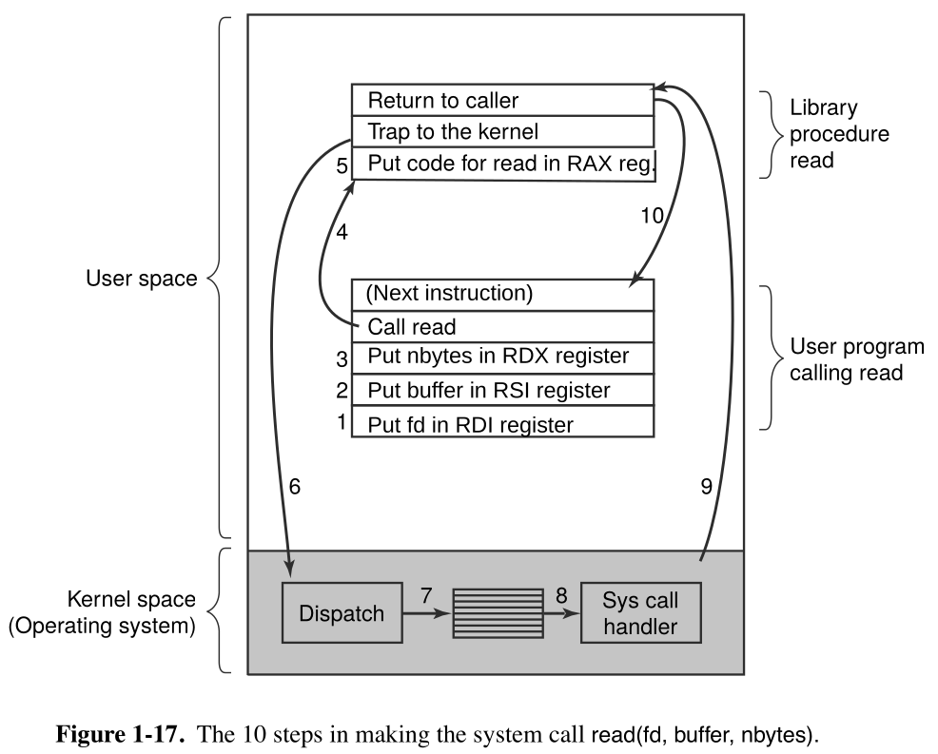
Solution
Not necessarily. A library that has a function called read() in C language can be a wrap of a system call called the same. This practice is usually used for abstract common operations which use systems calls. About which is more important that should be the library call. That because software rely on defined APIs. However this library function can be modified to adapt system calls so it try to avoid the program to recompile. This is actually the process followed by software like Wine and Proton which translate Windows system calls into a set of system calls in Linux and some other tweaks to provide the same behaviour like if it executed in Windows.

Exercise 1.27
Modern operating systems decouple a process address space from the machine’s physical memory. List two advantages of this design.
Solution
First will improve isolation in memory address because if program uses physical memory to run then in theory it can address memory space used by other process. Second, software don’t have to reserve a fixed address space, because if it use physical memory then a fixed space of memory should be reserved so any software should use this space to avoid conflicts.

Exercise 1.28
To a programmer, a system call looks like any other call to a library procedure. Is it important that a programmer know which library procedures result in system calls? Under what circumstances and why?
Solution
It is important to differentiate normal procedures to systems calls because the programmer:
- Should be aware that system calls has a expensive overhead due to context switch.
- Should be aware that system calls can block or modify normal execution because signalling
- Should be aware that correct permissions should be given because system calls are heavily privilege aware

Exercise 1.29
Figure 1-23 shows that a number of UNIX system calls have no Win32 API equivalents. For each of the calls listed as having no Win32 equivalent, what are the consequences for a programmer of converting a UNIX program to run under Windows?
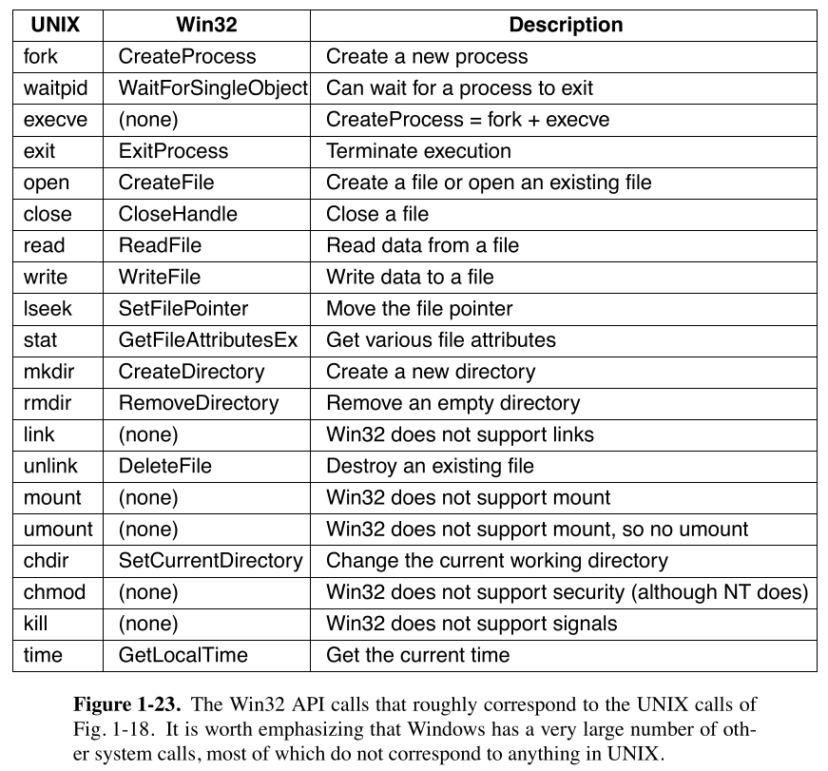
Solution
If there’s no 1 to 1 conversion then it should do many tweaks to simulate the UNIX system call into many Win32 system calls. However there’s sometimes that some UNIX system call use a certain feature exclusive of Windows making impossible then to translate. That mean code rewrite, loss of functionality and hard debugging code.

Exercise 1.30
A portable operating system is one that can be ported from one system architecture to another without any modification. Explain why it is infeasible to build an operating system that is completely portable. Describe two high-level layers that you will have in designing an operating system that is highly portable.
Solution
Is hardly impossible to get a total portable code. Most of the time because the behaviour and features differences between computer architectures (Most of the time is about memory management units and privilege modes which are the most compatibility breakers). So hardware drivers become the most affected by these changes, so it makes mandatory to rewrite drivers. Usually OS divide specific machine operations from the rest of the OS to be sure of modifying the minimum necessary code. Also for portability is important to make compilers works to be architecture specific so it can translate correctly the programming code (mostly C) into machine code.

Exercise 1.31
Explain how separation of policy and mechanism aids in building microkernel-based operating systems.
Solution
Because it can make the kernel even smaller and secure. This is because it reduce code footprint and makes for the user process that implement the policy to follow the principle of least authority. The policy can be handled by a user process making a specific API for other program to talk to it making also kernel system calls reduced.

Exercise 1.32
Virtual machines have become very popular for a variety of reasons. Nevertheless, they have some downsides. Name one.
Solution
One is the resource consumption caused by running a complete OS in order to run apps, a second downside is the boot time required for a VM to start.

Exercise 1.33
Here are some questions for practicing unit conversions:
- How long is a nanoyear in seconds?
- Micrometers are often called microns. How long is a megamicron?
- How many bytes are there in a 1-PB memory?
- The mass of the earth is 6000 yottagrams. What is that in kilograms?
Solution

Exercise 1.34
Write a shell that is similar to Fig. 1-19 but contains enough code that it actually works so you can test it. You might also add some features such as redirection of input and output, pipes, and background jobs.
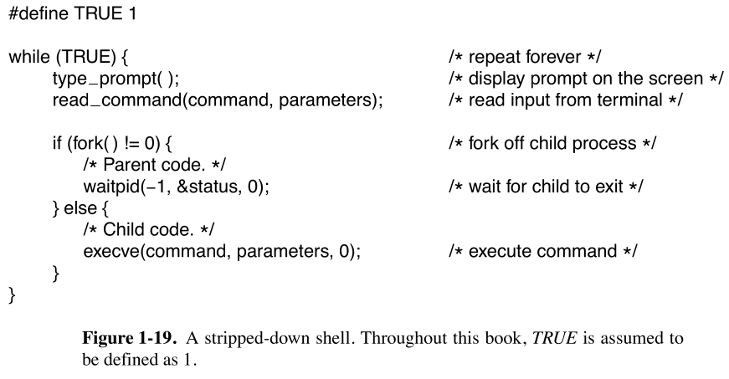
Solution
/*pending*/

Exercise 1.35
If you have a personal UNIX-like system (Linux, MINIX 3, FreeBSD, etc.) available that you can safely crash and reboot, write a shell script that attempts to create an unlimited number of child processes and observe what happens. Before running the experiment, type sync to the shell to flush the file system buffers to disk to avoid ruining the file system. You can also do the experiment safely in a virtual machine.
Note: Do not try this on a shared system without first getting permission from the system administrator. The consequences will be instantly obvious so you are likely to becaught and sanctions may follow.
Solution
This small code will crash the system consuming all the available RAM creating unlimited child processes

1 #!/bin/bash
2
3 forkbomb() {
4 forkbomb | forkbomb&
5 }
6
7 forkbomb

Exercise 1.36
Examine and try to interpret the contents of a UNIX-like or Windows directory with a tool like the UNIX od program. (Hint: How you do this will depend upon what the OS allows. One trick that may work is to create a directory on a USB stick with one operating system and then read the raw device data using a different operating system that allows such access.)
Solution
Not possible to achieve

Chapter 2

Exercise 2.1
In Fig. 2-2, three process states are shown. In theory, with three states, there could be six transitions, two out of each state. However, only four transitions are shown. Are there any circumstances in which either or both of the missing transitions might occur?
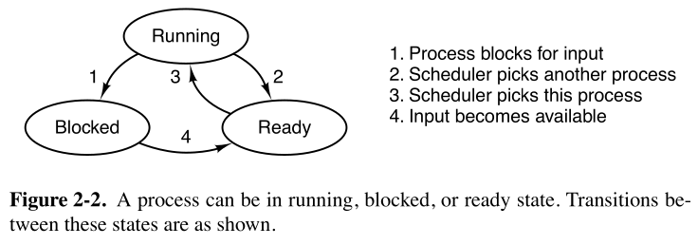
Solution
Because these transitions are impossible or doesn’t make sense. For example going from blocked to running happen if the process is already loaded in the CPU but what would be the point of having a FSM to do these transitions if we won’t be avoiding a blocked process to make the CPU gone idle?. Going form ready to blocked is impossible because how can you block a process that isn’t actually running?

Exercise 2.2
Suppose that you were to design an advanced computer architecture that did process switching in hardware, instead of having interrupts. What information would the CPU need? Describe how the hardware process switching might work.
Solution
There are some conditions to be met when a context switch happen. First we need to save the registers content. Second we need to change the stack pointer and the program counter. Third we need to change page table. Fourth we need to flush cache.
If an architecture want to accelerate these process in hardware it can duplicate the register and atomically swap to them. Then even if you have a specific privileged profiles you can have a register copy for every privilege context. Then from the new registers of that context you can load other registers data from stack and jump to the saved program counter. It can be forced to drop all pages for the previous context and load the last used pages from the actual privilege context. Finally to flush cache you can have also a specific instructions for force to invalidate all cache content.

Exercise 2.3
On all current computers, at least part of the interrupt handlers are written in assembly language. Why?
Solution
Because every ISA has their own implementation of tools and privileges mode. For RISC-V it has specific registers and tools associated with every privilege mode inside the core. For example M-mode is related to pure hardware procedures. Of its own has a specific register to track internal status (mstatus), it has mtvec that points to a specific locations where is supposed to lie the interrupt handlers but with mcause you can set a vectored interrupt table to directly point to procedures without checking possible interrupts, as you see all this is machine specific and there is not a direct C instruction or rule (because it want to be the least ISA dependent it can). To be able to use privileged instructions on the core, machine code become the only way. However assembly code is the best way to program machine code to be readable and manageable.

Exercise 2.4
When an interrupt or a system call transfers control to the operating system, a kernel stack area separate from the stack of the interrupted process is generally used. Why?
Solution
It is like this for many reasons. One if for process memory boundaries to achieve isolation (more if the processes doesn’t run with the same privileges). Second is for manageability because is difficult to track the data wrote by the kernel in order to wipe out when it finish to use process stack. Third because is common to save process context in the stack and any bug that makes the kernel to delete the context can lead to a fatal error. Have a separated stack is easier, more secure, and reliable than using the same space.

Exercise 2.5
A computer system has enough room to hold five programs in its main memory. These programs are idle waiting for I/O half the time. What fraction of the CPU time is wasted?
Solution

In that case the percent of CPU waste is about 100%-96.875%=3.125%

Exercise 2.6
A computer has 4 GB of RAM of which the operating system occupies 512 MB. The processes are all 256 MB (for simplicity) and have the same characteristics. If the goal is 99% CPU utilization, what is the maximum I/O wait that can be tolerated?
Solution
If 4GB of RAM is the limit and we already are using 512MB for OS then this left us with

In that case to achieve 99% we need

So in order to have 99% of CPU busy every process has to wait 72% of their execution time waiting I/O

Exercise 2.7
Multiple jobs can run in parallel and finish faster than if they had run sequentially. Suppose that two jobs, each needing 20 minutes of CPU time, start simultaneously. How long will the last one take to complete if they run sequentially? How long if they run in parallel? Assume 50% I/O wait.
Solution
If 20 min are the useful work time of the CPU and if it had 50% of I/O wait. Then every process takes about 40 minutes to complete. If we run sequentially then we just add 40 min 2 times making a total of 80min to run both processes. If we run these in parallel then the useful time of the CPU will be of

Then in order to complete both processes then the 20 min per process of useful work has to be scheduled by a busy processor of 0.75 of its capacity making 40min/0.75=53.333 min to complete both processes.

Exercise 2.8
Consider a multiprogrammed system with degree of 6 (i.e., six programs in memory at the same time). Assume that each process spends 40% of its time waiting for I/O. What will be the CPU utilization?
Solution

Exercise 2.9
Assume that you are trying to download a large 2-GB file from the Internet. The file is available from a set of mirror servers, each of which can deliver a subset of the file’s bytes; assume that a given request specifies the starting and ending bytes of the file. Explain how you might use threads to improve the download time.
Solution
We can split the requested file into chunks, and download one chunk per thread. As is it done on a peer to peer connection. Many threads can open many network connections to different servers so it can download just a part to then join together.

Exercise 2.10
In the text it was stated that the model of Fig. 2-10(a) was not suited to a file server using a cache in memory. Why not? Could each process have its own cache?
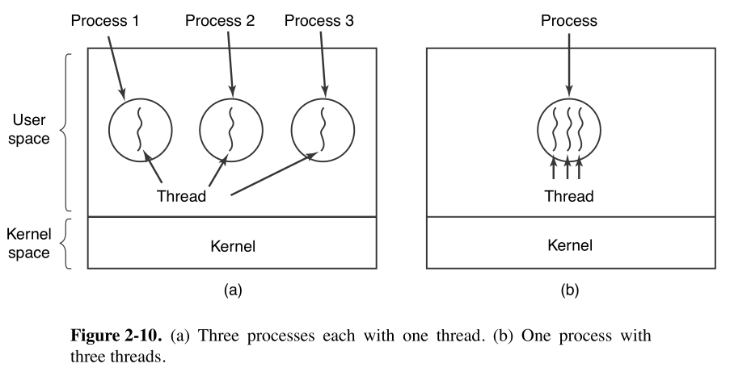
Solution
Because on the first diagram we create a new process every time we want to create a thread. So every process will have its own memory mapping and resources associated. So it makes completely undesirable as file server because the context switch and slow communication though IPC (instead shared memory). Also it makes useless to have cache associated to every process because for every context switch it has to flush the content of the memory. So every process cannot have its own cache at the same time. But also using many process as file server sucks because it can leave a file at half of a write on a inconsistent state and it has to coordinate to other process to avoid data corruption.

Exercise 2.11
If a multithreaded process forks, a problem occurs if the child gets copies of all the parent’s threads. Suppose that one of the original threads was waiting for keyboard input. Now two threads are waiting for keyboard input, one in each process. Does this problem ever occur in single-threaded processes?
Solution
Yes. This still happen if the fork can be run when the process is blocked by a read (which apparently is possible). However the case which is talked here apparently assume that fork() and read() cannot be run concurrently on the same thread. If this is the case then it talks about the scenario that one thread call read() and other fork(). In that case then the answer is no.

Exercise 2.12
In Fig. 2-8, a multithreaded Web server is shown. If the only way to read from a file is the normal blocking read system call, do you think user-level threads or kernel-level threads are being used for the Web server? Why?
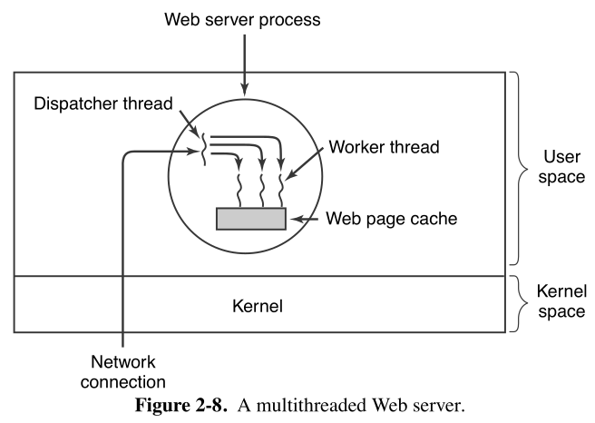
Solution
Both kind of threads has its cons and pros for this workload. The user-level thread can be used to easily create threads to dispatch many petitions quickly. However because the main workload is to read the content of a file using read() then the complete process will block (with all theirs threads). Now because kernel threads run at kernel level it can do a read without block other threads because the kernel has knowledge about which specific thread is making the request. However I will chose kernel thread because you can still reuse these threads instead creating new ones.

Exercise 2.13
In the text, we described a multithreaded Web server, showing why it is better than a single-threaded server and a finite-state machine server. Are there any circumstances in which a single-threaded server might be better? Give an example.
Solution
A well designed multithreading algorithm is almost always better than single thread if the CPU is the computation boundary. However this not always happen like web servers if the traffic is small and intermittent you can easily cover up with a single thread because it send frequent and small I/O data. Something that you wont gain anything with multi threads (it is actually worse because you have to schedule the threads an coordinate even if just one is working).

Exercise 2.14
In Fig. 2-11 the register set is listed as a per-thread rather than a per-process item. Why? After all, the machine has only one set of registers.
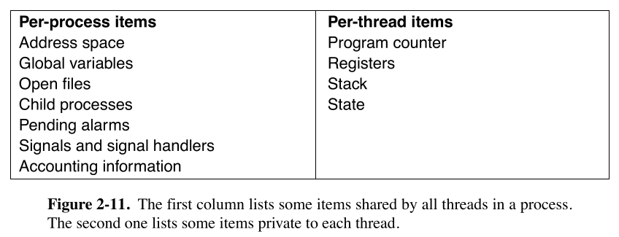
Solution
The context of an execution are defined by the register of the CPU. On it you have your variables, the following instruction to execute, the status of a operation, where you will save the results. These matters are completely attached to the hardware execution. The process items are OS abstractions of resources that the OS will handle and because the process is the minimal unit of execution for OS then these resources are shared by all threads. You need to save the state of these registers in memory to preserve the execution context because when you do a context switch you cannot tell what the CPU was running before. And the opposite is true, with the registers you can tell what the CPU has to do next.

Exercise 2.15
Why would a thread ever voluntarily give up the CPU by calling thread yield? After all, since there is no periodic clock interrupt, it may never get the CPU back.
Solution
Because the point of threads is to cooperate between themselves. If a thread know that has to wait a signal of other thread, or it will block other threads by a I/O operation or other kind or circumstances the thread will yield the execution time to other. At least is supposed that the programmer will do their best to make this time sharing fair.

Exercise 2.16
Can a thread ever be preempted by a clock interrupt? If so, under what circumstances? If not, why not?
Solution
At user level thread the execution can be preempted interrupted only if the process has consumed its quantum. It can be also interrupted if its blocked but for that the thread has to yield and it cannot be considered as preempted. Now in kernel thread because it can be clock interrupted because the kernel has track of the thread status (because the thread table is visible by the kernel) and it can save the status before change the execution context, but also it accept the interruption if the quantum has already be consumed.

Exercise 2.17
In this problem, you are to compare reading a file using a single-threaded file server and a multithreaded server. It takes 12 msec to get a request for work, dispatch it, and do the rest of the necessary processing, assuming that the data needed are in the block cache. If a disk operation is needed, as is the case one-third of the time, an additional 75 msec is required, during which time the thread sleeps. How many requests/sec can the server handle if it is single threaded? If it is multithreaded?
Solution
If the server is single thread then the workflow of the process has to execute in order and sequentially so the rate of request are:

However for multi thread the order of these process doesn’t has to come like that because you can had a thread that dispatch and put in a queue the petition and other thread can get the data from the disk at the same time so the rate of petitions per second are:

Exercise 2.18
What is the biggest advantage of implementing threads in user space? What is the biggest disadvantage?
Solution
The biggest advantage is that you can implement them in any system. You don’t have to rewrite the kernel to add this function. The biggest disadvantage is the lack of control of these threads in their behaviour on interrupts or in yield control.

Exercise 2.19
In Fig. 2-14 the thread creations and messages printed by the threads are interleaved at random. Is there a way to force the order to be strictly thread 1 created, thread 1 prints message, thread 1 exits, thread 2 created, thread 2 prints message, thread 2 exists, and so on? If so, how? If not, why not?
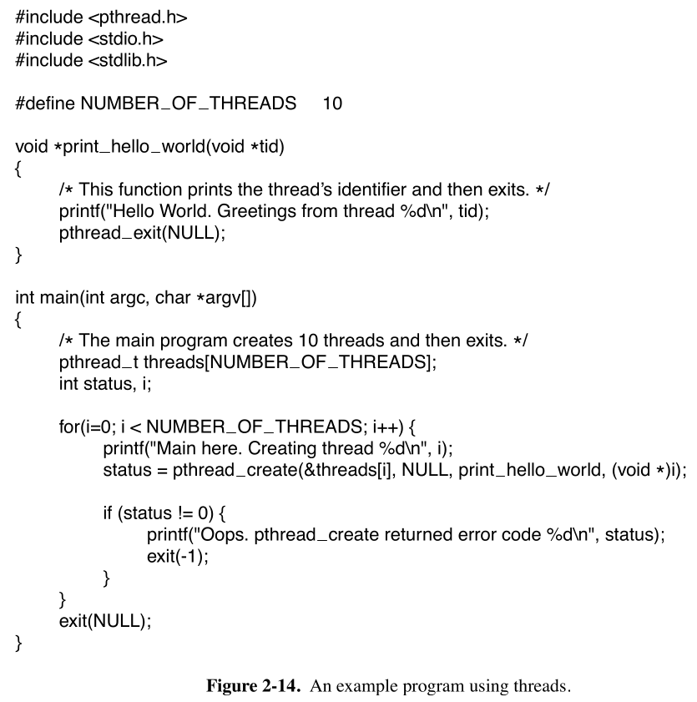
Solution
You can make the threads to wait for the thread before to finish using the pthread_join(). In order to example that you can see the next code. The sleep() will block any thread with an even id. Without the join the thread creation will continue until the main function finishes, even if the other threads still haven’t finished the program will end. However with join will wait the sleep blocking of every thread in order.

1 #include <pthread.h>
2 #include <err.h>
3 #include <errno.h>
4 #include <stdio.h>
5 #include <stdlib.h>
6 #include <unistd.h>
7
8 #define NUMBER_OF_THREADS 8
9
10 void *print_hello_world(void *tid)
11 {
12 if(*(int*)tid%2==0)
13 {
14 sleep(1);
15 }
16 printf("Hello World, Greetings from thread %d\n", *(int*)tid);
17 pthread_exit(NULL);
18 }
19
20 int main(int argc, char *argv[])
21 {
22 pthread_t threads[NUMBER_OF_THREADS];
23
24 for(int i=0; i<NUMBER_OF_THREADS; i++)
25 {
26 printf("Main here. Creating thread %d\n", i);
27 int *ptr_i = malloc(sizeof(int));
28 *ptr_i = i;
29 if (pthread_create(&threads[i], NULL, &print_hello_world, ptr_i) != 0)
30 err(errno, "Failed creating thread");
31 pthread_join(threads[i], NULL);
32 }
33 exit(0);
34 }

Exercise 2.20
In the discussion on global variables in threads, we used a procedure create global to allocate storage for a pointer to the variable, rather than the variable itself. Is this essential, or could the procedures work with the values themselves just as well?
Solution
It is essential to behave correctly because these variables are on the heap. If you could store these variables on the stack then you could store the variable itself. However usually for ABI and even machine specific conventions the stack will be bounded by stack frames making these variables to be lost within the time because will be overwritten. If you want to use a thread global variable inside a stack then you have to copy to the variable inside the function (but then is not a global variable anymore). Using a pointer makes easy to manage the memory and possible to functions inside the thread to access the variable.

Exercise 2.21
Consider a system in which threads are implemented entirely in user space, with the run-time system getting a clock interrupt once a second. Suppose that a clock interrupt occurs exactly while some thread executing in the run-time system is at the point of blocking or unblocking a thread. What problem might occur? Can you solve it?
Solution
What could happen is a race condition. If this process is constantly blocked and other threads depends of some output what can happen is that some process can be half done when is interrupted. When other thread check the state of the output can be took as the thread finished correctly and do something about it but the interrupted thread cannot notice that the other thread has done anything. To solve this we need a synchronous mechanism to make sure that some critical region is has be done correctly.

Exercise 2.22
Suppose that an operating system does not have anything like the select system call to see in advance if it is safe to read from a file, pipe, or device, but it does allow alarm clocks (timers) to be set that interrupt blocked system calls. Is it possible to implement in user space a threads package that will not block all threads when one thread performs a system call that may block? Explain your answer.
Solution
You can do a trick. If you know that a thread is going to do a blocking system call then you can set a quick timer to interrupt the syscall and give the control again to the thread. If you can do this quickly and using syscalls that preserve the result like read() that even if it get an error (because the forced interrupt) you can use that to tell if the file is ready to be read for example.

Exercise 2.23
Does the busy waiting solution using the turn variable (Fig. 2-23) work when the two processes are running on a shared-memory multiprocessor, that is, two CPUs sharing a common memory?
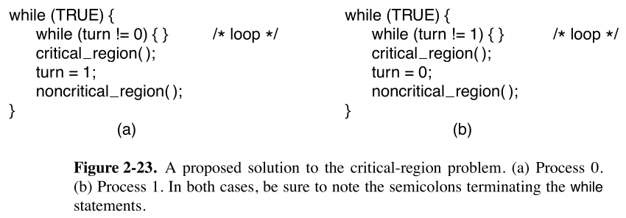
Solution
The only way that you can be sure of this will work with multiprocessor is if the instructions that write and read the turn variable is atomic. If some CPU run faster and do not force an implicit synchronous buffer then it can change the memory value and be undetectable at hardware level. For example in RISC-V it courage the use of weak memory models and the use of software synchronize mechanism to assure the integrity of reads and writes. The use of lr.w and sc.w is necessary instead a simple lw and sw.

Exercise 2.24
Does Peterson’s solution to the mutual-exclusion problem shown in Fig. 2-24 work when process scheduling is preemptive? How about when it is nonpreemptive?
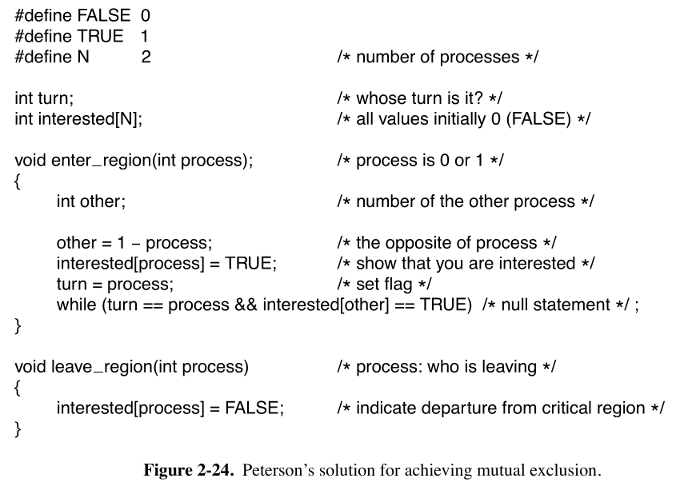
Solution
No matter the kind of interrupt. Peterson’s solution make impossible to some thread to enter into their critical section if the other thread is interested on running their own critical section. Even if they compete in overwrite the turn shared variable the array will tell if the other thread is potentially in their critical region. The only way to making these to enter at the same time is to write the turn variable to be read as 0 and 1 at the same time which is impossible.

Exercise 2.25
Can the priority inversion problem discussed in Sec. 2.4.4 happen with user-level threads? Why or why not?
Solution
The problem arises when a low priority thread inside their critical section is interrupted by a high priority thread that is busy waiting by the lower thread but cannot change schedule because it has higher priority than the other thread. Inside user level threads this is not possible because the OS cannot differentiate between threads so it cannot associate a exclusive priority by thread. Not only the nice value is shared by threads but also the privilege execution.

Exercise 2.26
In Sec. 2.4.4, a situation with a high-priority process, H, and a low-priority process, L, was described, which led to H looping forever. Does the same problem occur if round-robin scheduling is used instead of priority scheduling? Discuss.
Solution
Inside the round robin it eventually unlock this situation because eventually the L process will run. Even if H process has higher priority. Instead in priority scheduling the rules will always prefer to choose H process inside the ready queue instead L.

Exercise 2.27
In a system with threads, is there one stack per thread or one stack per process when user-level threads are used? What about when kernel-level threads are used? Explain.
Solution
There is one stack per thread. Any execution context is needed a stack, registers and program counter. Because a thread is an execution context inside a process then it has to save one stack per thread. In Kernel level threads is the same. However the content of the stack is managed by the kernel.

Exercise 2.28
When a computer is being developed, it is usually first simulated by a program that runs one instruction at a time. Even multiprocessors are simulated strictly sequentially like this. Is it possible for a race condition to occur when there are no simultaneous events? Explain.
Solution
Yes even inside machines with a single core which execute their code in order can happen a race condition. If these threads are scheduled in a way that interrupt between their critical sections then a race condition can happen.

Exercise 2.29
The producer-consumer problem can be extended to a system with multiple producers and consumers that write (or read) to (from) one shared buffer. Assume that each producer and consumer runs in its own thread. Will the solution presented in Fig. 2-28, using semaphores, work for this system?
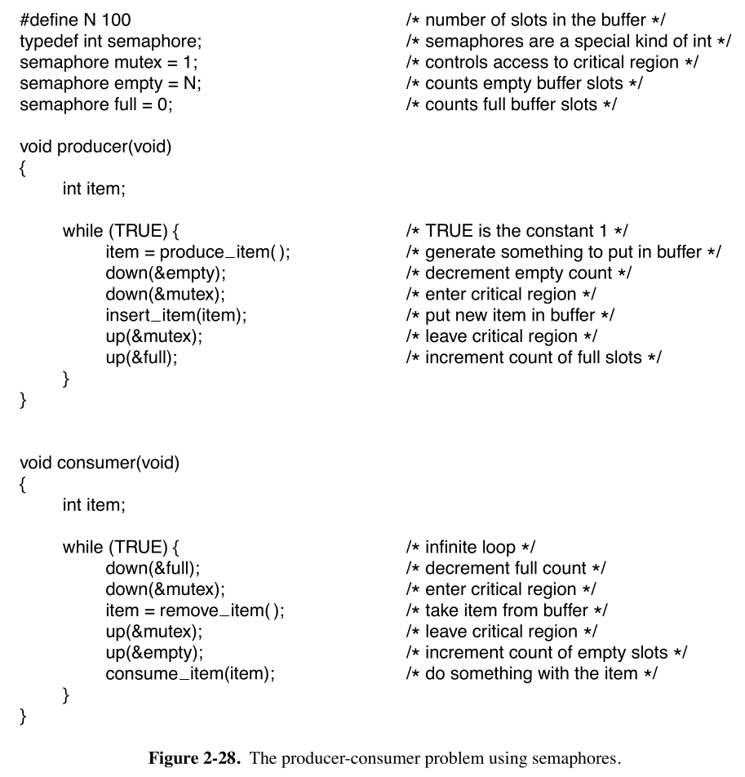
Solution
Yes It will work because the variables full and empty are coordinated between themselves to always make sure that one producer will cancel the effects of one consumer. Imagine that you have 2 consumers. If the queue has 2 items to be consumed then both can execute without interfering each other. When its just 1 then one thread will lock full variable before the other thread do that and because it use other flag (empty) to tell the producers that consumer has finished then the other consumer cannot do a race condition.

Exercise 2.30
Consider the following solution to the mutual-exclusion problem involving two processes P0 and P1. Assume that the variable turn is initialized to 0. Process P0’s code is presented below.

/* Other code */
while (turn != 0) { } /* Do nothing and wait. */
Critical Section /* . . . */
turn = 0;
/* Other code */

For process P1, replace 0 by 1 in above code. Determine if the solution meets all the required conditions for a correct mutual-exclusion solution.
Solution
These are the needed requirements
- No two processes may be simultaneously inside their critical regions.
  - If these instructions are atomic then yes. This requirement is met because in order to execute both their critical section is to the variable turn to be 0 and 1 at the same time because turn is strictly set after the critical region is finished
- No assumptions may be made about speeds or the number of CPUs.
  - No timing assumption is happening here. If one thread is faster than other will not happen a race condition
- No process running outside its critical region may block any process.
  - This is where it has issues because if both thread are in their non critical region. One thread will be blocked until the other thread finishes their non-critical region
- No process should have to wait forever to enter its critical region.
  - If both threads have the same priority then no inversion priority can happen. It will always get to their critical region if a fair schedule assure that both processes execute

Exercise 2.31
How could an operating system that can disable interrupts implement semaphores?
Solution
To get a semaphore we need to be sure that it will respect 2 properties of semaphores:
- Have a counter
- Have mechanisms to avoid losing signals
- Bu sure to be mutual exclusive
The avoid of interrupts are possible if you block the process that want to do an up() when the semaphore is full and block the process that want to do an down() on an empty semaphore and be sure to track this processes on a list. If a process want to do an up() into a full semaphore then it has to add itself to a list (which also need to be exclusively accessible to the critical process) and then yield the control to another thread. If another thread do an down() then it will check if the semaphore is full and if it is then will remove the thread from the blocked list and it will change the process status to be able to schedule again. With this strategy you don’t have to interrupt any thread.

Exercise 2.32
Show how counting semaphores (i.e., semaphores that can hold an arbitrary value) can be implemented using only binary semaphores and ordinary machine instructions.
Solution
To get a semaphore we need to be sure that it will respect 2 properties of semaphores:
- Have a counter
- Have mechanisms to avoid losing signals
- Bu sure to be mutual exclusive
It can be done associating 2 binary semaphores to a normal counter which will count the number of up()-down() that were done. The key idea is that every process will attempt to down() the mutual exclusive semaphore. If it is occupied then it won’t proceed until released. Once the process has the ownership of the semaphore then it will decrement the counter. If the counter get less than 0 (that mean a down() were done on an empty semaphore) then the process will flag itself into a second binary semaphore to trace that it is asleep to then yield until another process increment the counter and if it watch a process asleep then it will wake it to put them on the ready process queue.

Exercise 2.33
If a system has only two processes, does it make sense to use a barrier to synchronize them? Why or why not?
Solution
Yes it makes sense. Because you could make these process to do a task for what one process has to wait to another process (probably because a dependency) and you need to segment the parallel task into phases to achieve. One example is the synchronization between many hardware threads. Because any core can do a write on any moment and even at any order then is necessary to have a instructions like FENCE to force every thread that access the memory to wait until all threads has finished any memory operation to have a global memory coherence.

Exercise 2.34
Can two threads in the same process synchronize using a kernel semaphore if the threads are implemented by the kernel? What if they are implemented in user space? Assume that no threads in any other processes have access to the semaphore. Discuss your answers.
Solution
For Kernel threads this goes really smooth because the kernel threads are global identifiable threads when a thread take the semaphore to do their critical section it do without blocking their coworkers. Now because user threads are not identifiable by the kernel individually when it traps to kernel mode it blocks their coworkers killing all the purpose of gain multitask using many threads.

Exercise 2.35
Synchronization within monitors uses condition variables and two special operations, wait and signal. A more general form of synchronization would be to have a single primitive, waituntil, that had an arbitrary Boolean predicate as parameter. Thus, one could say, for example,
waituntil x < 0 or y + z < n
The signal primitive would no longer be needed. This scheme is clearly more general than that of Hoare or Brinch Hansen, but it is not used. Why not? (Hint: Think about the implementation.)
Solution
What I could think is that the CPU should implement atomic operations of conditionals in order to be able to implement waituntil. For example you could think of implementing this primitives on RISC-V. For mutual exclusion you use LR.W and SC.W in order to assure mutual exclusion and is more than enough. However in this example we need the use of instructions like AMOSWAP.W, AMOXOR.W, AMOMIN.W and so on, but if you think even with these you cannot assure an atomic execution because you need to break down complex boolean expressions in many instructions (using many atomic instructions doesn’t make it atomic as a whole). And if you think you usually will get better performance using mutex in monitors than doing waituntil (because it doesn’t seems clear why this is different of a spinlock).

Exercise 2.36
A fast-food restaurant has four kinds of employees: (1) order takers, who take customers’ orders; (2) cooks, who prepare the food; (3) packaging specialists, who stuff the food into bags; and (4) cashiers, who give the bags to customers and take their money. Each employee can be regarded as a communicating sequential process. What form of interprocess communication do they use? Relate this model to processes in UNIX.
Solution
The usage of message passing is perfect for this task because the results of some process can be sent when the process is ready to sent the message and it is received in the order the sender wanted to. This behaves like UNIX use pipeline to use the outstream of one process to inject them as input to the following process.

Exercise 2.37
Suppose that we have a message-passing system using mailboxes. When sending to a full mailbox or trying to receive from an empty one, a process does not block. Instead, it gets an error code back. The process responds to the error code by just trying again, over and over, until it succeeds. Does this scheme lead to race conditions?
Solution
No race condition can happen whenever process who send the message is aware the message is lost and when an error is met it only try to send the message again. However this can lead to starvation because it can keep spinlocking for a while and it is worse if some process has a higher priority that the other.

Exercise 2.38
The CDC 6600 computers could handle up to 10 I/O processes simultaneously using an interesting form of round-robin scheduling called processor sharing. A process switch occurred after each instruction, so instruction 1 came from process 1, instruction 2 came from process 2, etc. The process switching was done by special hardware, and the overhead was zero. If a process needed T sec to complete in the absence of competition, how much time would it need if processor sharing was used with n processes?
Solution
It will increase at a rate of T*n seconds because every instructions inside the T seconds will be paired by n instructions of n different processes.

Exercise 2.39
Consider the following piece of C code:
void main( ) {
fork( );
fork( );
exit( );
}
How many child processes are created upon execution of this program?
Solution
The number of child processes will be 4. On every fork the whole program (text, data, stack, heap and even the CPU state) is copied into a new memory space. And because the program counter is preserved then when another fork is done both processes created before create another process.

Exercise 2.40
Round-robin schedulers normally maintain a list of all runnable processes, with each process occurring exactly once in the list. What would happen (scheduling-wise) if a process occurred twice in the list? Can you think of any reason for allowing this?
Solution
Because you want to prioritize the execution time of one process over others. Because if it appear 2 times on the list this makes that this process has twice the execution time on a single cycle of the round robin.

Exercise 2.41
Can a measure of whether a process is likely to be CPU bound or I/O bound be determined by analyzing source code? How can this be determined at run time?
Solution
By analyzing the source code you can try to perform a calculation by counting the number of machine instructions and try to get execution with the formula [instructions/program*cycles/instructions*time/cycles]. For I/O is more difficult because a same I/O request can take different time but you can make an estimation counting the mean time of every I/O response and how much of this request exists. Now, in run time is more difficult. The best thing you can do is setting a timer to measure some fragment of code. This is more precise because this counter is affected by other circumstances like scheduling and you can see the real effects more than theoretical performance.

Exercise 2.42
Explain how time quantum value and context switching time affect each other, in a round-robin scheduling algorithm.
Solution
For every expiration of a quantum time a context switch has to happen. Because switching time will take an fixed time you have to do a trade off between taking to much quantum time to decrement the not productive time of context switching but making more unfair execution time or taking little quantum time wasting CPU time in context switching but being more fair to give time to other programs to execute.

Exercise 2.43
Measurements of a certain system have shown that the average process runs for a time T before blocking on I/O. A process switch requires a time S, which is effectively wasted (overhead). For round-robin scheduling with quantum Q, give a formula for the CPU efficiency for each of the following:
- Q = ∞
- Q > T
- S < Q < T
- Q = S
- Q nearly 0
Solution
The efficiency is calculated as following:

Now the only thing remaining is to classify what is useful work and which useless. From a process perspective all the time T is useful because is executing the process and the S time is the useless work because is context switching. Q here only tells how many times S will happen by knowing how much Q time is inside T. Then the final formula is something like this:

In that case:
- If Q=∞ then the efficiency in theory is 100%, however because at least 1 context switch is expected, when execution is over then this left us with

- Something similar happen when Q>T. Quantum time doesn’t provoke a context switch but one context switch is assured

- In this case at least one quantum time interruption is assured. And quantum time is coherent with the context switch time. So this left us with the original formula

- In this case then we can substitute the term and we get that efficiency is 50%
- If Q is nearly 0 then the switches time tend to be infinite. That leave us with a efficiency of nearly 0%

Exercise 2.44
Five jobs are waiting to be run. Their expected run times are 9, 6, 3, 5, and X. In what order should they be run to minimize average response time? (Your answer will depend on X.)
Solution
The best strategy to get a nice response time is to sort the shortest jobs first so:
If X<=3 then Schedule:= X,3,5,6,9
If X>3 and X<=5 then Schedule:= 3.X,5,6,9
If X>6 and X<=9 then Schedule:= 3,X,5,6,X,9
If X>9 then Schedule:= 3,5,6,9,X

Exercise 2.45
Five batch jobs, A through E, arrive at almost the same time. They have estimated running times of 10, 6, 2, 4, and 8 minutes. Their (externally determined) priorities are 3, 5, 2, 1, and 4, respectively, with 5 being the highest priority. For each of the following scheduling algorithms, determine the mean process turnaround time. Ignore process switching overhead.
- Round robin.
- Priority scheduling.
- First-come, first-served (run in order 10, 6, 2, 4, 8).
- Shortest job first.
For (a), assume that the system is multiprogrammed, and that each job gets its fair share of the CPU. For (b) through (d), assume that only one job at a time runs, until it finishes. All jobs are completely CPU bound.
Solution
- Order: C, D, B, E, A | Time 10, 18, 24, 28, 30 | AVG Time: 22
- Order: B, E, A, C, D | Time: 6, 14, 24, 26, 30 | AVG Time: 20
- Order: A, B, C, D, E | Time: 10, 16, 18, 22, 30 | AVG Time: 19.2
- Order: C, D, B, E, A | Time: 2, 6, 12, 20, 30 | AVG Time: 14

Exercise 2.46
A process running on CTSS needs 30 quanta to complete. How many times must it be swapped in, including the very first time (before it has run at all)?
Solution
It will need 5 swaps to complete.

Exercise 2.47
Consider a real-time system with two voice calls of periodicity 5 msec each with CPU time per call of 1 msec, and one video stream of periodicity 33 msec with CPU time per call of 11 msec. Is this system schedulable? Show how you derived your answer.
Solution
We need to calculate the CPU load that these events had. If both overpasses the CPU capacity then they are not able to schedule like real time applications. As a remainder m mean the number of real time processes to schedule, i as some event, C_{i} is how much time takes to the CPU accomplish the task and P_{i} The period where the deadline has to be met.

So yes, it is schedulable.

Exercise 2.48
For the above problem, can another video stream be added and have the system still be schedulable?
Solution

So, no. With another video stream this is not possible to schedule as real time application.

Exercise 2.49
The aging algorithm with a = 1/2 is being used to predict run times. The previous four runs, from oldest to most recent, are 40, 20, 40, and 15 msec. What is the prediction of the next time?
Solution

Exercise 2.50
A soft real-time system has four periodic events with periods of 50, 100, 200, and 250 msec each. Suppose that the four events require 35, 20, 10, and x msec of CPU time, respectively. What is the largest value of x for which the system is schedulable?
Solution

Exercise 2.51
A real-time system needs to handle two voice calls that each run every 6 msec and consume 1 msec of CPU time per burst, plus one video at 25 frames/sec, with each frame requiring 20 msec of CPU time. Is this system schedulable?
Solution

So, yes this system is schedulable.

Exercise 2.52
Consider a system in which it is desired to separate policy and mechanism for the scheduling of kernel threads. Propose a means of achieving this goal.
Solution
Because kernel threads are individually tracked by the kernel ins scheduling then the policy that the kernel choice would affect the threads at global. But because the process has knowledge of the purpose of their children maybe it want every thread to be scheduled with a different policy to maximize performance. So maybe it is a good idea in this case to separate policy from mechanism.

Exercise 2.53
The readers and writers problem can be formulated in several ways with regard to which category of processes can be started when. Carefully describe three different variations of the problem, each one favoring (or not favoring) some category of processes (e.g., readers or writers). For each variation, specify what happens when a reader or a writer becomes ready to access the database, and what happens when a process is finished.
Solution
The only parameter that can be changed in this paradigm is the priority of which process should be started. For example if:
- Readers have priority. Writers attempting to access while a reader is active must block until the reader completes. Any reader can join concurrently. Only when all readers are finished then all writers can be unblocked to perform on the database. Any pending reader will be immediately started even when writers are waiting, but only when all writers finish.
- Writers have priority. Readers attempting to access while a writer is active must block until the writer completes. Any writer can join but it must be one at a time. Only when all writers are finished then all readers can be unblocked to perform on the database. Any reader will be immediately started even when reader are waiting.
- Both has the same priority level. Only readers or writers can be at the database at once so the priority is given to the currently active process. So the pending writer/reader queue should be shared into a signle FIFO queue if fairness is a goal. Then any process can join only if the last one has finished and these process should go one at a time.

Exercise 2.54
Write a shell script that produces a file of sequential numbers by reading the last number in the file, adding 1 to it, and then appending it to the file. Run one instance of the script in the background and one in the foreground, each accessing the same file. How long does it take before a race condition manifests itself? What is the critical region? Modify the script to prevent the race. (Hint: use
ln file file.lock
to lock the data file.)
Solution
In the following code we can watch both cases. When you run many threads of badLockFunction() it will soon to get errors because race conditions. If the count goes to 10000 it will repeat wrongly the results. For example in one run it get 12548 counted numbers. Now the goodLockFunction() repeat this algorithm but providing a lock on the file. We use flock tool to lock a on write a stream created by us. We open channel 9 and attach it to the file. Then we acquire the lock on read mode of channel 9. All the algorithm is the critical section because first we need to read the file and we need to make sure no other thread is modifying it, second the count operations has to be done just by a single thread, we don’t want to threads to repeat themselves and finally we has to be sure to write the value without any other thread trying to read or write on the file. After every iteration we release the lock. Finally when we finish we make sure to close the channel stream.

1 #!/bin/bash
2
3 filename="countFile"
4
5 if [ ! -f "$filename" ]; then
6 touch $filename
7 else
8 : > $filename
9 fi
10
11 badLockFunction() {
12 local thread_id=$BASHPID
13 local count=0
14 while [ $count -lt 10000 ]; do
15 readcount=$(tail -n 1 "$filename")
16 if [ -z "$readcount" ]; then
17 count=0
18 fi
19 count=$((count +1))
20 echo "$count" >> $filename
21 echo "$count done by $thread_id"
22 done
23 }
24
25 goodLockFunction() {
26 local thread_id=$BASHPID
27 local count=0
28 exec 9>>"$filename"
29 while [ $count -lt 10000 ]; do
30 flock -x 9
31 readcount=$(tail -n 1 "$filename")
32 if [ -z "$readcount" ]; then
33 count=0
34 fi
35 count=$((count +1))
36 echo "$count" >&9
37 flock -u 9
38 echo "$count done by $thread_id"
39 done
40 exec 9>&-
41 }
42
43 badLockFunction &
44 badLockFunction &
45 #goodLockFunction &
46 #goodLockFunction &
47
48 wait

Exercise 2.55
Assume that you have an operating system that provides semaphores. Implement a message system. Write the procedures for sending and receiving messages.
Solution
The following code demonstrate a really simple message system using semaphores. Actually the algorithm for sending and receiving messages are the same as the producer consumer algorithm. I use the semaphore and mutex tools provided by Linux to provide a safe thread algorithm. Take in count this program only works for user space threads and any difference on quantity between consumer or producer threads will lead into a forever sleep program waiting.

1 #include <err.h>
2 #include <errno.h>
3 #include <semaphore.h>
4 #include <signal.h>
5 #include <stdio.h>
6 #include <stdlib.h>
7 #include <string.h>
8 #include <pthread.h>
9 #include <time.h>
10 #include <unistd.h>
11
12 #define MAX_MSG 40
13 #define PRODUCERS 8
14 #define CONSUMERS 8
15
16 typedef struct {
17 int idx;
18 char data[30];
19 } message_t;
20
21 sem_t used_slots_sem;
22 sem_t unused_slots_sem;
23 int tail = 0, head = 0;
24 pthread_mutex_t lock = PTHREAD_MUTEX_INITIALIZER;
25
26 message_t buffer[MAX_MSG];
27
28 message_t createMsg(int index) {
29 message_t generatedMsg;
30 const char *words[] = {"apple", "banana", "cherry", "date", "elderberry"};
31 int num_words = sizeof(words) / sizeof(words[0]);
32 generatedMsg.idx = index;
33 strcpy(generatedMsg.data, words[rand() % num_words]);
34 return generatedMsg;
35 }
36
37 void printMsg(message_t msg, int index) {
38 printf("Producer number %d says %s to consumer %d\n", msg.idx, msg.data, index);
39 }
40
41 void send(message_t msg) {
42 sem_wait(&unused_slots_sem);
43 pthread_mutex_lock(&lock);
44 buffer[head] = msg;
45 head = (head + 1) % MAX_MSG;
46 pthread_mutex_unlock(&lock);
47 sem_post(&used_slots_sem);
48 }
49
50 message_t receive(void) {
51 sem_wait(&used_slots_sem);
52 pthread_mutex_lock(&lock);
53 message_t readMsg = buffer[tail];
54 tail = (tail + 1) % MAX_MSG;
55 pthread_mutex_unlock(&lock);
56 sem_post(&unused_slots_sem);
57 return readMsg;
58 }
59
60 void* producer(void* args) {
61 int prodNum = *(int*)args;
62 free(args);
63 message_t msgCreated;
64 for(int i=0; i<10; i++) {
65 msgCreated = createMsg(prodNum);
66 send(msgCreated);
67 }
68 pthread_exit(0);
69 }
70
71 void* consumer(void *args) {
72 int consNum = *(int*)args;
73 free(args);
74 message_t msgConsumed;
75 for(int i=0; i<10; i++) {
76 msgConsumed = receive();
77 printMsg(msgConsumed, consNum);
78 }
79 pthread_exit(0);
80 }
81
82 int main(int argc, char *argv[]) {
83 if (sem_init(&used_slots_sem, 0, 0) == -1)
84 err(errno, "Failed to initialize used slots semaphore");
85 if (sem_init(&unused_slots_sem, 0, MAX_MSG) == -1)
86 err(errno, "Failed to initialize unused slots semaphore");
87
88 pthread_t producers[PRODUCERS];
89 pthread_t consumers[CONSUMERS];
90
91 srand(time(NULL));
92
93 for(int i=0; i<PRODUCERS; i++) {
94 int *prod_i = malloc(sizeof(int));
95 *prod_i = i;
96 if (pthread_create(&producers[i], NULL, &producer, prod_i) != 0)
97 err(errno, "Failed creating producer thread");
98 }
99
100 for(int i=0; i<CONSUMERS; i++) {
101 int *cons_i = malloc(sizeof(int));
102 *cons_i = i;
103 if (pthread_create(&consumers[i], NULL, &consumer, cons_i) != 0)
104 err(errno, "Failed creating consumer thread");
105 }
106
107 for(int i=0; i<PRODUCERS; i++) {
108 pthread_join(producers[i], NULL);
109 }
110
111 for(int i=0; i<CONSUMERS; i++) {
112 pthread_join(consumers[i], NULL);
113 }
114
115 sem_destroy(&used_slots_sem);
116 sem_destroy(&unused_slots_sem);
117 return 0;
118 }

Exercise 2.56
Rewrite the program of Fig. 2-23 to handle more than two processes.
Solution
The following code is a generalization of how can you get thread synchronization by just doing spin locks. This is an algorithm called bakery. What it does is to use 2 arrays. One called entering that helps to advertise to other threads that this thread is seeking to lock. And the number array which looks to give a higher number that any other thread, this is with the objective of avoid starvation of other threads that went before. So it first send a signal to seek to lock and then read the signal of other threads. It will spin lock until no other thread compete to lock themselves. Then it will check if any thread is locked by reading other thread numbers. If not then it has to verify if it has priority by having the smallest number. If not then it will spin lock until it become the smaller. In case that one or many threads has the same number (it can happen because the number assignation isn’t atomic) then it will untie by selecting a preferred thread (in this case the one smaller thread_id). Finally to unlock it will just drop the number value of the thread.

1 #include <pthread.h>
2 #include <err.h>
3 #include <errno.h>
4 #include <stdio.h>
5 #include <stdlib.h>
6 #include <unistd.h>
7 #include <limits.h>
8 #include <stdbool.h>
9
10 #define NUMBER_OF_THREADS 8
11
12 volatile int entering[NUMBER_OF_THREADS];
13 volatile int number[NUMBER_OF_THREADS];
14 int shared_counter=0;
15
16 int max(volatile int* array, int size) {
17 int result = *(array);
18 for(int i=0; i<size; i++) {
19 if(result<*(array+i)){
20 result = *(array+i);
21 }
22 }
23 return result;
24 }
25
26 void lock(int i) {
27 entering[i] = true;
28 number[i] = 1 + max(&number[0], sizeof(number)/sizeof(int));
29 entering[i] = false;
30 for (int j = 0; j < NUMBER_OF_THREADS; j++) {
31 while (entering[j]);
32 while (number[j] != 0 &&
33 (number[j] < number[i] || (number[j] == number[i] && j < i)));
34 }
35 }
36
37 void unlock(int i) {
38 number[i] = 0;
39 }
40
41 void *bakery(void *ptr_tid)
42 {
43 int tid = *(int*)ptr_tid;
44 free(ptr_tid);
45 while(true) {
46 lock(tid);
47 if (shared_counter >= INT_MAX-1) {
48 unlock(tid);
49 break;
50 }
51 shared_counter++;
52 printf("Hey, Critical section of thread %d here!, Counter is at %d\n", tid, shared_counter);
53 unlock(tid);
54 }
55 pthread_exit(NULL);
56 }
57
58 int main(int argc, char *argv[])
59 {
60 pthread_t threads[NUMBER_OF_THREADS];
61
62 for(int i=0; i<NUMBER_OF_THREADS; i++)
63 {
64 int *ptr_i = malloc(sizeof(int));
65 *ptr_i = i;
66 printf("Main here. Creating thread %d\n", i);
67 if (pthread_create(&threads[i], NULL, &bakery, ptr_i) != 0)
68 err(errno, "Failed creating thread");
69 }
70 for(int i=0; i<NUMBER_OF_THREADS; i++)
71 {
72 pthread_join(threads[i], NULL);
73 }
74 exit(0);
75 }

Exercise 2.57
Write a producer-consumer problem that uses threads and shares a common buffer. However, do not use semaphores or any other synchronization primitives to guard the shared data structures. Just let each thread access them when it wants to. Use sleep and wakeup to handle the full and empty conditions. See how long it takes for a fatal race condition to occur. For example, you might have the producer print a number once in a while. Do not print more than one number every minute because the I/O could affect the race conditions.
Solution
/*Pending*/

Exercise 2.58
A process can be put into a round-robin queue more than once to give it a higher priority. Running multiple instances of a program each working on a different part of a data pool can have the same effect. First write a program that tests a list of numbers for primality. Then devise a method to allow multiple instances of the program to run at once in such a way that no two instances of the program will work on the same number. Can you in fact get through the list faster by running multiple copies of the program? Note that your results will depend upon what else your computer is doing; on a personal computer running only instances of this program you would not expect an improvement, but on a system with other processes, you should be able to grab a bigger share of the CPU this way.
Solution
/*Pending*/

Exercise 2.59
The objective of this exercise is to implement a multithreaded solution to find if a given number is a perfect number. N is a perfect number if the sum of all its factors, excluding itself, is N ; examples are 6 and 28. The input is an integer, N . The output is true if the number is a perfect number and false otherwise. The main program will read the numbers N and P from the command line. The main process will spawn a set of P threads. The numbers from 1 to N will be partitioned among these threads so that two threads do not work on the name number. For each number in this set, the thread will determine if the number is a factor of N . If it is, it adds the number to a shared buffer that stores factors of N . The parent process waits till all the threads complete. Use the appropriate synchronization primitive here. The parent will then determine if the input number is perfect, that is, if N is a sum of all its factors and then report accordingly.
(Note: You can make the computation faster by restricting the numbers searched from 1 to the square root of N .)
Solution
/*Pending*/

Chapter 3

Exercise 3.1
The IBM 360 had a scheme of locking 2-KB blocks by assigning each one a 4-bit key and having the CPU compare the key on every memory reference to the 4-bit key in the PSW. Name two drawbacks of this scheme not mentioned in the text.
Solution
One would be a platform dependent memory restriction. This restrictions limit what applications and the OS can do because the OS is limited to track 16 permission levels which are not enough now days. Second will be the fixed page size making inflexible for OS about take advantage of changing page sizes, now days 2KB of page size is just to small requiring larger page tables. Another inconvenient would be slow memory operations because it has to make a comparison every time.

Exercise 3.2
In Fig. 3-3 the base and limit registers contain the same value, 16,384. Is this just an accident, or are they always the same? If it is not an accident, why are they the same in this example?
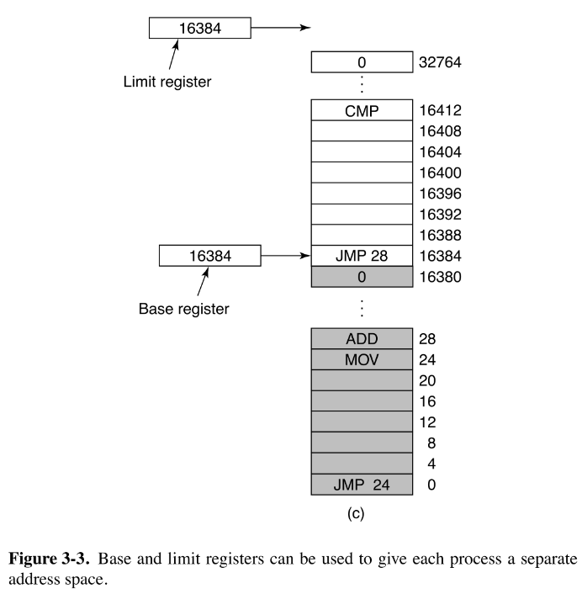
Solution
Both register could be different. The reason both has the same value is because 2 programs that use 16KB of RAM are next to each other and one of the program are at the real 0 address so it is mapped the space of 0 to 16,384. Then another program of 16KB is allocated next to this program where it is mapped from 16,384 to 32,768. The base register of the second program is the same of the limit register of the firs program and because they are of the same size the limit is also the same.

Exercise 3.3
A swapping system eliminates holes by compaction. Assuming a random distribution of many holes and many data segments and a time to read or write a 32-bit memory word of 4 nsec, about how long does it take to compact 4 GB? For simplicity, assume that word 0 is part of a hole and that the highest word in memory contains valid data.
Solution
In this scenario the worst case will require to scan to almost all the RAM to compact the spaces. To do this we need to read (to search valid data) and write (to move data) so for this we will need 4GB/4B*4nsec*2=8sec

Exercise 3.4
Consider a swapping system in which memory consists of the following hole sizes in memory order: 10 MB, 4 MB, 20 MB, 18 MB, 7 MB, 9 MB, 12 MB, and 15 MB. Which hole is taken for successive segment requests of
- 12 MB
- 10 MB
- 9 MB
for first fit? Now repeat the question for best fit, worst fit, and next fit.
Solution
- For first fit the 12MB will occupy first 20MB hole, then for the 10MB will fit the 10MB hole and finally the 9MB will fit the 18MB hole
- For best fit the 12MB will occupy first 12MB hole, then for the 10MB will fit the 10MB hole and finally the 9MB will fit the 9MB hole
- For worst fit the 12MB will occupy first 20MB hole, then for the 10MB will fit the 18MB hole and finally the 9MB will fit the 15MB hole
- For next fit the 12MB will occupy first 20MB hole, then for the 10MB will fit the 18MB hole and finally the 9MB will fit the 9MB hole

Exercise 3.5
What is the difference between a physical address and a virtual address?
Solution
A physical address is the address that points to the real hardware address of the main memory. Instead a virtual address is a translated address from physical memory that usually tries to extend memory mapping using storage memory as main memory. It also allows for many processes to share main memory without colliding physical memory addresses.

Exercise 3.6
For each of the following decimal virtual addresses, compute the virtual page number and offset for a 4-KB page and for an 8-KB page: 20000, 32768, 60000.
Solution
First will come really handy if we translate these decimal numbers into binary

Decimal | Binary | Page size 4KB |  | Page size 8KB
Decimal | Binary | Page # | Offset | Page # | Offset
20000 | 0100_1110_0010_0000 | 4 | 3616 | 2 | 3616
32768 | 1000_0000_0000_0000 | 8 | 0 | 4 | 0
60000 | 1110_1010_0110_0000 | 14 | 2656 | 7 | 2656

Exercise 3.7
Using the page table of Fig. 3-9, give the physical address corresponding to each of the following virtual addresses:
- 20
- 4100
- 8300
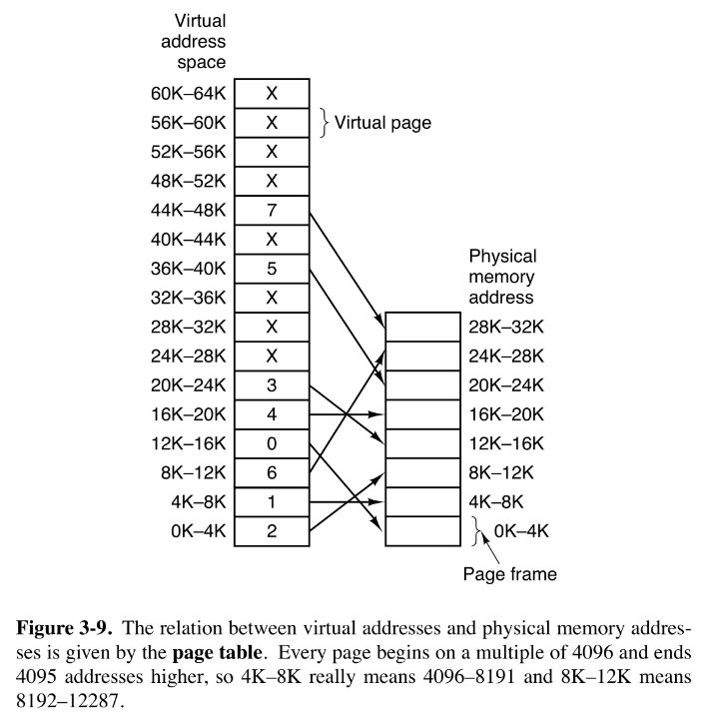
Solution
- 8212
- 4100
- 24684

Exercise 3.8
The Intel 8086 processor did not have an MMU or support virtual memory. Nevertheless, some companies sold systems that contained an unmodified 8086 CPU and did paging. Make an educated guess as to how they did it. (Hint: Think about the logical location of the MMU.)
Solution
The MMU could be separated from the CPU. It works the same as when is it internally because you has to modify the bus structure so all memory operations passes through the MMU for addresses be translated before they reach the bus and then the target device. It need also a communication between the MMU and the CPU so the MMU could trigger an interrupt when a page fault occur.

Exercise 3.9
What kind of hardware support is needed for a paged virtual memory to work?
Solution
The most essential hardware required for page virtual memory is the MMU. This device will take care of all addresses translations. Next will be the TLB to speed up address translations of the most used pages. Some other features could include physical memory protections for setup permissions inside the page. Also is requires a register that point into the beginning of the page table.

Exercise 3.10
Copy on write is an interesting idea used on server systems. Does it make any sense on a smartphone?
Solution
Yes it does. It helps to reduce the amount of main memory consumed because it only generate a copy of a page if it was modified so if many threads of the same process can read exactly the same pages as their fellows. This has all the sense in smartphones because their limited memory.

Exercise 3.11
Consider the following C program:

int X[N];
int step = M; /* M is some predefined constant */
for (int i = 0; i < N; i += step) X[i] = X[i] + 1;

- If this program is run on a machine with a 4-KB page size and 64-entry TLB, what values of M and N will cause a TLB miss for every execution of the inner loop?
- Would your answer in part (a) be different if the loop were repeated many times? Explain.
Solution
- If you set M>=4096/4=1024 and N>M then you should to be able to trigger a TLB miss on every step of the loop.
- However if the loop is executed more than one time then all the entries will be eventually in TLB so would need N>=64*1024=65536 in order to exhaust all TLB entries to trigger every time a TLB miss. Also it is explicit that M>=4096/4=1024.

Exercise 3.12
The amount of disk space that must be available for page storage is related to the maximum number of processes, n, the number of bytes in the virtual address space, v, and the number of bytes of RAM, r. Give an expression for the worst-case disk-space requirements. How realistic is this amount?
Solution
If we go to space consumed we had in theory to reserve n*v-r bytes but you should be able to map all virtual address on disk because you will eventually swap these pages into disk again so in worst case scenario you had to reserve n*v bytes. Now on modern systems is used page systems that use 48 bits address space making necessary to use petabytes just for a few processes.

Exercise 3.13
If an instruction takes 1 nsec and a page fault takes an additional n nsec, give a formula for the effective instruction time if page faults occur every k instructions.
Solution
page fault time = 1ns * 1/k*n nsec

Exercise 3.14
A machine has a 32-bit address space and an 8-KB page. The page table is entirely in hardware, with one 32-bit word per entry. When a process starts, the page table is copied to the hardware from memory, at one word every 100 nsec. If each process runs for 100 msec (including the time to load the page table), what fraction of the CPU time is devoted to loading the page tables?
Solution
With 8KB of page size that mean that 13 bits are used as offset and the remaining 19 bits are used to map page entries so we had 512K page entries per process. Then the fraction of CPU overload will be of 100ns*512K/100msec = 0.524288. That mean will spend 52.5% of the time loading pages.

Exercise 3.15
Suppose that a machine has 48-bit virtual addresses and 32-bit physical addresses.
- If pages are 4 KB, how many entries are in the page table if it has only a single level? Explain.
- Suppose this same system has a TLB (Translation Lookaside Buffer) with 32 entries. Furthermore, suppose that a program contains instructions that fit into one page and it sequentially reads long integer elements from an array that spans thousands of pages. How effective will the TLB be for this case?
Solution
- If we had 4KB page size that mean we are using 12 bits for offset leaving 36 bits for page entries.
- For a long integer array (64 bits) you can keep 2^12/2^6=64 elements of that array per page. So for the instruction page you always will get a hit and for data pages you will had a TLB miss every 64 reads.

Exercise 3.16
You are given the following data about a virtual memory system:
- The TLB can hold 1024 entries and can be accessed in 1 clock cycle (1 nsec).
- A page table entry can be found in 100 clock cycles or 100 nsec.
- The average page replacement time is 6 msec.
If page references are handled by the TLB 99% of the time, and only 0.01% lead to a page fault, what is the effective address-translation time?
Solution

Exercise 3.17
Suppose that a machine has 38-bit virtual addresses and 32-bit physical addresses.
- What is the main advantage of a multilevel page table over a single-level one?
- With a two-level page table, 16-KB pages, and 4-byte entries, how many bits should be allocated for the top-level page table field and how many for the next level page table field? Explain.
Solution
- You would require less memory to keep used pages and page tables.
- With 16KB of page size this give us 14 bits for offset. Leaving us 24 bits of page addressing. Now to be able to split page table we should be sure of how many entries we can hold on a single page 16KB/4B = 2^12 entries. So you had to split page tables in two 12 bits page addressing.

Exercise 3.18
Section 3.3.4 states that the Pentium Pro extended each entry in the page table hierarchy to 64 bits but still could only address only 4 GB of memory. Explain how this statement can be true when page table entries have 64 bits.
Solution
That was because they added a feature called Physical Address Extension. This feature could adjust the number of page levels and to define if they were going to operate in 64 bits. On a conventional PAE mode it will divide page tables in 3 levels, First level of 2 bits which point to 4 page entries, next level of 9 bits, other level of 9 bits and 12 bits offset. This entries instead of being 32 bits will be of 64 bits. So this expand the physical addressable space from 32 bits to 64 bits. Not be confused, programs still are 32 bits so their virtual address space is 32 bits wide (4GB capacity limit). However the OS keep track of this 64 bits address space so it can fill up the page tables with 64 bits entries so all virtual addresses (32 bits) are associated with an physical address (64-bits).

Exercise 3.19
A computer with a 32-bit address uses a two-level page table. Virtual addresses are split into a 9-bit top-level page table field, an 11-bit second-level page table field, and an offset. How large are the pages and how many are there in the address space?
Solution
To get the full virtual address we need to concatenate all the bits of all page table levels. This give us with 20 bits for virtual addressing . Now If the CPU use 32 bits addresses then this leave us with 12 bits of offset, that mean 4KB page size. For the first level we had 512 page entries which every entry points to a second level page table which had 2048 page entries. These give us in total 2^20 pages in total virtual space.

Exercise 3.20
A computer has 32-bit virtual addresses and 4-KB pages. The program and data together fit in the lowest page (0–4095) The stack fits in the highest page. How many entries are needed in the page table if traditional (one level) paging is used? How many page table entries are needed for two-level paging, with 10 bits in each part?
Solution
With the page size of 4KB then this leave us with 2^20 page entries for the first level requiring to store 1048576 entries. If we split virtual addressing in groups of 10 bits then we had 2 levels. Every of these level had 2^10 entries. On the first level page table we store 1024 entries and all of these entries will point to a second level page table. This table will had also 1024 entries. Now as the question say. All program data and instructions is stored into a single page (the lowest from 0-4095) and the stack will be allocated on the highest page so you will require the first level page table with 1024 entries and two second level page tables one addressing the lowest and the highest pages. Requiring a total of 3072 entries in memory.

Exercise 3.21
Below is an execution trace of a program fragment for a computer with 512-byte pages. The program is located at address 1020, and its stack pointer is at 8192 (the stack grows toward 0). Give the page reference string generated by this program. Each instruction occupies 4 bytes (1 word) including immediate constants. Both instruction and data references count in the reference string.
Load word 6144 into register 0
Push register 0 onto the stack
Call a procedure at 5120, stacking the return address
Subtract the immediate constant 16 from the stack pointer
Compare the actual parameter to the immediate constant 4
Jump if equal to 5152
Solution
The first instructions load a word which their data is located at the begging of page 12
The second instructions write the register value into the stack which point at the begging of page 16 but because it is decreasing it will load the value at the very bottom of page 15 (8188).
The third instruction will load an procedure which their address is located at the begging of page 10 but also will write at page 15 because it has to save registers values at the stack (8184).
The forth instruction will subtract to the stack pointer making to point now at 8168
The fifth instruction doesn’t call any page
The sixth instruction will try to jump at address 5152 which is an address located at page 10

Exercise 3.22
A computer whose processes have 1024 pages in their address spaces keeps its page tables in memory. The overhead required for reading a word from the page table is 5 nsec. To reduce this overhead, the computer has a TLB, which holds 32 (virtual page, physical page frame) pairs, and can do a lookup in 1 nsec. What hit rate is needed to reduce the mean overhead to 2 nsec?
Solution
To get hit ratio we can calculate

It will require to achieve that performance that at least 28 of the 32 entries to be a hit.

Exercise 3.23
How can the associative memory device needed for a TLB be implemented in hardware, and what are the implications of such a design for expandability?
Solution
It will need to had an structure and technology similar to a cache because is really a cache. It need a comparator in hardware to check valid bits. Some kind of decoder to check entries values and a multiplexer to select the right entry.

Exercise 3.24
A machine has 48-bit virtual addresses and 32-bit physical addresses. Pages are 8 KB. How many entries are needed for a single-level linear page table?
Solution
With the given 8KB of page size then we had an offset bits of 13. Now this will leave us with 48-13=35 bits addressing for page entries. So it will need 2^35=256G of page entries.

Exercise 3.25
A computer with an 8-KB page, a 256-MB main memory, and a 64-GB virtual address space uses an inverted page table to implement its virtual memory. How big should the hash table be to ensure a mean hash chain length of less than 1? Assume that the hash-table size is a power of two.
Solution
With a page size of 8KB then we had 13 bits offset. For page frames we had log₂(256MB/8KB)=15 bits and for virtual address we had log₂(64GB/8KB)=23 bits virtual addressing. To build an inverted page table of length 1 per process we need 32K entries. If we want then to has chain be less than that we need to duplicate the number of entries to 64K entries leaving a length of 0.5.

Exercise 3.26
A student in a compiler design course proposes to the professor a project of writing a compiler that will produce a list of page references that can be used to implement the optimal page replacement algorithm. Is this possible? Why or why not? Is there anything that could be done to improve paging efficiency at run time?
Solution
Page replacement not depend only of the running process but all the process running on the system. Also even if the process has knowledge of all the process in the system is impossible to predict user inputs and dynamic memory allocations and deferences. What the compiler can do is to reduce page faults by reducing code footprint, keep look of addresses references to try to reduce page references, try to align code to pages and maybe increase page sizes.

Exercise 3.27
Suppose that the virtual page reference stream contains repetitions of long sequences of page references followed occasionally by a random page reference. For example, the sequence: 0, 1, ... , 511, 431, 0, 1, ... , 511, 332, 0, 1, ... consists of repetitions of the sequence 0, 1, ... , 511 followed by a random reference to pages 431 and 332.
- Why will the standard replacement algorithms (LRU, FIFO, clock) not be effective in handling this workload for a page allocation that is less than the sequence length?
- If this program were allocated 500 page frames, describe a page replacement approach that would perform much better than the LRU, FIFO, or clock algorithms.
Solution
- Because the queue (the page frames) inside these algorithms need to be larger to the sequence length because if not then the sequence cannot be perceived by the algorithm because will start to replace last used pages will be pages 0 and 1 before it reaches the end of the sequence and will start trashing.
- There’s no solutions given the list of algorithms on the book. However there are techniques like sequential page replacement with prefetching that can help in this scenario. This algorithms use a small page frames and keep allocating pages in sequential order. This is desirable until it get to the random page reference where the algorithm fails to predict but it quickly recover by eventually flushing the random access from the pattern.

Exercise 3.28
If FIFO page replacement is used with four page frames and eight pages, how many page faults will occur with the reference string 0172327103 if the four frames are initially empty? Now repeat this problem for LRU.
Solution
The FIFO algorithm has 6 pages faults in total and the steps goes as follows:
0xxx -> Page fault at page 0
01xx -> Page fault at page 1
017x -> Page fault at page 7
0172 -> Page fault at page 2
1723 -> Page fault at page 3, Replacing page 0
1723 -> Hit page 2
1723 -> Hit page 7
1723 -> Hit page 1
7230 -> Page fault at page 0, Replacing page 1
7230 -> Hit page 3
The LRU algorithm has 7 pages faults in total and the steps goes as follows:
0xxx -> Page Fault at page 0
10xx -> Page Fault at page 1
710x -> Page Fault at page 7
2710 -> Page Fault at page 2
3271 -> Page Fault at page 3, replacing least used page 0
2371 -> Hit Page 2
7231 -> Hit Page 7
1723 -> Hit Page 1
0172 -> Page Fault at page 0, replacing least used page 3
3017 -> Page Fault at page 3, replacing least used page 2

Exercise 3.29
Consider the page sequence of Fig. 3-15(b). Suppose that the R bits for the pages B through A are 11011011, respectively. Which page will second chance remove?
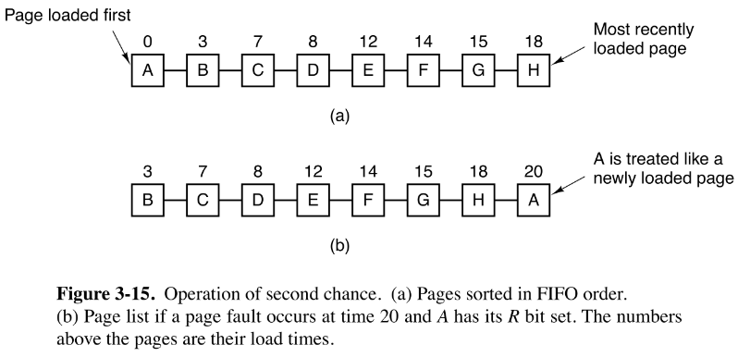
Solution
Page D because B and C has it R bit up and when reset they move at the beginning of the queue but D has R bit down and it will be evicted.

Exercise 3.30
A small computer on a smart card has four page frames. At the first clock tick, the R bits are 0111 (page 0 is 0, the rest are 1). At subsequent clock ticks, the values are 1011, 1010, 1101, 0010, 1010, 1100, and 0001. If the aging algorithm is used with an 8-bit counter, give the values of the four counters after the last tick.
Solution
Page frame 0 sequence:
01101110
Page frame 1 sequence:
01001001
Page frame 2 sequence:
00110111
Page frame 3 sequence:
10001011

Exercise 3.31
Give a simple example of a page reference sequence where the first page selected for replacement will be different for the clock and LRU page replacement algorithms. Assume that a process is allocated 3=three frames, and the reference string contains page numbers from the set 0, 1, 2, 3.
Solution
There are many differences between both algorithms that could exploit different page replace. The next sequence will exploit the sequential search of the clock versus the aging mechanism of the LRU
One possible sequence is 0, 1, 2, 0, 3, here is why.
In the clock sequence it will fill the page frames with the sequence 0, 1, 2. Now all page frames has the R bit set in 1. Now we make a reference to page 0 to hit the page and maintain R bit at frame 0. Now on the following page fault at page 3 the clock handle will clear R bit for frames 0, 1 and 2 (in that order) so eventually after complete the second revolution of the clock it will land at frame 0 and will replace page 0 with page 3.
Instead in LRU the page sequence will lead to frame 1 to be the frame with more age because the order of age are the following 3,0,2,1. So it will replace at frame 1 the page 1 for page 3.

Exercise 3.32
In the WSClock algorithm of Fig. 3-20(c), the hand points to a page with R = 0. If τ = 400, will this page be removed? What about if τ = 1000?
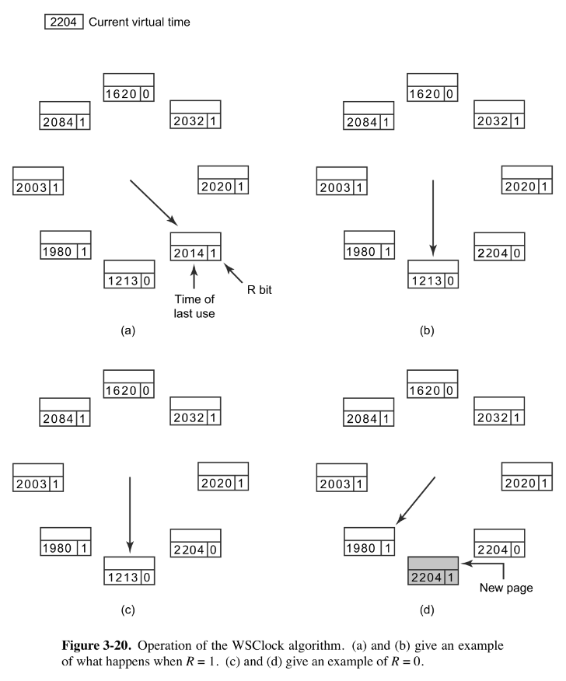
Solution
For the selected page the difference between the current time and the page age is 2204-1213=991. To avoid evict the page, τ has to be greater than 991 so for tick value of 400 it will replace the page but with the value of 1000 will not.

Exercise 3.33
Suppose that the WSClock page replacement algorithm uses a τ of two ticks, and the system state is the following:

Page | Time Stamp | V | R | M
0 | 6 | 1 | 0 | 1
1 | 9 | 1 | 1 | 0
2 | 9 | 1 | 1 | 1
3 | 7 | 1 | 0 | 0
4 | 4 | 0 | 0 | 0

where the three flag bits V, R, and M stand for Valid, Referenced, and Modified, respectively.
- If a clock interrupt occurs at tick 10, show the contents of the new table entries. Explain. (You can omit entries that are unchanged.)
- Suppose that instead of a clock interrupt, a page fault occurs at tick 10 due to a read request to page 4. Show the contents of the new table entries. Explain. (You can omit entries that are unchanged.)
Solution
- With the clock interruption it will scan and update the value of R bit of all entries. In page 0 the difference between the clock tick and the time stamp is greater than 2. However the page is dirty so it will schedule a write back to disk and set the M bit to 0. Because the page is candidate to be evicted there’s no reason to update the time stamp. For pages 1 and 2 the difference between the clock tick and the time stamp is less than 2 so it will update time stamps to actual clock tick and set R bit to 0. For pages 3 and 4 nothing happens. Both pages are candidate to be evicted so no R and time stamp update.

Page | Time Stamp | V | R | M
0 | 6 | 1 | 0 | 0
1 | 10 | 1 | 0 | 0
2 | 10 | 1 | 0 | 1
3 | 7 | 1 | 0 | 0
4 | 4 | 0 | 0 | 0

- On a page fault the algorithm will evict all pages that should not valid at the moment (that mean all pages with R and M unset). It will search in all entries and modify these entries. So pages 0, 1 and 2 are unaffected. For page 3 it will unset V bit and finally for page 4 because the reason of the interruption is a page fault on this page then it will try to read from disk and once is the page in memory will set V and R bits so the final table should look like this

Page | Time Stamp | V | R | M
0 | 6 | 1 | 0 | 1
1 | 9 | 1 | 1 | 0
2 | 9 | 1 | 1 | 1
3 | 7 | 0 | 0 | 0
4 | 10 | 1 | 1 | 0

Exercise 3.34
A student has claimed that ‘‘in the abstract, the basic page replacement algorithms (FIFO, LRU, optimal) are identical except for the attribute used for selecting the page to be replaced.’’
- What is that attribute for the FIFO algorithm? LRU algorithm? Optimal algorithm?
- Give the generic algorithm for these page replacement algorithms.
Solution
- For FIFO the page to be replaced is the older page of being loaded. For LRU is the older page of being used. For optimal is the page that wont be used the furthest time.
- The algorithm will be measure the parameter and will order the pages inside a list with that criteria. When a page fault occurs and the list is full it will replace the less valuable page inside the list.

Exercise 3.35
How long does it take to load a 64-KB program from a disk whose average seek time is 5 msec, whose rotation time is 5 msec, and whose tracks hold 1 MB
- for a 2-KB page size?
- for a 4-KB page size?
The pages are spread randomly around the disk and the number of cylinders is so large that the chance of two pages being on the same cylinder is negligible.
Solution
In order to get the total disk latency we had to know that for every page to be seek the disk has to
- Put the head in the right track which is the seek time (determined by the mechanical properties of the disk)
- Then it has to read the right sector inside the disk. The mean time to get to the right sector will be the half of the rotational time because this track can be on the end or the beginning of the track so in average case tend to be at half way
- Finally it start the read speed is what we know as the transfer rate. This parameter is not given to us but we can do a guess. To read a whole track content we need to do a full rotation. In that case we can just try to read the portion that we want to read of that track, so take the proportion and multiply by the rotation speed
Remember all this process for just one page retrieve so to the load latency when
- The page size is 2KB is

- The page size is 4KB is

Exercise 3.36
A computer has four page frames. The time of loading, time of last access, and the R and M bits for each page are as shown below (the times are in clock ticks):

Page | Loaded | Last Ref. | R | M
0 | 126 | 280 | 1 | 0
1 | 230 | 265 | 0 | 1
2 | 140 | 270 | 0 | 0
3 | 110 | 285 | 1 | 1

- Which page will NRU replace?
- Which page will FIFO replace?
- Which page will LRU replace?
- Which page will second chance replace?
Solution
- In NRU algorithm the page to be replaced is the page with the less value class. Page 0 fit to be class 2 (R=1, M=0). Page 1 fit in class 1 (R=0, M=1). Page 2 is member of class 0 (R=0, M=0). And finally page 3 fit inside class 3 classification (R=1, M=1). So the page selected to be replaced is page 2
- In FIFO the page to be replaced is the one with the oldest time of being loaded. In that case the page to be replaced is page 3 with 110 ticks old (the ticks is the timestamp not the currently tick).
- In LRU the page to be replaced is the one with the oldest time of being used. In that case page to be replaced is page 1 with 265 ticks old (the ticks is the timestamp not the currently tick).
- On a second chance replace algorithm will first considerate candidate page 3 for being the older page loaded, because bit R is 1 then it will be moved at the beginning of the queue. Now the next page to be considered is page 2 and now with R and M bits unset this page then will be evicted.

Exercise 3.37
Suppose that two processes A and B share a page that is not in memory. If process A faults on the shared page, the page table entry for process A must be updated once the page is read into memory.
- Under what conditions should the page table update for process B be delayed even though the handling of process A’s page fault will bring the shared page into memory? Explain.
- What is the potential cost of delaying the page table update?
Solution
- For systems using copy on write model for shared pages. There’s no reason to go ahead into update page table B because any modification done by A into the page then the system had to drop the page entry hold by B and update it.
- The most expensive cost will be for process B to request this page before being updated because it has then to page fault, and then make a copy from the original page.

Exercise 3.38
Consider the following two-dimensional array:
int X[64][64];
Suppose that a system has four page frames and each frame is 128 words (an integer occupies one word). Programs that manipulate the X array fit into exactly one page and always occupy page 0. The data are swapped in and out of the other three frames. The X array is stored in row-major order (i.e., X[0][1] follows X[0][0] in memory). Which of the two code fragments shown below will generate the lowest number of page faults? Explain and compute the total number of page faults.
Fragment A
for (int j = 0; j < 64; j++)
for (int i = 0; i < 64; i++) X[i][j] = 0;
Fragment B
for (int i = 0; i < 64; i++)
for (int j = 0; j < 64; j++) X[i][j] = 0;
Solution
When the data flows as described then if you follow the fragment B that mean that you search the memory in order. If so if we have 128 words per page then we can read 2 full rows per page so it faults 32 times. However for fragment A it goes skipping this memory spaces by going for row order instead column order. That mean it scan just 2 numbers per page. So it goes for all 64 columns doing a page fault of 32 times making a total of 2048 page faults. Unless you break the code so it scans subgroups of 6 rows (because we have 3 page frames) then we can speed up this up to Fragment B performance.

Exercise 3.39
You have been hired by a cloud computing company that deploys thousands of servers at each of its data centers. They have recently heard that it would be worthwhile to handle a page fault at server A by reading the page from the RAM memory of some other server rather than its local disk drive.
- How could that be done?
- Under what conditions would the approach be worthwhile? Be feasible?
Solution
- It can be done if you first connect both machines into a network and modify the definition of the swap space so disk and RAM from the other machines behaves as one. So first request to the second machine to retrieve the page in case they have it in memory and then if not the first machine can request to the disk.
- Only if the network latency and RAM seek of the second machine are faster that seeking in disk.

Exercise 3.40
One of the first timesharing machines, the DEC PDP-1, had a (core) memory of 4K 18-bit words. It held one process at a time in its memory. When the scheduler decided to run another process, the process in memory was written to a paging drum, with 4K 18-bit words around the circumference of the drum. The drum could start writing (or reading) at any word, rather than only at word 0. Why do you suppose this drum was chosen?
Solution
I wonder it is because it can swap really fast between the pages of one process to another helping with timesharing. If you have this drum around the memory core then you could just dump all its content into the drum with just one single rotation of the drum. This is because addressing into the drum doesn’t need a starting point so it has 2 positive consequences. First it takes the same amount of time to read or write at any address and second it makes to appear like many sequential memory operations behaves like a single big memory operation improving mean memory operations delay.

Exercise 3.41
A computer provides each process with 65,536 bytes of address space divided into pages of 4096 bytes each. A particular program has a text size of 32,768 bytes, a data size of 16,386 bytes, and a stack size of 15,870 bytes. Will this program fit in the machine’s address space? Suppose that instead of 4096 bytes, the page size were 512 bytes, would it then fit? Each page must contain either text, data, or stack, not a mixture of two or three of them.
Solution
For page size of 4096 bytes the number of possible entries will be of 16. So to map all memory in page table we would need 8 pages for text, 5 pages for data and 4 pages for stack. However this exceed the limit so it cannot be possible to map all of it. But for 512 bytes page size this changes, in this scheme the number of entries are of 128. In this case the number of pages required for text are 64, for data are 33 and for stack is 31. Now this barely fits in memory.

Exercise 3.42
It has been observed that the number of instructions executed between page faults is directly proportional to the number of page frames allocated to a program. If the available memory is doubled, the mean interval between page faults is also doubled. Suppose that a normal instruction takes 1 microsec, but if a page fault occurs, it takes 2001μsec (i.e., 2 msec) to handle the fault. If a program takes 60 sec to run, during which time it gets 15,000 page faults, how long would it take to run if twice as much memory were available?
Solution
If in that minute it happened 15000 page fault that mean that 15000*2msec=30 seconds of this program execution were wasted in page fault and the other 30 seconds were used in actual instructions executions, that mean it executed 30,000,000 instructions. This makes 30,000,000/15,000=2,000 instructions per page fault. With memory doubles then the instructions per page fault is also doubled at 4,000 instructions per fault. So we then need (30,000,000*1 microsec + 30,000,000/4,000*2 msec)=45 seconds in total.

Exercise 3.43
A group of operating system designers for the Frugal Computer Company are thinking about ways to reduce the amount of backing store needed in their new operating system. The project manager has just suggested not bothering to save the program text in the swap area at all, but just page it in directly from the binary file whenever it is needed. Under what conditions, if any, does this idea work for the program text? Under what conditions, if any, does it work for the data?
Solution
This could work. But this open the great hazard of someone be able to modify this file meanwhile its executing. For text segments the only solutions What I can think is to make a locked copy not a level user but a kernel level to assure integrity of the program. For data the most problematic part is the mutable nature of data. Only could be paged from the binary if this behaves as a constants, also the lock managed by kernel is a must, but as first that something from data has to be written then isn’t possible.

Exercise 3.44
A machine-language instruction to load a 32-bit word into a register contains the 32-bit address of the word to be loaded. What is the maximum number of page faults this instruction can cause?
Solution
It can cause a maximum of 2 page faults if you try to load a not aligned word, because one part can be at the bottom of a page and the remaining part at the beginning.

Exercise 3.45
Explain the difference between internal fragmentation and external fragmentation. Which one occurs in paging systems? Which one occurs in systems using pure segmentation?
Solution
Internal fragmentation occurs in paging system mostly. It happen where the size of the data is smaller than the page size or segment size, however from memory perspective the whole page/segment is allocated even if inside this page/ segment all data is logically not used. External fragmentation occur only with segment systems, this is because it happen when segments are removed from memory (deallocate) leave a hole and because usually segments are from different sizes it make difficult to fill correctly.

Exercise 3.46
When segmentation and paging are both being used, as in MULTICS, first the segment descriptor must be looked up, then the page descriptor. Does the TLB also work this way, with two levels of lookup?
Solution
No two level lookup are necessary, it can be saved the direct conversion of a segment descriptor to a page address. However instead page table entries, the segment descriptors are more complex because it save the page size, read/write/execution permissions and other options. So a TLB can be implemented so any address could cache their respective page but you need to add these descriptors and check these logical options to be sure to not skipping restrictions.

Exercise 3.47
We consider a program which has the two segments shown below consisting of instructions in segment 0, and read/write data in segment 1. Segment 0 has read/execute protection, and segment 1 has just read/write protection. The memory system is a demand paged virtual memory system with virtual addresses that have a 4-bit page number, and a 10-bit offset. The page tables and protection are as follows (all numbers in the table are in decimal):

Segment 0 (Read/Execute) |  | Segment 1 (Read/Write)
Virtual Page # | Page Frame # | Virtual Page # | Page Frame #
0 | 2 | 0 | On Disk
1 | On Disk | 1 | 14
2 | 11 | 2 | 9
3 | 5 | 3 | 6
4 | On Disk | 4 | On Disk
5 | On Disk | 5 | 13
6 | 4 | 6 | 8
7 | 3 | 7 | 12

For each of the following cases, either give the real (actual) memory address which results from dynamic address translation or identify the type of fault which occurs (either page or protection fault).
- Fetch from segment 1, page 1, offset 3
- Store into segment 0, page 0, offset 16
- Fetch from segment 1, page 4, offset 28
- Jump to location in segment 1, page 3, offset 32
Solution
- It will hit the page however, it will trow a protection fault because no execution permissions are allowed
- It will hit the page however, It will trow a protection fault because no writes are allowed
- It will first page fault, once the page is on memory, it will trow a protection fault because no execution permissions are allowed
- It will hit the page, however jumping through code mean an implicit execution so, it will trow a protection fault because no execution permissions are allowed

Exercise 3.48
Can you think of any situations where supporting virtual memory would be a bad idea, and what would be gained by not having to support virtual memory? Explain.
Solution
Only on really embedded systems where only one program will be executing in memory. This kind of programs usually embed libraries and some other utilities to manage resources as a OS but not be confused. This is the only program running in memory and it handle everything.

Exercise 3.49
Virtual memory provides a mechanism for isolating one process from another. What memory management difficulties would be involved in allowing two operating systems to run concurrently? How might these difficulties be addressed?
Solution
Well without any kind of abstraction there’s no possible way that 2 OS can share the same hardware without killing themselves in the process because they will be constantly modifying memory regions of the other OS and leading with inconsistencies and many other problem of managing memory and hardware. The way to address this problem is using a hypervisor. The hypervisor provides the abstraction necessary on hardware resources and creating a pool of them. Then it can share and manage the share of the resources between Operating Systems so they do not interfere each other.

Exercise 3.50
Plot a histogram and calculate the mean and median of the sizes of executable binary files on a computer to which you have access. On a Windows system, look at all .exe and .dll files; on a UNIX system look at all executable files in /bin, /usr/bin, and /local/bin that are not scripts (or use the file utility to find all executables). Determine the optimal page size for this computer just considering the code (not data). Consider internal fragmentation and page table size, making some reasonable assumption about the size of a page table entry. Assume that all programs are equally likely to be run and thus should be weighted equally.
Solution
/*Pending*/

Exercise 3.51
Write a program that simulates a paging system using the aging algorithm. The number of page frames is a parameter. The sequence of page references should be read from a file. For a given input file, plot the number of page faults per 1000 memory references as a function of the number of page frames available.
Solution
/*Pending*/

Exercise 3.52
Write a program that simulates a toy paging system that uses the WSClock algorithm. The system is a toy in that we will assume there are no write references (not very realistic), and process termination and creation are ignored (eternal life). The inputs are:
- The reclamation age threshold
- The clock interrupt interval expressed as number of memory references
- A file containing the sequence of page references
- Describe the basic data structures and algorithms in your implementation.
- Show that your simulation behaves as expected for a simple (but nontrivial) input example.
- Plot the number of page faults and working set size per 1000 memory references.
- Explain what is needed to extend the program to handle a page reference stream that also includes writes.
Solution
/*Pending*/

Exercise 3.53
Write a program that demonstrates the effect of TLB misses on the effective memory access time by measuring the per-access time it takes to stride through a large array.
- Explain the main concepts behind the program, and describe what you expect the output to show for some practical virtual memory architecture.
- Run the program on some computer and explain how well the data fit your expectations.
- Repeat part (b) but for an older computer with a different architecture and explain any major differences in the output.
Solution
/*Pending*/

Exercise 3.54
Write a program that will demonstrate the difference between using a local page replacement policy and a global one for the simple case of two processes. You will need a routine that can generate a page reference string based on a statistical model. This model has N states numbered from 0 to N < 1 representing each of the possible page references and a probability pi associated with each state i representing the chance that the next reference is to the same page. Otherwise, the next page reference will be one of the other pages with equal probability.
- Demonstrate that the page reference string-generation routine behaves properly for some small N .
- Compute the page fault rate for a small example in which there is one process and a fixed number of page frames. Explain why the behavior is correct.
- Repeat part (b) with two processes with independent page reference sequences and twice as many page frames as in part (b). Repeat part (c) but using a global policy instead of a local one. Also, contrast the
- per-process page fault rate with that of the local policy approach.
Solution
/*Pending*/

Exercise 3.55
Write a program that can be used to compare the effectiveness of adding a tag field to TLB entries when control is toggled between two programs. The tag field is used to effectively label each entry with the process id. Note that a nontagged TLB can be simulated by requiring that all TLB entries have the same tag at any one time. The inputs will be:
- The number of TLB entries available
- The clock interrupt interval expressed as number of memory references
- A file containing a sequence of (process, page references) entries
- The cost to update one TLB entry
- Describe the basic data structures and algorithms in your implementation.
- Show that your simulation behaves as expected for a simple (but nontrivial) input example.
- Plot the number of TLB updates per 1000 references.
Solution
/*Pending*/

