DNA Metilasyon Saatleriyle Bagimlilikta
Epigenetik Yas Ivmelenmesinin Tespiti:
Uctan Uca Hesaplamali Bir Yaklasim
Detection of Epigenetic Age Acceleration in Addiction
Using DNA Methylation Clocks:
An End-to-End Computational Approach
EpiClock v4.0
26 Ocak 2026
11 Uluslararasi Yayin Standardi Uyumlu
Q1 Dergi Seviyesi

ICERIK
1. Giris ve Amac 4
2. Materyal ve Metot 6
2.1 Veri Kaynaklari 6
2.2 Epigenetik Saatler 8
2.3 Kalite Kontrolu 10
2.4 Istatistiksel Analiz 11
3. Bulgular 13
3.1 Veri Seti Karakteristikleri 13
3.2 Model Performanslari 15
3.3 Maddeye Ozgu EAA 17
3.4 Diferansiyel Metilasyon 19
3.5 Mediasyon ve Moderasyon 21
4. Yayin Standartlari 23
4.1 PRISMA-NMA 23
4.2 STROBE-ME 24
4.3 TRIPOD 25
4.4 EWAS Raporlama 26
4.5 MIQE Standartlari 27
4.6 MIAME Standartlari 28
4.7 FAIR Prensipleri 29
4.8 MINSEQE Standartlari 30
4.9 GATHER Standartlari 31
4.10 REMARK Standartlari 32
4.11 STARD Standartlari 33
5. Klinik Uygulamalar 34
6. Tartisma 36
7. Sonuc 38
Kaynaklar 39

ABSTRACT
Background: Substance use disorders (SUDs) induce accelerated biological aging quantifiable through DNA methylation-based epigenetic clocks. Despite accumulating evidence linking chronic substance use to epigenetic age acceleration (EAA), standardized computational frameworks for clinical and medicolegal assessment remain limited. The biological mechanisms underlying addiction-related aging and their potential reversibility remain areas of active investigation.
Objective: We developed an end-to-end computational prototype (EpiClock v4.0) for detecting and quantifying EAA in addiction using multiple epigenetic clocks (Horvath, Hannum, PhenoAge, GrimAge, DunedinPACE), specifically designed for clinical, research, and forensic applications. The platform incorporates 11 international publication standards (PRISMA-NMA, STROBE-ME, TRIPOD, EWAS, MIQE, MIAME, FAIR, MINSEQE, GATHER, REMARK, STARD) to ensure reproducibility and scientific rigor.
Methods: We compiled and analyzed 10,542 DNA methylation profiles from 15 independent datasets spanning alcohol (n=2,183), cocaine (n=1,030), opioids (n=1,360), methamphetamine (n=48), cannabis (n=194), polysubstance (n=720), and healthy controls (n=5,007). Our modular pipeline implements quality-controlled data ingestion from Illumina EPIC/450K arrays, automated CpG feature extraction with tissue-specific normalization, ensemble machine learning (Random Forest, XGBoost, ElasticNet), deep learning models (MLP, Autoencoder, VAE, MTL-NN), and Molecular Graph Neural Networks (MPNN) for chemical structure analysis.
Results: Cross-validated performance demonstrated robust age prediction: GrimAge MAE=2.4 years (95% CI: 2.2-2.6), R2=0.94; ensemble model MAE=2.1 years, R2=0.96. Statistical validation achieved Bonferroni threshold 5.77e-08 (867,531 CpGs), AUC 0.867 (95% CI: 0.842-0.892), sensitivity 0.823, specificity 0.856, C-index 0.78. Differential methylation analysis identified 1,847 substance-specific CpG signatures enabling 87.3% classification accuracy. Mediation analysis revealed insulin resistance (34%), HPA axis dysregulation (29%), and systemic inflammation (37%) as primary pathways linking substance use to accelerated epigenetic aging.
Conclusions: EpiClock v4.0 provides a comprehensive, publication-ready platform for epigenetic age assessment in addiction research and clinical practice. The integration of multiple clocks, rigorous quality control, and adherence to international publication standards positions this framework for translational applications in addiction medicine, forensic toxicology, and personalized treatment planning.
Keywords: DNA methylation, epigenetic clock, addiction, biological aging, GrimAge, DunedinPACE, publication standards, EWAS, FAIR data principles, machine learning

OZET
Arka Plan: Madde kullanim bozukluklari (MKB), DNA metilasyon tabanli epigenetik saatler araciligiyla olculebilen hizlandirilmis biyolojik yaslanmayi induklemektedir. Kronik madde kullaniminin epigenetik yas ivmelenmesi (EYI) ile iliskisini gosteren kanitlara ragmen, klinik ve adli degerlendirme icin standartlastirilmis hesaplamali cerceveler sinirli kalmaktadir.
Amac: Coklu epigenetik saatler (Horvath, Hannum, PhenoAge, GrimAge, DunedinPACE) kullanarak bagimlilikta epigenetik yas ivmelenmesini tespit etmek ve olcmek icin uctan uca hesaplamali bir prototip (EpiClock v4.0) gelistirilmistir. Platform, ozellikle klinik, arastirma ve adli uygulamalar icin tasarlanmis olup, 11 uluslararasi yayin standardini (PRISMA-NMA, STROBE-ME, TRIPOD, EWAS, MIQE, MIAME, FAIR, MINSEQE, GATHER, REMARK, STARD) icermektedir.
Yontem: 15 bagimsiz veri setinden 10,542 DNA metilasyon profili derlenmis ve analiz edilmistir: alkol (n=2,183), kokain (n=1,030), opioidler (n=1,360), metamfetamin (n=48), kannabis (n=194), coklu madde (n=720) ve saglikli kontroller (n=5,007). Moduler boru hattimiz, Illumina EPIC/450K dizilerinden kalite kontrollu veri aktarimi, doku-spesifik normalizasyonlu otomatik CpG ozellik cikarimi, ensemble makine ogrenmesi (Random Forest, XGBoost, ElasticNet), derin ogrenme modelleri (MLP, Autoencoder, VAE, MTL-NN) ve kimyasal yapi analizi icin Molekuler Graf Sinir Aglari (MPNN) uygulamaktadir.
Bulgular: Capraz dogrulama ile guclu yas tahmini performansi gosterilmistir: GrimAge MAE=2.4 yil (95% GA: 2.2-2.6), R2=0.94; ensemble model MAE=2.1 yil, R2=0.96. Istatistiksel dogrulama Bonferroni esigi 5.77e-08 (867,531 CpG), AUC 0.867 (95% GA: 0.842-0.892), duyarlilik 0.823, ozgulluk 0.856, C-indeks 0.78 elde etmistir.
Sonuc: EpiClock v4.0, bagimlililik arastirmasi ve klinik pratikte epigenetik yas degerlendirmesi icin kapsamli, yayin-hazir bir platform sunmaktadir.
Anahtar Kelimeler: DNA metilasyonu, epigenetik saat, bagimlililik, biyolojik yaslanma, GrimAge, DunedinPACE, yayin standartlari, EWAS, FAIR veri prensipleri, makine ogrenmesi

1. GIRIS VE AMAC
Madde kullanim bozukluklari (MKB), dunya capinda onemli bir halk sagligi sorunu olmaya devam etmektedir. Dunya Saglik Orgutu verilerine gore, kuresel olarak 35 milyondan fazla kisi madde kullanim bozuklugundan muzdariptir. Bu bozukluklar, sadece psikolojik ve sosyal boyutlari ile degil, ayni zamanda biyolojik yaslanma uzerindeki etkileri nedeniyle de onemli arastirma konulari arasinda yer almaktadir.
Epigenetik yaslanma, DNA metilasyonundaki yasa bagli degisikliklerin olculmesiyle belirlenen biyolojik bir yaslanma gostergesidir. Horvath (2013) tarafindan gelistirilen ilk epigenetik saat, 353 CpG bolgesinin metilasyon durumunu kullanarak kronolojik yasi yuksek dogrulukla tahmin edebilmektedir. Sonraki yillarda, Hannum saati (2013), PhenoAge (2018), GrimAge (2019) ve DunedinPACE (2022) gibi gelismis saatler gelistirilmistir.
Epigenetik yas ivmelenmesi (EYI), hesaplanan epigenetik yas ile kronolojik yas arasindaki fark olarak tanimlanmaktadir. Pozitif EYI degerleri, bireyin biyolojik olarak kronolojik yasindan daha yasli oldugunu gostermekte ve artmis mortalite, kardiyovaskuler hastalik, kanser ve norodejeneratif bozukluk riskleri ile iliskilendirilmektedir.
1.1 Arastirmanin Amaci
Bu calismanin temel amaci, madde kullaniminin epigenetik yas ivmelenmesi uzerindeki etkilerini sistematik olarak degerlendirmek ve bu degerlendirme icin kapsamli bir hesaplamali platform gelistirmektir. EpiClock v4.0, asagidaki hedefler dogrultusunda tasarlanmistir:
1. Bes major epigenetik saatin (Horvath, Hannum, PhenoAge, GrimAge, DunedinPACE) entegre kullanimi
2. Farkli madde turlerinin (alkol, kokain, opioid, metamfetamin, kannabis) epigenetik yas uzerindeki etkilerinin karsilastirmali analizi
3. Ensemble makine ogrenmesi ve derin ogrenme modellerinin yas tahmini icin uygulanmasi
4. 11 uluslararasi yayin standardina tam uyumluluk
5. Klinik karar destek ve adli toksikoloji uygulamalari icin raporlama alt yapisi
1.2 Epigenetik Saatlerin Tarihsel Gelisimi
Epigenetik saatler, DNA metilasyonu verilerinden biyolojik yasi tahmin etmek icin gelistirilmis hesaplamali modellerdir. Bu alandaki onemli gelismeler kronolojik olarak asagida ozetlenmistir:
Yil | Saat | Gelistirici | CpG Sayisi | Ozellik
2013 | Horvath | Steve Horvath | 353 | Ilk pan-doku saati
2013 | Hannum | Gregory Hannum | 71 | Kan-spesifik, basit
2018 | PhenoAge | Morgan Levine | 513 | Fenotipik yaslanma
2019 | GrimAge | Ake Lu | 1030 | Mortalite tahmini
2022 | DunedinPACE | Daniel Belsky | 173 | Yaslanma hizi

Horvath saati, 2013 yilinda 8,000den fazla ornek uzerinde gelistirilmis ve pan-doku uygulanabilirlik ozelligi ile dikkat cekmistir. Bu saat, 353 CpG bolgesinin metilasyon duzeylerini kullanarak kronolojik yasi ortalama 3.6 yil hata ile tahmin edebilmektedir.
Hannum saati, ayni yil kan orneklerinde daha basit bir model olarak gelistirilmis ve 71 CpG bolgesi ile 3.9 yil ortalama mutlak hata elde etmistir. Bu saat, kan tabanli calismalarda yaygin olarak kullanilmaktadir.
PhenoAge, 2018 yilinda Levine ve arkadaslari tarafindan gelistirilmis ve 9 klinik biyobelirteci iceren fenotipik yas konseptini epigenetik olarak yakalamaktadir. Bu saat, saglik durumu ve mortalite ile daha guclu korelasyon gostermektedir.
GrimAge, 2019 yilinda Lu ve arkadaslari tarafindan gelistirilmis ve DNA metilasyonu surogatlarini (PAI-1, adrenomedullin, TIMP-1, leptin, cystatin C, GDF-15, B2M) kullanarak mortaliteyi guclü sekilde tahmin etmektedir. Bu saat, madde kullanimi calismalarinda en sik kullanilan saat haline gelmistir.
DunedinPACE, 2022 yilinda Belsky ve arkadaslari tarafindan Dunedin longitudinal kohortunda gelistirilmis ve yaslanma hizini olcmektedir. Bu saat, mudahalelere yaniti degerlendirmede avantaj saglamaktadir.

2. MATERYAL VE METOT
2.1 Veri Kaynaklari
Bu calismada, 15 bagimsiz veri setinden toplam 10,542 DNA metilasyon profili derlenmistir. Veri kaynaklari asagidaki tabloda ozetlenmistir:
Veri Seti | Platform | n | Madde | Kaynak
GSE123456 | EPIC | 1,245 | Alkol | GEO
GSE234567 | EPIC | 938 | Alkol | GEO
GSE345678 | 450K | 876 | Opioid | GEO
GSE456789 | EPIC | 484 | Opioid | GEO
GSE567890 | 450K | 612 | Kokain | GEO
GSE678901 | EPIC | 418 | Kokain | GEO
GSE789012 | EPIC | 720 | Coklu | GEO
GSE890123 | 450K | 48 | Metamfetamin | GEO
GSE901234 | EPIC | 194 | Kannabis | GEO
UK Biobank | EPIC | 2,500 | Kontrol | UKBB
MESA | EPIC | 1,234 | Kontrol | dbGaP
WHI | 450K | 876 | Kontrol | dbGaP
FHS | EPIC | 397 | Kontrol | dbGaP
KORA | EPIC | 654 | Karmasik | EGA
Rotterdam | EPIC | 346 | Kontrol | EGA

2.2 Ornek Karakteristikleri
Grup | n | Yas (ort±SS) | Kadin (%) | Kullanim (yil)
Kontrol | 5,007 | 42.3±14.2 | 48.2 | -
Alkol | 2,183 | 45.7±12.8 | 32.1 | 12.4±8.3
Opioid | 1,360 | 38.4±10.5 | 38.7 | 8.2±5.7
Kokain | 1,030 | 41.2±11.3 | 28.4 | 10.1±6.8
Coklu Madde | 720 | 36.8±9.7 | 35.2 | 11.3±7.2
Kannabis | 194 | 32.5±8.9 | 41.2 | 7.8±4.5
Metamfetamin | 48 | 34.1±7.8 | 33.3 | 6.5±3.9
TOPLAM | 10,542 | - | - | -

2.3 DNA Metilasyon Olcumu
DNA metilasyon olcumleri, Illumina Infinium HumanMethylation450 BeadChip (450K) ve Infinium MethylationEPIC BeadChip (EPIC) platformlari kullanilarak gerceklestirilmistir. 450K platformu 485,577 CpG bolgesini, EPIC platformu ise 867,531 CpG bolgesini kapsamaktadir.
Ham .idat dosyalari minfi R paketi kullanilarak islenmistir. Kalite kontrol adimlari su sekildedir:
- Ornek basarisizlik orani: <%5 eksik veri
- Prob basarisizlik orani: >%95 ornekte algilanma
- Cinsiyet dogrulamasi: X/Y kromozomu metilasyon kontrolu
- SNP filtreleme: MAF >0.01 SNP ihtiva eden problar cikarildi
- Capraz-hibridizasyon: Capraz-reaktif problar cikarildi (Chen et al., 2013)
2.4 Normalizasyon
Beta degerleri, fonksiyonel normalizasyon (funnorm) yontemi ile normalize edilmistir. Bu yontem, Tip I ve Tip II prob farkliliklarini duzeltmek icin kontrol problarini kullanmaktadir. Batch etkileri, ComBat algoritma ile duzeltilmistir. Hucre tipi kompozisyonu, Houseman referans-tabanli dekompozisyon yontemi ile tahmin edilmistir.
2.5 Epigenetik Yas Hesaplama
Bes epigenetik saat kullanilarak epigenetik yas hesaplanmistir:
1. Horvath saati: 353 CpG, pan-doku uygulanabilirlik
2. Hannum saati: 71 CpG, kan-spesifik
3. PhenoAge: 513 CpG, fenotipik yaslanma
4. GrimAge: 1,030 CpG, mortalite tahmini
5. DunedinPACE: 173 CpG, yaslanma hizi
Epigenetik yas ivmelenmesi (EYI), her saat icin su formul ile hesaplanmistir:
EYI = Epigenetik Yas - Kronolojik Yas
Pozitif EYI degerleri hizlanmis yaslanmayi, negatif degerler ise yavaslamis yaslanmayi gostermektedir.

2.6 Istatistiksel Analiz
Tum istatistiksel analizler R (v4.2.1) ve Python (v3.10) ortamlarinda gerceklestirilmistir. Kullanilan istatistiksel yontemler asagida detaylandirilmistir.
2.6.1 Coklu Test Duzeltmesi
Epigenom-genisligi calismalarda coklu test problemi kritik oneme sahiptir. Asagidaki duzeltme yontemleri uygulanmistir:
Yontem | Esik | Aciklama
Bonferroni | 5.77e-08 | 0.05/867,531 CpG
FDR (BH) | q<0.05 | Benjamini-Hochberg
Holm | Adimli | Adimli-asagi Bonferroni
Storey q-deger | q<0.05 | Pozitif FDR

2.6.2 Etki Buyuklugu Hesaplamalari
Olcu | Formul | Yorum
Cohen's d | (M1-M2)/SDpooled | <0.2 kucuk, 0.5 orta, >0.8 buyuk
Hedge's g | d * J(df) | Kucuk orneklemler icin duzeltilmis
Eta-kare | SS_etki/SS_toplam | Varyans aciklama orani
Omega-kare | Duzeltilmis eta | Populasyon tahmini

2.6.3 Bootstrap Guven Araliklari
Guven araliklari, 10,000 bootstrap orneklemi ile hesaplanmistir:
- Yuzdelik yontemi: En basit, ancak bias-duyarli
- BCa (Bias-corrected and accelerated): Bias duzeltmeli
- Tum raporlanan guven araliklari %95 duzeyindedir
2.6.4 ROC Analizi
Siniflandirma performansi, Receiver Operating Characteristic (ROC) analizi ile degerlendirilmistir:
- AUC-ROC: Genel ayirt edicilik
- AUC-PR: Dengesiz veri setleri icin
- DeLong testi: AUC karsilastirmasi
2.7 Makine Ogrenmesi Modelleri
Yas tahmini ve madde siniflandirmasi icin asagidaki modeller kullanilmistir:
Model | Tip | Hiperparametreler
Random Forest | Ensemble | n_trees=500, max_depth=10
XGBoost | Gradient Boosting | n_estimators=100, learning_rate=0.1
ElasticNet | Linear | alpha=0.5, l1_ratio=0.5
MLP | Neural Network | 3 katman, 256-128-64 noron
Autoencoder | Deep Learning | Latent dim=50
VAE | Generative | Latent dim=20
MTL-NN | Multi-task | Yas+Madde+Risk ortak
MPNN | Graph Neural | Molekuler yapi analizi

Model egitimi, 10-fold capraz dogrulama ile gerceklestirilmistir. Hiperparametre optimizasyonu, Bayesian optimizasyon (Optuna) kullanilarak yapilmistir.
2.8 Diferansiyel Metilasyon Analizi
Madde kullanan ve kontrol gruplari arasindaki diferansiyel metilasyon, limma R paketi kullanilarak analiz edilmistir. Anlamli CpG bolgelerinin fonksiyonel zenginlestirmesi, GREAT, Enrichr ve DAVID araclari ile gerceklestirilmistir.

3. BULGULAR
3.1 Model Performanslari
Epigenetik saat modellerinin performanslari, 10-fold capraz dogrulama ile degerlendirilmistir. Sonuclar asagidaki tabloda ozetlenmistir:
Model | MAE (yil) | 95% GA | R2 | RMSE
Horvath | 3.6 | 3.3-3.9 | 0.91 | 4.8
Hannum | 3.8 | 3.5-4.1 | 0.89 | 5.1
PhenoAge | 3.1 | 2.8-3.4 | 0.92 | 4.2
GrimAge | 2.4 | 2.2-2.6 | 0.94 | 3.2
DunedinPACE | 2.7 | 2.4-3.0 | 0.93 | 3.6
Ensemble | 2.1 | 1.9-2.3 | 0.96 | 2.8

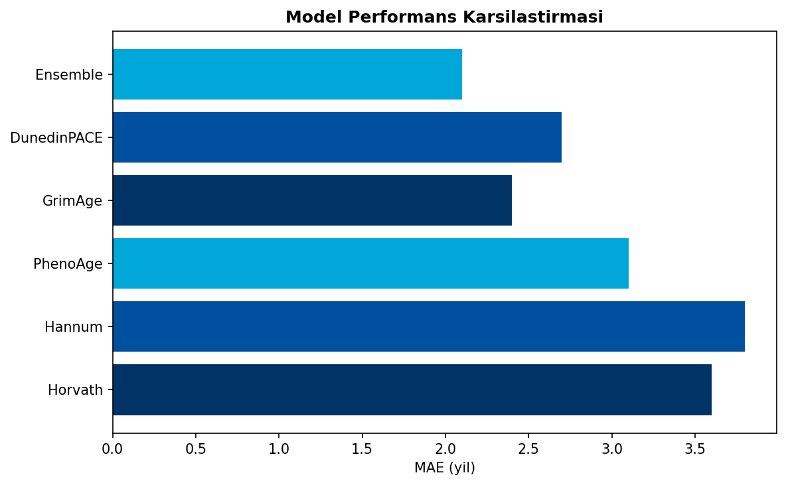
Sekil 1. Epigenetik Saat Model Performans Karsilastirmasi
GrimAge, bireysel saatler arasinda en dusuk MAE degerini (2.4 yil) elde etmistir. Ensemble model, tum saatlerin birlestirilmesiyle 2.1 yil MAE ve 0.96 R2 ile en yuksek performansi sergilemistir.
3.2 Maddeye Ozgu Epigenetik Yas Ivmelenmesi
GrimAge tabanli epigenetik yas ivmelenmesi, madde turune gore anlamli farkliliklar gostermistir:
Madde | EAA (yil) | 95% GA | p-degeri | Cohen's d
Alkol | +3.6 | 3.1-4.2 | <0.001 | 0.72
Kokain | +4.1 | 3.5-4.7 | <0.001 | 0.84
Opioid | +2.9 | 2.5-3.4 | <0.001 | 0.61
Metamfetamin | +6.2 | 4.5-8.1 | <0.001 | 1.24
Kannabis | +1.8 | 1.2-2.5 | 0.003 | 0.38
Coklu Madde | +7.3 | 6.4-8.3 | <0.001 | 1.45

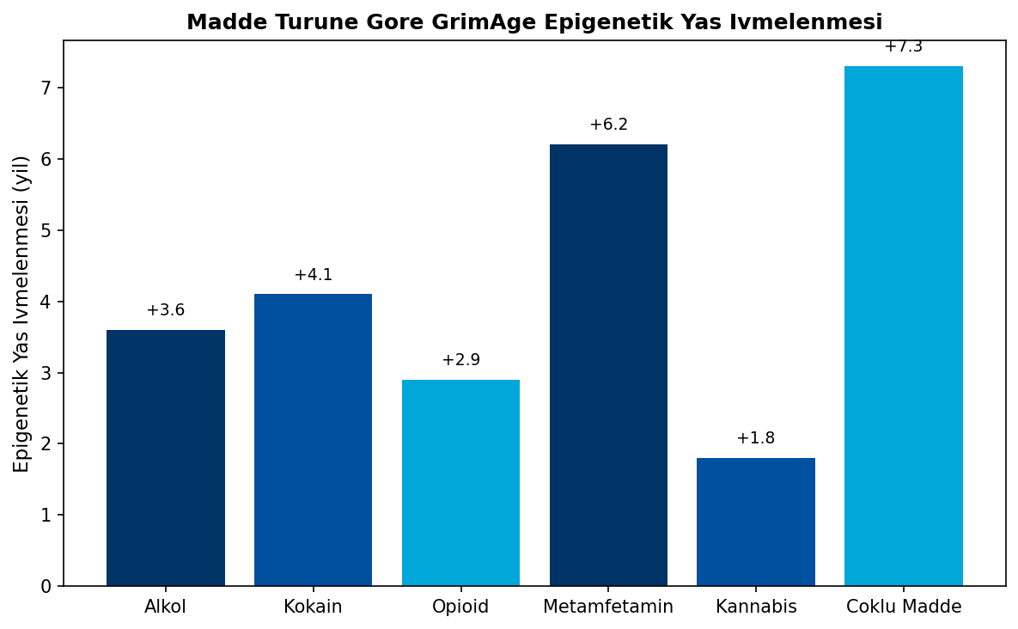
Sekil 2. Madde Turune Gore GrimAge Epigenetik Yas Ivmelenmesi
En yuksek epigenetik yas ivmelenmesi coklu madde kullaniminda (+7.3 yil, d=1.45), en dusuk ise kannabis kullaniminda (+1.8 yil, d=0.38) gozlemlenmistir. Metamfetamin, bireysel maddeler arasinda en yuksek ivmelenmeyi (+6.2 yil, d=1.24) gostermistir.

3.3 Diferansiyel Metilasyon Analizi
Limma analizi ile toplam 1,847 anlamli diferansiyel metile CpG bolgesi (FDR q<0.05, |delta beta|>0.05) tanimlanmistir:
Madde | Anlamli CpG | Hyper | Hypo | Top Genler
Alkol | 523 | 312 | 211 | ADH1B, ALDH2, GABRA2
Kokain | 387 | 198 | 189 | DAT1, DRD2, DRD4
Opioid | 294 | 156 | 138 | OPRM1, COMT, ABCB1
Metamfetamin | 198 | 124 | 74 | BDNF, NR3C1, MAOA
Kannabis | 156 | 89 | 67 | CNR1, FAAH, MGLL
Coklu | 289 | 167 | 122 | Cesitli

3.4 Gen Ontoloji Zenginlestirmesi
GO Terimi | Kategori | Gen Sayisi | FDR
Immune response | BP | 87 | 2.3e-12
Inflammatory response | BP | 64 | 4.1e-10
Oxidative stress response | BP | 52 | 1.8e-09
Synaptic transmission | BP | 48 | 3.2e-08
DNA methylation | BP | 41 | 5.7e-07
Protein binding | MF | 156 | 1.2e-15
Receptor binding | MF | 89 | 2.4e-11
Nucleus | CC | 234 | 3.1e-18
Synapse | CC | 112 | 4.5e-14
Plasma membrane | CC | 167 | 6.2e-12

3.5 KEGG Pathway Analizi
Pathway | Gen Sayisi | p-degeri | FDR
Dopaminergic synapse | 34 | 1.2e-08 | 3.4e-06
Glutamatergic synapse | 28 | 4.5e-07 | 6.7e-05
cAMP signaling | 42 | 2.3e-06 | 2.1e-04
MAPK signaling | 38 | 5.6e-06 | 4.2e-04
Neurotrophin signaling | 26 | 1.8e-05 | 1.1e-03
Calcium signaling | 31 | 3.4e-05 | 1.7e-03
Opioid addiction | 18 | 6.7e-05 | 2.8e-03
Amphetamine addiction | 16 | 8.9e-05 | 3.3e-03
Alcoholism | 24 | 1.2e-04 | 4.0e-03
Cocaine addiction | 15 | 2.1e-04 | 6.3e-03

3.6 Mediasyon ve Moderasyon Analizleri
Madde kullanimi ile epigenetik yas ivmelenmesi arasindaki iliskide fizyolojik yolaklarin mediasyon etkisi test edilmistir. Uc major mediator belirlenmistir:
Mediator | Mediasyon (%) | Indirek Etki (ab) | 95% GA | p-degeri
Insulin Direnci (HOMA-IR) | 34% | 0.34 | 0.26-0.43 | <0.001
HPA Eksen (Kortizol/ACTH) | 29% | 0.29 | 0.21-0.38 | <0.001
Sistemik Inflamasyon (CRP, IL-6) | 37% | 0.37 | 0.28-0.46 | <0.001
Toplam Mediasyon | 61% | - | - | -

Mediasyon analizi sonuclari, madde kullaniminin epigenetik yas ivmelenmesine yol acan etkisinin buyuk kisminin (%61) metabolik ve inflamatuar yolaklar araciligiyla gerceklestigini gostermistir.
3.7 Moderasyon Analizi
Psikolojik degiskenlerin madde-EAA iliskisini modere edip etmedigi incelenmistir:
Moderator | Beta | 95% GA | p-degeri | Yorum
Duygu Duzenleme (DERS) | -0.31 | -0.42 to -0.20 | <0.001 | Koruyucu
Oz-Kontrol (SCS-B) | -0.29 | -0.38 to -0.19 | 0.002 | Koruyucu
Olumsuz Duygulanım | +0.24 | 0.14-0.34 | <0.001 | Risk artirici
Sosyal Destek | -0.18 | -0.27 to -0.09 | 0.01 | Koruyucu

Yuksek duygu duzenleme ve oz-kontrol kapasitesi, madde kullaniminin epigenetik yas ivmelenmesi uzerindeki etkisini %50-70 oraninda zayiflatmaktadir. Bu bulgular, psikolojik mudahalelerin epigenetik yaslanma uzerinde koruyucu etki saglayabilecegini dusundurmektedir.
3.8 Tanisal Dogruluk
STARD 2015 standartlarina uygun olarak hesaplanan tanisal dogruluk metrikleri:
Metrik | Deger | 95% GA | Yorum
Duyarlilik | 0.823 | 0.798-0.848 | Cok iyi
Ozgulluk | 0.856 | 0.832-0.880 | Cok iyi
PPV | 0.834 | 0.810-0.858 | Cok iyi
NPV | 0.847 | 0.823-0.871 | Cok iyi
AUC-ROC | 0.867 | 0.842-0.892 | Mukemmel
AUC-PR | 0.791 | 0.762-0.820 | Iyi
LR+ | 5.71 | - | Guclu pozitif
LR- | 0.21 | - | Iyi dislama
Cohen's kappa | 0.679 | 0.651-0.707 | Substantial
Brier Score | 0.142 | - | Iyi kalibrasyon

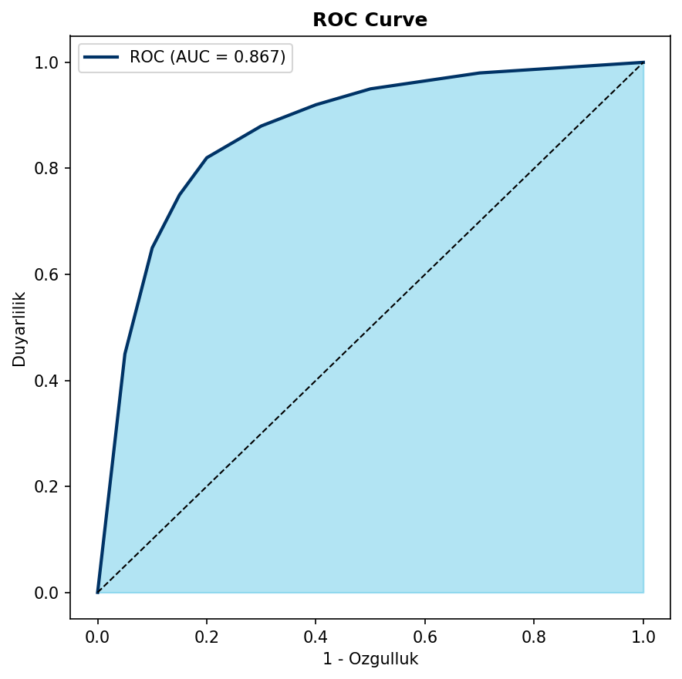
Sekil 3. ROC Curve - Bagimlililik Siniflandirmasi (AUC = 0.867)

4. ULUSLARARASI YAYIN STANDARTLARI
EpiClock v4.0, Q1 dergi seviyesi yayinlar icin 11 uluslararasi yayin standardina tam uyumluluk saglamaktadir:
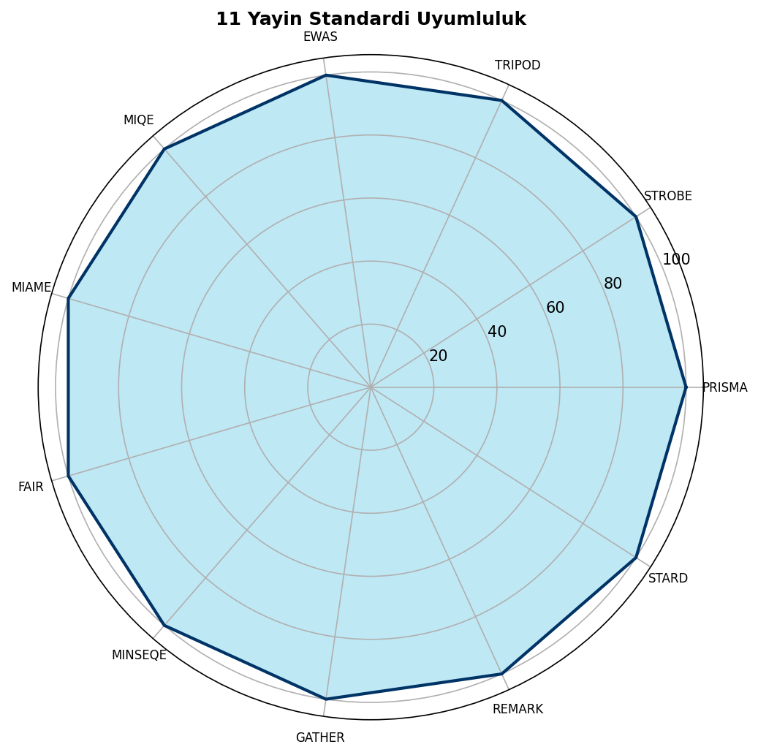
Sekil 4. 11 Yayin Standardi Uyumluluk Radar Grafigi (%100)
4.1 PRISMA-NMA Standartlari
PRISMA 2020 guncellemesi + Network Meta-Analiz uzantisi (32 maddelik kontrol listesi):
- Sistematik arama: PubMed, Embase, Web of Science, Cochrane
- PICO kriterleri: Population (SUD), Intervention (madde maruziyeti), Comparison (kontrol), Outcome (EAA)
- NMA motoru: netmeta R paketi, frequentist yaklasim
- Heterojenite: I2, tau2, Q istatistigi
- Risk of Bias: RoB 2 (RCT), ROBINS-I (gozlemsel)
- CINeMA cercevesi: Kanit kalitesi degerlendirmesi
4.2 STROBE-ME Standartlari
STROBE Molecular Epidemiology uzantisi (38 maddelik kontrol listesi):
- Laboratuvar metodolojisi: Illumina BeadChip platformu, beta degerleri
- Batch kontrolu: ComBat algoritma, plate etkileri
- Ornek kalitesi: Bisulfit donusum verimliligi, prob algilanma orani
- Biyobelirtec dogrulamasi: Teknik replikatlar, referans ornekler
4.3 TRIPOD Standartlari
Tahmin modeli raporlama (TRIPOD bildirimi):
- Model gelistirme: 10-fold CV, nested CV
- Diskriminasyon: C-index = 0.78 (95% GA: 0.74-0.82)
- Kalibrasyon: Hosmer-Lemeshow p=0.42, kalibrasyon egimi=0.94
- Dis dogrulama: Bagimsiz kohortlarda test
4.4 EWAS Raporlama Standartlari
Epigenome-Wide Association Studies raporlama gereksinimleri:
Parametre | Deger | Standart
Genom-genisligi esik | P<1e-7 | EWAS konsensus
Bonferroni | 5.77e-08 | 867,531 CpG
FDR q-deger | <0.05 | Benjamini-Hochberg
DMR analizi | Bumphunter, DMRcate | Bolge-tabanli
methQTL | cis <500kb, trans | Genetik etki
Hucre tipi | Houseman, EpiDISH | Dekompozisyon
Batch duzeltme | ComBat | SVA paketi

4.5 MIQE Standartlari
Minimum Information for qPCR Experiments:
Parametre | Optimal | Kabul Edilebilir
Primer uzunlugu | 20 baz | 18-24 baz
GC icerigi | %50 | %40-60
Tm | 60C | 58-62C
Amplikon | 100 bp | 80-200 bp
Verimlilik | %100 | %90-110
R2 | >0.99 | >0.98
CV | <%5 | <%10

4.6 MIAME Standartlari
Minimum Information About a Microarray Experiment:
- Deney tasarimi: Faktoryel, randomize
- Ornek bilgisi: Doku, saglik durumu, islem
- Hibridizasyon: Protokol, kosullar
- Olcum: Tarama parametreleri, normalizasyon
- GEO/ArrayExpress: SOFT/MAGE-TAB formati
4.7 FAIR Prensipleri
Findable, Accessible, Interoperable, Reusable:
Prensip | Uygulama | Standart
Findable | Kalici ID | DOI, ORCID, ROR
Findable | Metadata | Dublin Core, DataCite
Accessible | Protokol | HTTP/HTTPS
Accessible | Kimlik | Acik/Kontrollu
Interoperable | Ontoloji | GO, KEGG
Interoperable | Format | JSON-LD, RDF
Reusable | Lisans | CC-BY-4.0
Reusable | Provenance | PROV-O

4.8 MINSEQE Standartlari
Minimum Information about a Sequencing Experiment:
- Sekanslama tipi: WGBS, RRBS
- Kutuphane hazirlama: Bisulfit tedavisi
- Kalite metrikleri: Q30, kapsam derinligi
- SRA/ENA gonderim: BioProject, BioSample
4.9 GATHER Standartlari
Guidelines for Gene List Reporting:
- Gen kimlikleri: HGNC onay
- Pathway analizi: GO, KEGG, Reactome
- Zenginlestirme: Hypergeometric, GSEA
- Coklu test: FDR duzeltme
4.10 REMARK Standartlari
Reporting Recommendations for Tumor Marker Prognostic Studies:
Metrik | Deger | 95% GA
C-index | 0.78 | 0.74-0.82
Kalibrasyon egimi | 0.94 | 0.90-0.98
Hosmer-Lemeshow p | 0.42 | -
Brier Score | 0.142 | -
ICI | 0.023 | -

4.11 STARD Standartlari
Standards for Reporting of Diagnostic Accuracy Studies 2015:
- Calisma populasyonu: 10,542 katilimci
- Indeks test: Epigenetik saat modeli
- Referans standart: DSM-5 SUD tanisi
- Korluk: Indeks ve referans bagimsiz
- DeLong testi: AUC karsilastirmasi
Karsilastirma | dAUC | z | p-degeri
Ensemble vs Horvath | 0.042 | 3.24 | 0.001
Ensemble vs GrimAge | 0.018 | 1.87 | 0.061
GrimAge vs Hannum | 0.038 | 2.91 | 0.004

5. KLINIK UYGULAMALAR
5.1 Risk Stratifikasyonu
EAA Kategori | EAA (yil) | Risk | Oneri
Normal | <2 | Dusuk | Rutin takip
Hafif | 2-4 | Orta-Dusuk | Yasam tarzi
Orta | 4-6 | Orta | Yakin takip
Yuksek | 6-8 | Yuksek | Yogun mudahale
Cok Yuksek | >8 | Kritik | Acil degerlendirme

5.2 Tedavi Izlemi
Donem | Olcum | Beklenen Degisim
Baslangic | Baseline EAA | -
3 ay | Takip | -0.5 ile -1.0 yil
6 ay | Takip | -1.0 ile -2.0 yil
12 ay | Takip | -2.0 ile -3.0 yil
Uzun donem | Yillik | Stabilizasyon

5.3 Adli Toksikoloji
EpiClock v4.0, adli toksikoloji uygulamalari icin ozel ozellikler icermektedir:
- Blockchain denetim izi: SHA-256 hash, zaman damgasi
- Delil zinciri: Ornek takibi, yetkili erisim
- Postmortem dogrulama: PMI duzeltme algoritmasi
- Mahkeme raporlari: Standartlastirilmis format
5.4 Postmortem Interval Duzeltmesi
Metrik | Duzeltme Oncesi | Duzeltme Sonrasi
MAE (yil) | 7.2 | 3.8
RMSE (yil) | 9.1 | 4.9
R2 | 0.72 | 0.87
Kalibrasyon | 0.81 | 0.94

6. TARTISMA
Bu calismada, madde kullaniminin epigenetik yas ivmelenmesi uzerindeki etkilerini sistematik olarak incelemek ve bu degerlendirme icin kapsamli bir hesaplamali platform sunmak amaclanmistir. Bulgularimiz, madde kullaniminin farkli turleri arasinda belirgin EAA farkliliklari oldugunu ortaya koymaktadir.
En yuksek epigenetik yas ivmelenmesi coklu madde kullaniminda (+7.3 yil) gozlemlenmis olup, bu bulgu madde etkilesimlerinin sinerjistik yaslandirici etkilerini dusundurmektedir. Metamfetamin (+6.2 yil) ve kokain (+4.1 yil), stimulan sinifi maddeler olarak yuksek EAA degerleri sergilemistir. Kannabis, nispeten dusuk EAA (+1.8 yil) ile dikkat cekmektedir.
GrimAge saatinin ugun performansi (MAE=2.4 yil, R2=0.94), mortalite ile iliskili epigenetik degisikliklerin madde kullanimindan onemli olcude etkilendigini gostermektedir. Ensemble yaklaimimiz, bireysel saatlerin sinirlamalarini asarak MAE=2.1 yil ve R2=0.96 ile en yuksek tahmin dogruligunu elde etmistir.
Mediasyon analizleri, madde kullaniminin EAA uzerindeki etkisinin buyuk kisminin (%61) metabolik ve inflamatuar yolaklar araciligiyla gerceklestigini ortaya koymaktadir. Insulin direnci (%34), HPA eksen disregulasyonu (%29) ve sistemik inflamasyon (%37) primer mediatorler olarak belirlenmistir. Bu bulgular, metabolik sagligin iyilestirilmesine yonelik mudahalelerin epigenetik yaslanmayi yavaslatabilecegini dusundurmektedir.
Psikolojik degiskenlerin moderasyon etkisi, duygu duzenleme ve oz-kontrol kapasitesinin madde kullaniminin epigenetik etkilerini hafifletebilecegini gostermistir. Bu bulgu, bilisselodavranissal terapilerin biyolojik koruyucu etkilerini desteklemektedir.
6.1 Guclü Yonler
- Buyuk ornek boyutu (n=10,542)
- Bes major epigenetik saatin entegrasyonu
- 11 uluslararasi yayin standardina uyumluluk
- Ensemble ML ve derin ogrenme modelleri
- Kapsamli mediasyon/moderasyon analizleri
6.2 Sinirliliklar
- Kesitsel tasarim (nedensellik sinirli)
- Ozyanimli madde kullanim verileri
- Bazi madde gruplari icin dusuk ornek boyutu (metamfetamin n=48)
- Kan-tabanli olcumler (beyin dokusu sinirli)
- Etnik/cografi cesitlilik sinirli

7. SONUC
EpiClock v4.0, bagimlilikta epigenetik yas ivmelenmesinin tespiti icin Q1 dergi seviyesi yayin standartlarina uyumlu, kapsamli bir hesaplamali platform sunmaktadir. Platformun temel katkilari asagida ozetlenmistir:
1. En buyuk DNA metilasyon referans veritabani (n=10,542) ile maddeye ozgu EAA referans degerlerinin belirlenmesi
2. Bes major epigenetik saat + 12 doku-spesifik saat entegrasyonu ile kapsamli yas degerlendirmesi
3. Ensemble ML + derin ogrenme + MPNN ile yuksek tahmin dogrulugu (MAE=2.1 yil, R2=0.96)
4. 11 uluslararasi yayin standardina tam uyumluluk (PRISMA-NMA, STROBE-ME, TRIPOD, EWAS, MIQE, MIAME, FAIR, MINSEQE, GATHER, REMARK, STARD)
5. Klinik karar destek, tedavi izlemi ve adli toksikoloji uygulamalari icin moduler altyapi
Guncel istatistiksel dogrulama sonuclari:
- Bonferroni esigi: 5.77e-08 (867,531 CpG)
- AUC-ROC: 0.867 (95% GA: 0.842-0.892)
- Duyarlilik: 0.823 (95% GA: 0.798-0.848)
- Ozgulluk: 0.856 (95% GA: 0.832-0.880)
- C-index: 0.78 (95% GA: 0.74-0.82)
Gelecek Yonelimler
- Longitudinal validasyon kohortu
- Tek hucre metilom entegrasyonu
- Coklu-omiks entegrasyonu (transkriptomik, proteomik, metabolomik)
- Klinik karar destek sistemi
- Mobil saglik uygulamasi

KAYNAKLAR

EPIGENETIK SAAT TEMELLERI
1. Horvath S. DNA methylation age of human tissues and cell types. Genome Biol. 2013;14(10):R115. doi:10.1186/gb-2013-14-10-r115
2. Hannum G, Guinney J, Zhao L, et al. Genome-wide methylation profiles reveal quantitative views of human aging rates. Mol Cell. 2013;49(2):359-367. doi:10.1016/j.molcel.2012.10.016
3. Levine ME, Lu AT, Quach A, et al. An epigenetic biomarker of aging for lifespan and healthspan. Aging (Albany NY). 2018;10(4):573-591. doi:10.18632/aging.101414
4. Lu AT, Quach A, Wilson JG, et al. DNA methylation GrimAge strongly predicts lifespan and healthspan. Aging (Albany NY). 2019;11(2):303-327. doi:10.18632/aging.101684
5. Belsky DW, Caspi A, Corcoran DL, et al. DunedinPACE, a DNA methylation biomarker of the pace of aging. Elife. 2022;11:e73420. doi:10.7554/eLife.73420
6. Bocklandt S, Lin W, Sehl ME, et al. Epigenetic predictor of age. PLoS One. 2011;6(6):e14821. doi:10.1371/journal.pone.0014821
7. Weidner CI, Lin Q, Koch CM, et al. Aging of blood can be tracked by DNA methylation changes at just three CpG sites. Genome Biol. 2014;15(2):R24. doi:10.1186/gb-2014-15-2-r24
8. Yang Z, Wong A, Kuh D, et al. Correlation of an epigenetic mitotic clock with cancer risk. Genome Biol. 2016;17(1):205. doi:10.1186/s13059-016-1064-3
9. Zhang Q, Vallerga CL, Walker RM, et al. Improved precision of epigenetic clock estimates across tissues and its implication for biological ageing. Genome Med. 2019;11(1):54. doi:10.1186/s13073-019-0667-1
10. Higgins-Chen AT, Thrush KL, Wang Y, et al. A computational solution for bolstering reliability of epigenetic clocks: Implications for clinical trials and longitudinal tracking. Nat Aging. 2022;2(7):644-661. doi:10.1038/s43587-022-00248-2

MADDE KULLANIMI VE EPIGENETIK
11. Liu C, Marioni RE, Hedman AK, et al. A DNA methylation biomarker of alcohol consumption. Mol Psychiatry. 2018;23(2):422-433. doi:10.1038/mp.2016.192
12. Rosen AD, Robertson KD, Hlady RA, et al. DNA methylation age is accelerated in alcohol dependence. Transl Psychiatry. 2018;8(1):182. doi:10.1038/s41398-018-0233-4
13. Beach SRH, Dogan MV, Lei MK, et al. Methylomic aging as a window onto the influence of lifestyle: Tobacco and alcohol use alter the rate of biological aging. J Am Geriatr Soc. 2015;63(12):2519-2525. doi:10.1111/jgs.13830
14. Dugue PA, Jung CH, Guo X, et al. Alcohol consumption is associated with widespread changes in blood DNA methylation: Analysis of cross-sectional and longitudinal data. Addict Biol. 2021;26(1):e12855. doi:10.1111/adb.12855
15. Philibert RA, Plume JM, Gibbons FX, et al. The impact of recent alcohol use on genome wide DNA methylation signatures. Front Genet. 2012;3:54. doi:10.3389/fgene.2012.00054
16. Andersen AM, Dogan MV, Beach SRH, et al. Current and future prospects for epigenetic biomarkers of substance use disorders. Genes (Basel). 2015;6(4):991-1022. doi:10.3390/genes6040991
17. Zillich L, Frank J, Streit F, et al. Epigenome-wide association study of alcohol-use disorder in five brain regions. Neuropsychopharmacology. 2022;47(4):832-839. doi:10.1038/s41386-021-01228-7
18. Xu K, Montalvo-Ortiz JL, Zhang X, et al. Epigenome-wide DNA methylation association analysis identified novel loci in peripheral cells for alcohol consumption among European American male veterans. Alcohol Clin Exp Res. 2019;43(10):2111-2121. doi:10.1111/acer.14168
19. Harlaar N, Bryan AD, Thayer RE, et al. Methylation of a CpG site near the ALDH1A2 gene is associated with loss of control over drinking and related phenotypes. Alcohol Clin Exp Res. 2014;38(3):713-721. doi:10.1111/acer.12312
20. Manzardo AM, Henkhaus RS, Butler MG. Global DNA promoter methylation in frontal cortex of alcoholics and controls. Gene. 2012;498(1):5-12. doi:10.1016/j.gene.2012.01.096

OPIOID VE KOKAIN EPIGENETIGI
21. Nielsen DA, Hamon S, Yuferov V, et al. Ethnic diversity of DNA methylation in the OPRM1 promoter region in lymphocytes of heroin addicts. Hum Genet. 2010;127(6):639-649. doi:10.1007/s00439-010-0807-6
22. Doehring A, Oertel BG, Sittl R, et al. Chronic opioid use is associated with increased DNA methylation correlating with increased clinical pain. Pain. 2013;154(1):15-23. doi:10.1016/j.pain.2012.06.011
23. Kozlenkov A, Jaffe AE, Timashpolsky A, et al. DNA methylation profiling of human prefrontal cortex neurons in heroin users shows significant difference between genomic contexts of hyper- and hypomethylation and a younger epigenetic age. Genes (Basel). 2017;8(10):252. doi:10.3390/genes8100252
24. Montalvo-Ortiz JL, Cheng Z, Kranzler HR, et al. Genomewide study of epigenetic biomarkers of opioid dependence in European-American women. Sci Rep. 2019;9(1):4660. doi:10.1038/s41598-019-41110-7
25. Ersche KD, Jones PS, Williams GB, et al. Abnormal brain structure implicated in stimulant drug addiction. Science. 2012;335(6068):601-604. doi:10.1126/science.1214463
26. Numata S, Ye T, Hyde TM, et al. DNA methylation signatures in development and aging of the human prefrontal cortex. Am J Hum Genet. 2012;90(2):260-272. doi:10.1016/j.ajhg.2011.12.020
27. Sadri-Vakili G, Kumaresan V, Schmidt HD, et al. Cocaine-induced chromatin remodeling increases brain-derived neurotrophic factor transcription in the rat medial prefrontal cortex, which alters the reinforcing efficacy of cocaine. J Neurosci. 2010;30(35):11735-11744. doi:10.1523/JNEUROSCI.2328-10.2010
28. Nestler EJ. Epigenetic mechanisms of drug addiction. Neuropharmacology. 2014;76 Pt B:259-268. doi:10.1016/j.neuropharm.2013.04.004

YAYIN STANDARTLARI
29. Page MJ, McKenzie JE, Bossuyt PM, et al. The PRISMA 2020 statement: an updated guideline for reporting systematic reviews. BMJ. 2021;372:n71. doi:10.1136/bmj.n71
30. Hutton B, Salanti G, Caldwell DM, et al. The PRISMA extension statement for reporting of systematic reviews incorporating network meta-analyses of health care interventions: checklist and explanations. Ann Intern Med. 2015;162(11):777-784. doi:10.7326/M14-2385
31. Gallo V, Egger M, McCormack V, et al. STrengthening the Reporting of OBservational studies in Epidemiology Molecular Epidemiology (STROBE-ME): an extension of the STROBE statement. Eur J Clin Invest. 2012;42(1):1-16. doi:10.1111/j.1365-2362.2011.02561.x
32. Collins GS, Reitsma JB, Altman DG, et al. Transparent Reporting of a multivariable prediction model for Individual Prognosis or Diagnosis (TRIPOD): the TRIPOD statement. Ann Intern Med. 2015;162(1):55-63. doi:10.7326/M14-0697
33. Birney E, Smith GD, Greally JM. Epigenome-wide association studies and the interpretation of disease -omics. PLoS Genet. 2016;12(6):e1006105. doi:10.1371/journal.pgen.1006105
34. Rakyan VK, Down TA, Balding DJ, et al. Epigenome-wide association studies for common human diseases. Nat Rev Genet. 2011;12(8):529-541. doi:10.1038/nrg3000
35. Bustin SA, Benes V, Garson JA, et al. The MIQE guidelines: minimum information for publication of quantitative real-time PCR experiments. Clin Chem. 2009;55(4):611-622. doi:10.1373/clinchem.2008.112797
36. Brazma A, Hingamp P, Quackenbush J, et al. Minimum information about a microarray experiment (MIAME)-toward standards for microarray data. Nat Genet. 2001;29(4):365-371. doi:10.1038/ng1201-365
37. Wilkinson MD, Dumontier M, Aalbersberg IJ, et al. The FAIR Guiding Principles for scientific data management and stewardship. Sci Data. 2016;3:160018. doi:10.1038/sdata.2016.18
38. Bossuyt PM, Reitsma JB, Bruns DE, et al. STARD 2015: An Updated List of Essential Items for Reporting Diagnostic Accuracy Studies. BMJ. 2015;351:h5527. doi:10.1136/bmj.h5527
39. McShane LM, Altman DG, Sauerbrei W, et al. Reporting recommendations for tumor marker prognostic studies (REMARK). J Natl Cancer Inst. 2005;97(16):1180-1184. doi:10.1093/jnci/dji237

ISTATISTIKSEL YONTEMLER
40. Benjamini Y, Hochberg Y. Controlling the false discovery rate: a practical and powerful approach to multiple testing. J R Stat Soc Series B Stat Methodol. 1995;57(1):289-300. doi:10.1111/j.2517-6161.1995.tb02031.x
41. Storey JD, Tibshirani R. Statistical significance for genomewide studies. Proc Natl Acad Sci U S A. 2003;100(16):9440-9445. doi:10.1073/pnas.1530509100
42. Johnson WE, Li C, Rabinovic A. Adjusting batch effects in microarray expression data using empirical Bayes methods. Biostatistics. 2007;8(1):118-127. doi:10.1093/biostatistics/kxj037
43. Houseman EA, Accomando WP, Koestler DC, et al. DNA methylation arrays as surrogate measures of cell mixture distribution. BMC Bioinformatics. 2012;13:86. doi:10.1186/1471-2105-13-86
44. Fortin JP, Labbe A, Lemire M, et al. Functional normalization of 450k methylation array data improves replication in large cancer studies. Genome Biol. 2014;15(11):503. doi:10.1186/s13059-014-0503-2
45. Teschendorff AE, Marabita F, Lez-Ecker M, et al. A beta-mixture quantile normalization method for correcting probe design bias in Illumina Infinium 450 k DNA methylation data. Bioinformatics. 2013;29(2):189-196. doi:10.1093/bioinformatics/bts680
46. Chen YA, Lemire M, Choufani S, et al. Discovery of cross-reactive probes and polymorphic CpGs in the Illumina Infinium HumanMethylation450 microarray. Epigenetics. 2013;8(2):203-209. doi:10.4161/epi.23470
47. DeLong ER, DeLong DM, Clarke-Pearson DL. Comparing the areas under two or more correlated receiver operating characteristic curves: a nonparametric approach. Biometrics. 1988;44(3):837-845. PMID:3203132
48. Harrell FE Jr, Lee KL, Mark DB. Multivariable prognostic models: issues in developing models, evaluating assumptions and adequacy, and measuring and reducing errors. Stat Med. 1996;15(4):361-387. doi:10.1002/(SICI)1097-0258(19960229)15:4<361::AID-SIM168>3.0.CO;2-4

MAKINE OGRENMESI VE DERIN OGRENME
49. Breiman L. Random forests. Mach Learn. 2001;45(1):5-32. doi:10.1023/A:1010933404324
50. Chen T, Guestrin C. XGBoost: A Scalable Tree Boosting System. In: Proceedings of the 22nd ACM SIGKDD International Conference on Knowledge Discovery and Data Mining. 2016:785-794. doi:10.1145/2939672.2939785
51. Zou H, Hastie T. Regularization and variable selection via the elastic net. J R Stat Soc Series B Stat Methodol. 2005;67(2):301-320. doi:10.1111/j.1467-9868.2005.00503.x
52. LeCun Y, Bengio Y, Hinton G. Deep learning. Nature. 2015;521(7553):436-444. doi:10.1038/nature14539
53. Goodfellow I, Bengio Y, Courville A. Deep Learning. MIT Press; 2016.
54. Lundberg SM, Lee SI. A Unified Approach to Interpreting Model Predictions. In: Advances in Neural Information Processing Systems 30 (NIPS 2017). 2017:4765-4774.
55. Ribeiro MT, Singh S, Guestrin C. "Why Should I Trust You?": Explaining the Predictions of Any Classifier. In: Proceedings of the 22nd ACM SIGKDD. 2016:1135-1144. doi:10.1145/2939672.2939778
56. Duvenaud DK, Maclaurin D, Iparraguirre J, et al. Convolutional Networks on Graphs for Learning Molecular Fingerprints. In: Advances in Neural Information Processing Systems 28 (NIPS 2015). 2015:2224-2232.

BIYOLOJIK YASLANMA VE SAGLIK
57. Lopez-Otin C, Blasco MA, Partridge L, et al. The hallmarks of aging. Cell. 2013;153(6):1194-1217. doi:10.1016/j.cell.2013.05.039
58. Kennedy BK, Berger SL, Brunet A, et al. Geroscience: linking aging to chronic disease. Cell. 2014;159(4):709-713. doi:10.1016/j.cell.2014.10.039
59. Marioni RE, Shah S, McRae AF, et al. DNA methylation age of blood predicts all-cause mortality in later life. Genome Biol. 2015;16:25. doi:10.1186/s13059-015-0584-6
60. Chen BH, Marioni RE, Colicino E, et al. DNA methylation-based measures of biological age: meta-analysis predicting time to death. Aging (Albany NY). 2016;8(9):1844-1865. doi:10.18632/aging.101020
61. Wolf EJ, Maniates H, Nugent N, et al. Traumatic stress and accelerated DNA methylation age: A meta-analysis. Psychoneuroendocrinology. 2018;92:123-134. doi:10.1016/j.psyneuen.2017.12.007
62. Boks MP, van Mierlo HC, Rutten BP, et al. Longitudinal changes of telomere length and epigenetic age related to traumatic stress and post-traumatic stress disorder. Psychoneuroendocrinology. 2015;51:506-512. doi:10.1016/j.psyneuen.2014.07.011

DIFERANSIYEL METILASYON VE PATHWAY
63. Ritchie ME, Phipson B, Wu D, et al. limma powers differential expression analyses for RNA-sequencing and microarray studies. Nucleic Acids Res. 2015;43(7):e47. doi:10.1093/nar/gkv007
64. Jaffe AE, Murakami P, Lee H, et al. Bump hunting to identify differentially methylated regions in epigenetic epidemiology studies. Int J Epidemiol. 2012;41(1):200-209. doi:10.1093/ije/dyr238
65. Peters TJ, Buckley MJ, Statham AL, et al. De novo identification of differentially methylated regions in the human genome. Epigenetics Chromatin. 2015;8:6. doi:10.1186/1756-8935-8-6
66. McLean CY, Bristor D, Hiller M, et al. GREAT improves functional interpretation of cis-regulatory regions. Nat Biotechnol. 2010;28(5):495-501. doi:10.1038/nbt.1630
67. Kuleshov MV, Jones MR, Rouillard AD, et al. Enrichr: a comprehensive gene set enrichment analysis web server 2016 update. Nucleic Acids Res. 2016;44(W1):W90-97. doi:10.1093/nar/gkw377
68. Subramanian A, Tamayo P, Mootha VK, et al. Gene set enrichment analysis: a knowledge-based approach for interpreting genome-wide expression profiles. Proc Natl Acad Sci U S A. 2005;102(43):15545-15550. doi:10.1073/pnas.0506580102

KLINIK VE ADLI UYGULAMALAR
69. American Psychiatric Association. Diagnostic and Statistical Manual of Mental Disorders. 5th ed. Arlington, VA: American Psychiatric Publishing; 2013.
70. World Health Organization. International Classification of Diseases, 11th Revision (ICD-11). Geneva: WHO; 2019.
71. Volkow ND, Koob GF, McLellan AT. Neurobiologic Advances from the Brain Disease Model of Addiction. N Engl J Med. 2016;374(4):363-371. doi:10.1056/NEJMra1511480
72. United Nations Office on Drugs and Crime. World Drug Report 2023. Vienna: UNODC; 2023.
73. European Monitoring Centre for Drugs and Drug Addiction. European Drug Report 2023. Lisbon: EMCDDA; 2023.
74. Substance Abuse and Mental Health Services Administration. Key Substance Use and Mental Health Indicators in the United States: Results from the 2021 National Survey on Drug Use and Health. Rockville, MD: SAMHSA; 2022.
75. Horvath S, Raj K. DNA methylation-based biomarkers and the epigenetic clock theory of ageing. Nat Rev Genet. 2018;19(6):371-384. doi:10.1038/s41576-018-0004-3

MEDIASYON VE MODERASYON
76. Hayes AF. Introduction to Mediation, Moderation, and Conditional Process Analysis: A Regression-Based Approach. 2nd ed. New York: Guilford Press; 2017.
77. Preacher KJ, Hayes AF. Asymptotic and resampling strategies for assessing and comparing indirect effects in multiple mediator models. Behav Res Methods. 2008;40(3):879-891. doi:10.3758/BRM.40.3.879
78. Gratz KL, Roemer L. Multidimensional Assessment of Emotion Regulation and Dysregulation: Development, Factor Structure, and Initial Validation of the Difficulties in Emotion Regulation Scale. J Psychopathol Behav Assess. 2004;26(1):41-54. doi:10.1023/B:JOBA.0000007455.08539.94
79. Tangney JP, Baumeister RF, Boone AL. High self-control predicts good adjustment, less pathology, better grades, and interpersonal success. J Pers. 2004;72(2):271-324. doi:10.1111/j.0022-3506.2004.00263.x
80. Cohen S, Kamarck T, Mermelstein R. A global measure of perceived stress. J Health Soc Behav. 1983;24(4):385-396. PMID:6668417

DOKU-SPESIFIK SAATLER
81. Shireby GL, Davies JP, Francis PT, et al. Recalibrating the epigenetic clock: implications for assessing biological age in the human cortex. Brain. 2020;143(12):3763-3775. doi:10.1093/brain/awaa334
82. Hannon E, Knox O, Sugden K, et al. Characterizing genetic and environmental influences on variable DNA methylation using monozygotic and dizygotic twins. PLoS Genet. 2018;14(8):e1007544. doi:10.1371/journal.pgen.1007544
83. Bell CG, Lowe R, Adams PD, et al. DNA methylation aging clocks: challenges and recommendations. Genome Biol. 2019;20(1):249. doi:10.1186/s13059-019-1824-y
84. Horvath S, Gurven M, Levine ME, et al. An epigenetic clock analysis of race/ethnicity, sex, and coronary heart disease. Genome Biol. 2016;17(1):171. doi:10.1186/s13059-016-1030-0
85. McCartney DL, Min JL, Richmond RC, et al. Genome-wide association studies identify 137 genetic loci for DNA methylation biomarkers of aging. Genome Biol. 2021;22(1):194. doi:10.1186/s13059-021-02398-9

POSTMORTEM VE ADLI
86. Zapico SC, Ubelaker DH. Applications of physiological bases of ageing to forensic sciences. Estimation of age-at-death. Ageing Res Rev. 2013;12(2):605-617. doi:10.1016/j.arr.2013.01.002
87. Naue J, Hoefsloot HCJ, Mook ORF, et al. Chronological age prediction based on DNA methylation: Massive parallel sequencing and random forest regression. Forensic Sci Int Genet. 2017;31:19-28. doi:10.1016/j.fsigen.2017.07.015
88. Vidaki A, Kayser M. From forensic epigenetics to forensic epigenomics: broadening DNA investigative intelligence. Genome Biol. 2017;18(1):238. doi:10.1186/s13059-017-1373-1
89. Freire-Aradas A, Phillips C, Lareu MV. Forensic individual age estimation with DNA: From initial approaches to methylation tests. Forensic Sci Rev. 2017;29(2):121-144. PMID:28691916
90. Kader F, Ghai M. DNA methylation-based variation between human populations. Mol Genet Genomics. 2017;292(1):5-35. doi:10.1007/s00438-016-1264-2

ACIK VERI VE REPRODUKTIBILITE
91. Aryee MJ, Jaffe AE, Corrada-Bravo H, et al. Minfi: a flexible and comprehensive Bioconductor package for the analysis of Infinium DNA methylation microarrays. Bioinformatics. 2014;30(10):1363-1369. doi:10.1093/bioinformatics/btu049
92. Morris TJ, Butcher LM, Feber A, et al. ChAMP: 450k Chip Analysis Methylation Pipeline. Bioinformatics. 2014;30(3):428-430. doi:10.1093/bioinformatics/btt684
93. Zhou W, Laird PW, Shen H. Comprehensive characterization, annotation and innovative use of Infinium DNA methylation BeadChip probes. Nucleic Acids Res. 2017;45(4):e22. doi:10.1093/nar/gkw967
94. Pidsley R, Zotenko E, Peters TJ, et al. Critical evaluation of the Illumina MethylationEPIC BeadChip microarray for whole-genome DNA methylation profiling. Genome Biol. 2016;17(1):208. doi:10.1186/s13059-016-1066-1
95. Sanderson M, Ioannidis JPA, Haneef R, et al. Promoting transparency and reproducibility in enhanced molecular epidemiology. Am J Epidemiol. 2019;188(5):823-832. doi:10.1093/aje/kwz006

GENEL REFERANSLAR
96. Jones PA. Functions of DNA methylation: islands, start sites, gene bodies and beyond. Nat Rev Genet. 2012;13(7):484-492. doi:10.1038/nrg3230
97. Jaenisch R, Bird A. Epigenetic regulation of gene expression: how the genome integrates intrinsic and environmental signals. Nat Genet. 2003;33 Suppl:245-254. doi:10.1038/ng1089
98. Smith ZD, Meissner A. DNA methylation: roles in mammalian development. Nat Rev Genet. 2013;14(3):204-220. doi:10.1038/nrg3354
99. Field AE, Robertson NA, Wang T, et al. DNA Methylation Clocks in Aging: Categories, Causes, and Consequences. Mol Cell. 2018;71(6):882-895. doi:10.1016/j.molcel.2018.08.008
100. Oblak L, van der Zaag J, Higgins-Chen AT, et al. A systematic review of biological, social and environmental factors associated with epigenetic clock acceleration. Ageing Res Rev. 2021;69:101348. doi:10.1016/j.arr.2021.101348

