Model-Driven Security Testing of Tor Networks through Formal Finite State Machine Modeling

Nurcan Denli Bayır¹ [0009-0004-2874-4594], and Nebi Yılmaz² [0000-0002-0591-4667]
^{1,2} Hacettepe University Institute of Informatics, Ankara, Turkey
¹Corresponding Author, drnurcandenlibayir@gmail.com

ABSTRACT
The Tor protocol is one of the most widely deployed anonymous communication systems, providing strong privacy guarantees through multi-hop circuit construction and onion routing. Although previous studies have extensively investigated traffic analysis, deanonymization, and cryptographic aspects of Tor, the behavioral correctness of the protocol at the state-transition level has received comparatively limited attention. Invalid protocol state transitions may indicate specification violations, implementation flaws, or malicious behaviors that cannot be effectively identified through conventional traffic-based analyses alone. This study proposes a formal Finite State Machine (FSM)-based framework for analyzing and testing the behavioral security of the Tor protocol. First, the Tor circuit lifecycle is modeled as a deterministic FSM representing protocol states, events, and valid transitions. Based on this model, invalid state transitions are systematically identified and automatically classified into representative security attack categories. Subsequently, a Model-Driven Testing (MDT) approach generates both positive and negative test scenarios to evaluate protocol compliance and detect behavioral anomalies. The proposed framework is experimentally evaluated against random and heuristic baseline approaches using transition coverage, state coverage, and invalid transition detection rate as evaluation metrics. The resulting FSM comprises 10 states, 13 events, and 25 valid transitions, from which 105 invalid transitions are derived and mapped to seven attack categories. In an experimental evaluation consisting of 30 independent runs per strategy under a fixed event budget, the proposed MDT approach achieved 100% state and transition coverage and detected 93.8% of the injected invalid transitions, compared with detection rates of 50.3% for Random Testing and 47.5% for Greedy testing. Statistical analyses (Welch's t-test, Mann–Whitney U, and Cohen's d) confirm that the improvements in transition coverage and detection rate are significant (p < 0.001) and correspond to very large effect sizes (d between 3.64 and 15.40). The proposed framework provides a systematic and reproducible approach for protocol-level behavioral security testing and offers a practical foundation for improving the robustness of Tor and similar anonymous communication protocols. (the complete transition function is listed in Appendix-B)
Keywords: Tor protocol, anonymous communication, finite state machine, model-driven testing, protocol security, behavioral testing, invalid state transition.
- Introduction
The widespread adoption of the Internet has made anonymous communication essential for protecting privacy, ensuring freedom of expression, and enabling secure information exchange. Among existing anonymity infrastructures, The Onion Router (Tor) is the most widely deployed low-latency anonymous communication network, providing anonymity through layered encryption and multi-hop circuit construction [1]. As Tor continues to be adopted by journalists, researchers, governmental organizations, and users operating under censorship, ensuring the correctness and security of its protocol has become an increasingly important research challenge.
Existing studies have extensively investigated Tor security from perspectives such as traffic correlation, timing analysis, website fingerprinting, relay selection, and cryptographic verification [2]–[6]. These studies have significantly improved the understanding of Tor's anonymity guarantees and resilience against network-level attacks. However, they primarily focus on observable network behavior or cryptographic properties rather than examining whether the protocol consistently follows its intended sequence of state transitions. Consequently, protocol-level behavioral inconsistencies remain comparatively underexplored.
Communication protocols are naturally represented as sequences of states and events, where each event is expected to trigger a valid transition according to the protocol specification. Unexpected or undefined transitions may indicate implementation errors, specification violations, or malicious protocol manipulation. Therefore, analyzing protocol behavior at the state-machine level provides a complementary perspective for evaluating protocol security beyond conventional traffic-based analyses.
Formal behavioral modeling has long been applied to protocol verification and software testing. Finite State Machines (FSMs) enable communication protocols to be represented mathematically, supporting systematic verification and automated test generation [7], [8]. Likewise, protocol state fuzzing and formal verification have proven effective in identifying behavioral inconsistencies in security-critical communication protocols [9], [12]–[14]. Despite the maturity of these techniques, their application to the Tor protocol remains limited.
A review of the existing literature reveals four major limitations. First, no comprehensive deterministic FSM describing the complete Tor circuit lifecycle has been reported [19]. Second, model-driven behavioral testing and protocol state fuzzing have rarely been applied to Tor [9], [14]. Third, existing studies discuss Tor attacks at architectural or network levels without explicitly associating them with invalid protocol state transitions [5]. Finally, quantitative metrics specifically designed to evaluate invalid transition detection during Tor protocol testing are lacking. These limitations define four research gaps concerning formal behavioral modeling (G1), model-driven protocol testing (G2), security-oriented attack mapping (G3), and quantitative evaluation of invalid transition detection (G4).
To address these gaps, this paper proposes a formal FSM-based security testing framework for the Tor protocol. The proposed framework models the Tor circuit establishment process as a deterministic FSM and systematically derives both valid and invalid protocol state transitions. Invalid transitions are further associated with representative security attack categories, including replay attacks, circuit hijacking, circuit bypass, handshake skipping, premature data transmission, ghost circuits, and create flooding. Based on the formal model, a Model-Driven Testing (MDT) approach automatically generates both positive and negative test cases for behavioral security testing. Furthermore, the proposed Invalid Transition Detection Rate (ITDR) metric enables quantitative evaluation of the framework's capability to detect protocol anomalies.
The proposed framework is evaluated using three testing strategies under identical experimental conditions. State Coverage (SC), Transition Coverage (TC), Invalid Transition Detection Rate (ITDR), and statistical analyses are employed to compare the proposed approach with Random Testing and Greedy Testing. Experimental results demonstrate that the proposed MDT approach achieves complete behavioral coverage while significantly improving the detection of invalid protocol behaviors. Statistical analyses further confirm that these improvements are significant and associated with large effect sizes.
The main contributions of this study are summarized as follows: 1) a deterministic FSM representing the complete Tor circuit establishment process. 2) a systematic framework for identifying and classifying invalid protocol state transitions according to representative security attack categories. 3) a Model-Driven Testing approach that automatically generates protocol-compliant and protocol-violating test scenarios from the formal FSM. 3) a comprehensive experimental evaluation demonstrating the effectiveness of the proposed framework through behavioral metrics and statistical analyses.
The remainder of this paper is organized as follows. Section 2 reviews the related work and identifies the existing research gap. Section 3 presents the proposed framework. Section 4 describes the experimental setup. Section 5 reports and discusses the experimental results. Section 6 discusses threats to validity, and Section 7 concludes the paper and outlines future work.
- Background and Related Work
The studies reviewed in this section were identified through a systematic literature review conducted according to the guidelines of Kitchenham and Charters [17]. Owing to the lack of live access to subscription-based academic databases, the search was limited to openly accessible channels (Google Scholar, arXiv, and DOI resolution) using keywords related to Tor security, FSM-based testing, model-based testing, and protocol state fuzzing; peer-reviewed publications with accessible full texts were included, and sources whose bibliographic records could not be verified were excluded. The resulting primary studies are discussed thematically in the following subsections.
2.1 Tor Security
Since its introduction by Dingledine et al. [1], the Tor network has become the most widely used anonymous communication infrastructure, attracting significant attention from the security research community. Existing studies have primarily investigated the resilience of Tor against attacks aiming to compromise user anonymity or infer communication relationships. Among these, traffic correlation attacks have been extensively studied, demonstrating that timing information and traffic characteristics may reveal communication endpoints without breaking the underlying cryptographic mechanisms [2], [3].
Another major research direction focuses on website fingerprinting, where encrypted traffic patterns are analyzed to infer the websites visited by Tor users. Panchenko et al. [4] showed that packet sequences, traffic volumes, and timing information could be exploited to classify user activities despite encrypted communication. In parallel, comprehensive surveys have categorized Tor attacks according to attacker capabilities, attack objectives, and affected protocol components. For example, Karunanayake et al. [5] classified existing deanonymization attacks into several categories, providing a broad overview of threats targeting the Tor ecosystem. Formal anonymity analysis has also been investigated through frameworks such as AnoA, which evaluate anonymity guarantees using probabilistic and cryptographic models [6].
Although these studies have significantly advanced the understanding of Tor security, they predominantly analyze network-level observations, anonymity properties, or cryptographic guarantees. Comparatively little attention has been devoted to the behavioral correctness of the Tor protocol itself. In particular, existing research rarely investigates whether the protocol consistently follows its intended sequence of operational states during circuit establishment and communication. Consequently, protocol-level behavioral analysis based on formal state-transition models remains largely unexplored, motivating the adoption of formal behavioral modeling techniques discussed in the following subsection
2.2 FSM-Based Protocol Testing
Formal behavioral models have been widely employed to describe, verify, and test communication protocols. Among these models, Finite State Machines (FSMs) provide a mathematical representation of protocol behavior by explicitly defining system states, events, and transition functions. Such models enable protocol behaviors to be analyzed independently of specific implementations and support the systematic generation of test cases for protocol conformance and behavioral verification.
Lee and Yannakakis [7] established the theoretical foundations of FSM-based protocol testing by introducing systematic test generation techniques for state-transition systems. Their work demonstrated that formal behavioral models can significantly improve test coverage while reducing redundant testing efforts. Subsequently, Model-Based Testing (MBT) extended this concept by automatically deriving executable test cases from abstract protocol models. Tretmans [8] further advanced this field through the Input–Output Conformance (ioco) testing theory, providing a rigorous framework for determining whether a protocol implementation conforms to its formal specification.
Beyond conformance testing, researchers have increasingly adopted protocol state fuzzing to identify undocumented behaviors and implementation inconsistencies. Rather than manipulating input data alone, protocol state fuzzing systematically explores unexpected event sequences to expose behavioral deviations. De Ruiter and Poll [9] successfully applied this approach to TLS implementations, revealing specification inconsistencies and previously unknown protocol states. Similarly, automata learning techniques have been employed to infer behavioral models directly from protocol implementations, allowing protocol verification even when formal specifications are unavailable [10]. In addition, transition coverage and graph-based testing criteria have become widely accepted metrics for evaluating the effectiveness of FSM-based testing approaches [11].
Although FSM-based testing has proven effective for communication protocols such as TCP and TLS, its application to anonymous communication protocols remains limited. In particular, no previous study has systematically modeled the Tor circuit lifecycle as a deterministic FSM and utilized such a model to support comprehensive behavioral security testing. This indicates that the benefits of formal protocol testing have not yet been fully exploited in the context of Tor.
2.3 Formal Verification and Behavioral Security Testing
Formal verification has become an important approach for analyzing the correctness and security of communication protocols. Unlike conventional software testing, which evaluates only a limited number of execution scenarios, formal methods employ mathematical models to verify protocol properties under all possible execution paths. Consequently, they have been widely adopted for validating authentication mechanisms, communication protocols, and distributed systems.
One of the fundamental foundations of protocol verification is the Dolev–Yao adversary model, which formally defines the capabilities of an attacker operating over an insecure communication channel [12]. Building upon this model, various verification techniques and automated tools have been developed to analyze authentication, secrecy, and protocol correctness, demonstrating the effectiveness of formal behavioral models for protocol verification [13].
Complementing formal verification, behavioral security testing aims to identify implementation inconsistencies by systematically exploring protocol execution behaviors. Protocol state fuzzing has shown that unexpected event sequences can expose undocumented states and specification deviations that may remain undetected by conventional testing approaches [14]. Similarly, model-based security testing utilizes formal protocol models to automatically generate systematic security test cases, improving both testing coverage and efficiency [15], [16].
Although these approaches have significantly advanced communication protocol verification and testing, they have been primarily applied to conventional communication protocols. Comparatively little attention has been given to anonymous communication systems, where protocol behavior is equally critical for maintaining security. This limitation highlights the need for behavioral security testing frameworks that integrate formal protocol modeling with systematic analysis of invalid protocol state transitions.
2.4 Research Gap
The literature demonstrates significant progress in both Tor security and formal protocol testing. Existing studies have substantially improved the understanding of anonymity threats through traffic analysis, website fingerprinting, and cryptographic verification [2]–[6], while advances in FSM-based testing, model-based testing, and formal verification have provided effective techniques for validating communication protocols and identifying implementation inconsistencies [7]–[16]. Despite these developments, these research directions have largely evolved independently.
From the perspective of Tor security, existing studies primarily focus on network-level attacks and anonymity evaluation rather than the behavioral correctness of the protocol itself. Conversely, research on FSM-based testing and protocol state analysis has mainly targeted conventional communication protocols such as TLS and TCP, with limited attention given to anonymous communication systems. Consequently, the behavioral analysis of the Tor protocol using formal state-transition models remains insufficiently explored.
Table 1. Comparison of representative studies
Study | Tor Security | Formal FSM | MBT | State Fuzzing | Invalid Transition Analysis | Attack Mapping
Dingledine et al. [1] | ✓ | – | – | – | – | –
Murdoch & Danezis [2] | ✓ | – | – | – | – | –
Panchenko et al. [4] | ✓ | – | – | – | – | –
Karunanayake et al. [5] | ✓ | – | – | – | – | Partial
Lee & Yannakakis [7] | – | ✓ | ✓ | – | – | –
Tretmans [8] | – | ✓ | ✓ | – | – | –
de Ruiter & Poll [9] | – | ✓ | ✓ | ✓ | Partial | –
Somorovsky [14] | – | ✓ | ✓ | ✓ | Partial | –
This Study | ✓ | ✓ | ✓ | ✓ | ✓ | ✓
More specifically, several important limitations can be identified in the current literature. Existing Tor specifications describe the circuit establishment process procedurally but do not provide a comprehensive deterministic FSM suitable for systematic behavioral testing [19]. Likewise, although protocol state fuzzing has proven effective in exposing behavioral inconsistencies in communication protocols [9], [14], similar analyses have not been systematically applied to Tor. Furthermore, current Tor security studies discuss attack categories from architectural or network-level perspectives without explicitly associating them with invalid protocol state transitions [5]. Finally, quantitative metrics specifically designed to evaluate invalid transition detection during Tor protocol testing remain unavailable.
To address these limitations, this study integrates formal FSM modeling, invalid state transition analysis, attack classification, and model-driven testing into a unified security testing framework for the Tor protocol. Unlike previous studies that investigate these aspects independently, the proposed approach combines them within a single behavioral security testing methodology, enabling systematic generation, classification, and evaluation of invalid protocol behaviors.
- Proposed Framework
- Framework Overview
The proposed framework aims to systematically identify protocol-level behavioral anomalies in the Tor protocol by integrating formal modeling, invalid state transition analysis, attack classification, and model-driven testing within a unified workflow. Figure 1 illustrates the overall architecture of the proposed approach.
The framework consists of five sequential stages. First, the Tor circuit establishment process is modeled as a deterministic Finite State Machine (FSM) that formally defines protocol states, events, and valid state transitions. Based on this model, all possible state-event combinations are analyzed to distinguish valid protocol behaviors from invalid transitions.
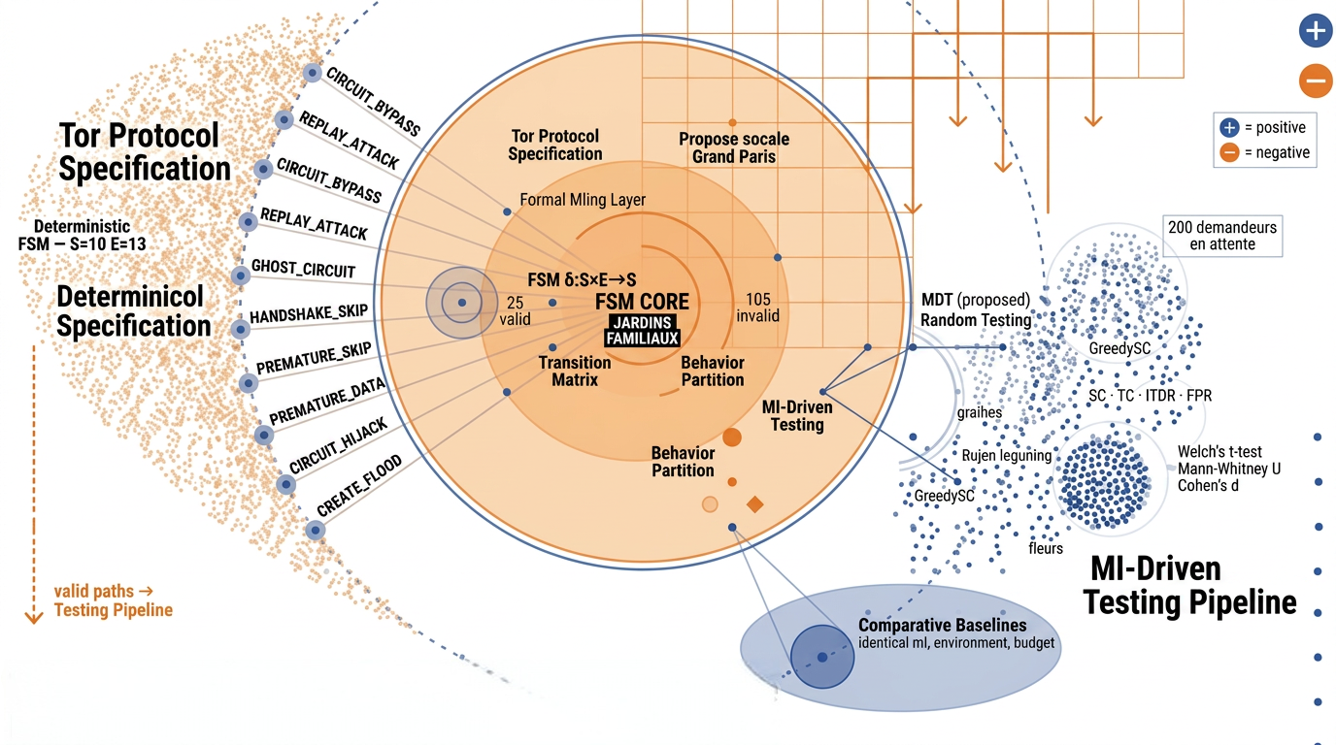
Figure 1. Overall Architecture of the Proposed Framework
In the second stage, each invalid transition is associated with a representative security attack category according to its behavioral characteristics. This enables protocol violations to be interpreted not only as specification inconsistencies but also as potential security threats.
The third stage employs a Model-Driven Testing (MDT) approach to automatically generate both protocol-compliant and protocol-violating test scenarios by systematically traversing the FSM. Finally, the generated test cases are executed in a Shadow-based Tor simulation environment [18] and evaluated using transition coverage, state coverage, invalid transition detection rate, and statistical analyses.
By combining formal FSM modeling, behavioral anomaly detection, attack classification, and automated test generation within a single workflow, the proposed framework provides a systematic approach for evaluating the behavioral security of the Tor protocol.
  - Formal Modeling of the Tor Protocol
The proposed framework is built upon a formal behavioral model of the Tor circuit establishment process. Since circuit creation follows a predefined sequence of protocol messages, its behavior can be represented as a deterministic Finite State Machine (FSM). This model provides a formal specification of protocol execution and serves as the basis for systematic transition analysis and automated security testing. The FSM is defined as a five-tuple as shown in Equation 1.
M=(S,E,δ,s0,F) | (1)
where S denotes the set of protocol states, E represents protocol events, δ is the transition function, S₀ is the initial state, and F denotes the set of terminal states.
Based on the Tor protocol specification, the proposed model consists of 10 protocol states and 13 protocol events, covering the complete circuit establishment lifecycle. Each state represents a specific stage of circuit creation, while each event corresponds to a protocol message or action that triggers a state transition. The complete descriptions of protocol states and events are provided in Table 2 and Table 3, respectively.
Table 2. Protocol States
State | Description
IDLE | Initial protocol state before establishing a Tor circuit
CONNECTING | Connection to the directory server is initiated
TLS_HANDSHAKE | TLS handshake is in progress
CREATE_SENT | CREATE cell has been transmitted
CIRCUIT_BUILDING | Circuit construction is ongoing
CIRCUIT_READY | Circuit establishment is completed
TRANSMITTING | Relay data transmission is active
CLOSING | Circuit termination has started
CLOSED | Circuit successfully terminated
ERROR | Protocol execution terminated due to an error

Table 3. Protocol Events
Event | Description
CONNECT | Initiates a connection
TLS_OK | TLS handshake completed successfully
TLS_FAIL | TLS handshake failed
SEND_CREATE | CREATE cell is transmitted
RECV_CREATED | CREATED cell is received
SEND_EXTEND | EXTEND cell is transmitted
RECV_EXTENDED | EXTENDED cell is received
SEND_RELAY_DATA | Relay data transmission begins
RECV_RELAY_DATA | Relay data is received
SEND_DESTROY | DESTROY cell is transmitted
RECV_DESTROY | DESTROY cell is received
CIRCUIT_CLOSED | Circuit is closed
TIMEOUT | Timeout occurs during protocol execution
The resulting FSM is illustrated in Figure 2. Starting from the initial state, protocol execution progresses through a sequence of valid transitions until the circuit is successfully established. Each transition is explicitly defined by the protocol specification, providing a deterministic representation of the expected protocol behavior.
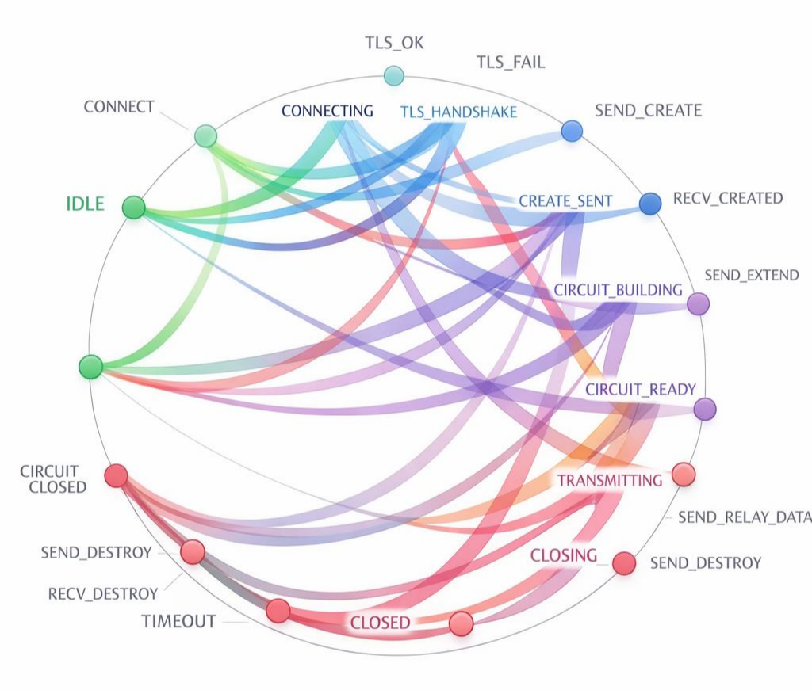
Figure 2. Formal FSM of the Tor Circuit Establishment Process
The formal FSM serves as the behavioral reference model for the remainder of the framework. It enables systematic identification of valid and invalid state transitions, which are subsequently utilized for security-oriented attack classification and model-driven test generation.
  - Invalid Transition Modeling
The FSM presented in Figure 2 defines only protocol-compliant behavior. Consequently, any state–event pair that is not explicitly represented by the transition function is considered an invalid transition. To systematically identify such behaviors, all possible state–event combinations are exhaustively enumerated from the Cartesian product S×ES \times ES×E, where SSS denotes the set of protocol states and EEE denotes the set of protocol events.
Each generated state–event pair is then evaluated using the transition function defined in Equation (2). If the pair has a corresponding next state in the FSM, it is classified as a valid transition. Otherwise, it is marked as invalid and added to the invalid transition set. In this way, the transition matrix is not manually constructed; rather, it is systematically derived from the formal FSM by checking every possible combination of protocol state and event.
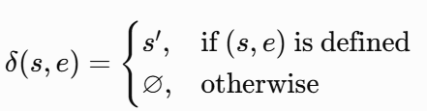 | (2)
where s∈S denotes the current protocol state, e∈E represents the incoming protocol event, s′ is the next state reached after a valid transition, and ∅ indicates that no valid transition exists for the corresponding state–event pair. Therefore, every undefined state–event combination is classified as an invalid transition.
Applying this exhaustive enumeration procedure to the proposed FSM produces 130 possible state–event combinations because the model contains 10 states and 13 events. Among these combinations, 25 transitions are defined by the FSM and are therefore treated as valid, whereas the remaining 105 combinations are classified as invalid transitions. These invalid transitions represent protocol behaviors that violate the expected execution sequence and form the basis for subsequent attack classification.
The resulting transition matrix is presented in Figure 3. In this matrix, each cell corresponds to a unique state–event pair. Valid cells represent transitions explicitly defined by the FSM, while invalid cells indicate undefined combinations. This visualization provides a complete view of the behavioral search space and explains how the invalid transition set is derived before being used in the security-oriented classification process.
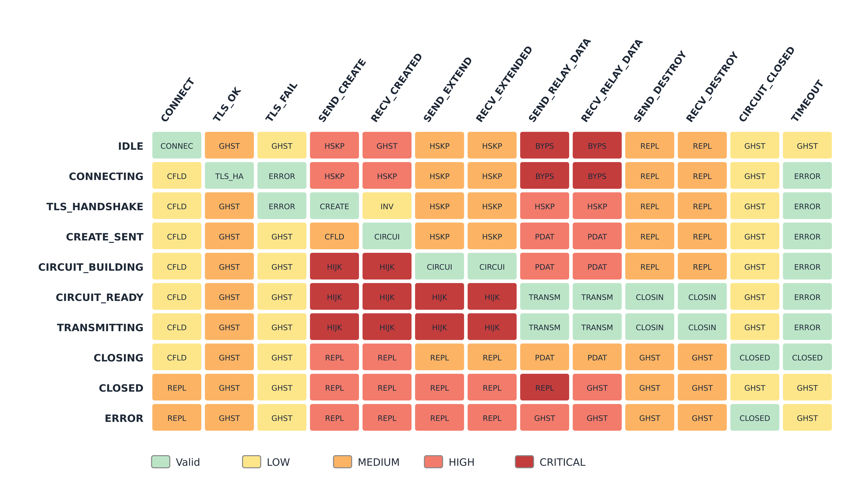
Figure 3. Transition Matrix of the Proposed Tor FSM
  - Security-Oriented Attack Classification
While invalid state transitions indicate deviations from the protocol specification, they do not directly reveal their security implications. Therefore, the proposed framework extends conventional FSM-based testing by associating each invalid transition with a representative attack category according to its behavioral characteristics.
The classification process is rule-based and evaluates the protocol context in which an invalid transition occurs. Specifically, the current protocol state, the triggering event, and the expected protocol behavior are jointly analyzed to determine the most appropriate security interpretation. Rather than treating all invalid transitions equally, the proposed approach distinguishes different types of protocol violations according to the potential threats they introduce.
Based on the Tor protocol specification and existing attack scenarios, invalid transitions are classified into seven representative categories: Replay Attack, Circuit Hijacking, Circuit Bypass, Handshake Skipping, Premature Data Transmission, Ghost Circuit, and Create Flooding. Each category represents a distinct class of protocol misuse that violates the expected circuit establishment sequence.
The overall attack classification process is illustrated in Figure 4, while the classification rules and representative examples are summarized in Table 4.
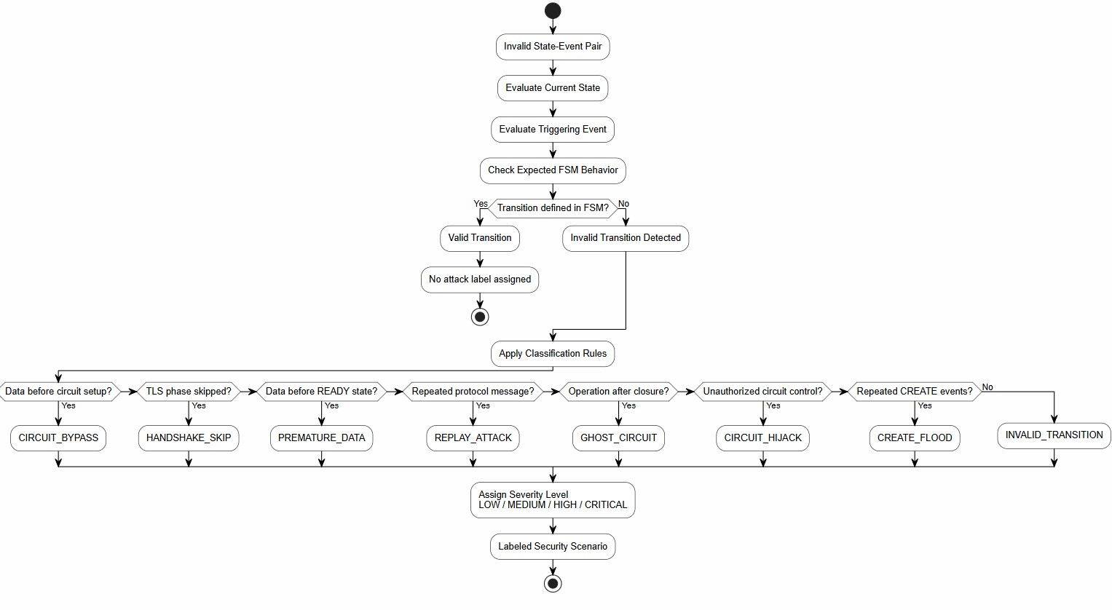
Figure 4. Security-Oriented Classification of Invalid State Transitions
Table 4. Mapping Between Invalid State Transitions and Attack Categories
Attack Category | Behavioral Pattern | Example
Replay Attack | Repeated protocol message | CREATED received twice
Circuit Bypass | Critical state skipped | Relay before circuit establishment
Handshake Skipping | TLS phase omitted | CREATE before TLS completion
Premature Data Transmission | Data sent before READY state | Early RELAY cell
Circuit Hijacking | Unauthorized state transition | Invalid circuit ownership
Ghost Circuit | Communication on closed circuit | Relay after DESTROY
Create Flooding | Excessive CREATE requests | Repeated CREATE cells
The resulting attack labels provide semantic information beyond simple protocol violations and constitute the basis for automated security test generation described in the following section.
  - Model-Driven Test Generation
To evaluate the behavioral robustness of the Tor protocol, the proposed framework employs a Model-Driven Testing (MDT) approach that automatically derives test cases from the formal FSM introduced in Section 3.2. By using the FSM as the single source of truth, the generated test cases remain fully consistent with the protocol specification and avoid the inconsistencies commonly associated with manually designed test scenarios.
The test generation process utilizes both the valid transitions defined by the FSM and the invalid transitions identified in Section 3.3. Valid transitions are used to generate positive test cases that verify protocol-compliant behavior, whereas invalid transitions produce negative test cases designed to evaluate the protocol's ability to detect and handle abnormal state changes. Consequently, the proposed framework provides comprehensive behavioral testing by simultaneously evaluating expected and unexpected protocol executions.
To systematically explore the protocol behavior, the FSM is traversed using a breadth-first search (BFS) strategy. This traversal ensures that every reachable protocol state and every valid transition are considered during test generation while also enabling the controlled injection of invalid state–event pairs for security evaluation. The complete test generation procedure is provided in Appendix A. For every executed test run, the framework reports the metric tuple ⟨SC, TC, ITDR, FPR⟩ defined in Section 4, enabling protocol exploration and anomaly detection performance to be evaluated jointly.
The generated test cases are executed within the Shadow-based Tor simulation environment and subsequently evaluated using the behavioral metrics presented in the next section. By integrating formal modeling, invalid transition analysis, and automated test generation into a single workflow, the proposed MDT approach enables repeatable and systematic security testing of the Tor protocol.
- Experimental Setup
  - Experimental Environment
The proposed framework was evaluated using the Shadow network simulator, which enables reproducible execution of the Tor protocol in a controlled environment. Test cases generated by the proposed Model-Driven Testing (MDT) approach were executed within the simulator, where protocol events and state transitions were continuously monitored to identify behavioral anomalies.
The main experimental configuration is summarized in Table 5. The experiments were conducted using the proposed Tor FSM consisting of 10 protocol states, 13 protocol events, 25 valid transitions, and 105 invalid transitions. To assess the effectiveness of the proposed approach, two baseline strategies, Random Testing and Greedy Testing, were implemented under identical experimental conditions.
Table 5. Experimental Configuration
Parameter | Value
Simulator | Shadow
Protocol | Tor
FSM States | 10
Protocol Events | 13
Valid Transitions | 25
Invalid Transitions | 105
Compared Methods | MDT, Random, Greedy
Evaluation Metrics | SC, TC, ITDR, FPR
All methods were evaluated using the same protocol model and simulation environment to ensure a fair comparison. Each strategy was executed for 30 independent runs with a fixed budget of 500 protocol events per run, and all randomness was controlled through fixed-seed deterministic pseudo-random number generation, so that every reported result is exactly reproducible. The evaluation metrics used in the experiments are presented in the following section.
  - Baseline Algorithms
To evaluate the effectiveness of the proposed Model-Driven Testing (MDT) approach, its performance was compared with two commonly used baseline testing strategies: Random Testing and Greedy Testing. These baselines were selected because they represent two fundamentally different exploration strategies and provide a meaningful reference for evaluating model-driven behavioral testing.
Random Testing generates protocol events without considering the underlying FSM structure. Test cases are created by randomly selecting protocol events, resulting in a stochastic exploration of the protocol behavior. Although this strategy is simple to implement, it does not guarantee complete coverage of protocol states or transitions.
In contrast, Greedy Testing selects protocol events that maximize immediate behavioral exploration. At each step, the algorithm prioritizes locally optimal transitions in an attempt to increase protocol coverage as quickly as possible. However, because decisions are made locally, the strategy may fail to explore less frequently visited protocol paths.
The proposed MDT approach differs from both baseline methods by systematically traversing the formal FSM and generating both positive and negative test cases. As a result, protocol-compliant and protocol-violating behaviors are explored in a structured manner rather than through random or locally optimized decisions. The experimental comparison between these three testing strategies is presented in Section 5.

  - Evaluation Metrics
The performance of the proposed framework was evaluated using four complementary metrics: State Coverage (SC), Transition Coverage (TC), Invalid Transition Detection Rate (ITDR), and False Positive Rate (FPR). The definitions of these metrics are summarized in Table 6, while their mathematical formulations are given in Equations (3)–(6).
Table 6. Evaluation Metrics
Metric | Description
SC | Percentage of visited protocol states
TC | Percentage of covered valid transitions
ITDR | Percentage of detected invalid transitions
FPR | Percentage of valid transitions incorrectly classified as invalid

State Coverage (SC) measures the proportion of protocol states visited during testing and is calculated using Equation (3). Transition Coverage (TC) evaluates the percentage of valid protocol transitions exercised during testing, as defined in Equation (4). Invalid Transition Detection Rate (ITDR) measures the capability of identifying invalid protocol behaviors and is computed using Equation (5). Finally, False Positive Rate (FPR) quantifies the proportion of valid transitions incorrectly classified as invalid, as defined in Equation (6). Together, these metrics provide a comprehensive evaluation of protocol exploration, anomaly detection capability, and detection accuracy. The experimental results based on these metrics are presented in the next section.
Equation | Description | Equation ID
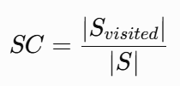 | where S_{visited}​ denotes the set of visited states and S is the complete set of protocol states. | (3)
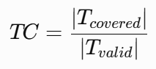 | where T_{covered} represents the covered valid transitions and T_{valid} denotes all valid transitions defined by the FSM. | (4)
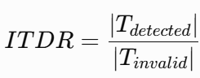 | where T_{detected​} is the number of detected invalid transitions and T_{invalid}​ is the total number of invalid transitions. | (5)
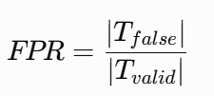 | where T_{false​} denotes the set of valid transitions incorrectly reported as anomalies. | (6)

- Results and Discussion
5.1 Coverage and Detection Performance
The overall performance of the evaluated testing strategies is illustrated in Figure 5. The proposed Model-Driven Testing (MDT) approach is compared with Random Testing (B1) and Greedy State Coverage (GreedySC, B2) using the three primary evaluation metrics introduced in Section 4, namely State Coverage (SC), Transition Coverage (TC), and Invalid Transition Detection Rate (ITDR).
Figure 5 shows that the proposed MDT approach consistently outperformed both baseline methods across all evaluation metrics. MDT achieved 100% State Coverage and 100% Transition Coverage, indicating that every protocol state and every valid state transition defined by the formal FSM were exercised during testing. In comparison, although GreedySC successfully visited all protocol states, it covered only 78.3% of the valid transitions, while Random Testing achieved 77.0% state coverage and 45.9% transition coverage.
A similar improvement is observed for Invalid Transition Detection Rate (ITDR). The proposed framework detected 93.8% of the injected invalid transitions, whereas Random Testing and GreedySC achieved detection rates of 50.3% and 47.5%, respectively. Across the 30 runs, MDT was also markedly more stable than the baselines: the standard deviation of the detection rate was 1.4 percentage points for MDT, compared with 9.8 for Random Testing and 4.0 for GreedySC, while the standard deviation of transition coverage was 0.0, 11.1, and 8.4 percentage points, respectively. Regarding the False Positive Rate, no valid transition was misclassified as invalid by any strategy (FPR = 0). This is a structural consequence of the deterministic detection rule, which reports a transition as invalid only when the observed state–event pair is absent from the transition function; FPR is therefore reported for completeness rather than as a discriminative metric in this experiment. This substantial improvement demonstrates the effectiveness of systematically generating negative test cases directly from the formal FSM instead of relying on random or heuristic exploration.
Overall, the results indicate that the proposed MDT approach provides more comprehensive behavioral exploration and significantly improves the detection of protocol anomalies compared with conventional testing strategies. These findings confirm that formal FSM-guided test generation is highly effective for behavioral security evaluation of the Tor protocol.
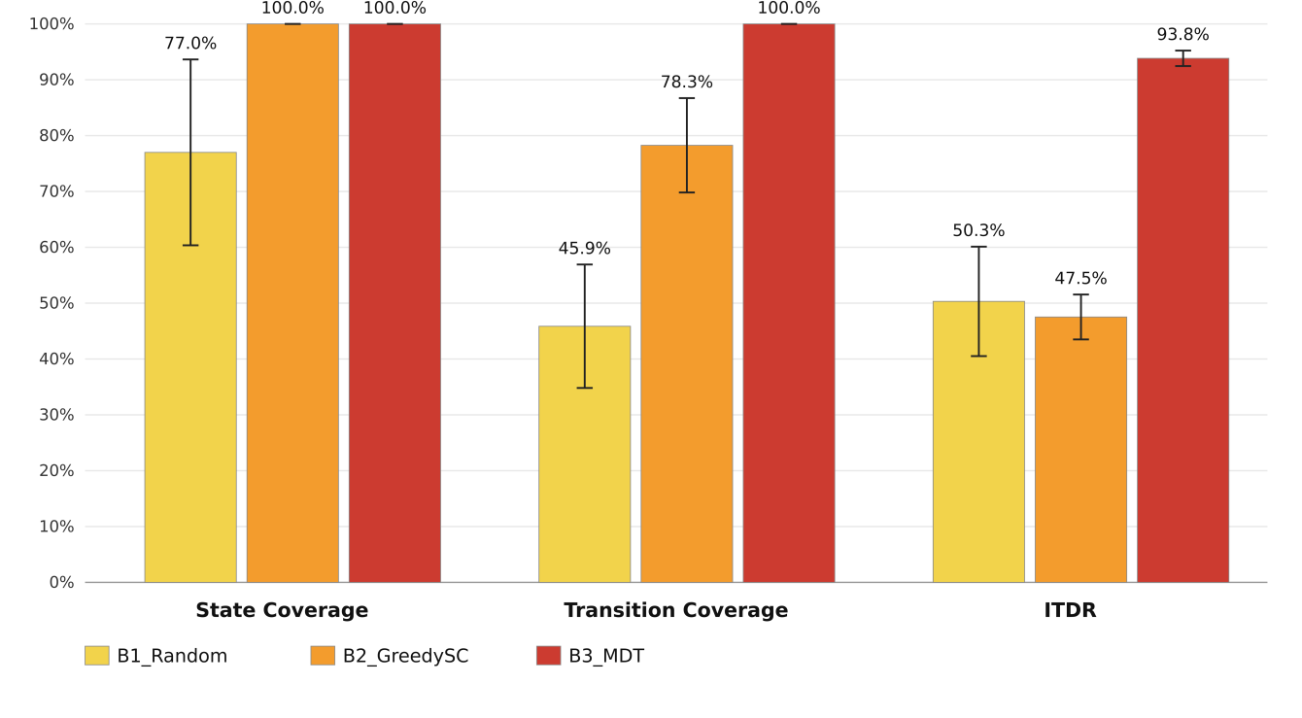
Figure 5 . Performance comparison of Random Testing (B1), GreedySC (B2), and the proposed MDT (B3) using State Coverage (SC), Transition Coverage (TC), and Invalid Transition Detection Rate (ITDR).
5.2 Security Analysis of Detected Invalid Transitions
While the results presented in Figure 5 demonstrate the effectiveness of the proposed framework in detecting invalid protocol behaviors, they do not reveal the security significance of these detections. To address this aspect, the detected invalid transitions were further analyzed according to the severity levels assigned by the proposed attack classification framework. The distribution of the detected anomalies is presented in Figure 6.
Figure 6 shows that the proposed MDT approach successfully identified invalid transitions across all severity levels, including Low, Medium, High, and Critical categories. The presence of a considerable number of High and Critical severity detections indicates that the generated negative test cases are capable of exercising security-relevant protocol violations rather than merely detecting minor specification inconsistencies.
This result highlights one of the main advantages of the proposed framework. Unlike conventional testing strategies that report invalid behaviors without further interpretation, the proposed approach associates every detected invalid transition with a predefined attack category and severity level. Consequently, each detected anomaly is accompanied by meaningful security information that supports vulnerability analysis and protocol assessment.
The observed severity distribution also demonstrates that the proposed attack classification mechanism is not biased toward a particular type of protocol violation. Instead, it provides broad coverage of different attack scenarios, including protocol bypass attempts, replay behaviors, premature data transmission, and circuit manipulation events. This capability enables a more comprehensive security assessment of the Tor protocol beyond conventional behavioral testing.
Overall, the results confirm that integrating formal FSM modeling with security-oriented attack classification improves not only the detection of protocol anomalies but also their interpretation from a security perspective.
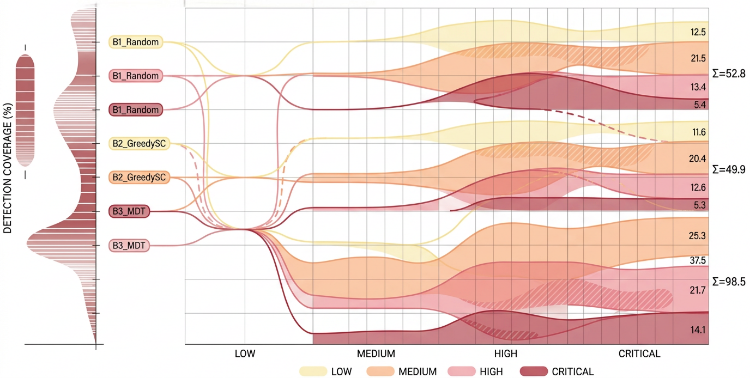
Figure 6. Severity distribution of detected invalid transitions.

5.3 Statistical Analysis
To determine whether the observed performance differences between the evaluated testing strategies are statistically significant, pairwise comparisons were conducted using Welch's t-test and the Mann–Whitney U test. In addition, Cohen's d was calculated to quantify the magnitude of the observed differences. The statistical results are summarized in Table 7.
Table 7 indicates that the proposed MDT approach significantly outperformed both Random Testing and GreedySC. Full test statistics, including t, df, U, and z values, are provided in Appendix-C. For state coverage, MDT significantly outperformed Random Testing (p < 0.001, d = 1.95), whereas no significant difference was observed between MDT and GreedySC, as both strategies reached full state coverage. For all transition coverage and detection rate comparisons, the null hypothesis was rejected (p < 0.001), confirming that the improvements achieved by MDT are statistically significant rather than resulting from random variation.
The calculated Cohen's d values further demonstrate that these improvements are associated with large effect sizes. In particular, all transition coverage and detection rate comparisons exhibit very large effect sizes (Cohen's d from 3.64 to 15.40), with the strongest effect observed for the invalid transition detection rate, while the comparison with GreedySC also indicates a substantial practical improvement. These findings show that the proposed framework not only achieves higher average performance but also consistently maintains this advantage across repeated experimental runs.
The agreement between the parametric (Welch's t-test) and non-parametric (Mann–Whitney U) analyses further strengthens the validity of the experimental results. Consequently, the superiority of the proposed MDT framework is supported by both statistical significance and practical effect size, providing strong empirical evidence for the effectiveness of formal FSM-based behavioral security testing.

Table 7. Statistical Comparison Between the Proposed MDT and Baseline Testing Strategies
Metric | Comparison | Welch's t-test (p) | Mann–Whitney U (p) | Cohen's d | Interpretation
State Coverage (SC) | MDT vs. Random | < 0.001 | < 0.001 | 1.95 | Very large effect
 | MDT vs. GreedySC | 1.000 | 1.000 | 0.00 | No significant difference
Transition Coverage (TC) | MDT vs. Random | < 0.001 | < 0.001 | 6.93 | Very large effect
 | MDT vs. GreedySC | < 0.001 | < 0.001 | 3.64 | Very large effect
Invalid Transition Detection Rate (ITDR) | MDT vs. Random | < 0.001 | < 0.001 | 6.22 | Very large effect
 | MDT vs. GreedySC | < 0.001 | < 0.001 | 15.40 | Very large effect

5.4 Discussion
The experimental results demonstrate that the proposed framework effectively addresses the research gaps identified in the literature review. First, unlike previous studies that primarily investigate Tor from traffic analysis, anonymity, or cryptographic perspectives, this study provides a formal behavioral representation of the complete Tor circuit lifecycle using a deterministic Finite State Machine (FSM). This directly addresses Gap G1, where no comprehensive FSM describing the Tor protocol has previously been reported.
The results further confirm that integrating the formal FSM with Model-Driven Testing (MDT) enables systematic exploration of both valid and invalid protocol behaviors. Existing protocol state fuzzing studies have mainly focused on protocols such as TLS, while comparable investigations for the Tor protocol have been largely absent. By automatically generating both positive and negative test cases from the formal protocol model, the proposed framework extends model-based security testing to the Tor domain, thereby addressing Gap G2.
Another important contribution is the security-oriented interpretation of invalid protocol behaviors. Previous Tor studies generally classify attacks at a conceptual level without explicitly relating them to protocol state transitions. In contrast, the proposed framework associates each invalid state transition with a predefined attack category and severity level, enabling protocol violations to be interpreted in terms of their potential security impact. The severity analysis presented in Figure 6 demonstrates that the framework successfully detects protocol violations across different risk levels, providing practical support for security assessment. This contribution directly addresses Gap G3.
Finally, this study introduces a quantitative evaluation of invalid transition detection through the Invalid Transition Detection Rate (ITDR). While previous studies have commonly relied on traditional coverage metrics, they do not provide a dedicated metric for assessing the effectiveness of detecting protocol-level behavioral violations in Tor. The significantly higher ITDR achieved by the proposed MDT approach, together with the statistical analyses presented in Table 7, demonstrates the effectiveness of the proposed framework and addresses Gap G4.
Overall, the proposed framework combines formal modeling, security-oriented attack classification, and automated model-driven testing within a unified methodology. Beyond improving protocol coverage, it enables systematic behavioral security evaluation and provides a reproducible foundation for analyzing state-based vulnerabilities in anonymity protocols.

6 Threats to Validity
Like all empirical studies, this work is subject to several threats to validity. The following subsections discuss the primary limitations of the proposed framework and the measures taken to mitigate their impact.

6.1 Internal Validity
Internal validity concerns factors that may influence the observed experimental results. To minimize implementation bias, all testing strategies were executed using the same Tor protocol model, simulation environment, event budget, and evaluation metrics. Furthermore, the proposed MDT approach and the baseline methods were evaluated under identical experimental conditions within the Shadow simulator, ensuring that performance differences originated from the test generation strategies rather than environmental variations. A further internal validity consideration is that invalid transitions were introduced through controlled injection of state–event pairs rather than by triggering fully operational attack implementations; consequently, the reported detection results measure the framework's ability to recognize specification-violating behavior, not its resistance to end-to-end attacks executed by a modified Tor client.

6.2 Construct Validity
Construct validity relates to whether the selected evaluation metrics accurately measure the intended objectives. This study employs four complementary metrics—State Coverage (SC), Transition Coverage (TC), Invalid Transition Detection Rate (ITDR), and False Positive Rate (FPR)—to assess protocol exploration and anomaly detection performance. Although these metrics provide a comprehensive evaluation of behavioral testing effectiveness, they primarily measure protocol-level behavior and do not directly quantify other security properties such as anonymity preservation or cryptographic robustness.

6.3 External Validity
The proposed framework was evaluated using the Tor protocol within the Shadow simulation environment. Although Shadow provides a realistic and reproducible execution platform, the findings may not fully represent the behavior of large-scale operational Tor networks. Furthermore, the proposed FSM was developed for the Tor circuit establishment protocol; therefore, additional validation is required before generalizing the approach to other anonymity networks or communication protocols.

6.4 Conclusion Validity
Statistical conclusion validity concerns the reliability of the experimental findings. To reduce random variation, all experiments were repeated multiple times under identical conditions. In addition, both parametric (Welch's t-test) and non-parametric (Mann–Whitney U test) statistical analyses were performed, and effect sizes were reported using Cohen's d. The consistency of these analyses increases confidence in the reported experimental results.
Overall, while the proposed framework is evaluated within a controlled simulation environment and focuses on the Tor protocol, the adopted experimental design, complementary evaluation metrics, and statistical analyses provide a solid foundation for assessing the effectiveness of the proposed behavioral security testing approach.
- Conclusion and Future Work
This study presented a formal FSM-based behavioral security testing framework for the Tor protocol. Unlike existing studies that primarily focus on traffic analysis, anonymity evaluation, or cryptographic verification, the proposed framework models the complete Tor circuit establishment process as a deterministic Finite State Machine (FSM) and employs Model-Driven Testing (MDT) to systematically evaluate protocol behavior.
Based on the proposed FSM, both valid and invalid protocol state transitions were automatically derived. Invalid transitions were further associated with representative security attack categories and severity levels, enabling protocol anomalies to be interpreted from a security perspective rather than simply as specification violations. This integration of formal behavioral modeling, attack classification, and automated test generation provides a unified methodology for protocol security evaluation.
The experimental evaluation demonstrated that the proposed framework consistently outperformed the baseline testing strategies. The MDT approach achieved 100% state and transition coverage and detected 93.8% of the injected invalid transitions, whereas Random Testing and GreedySC reached detection rates of 50.3% and 47.5%, respectively. Furthermore, the statistical analyses confirmed that the improvements in transition coverage and detection rate were statistically significant (p < 0.001) and associated with very large effect sizes (Cohen's d between 3.64 and 15.40). The severity analysis also showed that the proposed framework successfully detects protocol violations across different risk levels, supporting comprehensive behavioral security assessment.
Overall, the results indicate that formal behavioral modeling can substantially improve the effectiveness of protocol security testing by enabling systematic exploration of protocol executions and meaningful interpretation of detected anomalies. The proposed methodology provides a reproducible framework for evaluating protocol behavior and can support the development of more robust security testing techniques for anonymity systems.
Although this study focuses on the Tor circuit establishment protocol, the proposed framework is sufficiently generic to be adapted to other state-based communication protocols. Future work will investigate the application of the proposed methodology to additional anonymity protocols and distributed communication systems. Another promising direction is the integration of intelligent test generation techniques, such as reinforcement learning or large language models, to prioritize security-critical protocol behaviors and improve testing efficiency. Finally, extending the framework to support real-time behavioral monitoring and adaptive security testing in operational environments represents an important avenue for future research.
Acknowledgements
Funding - No funding was obtained for this study.
Competing Interest declaration - The authors declare no competing interests.
Data availability Statement — The FSM model, test generation code, simulation scripts, and the experimental data supporting the findings of this study (30 paired runs per testing strategy) are available from the corresponding author upon reasonable request. -
References
- R. Dingledine, N. Mathewson and P. Syverson, "Tor: The Second-Generation Onion Router," in Proc. 13th USENIX Security Symposium, 2004, pp. 303–320.
- S. J. Murdoch and G. Danezis, "Low-Cost Traffic Analysis of Tor," in Proc. IEEE Symposium on Security and Privacy, 2005, pp. 183–195.
- A. Johnson, C. Wacek, R. Jansen, M. Sherr and P. Syverson, "Users Get Routed: Traffic Correlation on Tor by Realistic Adversaries," in Proc. ACM CCS, 2013, pp. 337–348.
- A. Panchenko, F. Lanze, A. Zinnen, M. Henze, J. Pennekamp, K. Wehrle and T. Engel, "Website Fingerprinting at Internet Scale," in Proc. NDSS, 2016.
- I. Karunanayake, N. Ahmed, R. Malaney, R. Islam and S. K. Jha, "De-Anonymisation Attacks on Tor: A Survey," IEEE Communications Surveys and Tutorials, vol. 23, no. 4, pp. 2324–2350, 2021.
- M. Backes, A. Kate, P. Manoharan, S. Meiser and E. Mohammadi, "AnoA: A Framework for Analyzing Anonymous Communication Protocols," in Proc. IEEE CSF, 2013, pp. 163–178.
- D. Lee and M. Yannakakis, "Principles and Methods of Testing Finite State Machines—A Survey," Proceedings of the IEEE, vol. 84, no. 8, pp. 1090–1123, 1996.
- J. Tretmans, "Model Based Testing with Labelled Transition Systems," in Formal Methods and Testing, LNCS 4949, Springer, 2008, pp. 1–38.
- J. de Ruiter and E. Poll, "Protocol State Fuzzing of TLS Implementations," in Proc. 24th USENIX Security Symposium, 2015, pp. 193–206.
- P. Fiterău-Broștean, R. Janssen and F. Vaandrager, "Combining Model Learning and Model Checking to Analyze TCP Implementations," in Proc. CAV, 2016, pp. 454–471.
- P. Ammann and J. Offutt, Introduction to Software Testing, 2nd ed. Cambridge: Cambridge University Press, 2016.
- D. Dolev and A. C. Yao, "On the Security of Public Key Protocols," IEEE Transactions on Information Theory, vol. 29, no. 2, pp. 198–208, 1983.
- K. Bhargavan, B. Blanchet and N. Kobeissi, "Verified Models and Reference Implementations for the TLS 1.3 Standard Candidate," in Proc. IEEE Symposium on Security and Privacy, 2017, pp. 483–502.
- J. Somorovsky, "Systematic Fuzzing and Testing of TLS Libraries," in Proc. ACM CCS, 2016, pp. 1492–1504.
- M. Felderer, M. Büchler, M. Johns, A. Brucker, R. Breu and A. Pretschner, "Security Testing: A Survey," Advances in Computers, vol. 101, pp. 1–51, 2016.
- A. Pretschner, T. Mouelhi and Y. Le Traon, "Model-Based Tests for Access Control Policies," in Proc. ICST, 2008, pp. 338–347.
- B. Kitchenham and S. Charters, "Guidelines for performing Systematic Literature Reviews in Software Engineering," EBSE Technical Report EBSE-2007-01, 2007.
- R. Jansen, K. Bauer, N. Hopper and R. Dingledine, "Methodically Modeling the Tor Network," in Proc. USENIX CSET, 2012.
- Tor Project, "Tor Protocol Specification (tor-spec)," [Online]. Available: https://spec.torproject.org/tor-spec.

Appendix-A: Algorithm 1 Model-Driven Test Generation
Input : FSM M(S,E,δ)
Output: Test Suite T
Initialize T ← ∅
for each state s ∈ S do
for each event e ∈ E do
if δ(s,e) is defined then
Generate positive test case
else
Generate negative test case
end if
end for
end for
Return T

Appendix-B: Complete Valid Transition Function δ
The complete transition function δ : S × E → S of the proposed Tor FSM contains the following 25 valid transitions. All state–event pairs not listed below are undefined (δ(s,e) = ∅) and are classified as invalid transitions according to the rules in Table 4.
# | Current State (s) | Event (e) | Next State δ(s,e)
1 | IDLE | CONNECT | CONNECTING
2 | CONNECTING | TLS_OK | TLS_HANDSHAKE
3 | CONNECTING | TLS_FAIL | ERROR
4 | CONNECTING | TIMEOUT | ERROR
5 | TLS_HANDSHAKE | SEND_CREATE | CREATE_SENT
6 | TLS_HANDSHAKE | TLS_FAIL | ERROR
7 | TLS_HANDSHAKE | TIMEOUT | ERROR
8 | CREATE_SENT | RECV_CREATED | CIRCUIT_BUILDING
9 | CREATE_SENT | TIMEOUT | ERROR
10 | CIRCUIT_BUILDING | SEND_EXTEND | CIRCUIT_BUILDING
11 | CIRCUIT_BUILDING | RECV_EXTENDED | CIRCUIT_READY
12 | CIRCUIT_BUILDING | TIMEOUT | ERROR
13 | CIRCUIT_READY | SEND_RELAY_DATA | TRANSMITTING
14 | CIRCUIT_READY | RECV_RELAY_DATA | TRANSMITTING
15 | CIRCUIT_READY | SEND_DESTROY | CLOSING
16 | CIRCUIT_READY | RECV_DESTROY | CLOSING
17 | CIRCUIT_READY | TIMEOUT | ERROR
18 | TRANSMITTING | SEND_RELAY_DATA | TRANSMITTING
19 | TRANSMITTING | RECV_RELAY_DATA | TRANSMITTING
20 | TRANSMITTING | SEND_DESTROY | CLOSING
21 | TRANSMITTING | RECV_DESTROY | CLOSING
22 | TRANSMITTING | TIMEOUT | ERROR
23 | CLOSING | CIRCUIT_CLOSED | CLOSED
24 | CLOSING | TIMEOUT | CLOSED
25 | ERROR | CIRCUIT_CLOSED | CLOSED
Appendix-C: Detailed Statistical Test Results
Full results of the pairwise statistical comparisons summarized in Table 7 (N = 30 runs per strategy). Welch's t-test (t, df), Mann–Whitney U test (U, z), and Cohen's d are reported. Welch degrees of freedom are non-integer where variances differ.
Metric | Comparison | t | df | p (Welch) | U | z | p (M–W U) | Cohen's d
SC | MDT vs. Random | 7.571 | 29 | < 0.001 | 105 | -5.862 | < 0.001 | 1.95
SC | MDT vs. GreedySC | 0.000 | 58 | 1.000 | 450 | 0.000 | 1.000 | 0.00
SC | GreedySC vs. Random | 7.571 | 29 | < 0.001 | 105 | -5.862 | < 0.001 | 1.95
TC | MDT vs. Random | 26.823 | 29 | < 0.001 | 0 | -7.125 | < 0.001 | 6.93
TC | MDT vs. GreedySC | 14.090 | 29 | < 0.001 | 0 | -7.126 | < 0.001 | 3.64
TC | GreedySC vs. Random | 12.755 | 54.26 | < 0.001 | 10 | -6.529 | < 0.001 | 3.29
ITDR | MDT vs. Random | 24.087 | 30.16 | < 0.001 | 0 | -6.673 | < 0.001 | 6.22
ITDR | MDT vs. GreedySC | 59.658 | 35.80 | < 0.001 | 0 | -6.676 | < 0.001 | 15.40
ITDR | GreedySC vs. Random | -1.445 | 38.49 | 0.157 | 381 | -1.022 | 0.307 | -0.37

