Composition

NMR Metabolomics
Figure 2A in publication
print('ME dimensions')
[1] "ME dimensions"
MEconc_newlong %>% filter(!is.na(`Sample ID`)) %>% filter(!duplicated(`Sample ID`)) %>% dim
[1] 110 34
MEconc_newlong %>%ungroup %>% filter(!is.na(`Sample ID`)) %>% filter(!duplicated(Participant)) %>% dim
[1] 18 34
print('PB dimensions')
[1] "PB dimensions"
PBconc_new %>% filter(!is.na(Sample)) %>% filter(!duplicated(Sample)) %>% dim
[1] 43 90
PBconc_new %>% filter(!is.na(Sample)) %>% filter(!duplicated(Sample)) %>% filter(!duplicated(Participant)) %>% dim
[1] 18 90
df <- bind_rows(
MEconc_newlong %>%
filter(! (str_detect(met,'glycerol') | met == 'ERECTIC' | met=='TSP' | str_detect(met,'PC'))),
PBconc_newlong %>% filter(! (str_detect(met,'glycerol') | str_detect(met,'EDTA') | met == 'ERECTIC' | met=='TSP' | category=='internal signal' | str_detect(met,'PC') ))
) %>%
filter(!is.na(Participant)) %>%
group_by(Participant,Cycle,`Cycle day`,`Samples #`) %>%
# mutate(y = y / sum(y)) %>%
group_by(type,met, SigMa_class,category) %>%
dplyr::summarise(mny = sum(y)) %>%
group_by(type) %>%
dplyr::mutate(mny = mny / sum(mny)) %>%
dplyr::mutate(ypos = cumsum(mny) - 0.5*mny,
xpos = runif(n(),0.5,1.5)) %>%
ungroup()
df <- df %>% left_join(dflb, by = 'category')
df$lb <- factor(df$lb, levels = dflb$lb[1:9])

Composition
g_composition <- df %>%
ggplot(data= ., aes(x = '', y = mny,fill = lb)) +
geom_bar(stat="identity", width=1, color="white") +
coord_polar(theta ="y") +
theme_void() +
scale_fill_manual(values=dflb$color) +
facet_wrap(~type) +
guides(fill = guide_legend(nrow = 3)) +
labs(fill = NULL) +
theme(legend.position = 'bottom' )
g_composition
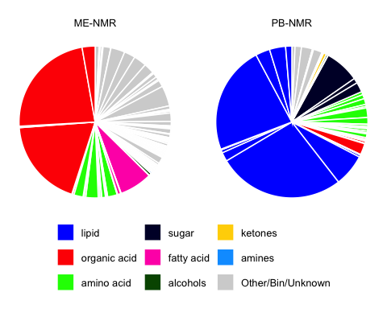

Table
df %>%
dplyr::select(type:mny,lb) %>%
spread(type,mny) %>%
reactable()
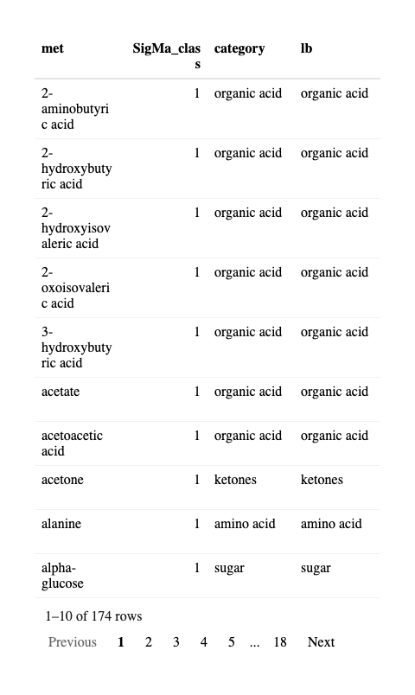
Sampling time, storage time and batch effect correction of ME-NMR data
MEconc_newlong <- MEconc_newlong %>%
mutate(Batch = ifelse(is.na(Batch),3,Batch),
`Sampling time` = ifelse(is.na(`Sampling time`),'XX',`Sampling time`),
`Storage time` = ifelse(is.na(`Storage time`),'XX',`Storage time`)) %>%
group_by(met) %>%
mutate(logy = residuals(lm(logy~factor(Batch) + factor(`Sampling time`) + factor(`Storage time`)))) %>%
ungroup
phyITSold <- phyITS
phyXold <- phyX
MEdf <- MEconc_newlong %>%
dplyr::select(`Sample ID`,`Samples #`, met, logy) %>%
spread(met,logy) %>% filter(!is.na(`Sample ID`))
MEdfsm <- phyX@sam_data %>%
data.frame() %>%
dplyr::select(BRK:Medication.during.sampling) %>%
left_join(MEdf, by = c('Sample.ID' = 'Sample ID'))
rownames(MEdfsm) <- sample_names(phyXold)
sample_data(phyITS) <- sample_data(phyX) <- sample_data(MEdfsm)
# save.image(file = '~/Dropbox/Bekzod&Isabella/Yongxin/data/QCcorrected_jan2026.Rdata')

16s

Primers
Primers for UMI16S:
Primers - Sequence
UMI_27Fa - GTCTCGTGGGCTCGGNNNNNNNNNNNNNNNAGAGTTTGATYMTGGCTYAG UMI_27Fb - GTCTCGTGGGCTCGGNNNNNNNNNNNNNNNAGGGTTCGATTCTGGCTCAG UMI_1540_R - GTCTCGTGGGCTCGGNNNNNNNNNNNNNNNTACGGYTACCTTGTTACGACT UMI_338Fa - GTCTCGTGGGCTCGGNNNNNNNNNNNNNNNACWCCTACGGGWGGCAGCAG UMI_338Fb - GTCTCGTGGGCTCGGNNNNNNNNNNNNNNNGACTCCTACGGGAGGCWGCAG UMI_1391R - GTCTCGTGGGCTCGGNNNNNNNNNNNNNNNGACGGGCGGTGTGTRCA
Sequencing depth
df_ME <- MEconc_newlong %>%
filter(!duplicated(`Samples #`))
df_descrip <- phyX@sam_data %>% data.frame()
phyX %>% subset_samples(!is.na(cycle)) %>% sample_sums() %>% summary
Min. 1st Qu. Median Mean 3rd Qu. Max.
158 12172 18628 16551 21661 26526
phyX@sam_data %>% data.frame %>% filter(!is.na(Sample.ID)) %>% filter(!duplicated(Sample.ID)) %>% dim
[1] 149 162
phyX@sam_data %>% data.frame %>% filter(!is.na(Sample.ID)) %>% filter(!duplicated(Participant)) %>% dim
[1] 19 162

Table
TAXlv <- c()
group_vars_list <- list()
for (i in 1:7){
txlv <- paste('ta',i,sep = '')
TAXlv <- c(TAXlv,txlv)
group_vars_list[[i]] <- TAXlv
}
i <- 0
phyXsummaries <- list()
for (group_vars in group_vars_list) {
i <- i+1
txlv <- paste('ta',i,sep = '')
phyXtaX <- phyX %>%
subset_samples(!is.na(Sample.ID)) %>%
transform_sample_counts(function(x) x / sum(x)) %>%
taxglom(txlv) %>%
psmelt() %>%
group_by_at(vars(one_of(group_vars))) %>%
dplyr::summarise(abu = sum(Abundance),
prevalence = sum(Abundance>0) / n()) %>%
ungroup() %>%
mutate(abu = abu/ sum(abu),
taxlevel = txlv) %>%
arrange(-abu)
phyXsummaries[[i]] <- phyXtaX
}
phyXtaX <- phyX %>%
subset_samples(!is.na(Sample.ID)) %>%
transform_sample_counts(function(x) x / sum(x)) %>%
psmelt() %>%
group_by(ta5,ta6,ta7,OTU) %>%
dplyr::summarise(abu = sum(Abundance),
prevalence = sum(Abundance>0) / n()) %>%
ungroup() %>%
mutate(abu = abu/ sum(abu),
taxlevel = 'ASV') %>%
arrange(-abu)
phyXsummaries[[8]] <- phyXtaX
fmrt <- list(
abu = colDef(format = colFormat(percent = TRUE, digits = 1)),
prevalence = colDef(format = colFormat(percent = TRUE, digits = 1))
)
phyXsummaries[[1]] %>% head %>% reactable(columns = fmrt)
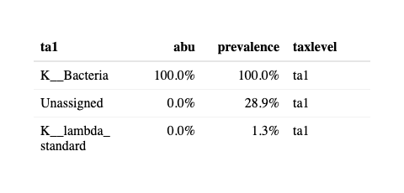
phyXsummaries[[2]] %>% head %>% reactable(columns = fmrt)
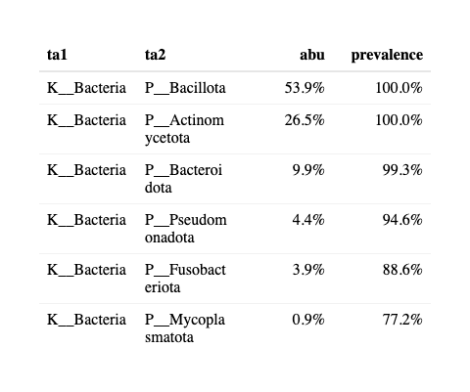
phyXsummaries[[3]] %>% head %>% reactable(columns = fmrt)
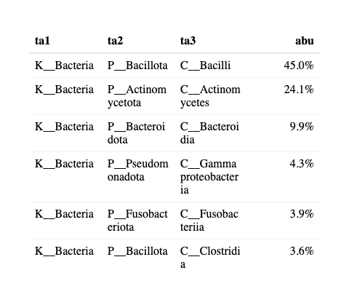
phyXsummaries[[4]] %>% head %>% reactable(columns = fmrt)
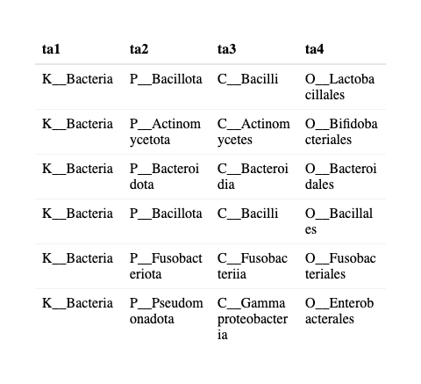
phyXsummaries[[5]] %>% dplyr::select(-ta1,-ta2) %>% head %>% reactable(columns = fmrt)
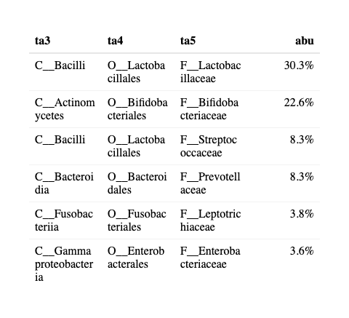
phyXsummaries[[6]] %>% dplyr::select(-ta1,-ta2,-ta3) %>% head %>% reactable(columns = fmrt)
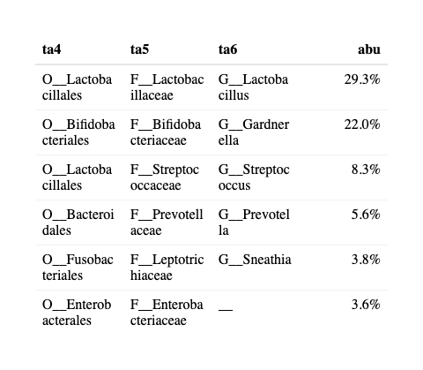
phyXsummaries[[7]] %>% dplyr::select(-ta1,-ta2,-ta3,-ta4) %>% head %>% reactable(columns = fmrt)
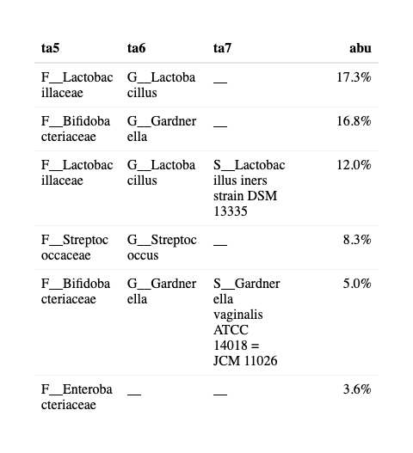
phyXsummaries[[8]] %>% head %>% reactable(columns = fmrt)
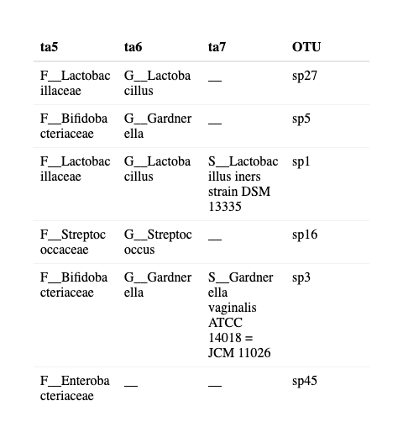

Composition

Overall distribution
Figure 2A in publication
b <- phyX %>%
subset_samples(!is.na(Sample.ID)) %>%
tax_glom('ta5') %>%
transform_sample_counts(function(x) x/ sum(x)) %>%
psmelt()
bsum <- b %>%
group_by(ta2,ta3,ta4,ta5) %>%
summarise(mn = mean(Abundance)) %>%
ungroup %>%
arrange(-mn) %>%
mutate(rnk = 1:n(),
lb = ifelse(rnk<9,substr(ta5,4,30),'Other'),
lb = factor(lb)) %>%
mutate(mny = mn / sum(mn)) %>%
mutate(ypos = cumsum(mn) - 0.5*mn,
xpos = runif(n(),0.5,1.5))
bsum$lb <- factor(bsum$lb, levels = bsum$lb[1:9])
g_composition16s <- bsum %>%
mutate(omics = 'ME-16s') %>%
ggplot(data = ., aes(x = '',y = mn, fill = lb)) +
geom_bar(stat="identity", width=1, color="white") +
coord_polar("y", start=0) +
scale_fill_manual(values=bsum16s$color) +
theme_void() +
guides(fill = guide_legend(nrow = 3)) +
labs(fill = NULL) +
# geom_text(data = bsum[1:8,], aes(x = xpos,y = ypos, label = lb), color = "black", size=3) +
theme(legend.position = 'bottom' ) +
facet_wrap(~omics)
g_composition16s
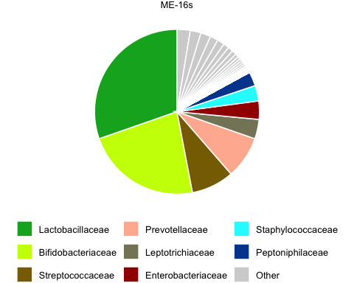

Individual distribution
otutb16s <- b %>% left_join(bsum, by = c('ta2','ta3','ta4','ta5'))
participantsort <- otutb16s %>%
filter(lb=='Lactobacillaceae') %>%
group_by(Participant) %>%
dplyr::summarise(ra = mean(Abundance)) %>%
arrange(-ra) %>%
mutate(rnk = 1:n())
g2B <- otutb16s %>%
mutate(Participant = factor(Participant, levels = participantsort$Participant)) %>%
ggplot(data = ., aes(day,Abundance, fill = lb)) +
scale_fill_manual(values=bsum16s$color) +
geom_bar(stat = 'identity',color = 'grey50') +
guides(fill = guide_legend(nrow = 1)) +
labs(fill = NULL, x = 'Day in Period') +
facet_grid(cycle~Participant , space = 'free', scales = 'free') +
theme_bw() +
theme(legend.position = 'bottom', axis.text.x = element_text(angle = 90))

ITS

Primers
Primers for ITS sequencing
ITS1 - GTCTCGTGGGCTCGGTCCGTAGGTGAACCTGCGG ITS4 - GTCTCGTGGGCTCGGTCCTCCGCTTATTGATATGC

Distribution of zero-reads
phyyITS_w <- phyITS %>% subset_samples(!is.na(cycle))
table(phyyITS_w@sam_data$Participant,sample_sums(phyyITS_w)>0)
FALSE TRUE
A 8 0
B 9 0
E 8 1
G 1 8
J 6 3
K 9 0
M 1 6
N 1 8
O 1 4
P 7 1
Q 7 2
R 9 0
S 2 6
U 9 0
V 3 1
W 7 1
X 3 5
Y 6 3
Z 3 0
Of the 19 women, 13 have at least a single sample with ITS sequences.

Sequencing depth
v <- phyITS %>% subset_samples(!is.na(cycle)) %>% sample_sums()
For all samples
summary(v)
Min. 1st Qu. Median Mean 3rd Qu. Max.
0 0 0 119 54 2116
For sample with at least one read
table(v>0)
FALSE TRUE
100 49
summary(v[v>0])
Min. 1st Qu. Median Mean 3rd Qu. Max.
12 64 178 361 504 2116

Table
TAXlv <- c()
group_vars_list <- list()
for (i in 1:7){
txlv <- paste('ta',i,sep = '')
TAXlv <- c(TAXlv,txlv)
group_vars_list[[i]] <- TAXlv
}
i <- 0
phyITSsummaries <- list()
phyITSsummaries_df <- data.frame()
for (group_vars in group_vars_list) {
i <- i+1
txlv <- paste('ta',i,sep = '')
phyITStaX <- phyITS %>%
subset_samples(!is.na(Sample.ID)) %>%
transform_sample_counts(function(x) x / sum(x + 1)) %>%
taxglom(txlv) %>%
psmelt() %>%
group_by_at(vars(one_of(group_vars))) %>%
summarise(abu = sum(Abundance),
prevalence = sum(Abundance>0) / n()) %>%
ungroup() %>%
mutate(abu = abu/ sum(abu),
taxlevel = txlv) %>%
arrange(-abu)
phyITSsummaries[[i]] <- phyITStaX
phyITSsummaries_df %>% bind_rows(phyITSsummaries_df, phyITStaX)
}
phyITStaX <- phyITS %>%
subset_samples(!is.na(Sample.ID)) %>%
transform_sample_counts(function(x) x / sum(x + 1)) %>%
psmelt() %>%
group_by(ta4,ta5,ta6,ta7,OTU) %>%
summarise(abu = sum(Abundance),
prevalence = sum(Abundance>0) / n()) %>%
ungroup() %>%
mutate(abu = abu/ sum(abu),
taxlevel = txlv) %>%
arrange(-abu)
phyITSsummaries[[8]] <- phyITStaX
phyITSsummaries[[1]] %>% head %>% reactable(columns = fmrt)
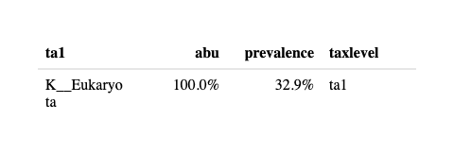
phyITSsummaries[[2]] %>% head %>% reactable(columns = fmrt)
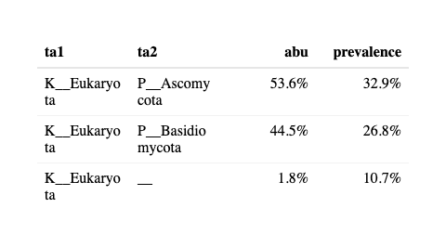
phyITSsummaries[[3]] %>% head %>% reactable(columns = fmrt)
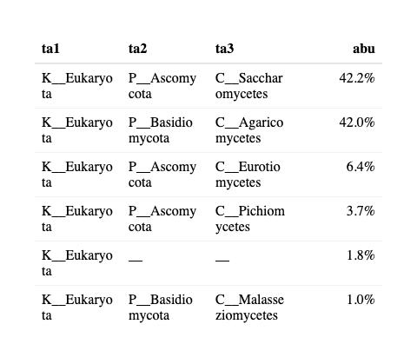
phyITSsummaries[[4]] %>% head %>% reactable(columns = fmrt)
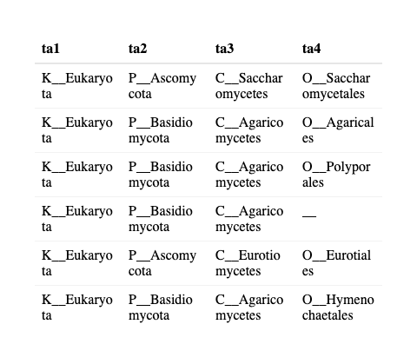
phyITSsummaries[[5]] %>% dplyr::select(-ta1,-ta2) %>% head %>% reactable(columns = fmrt)
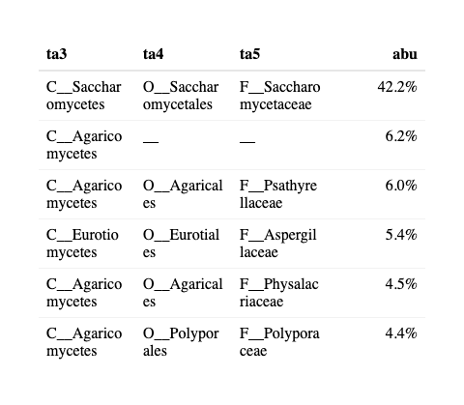
phyITSsummaries[[6]] %>% dplyr::select(-ta1,-ta2,-ta3) %>% head %>% reactable(columns = fmrt)
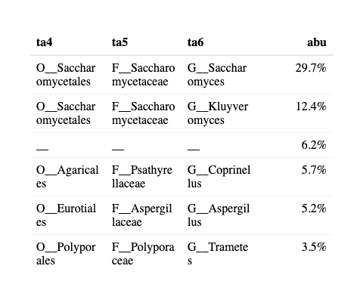
phyITSsummaries[[7]] %>% dplyr::select(-ta1,-ta2,-ta3,-ta4) %>% head %>% reactable(columns = fmrt)
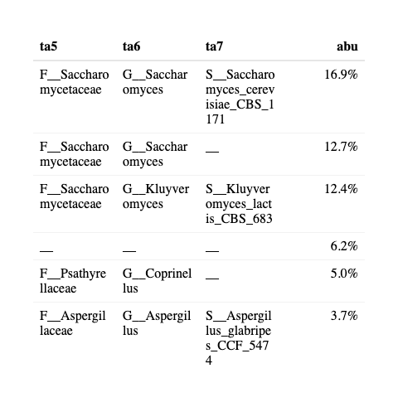
phyITSsummaries[[8]] %>% head %>% reactable(columns = fmrt)
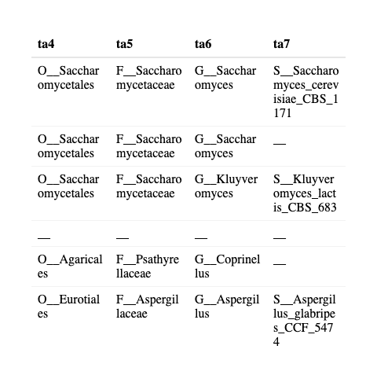

Composition

Overall distribution
Figure 2A in publication
b <- phyITS %>%
subset_samples(!is.na(Sample.ID)) %>%
tax_glom('ta5') %>%
transform_sample_counts(function(x) x/ (sum(x) + 1)) %>%
psmelt()
bsum <- b %>%
# group_by(ta6) %>%
group_by(ta3,ta4,ta5) %>%
summarise(mn = sum(Abundance)) %>%
ungroup %>%
arrange(-mn) %>%
mutate(rnk = 1:n(),
lb = ifelse(rnk<9,substr(ta5,4,30),'Other'),
lb = ifelse(is.na(lb),'Other',lb),
lb = ifelse(ta5 %in% c('F__','__'),paste('Class', substr(ta3,4,30),sep = ': '),lb)) %>%
ungroup() %>%
mutate(mn = mn / sum(mn))
bsum$lb <- factor(bsum$lb, levels = bsum$lb[1:9])
g_compositionITS <- bsum %>%
filter(!is.na(lb)) %>%
mutate(omics = 'ME-ITS') %>%
ggplot(data = ., aes(x = '',y = mn, fill = lb)) +
geom_bar(stat="identity", width=1, color="white") +
coord_polar("y", start=0) +
scale_fill_manual(values=bsumITS$color) +
theme_void() +
guides(fill = guide_legend(nrow = 3)) +
labs(fill = NULL) +
# ggrepel::geom_text_repel(data = bsum, aes(x = xpos,y = ypos, label = lb), color = "black", size=3) +
theme(legend.position = 'bottom' ) +
facet_wrap(~omics)
g_compositionITS
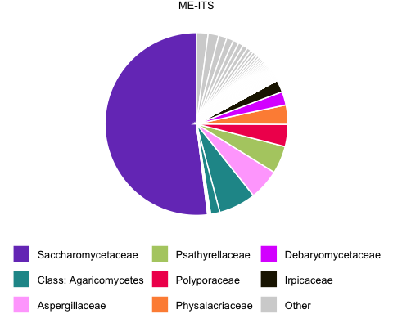

Individual distribution
library(ggpattern)
otutbITS <- b %>% left_join(bsumITS, by = c('ta3','ta4','ta5'))
participantsort <- otutbITS %>%
filter(lb == 'Saccharomycetaceae') %>%
group_by(Participant) %>%
dplyr::summarise(ra = mean(Abundance)) %>%
arrange(-ra) %>%
mutate(rnk = 1:n())
dfotutbITS <- otutbITS %>%
group_by(Participant,cycle,day,Sample.ID,lb) %>%
summarise(Abundance = sum(Abundance)) %>%
ungroup %>%
group_by(Sample.ID) %>%
mutate(Abundance = Abundance / sum(Abundance)) %>%
mutate(Participant = factor(Participant, levels = participantsort$Participant))
dfmiss <- dfotutbITS %>%
filter(is.na(Abundance)) %>%
filter(lb=='Other') %>%
mutate(Abundance = 1)
g2C <- dfotutbITS %>%
ggplot(data = ., aes(day,Abundance, fill = lb)) +
geom_bar(stat = 'identity',color = 'grey50') +
geom_bar(data = dfmiss, stat = 'identity', fill = 'yellow', alpha = 0.4, color = 'grey50') +
scale_fill_manual(values=bsumITS$color) +
labs(fill = NULL, x = 'Day in Period') +
theme_bw() +
facet_grid(cycle~Participant) +
guides(fill = guide_legend(nrow = 1)) +
theme(legend.position = 'bottom', axis.text.x = element_text(angle = 90))
g2C
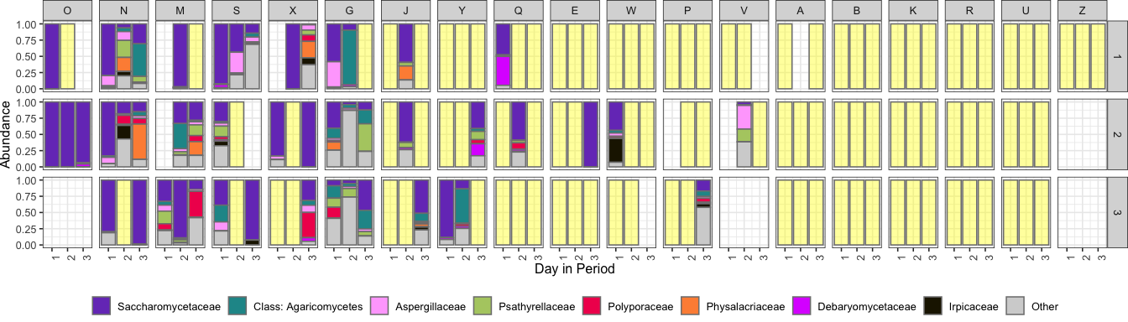

Figure 2 in publication
layout2 <- "
AABC
"
all_comp <- g_composition + g_composition16s + g_compositionITS +
plot_layout(design = layout2,guides = "collect") & theme(legend.position = 'bottom',
legend.direction = 'horizontal')
all_comp
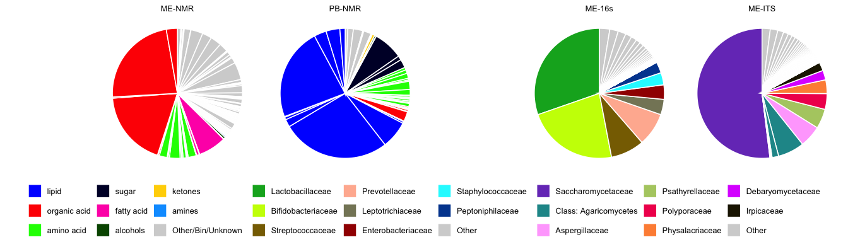
ggsave('FIG2A_composition.pdf',plot = all_comp, width = 14)
ggsave('FIG2B_16s_composition.pdf',plot = g2B, width = 14, height = 4)
ggsave('FIG2C_ITS_composition.pdf',plot = g2C, width = 14, height = 4)

Trajectories over time

ME
MEconc_newlong %>%
mutate(cycle_day = (as.numeric(Cycle)-1)*5 + `Cycle day`) %>%
ggplot(data = ., aes(cycle_day,logy, group = Participant, color = category)) +
geom_point() + geom_line() +
theme(legend.position = 'bottom') +
facet_wrap(~met, ncol = 5, scales = 'free')
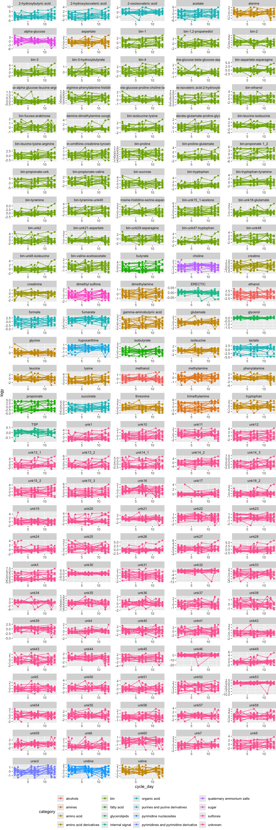

16s
otutb16s %>%
ggplot(data = ., aes(cycle_day,Abundance, group = Participant, color = lb)) +
geom_point() +
geom_line() +
scale_y_log10() +
theme(legend.position = 'bottom') +
facet_wrap(~OTU + ta5, ncol = 5)
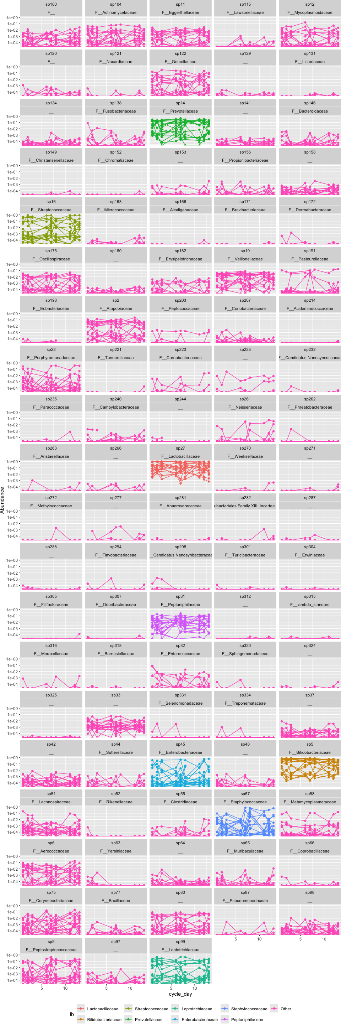

ITS
otutbITS %>%
ggplot(data = ., aes(cycle_day,Abundance, group = Participant, color = lb)) +
geom_point() +
geom_line() +
scale_y_log10() +
theme(legend.position = 'bottom') +
facet_wrap(~OTU + ta5, ncol = 5)
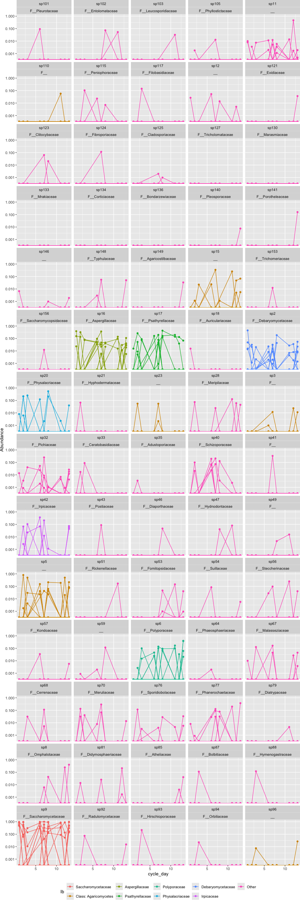

Effect of day-in-cycle

Vulcano plot
Figure 3B in publication
tidyall <- function(m0) {
r <- bind_rows(
m0 %>% anova() %>% tidy,
m0 %>% ranova() %>% tidy,
m0 %>% tidy)
return(r)
}
tidyall <- function(fit, data) {
fit@call$data <- as.data.frame(data)
bind_rows(
broom::tidy(anova(fit)) %>%
mutate(test = "fixed"),
broom::tidy(lmerTest::ranova(fit)) %>%
mutate(test = "random"),
broom.mixed::tidy(fit) %>%
mutate(test = "coefficient")
)
}
pc <- 1e-5
tb16s <- phyX %>%
subset_samples(!is.na(Sample.ID)) %>%
filter_taxa(function(x) sum(x > 0) > 4, TRUE) %>%
transform_sample_counts(function(x) x / sum(x)) %>%
psmelt() %>%
as.data.frame() %>%
mutate(lograbu = log(Abundance + pc)) %>%
group_by(ta3, ta4, ta5, ta6, ta7, OTU) %>%
group_modify(~ {
dat <- as.data.frame(.x)
fit <- lmerTest::lmer(
lograbu ~ factor(day) +
(1 | Participant) +
(1 | cycle_part),
data = dat
)
fit@call$data <- dat
# broom::tidy(lmerTest::ranova(fit))
tidyall(fit, dat)
}) %>%
ungroup()
tbITS <- phyITS %>%
subset_samples(!is.na(Sample.ID)) %>%
filter_taxa(function(x) sum(x>0)>4, TRUE) %>%
psmelt() %>% data.frame() %>%
mutate(lograbu = log(Abundance + pc)) %>%
group_by(ta3,ta4,ta5,ta6,ta7, OTU) %>%
group_modify(~ {
dat <- as.data.frame(.x)
fit <- lmerTest::lmer(
lograbu~ factor(day) +
(1 | Participant) +
(1 | cycle_part),
data = dat
)
fit@call$data <- dat
# broom::tidy(lmerTest::ranova(fit))
tidyall(fit, dat)
}) %>%
ungroup()
mME <- MEconc_newlong %>%
mutate(cycle_part = paste(Participant, Cycle)) %>%
group_by(met,category) %>%
group_modify(~ {
dat <- as.data.frame(.x)
fit <- lmerTest::lmer(
logy~ factor(`Cycle day`) + (1|`Participant`) + (1|cycle_part),
data = dat
)
fit@call$data <- dat
tidyall(fit, dat)
}) %>%
ungroup()
mME_pool <- MEconc_newlong %>%
filter(is.na(`Sample ID`)) %>%
filter(Cycle=='O') %>%
group_by(met,category) %>%
summarise(sd(logy))
dfplot <- bind_rows(mME %>% mutate(omics = 'ME-NMR') %>%
filter(!str_detect(met,'PC')) %>%
filter(!str_detect(met,'glycerol')) %>%
filter(!str_detect(met,'TSP')) %>%
filter(!str_detect(met,'ERECTI')) %>%
left_join(dflb, by = 'category'),
tbITS %>% mutate(omics = 'ME-ITS', met = OTU) %>% left_join(bsumITS, by = c('ta3','ta4','ta5')),
tb16s %>% mutate(omics = 'ME-16s',met = OTU) %>% left_join(bsum16s, by = c('ta3','ta4','ta5'))) %>%
filter(str_detect(term,'day')) %>%
filter(!is.na(estimate)) %>%
filter(parse_number(term)==2) %>%
mutate(omics = factor(omics, levels = c('ME-NMR','ME-16s','ME-ITS')))
g_box <- dfplot %>%
ggplot(data =., aes(estimate, fill = omics)) +
geom_boxplot()+
facet_wrap(~omics, scales = 'free_x') +
scale_fill_manual(values = colorcodes, breaks = colorcodesnames) +
theme_bw() +
theme(legend.position = 'none',
strip.text = element_blank(),
strip.background = element_blank(),
axis.text.y = element_blank(),
axis.ticks.y = element_blank(),
panel.grid.major.y = element_blank(),
panel.grid.minor.y = element_blank())
g_vulc <- dfplot %>%
ggplot(data =., aes(estimate,-log10(p.value), label = met, color = lb)) +
geom_point() +
facet_wrap(~omics, scales = 'free_x') +
scale_color_manual(values = bind_rows(dflb, bsum16s,bsumITS)$color,
breaks = bind_rows(dflb, bsum16s,bsumITS)$lb) +
ggrepel::geom_text_repel(data = dfplot[dfplot$p.value<0.01,]) +
theme_bw() +
theme(legend.position = 'none', axis.title.x = element_blank(), axis.text.x = element_blank())
library(patchwork)
layout <- "
A
A
A
A
B
"
g_day2 <- g_vulc + g_box+
plot_layout(design = layout)
g_day2
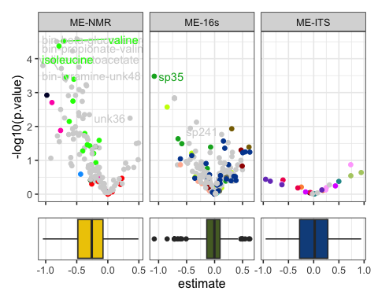
ggsave('FIG3B_vulcano.pdf',plot = g_day2, width = 8)

Tables

NMR
fmrt <- list(
# estimate = colDef(format = colFormat(scientific = TRUE, digits = 2)),
estimate = colDef(
cell = function(value) {
if (is.na(value)) return("")
formatC(value, format = "e", digits = 2)
}
),
std.error = colDef(
cell = function(value) {
if (is.na(value)) return("")
formatC(value, format = "e", digits = 2)
}
),
p.value = colDef(
cell = function(value) {
if (is.na(value)) return("")
formatC(value, format = "e", digits = 2)
}
)
)
dfplot %>%
ungroup %>%
filter(omics=='ME-NMR') %>%
filter(!duplicated(met)) %>%
arrange(p.value) %>%
dplyr::select(met,category,estimate,std.error,p.value) %>%
reactable(columns = fmrt) %>%
add_subtitle("NMR metabolomics - Effect of day 1 vs 2. Effect-sizes and inference used in the vulcano-plots, sorted by inference")
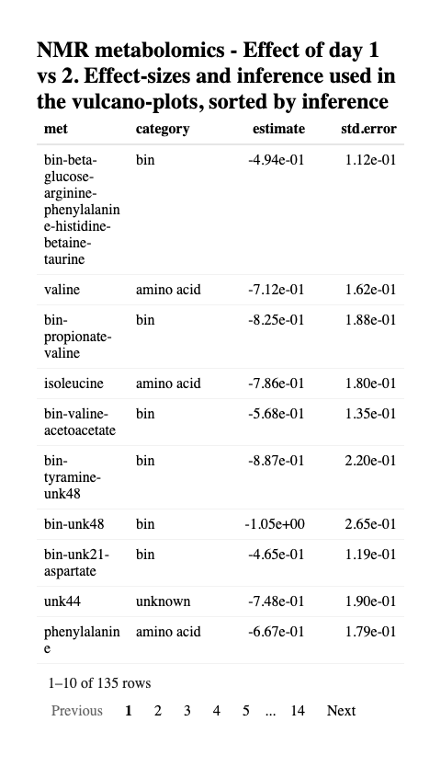

16s microbiome
dfplot %>%
ungroup %>%
filter(omics=='ME-16s') %>%
left_join(phyXsummaries[[8]], by = c('met' = 'OTU')) %>%
filter(!duplicated(met)) %>%
arrange(p.value) %>%
dplyr::select(ta4:OTU,estimate,std.error,p.value) %>%
reactable(columns = fmrt) %>%
add_subtitle("16s sequencing - Effect of day 1 vs 2. Effect-sizes and inference used in the vulcano-plots, sorted by inference")
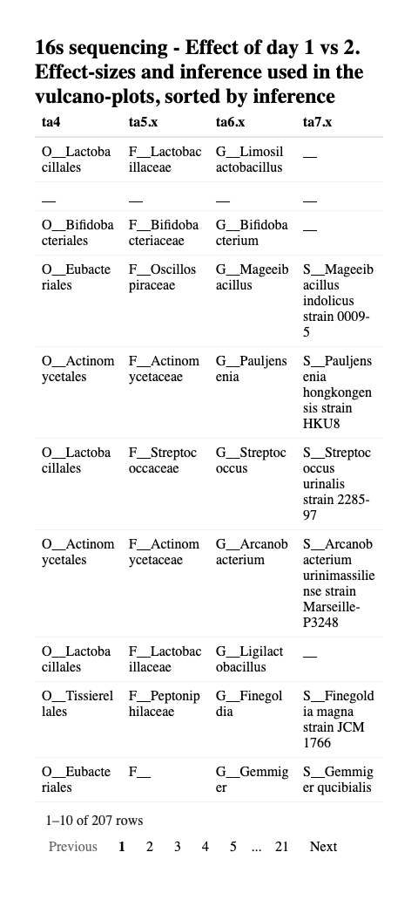

ITS Fungome
dfplot %>%
ungroup %>%
filter(omics=='ME-ITS') %>%
left_join(phyITSsummaries[[8]], by = c('met' = 'OTU')) %>%
filter(!duplicated(met)) %>%
arrange(p.value) %>%
dplyr::select(ta4.x:OTU,estimate,std.error,p.value) %>%
reactable(columns = fmrt) %>%
add_subtitle("ITS sequencing - Effect of day 1 vs 2. Effect-sizes and inference used in the vulcano-plots, sorted by inference")
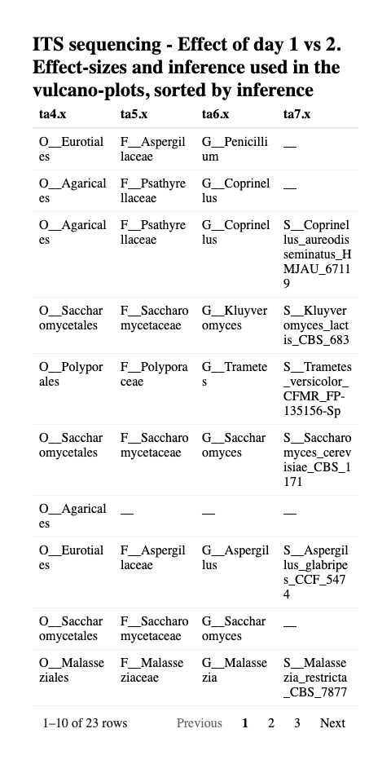

Simplex of variance partitioning
mME_pool %>%
left_join(mME %>%
mutate(omics = 'ME-NMR') %>%
filter(effect=='ran_pars') %>%
filter(str_detect(group,'Resi')),
by = c('met','category')) %>%
ggplot(data = ., aes(`sd(logy)`,estimate)) +
geom_point() + coord_equal() + geom_abline()
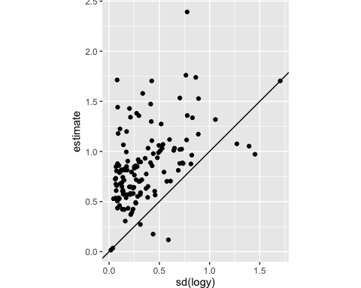

Figure 3A in publication
tbseq <- bind_rows(tbITS %>% mutate(omics = 'ME-ITS'),
tb16s %>% mutate(omics = 'ME-16s')) %>%
filter(effect=='ran_pars') %>%
dplyr::select(-p.value) %>%
dplyr::mutate(vr = estimate^2) %>%
group_by(omics,ta3,ta4,ta5,ta6,ta7,OTU) %>%
dplyr::mutate(relvr = vr / sum(vr))
tbME <- mME %>%
mutate(omics = 'ME-NMR') %>%
filter(effect=='ran_pars') %>%
dplyr::select(-p.value) %>%
group_by(met,category) %>%
dplyr::mutate(vr = estimate^2,
relvr = vr / sum(vr))
brks <- c(0,0.33,0.67,1.00)
gSIMPLX_ME <- tbseq %>%
dplyr::select(omics,group,relvr) %>%
spread(group,relvr) %>%
left_join(bind_rows(bsum16s,bsumITS), by = 'ta5') %>%
bind_rows(
tbME %>% filter(!str_detect(met,'PC')) %>%
dplyr::select(omics,group,relvr) %>%
spread(group,relvr) %>% left_join(dflb, by = 'category') ) %>%
mutate(cycle_part = ifelse(cycle_part==0,0.02,cycle_part),
Participant = Participant /(Participant + cycle_part + Residual),
Residual = Residual /(Participant + cycle_part + Residual)) %>%
ungroup %>%
mutate(omics = factor(omics, levels = c('ME-NMR','ME-16s','ME-ITS'))) %>%
ggtern(data =., aes(cycle_part, Participant, Residual, color = lb)) +
geom_point() +
scale_T_continuous(breaks = brks) +
scale_L_continuous(breaks = brks) +
scale_R_continuous(breaks = brks) +
scale_color_manual(values = bind_rows(dflb,bsum16s,bsumITS)$color,
breaks = bind_rows(dflb,bsum16s,bsumITS)$lb ) +
xlab('Between Cycles') +
ylab('Between Women') +
zlab('Within Cycle') +
theme(tern.panel.background = element_rect(fill = "white"),
tern.panel.grid.major = element_line(color = "black"),
tern.axis.arrow.show = TRUE,
tern.axis.title.T = element_blank(),
tern.axis.title.L = element_blank(),
tern.axis.title.R = element_blank(),
legend.position = 'bottom') +
facet_wrap(~omics)
gSIMPLX_ME
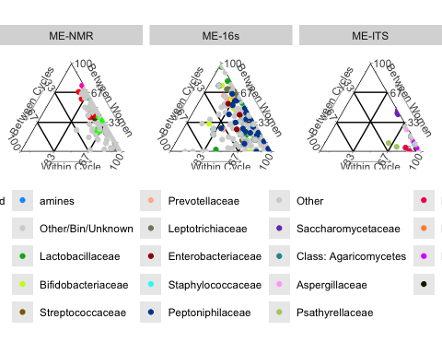
ggsave('FIG3A_simplex.pdf',plot = gSIMPLX_ME, width = 7)

