Demographics

Demographic characterization
metavars <- c("Residence","Age", "Diet", "Contraceptives", "Regular/daily medication" , "Nicotin")
metavars2 <- c("Coitus","Alcohol", "Medication during sampling")
metadata <- rio::import('~/Dropbox/Bekzod&Isabella/ME_translation_key/Metadata.xlsx', sheet = 'Samples') %>%
filter(!is.na(Residence))
dfmeta <- phyX@sam_data %>%
data.frame() %>%
filter(!is.na(Participant))
hasdata <- full_join(
data.frame(Sample.name = paste(dfmeta$Participant,dfmeta$cycle,'.',dfmeta$day, sep = ''),
has_seq = 1),
data.frame(Sample.name = paste(MEconc_newlong$Participant,MEconc_newlong$Cycle,'.',MEconc_newlong$`Cycle day`, sep = ''), has_nmr = 1) %>% filter(!duplicated(Sample.name)),
by = 'Sample.name') %>%
mutate(hasdata = ifelse(has_seq==1 | has_nmr==1,1,0))
dftb1 <- metadata %>%
filter(`Blood origen`=='ME') %>%
left_join(hasdata, by = c('Sample ID' = 'Sample.name')) %>%
group_by(Participant) %>%
mutate(n_seq = sum(has_seq, na.rm = T),
n_NMR = sum(has_nmr, na.rm = T),
Coitus_any = (sum(Coitus,na.rm = T)>0) %>% as.numeric(),
Alcohol_any = (sum(Alcohol,na.rm = T)>0) %>% as.numeric(),
Meds_any = (sum(`Medication during sampling`,na.rm = T)>0) %>% as.numeric()) %>%
filter(!duplicated(Participant)) %>%
mutate(missNMR = ifelse(n_NMR > 6,'>median_nobs','<median_nobs'),
missSeq = ifelse(n_seq ==9,'>median_nobs','<median_nobs'))
tb1 <- dftb1 %>% tableone::CreateTableOne(data = ., vars = c(metavars,'n_seq','n_NMR','Coitus_any','Alcohol_any','Meds_any'), factorVars = c(metavars, 'Coitus_any','Alcohol_any','Meds_any'))
tb1missNMR <- dftb1 %>% tableone::CreateTableOne(data = .,
strata = 'missNMR',
vars = c(metavars,'n_seq','Coitus_any','Alcohol_any','Meds_any'), factorVars = c(metavars, 'Coitus_any','Alcohol_any','Meds_any'))
tb1missSeq <- dftb1 %>% tableone::CreateTableOne(data = .,
strata = 'missSeq',
vars = c(metavars,'n_NMR','Coitus_any','Alcohol_any','Meds_any'), factorVars = c(metavars, 'Coitus_any','Alcohol_any','Meds_any'))
tab1AMat <- print(tb1, nonnormal = c('n_seq','n_NMR'), printToggle = F)
tab1AMat_NMR <- print(tb1missNMR, nonnormal = c('n_seq','n_NMR'), printToggle = F)
tab1AMat_SEQ <- print(tb1missSeq, nonnormal = c('n_seq','n_NMR'), printToggle = F)
tb12 <- metadata %>%
filter(`Blood origen`=='ME') %>%
left_join(hasdata, by = c('Sample ID' = 'Sample.name')) %>%
filter(hasdata == 1) %>%
tableone::CreateTableOne(data = ., vars = metavars2, factorVars = metavars2)
tab1BMat <- print(tb12, nonnormal = c('n_seq','n_NMR'), printToggle = F)
tab1AMat %>% knitr::kable(caption = 'Participant level demographic characterization')
Participant level demographic characterization
 | Overall
n | 19
Residence = C (%) | 8 (42.1)
Age (%)
M | 8 (42.1)
O | 6 (31.6)
Y | 5 (26.3)
Diet (%)
F | 6 (31.6)
O | 8 (42.1)
V | 5 (26.3)
Contraceptives = 1 (%) | 3 (15.8)
Regular/daily medication = Y (%) | 5 (26.3)
Nicotin = 1 (%) | 6 (31.6)
n_seq (median [IQR]) | 9.00 [8.00, 9.00]
n_NMR (median [IQR]) | 6.00 [4.50, 8.00]
Coitus_any = 1 (%) | 7 (36.8)
Alcohol_any = 1 (%) | 16 (84.2)
Meds_any = 1 (%) | 9 (47.4)
tab1AMat_NMR %>% knitr::kable(caption = 'Participant level demographic characterization - stratified by number of observed samples with NMR data')
Participant level demographic characterization - stratified by number of observed samples with NMR data
 | <median_nobs | >median_nobs | p | test
n | 11 | 8
Residence = C (%) | 5 (45.5) | 3 ( 37.5) | 1.000
Age (%) |  |  | 0.890
M | 5 (45.5) | 3 ( 37.5)
O | 3 (27.3) | 3 ( 37.5)
Y | 3 (27.3) | 2 ( 25.0)
Diet (%) |  |  | 0.278
F | 2 (18.2) | 4 ( 50.0)
O | 5 (45.5) | 3 ( 37.5)
V | 4 (36.4) | 1 ( 12.5)
Contraceptives = 1 (%) | 2 (18.2) | 1 ( 12.5) | 1.000
Regular/daily medication = Y (%) | 3 (27.3) | 2 ( 25.0) | 1.000
Nicotin = 1 (%) | 3 (27.3) | 3 ( 37.5) | 1.000
n_seq (median [IQR]) | 8.00 [6.50, 9.00] | 9.00 [8.00, 9.00] | 0.344 | nonnorm
Coitus_any = 1 (%) | 4 (36.4) | 3 ( 37.5) | 1.000
Alcohol_any = 1 (%) | 8 (72.7) | 8 (100.0) | 0.331
Meds_any = 1 (%) | 5 (45.5) | 4 ( 50.0) | 1.000
tab1AMat_SEQ %>% knitr::kable(caption = 'Participant level demographic characterization - stratified by number of observed samples with Sequencing data')
Participant level demographic characterization - stratified by number of observed samples with Sequencing data
 | <median_nobs | >median_nobs | p | test
n | 9 | 10
Residence = C (%) | 4 (44.4) | 4 (40.0) | 1.000
Age (%) |  |  | 0.324
M | 5 (55.6) | 3 (30.0)
O | 3 (33.3) | 3 (30.0)
Y | 1 (11.1) | 4 (40.0)
Diet (%) |  |  | 0.723
F | 3 (33.3) | 3 (30.0)
O | 3 (33.3) | 5 (50.0)
V | 3 (33.3) | 2 (20.0)
Contraceptives = 1 (%) | 2 (22.2) | 1 (10.0) | 0.921
Regular/daily medication = Y (%) | 1 (11.1) | 4 (40.0) | 0.365
Nicotin = 1 (%) | 3 (33.3) | 3 (30.0) | 1.000
n_NMR (median [IQR]) | 5.00 [3.00, 7.00] | 7.00 [5.25, 8.00] | 0.064 | nonnorm
Coitus_any = 1 (%) | 3 (33.3) | 4 (40.0) | 1.000
Alcohol_any = 1 (%) | 8 (88.9) | 8 (80.0) | 1.000
Meds_any = 1 (%) | 4 (44.4) | 5 (50.0) | 1.000
tab1BMat %>% knitr::kable(caption = 'Sample level demographic characterization')
Sample level demographic characterization
 | Overall
n | 151
Coitus = 1 (%) | 12 ( 8.2)
Alcohol = 1 (%) | 51 (34.9)
Medication during sampling = 1 (%) | 17 (38.6)
library(openxlsx)
wb <- createWorkbook()
addWorksheet(wb, "Participant")
tab1AMat %>% as.data.frame() %>% rownames_to_column() %>%
writeData(wb, "Participant", x = .)
addWorksheet(wb, "Sample")
tab1BMat %>% as.data.frame() %>% rownames_to_column() %>%
writeData(wb, "Sample", x = .)
# Save file
# saveWorkbook(wb, "TableOne.xlsx", overwrite = TRUE)

Betadiversity
Effect of demographics / meta-information
metavars <- c("Age", "Residence", "Diet", "Contraceptives", "Regular/daily medication" , "Nicotin", "Coitus", "Alcohol", "Medication during sampling" )
dfmeta <- MEconc_newlong %>%
filter(!duplicated(`Samples #`)) %>%
dplyr::select(`Samples #`,Participant, metavars) %>%
gather(demo,val,-`Samples #`,-Participant)
dfmetaPB <- PBconc_newlong %>%
filter(!duplicated(`Samples #`)) %>%
dplyr::select(`Samples #`,Participant,metavars) %>%
gather(demo,val,-`Samples #`,-Participant)
SCORESdemo <- resDEMO <- data.frame()
nperm <- 999
for (i in 1:length(metavars)){
# for (i in 1:2){
# i <- 3
mvar <- metavars[i]
mvar2 <- mvar %>% gsub(' ','.',x = .) %>% gsub('/','.',x = .)
######## ME-NMR
dfsel <- dfmeta %>%
filter(demo==mvar) %>%
filter(!is.na(val)) %>%
arrange()
dfselun <- dfsel %>% ungroup %>% filter(!duplicated(Participant))
df <- MEconc_newlong %>%
filter(!is.na(Participant)) %>%
filter(`Samples #` %in% dfsel$`Samples #`) %>%
filter(!str_detect(met,'PC')) %>%
filter(!(str_detect(met,'glycerol') | met == 'ERECTIC' | met=='TSP' | str_detect(met,'PC'))) %>%
filter(!(str_detect(met,'glycerol') | str_detect(met,'EDTA') | met == 'ERECTIC' | met=='TSP' )) %>%
dplyr::select(`Samples #`, met,logy) %>%
spread(met,logy)
rME <- adonis2(scale(df) ~ val, data=dfsel, permutations=0, method = 'euclidean') %>%
tidy %>%
mutate(demo = mvar, omics = 'ME-NMR')
rMEperm <- data.frame()
for (j in 1:nperm){
dfselperm <- dfsel %>%
left_join(dfselun %>% mutate(val2 = sample(val)), by = 'Participant')
rMEperm <- rMEperm %>%
bind_rows(adonis2(scale(df) ~ val2, data=dfselperm,
permutations=0, method = 'euclidean') %>%
tidy %>% filter(term=='Model') %>%
mutate(demo = mvar, omics = 'ME-NMR', type = 'perm') )
}
pv <- sum(rMEperm$statistic>rME$statistic[1]) / dim(rMEperm)[1]
rME$p.value2 <- NA
rME$p.value2[1] <- pv
### vectors for PCA
mPCA_i <- prcomp(df, scale. = T)
scrsME <- mPCA_i$x[,1:4] %>%
data.frame() %>%
mutate(demo = mvar,
val = dfsel$val %>% as.character(),
omics = 'ME-NMR')
######## PB-NMR
dfsel <- dfmetaPB %>%
filter(demo==mvar) %>%
filter(!is.na(val)) %>%
arrange()
dfselun <- dfsel %>% ungroup %>% filter(!duplicated(Participant))
if ((dfsel$val %>% unique() %>% length())==1 | dim(dfsel)[1]==0) {
print(i)
rPB <- data.frame(term='Model',R2 = NA, p.value = 1) %>% mutate(demo = mvar, omics = 'PB-NMR')
}
else {
df <- PBconc_newlong %>%
filter(!is.na(Participant)) %>%
filter(`Samples #` %in% dfsel$`Samples #`) %>%
filter(!str_detect(met,'PC')) %>%
filter(!(str_detect(met,'glycerol') | met == 'ERECTIC' | met=='TSP' | str_detect(met,'PC'))) %>%
filter(!(str_detect(met,'glycerol') | str_detect(met,'EDTA') | met == 'ERECTIC' | met=='TSP' )) %>%
dplyr::select(`Samples #`, met,logy) %>%
spread(met,logy)
rPB <- adonis2(scale(df) ~ val, data=dfsel, permutations=0, method = 'euclidean') %>% tidy %>%
mutate(demo = mvar, omics = 'PB-NMR')
rPBperm <- data.frame()
for (j in 1:nperm){
dfselperm <- dfsel %>%
left_join(dfselun %>% mutate(val2 = sample(val)), by = 'Participant')
rPBperm <- rPBperm %>%
bind_rows(adonis2(scale(df) ~ val2, data=dfselperm,
permutations=0, method = 'euclidean') %>%
tidy %>% filter(term=='Model') %>%
mutate(demo = mvar, omics = 'ME-NMR', type = 'perm') )
}
pv <- sum(rPBperm$statistic>rPB$statistic[1]) / dim(rPBperm)[1]
rPB$p.value2 <- NA
rPB$p.value2[1] <- pv
### vectors for PCA
mPCA_i <- prcomp(df, scale. = T)
scrsPB <- mPCA_i$x[,1:4] %>%
data.frame() %>%
mutate(demo = mvar,
val = dfsel$val %>% as.character(),
omics = 'ME-NMR')
}
# phyX@sam_data$demo <- phyX@sam_data %>% data.frame() %>% dplyr::select(mvar2)
####### 16s
phyXsel <- phyX
samdf <- data.frame(phyX@sam_data,demo = phyX@sam_data %>% data.frame() %>% dplyr::select(mvar2) %>% unlist %>% as.vector())
phyXsel@sam_data <- sample_data(samdf)
phyXsel <- phyXsel %>%
subset_samples(!is.na(demo)) %>%
transform_sample_counts( function(x) x / sum(x))
D16s <- phyXsel %>% phyloseq::distance("bray")
dfsel <- data.frame(sample_data(phyXsel))
dfselun <- dfsel%>% filter(!duplicated(Participant))
r16s <- adonis2(D16s ~ demo, data = dfsel, permutations = 0) %>% tidy %>%
mutate(demo = mvar, omics = 'ME-16s')
r16sperm <- data.frame()
for (j in 1:nperm){
dfselperm <- dfsel %>%
left_join(dfselun %>% mutate(demo2 = sample(demo)), by = 'Participant')
r16sperm <- r16sperm %>%
bind_rows(adonis2(D16s ~ demo2, data = dfselperm, permutations = 0) %>% tidy %>%
mutate(demo = mvar, omics = 'ME-16s') %>% filter(term=='Model'))
}
pv <- sum(r16sperm$statistic>r16s$statistic[1]) / dim(r16sperm)[1]
r16s$p.value2 <- NA
r16s$p.value2[1] <- pv
### vectors for PCoA
NMDS <- monoMDS(D16s, k = 4)
scrsME16s <- NMDS$points[,1:4] %>% data.frame()
colnames(scrsME16s) <- paste('PC',1:4, sep = '')
scrsME16s <- scrsME16s %>%
mutate(demo = mvar,
val = dfsel$demo %>% as.character(),
omics = 'ME-16s')
##### ITS
phyXsel <- phyITS
samdf <- data.frame(phyITS@sam_data,demo = phyITS@sam_data %>% data.frame() %>% dplyr::select(mvar2) %>% unlist %>% as.vector())
phyXsel@sam_data <- sample_data(samdf)
phyXsel <- phyXsel %>%
subset_samples(!is.na(demo)) %>%
transform_sample_counts( function(x) as.numeric(x>0))
DITS <- phyXsel %>% phyloseq::distance("euclidean")
dfsel <- data.frame(sample_data(phyXsel))
dfselun <- dfsel%>% filter(!duplicated(Participant))
rITS <- adonis2(DITS ~ demo, data = dfsel, permutations = 0) %>% tidy %>%
mutate(demo = mvar, omics = 'ME-ITS')
rITSperm <- data.frame()
for (j in 1:nperm){
dfselperm <- dfsel %>%
left_join(dfselun %>% mutate(demo2 = sample(demo)), by = 'Participant')
rITSperm <- rITSperm %>%
bind_rows(adonis2(DITS ~ demo2, data = dfselperm, permutations = 0) %>% tidy %>%
mutate(demo = mvar, omics = 'ME-ITS') %>% filter(term=='Model'))
}
pv <- sum(rITSperm$statistic>rITS$statistic[1]) / dim(rITSperm)[1]
rITS$p.value2 <- NA
rITS$p.value2[1] <- pv
### vectors for PCoA
NMDS <- monoMDS(DITS, k = 4)
scrsMEITS <- NMDS$points[,1:4] %>% data.frame()
colnames(scrsMEITS) <- paste('PC',1:4, sep = '')
scrsMEITS <- scrsMEITS %>%
mutate(demo = mvar,
val = dfsel$demo %>% as.character(),
omics = 'ME-ITS')
phyXsel <- phyITS
samdf <- data.frame(phyITS@sam_data,demo = phyITS@sam_data %>% data.frame() %>% dplyr::select(mvar2) %>% unlist %>% as.vector())
phyXsel@sam_data <- sample_data(samdf)
phyXsel <- phyXsel %>%
subset_samples(!is.na(demo)) %>%
transform_sample_counts( function(x) sqrt(x))
DITS <- phyXsel %>% phyloseq::distance("euclidean")
rITS2 <- adonis2(DITS ~ demo, data = data.frame(sample_data(phyXsel))) %>%
tidy %>%
mutate(demo = mvar, omics = 'ME-ITS-sqrt_counts')
resDEMO <- bind_rows(resDEMO,rME,rPB,r16s,rITS,rITS2)
scrs <- bind_rows(scrsME,scrsME16s,scrsMEITS,scrsPB)
SCORESdemo <- bind_rows(SCORESdemo,scrs)
}
save(file = 'betademo_res.RData', list = c('SCORESdemo','resDEMO','metavars'))

Overall explained variance versus demo
Figure 4A in publication
fmrt <- list(
R2 = colDef(format = colFormat(percent = TRUE, digits = 2)),
p.value2 = colDef(name = 'p-value', format = colFormat(digits = 3))
)
resDEMO %>%
filter(term=='Model') %>%
filter(!is.na(df)) %>%
filter(!str_detect(omics,'sqrt')) %>%
dplyr::select(demo,omics,df,R2,p.value2) %>%
reactable(columns = fmrt) %>% add_subtitle('Overall variance explained (on beta-diversity) by individual demographic information')
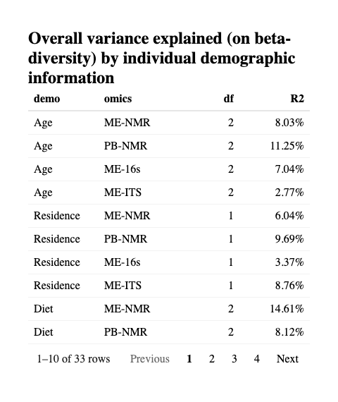
Fig4A <- resDEMO %>%
mutate(pv = myround2(p.value2),
pv2 = gtools::stars.pval(p.value2)) %>%
filter(term=='Model') %>%
filter(!str_detect(omics,'sqrt')) %>%
ggplot(data = ., aes(demo,R2, fill = omics, label = pv2)) +
geom_bar(stat = 'identity', position = position_dodge()) +
coord_flip() +
ylim(c(0,0.16)) +
geom_text(position = position_dodge(width = 1), hjust = -0.8, vjust = 0.9) +
scale_fill_manual(values = colorcodes) +
theme_bw() +
labs(fill = NULL) +
theme(legend.position = 'top') +
xlab(NULL)
Fig4A
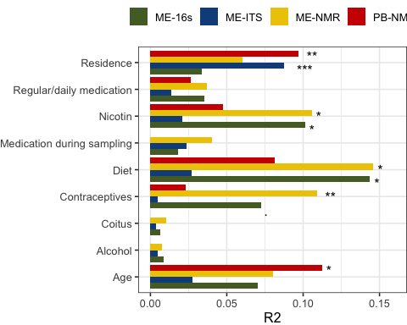
ggsave(filename = 'FIG4_betadiv.pdf', plot = Fig4A,width = 6,height = 5.2)

Examples
Figure 4B in publication
g1 <- MEconc_newlong %>%
filter(str_detect(met,'unk29-asparagine') |
str_detect(met,'arabinose')) %>% # |
# str_detect(met,'bin-ornithine-creatinine-tyrosine')) %>%
mutate(met = met %>% gsub('unk29-','',x = .) %>% gsub('bin-','',x = .)) %>%
filter(!is.na(Diet)) %>%
ggplot(data = ., aes(Diet,logy, fill = Diet)) +
geom_boxplot() +
scale_fill_manual(values = c('red','blue','chartreuse3')) +
ggbeeswarm::geom_beeswarm() +
theme_bw() +
# facet_wrap(~met, scales = 'free', ncol = 1) +
facet_grid(met~., scales = 'free') +
theme(legend.position = 'none')
g1b <- MEconc_newlong %>%
mutate(Nicotin = Nicotin %>% factor()) %>%
filter(str_detect(met,'trimethylamine')) %>%
filter(!is.na(Nicotin)) %>%
ggplot(data = ., aes(Nicotin,logy, fill = Nicotin)) +
geom_boxplot() +
ggbeeswarm::geom_beeswarm() +
theme_bw() +
# facet_wrap(~met, scales = 'free', ncol = 1) +
facet_grid(met~., scales = 'free') +
theme(legend.position = 'none')
g2 <- MEconc_newlong %>%
filter(str_detect(met,'unk29-asparagine') |
str_detect(met,'arabinose')) %>% # |
mutate(met = met %>% gsub('unk29-','',x = .) %>% gsub('bin-','',x = .)) %>%
mutate(met = met %>% gsub('unk','',x = .)) %>%
filter(!is.na(Diet)) %>%
mutate(cycle_day = parse_number(Cycle)*4 + `Cycle day`) %>%
ggplot(data = ., aes(cycle_day,logy, group = Participant, color =Diet)) +
geom_line() + geom_point() +
scale_x_continuous(breaks = c(5,6,7,9,10,11,13,14,15),
labels = c('1-1','1-2','1-3','2-1','2-2','2-3','3-1','3-2','3-3')) +
scale_color_manual(values = c('red','blue','chartreuse3')) +
# facet_wrap(~met, scales = 'free', ncol = 1) +
facet_grid(met~., scales = 'free') +
theme_bw() +
xlab('Cycle-Day') +
theme(legend.position = 'none',
strip.text.y = element_blank(),
strip.background.y = element_blank()
)
g2b <- MEconc_newlong %>%
filter(str_detect(met,'trimethylamine')) %>%
filter(!is.na(Nicotin)) %>%
mutate(cycle_day = parse_number(Cycle)*4 + `Cycle day`,
Nicotin = Nicotin %>% factor()) %>%
ggplot(data = ., aes(cycle_day,logy, group = Participant, color =Nicotin)) +
geom_line() + geom_point() +
scale_x_continuous(breaks = c(5,6,7,9,10,11,13,14,15),
labels = c('1-1','1-2','1-3','2-1','2-2','2-3','3-1','3-2','3-3')) +
# facet_wrap(~met, scales = 'free', ncol = 1) +
facet_grid(met~., scales = 'free') +
theme_bw() +
xlab('Cycle-Day') +
theme(legend.position = 'none',
strip.text.y = element_blank(),
strip.background.y = element_blank()
)
layout <- "
AAAB
AAAB
CCCD
"
FIG2b <- g2 + g1 + g2b + g1b + plot_layout(design = layout , axes = 'collect')
FIG2b
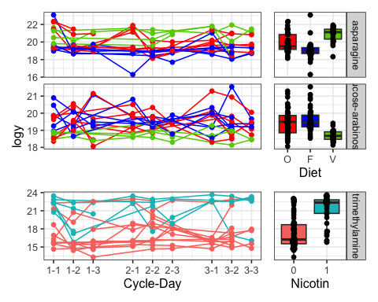
ggsave(filename = 'FIG4_dietexamples.pdf', plot = FIG2b,width = 5,height = 5)

Multivariate distribution (PC1 vs PC2)
SCORESdemo %>%
ggplot(data = ., aes(PC1,PC2, color = val)) +
geom_point() +
stat_ellipse(aes(group = val)) +
facet_wrap(~demo + omics, scales = 'free', ncol = 3) +
theme(legend.position = 'bottom')
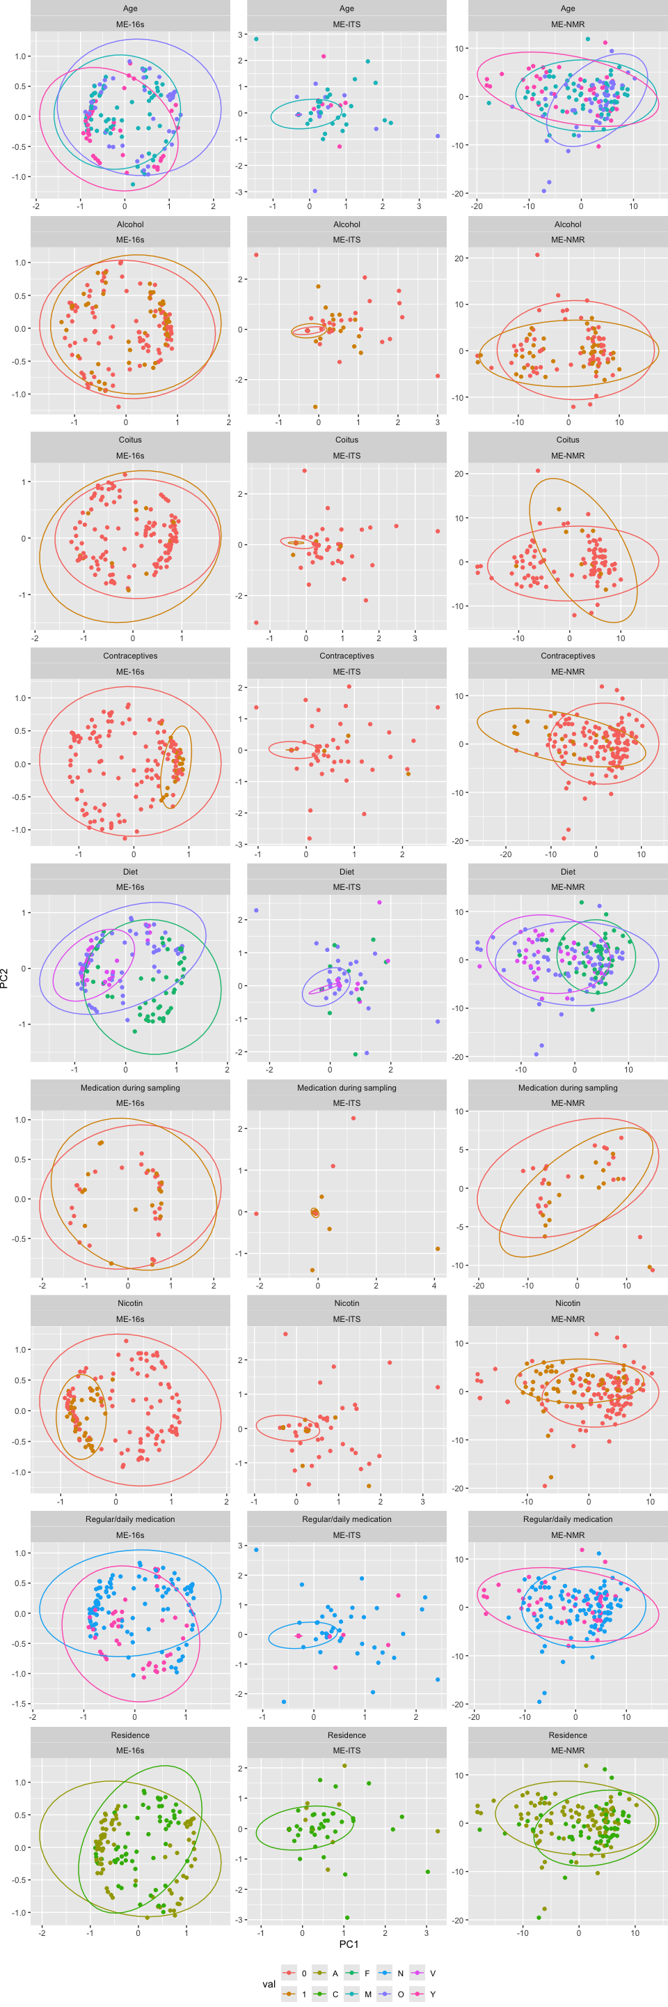

Multivariate distribution (PC3 vs PC4)
SCORESdemo %>%
ggplot(data = ., aes(PC3,PC4, color = val)) +
geom_point() +
stat_ellipse(aes(group = val)) +
facet_wrap(~demo + omics, scales = 'free', ncol = 3) +
theme(legend.position = 'bottom')
