Prediction

Compare 16s/ITS versus ME-NMR
phyXlong <- phyX %>%
subset_samples(!is.na(Sample.ID)) %>%
transform_sample_counts(function(x) x / sum(x)) %>%
filter_taxa(function(x) sum(x > 0)>10, TRUE) %>%
psmelt() %>%
dplyr::select(OTU:TSP, ta1:ta7) %>%
full_join(MEconc_newlong %>%
filter(!is.na(Participant)) %>%
filter(`Blood origen`=='ME') ,
by = c('Sample.ID' = 'Sample ID', 'Participant', 'Period')) %>%
filter(!is.na(Abundance)) %>%
filter(!is.na(logy)) %>%
filter(!str_detect(met,'EREC')) %>%
filter(!str_detect(met,'TSP')) %>%
dplyr::select(OTU:ta7,met,category, type:logy)
tb_cor <- phyXlong %>%
group_by(OTU,met,ta1,ta2,ta3,ta4,ta5,ta6,ta7) %>%
do(cor.test(data = ., ~ logy + Abundance,method = 'spearman') %>% tidy)
tb_lmer <- phyXlong %>%
# filter(met=='uridine') %>%
# filter(OTU=='sp1') %>%
mutate(logabu = log(Abundance+0.0001)) %>%
group_by(OTU,met,ta1,ta2,ta3,ta4,ta5,ta6,ta7) %>%
do(lmer(data = ., logy ~ logabu + factor(day) + (1|Participant) + (logabu|Participant)) %>% tidy)
# tb_lmer %>% filter(str_detect(term,'log')) %>% arrange(p.value)
save(file = 'microbiome_vs_nmr_models.RData', list = c('tb_lmer', 'tb_cor','phyXlong'))

All versus all (16s vs NMR)
load(file = 'microbiome_vs_nmr_models.RData')
fmrt <- list(
p.value = colDef(
cell = function(value) {
if (is.na(value)) return("")
formatC(value, format = "e", digits = 2)
}
),
estimate = colDef(
cell = function(value) {
if (is.na(value)) return("")
formatC(value, format = "e", digits = 2)
}
),
std.error = colDef(
cell = function(value) {
if (is.na(value)) return("")
formatC(value, format = "e", digits = 2)
}
)
)
tb_lmer2 <- tb_lmer %>%
filter(term=='logabu') %>%
ungroup %>%
mutate(ta5 = ifelse(ta5 %in% c('F__','__'),'Other',ta5),
ta5lmp = ta5 %>% fct_lump(n = 14),
qval = p.adjust(p.value,'fdr'),
pvcut = ifelse(p.value<0.05,'sign','ns'))
tb_lmer2 %>%
ggplot(data =.,aes(estimate,-log10(p.value))) +
geom_point()
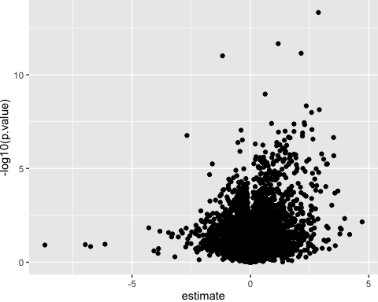
tb_lmer2 %>%
ungroup %>%
dplyr::select(met,ta4,ta5,ta6,ta7,estimate,std.error, p.value) %>%
reactable(columns = fmrt)
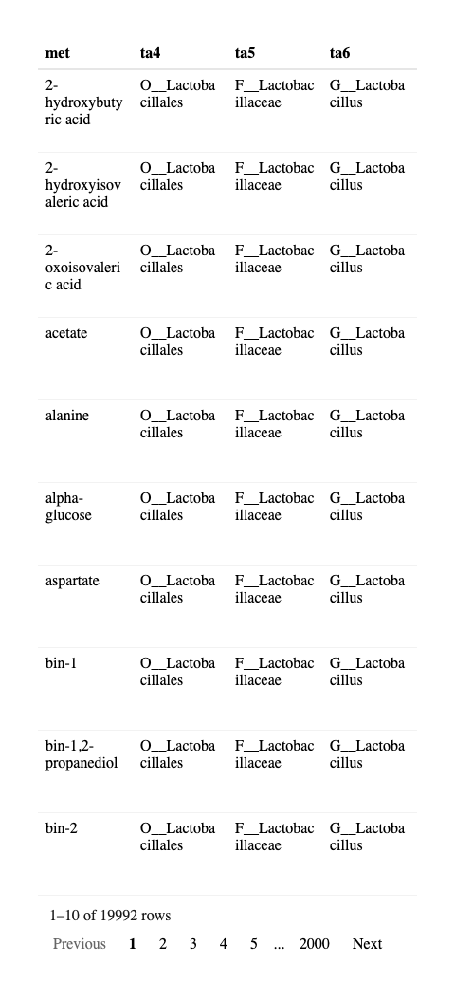
tb_lmer2 %>% filter(str_detect(term,'log')) %>%
ggplot(data =.,aes(ta5lmp, estimate,fill = pvcut)) +
geom_boxplot() +
theme(legend.position = 'bottom') +
coord_flip()
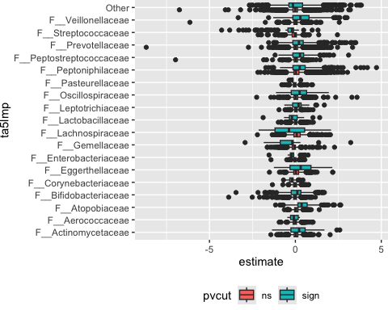
# tb_lmer %>% filter(str_detect(term,'log')) %>%
# group_by(ta5lmp) %>%
# dplyr::summarise(nneg = sum(estimate<0), npos = sum(estimate>0),
# pv = 1 - pbinom(max(npos,nneg)-1,nneg+npos,0.5))
gHM <- tb_lmer2 %>%
group_by(OTU) %>%
mutate(mq1 = min(qval)) %>%
ungroup() %>%
group_by(met) %>%
mutate(mq2 = min(qval)) %>%
filter(mq1<0.05 & mq2<0.05) %>%
mutate(OTU2 = paste(ta4,ta5,ta6,ta7,OTU, sep = '') %>% factor()) %>%
ggplot(data = ., aes(as.numeric(OTU2),substr(met,1,20),fill = estimate)) +
geom_tile() +
scale_fill_gradient2(mid = 'white', midpoint = 0)
ggsave(filename = 'Met_16s.pdf', plot = gHM, height = 20, width = 20)
phyXlong %>%
# filter(met=='lactate') %>% filter(OTU=='sp145') %>%
filter(met=='butyrate') %>% filter(OTU=='sp189') %>%
mutate(logabu = log(Abundance+0.0001)) %>%
ggplot(data = ., aes(logabu,logy, color = Participant, group = Participant)) +
geom_point() + geom_line() + stat_smooth(method = lm, se = F) + facet_wrap(~ta6 + ta7)
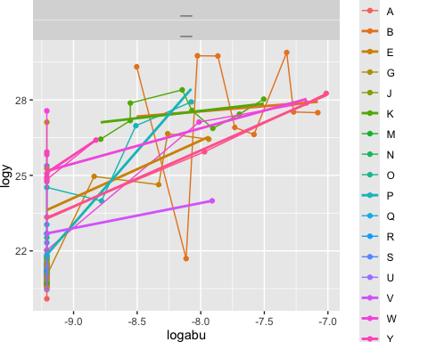

Multivariate prediciton models using nested-cv
library(caret)
library(nestedcv)
make_loio_folds <- function(ids) {
if (anyNA(ids)) {
stop("ids must not contain missing values")
}
ids <- as.character(ids)
n_ids <- length(unique(ids))
if (n_ids < 3L) {
stop("At least three unique IDs are required for nested leave-one-ID-out CV")
}
# Outer test folds: indices refer to rows in the complete dataset
outer_folds <- split(
seq_along(ids),
factor(ids, levels = unique(ids))
)
# Inner test folds: indices refer to rows in each outer-training dataset
inner_folds <- lapply(outer_folds, function(outer_test) {
outer_train <- setdiff(seq_along(ids), outer_test)
train_ids <- ids[outer_train]
split(
seq_along(train_ids),
factor(train_ids, levels = unique(train_ids))
)
})
list(
outer_folds = unname(outer_folds),
inner_folds = lapply(inner_folds, unname)
)
}

From 16s to NMR
phyXpp <- phyX %>%
subset_samples(!is.na(Sample.ID)) %>%
subset_samples(!is.na(X2.hydroxyisovaleric.acid)) %>%
transform_sample_counts(function(x) x / sum(x)) %>%
filter_taxa(function(x) sum(x > 0)>10, TRUE)
X <- phyXpp@otu_table %>% data.frame()
X <- log(X + +0.0001)
Y <- phyXpp@sam_data %>% data.frame() %>% dplyr::select(-TSP,-ERECTIC)
folds <- make_loio_folds(Y$Participant)
unmet <- unique(MEconc_newlong$met)
unmet <- unmet[!(unmet %in% c("ERECTIC","TSP"))]
for (i in unmet){
print(i)
yy <- MEconc_newlong %>% filter(met==i) %>% filter(!is.na(Participant)) %>% filter(`Blood origen`=='ME')
YY <- Y %>%
left_join(yy, by = c('Participant','Period','Cycle.day' = 'Cycle day'))
y <- YY$logy
sdy <- sd(y)
fit <- nestedcv::nestcv.train(
x = X,
y = y,
method = "spls", # any caret model
preProc = c("center", 'scale'),
tuneGrid = expand.grid(K = 1:3,# K sets number of components
eta = seq(0,1,0.1), # eta sets sparsity
kappa = 0.5),
outer_folds = folds$outer_folds,
inner_folds = folds$inner_folds,
finalCV = FALSE,
cv.cores = 1
)
fit$sdy <- sdy
fit$metabolite <- i
flnm <- paste('./MLresults16s/metabolite_16smodels_nestedcv',
i %>%
gsub('-','',x = .) %>%
gsub(' ','',x = .) %>%
gsub(',','',x = .),
'_v2.RData', sep = '')
save(file = flnm, list = c('fit','i'))
}

From ITS to NMR
phyITSpp <- phyITS %>%
subset_samples(!is.na(Sample.ID)) %>%
subset_samples(!is.na(X2.hydroxyisovaleric.acid)) %>%
transform_sample_counts(function(x) as.numeric(x>0)) %>%
filter_taxa(function(x) sum(x > 0)>9, TRUE)
X <- phyITSpp@otu_table %>% data.frame()
X <- log(X + +0.0001)
Y <- phyITSpp@sam_data %>% data.frame() %>% dplyr::select(-TSP,-ERECTIC)
folds <- make_loio_folds(Y$Participant)
unmet <- unique(MEconc_newlong$met)
unmet <- unmet[!(unmet %in% c("ERECTIC","TSP"))]
for (i in unmet){
print(i)
yy <- MEconc_newlong %>% filter(met==i) %>% filter(!is.na(Participant)) %>% filter(`Blood origen`=='ME')
YY <- Y %>%
left_join(yy, by = c('Participant','Period','Cycle.day' = 'Cycle day'))
y <- YY$logy
sdy <- sd(y)
fit <- nestedcv::nestcv.train(
x = X,
y = y,
method = "spls", # any caret model
preProc = c("center", 'scale'),
tuneGrid = expand.grid(K = 1:2,# K sets number of components
eta = seq(0,1,0.1), # eta sets sparsity
kappa = 0.5),
outer_folds = folds$outer_folds,
inner_folds = folds$inner_folds,
finalCV = FALSE,
cv.cores = 1
)
fit$sdy <- sdy
fit$metabolite <- i
flnm <- paste('./MLresultsITS/metabolite_ITSmodels_nestedcv',
i %>%
gsub('-','',x = .) %>%
gsub(' ','',x = .) %>%
gsub(',','',x = .),
'_v2.RData', sep = '')
save(file = flnm, list = c('fit','i'))
}
library(caret)
library(nestedcv)
flnm <- list.files('./MLresults16s/')
beta <- res16s <- data.frame()
for (fl in flnm){
load(file = paste('./MLresults16s/',fl,sep = ''))
k <- summary(fit)$final_param$K
s <- summary(fit)$result %>% as.data.frame() %>%
rownames_to_column('stat') %>%
mutate(metabolite = i,method = '16s',sdy = fit$sdy, ncomp = k)
s$x <- as.numeric(s$x)
res16s <- bind_rows(res16s,s)
beta <- beta %>% bind_rows(data.frame(breg = fit$final_fit$finalModel$betahat,
metabolite = i,
method = '16s',
sdy = fit$sdy,
ncomp = k
) %>%
rownames_to_column('OTU'))
}
flnm <- list.files('./MLresultsITS/')
resITS <- data.frame()
for (fl in flnm){
load(file = paste('./MLresultsITS/',fl,sep = ''))
k <- summary(fit)$final_param$K
s <- summary(fit)$result %>% as.data.frame() %>%
rownames_to_column('stat') %>%
mutate(metabolite = i,method = 'ITS',sdy = fit$sdy, ncomp = k)
s$x <- as.numeric(s$x)
resITS <- bind_rows(resITS,s)
beta <- beta %>% bind_rows(data.frame(breg = fit$final_fit$finalModel$betahat,
metabolite = i,
method = 'ITS',
sdy = fit$sdy,
ncomp = k
) %>%
rownames_to_column('OTU'))
}
load(file = '~/OneDrive - University of Copenhagen/KU_work/menstrual_effluent/multiomics_menstrual_effluent/RMSE0_loio.RData')
MLstat16s <- RMSE0 %>% left_join(res16s %>% filter(stat=='RMSE') %>% filter(!duplicated(metabolite))) %>% mutate(method = '16s')
MLstatITS <- RMSE0 %>% left_join(resITS %>% filter(stat=='RMSE') %>% filter(!duplicated(metabolite))) %>% mutate(method = 'ITS')
MLstat <- bind_rows(MLstat16s,MLstatITS) %>%
mutate(stat = 'RMSE',
ncomp = ifelse(is.na(x),0,ncomp),
x = ifelse(is.na(x),rmse0,x)) %>%
left_join(MEclass, by = c('metabolite' = 'Interval_name2'))
beta <- beta %>% left_join(MEclass, by = c('metabolite' = 'Interval_name2'))
save(file = '~/OneDrive - University of Copenhagen/KU_work/menstrual_effluent/multiomics_menstrual_effluent/MLstats.RData',
list = c('MLstat','res16s','resITS', 'beta'))

Per metabolite - CV predictive perormance.
load(file = '~/OneDrive - University of Copenhagen/KU_work/menstrual_effluent/multiomics_menstrual_effluent/MLstats.RData')
MLstat <- MLstat %>%
mutate(
Rsquared = 1 - (x^2 / rmse0^2),
quality = ifelse(Rsquared < (-0.2),'overfitted','ok'),
Rsquared = ifelse(Rsquared < (-0.2),-0.2,Rsquared))
MLstat %>%
ggplot(data = ., aes(substr(metabolite,1,50),Rsquared, color = method, shape = quality)) +
geom_point() + theme(axis.text.x = element_text(angle = 90, hjust = 1))
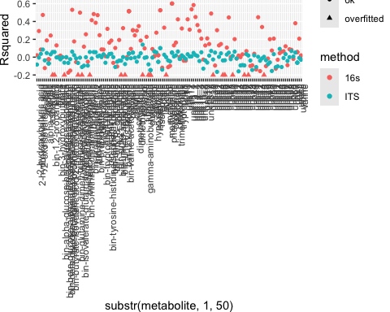
g_r2 <- MLstat %>%
left_join(dflb, by = 'category') %>%
filter(!is.na(lb)) %>%
# group_by(lb) %>%
# mutate(category2 = paste(lb, ' (#', n() / 2,')', sep = '')) %>%
# ungroup %>%
mutate(lb = lb %>% factor(levels = dflb$lb[1:9])) %>%
ggplot(data= ., aes(lb,Rsquared, fill = method)) +
geom_boxplot() +
# scale_y_reverse() +
geom_point(position = position_dodge(width = 0.75)) +
# geom_hline(data = data.frame(R2cut = c(R2sign_16s,R2sign_ITS), method = c('16s','ITS')),
# aes(yintercept = R2cut, color = method)) +
# geom_point(position = position_dodge(width = 0.8), aes(group = method), size = 1) +
scale_fill_manual(values = colorcodes[1:2], labels = colorcodesnames[1:2]) +
scale_color_manual(values = colorcodes[1:2], labels = colorcodesnames[1:2], guide = 'none') +
# scale_x_discrete(breaks = dflb$lb[1:9], values = dflb$lb[1:9]) +
theme_bw() +
theme(axis.text.x = element_text(angle = 90, hjust = 1, vjust = 0),
legend.position = 'bottom') + labs(fill = NULL) +
xlab(NULL)
g_r2
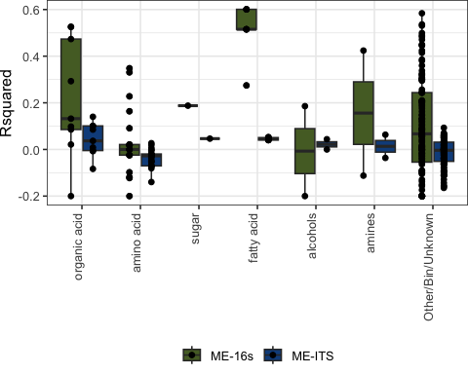
MLstat %>%
filter(!is.na(Rsquared)) %>%
lm(rank(Rsquared) ~ method + category ,data = .) %>% anova %>% tidy
# A tibble: 3 × 6
term df sumsq meansq statistic p.value
<chr> <int> <dbl> <dbl> <dbl> <dbl>
1 method 1 187572. 187572. 28.6 0.000000175
2 category 14 403979. 28856. 4.41 0.000000369
3 Residuals 296 1938475. 6549. NA NA
MLstat %>%
filter(!is.na(Rsquared)) %>%
group_by(method) %>%
summarise(R2m = median(Rsquared),
q1 = quantile(Rsquared,0.25),
q3 = quantile(Rsquared,0.75))
# A tibble: 2 × 4
method R2m q1 q3
<chr> <dbl> <dbl> <dbl>
1 16s 0.0670 -0.0425 0.279
2 ITS -0.00424 -0.0515 0.0337
Figure 5A in publication
library(gplots)
ggbeta <- beta %>%
left_join(MLstat %>% dplyr::select(rmse0,x,Rsquared, metabolite,method,ncomp), by = c('metabolite','method')) %>%
left_join(dflb, by = 'category') %>%
mutate(breg = breg/sdy) %>%
filter(method == '16s') %>%
filter(Rsquared>0.5) %>%
left_join(tb_lmer2 %>% dplyr::select(OTU,met,estimate:pvcut), by = c('OTU','metabolite' = 'met')) %>%
group_by(metabolite) %>%
mutate(nn = sum(abs(breg)>0)) %>%
filter(nn>0) %>%
group_by(OTU) %>%
mutate(nn2 = sum(abs(breg)>0)) %>%
filter(nn2>0) %>%
left_join(phyX@tax_table %>% data.frame() %>% rownames_to_column('OTU') %>%
left_join(bsum16s, by = c('ta2','ta3','ta4','ta5')), by = 'OTU') %>%
ungroup %>%
mutate(taxall = paste(ta2,ta3,ta4,ta5, sep = '') %>% factor() %>% as.numeric(),
OTU = OTU %>% fct_reorder(taxall)) %>%
mutate(stars = gtools::stars.pval(qval))
lbs <- ggbeta %>%
group_by(OTU) %>%
dplyr::summarise(lb = ta5[1],
lb4 = ta4[1],
lb3 = ta3[1],
lb2 = ta2[1],
n()) %>%
arrange(lb)
# 1) find lowest level of id, 2) remove F__
for (i in which(nchar(lbs$lb)<4)){
id <- which(nchar(lbs[i,])>4)[1]
if (is.na(id)) {
lbs$lb[i] <- 'unassigned'
}
else {
# print(as.character(lbs[i,id]))
lbs$lb[i] <- as.character(lbs[i,id])
}
}
lbs <- lbs %>%
mutate(lb = lb %>%
gsub('F__','',x = .) %>%
gsub('__','-',x = .))
g5_all <- ggbeta %>%
# remove bin from mtb label
mutate(metabolite = gsub('bin.','',x = metabolite)) %>%
# filter of only bins / unk
# filter(nchar(metabolite)>6) %>%
mutate(metabolite = gsub('X2.','2-',x = metabolite)) %>%
# filter(!str_detect(metabolite,'unk')) %>%
# filter(!str_detect(metabolite,'1_2')) %>%
ggplot(data = ., aes(metabolite,OTU,fill = breg,label = stars)) +
geom_tile() +
geom_text() +
scale_y_discrete(labels = lbs$lb,breaks =lbs$OTU ) +
scale_fill_gradient2(mid = 'white',midpoint = 0) +
theme_minimal() +
theme(legend.position = 'top', axis.text.x = element_text(angle = 90, hjust = 1, vjust = 0.5)) +
xlab(NULL) + ylab(NULL)
g5_sel <- ggbeta %>%
# remove bin from mtb label
mutate(metabolite = gsub('bin-','',x = metabolite)) %>%
mutate(metabolite = gsub('1_2','',x = metabolite) %>% trimws()) %>%
# filter of only bins / unk
filter(nchar(metabolite)>6) %>%
filter(!str_detect(metabolite,'unk')) %>%
# filter(!str_detect(metabolite,'1_2')) %>%
ggplot(data = ., aes(metabolite,OTU,fill = breg, label = stars)) +
geom_tile() +
scale_y_discrete(labels = lbs$lb,breaks =lbs$OTU ) +
scale_fill_gradient2(mid = 'white',midpoint = 0) +
geom_text() +
# scale_color_manual(values = alpha(c('white','black'))) + #,c(0,1))) +
theme_minimal() +
theme(legend.position = 'top', axis.text.x = element_text(angle = 90, hjust = 1, vjust = 0.5)) +
xlab(NULL) + ylab(NULL)

Coefficients - all
g5_all
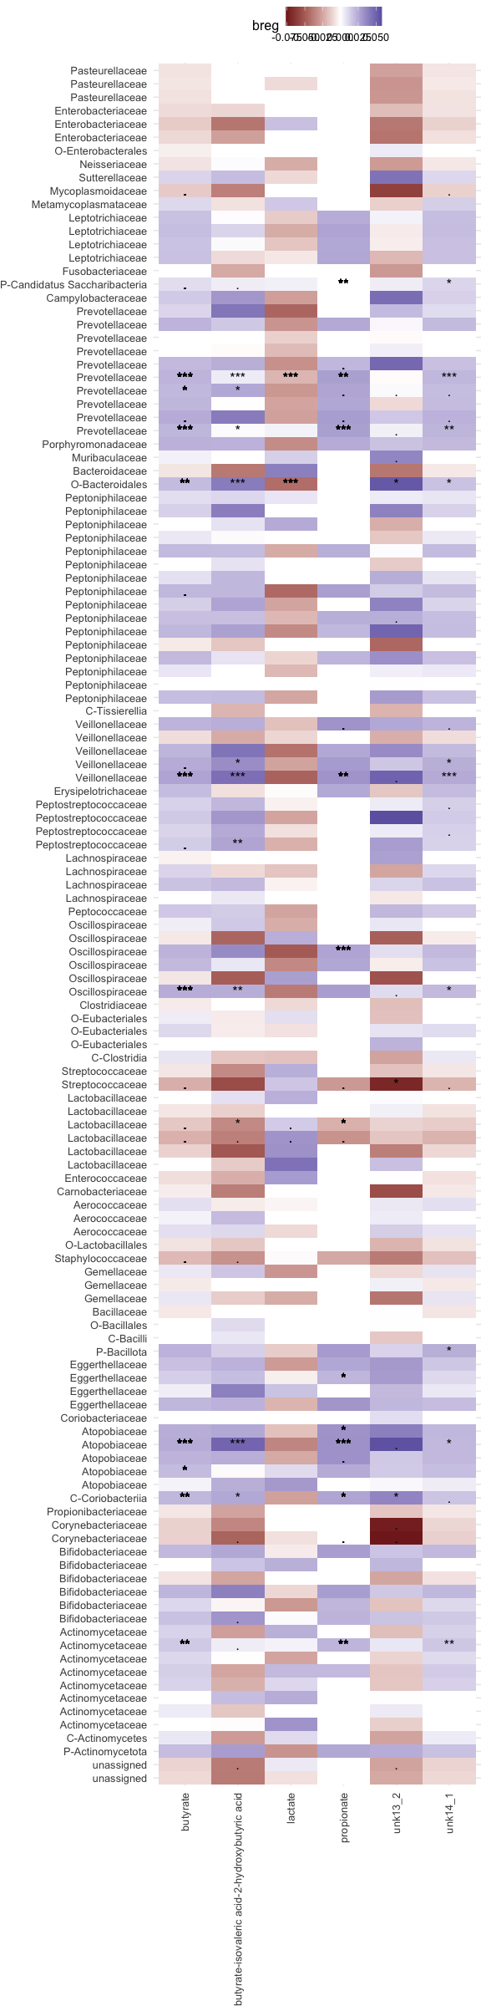

Coefficients - selected
Figure 5B in publication
g5_sel
