Stability

Multivariate Stability measures for each individual
Figure 4C in publication
df <- MEconc_newlong %>%
ungroup %>%
filter(!is.na(`Sample ID`)) %>%
filter(!str_detect(met,'PC')) %>%
filter(!(str_detect(met,'glycerol') | met == 'ERECTIC' | met=='TSP' | str_detect(met,'PC'))) %>%
filter(!(str_detect(met,'glycerol') | str_detect(met,'EDTA') | met == 'ERECTIC' | met=='TSP' )) %>%
dplyr::select(`Sample ID`, met,logy) %>%
spread(met,logy)
DMENMR <- dist(scale(df[,-1]))
medianNMR <- DMENMR %>% as.vector() %>% median()
df <- df %>% mutate(Participant = `Sample ID` %>% substr(1,1))
phyXsel16s <- phyX %>%
subset_samples(!is.na(Sample.ID)) %>%
transform_sample_counts( function(x) x / sum(x))
D16s <- phyXsel16s %>% phyloseq::distance("bray")
median16s <- D16s %>% as.vector() %>% median()
phyXselits <- phyITS %>%
subset_samples(!is.na(Sample.ID)) %>%
transform_sample_counts( function(x) as.numeric(x>0))
DITS <- phyXselits %>% phyloseq::distance("euclidean")
medianITS <- DITS %>% as.vector() %>% median()
res_withindist <- data.frame()
for (P in unique(df$Participant)){
ic <- df$Participant==P
# print(sum(ic))
#print(sum(ic))
iD <- as.matrix(DMENMR)[ic,ic] / medianNMR # scale distance to equal median.
res_withindist <- res_withindist %>%
bind_rows(data.frame(Participant = P,
nsamples = sum(ic),
withinparticipantdist = iD[upper.tri(iD)],
omics = 'ME-NMR'))
ic <- phyXsel16s@sam_data$Participant==P
iD<- as.matrix(D16s)[ic,ic] / median16s
if (length(iD)==1) {wd <- NA} else {wd <- iD[upper.tri(iD)]}
res_withindist <- res_withindist %>%
bind_rows(data.frame(Participant = P,
nsamples = sum(ic),
withinparticipantdist = wd,
omics = 'ME-16s'))
ic <- phyXselits@sam_data$Participant==P
iD<- as.matrix(DITS)[ic,ic] / medianITS
if (length(iD)==1) {wd <- NA} else {wd <- iD[upper.tri(iD)]}
res_withindist <- res_withindist %>%
bind_rows(data.frame(Participant = P,
nsamples = sum(ic),
withinparticipantdist = wd,
omics = 'ME-ITS'))
}
res_withindistsum <- res_withindist %>%
group_by(Participant,omics) %>%
summarise(n_comparisons = n(), mnd = mean(withinparticipantdist),
nsamples = mean(nsamples))
res_withindistsum %>% group_by(omics) %>%
summarise(sum(nsamples),
length(unique(Participant)),
quantile(nsamples,0.75),
median(nsamples),
quantile(nsamples,0.25)) %>%
reactable() %>%
add_subtitle('Descriptives of samples going into stability calculations')
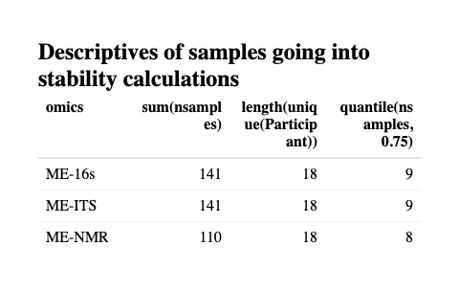
r <- res_withindistsum %>%
dplyr::select(-n_comparisons) %>%
spread(omics,mnd) %>%
ungroup %>%
dplyr::select(-Participant) %>%
rstatix::cor_mat()
pv <- res_withindistsum %>%
dplyr::select(-n_comparisons) %>%
spread(omics,mnd) %>%
ungroup %>%
dplyr::select(-Participant) %>%
rstatix::cor_pmat()
FIG3b <- r %>% gather(omics,val,-rowname) %>%
filter(val<1) %>%
ggplot(data = ., aes(omics,rowname,fill = val, label= paste('r =',val))) +
scale_fill_gradient2(low = 'blue',high = 'red', mid = 'white', midpoint = 0, limits = c(0,1)) +
geom_tile() + geom_text() +
ylab(NULL) + theme_bw() +
theme(legend.position = 'none')
FIG3a <- res_withindistsum %>%
mutate(omics = factor(omics, levels = c('ME-NMR','ME-16s','ME-ITS'))) %>%
ggplot(data = ., aes(omics, mnd, fill = omics)) +
geom_violin() +
geom_hline(yintercept = 1) +
scale_fill_manual(values = colorcodes, breaks = colorcodesnames) +
geom_line(aes(group = Participant)) +
geom_point()+
theme_bw() +
ylab('Mean within participant distance') +
theme(legend.position = 'none')
r %>% reactable() %>% add_subtitle('Correlation between overall stability')
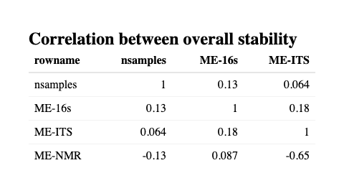
pv %>% reactable() %>% add_subtitle('Inference (pv) between overall stability')
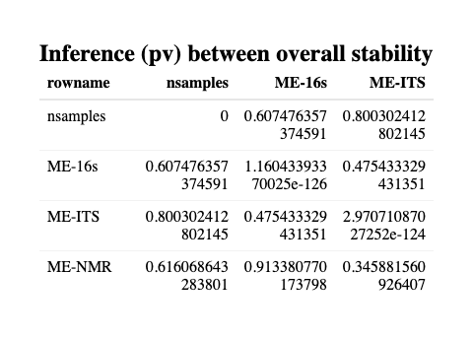

Compare within-women stability with demographics
variablemetavars <- c("Alcohol","Coitus", "Medication during sampling" )
metavars <- c("Age", "Residence", "Diet", "Contraceptives", "Regular/daily medication" , "Nicotin")
dfmeta <- MEconc_newlong %>%
filter(!duplicated(`Samples #`)) %>%
dplyr::select(`Samples #`,Participant, metavars) %>%
gather(demo,val,-`Samples #`,-Participant) %>%
filter(!is.na(Participant)) %>%
dplyr::select(-`Samples #`) %>%
group_by(demo) %>%
filter(!duplicated(Participant)) %>%
full_join(res_withindistsum, by = 'Participant')
fmrt <- list(
relssq = colDef(format = colFormat(percent = TRUE, digits = 1)),
p.value = colDef(
cell = function(value) {
if (is.na(value)) return("")
formatC(value, format = "e", digits = 2)
}
)
)
dfmeta %>%
ggplot(data = ., aes(val,mnd)) +
geom_violin() +
geom_jitter() +
facet_grid(omics~demo, scales = 'free')
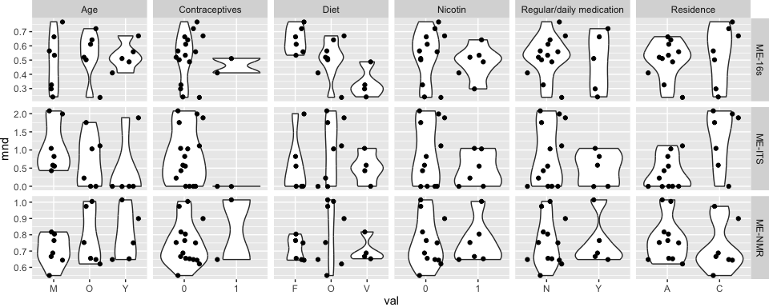

Correlation table
Inference as table
dfmeta %>%
group_by(omics,demo) %>%
do(lm(data = ., mnd~val) %>% anova %>% tidy) %>%
group_by(demo,omics) %>%
mutate(relssq = sumsq / sum(sumsq)) %>%
filter(term=='val') %>%
arrange(p.value) %>%
dplyr::select(omics,demo,df,relssq,p.value) %>%
reactable(columns = fmrt) %>% add_subtitle('Variation in stability explained by demographics')
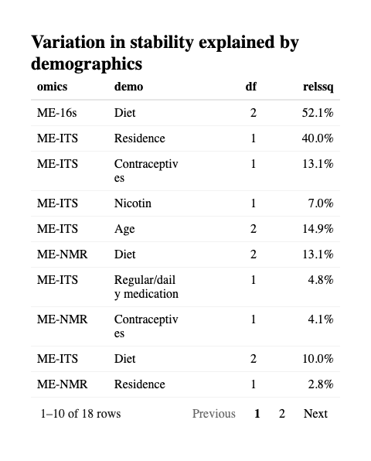
FIG3c <- dfmeta %>%
filter(demo=='Diet') %>%
mutate(omics = factor(omics, levels = c('ME-NMR','ME-16s','ME-ITS'))) %>%
mutate(val = factor(val,levels = c('O','F','V'))) %>%
ggplot(data = ., aes(val,mnd, fill = val)) +
geom_violin() +
geom_hline(yintercept = 1) +
scale_fill_manual(values = c('red','blue','chartreuse3')) +
ggbeeswarm::geom_beeswarm() +
theme_bw() + theme(legend.position = 'none') +
ylab('Mean within participant distance') + xlab('Diet') +
ggpubr::stat_compare_means(method = 'anova') +
facet_grid(.~omics)

Overall stability per women - across omics modalities
Figure 5 in publication Example on diet.
ggsave(filename = 'FIG5_betastab.pdf', plot = FIG3a, height = 5,width = 3)
layout <- "
ABB
"
FIG5 <- FIG3a + FIG3c + plot_layout(design = layout , axes = 'collect')
FIG5
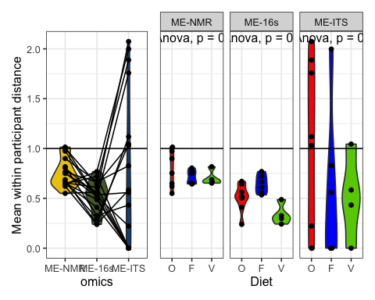
ggsave(filename = 'FIG5_betastab.pdf', plot = FIG5, height = 5,width = 8)

