 | VAG to EGL - using the tool

One time setup
The necessary one time setup is described in the document – Vag2Egl_workspaceSetup.doc. It is necessary to use the guidelines in that document before converting your first VAG application.

Daily use of the tool
.. is simple as long as you have already
Step 1: align S0A-ProjectSetup.cmd (Figure 1)
a. Set the application group name for V2EPARM_MODULE. It must be lower case.
b. Set the application group name for V2EPARM_MODULEPFX. It must be UPPER CASE
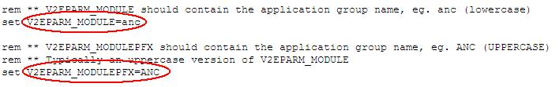
FIGURE 1

Step 2: run the tool (Figure 2)
a. Open a command line (cmd.exe)
b. Change current directory to c:\vag2egl
c. Run the command S-all.bat and relax for a few moments. If the application group you migrate is a large one, it can take hours to complete - small application groups can finish in less than one minute.
If this ends without error messages, the application group has now been migrated and imported.

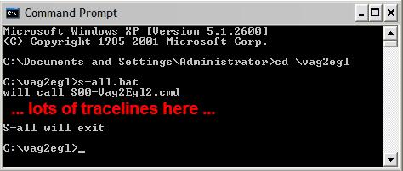
FIGURE 2

Step 3: make the application group visible in RBD (Figure 3)

a. Highlight the EGLSource folder in the Project Explorer and press <F5>
b. Remember to build code if you have 'Build Automatically' off (<CTRL<+<B>)
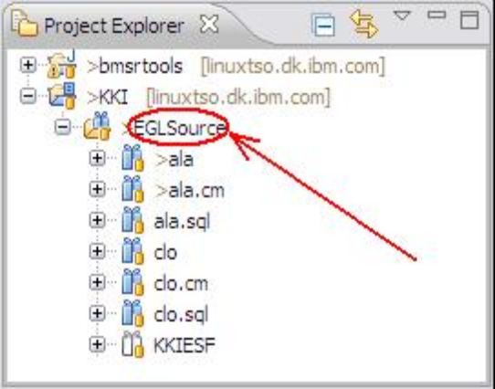
FIGURE 3

Step 4: Handle errors in imported code

This is where the developer skills are necessary. The imported code will most likely contain errors marked in the Project Explorer with red x-es. Some of the corrections necessary will be simple, others will be more hard to eliminate. You are encouraged to maintain a list of how to resolve certain types of errors as a service to your colleagues and your self.

Troubleshooting

Generated files are almost empty
It is likely you didn't restart the development environment after changing the capabilities. Restart (or reboot).

How to obtain more info during the conversion process
If you need trace information during the conversion process, set the V2EPARM_TRACE value to anything in the S0A-ProjectSetup.cmd file. This will make some of the steps to produce tonnes of output.

How to pause between the steps
Setting the V2EPARM_WAIT_WHEN_END value to NO in the S0A-ProjectSetup.cmd file makes the S-all.bat program to execute the steps without pause. If this is a problem, set the value to anything but NO.

A Java execution error is displayed during execution
Java 1.6 is necessary in order to execute the tool. If you have Java version 1.5 or earlier as your default ('first in your PATH'), the tool will fail.

Migration takes long time
Yes, it is a demanding process. You can experiment with setting 'Build Automatically' off. Then you must remember to build (<CTRL> + <B>) when import has finished.

...........................

