 | VAG to EGL – Workspace setup

About this document
This document shows, with KKI as an example, how to set up a new workspace when you need to make some VAG to EGL conversion using the VAG2EGL migration tool.

Prerequisites
You need to install Rational Business Developer (RBD) in at least version 7.5.1.3 (ie. including the fixpack 3). This document is written based on that RBD version. It is likely the method will work with future releases as well.
You also need to have java version 6 installed.

One time setup
1. Create new workspace named KKI, eg. C:\KKI
Menu: File --> Switch workspace ... Fill in new workspace name.
2. Open Preferences window
Menu: Window-->Preferences

3. Enable EGL Text UI capability (shown in figure 1)
a. In the Preferences window expand the General section and click on Capabilities (step 1)
b. Click the Advanved... button (step 2)
c. Expand the EGL Developer section (step 3)
d. Enable the EGL Text UI capability and EGL VAGen Migration (step 4)

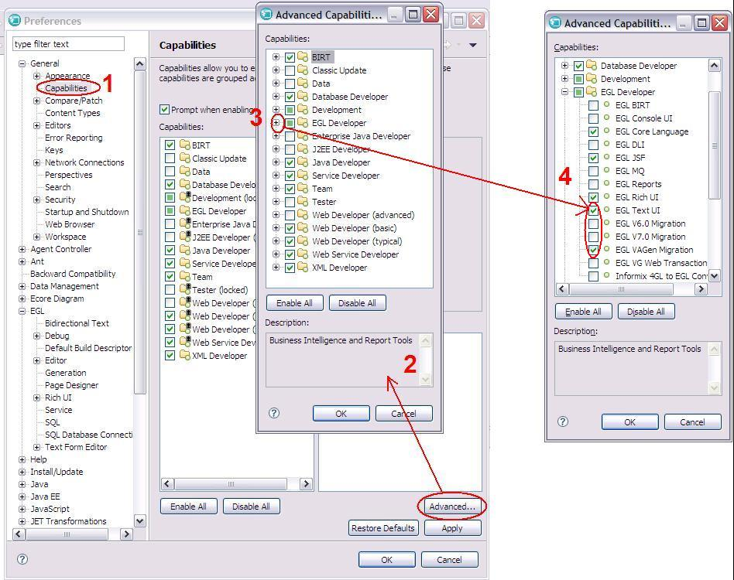
FIGURE 1 - Enable EGL Text UI capability.

4. EGL--> EGL Base: Enable VisualAge Generator compatibility (shown in figure 2)
a. In the Preferences window, click on EGL (step 1)
b. Enable the VisualAge Generator compatibility feature. (step 2)

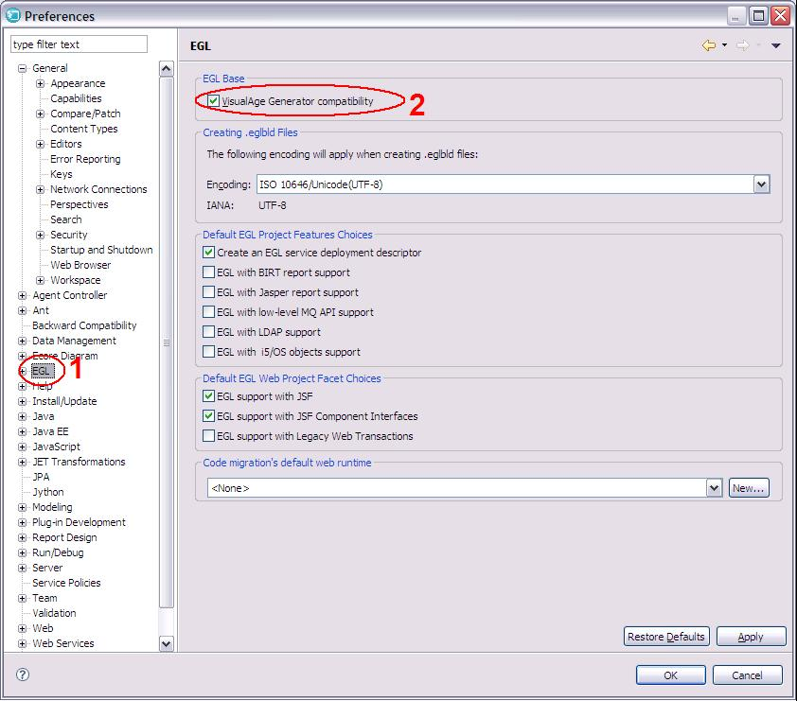
FIGURE 2 - Enable VisualAge Generator compatibility

5. Create a new repository location
a. Open the CVS Repositoty Exploring perspective
b. In the left side pane, which should be empty, right click and select new --> Repository Location...
c: Create a new repository location like in figure 3. Use your userid and password for the cvs repository server.
Note: pay attention to the connection type field.

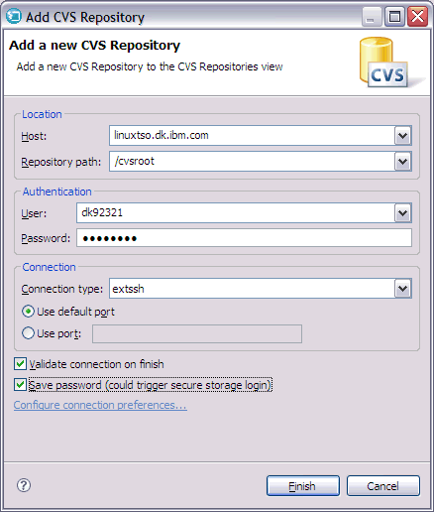
FIGURE 3 - new repository location

6. Get code from CVS (figure 4)
a. expand the server in the view
b. expand the HEAD section
c. right click the bmsrtools and KKI packages and select Check Out

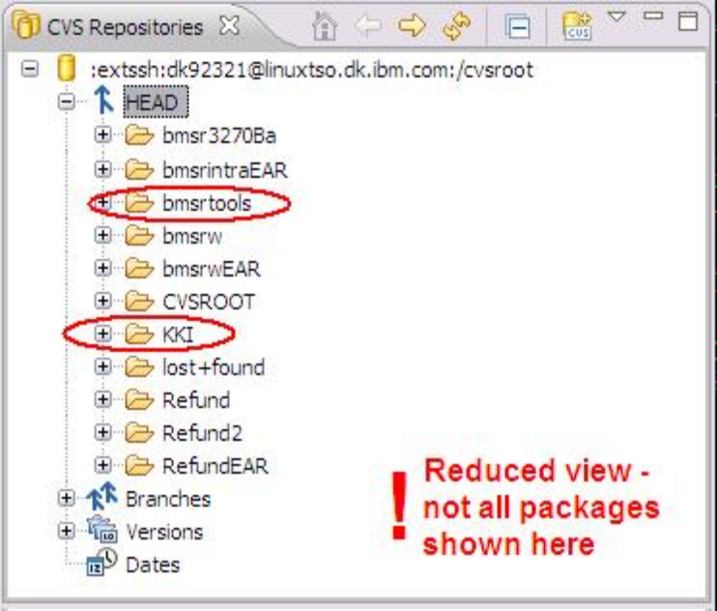
FIGURE 4 - check out code from CVS

7. Wait for the workspace build to finish.

8. Setup working directory
a. Open a DOS prompt
b. change directory to where bmsrtools is present. In the example it is in c:\KKI\bmsrtools\
c. Further, change to the src\vag2egl\ subdirectory.
d. From there, execute the command file Build-Vag2Egl from workspace.cmd file. (Figure 5)
e. After this, a c:\vag2egl\ directory has been created.

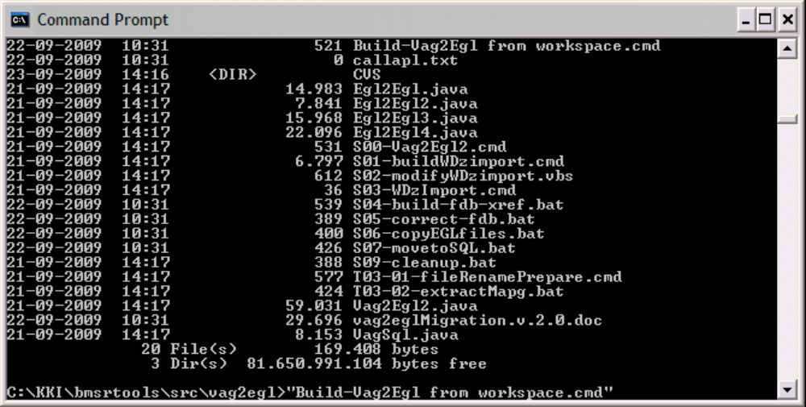
FIGURE 5 - Set up working directory

9. Prerequisite
Your default java environment must be java 6 (java 1.6).In order to have the VAG2EGL migration tool to work, in is necessary to have Java6 as your default java. To check if this is fulfilled, write the command java -fullversion in your command line. If it says java version "1.5.0" you run on java 5. If it says java version "1.6.0" you are fit.

FIGURE 6 - an example of a java version not compatible with the migration tool.

10. Set up working parameters
a. Some parameters are necessary to set up one time and some are necessary to set up for every system / application group, you migrate. All manageable parameters are defined in the file c:\vag2egl\S0A-ProjectSetup.cmd.
b. Open the file c:\vag2egl\S0A-ProjectSetup.cmd in an editor.
c. Change the

11. Restart development environment
a. Some development capabilities in Rational Business Developer will not take effect until you restart the environment. For this reason, restart the program.

(By Jais Knudsen, 2009-09-23).

...........................

