CRIME RECORD MANAGEMENT SYSTEM

Software Requirements Specification (SRS)

Submitted By:
Member 1:Md Nausheen
Member 2: M.Spandana
Member 3: S.Yaswanth

Department of Computer Science and Engineering

Guide: Dolly Sree

College Name: National Institute Of Technology , Andhra Pradesh.

Academic Year: 2026–2027

1.INRODUCTION
The Crime Record Management System (CRMS) is a web-based application developed to simplify and automate the management of crime-related information within police departments. The system provides a centralized platform for maintaining criminal records, FIRs, case details, evidence, and officer information. It improves operational efficiency by reducing paperwork, ensuring secure data storage, and enabling quick retrieval of information for authorized users.

2.PROBLEM STATEMENT
The Crime Record Management System (CRMS) is designed to replace the traditional paper-based crime record management process with a secure, centralized, web-based application. In many police departments, maintaining criminal records, FIR details, investigation updates, and evidence manually leads to delays, data duplication, and difficulties in retrieving information. The proposed system provides an efficient digital platform where authorized officers can manage criminal information, register FIRs, assign cases, track investigations, and generate reports. By automating these processes, the system improves productivity, reduces paperwork, enhances data security, and enables faster decision-making during criminal investigations.
3.OBJECTIVES
To develop a secure, user-friendly, web-based Crime Record Management System that efficiently manages crime-related information and supports police departments in maintaining criminal records digitally.
4.SPECIFIC OBJECTIVES
- To digitize criminal records and eliminate dependence on paper-based record keeping.
- To provide an efficient system for registering and managing FIRs.
- To maintain detailed information about criminals, police officers, investigations, and evidence.
- To provide a powerful search system for quick retrieval of crime records.
- To generate reports for crime analysis and administrative purposes.
- To improve data security by allowing access only to authorized users.
- To reduce manual work, paperwork, and record duplication
- To improve coordination among police personnel through a centralized database.
- To provide a responsive and user-friendly interface.
- To ensure accurate and reliable storage of crime-related information.

5.SCOPE OF THE SYSTEM
The Crime Record Management System is designed for police departments to manage crime-related information efficiently through a centralized web application. The system provides functionalities for user authentication, criminal record management, FIR registration, officer management, case tracking, evidence management, and report generation. It enables authorized users to securely access, update, and retrieve information while maintaining data integrity and confidentiality.
The system is intended for use by police administrators and authorized officers. It does not provide public access to crime records.

6.PROPOSED SYSTEM
The proposed Crime Record Management System is a MERN stack web application that automates the management of crime-related records. It replaces manual paperwork with a digital platform that stores information in a centralized database.
The system allows authorized users to:
- Login securely using authentication.
- Manage criminal records.
- Register and update FIRs.
- Manage police officer information.
- Assign and track investigation cases.
- Upload and manage evidence.
- Search crime records efficiently.
- Generate reports and crime statistics.

7.USERS OF THE SYSTEM
User Roles
Administrator
- Manage police officers
- Manage criminal records
- View all FIRs
- Generate reports
- Manage user accounts
- Monitor overall system activities
- Generate system reports
Police Officer
- Register FIRs
- Update investigation status
- Manage assigned cases
- Upload evidence
- Search criminal records
- View assigned cases
- Update investigation progress

8.FUNCTIONAL REQUIREMENTS
Functional Requirements
Authentication
- Secure Login
- Logout
- Role-Based Access Control
Dashboard
- Crime Statistics
- Recent FIRs
- Active Cases
- Officer Statistics
Criminal Management
- Add Criminal
- Update Criminal
- Delete Criminal
- Search Criminal
- View Criminal Details
FIR Management
- Register FIR
- Update FIR
- Delete FIR
- Search FIR
- View FIR Details
Officer Management
- Add Officer
- Update Officer
- Delete Officer
- Search Officer
Case Management
- Create Case
- Assign Officer
- Update Case Status
- Close Case
Evidence Management
- Upload Evidence
- Download Evidence
- View Evidence
Reports
- Monthly Reports
- Crime Statistics
- Officer Reports
- Export Reports

9.NON-FUNCTIONAL REQUIREMENTS
Security
- JWT-based authentication
- Password encryption
- Role-based authorization
Performance
- Fast response time
- Efficient search operations
Reliability
- Accurate data storage
- Consistent system availability
Scalability
- Support increasing numbers of records and users
Usability
- Responsive interface
- Easy navigation
- User-friendly design

10.TECHNOLOGY STACK :
Component | Technology
Frontend | React.js (Vite)
Styling | Tailwind CSS
Backend | Node.js + Express.js
Database | MongoDB Atlas
Authentication | JWT
Version Control | Git & GitHub
Project Management | Jira
API Testing | Thunder Client / Postman
Deployment | Vercel & Render

11.USE CASE DIAGRAM
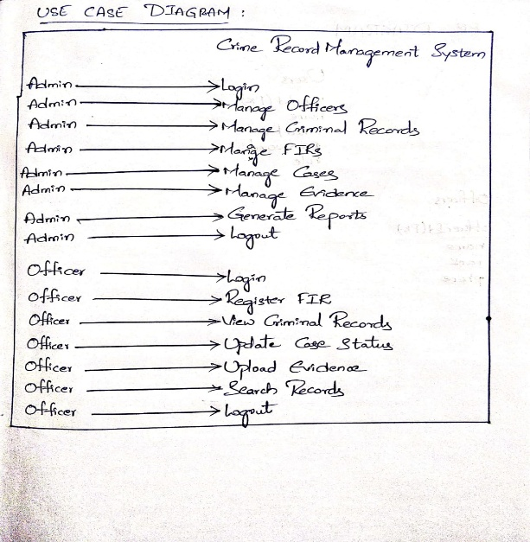
12.ACTIVITY DIAGRAM:
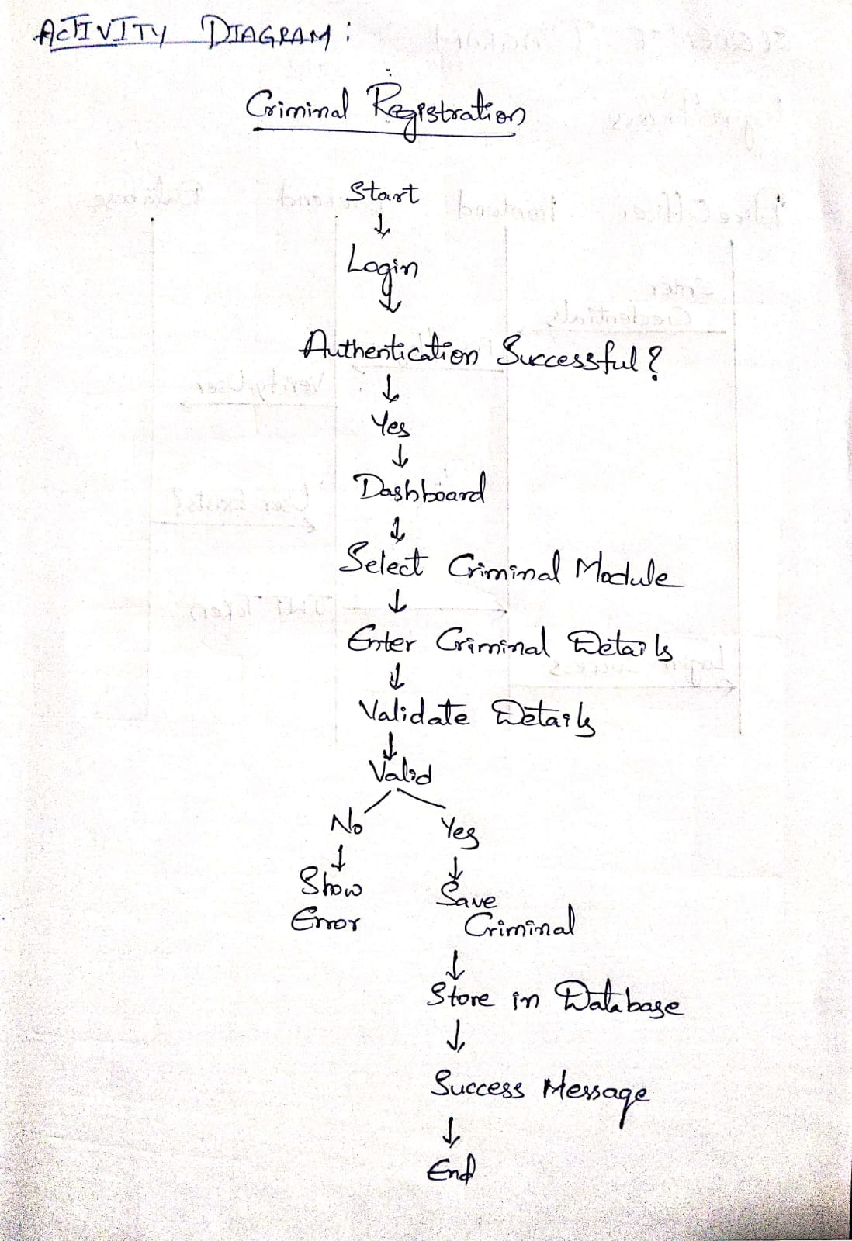
13.ER DIAGRAM

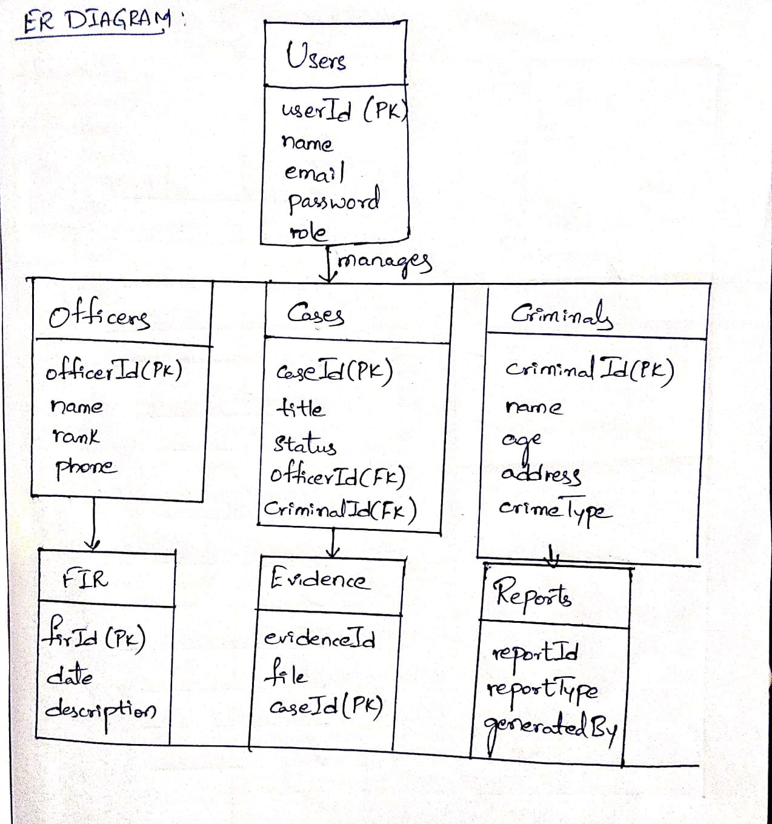

14.CLASS DIAGRAM
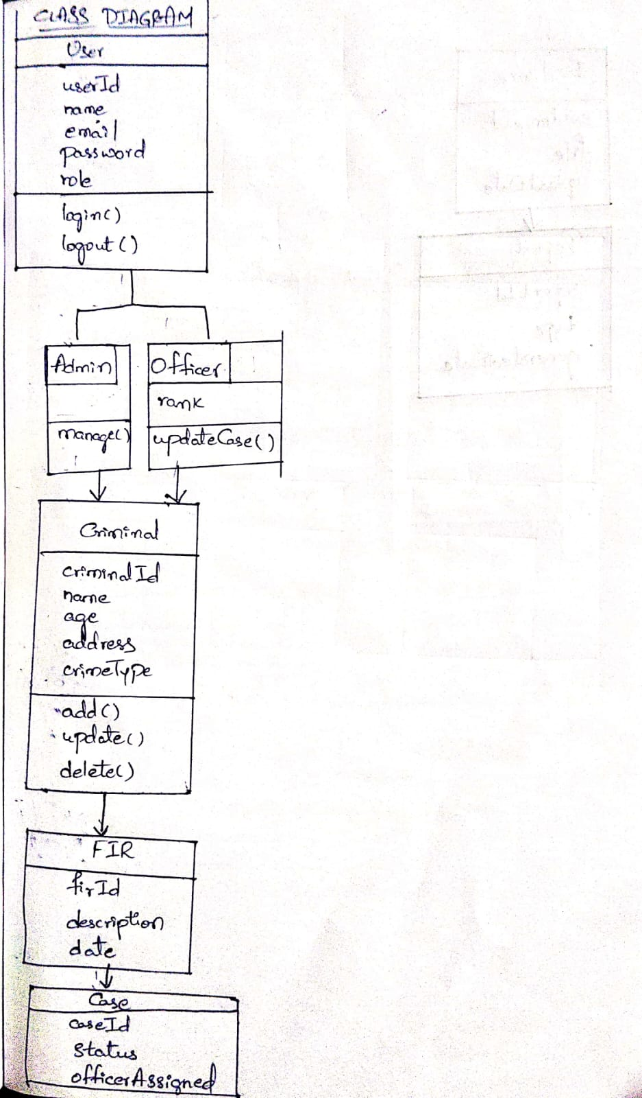
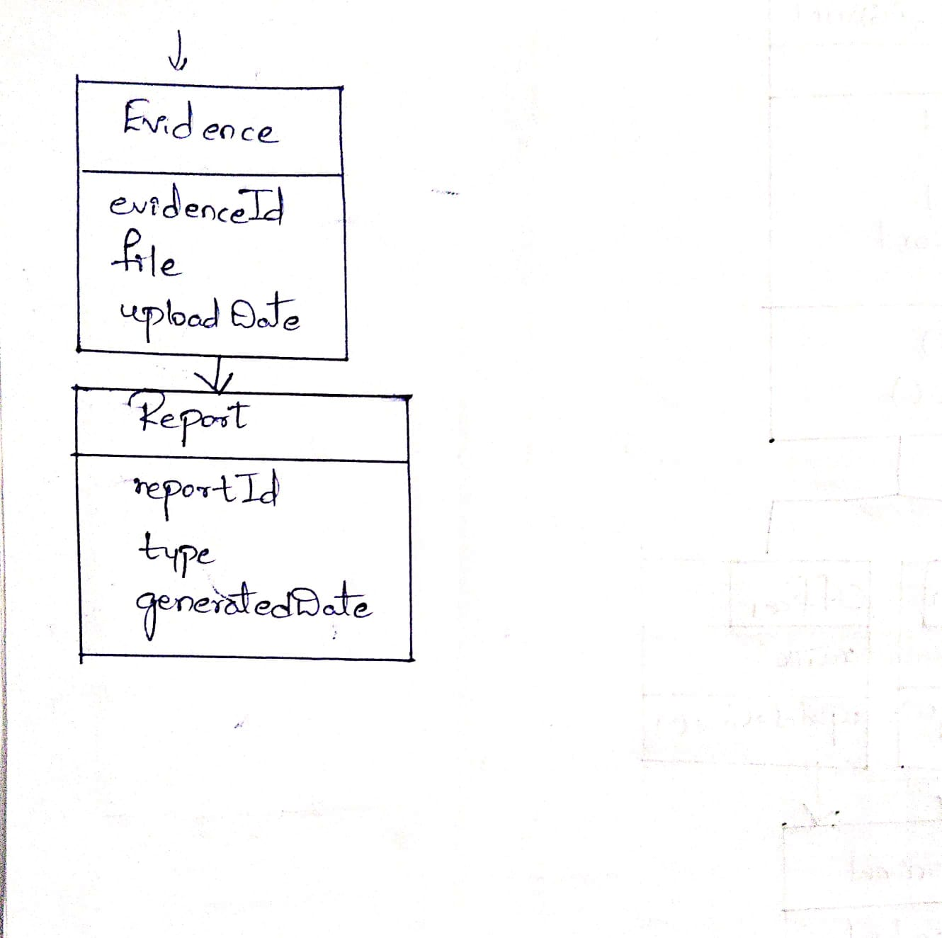
15.ASSUMPTIONS
- Users have valid login credentials.
- Internet connectivity is available.
- Only authorized personnel access the system.
- MongoDB Atlas and hosting services remain available.

16.CONSTRAINTS
- Internet connection is required.
- Unauthorized users cannot access sensitive data.
- The system depends on third-party cloud services such as MongoDB Atlas and deployment platforms.
- Performance may vary depending on server resources and network speed.

17.FUTURE ENHANCEMENTS
- Face Recognition
- Fingerprint Identification
- Crime Prediction using Machine Learning
- Mobile Application
- GIS-based Crime Mapping
- SMS/Email Notifications

18.CONCLUSION
The Crime Record Management System provides a secure, centralized, and efficient solution for managing crime-related information digitally. By integrating criminal records, FIR management, case tracking, officer management, evidence handling, and report generation into a single platform, the system enhances operational efficiency, improves data security, and reduces manual paperwork. The proposed system serves as a reliable and scalable solution for modern police departments.

