Liber-Primus Hangman demo v0.1
Introduction: This is a working demo, with limited testing. It’s all prototpye code ;-) The purpose of this app is to help find possible phrases that could be in the Liber Primus.
Requires: python 2 or 3 and PyQT4 or windows binary LP_Hangman.exe
Tested on linux and Windows 7
Get ngram data: can’t share on git too big a file compressed, please see
https://www.dropbox.com/s/36irgziw9o75b5z/ngram_data.7z?dl=0
Uncompress ngram_data.7z
Important: ngram_data files must be in this relative path
<install>\ngram_data\4gram\<letters>\file.text
And
<install>\ngram_data\1gram\<letter>\file.text
It’s way too big: The way of separating n-gram data into many files makes access fast, but takes up much more space. This can probably be improved. But don’t we all have many spare GB?
Run: LP_Hangman.py
Known Issues: The Liber Primus sentences structure is basically correct, but without punctuation at the moment. Sentences with less than 4 words will result in undefined behaviour. Yeah ,we know there’s a lot of data, we’ll keep working on that.
MORE HELP: http://webchat.freenode.net/?channels=cicadasolvers

Hints and Tips: Hopefully you should see something like this:
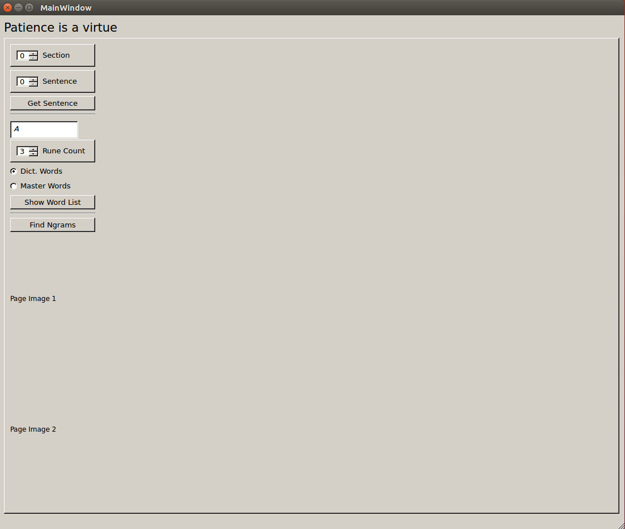
Choose a section (by side images) and sentence (by 4-dots). Press “Get Sentence”. This should build the main display with a GUI_wordWidget for each word. The displayed image pages from the Liber Primus are not yet correct.
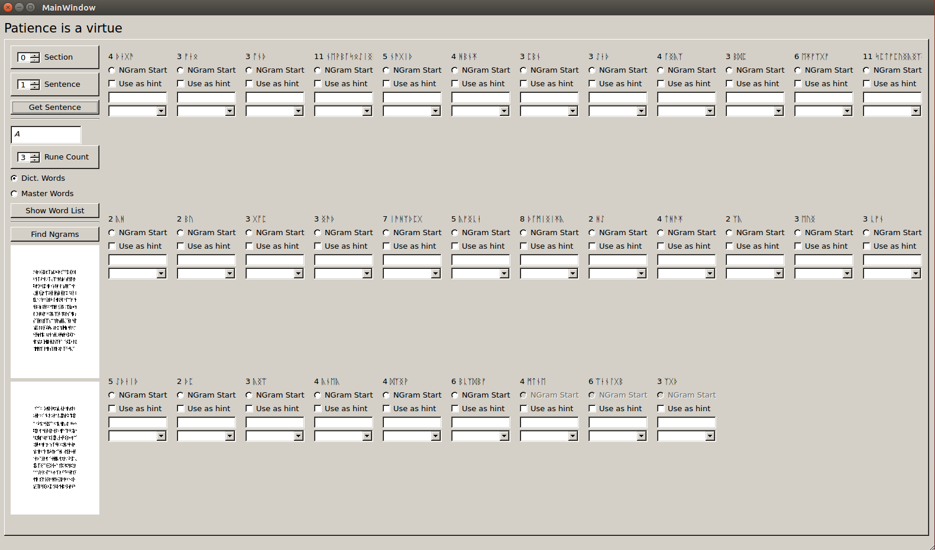
Example GUI_wordWidget
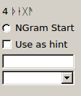
Each GUI_wordWidget has:
Top label, with word-rune-count and runes
Ngram Start radio-Button, select to make this word the start of the 4-gram being considered
Use as hint check box, select if you want to use the current Text Entry as a hint when looking up n-grams
Text Entry, your chosen word (or first letters of a word)
Unique Words, Combo box that is filled with unique words after an N-gram search
Choose an N-gram
We work in 4-grams, choose an Ngram Start radiobutton, this will activate the current and next 3 GUI_wordWidgets and deactivate the rest. The last 3 n-grams of the sentence should always be de-activated.
Press “Find Ngrams” this looks up mathching ngrams in the raw data. Each unique word will be added to the combo boxes, and a pop-up-window of all the complete n-grams will be displayed, with counts in the data.
For quicker results choose the first letter (or first few letters) of the first n-gram, and make sure “Use as hint” is checked. “Use as hint” for each word in the n-gram can be used to narrow your search.
While searching, the search criteria will be displayed in the Top Left.
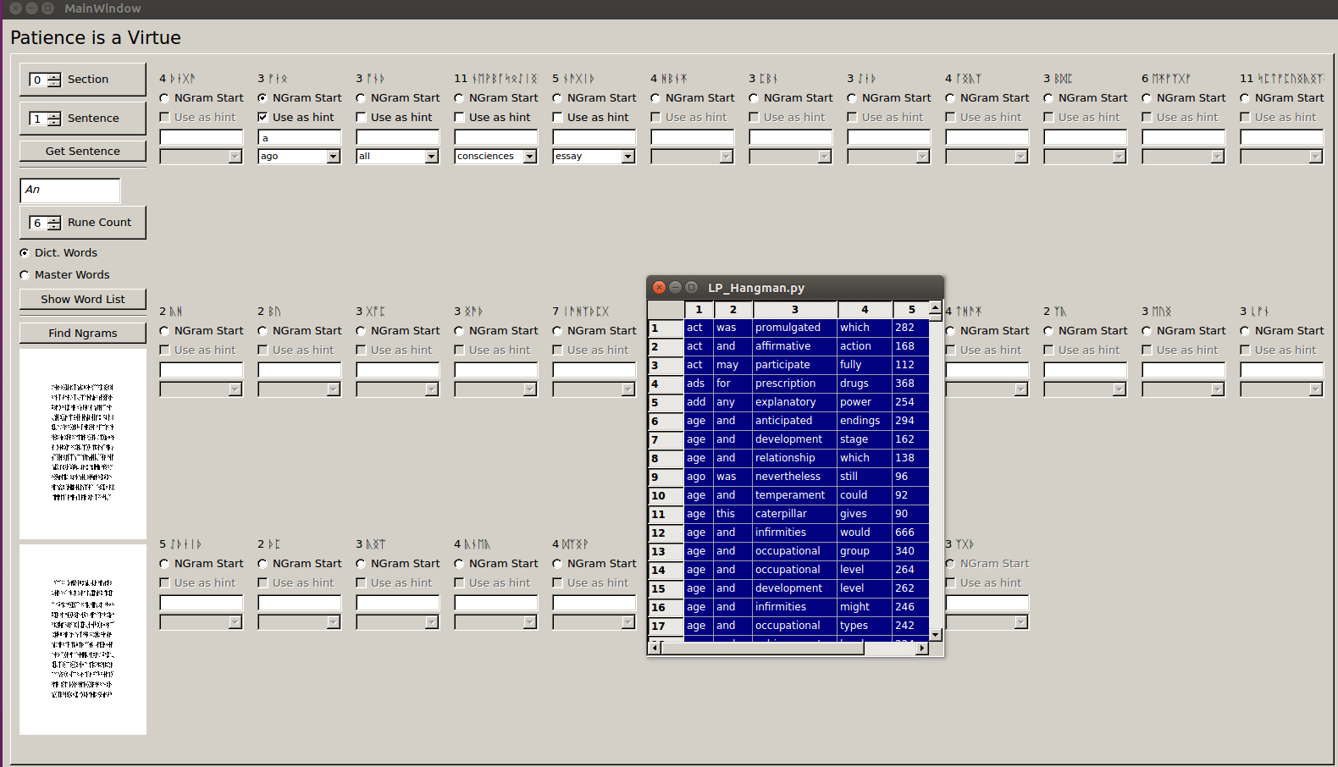

Once you’ve picked a word or two use them as hints and move on to a later ngram.
oneGram_Finder
Not sure of what words you can choose? Try the oneGram_Finder, on the Left hand Panel. Choose your starting letters, word-rune-count, and press “Show Word List” to display a pop-up window of all matching words, with their count from the corpus.
Controls
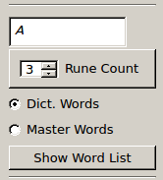
Example 1-grams:
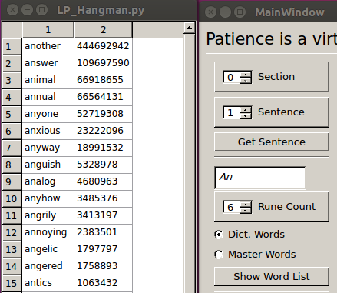

Master Words or Dict. Words ?
This radiobutton limits the serachs to common words from the master list, or uses all words found In a typical dictionary.

