SCOPE++: Sequence Classification Of homoPolymer Emissions (Supplementary Materials)
James T. Morton¹, Patricia Abrudan², Nathan Figueroa, and Chun Liang^{1,2}*, John E. Karro^{1,3,4}*
¹Department of ¹Computer Science and Software Engineering, ²Botany, ³Microbiology, and ⁴Statistics, Miami University, Oxford, Ohio, USA.

1. Methods

SCOPE++ identifies poly(A) tails through the alignment of imperfect sequence reads to a Hidden Markov Model. Using sliding windows for initial parameter values, a random sampling of the input as training data, and Viterbi training for HMM parameter optimization, SCOPE++ utilizes the Viterbi algorithm to approximate the most likely position of a poly(A) tail within any given fragment.

HMM Topology SCOPE++ identifies poly(A) tails using a variable-state Hidden Markov Model conforming to the topology illustrated in Figure 1 of the main manuscript. In Figure S1 we see a sequence read and its subdivision into four segment types (background, upstream tail ends, tail interior, and downstream-tail end). Each state corresponds to one of these segments; by aligning the read to the HMM we implicitly assign each base to a segment type, and thus identify our poly(A) tail bases (those assigned to the poly(A) state or any of the A states). The circular nature of the HMM topology allows for multiple poly(A) tails to be identified in a single fragment.

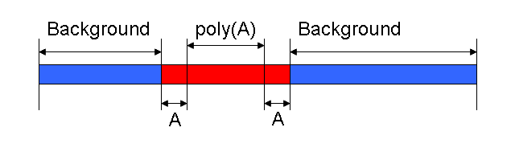
Figure S1: Example of a sequence read containing an identified poly(A) tail that has been divided into four types of segment: background (bases not part of the poly(A) tail), upstream tail-ends (tail bases within x of the upstream tail boundary), interior tail bases (further than at least x bases away from either boundary), and down-stream tail-ends.

Parameter Estimation Starting with this fixed topology and a set of fragments for cleaning, we need to estimate several parameters for the HMM which may be dependent on the characteristics of the biological data or the sequencing processes. Specifically, we need:

Transition probabilities: The probability that a given base is at the end of its segment. (e.g. The probability that a given poly(A) base is at the edge of the poly(A) tail, and hence will be followed by a base falling into an end-segment).

Emission probabilities: the base content distribution probabilities for each state type. Bases within a poly(A) tail may be listed as something other than adenine due to sequencing errors, leading to poly(A) state emission probabilities dependent on the sequencing technology’s propensity for such errors. For bases outside of the poly(A) tail, the distribution will be dependent on characteristics of the transcript containing the fragment. Hence the emission state probabilities will vary between data sets.

Note that the probabilities involving the end-segment states (the “A” states) are fixed: each of these states must transition to the next state with probability 1 (a characteristic inherent in their definition), and we require that each match an A (or T if searching a 3’ strand) with probability 1. That is, we do not allow errors at the last x bases at either end of the segment. Identifying errors at the very ends through computational means is inherently problematic (how could we distinguish a miss-called A at the end from a correctly called non-tail base next to the end?), so dis-allowing end errors is unlikely to contribute to an additional loss of result quality. In practice we use very small values of x (e.g. x=1), and by setting x to 0 a user can eliminate these states from the topology and hence remove such an assumption.

Given a large set of data to be cleaned and the fixed HMM topology, we estimate the remaining parameters by taking a sampling of the fragments, determining the approximate location of the poly(A) tails, and using these as the basis for Viterbi training. More specifically: we first employ a sliding window scoring filter to a random sample of the input data. The base-width M of the window is user specified (with a default value of M=10 nucleotides), and we start by looking at each length M window and scoring it by the difference in the number of adenine and non-adenine bases (or thymine if searching a complementary strand). We identify a window W_{Center} with the highest such score and, if the score exceeds a pre-determined threshold (2 by default), we take this as a potential subsequence of a poly(A) tail. The boundary windows, W_{left} and W_{right}, are then selected by finding the windows with scores at the threshold value surrounding W_{Center}. The centers of these boundary windows mark the edges of window W. W is now a segment with a large A (or T) content, and is labeled as a putative tail. In Figure S2 we see an example of the process using M=8. This method does (intentionally) tend towards the over-estimation of the actual boundaries, allowing us to compensate for the presence of base-call errors at the ends of the poly(A) tail.

Once we have collected our putative set of poly(A) tails from the fragment samples, we can estimate the HMM parameters. The emission probabilities can be determined by counting the base occurrences in each poly(A) tail and normalizing them to form a discrete distribution. Transition probabilities are calculated under the assumption that the tail length is geometrically distributed, with the expected length taken from the sample mean of the putative tails. In other words, we assume:

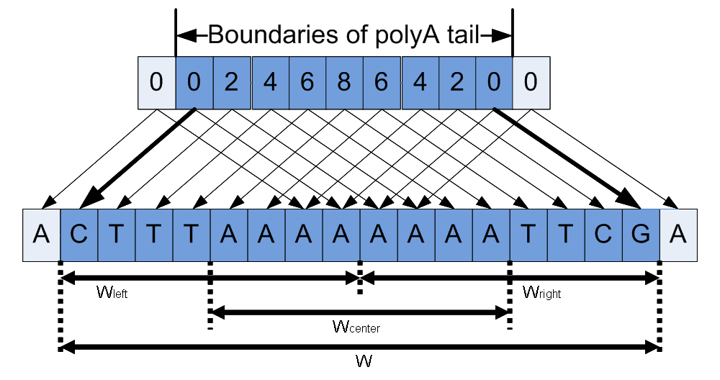
Figure S2: Illustration of poly(A) boundary estimation

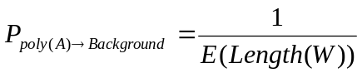

where the left side represents the probability that a given tail base is the last base of the tail. From this and the sample estimate of E(Length(W)) (as well as a similar assumption for background segments) we can easily derive initial estimates for all HMM transition probabilities. Following this, estimates can be further refined using Viterbi training. This algorithm adjusts parameters to maximize the sum of the scores resulting from the mapping of each member of the training set to the HMM using the Viterbi algorithm. That is, it heuristically adjusts the HMM parameters (given the fixed topology) that lead to the highest likelihood of matching the training set, and uses those parameters for the general problem.

Complexity The runtime of our algorithms, both training and mapping, are dependent on the runtime of the Viterbi algorithm; all other procedures used here will have runtimes bounded linearly in the number of bases. In general Viterbi is an O(nm²) algorithm, where n is the number of bases and m is the number of states. Given the size of n in Next-Generation sequencing output this could become prohibitive with even a moderate sized m, but we have two factors in our favor. First: m is dependent only on x (m = 2x+2), and x must be small to avoid high rates of false negatives. Second: the topology of the HMM is such that no state has more than two transitions into it. With a slight modification of the Viterbi algorithm this is easily exploitable, reducing the runtime to O(nx), or O(n) for any fixed value of x that will be used. (See Durbin et al. (Durbin et al., 1998) for a description of the Viterbi algorithm; the modification of this is trivial.) So, for a fixed, small x (and hence a fixed, small number of basses), we end up with a Viterbi implementation that has a runtime bound linear in the number of bases and with a small enough constant to allow the number of applications necessary for high throughput data (see the Results section of this document for an empirical verification).

2. Banchmark Data

In order to determine result quality, and to run a differential comparison against other tools, we needed benchmark sets for which correct poly(A) annotations are known. Further, we wanted to test result quality for each sequencing technology type (Illumina, 454, and Sanger), and also separate searching for poly(A) tails from the search for poly(T) tails on the reverse complement. As such we required six different benchmark sets.

Starting with 10 Gb of Illumina-sequenced Arabidopsis fragments, 29 Gb of 454-sequenced Chlamydomonas fragments, and 43 Gb Sanger-sequence human fragments (Wu et al., 2011), we chose 500 5’ sequences identified as having poly(A) tails and 500 3’ sequences identified as having poly(T) for each set, with all annotations performed and verified by human inspection. Each data set has 50 perfect (i.e. error-free) homopolymer sequences and 450 imperfect homopolymer sequences.

3. Tool Results

Quality of Results Result quality was tested using four measurements: sensitivity; percent of identified poly(A)/poly(T) tails that had both boundaries correctly identified; percent of identified poly(A)/poly(T) tails that had their “inner” boundary correctly identified (as SeqTrim and SeqClean do not identify outer edges); and sum-of-square inner boundary error (the average, over all identified tails, of the square of the difference between the predicted inner edge position and the actual inner edge position). We separate the second and third measures as the second is more important in terms of our objective (the precise identification of poly(A) tails), but the third reflects the objectives of the SeqTrim and SeqClean cools (and hence is a fairer comparison). Table S1 contains the results of applying each of the tools being tested to each of the six data sets using default tool parameters, as well as using SCOPE++ tool parameters tailored to each data set.

Error robustness We also compare the robustness of each tool to sequencing error. That is, the ability of each to tool to compensate for errors introduced into the sequence by the technology. The probability of a sequencing error will vary with technology, and we would expect the result quality to deteriorate as sequencing error increases. We tested this by introducing simulated error into our benchmark datasets. For each identified poly(A) tail, each base was set to an A with probability 1-p, and a randomly picked non-A base with probability p, thus simulating a base-call error of p. In Figure S1 we graphically show the results of ranging the error rate from 0 to 10 errors per 100 bases, using the human-validated Illumina data as our seed set for the simulation. We note that, unlike SeqClean or SeqTrim, SCOPE++ shows virtually no change in its sensitivity as the error rate increases, though its boundary accuracy decays at roughly the same rate as does SeqClean (but at a slower rate than SeqTrim).

Table S1: Results when applying each tool to the human-validated benchmark sets. "inner end" refers to the end of the poly(A) tail adjacent to coding data. Average square of boundary error is calculated by taking the average square of the distance between the predicted (inner) end and the actual inner end. The first three rows of each metric reports results using default tool parameters. The fourth row reflects the effect of optimizing SCOPE++ parameters separately for each dataset.

Runtime As SeqClean and SeqTrim are preforming tasks in addition to tail-cleaning, any runtime comparison between them and SCOPE++ would be meaningless. We did, however, empirically verify our claim of a runtime linear in the input size through a boot-strapping simulation (randomly picking, with replacement, m sequences from our initial dataset for the simulated set). For each size tested we ran the program on thirty simulated tests of SCOPE++, plotting the results in Figure S2. We observe the predicted linear correlation with 300,000 sequences, requiring approximately 30 seconds to process.

References
Durbin,R. et al. (1998) Biological Sequence Analysis: Probabilistic Models of Proteins and Nucleic Acids Cambridge University Press.
Wu,X. et al. (2011) Genome-wide landscape of polyadenylation in Arabidopsis provides evidence for extensive alternative polyadenylation. Proceedings of the National Academy of Sciences, 108, 12533–12538.

 |  | Illumina (Arabidopsis) |  | 454 (Chalamydomonus) |  | Sanger (Human) |  | Average
 |  | 5’ Strand | 3’ Strand | 5’ Strand | 3’ Strand | 5’ Strand | 3’ Strand | Average
Sensitivity | SeqTrim | 0.890 | 0.844 | 0.950 | 0.994 | 0.634 | 0.960 | 0.879
Sensitivity | SeqClean | 0.966 | 0.972 | 0.998 | 0.996 | 0.850 | 0.990 | 0.962
Sensitivity | SCOPE++ (default) | 1.000 | 0.998 | 1.000 | 0.998 | 0.998 | 0.996 | 0.998
Sensitivity | SCOPE++ (optimized) | 1.000 | 0.998 | 1.000 | 0.998 | 0.996 | 1.000 | 0.999
% correct boundary identification | SeqTrim | 0.240 | 0.268 | 0.099 | 0.000 | 0.151 | 0.237 | 0.166
% correct boundary identification | SeqClean | 0.414 | 0.181 | 0.100 | 0.002 | 0.165 | 0.810 | 0.279
% correct boundary identification | SCOPE++ (default) | 0.952 | 0.770 | 0.754 | 0.661 | 0.511 | 0.741 | 0.732
% correct boundary identification | SCOPE++ (optimized) | 1.000 | 0.998 | 1.000 | 0.998 | 0.996 | 1.000 | 0.999
% correct boundary identification (inner) | SeqTrim | 0.611 | 0.633 | 0.389 | 0.670 | 0.252 | 0.302 | 0.476
% correct boundary identification (inner) | SeqClean | 0.965 | 0.860 | 0.743 | 0.942 | 0.445 | 0.911 | 0.811
% correct boundary identification (inner) | SCOPE++ (default) | 0.964 | 0.824 | 0.902 | 0.956 | 0.599 | 0.749 | 0.832
% correct boundary identification (inner) | SCOPE++ (optimized) | 1.000 | 0.998 | 1.000 | 0.998 | 0.996 | 1.000 | 0.999
Average square of boundary error  (inner) | SeqTrim | 0.169 | 0.171 | 0.157 | 0.281 | 4.193 | 2.178 | 1.192
Average square of boundary error  (inner) | SeqClean | 0.258 | 0.913 | 0.190 | 0.483 | 1.257 | 5.432 | 1.422
Average square of boundary error  (inner) | SCOPE++ (default) | 0.198 | 0.423 | 0.233 | 0.557 | 1.143 | 1.438 | 0.665
Average square of boundary error  (inner) | SCOPE++ (optimized) | 1.000 | 0.998 | 1.000 | 0.998 | 0.996 | 1.000 | 0.999

Figure S1: Robustness to error. Based on the introduction of simulated error to our human-validated Illumina 5’ data set, ranging the error from 0 to 0.1 base-call errors per base.

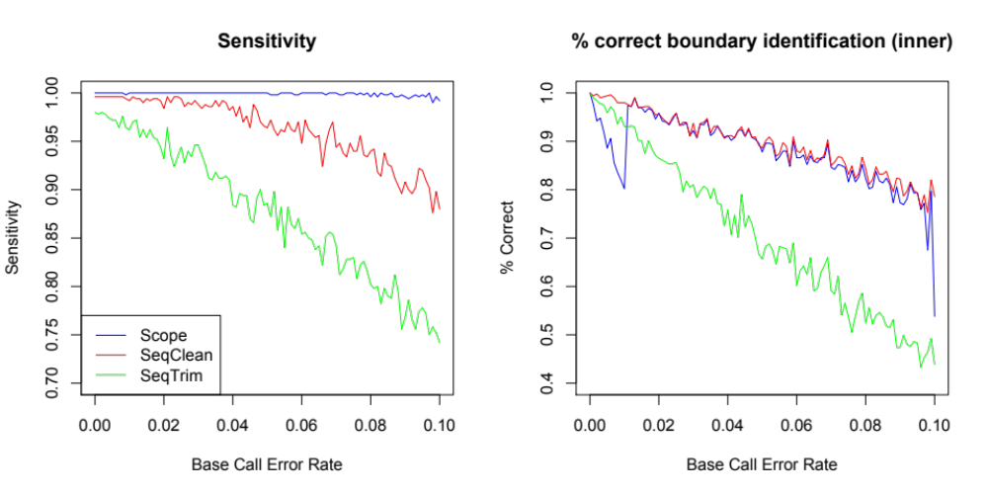

Figure S2: Runtime. A plot of runtime as a function of number of sequence reads, verifying a runtime bound that is linear in the input size. Test sets were created by a random sampling of the Illumina sequences (75 bases per fragement), for a total of 1500 runs over input sizes ranging from 0.75 Mb to 37.50 Mb (500,000 sequences), with the slowest run requiring 18.02 seconds for 36.75 Mb (distributed between 490,000 Illumina fragments). The least squares fit is shown in red (with a correlation coefficient of r = 0.992).
