Appendix C: IEEE 830 Template
Software Requirements Specification
for
Plainbase
Version v5
Prepared by Hubert Baranowski
Lodz University of Technology
21.04.2026
Table of Contents
Revision History
Name | Date | Reason for Changes | Version
Hubert Baranowski | 03.03.2026r. | Initial version | V1
Hubert Baranowski | 17.03.2026r. | Use case diagram | V2
Hubert Baranowski | 31.03.2026r. | Class diagram | V3
Hubert Baranowski | 14.04.2026r. | Sequence, state and activity diagrams | V4
Hubert Baranowski | 21.04.2026r. | Finalization of SRS | V5

1. Introduction

1.1. Purpose
Plainbase is a web application that allows users to query a PostgreSQL database using plain English instead of writing SQL manually. The purpose of this SRS is to describe the most important functional and nonfunctional requirements for the first version of the system. The system is intended for users who understand what data they need but do not have database programming knowledge.

1.2. Document Conventions
This document follows the IEEE 830 SRS structure in a shortened form. Functional requirements use the REQ prefix and nonfunctional requirements use the NF prefix. Requirements containing the word shall are mandatory.

1.3. Intended Audience and Reading Suggestions
The document is intended for developers, testers, maintainers, and project reviewers. Developers should focus on system features and interfaces, while testers should focus on the requirement lists in Sections 5 and 6.

1.4. Product Scope
Plainbase reduces the SQL knowledge barrier by translating a user question into a read-only SQL query, validating it, executing it on PostgreSQL, and displaying the results in a browser. The current release focuses on user account access, natural language query submission, SQL generation, read-only enforcement, result display, generated SQL transparency, schema reference, CSV export, and user-friendly error handling.

1.5. References
- IEEE Std 830-1998: Recommended Practice for Software Requirements Specifications.
- Plainbase Product Requirements Document, Version 1.0.
- PostgreSQL, Next.js, Anthropic Claude API, Railway, and PlantUML documentation.

2. Overall Description

2.1. Product Perspective
Plainbase is a new self-contained web application. It is not a complete business intelligence platform or database administration tool. It provides a simple browser interface connected to a backend API, an LLM service, and a PostgreSQL database. All database execution is handled server-side.

2.2. Product Features
- Registration and login for access to the query interface.
- Plain English input for database questions.
- SQL generation using the Claude API and schema context.
- Read-only SQL validation before execution.
- Formatted results table limited to 100 rows by default.
- Display-only generated SQL for transparency.
- Collapsed-by-default schema reference panel.
- CSV export and plain-English error messages.

2.3. User Classes and Characteristics
Primary users are non-technical data consumers such as analysts, managers, students, or domain experts who can describe their information need but cannot write SQL. Technical users, such as developers or maintainers, configure the database, deployment environment, and API keys.

2.4. Operating Environment
Plainbase runs as a Next.js web application in a Node.js environment and connects to PostgreSQL. It is intended to be deployed on Railway or a comparable hosting platform. Users access the system through modern browsers such as Chrome, Firefox, Safari, or Edge.

2.5. Design and Implementation Constraints
- The database engine for the current release shall be PostgreSQL.
- The system shall use server-side API routes for query execution.
- Only read-only SELECT statements shall be executed.
- Secrets such as DATABASE_URL and Claude API keys shall be stored as server-side environment variables.
- Generated SQL shall be displayed but not editable in the current release.
- Query results shall be limited to 100 rows by default.

2.6. Assumptions and Dependencies
The system depends on access to PostgreSQL, the Claude API, and schema metadata. It is assumed that users can phrase questions in plain English and that the connected database schema is suitable for read-only querying.

2.7. Use Case Diagram
The use case diagram gives a high-level view of how the User interacts with Plainbase: registering or logging in, asking questions, viewing schema information, viewing results, inspecting generated SQL, and exporting CSV files. External processing is supported by the Claude API and the backend query system.
Figure 1: Use Case Diagram - Plainbase

2.8. System Class Diagram
The class diagram shows the main structural components: PlainbaseApp, QueryRouteHandler, SchemaRouteHandler, LlmService, SqlValidator, and DbPoolProvider. The diagram emphasizes separation between UI state, API handling, SQL generation, validation, and database access.
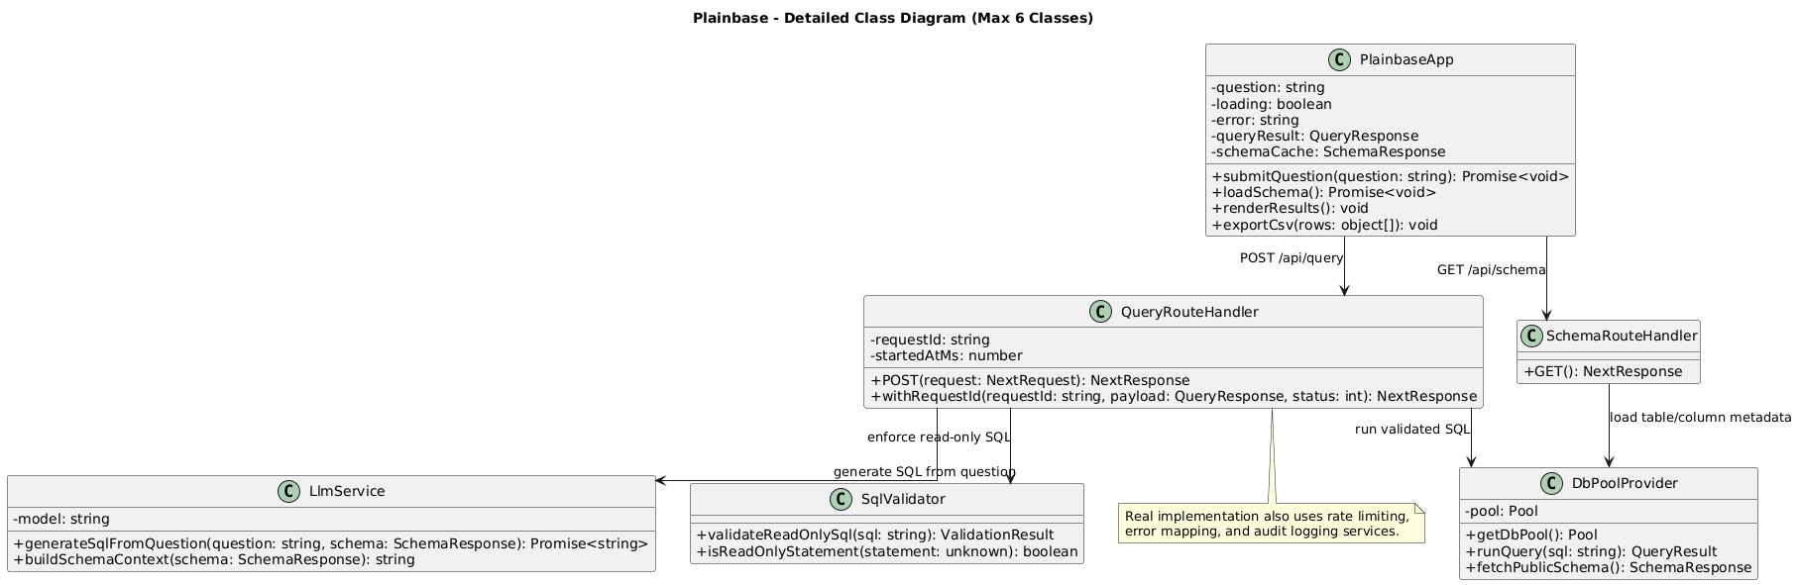
Figure 2: Class Diagram - Plainbase

3. System Features
The system is divided into the following main features:
- User account access: users register and log in before using the system.
- Natural language query submission: users enter a database question in plain English.
- Request processing and SQL generation: the backend sends the question and schema context to the LLM.
- Read-only SQL validation: the backend rejects unsafe SQL before execution.
- Database result view: validated queries are executed and displayed as a table.
- Schema reference and CSV export: users can inspect available tables and export results.
- Error handling and rate limiting: invalid or excessive requests return safe messages.

4. External Interface Requirements

4.1. User Interfaces Overview
The system shall provide a graphical browser interface. Before authentication, the user sees registration and login options. After authentication, the user sees a question input field, Run button, loading state, result table, display-only SQL section, Export CSV button, error area, and collapsible schema reference panel. The schema panel is collapsed by default.

4.2. Hardware Interfaces
Plainbase requires no special hardware. Users need a device capable of running a modern web browser. The server must be capable of running a Node.js web application and connecting to PostgreSQL.

4.3. Software Interfaces
- The frontend shall communicate with backend API routes over HTTP/HTTPS.
- The /api/query route shall process submitted questions and return results or errors.
- The /api/schema route shall return table and column metadata for the schema panel.
- The backend shall call the Claude API to generate SQL.
- The backend shall execute validated SQL against PostgreSQL only after validation.

5. System Features/Modules

5.1. Query Processing Pipeline

5.1.1 Description and Priority
This high-priority module covers the complete query flow: user input, backend processing, LLM SQL generation, SQL validation, database execution, and result display.

5.1.2 Stimulus/Response Sequences
Stimulus: A logged-in user submits a plain English question. Response: The system validates the request, generates SQL, validates the SQL, executes it if safe, and displays the results. If any step fails, the system returns a clear error message.

5.1.3 Functional Requirements
- REQ-1: The system shall allow users to register and log in.

- REQ-2: The application shall allow a logged-in user to submit a natural language database question.
- REQ-3: The backend shall generate PostgreSQL SQL using the user question and database schema context.
- REQ-4: The system shall validate every generated SQL statement before execution.
- REQ-5: The system shall execute only read-only SELECT queries.
- REQ-6: The system shall reject unsafe SQL statements such as INSERT, UPDATE, DELETE, DROP, ALTER, CREATE, and TRUNCATE.
- REQ-7: The system shall display query results in a formatted table with column headers.
- REQ-8: The system shall limit result sets to 100 rows by default.
- REQ-9: The system shall display the generated SQL as read-only text.
- REQ-10: The system shall provide a collapsed-by-default schema reference panel.
- REQ-11: The system shall allow the current result set to be exported as a CSV file.
- REQ-12: The system shall return user-friendly error messages for invalid input, unsafe SQL, rate limits, LLM errors, or database errors.

5.2. State Diagram
The state diagram presents the lifecycle of one query request. A request begins as Received, may be Rejected, moves through GeneratingSql and RunningSql when valid, and finishes as Success or Failed.
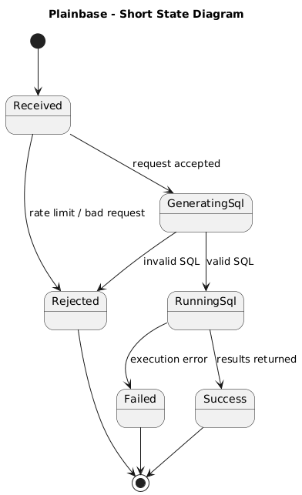
Figure 3: State Diagram - Plainbase Query Request

5.3. Activity Diagram
The activity diagram shows the backend decision flow. The request and rate limit are checked first. SQL is generated only for valid requests, and database execution happens only after SQL validation succeeds.
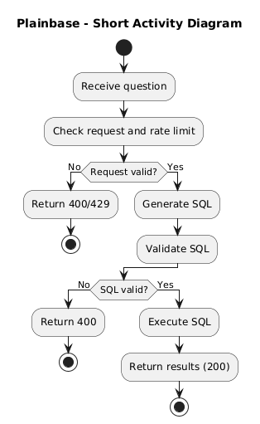
Figure 4: Activity Diagram - Plainbase Query Processing

5.4. Sequence Diagram
The sequence diagram shows communication between the User, PlainbaseApp, /api/query, LlmService, SqlValidator, and PostgreSQL. Invalid SQL returns an error before any database execution; valid SQL is executed and returned as results.
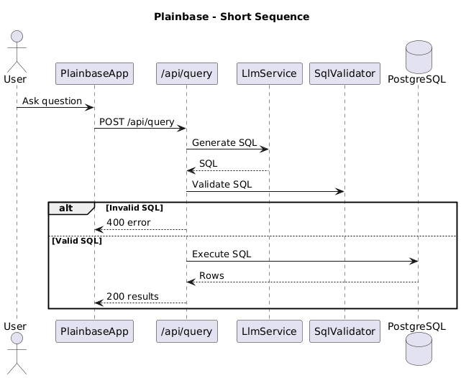
Figure 5: Sequence Diagram - Plainbase Query Flow

6. Nonfunctional Requirements

6.1. Performance
- NF-1.1: Typical query responses shall be returned in less than 5 seconds.
- NF-1.2: Result sets shall be limited to 100 rows by default.
- NF-1.3: The interface shall show a loading state during processing.

6.2. Security
- NF-2.1: Database access shall happen server-side only.
- NF-2.2: Secrets shall not be exposed to the browser.
- NF-2.3: Non-read-only SQL shall be rejected before execution.
- NF-2.4: Raw database errors and stack traces shall not be shown to users.
- NF-2.5: The main query interface shall be restricted to logged-in users.

6.3. Usability and Maintainability
- NF-3.1: The interface shall be understandable for users without SQL training.
- NF-3.2: The schema reference shall help users phrase valid questions.
- NF-3.3: The codebase shall separate UI, API routes, LLM integration, validation, and database access into maintainable modules.
- NF-3.4: The system shall be structured so future query history, charts, and multi-database support can be added later.

