《Introduction to Database System A*》Experiment report 7
contents：DML in SQL |  | lab：10-409/11.14
 |  | Instructor:liuli
Student ID: | Student Name:
Software Environment ：
Windows+Mysql+GUI

The exercises are all based on the supplier-parts database.
Tables:
S:supplier(with supplier’s ID[SID], name[SNAME], locations[CITY] and the associated status[STATUS])
P:part(with each part’s id[PID], name[PNAME], color[COLOR], weight[WEIGHT] and the location[CITY] it stores in)
SP:supplier-part(the shipment of part[PID] from supplier[SID] with the quantity[QTY])

Part 1:Set up database and tables. Input data below to the tables.

S
SID | SNAME | STATUS | CITY
S1 | Smith | 20 | London
S2 | Jones | 10 | Paris
S3 | Blake | 30 | Paris
S4 | Clark | 20 | London
S5 | Adams | 30 | Athens

P
PID | PNAME | COLOR | WEIGHT | CITY
P1 | Nut | Red | 12 | London
P2 | Bolt | Green | 17 | Paris
P3 | Screw | Blue | 17 | Oslo
P4 | Screw | Red | 14 | London
P5 | Cam | Blue | 12 | Paris
P6 | Cog | Red | 19 | London

SP
SID | PID | QTY
S1 | P1 | 300
S1 | P2 | 200
S1 | P3 | 400
S1 | P4 | 200
S1 | P5 | 100
S1 | P6 | 100
S2 | P1 | 300
S2 | P2 | 400
S3 | P2 | 200
S4 | P3 | 200
S4 | P4 | 300
S4 | P5 | 400

- Get supplier numbers for suppliers in Paris with status >20
SELECT sid
FROM S
WHERE city = 'Paris' AND status > 20;
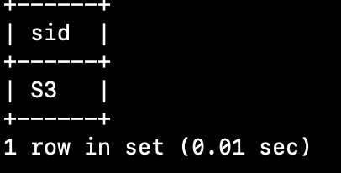

- Get part numbers for all parts supplied , with redundant duplicates eliminated
SELECT DISTINCT pid
FROM p;
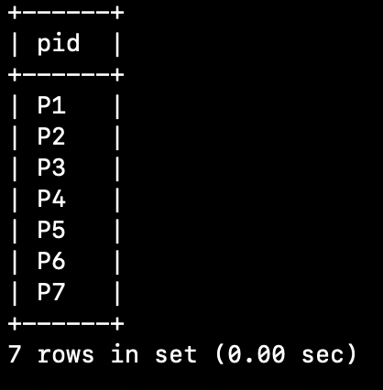

- get supplier numbers and status for suppliers in Paris, in ascending supplier number order within descending status order:
SELECT sid,status
FROM s
WHERE CITY = 'Paris'
ORDER BY sid ASC, status DESC;
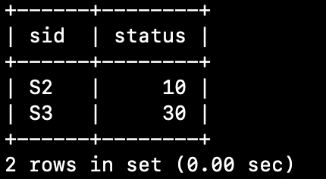

- Get parts whose weight is in the range 16 to 19 inclusive
SELECT *
FROM p
WHERE weight BETWEEN 16 AND 19;
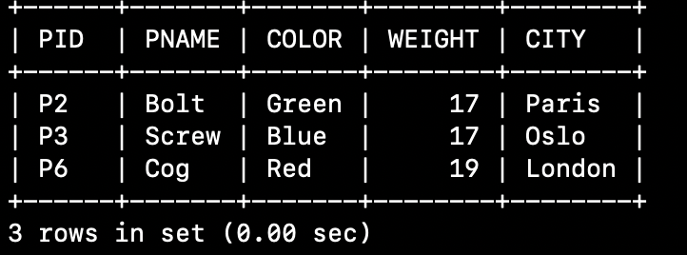

- For all parts, get the part number and the weight of the part in grams with gwht as title
SELECT pid, weight * 454 AS grams
FROM p;
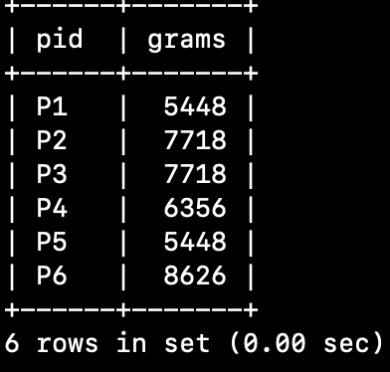

- Get supplier names for suppliers who supply part p2(3 solutions)

SELECT sname
FROM s,sp
WHERE s.sid = sp.sid AND sp.pid = 'p2';

SELECT sname
FROM s
WHERE sid IN
(SELECT sid
FROM sp
WHERE pid = 'p2');

SELECT sname
FROM
(SELECT sname
FROM s
WHERE
EXISTS
(SELECT *
FROM sp
WHERE sp.sid = s.sid AND sp.pid = 'P2')) a;
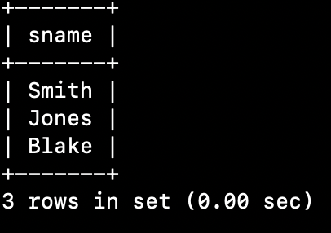

- Get all supplier-number/part-number pairs such that the supplier and part concerned are “colocated”(in the same city)
SELECT pid,sid
FROM p,s
WHERE p.city = s.city;
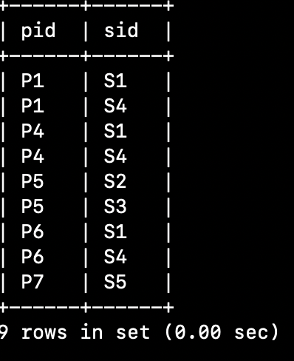

- Get all pairs of supplier numbers such that the suppliers concerned are collocated
SELECT s1.sid, s2.sid
FROM s s1, s s2
WHERE s1.city = s2.city AND s1.sid > s2.sid;
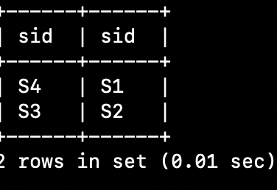

- Get all pairs of city names such that a supplier located in the first city supplies a part stored in the second city
SELECT s.city, p.city
FROM s,p,sp
WHERE s.sid=sp.sid AND p.pid=sp.pid AND s.city != p.city;
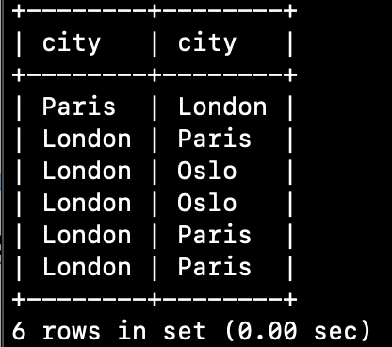

- Get the total quantity of part p2 supplied:
SELECT SUM(QTY)
FROM sp
WHERE pid = 'p2';
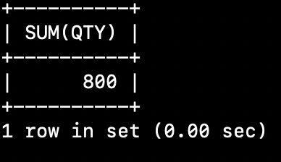

- Get the total number of suppliers
SELECT COUNT(*) FROM s;
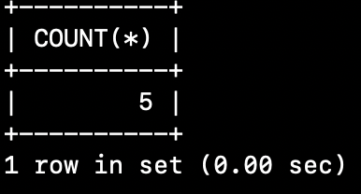

- Get the maximum and minimum quantity for part p2
SELECT MAX(QTY), MIN(QTY) FROM sp WHERE pid = 'p2';
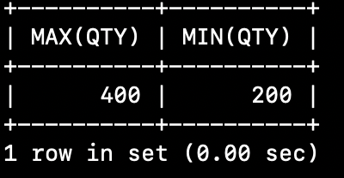

- For each part supplied, get the part number and the total shipment quantity(group by in SQL)
SELECT pid,SUM(qty)
FROM sp
GROUP BY pid;
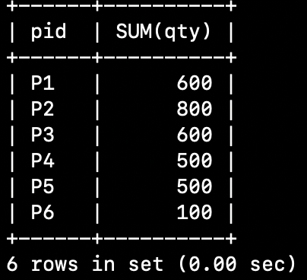

- Get distinct part numbers for all parts supplied by more than one supplier
SELECT DISTINCT pid
FROM sp
GROUP BY pid
HAVING count(sid) > 1;
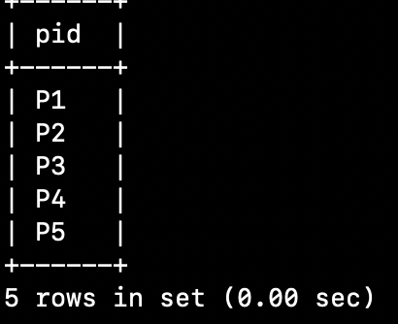

- Get supplier names for suppliers who supply at least one red part
SELECT DISTINCT sname
FROM s, (SELECT pid FROM p WHERE COLOR = 'red') pred, sp
WHERE s.sid=sp.sid AND pred.pid=sp.pid;
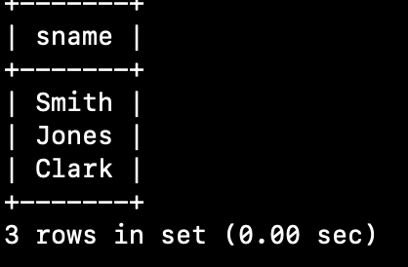

- Get supplier names for suppliers who do not supply part p2
SELECT DISTINCT sname
FROM s, (SELECT sid FROM sp WHERE pid != 'p2') sp2
WHERE s.sid = sp2.sid;
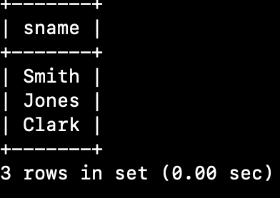

- Get part numbers for parts that either weigh more than 16 pounds or are supplied by supplier s2,or both
select pid FROM p
WHERE weight > 16 OR pid IN
(SELECT pid
FROM sp
WHERE sid='s2');
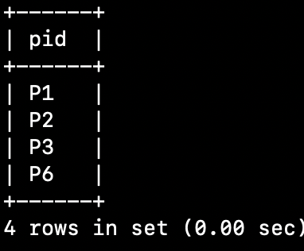
- Insert part p7(city Athens ,weight 24,name and color at present unknown into table P)
INSERT INTO p(PID,WEIGHT,CITY)
VALUES
('P7',24,'Athens');
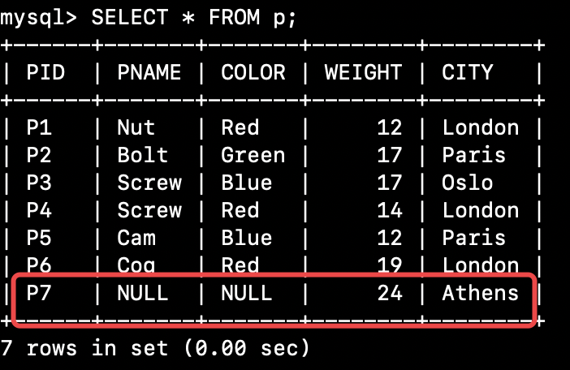

- Delete all shipments with quantity greater than 300:
DELETE FROM sp
WHERE qty > 300;
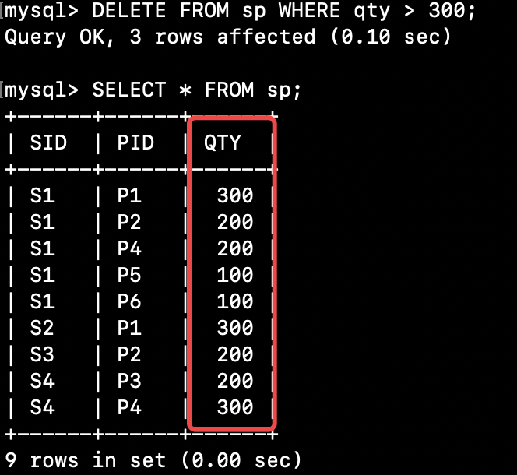

- Change the color of part p2 to yellow, increase the weight by 5, and set the city to Oslo:
UPDATE p SET color='yellow', weight=weight+5, city='Oslo'
WHERE pid = 'p2';
