《Introduction to Database System A*》optional Experiment 7
contents：DML in SQL |  | lab：10-409/11.14
 |  | Instructor:liuli
Student ID:2017329621125 | Student Name:田野
Software Environment ：
Windows+Mysql+GUI

Experiment background:
Bookstore
窗体顶端
Consider the following database schema for a BOOKSTORE database:
- Books (bookid, title, author, year)
- Customers (customerid, name, email)
- Purchases (customerid, bookid, year)
- Reviews (customerid, bookid, rating)
- Pricing (bookid, format, price)
The Books relation stores information about books sold by the bookstore. Note that bookid is the primary key. An example tuple is as follows:
(105, 'JAVA PROGRAMMING', 'JOHN DOE', 2001)
The Customers relation stores information about the customers of the bookstore. Note that customerid is the primary key. An example tuple is as follows:
(210, 'JOHN SMITH', 'SMITH@YAHOO.COM')
The Purchases relation stores information about the customer purchases of books. Note that customerid and bookid form the primary key. An example tuple is as follows:
(210, 105, 2002), indicating that 'JOHN SMITH' with customerid 210 purchased the 'JAVA PROGRAMMING' book with bookid 105 in the year 2002.
The Reviews relation stores information about the customer reviews/ratings of the books. The ratings field refers to the number of "stars" given to the book. Note that and bookid form the primary key. An example tuple is as follows:
(210, 105, 3), indicating that 'JOHN SMITH' with customerid 210 gave a 3-star rating to the 'JAVA PROGRAMMING' book with bookid 105.
The Pricing relation stores information about the price of the various books sold by the bookstore. Note that the same book can be available in multiple formats at possibly different prices. The price field refers to the number of dollars. For instance a $25 purchase will have a price field of 25. Note that the bookid and format fields form the primary key for the relation. An example tuple is as follows:
(105, 'AUDIO', 25), indicating that the 'JAVA PROGRAMMING' book with bookid 105 is available in the audio format for $25.
Given the above schema, write queries for the following:
- Use create table statement to set tables for each schema.
CREATE TABLE books (
bookid` int(11),
title varchar(20),
author varchar(20),
year year(4),
PRIMARY KEY (bookid)
);
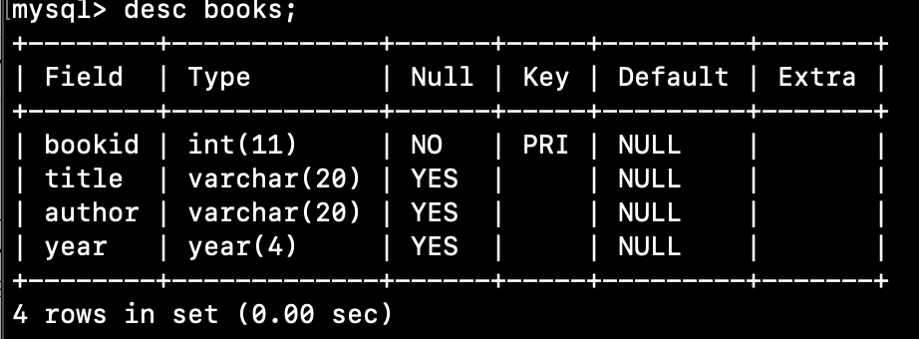

CREATE TABLE customers (
customerid int(11),
name varchar(20),
email varchar(20),
PRIMARY KEY (customerid)
);
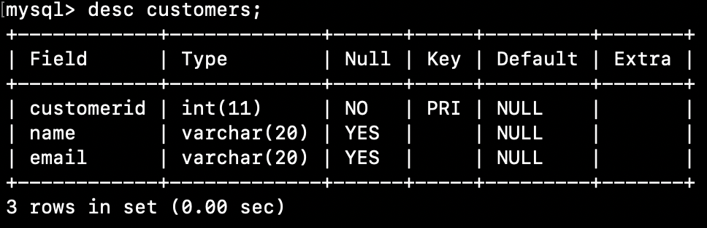

CREATE TABLE Purchases(
customerid INT(11),
bookid INT(11),
year YEAR(4),
PRIMARY KEY(customerid, bookid)
);
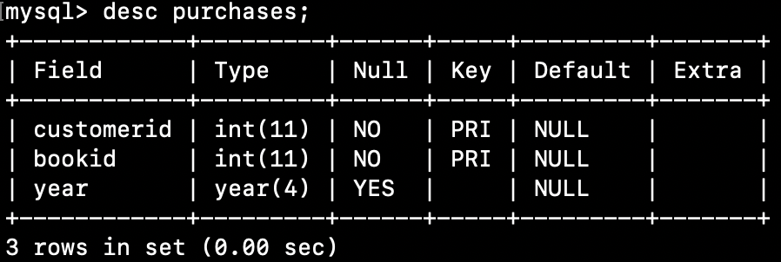

CREATE TABLE Reviews(
customerid INT(11),
bookid INT(11),
rating INT,
PRIMARY KEY(bookid)
);
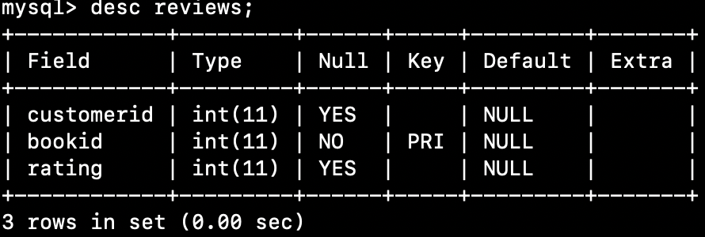

CREATE TABLE Pricing(
bookid INT(11),
format VARCHAR(20),
price INT(11),
PRIMARY KEY(bookid,format)
);
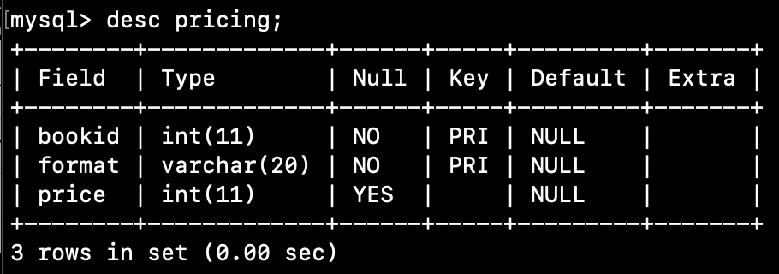

- Add tuples for 5 tables.
INSERT INTO books(bookid, title, author, year)
VALUES
(105, 'JAVA PROGRAMMING', 'JOHN DOE', 2001);
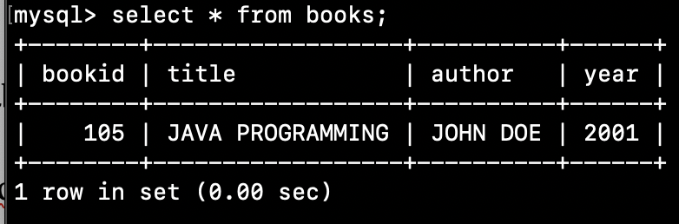

INSERT INTO customers(customerid, name, email)
VALUES
(210, 'JOHN SMITH', 'SMITH@YAHOO.COM')
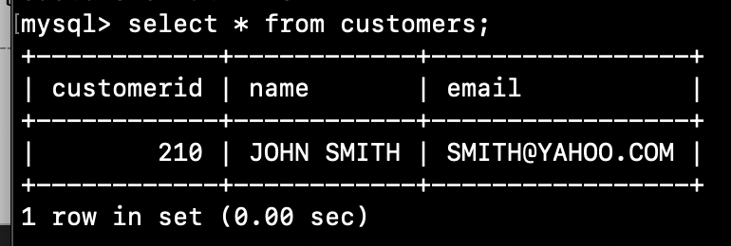

INSERT INTO purchases(customerid, bookid, year)
VALUES
(210,105,2002);
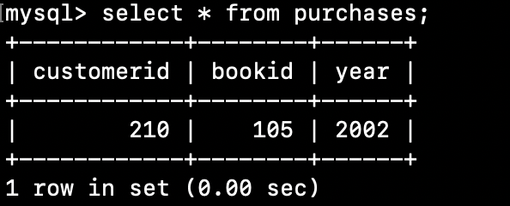

INSERT INTO reviews(customerid, bookid, rating)
VALUES
(210, 105,3);
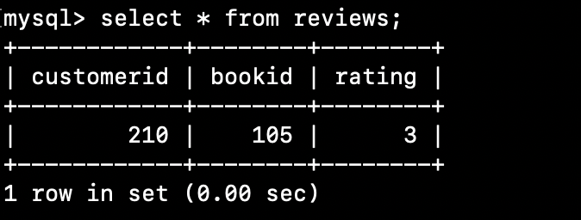

INSERT INTO pricing(bookid, format, price)
VALUES
(105, 'AUDIO', 25);
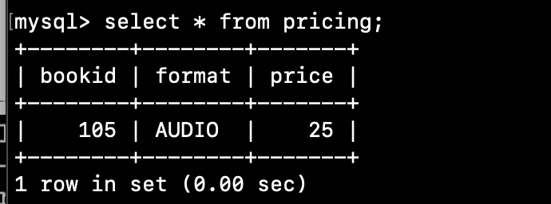

- Find books (show their titles) written by 'EDMUND MORGAN' since year 1990.
SELECT title
FROM books
WHERE author = 'EDMUND MORGAN' AND year >= 1990;
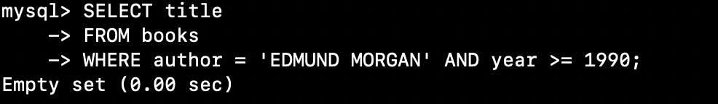

- Find books (show their titles, authors and prices) that are on 'CIVIL WAR' (i.e., the title field contains 'CIVIL WAR'), available in 'AUDIO' format.

SELECT books.title, books.author, pricing.price
FROM books,pricing
WHERE books.bookid = pricing.bookid
AND books.title LIKE '%CIVIL WAR%'
AND pricing.format='AUDIO';


- For each year, 'JOHN CHAMBERS' purchased at least one book, find the number of books purchased. That is, the output should be a set of tuples, each indicating a year and the number of books purchased by 'JOHN CHAMBERS' in that year.
SELECT p.year, count(p.bookid)
FROM customers c, purchases p
WHERE c.name = 'JOHN CHAMBERS'
AND p.customerid=c.customerid
GROUP BY p.year;


- Find customers (show their names and book numbers) who purchased more than one book in year 2003.
SELECT c.name, COUNT(p.bookid) AS booknumbers
FROM customers c, purchases p
WHERE c.customerid=p.customerid
AND p.year=2003
GROUP BY c.name
HAVING COUNT(p.bookid) > 1;
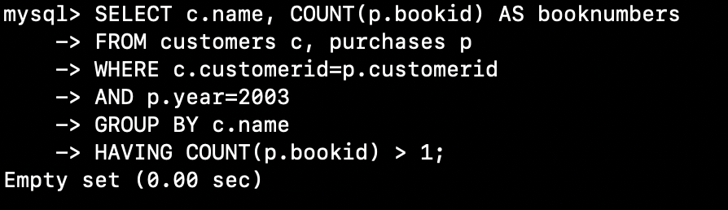
- Find the ratings information (show titles, average ratings) for books on 'CIVIL WAR' (i.e., title contains 'CIVIL WAR').
SELECT b.title, AVG(r.rating)
FROM books b, reviews r
WHERE r.bookid=b.bookid
AND b.title LIKE '%CIVIL WAR%'
GROUP BY b.title;
