《Introduction to Database System A*》Experiment 8

contents：constrains  Priamry key constrains ,foreign key constrains,check constrains |  | lab：10-409
Instructor: liuli
Stu_id 2017329621125 | Stu_name 田野
Software Environment ：
MYSQL/SQLServer
Purpose：
1.To understand database constrains better by implementing constrains declaration （ primary key, foreign key, not null, check etc. ）on the running database.

notation：

- Define table
CREATE TABLE <table_name>(
Attributes1 TYPE [DEFAULT value][NOT NULL][<constraints >],
Attributes2 TYPE [DEFAULT value][NOT NULL][<constraints >],
……
[constraints]
)
- Define constraints
- Declare primary key Constraint
  - declare primary key constraint when we declare an attribute
  - Make an additional declaration that says a particular attribute or set of attributes form a key.eg.
CREATE TABLE <name> (
<list of elements>
PRIMARY KEY(<attributes>)
Or UNIQUE(<attributes>)
);

- Declare Foreign key Constraint
(before declare the foreign key, the referenced attribute or attributes set must have been defined as the primary key in the referenced table)
CREATE TABLE <name> (
<list of elements>
Foreign key(<attributes>) REFERENCES <table>(<attributes>)
[ON UPDATE SET NULL|CASCADE]
[ON DELETE SET NULL|CASCADE]
);

- Declare SQL CHECK Constraint on CREATE TABLE
CREATE TABLE <name> (
<list of elements>
CHECK(<conditions>)
);

Example:

CREATE TABLE movieexec (
name char(30),
address varchar(100) ,
cert int(11) ,
netWorth int(11) ,
PRIMARY KEY (cert)
)

CREATE TABLE Studio (
name CHAR(30) PRIMARY KEY,
address VARCHAR(255) NOT NULL,
code INT CHECK(code>30000),
presC INT DEFAULT 0,
FOREIGN KEY(presC) REFERENCES MovieExec(cert)
ON DELETE CASCADE
ON UPDATE SET NULL
);

Experiment contents:
Background description is shown in project1:
Schema for our running example:
Movies(title,year,length,movietype, studioname, producerC)
movieStar(name,address,gender,birthdate)
starsIn(movietitle,movieyear,starname)
Studio(name,address,presC)
Movieexec(name,address,cert,networth)
list your answer in the last page. Handing your answer file with the file name as Experiment8 _ID.
part1: Create new database as “my_own_Movie_database”;Write Create table statement with SQL to define the table based on the above relation schema ;be sure to include the constrains in the following list:( To define the foreign key constraint,you should define primary key in referenced table first );
- declare primary key for each relation based on the schema above;
- the length in movie can not be null;
- the gender in Moviestar can only either be ‘F’ or ‘M’;
- declare the foreign key constraints for the database such that every studio in movies must appear in table studio(studioname in table movies references the table studio);
- declare the foreign key constraints for the database such that every star in starsin must appear in table moviestar; (choose policies such that the update of starname from moviestar leads to same changes in the table starsin ; deletion of stars from moviestar leads to the null value of the movie in table starsin)
- declare the foreign key constraints for the database such that each movie in starsin must appear in table movies; (choose policies such that the update of movie information(title, year or both) from movies leads to same changes in the table starsin ; deletion of movies from movies leads to deletion of the corresponding tuples in table starsin)
Write the SQL statement to create tables for the database

Part 2: load data from our experimental document data_for_movie.sql.and then based on foreign key constraints,add the following information for tables(movies,studio,starsin,moviestar) in a reasonable order.
Movie: ''Harry Potter and the Order of the Phoenix ',2007,120minutes
Studio:'Warner Bros.'
stars:Daniel Radcliffe,birthdate:1989-7-23,male actors in the movie
Write the SQL statement to add these tuples.
Then :copy the picture for data on each table in the answering area.

*Part 3:write 5 numbers of sql sentences of manipulation(insert,update,delete) on table movies,moviestar,or starsin so that there may be violation of foreign key constraints running these statements.analyze the reason.

Part 4:
Let’s consider the following foreign key constrains for table movies.
FOREIGN KEY(studioname)
REFERENCES studio(name)
ON DELETE SET NULL
ON UPDATE CASCADE
explain what happens, if anything, to maintain the referential integrity constrains in each of the following cases:
- a tuple in STUDIO is deleted;
- Update a name value in STUDIO;
- Update studioname in movies from the old value to a new value that is not in studio;

Part 1:

Create table statement including constraint
CREATE DATABASE my_own_Movie_database;

CREATE TABLE studio(
name VARCHAR(20),
address VARCHAR(100),
presC INTEGER(5),
PRIMARY KEY(name)
);

CREATE TABLE movies(
title VARCHAR(30),
year INTEGER(4),
length INTEGER(4) NOT NULL,
movietype VARCHAR(30),
studioname VARCHAR(30),
producerC INTEGER(2),
PRIMARY KEY(title,year),
FOREIGN KEY(studioname) REFERENCES studio(name) );

CREATE TABLE moviestar(
name VARCHAR(30),
address VARCHAR(100),
gender char(1),
CHECK(gender = 'F' or gender ='M'),
birthdate DATE,
PRIMARY KEY(name)
);

CREATE TABLE starsin(
movietitle VARCHAR(30),
movieyear INT(5),
starname VARCHAR(30),
FOREIGN KEY(starname) REFERENCES moviestar(name)
ON DELETE SET NULL
ON UPDATE CASCADE,
FOREIGN KEY(movietitle, movieyear) REFERENCES movies(title,year)
ON DELETE CASCADE
ON UPDATE CASCADE
);

CREATE TABLE Movieexec(
name varchar(30),
address varchar(100),
cert integer(20),
networth integer(20),
PRIMARY KEY(name)
);

Part 2:

Questions:
1.
INSERT INTO moviestar(name, gender, birthdate)
VALUES
('Daniel Radcliffe','M','1989-7-23');

2.
INSERT INTO studio(name)
VALUES
('Warner Bros');

3.
INSERT INTO movies(title,year,length,studioname)
VALUES
('Harry Potter and the Order of the Phoenix',2007,120,'Warner Bros');

4.
INSERT INTO starsin
VALUES
('Harry Potter and the Order of the Phoenix',2007,'Daniel Radcliffe');

Pictures:
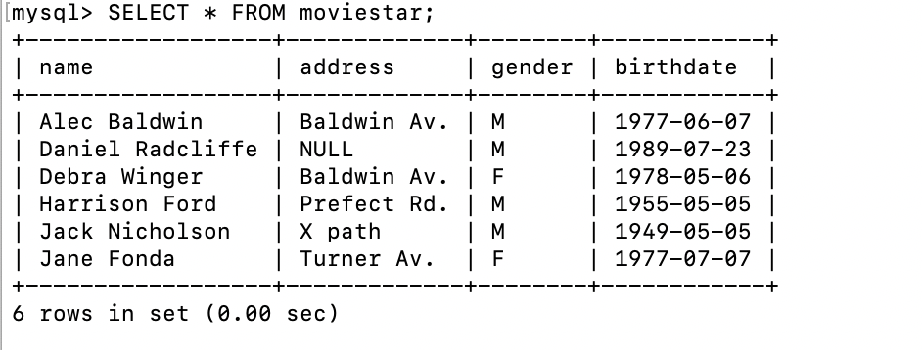

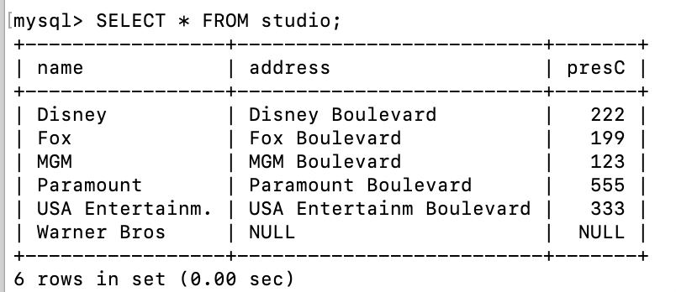

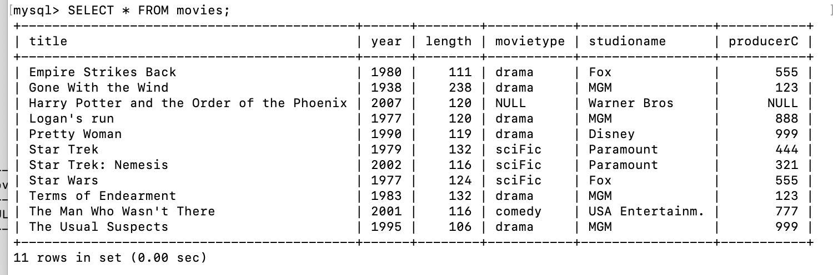

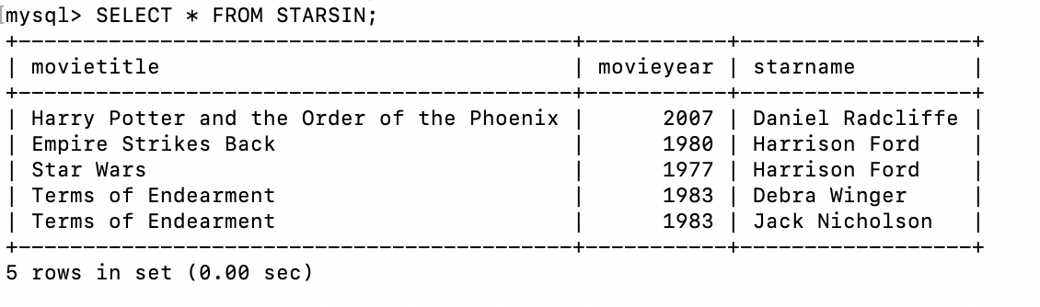

Part 3:
- INSERT INTO starsin VALUES ('movie',2019,'ttt');
Reason: When insert some data into starsin, because there are foreign key, so if the data’s movietitle starname and doesn’t exists in movie table and moviestar table, it will raise error.

- Insert into movieStar
VALUES
(‘Mark', ‘Tony’, ’Female’, ’1998-04-01');
Reason: gender in movieStar must be ‘F’ or ‘M’.

- Delete from movieStar where name=‘Jack Nicholson’;
Reason: Because of the foreign key constraint, name from movieStar can not be deleted if it exists in starsIn. And ‘Jack Nicholson’ is in starname from starsIn.
- Insert into Movies (year, length, movietype, studioname, producerC)
VALUES
(1988,132,’drama’,’Fox',123);
Reason: In movies title is the primary key, and it can’t be null.

- Update starsIn set starname=‘Tony Stark’;
Reason: starsname in starIn must also be in name from movieStar. But ‘Tony Stark’ is not in movieStar. So it can not be updated in starsIn.

Part 4:
- Because the on delete is set null, so when a tuple in STUDIO is deleted, in table movies, the tuple which has the same studio name will be deleted either.

- Because the on update is cascade, so when a name value in STUDIO is updated, in the movies, the corresponding name will be updated to the new name too.

- This operation will raise an error and will not be executed. Because the foreign key restrict studionamne in movies must appear in the studio.

