《Introduction to Database System A*》Experiment report 5
contents：DML in SQL,fsubquery |  | lab：10-409
 |  | Instructor:liuli
Student ID:2017329621125 | Student Name:田野
Software Environment ：
Windows+Mysql+GUI

- Purpose：
The exercise is to have a taste on subquery
To use in any all exists properly before subquery

- Guidance for the laboratory exercise：
notation：
SELECT [DISTINCT] A₁[AS ALIAS1], A₂[as ALIAS2]…
FROM R
[WHERE condtion]
[GROUP BY A_{i},A_{j}
HAVING _{condition}]
[ORDER BY attribute list ASC|DESC];

- Tips for SQL statement in MySQL:
Steps

contents ():
(1)Write SQL statements and execute each statement for the following queries(questions );
(2) After you have successfully execute the statement, copy this statement to the document ; paste the snapshot picture for each execution result of the SQL statement in the document; Handing your answer file using the file name as exp5 _ID(ID should be replaced by your own student ID);

Experiment background:
we have set up a database “my_movie_database” with the relations schema below:
Movies(title,year,length,movietype, studioname, producerC)
movieStar(name,address,gender,birthdate)
starsIn(movietitle,movieyear,starname)
Studio(name,address,presC)
Movieexec(name,address,cert,networt
Experiment questions:
Part 1. Query over multirelations:

- Find the name of president who manage the movie“Fox” (require subquery in WHERE clause )
answer:
SELECT name
FROM Movieexec
WHERE cert IN ( SELECT producerC
FROM Movies
WHERE studioname = "Fox");
picture:
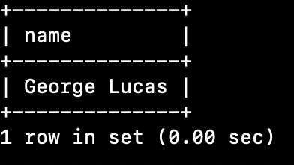

- Find the name and address of stars who acted in movie ‘star wars’ (require the subquery in FROM clause)
Answer:
SELECT starname, address
FROM movieStar m1,
(SELECT starname FROM starsIn WHERE movietitle = 'Star Wars') m2
WHERE m1.name = m2.starname;

picture:
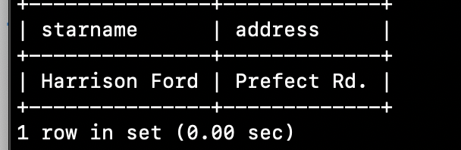
Part 2. IN\EXISTS\ALL\ANY:
- Find those stars who are in table ‘starsin’ and also in table moviestar,return their name distinctly；（require using of [NOT]IN）
answer:
SELECT DISTINCT starname
FROM starsin
WHERE starname IN (SELECT name FROM moviestar);

picture:
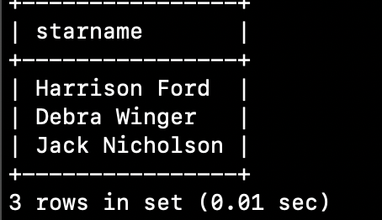

- find the executives who had the highest networth,return the name and networth. (require ALL or ANY in subqueries in answer).
answer:
SELECT name, networth
FROM movieexec
WHERE networth >=
ALL(SELECT networth FROM movieexec);

picture:
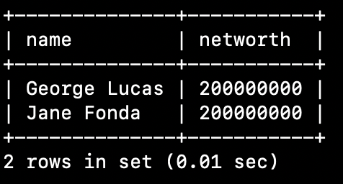

- find the movie star who only acted in one movie,return the name in order of name. (require two ways,Having or [NOT]EXISTS to answer)
answer 1:(Using having)
SELECT starname
FROM starsin
GROUP BY starname
HAVING count(starname) = 1
ORDER BY starname;

answer 2:(Using [NOT]EXISTS)
SELECT starname
FROM starsin AS a
WHERE NOT EXISTS
(SELECT *
FROM starsin AS b
WHERE a.movietitle <> b.movietitle
AND a.movieyear <> b.movieyear
AND a.starname = b.starname)
ORDER BY starname;

picture:
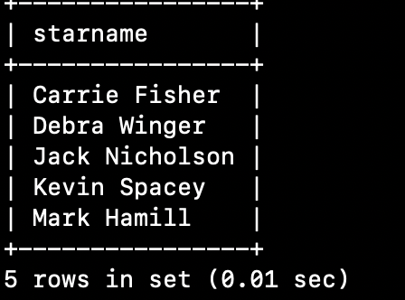

- find moviestar younger than ‘Jane fonda’(3 ways.one must use subquery)
answer:
1.
SELECT name
FROM moviestar
WHERE birthdate >
(SELECT birthdate
FROM moviestar
WHERE name = 'Jane Fonda');

2.
SELECT m1.name
FROM moviestar m1, moviestar m2
WHERE m2.name = "Jane fonda"
AND m2.birthdate < m1.birthdate;

3.
SELECT name
FROM ( SELECT name
FROM moviestar
WHERE birthdate >
(SELECT birthdate
FROM moviestar
WHERE name = 'Jane Fonda')) AS a;

picture:
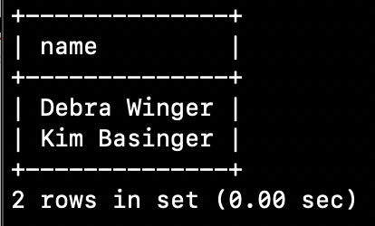

- Finde movieexec richer than ‘ted turner’ (2 ways.one must use subquery)
answer:
1.
SELECT name
FROM movieexec
WHERE networth >
(SELECT networth
FROM movieexec
WHERE name = "Ted Turner");

2.
SELECT m1.name
FROM movieexec m1, movieexec m2
WHERE m2.name = "Ted Turner"
AND m1.networth > m2.networth;

picture:
