《Introduction to Database System A*》Experiment 9

contents：view and index  triggers |  | lab：10-409
Instructor: liuli
Stu_id 2017329621125 | Stu_name 田野
Software Environment ：
MYSQL/
Purpose：
1.To understand database view and index, to understand triggers on the running database.

notation：

- Defineview
CREATE VIEW <VIEW_name> AS(
Select statement
)
- Define index
CREATE INDEX <INDEXname> ON <table_name>(
<list of elements>
);
3.Define trigger
CREATE TRIGGER trigger_name
BEFORE|AFTER INSERT|DELETE|UPDATE ON tbl_name
[referencing variables]
[FOR EACH ROW]
Action

Example:
CREATE TRIGGER moviedeletedtrigger
after delete on movies
for each row
Delete from starsin
where movietitle=old.title and movieyear=old.year

Experiment contents:
Background description is shown in project1:
Schema for our running example:
Movies(title,year,length,movietype, studioname, producerC)
movieStar(name,address,gender,birthdate)
starsIn(movietitle,movieyear,starname)
Studio(name,address,presC)
Movieexec(name,address,cert,networth)
list your answer in the last page. Handing your answer file with the file name as Experiment9 _ID.
part1: work on the exiting database “my_own_Movie_database”;Write Create view statement with SQL to define the view based on the tables in the database ;
- A view MGMMovies giving the title,year,length,movietype,studioname( (the view involve the movies produced by MGM studio));
- A view studioPres giving the name,address,and certificate number of all executives who are studio presidents ;
- A view RichExec giving the name,address,cerificate number and net worth of all executives with a net worth of at least $10,000,000
- A view executivestar giving the name,address,gender,birthdate,certificate number,and networth of all individuals who are both executives and stars;
- A view MGMFemalSTAFF giving the title,year,starname,gender

Part 2: Write the SQL statement to query or modify on view.
- Find the names of females who are both stars and executive;
- Find the names of those executives who are both studio presidents and worth at least $10,000,000;
- Remove the view MGMFemalSTARFF from databse

Then :copy the picture for each result.

Part 3:delcare indexes on the following attribures or combination of attributes.
- Studioname
- Movietype
- Address of moviestar

*Part 4:
define four triggers so that they work as the same functions of the foreign key in the following:

CREATE TABLE starsin (
movieTitle char(100) ,
movieYear int(11) ,
starName char(30) ,
foreign key(movietitle,movieyear) references movies(title,year)
on delete cascade
on update cascade,
foreign key(starname) references moviestar(name)
on delete set null
on update cascade
);

Part 1:

Create table statement including constraint
CREATE VIEW MGMMovies
AS SELECT title,year,length,movietype,studioname
FROM movies
WHERE studioname='MGM';
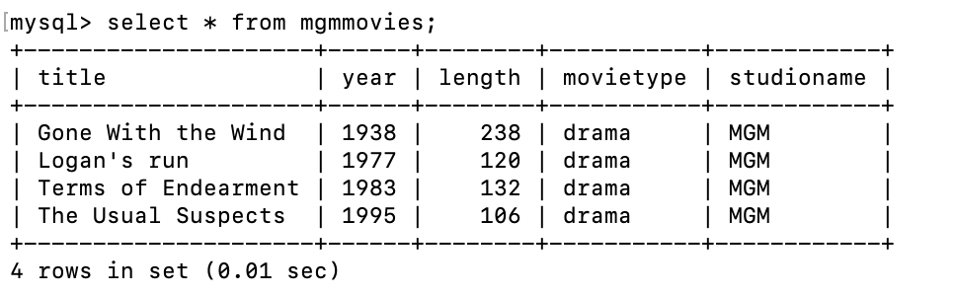

CREATE VIEW studioPres
AS
SELECT name,address,cert,networth
FROM movieexec
WHERE cert IN (SELECT presC FROM studio);
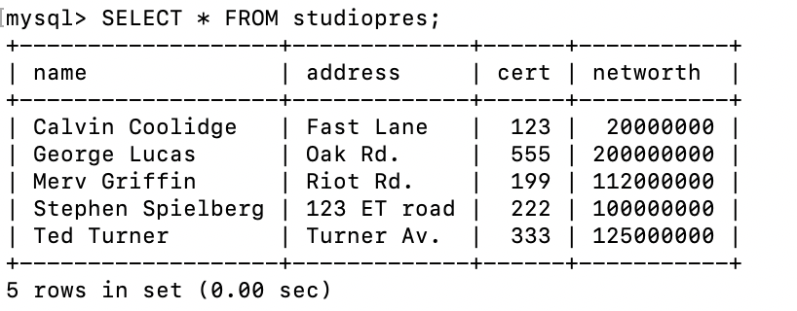

CREATE VIEW RichExec
AS
SELECT name,address,cert,networth
FROM movieexec
WHERE networth >= 10000000;
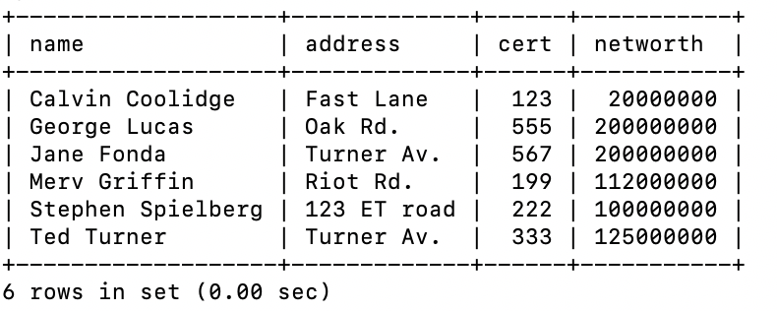

CREATE VIEW executivestar
AS
SELECT m.name,m.address,gender,birthdate,cert,networth FROM movieexec m,moviestar
WHERE m.name = moviestar.name;

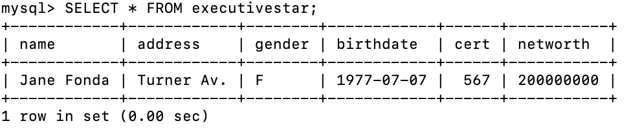

CREATE VIEW MGMFemalSTAFF
AS
SELECT movies.title,movies.year,moviestar.name,moviestar.gender
FROM movies,moviestar,starsin
WHERE starsin.movietitle = movies.title
AND starsin.starname = moviestar.name
AND movies.studioname='MGM'
AND moviestar.gender = 'F';

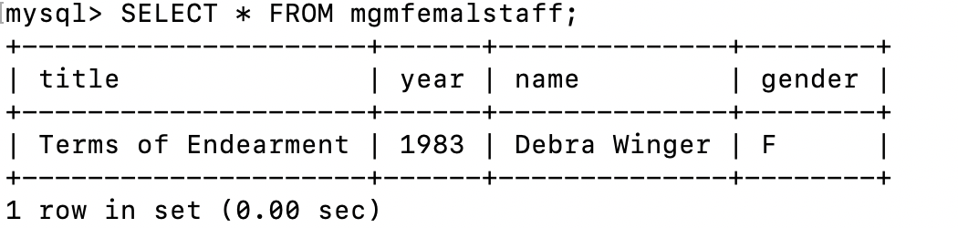

Part 2:
1.
SELECT executivestar.name
FROM executivestar, moviestar
WHERE executivestar.name=moviestar.name
AND moviestar.gender='F';

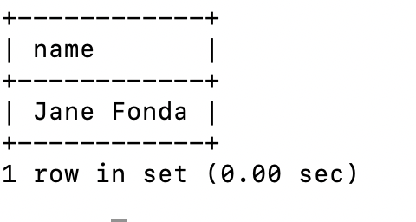

2.
SELECT R.name
FROM richexec R,studio
WHERE R.cert = studio.presc;
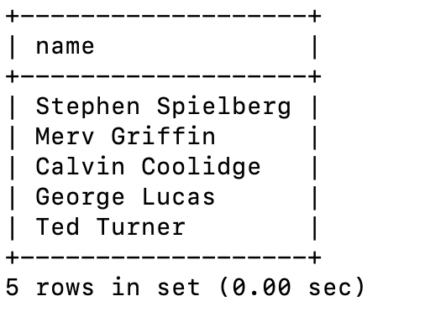

3.
DROP VIEW mgmfemalstaff;
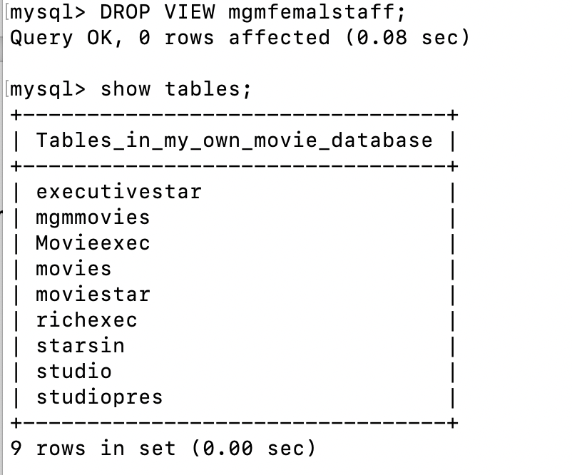

Part 3:
CREATE INDEX nameindex ON movies(studioname);

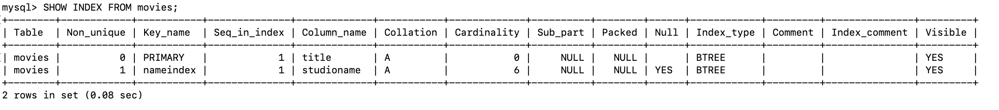

CREATE INDEX typeindex ON movies(movietype);
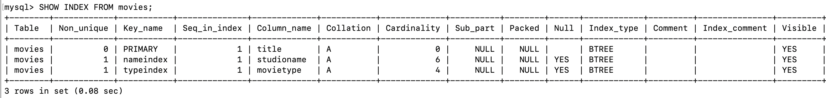

CREATE INDEX typeindex ON moviestar(name,address);
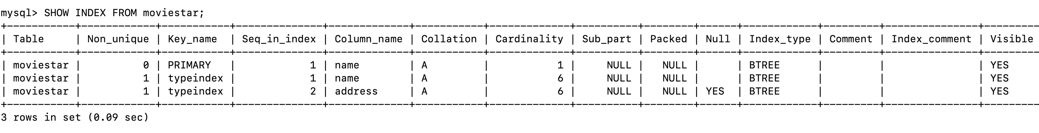

Part 4:
1.
CREATE TRIGGER moviedelete
AFTER DELETE ON movies
FOR EACH ROW
DELETE FROM starsin
WHERE starsin.movietitle=old.title
AND starsin.movieyear = old.year;

CREATE TRIGGER movieupdate
AFTER UPDATE ON movies
FOR EACH ROW
UPDATE starsin
SET starsin.movietitle = new.title
AND starsin.movieyear = new.year
WHERE starsin.movietitle=old.title
AND starsin.movieyear = old.year;

CREATE TRIGGER moviestardelete
AFTER DELETE ON moviestar
FOR EACH ROW
UPDATE starsin SET starname=null
WHERE starname=old.name;

CREATE TRIGGER moviestarupdate
AFTER UPDATE ON moviestar
FOR EACH ROW
UPDATE starsin
SET statsin.starname=new.name
WHERE starsin.starname=old.name;

