Section 1
Exercise 11.1.1
a)
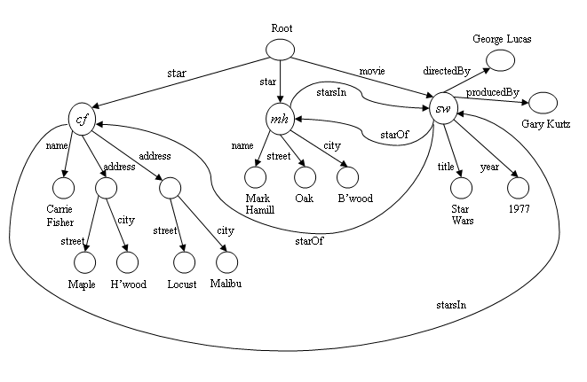

b)
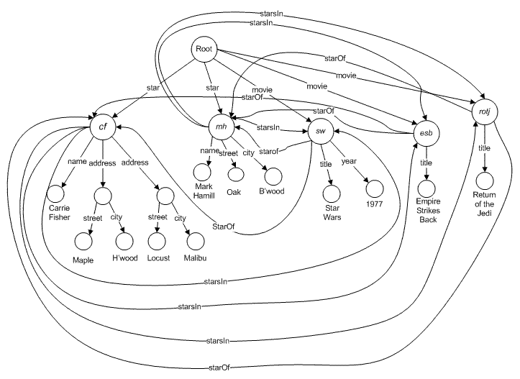

c)
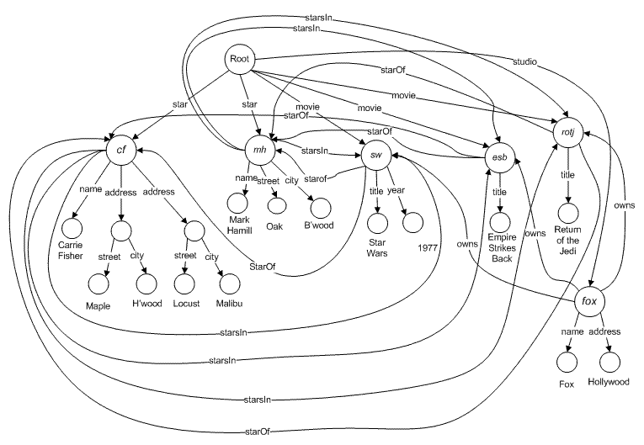

Exercise 11.1.2
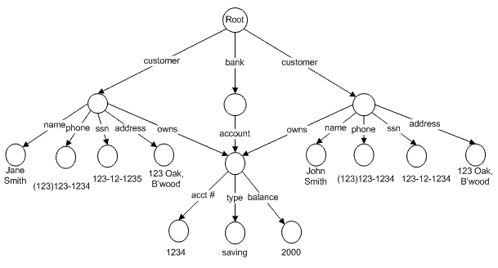
Exercise 11.1.3
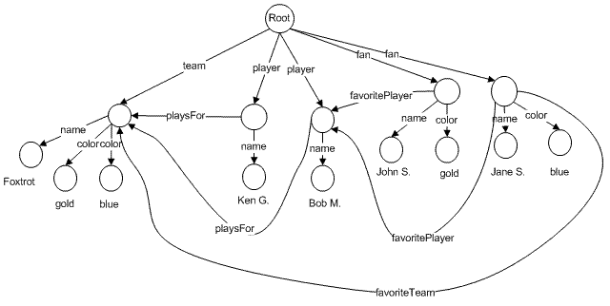

Exercise 11.1.4
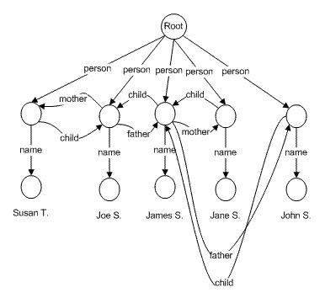
Exercise 11.1.5
In the semistructured model, nodes represent data elements, i.e., entities rather than entity sets. In the UML model, nodes of all types represent object sets, and the data is not represented at all.

Section 2
Exercise 11.2.1
<? xml version = "1.0" encoding = "utf-8" standalone = "yes" ?>
<StarMovieData>
<Star starID = "cf" starredIn = "sw">
<Name>Carrie Fisher</Name>
<Address>
<Street>123 Maple St.</Street>
<City>Hollywood</City>
</Address>
<Address>
<Street>5 Locust Ln.</Stree>
<City>Malibu</City>
</Address>
</Star>
<Star starID = "mh" starredIn = "sw">
<Name>Mark Hamill</Name>
<Address>
<Street>456 Oak Rd.</Street>
<City>Brentwood</City>
</Address>
</Star>
<Movie movieID = "sw" starsOf = "cf mh">
<Title>Star Wars</Title>
<Year>1977</Year>
</Movie>
</StarMovieData>

Exercise 11.2.2

Title | Year | Length | Genre
Gone with the Wind | 1939 | 231 | Drama
Star Wars | 1977 | 124 | SciFi
Wayne’s World | 1992 | 95 | Comedy

Figure 2.3: The Relation Movies

The relation Movies in XML:

<Movies>
<Movie>
<Title>Gone with the Wing</title>
<Year>1939</year>
<Length>231</length>
<Genre>Drama</genre>
</Movie>
<Movie>
<Title>Star Wars</Title>
<Year>1977</year>
<Length>124</length>
<Genre>SciFi</genre>
</Movie>
<Movie>
<Title>Wayne’s World</Title>
<Year>1992</year>
<Length>95</length>
<Genre>Comedy</genre>
</Movie>
</Movies>

Exercise 11.2.3

An empty element can be represented as a SubElement whose childID value is null (or a predefined ID that does not map to any element).

Exercise 11.2.4

DocRoot(docID, rootElementID)
Element(elementID, position)
ElementAttribute(elementID, name, value)
ElementValue(elementID, value)
SubElementOf(parentID, childID)

Section 3

Exercise 11.3.1

<?xml version = "1.0" encoding = "utf-8" standalone = "yes" ?>
<StarMovieData>
<Star starID = "cf" starredIn = "sw tesb rotj hahs">
<Name>Carrie Fisher</Name>
<Address>
<Street>123 Maple St.</Street>
<City>Hollywood</City>
</Address>
<Address>
<Street>5 Locust Ln.</Street>
<City>Malibu</City>
</Address>
</Star>
<Star starID = "mh" starredIn = "sw tesb rotj">
<Name>Mark Hamill</Name>
<Address>
<Street>456 Oak Rd.</Street>
<City>Brentwood</City>
</Address>
</Star>
<Star starID = "hf" starredIn = "sw tesb rotj fw">
<Name>Harrison Ford</Name>
</Star>
<Star starid = "md" starredIn = "tbi">
<Name>Matt Damon</Name>
</Star>
<Movie movieID = "sw" starsOf = "cf mh hf">
<Title>Star Wars</Title>
<Year>1977</Year>
</Movie>
<Movie movieID = "tesb" starsOf = "cf mh hf">
<Title>The Empire Strikes Back</Title>
<Year>1980</Year>
</Movie>
<Movie movieID = "rotj" starsOf = "cf mh hf">
<Title>Return of the Jedi</Title>
<Year>1983</Year>
</Movie>
<Movie movieID = "fw" starsOf = "hf">
<Title>Firewall</Title>
<Year>2006</Year>
</Movie>
<Movie movieID = "hahs" starsOf = "cf">
<Title>Hannah and Her Sisters</Title>
<Year>1985</Year>
</Movie>
<Movie movieID = "tbi" starsOf = "md">
<Title>The Bourne Identity</Title>
<Year>2002</Year>
</Movie>
</StarMovieData>

Exercise 11.3.2

<!DOCTYPE Bank [
<!ELEMENT BANK (CUSTOMER*, ACCOUNT*)>
<!ELEMENT CUSTOMER (NAME, ADDRESS, PHONE, SSNO)>
<!ATTLIST CUSTOMER
custId ID
owns IDREFS>
<!ELEMENT NAME (#PCDATA)>
<!ELEMENT ADDRESS (#PCDATA)>
<!ELEMENT PHONE (#PCDATA)>
<!ELEMENT SSNO (#PCDATA)>
<!ELEMENT ACCOUNT (NUMBER, TYPE, BALANCE)>
<!ATTLIST ACCOUNT
acctId ID
ownedBy IDREFS>
<!ELEMENT NUMBER (#PCDATA)>
<!ELEMENT TYPE (#PCDATA)>
<!ELEMENT BALANCE (#PCDATA)>
]>

Exercise 11.3.3

<!DOCTYPE Sport [
<!ELEMENT SPORT(TEAM*, FAN*)>
<!ELEMENT TEAM(NAME, PLAYER+, COLOR+)>
<!ATTLIST TEAM
captain IDREF #REQUIRED
teamID ID #REQUIRED>
<!ELEMENT PLAYER(NAME)>
<ATTLIST PLAYER
playerID ID #REQUIRED>
<!ELEMENT FAN(NAME, COLOR*)>
<ATTLIST FAN
favoriteTeams IDREFS
favoritePlayers IDREFS>
<!ELEMENT COLOR (#PCDATA)>
<!ELEMENT NAME (#PCDATA)>
]>

Exercise 11.3.4

<!DOCTYPE Genealogy [
<!ELEMENT GENEALOGY(PERSON*)>
<!ELEMENT PERSON EMPTY>
<ATTLIST PERSON
name CDATA #REQUIRED
personID ID #REQUIRED
motherID IDREF
fatherID IDREF
childrenID IDREFS>
]>

Exercise 11.3.5

Relation schema: RELATIONNAME(attribute list)

<!DOCTYPE RELATIONNAME [
<!ELEMENT RELATIONNAME(ROW*)>
<!ELEMENT ROW(attribute list)>
for each attribute T in the attribute list
<!ELEMENT T (#PCDATA)>
]

note: the singular form of the relation name should used in place of ROW

Section 4
Exercise 11.4.1

<Movies>
<Movie>
<Title>Star Wars</Title>
<Year>1977</Year>
</Movie>
</Movies>

<Movies>
<Movie>
<Title>Star Wars</Title>
<Year>’77</Year> <!-- not an integer -->
</Movie>
</Movies>

Exercise 11.4.2

<?xml version="1.0" encoding="UTF-8"?>
<xs:schema xmlns:xs="http://www.w3.org/2001/XMLSchema">
<xs:complexType name="Movies">
<xs:sequence>
<xs:element name="Movie" minOccurs="0" maxOccurs="unbounded">
<xs:complexType>
<xs:sequence>
<xs:element name="Title" type="xs:string" />
<xs:element name="Year" type="xs:integer" />
</xs:sequence>
</xs:complexType>
</xs:element>
</xs:sequence>
</xs:complexType>
</xs:schema>

Exercise 11.4.3

<!DOCTYPE MOVIES [
<!ELEMENT Title (#PCDATA)>
<!ELEMENT Year (#PCDATA)>
<!ELEMENT Genre (#PCDATA)>
<!ELEMENT Movies (Movie*)>
<!ELEMENT Movie (Title, Year, Genre?)>
]>

<!DOCTYPE STARS [
<!ELEMENT Stars (Star+)>
<!ELEMENT Star (Name, Address, StarredIn*)>
<!ELEMENT Name (#PCDATA)>
<!ELEMENT Address (#PCDATA)>
<!ELEMENT StarredIn EMPTY>
<!ATTLIST StarredIn
title CDATA #IMPLIED
year CDATA #IMPLIED>
]>

Note: DTD is not as granular as XML schema; some restrictions in XML schema cannot be enforced in DTD without modifying the structures of the XML it defines.

