《Introduction to Database System A*》Experiment report 2
contents：simple query in algebra and SQL |  | Time:2019.9.19/3
 |  | Instructor:liuli
Student ID:2017329621125 | Student Name:田野
Software Environment ：
Windows+Mysql+GUI
- Purpose：
The exercise is to have a little taste on simple query by algebra and select statement in SQL

- Guidance for the laboratory exercise：
refer to guidance_1.doc
1.to query from a relation
Select [expression] list
From tablename
Where Condition;
Key word in condition :<,<=,>,>=,<>, and,not,or
- Tips for SQL statement in MySQL:
In SQL statement , value of data with the type of string , date or time should be surrounded by single quote (eg.’2007-01-01’ or ‘US.’)

- Algebra operators: π、 σ、x、⋈…

Step 1: (1)Write SQL statements and execute each statement for the following queries(questions );(2) After you have successfully execute each statement, copy this statement to this document ; paste the snapshot picture for each execution result of the SQL statement in the document; Handing your answer file using the file name as exp2_ID(ID should be replaced by your own student ID);
- The electronic version of your document should be handed in before you leave the lab.

Experiment background:
we have set up a database “my_first_database” with the relations schema below:
Movies(title,year,length,movietype, studioname, producerC)
movieStar(name,address,gender,birthdate)
starsIn(movietitle,movieyear,starname)
Studio(name,address,presC)
Movieexec(name,address,cert,networth
Example tasks and answers:
Find all movies which is produced by studio ‘MGM’
SQL ANSWER:
Select * from movies where studioname='MGM'
RESULTING PICTURE:
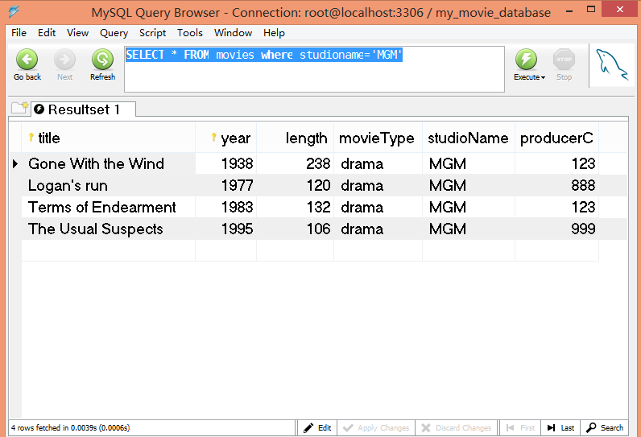

Experiment tasks:
answer each questions below:
Query to database in SQL statement:
- write select statement in SQL to answer the following questions
  - Find the address of the movie star“Jane Fonda”
Algebra answer:
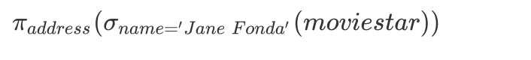
SQL ANSWER:
select address from moviestar where name = 'Jane Fonda';

RESULTING PICTURE:


  - Find the studio(name) who issued the movie “Star Wars”
Algebra answer:
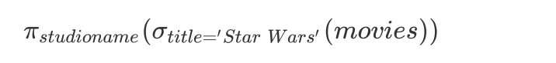
SQL ANSWER:
select studioname from movies where title = 'Star Wars';

RESULTING PICTURE:

  - Find the movies with length less than 120,return title,year and length
Algebra answer:

SQL ANSWER:
select title,year,length from movies where length < 120;

RESULTING PICTURE:
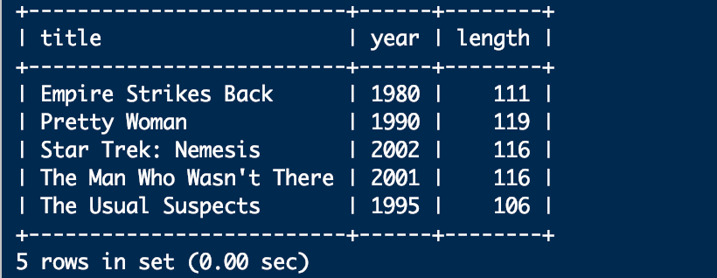

  - Find movies by returning the title, year, length in hours with a new name as dur_inHrs for the column. produce new column with value as ‘hrs’ and title as ‘inhours’
SQL ANSWER:
select title,year,length/60 as dur_inHrs, 'hrs' as inhours from movies;

RESULTING PICTURE:
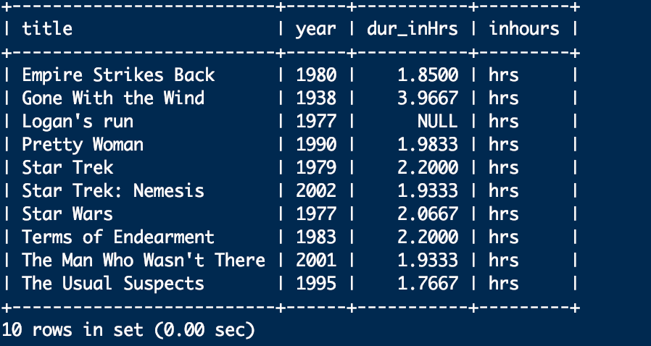

  - Find all executives worth at least $10,000,000(return values on all attributes).
SQL ANSWER:
select * from movieexec where networth >= 10000000;

RESULTING PICTURE:
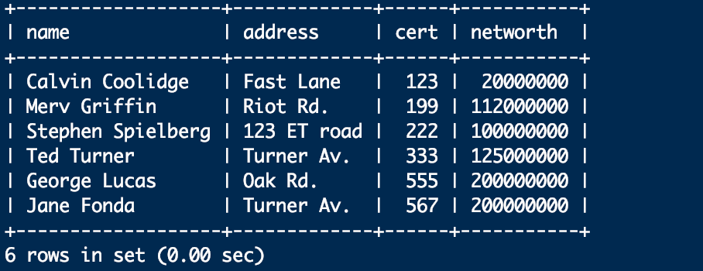

  - Using movies(title,year,length,movietype,studioname) and studio(name,address),
Return the address of studio issuing star wars movie
Algebra answer:
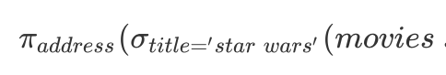⋈
*find data for your database,input them in your database
For hand in:
Fill in the answers for each question,rename the document as exp2_id.then hand in

