《Introduction to Database System A*》Experiment 4
contents：DML in SQL,full query |  | lab：10-409
 |  | Instructor:liuli
Student ID:2017329621125 | Student Name:田野
Software Environment ：
Windows+Mysql+GUI

- Purpose：
The exercise is to have a taste on simple query
To understand group,having clause
To query over multirelatons
To order the result

- Guidance for the laboratory exercise：
notation：
SELECT [DISTINCT] A₁[AS ALIAS1], A₂[as ALIAS2]…
FROM R
[WHERE condtion]
[GROUP BY A_{i},A_{j}
HAVING _{condition}]
[ORDER BY attribute list ASC|DESC];

- Tips for SQL statement in MySQL:
A₁,A_{n} could be reasonable expressions involving attribute, constant or function
Condition is to restrict the tuples in the working relations.
- SELECT could be followed by aggregation such as count(A_{n})、sum(A_{n})、max(A_{n})、min(A_{n}) to do calculation within the table or group(if there is” group by” clause).
- DISTINCT: eliminate the duplicated tuples
- GROUP BY clause is used to group the table，producing one tuple for each group. Usually, a HAVING clause will follow the GROUP BY clause to restrict the group satisfying the condition within Having clause.
e.g.SELECT DISTINCT sp.pid FROM sp GROUP BY pid HAVING count(sid)>1;
- If there is an ORDER BY clause in the statement，reorder the tuples according to the attribute list in the ORDER BY clause in ascending or descending order.
- Steps

contents ():
(1)Write SQL statements and execute each statement for the following queries(questions );
(2) After you have successfully execute the statement, copy this statement to the document ; paste the snapshot picture for each execution result of the SQL statement in the document; Handing your answer file using the file name as exp4 _ID(ID should be replaced by your own student ID);

Experiment background:
we have set up a database “my_movie_database” with the relations schema below:
Movies(title,year,length,movietype, studioname, producerC)
movieStar(name,address,gender,birthdate)
starsIn(movietitle,movieyear,starname)
Studio(name,address,presC)
Movieexec(name,address,cert,networt
Experiment questions:
Part 1. Query over multi-relations:

- Who was the president of MGM studios,return the distinct name.
SQL ANSWER:
SELECT DISTINCT m.name AS president, s.name AS studio
FROM movieexec m, studio s
WHERE m.cert = s.presC AND s.name = 'MGM';

RESULTING PICTURE:


- Who were the male stars in Star Wars? (Return the star's name).
SQL ANSWER:
SELECT distinct name
FROM moviestar, starsIn
WHERE movietitle='Star Wars'
AND gender='M'
AND starname=name;
RESULTING PICTURE:


- Who were the stars in the movies which were issued by MGM, return their name, birthdate, listing the result in a descending order by name
SQL ANSWER:
SELECT DISTINCT name, birthdate
FROM moviestar,starsin,movies
WHERE title=movietitle
AND studioname='MGM'
AND starname=name
ORDET BY name DESC;

RESULTING PICTURE:
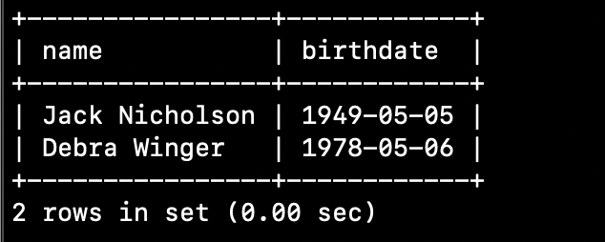

- Which movie is longer than ‘Star Wars’ in 1977. Return their title,year,movietype and length,listing the result by type in ascending order and then among the same type of movie, by length in descending order.
SQL ANSWER:
SELECT title, year,movietype,length
FROM movies
WHERE length > (SELECT length FROM movies WHERE year=1977 AND title='Star Wars')
GROUP BY movietype,title,year,length
ORDER BY movietype ASC,length DESC;

RESULTING PICTURE:
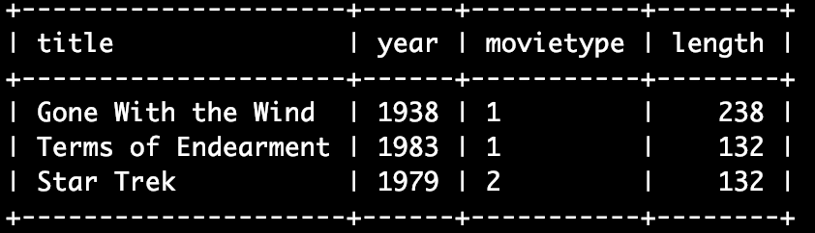
Part 2. Grouping and aggregation:
- Find the total length of movies for each studio(not include unknown studio) , return studio(name) and total_length,reorder the result by studio’s name in descending order;
SQL ANSWER:
SELECT studioname,sum(length) as total_length
FROM movies
GROUP BY studioname
ORDER BY studioname DESC;
RESULTING PICTURE:
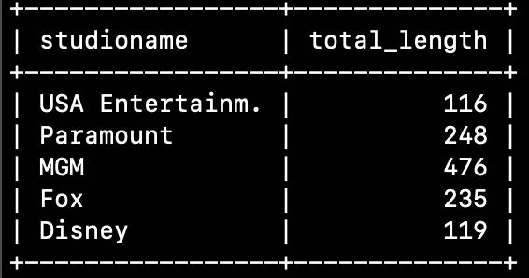

- Using starsin(movietitle,movieyear, starName)
return number of movies for each star
SQL ANSWER:
SELECT starname, count(*)
FROM starsin
GROUP BY starname;

RESULTING PICTURE:
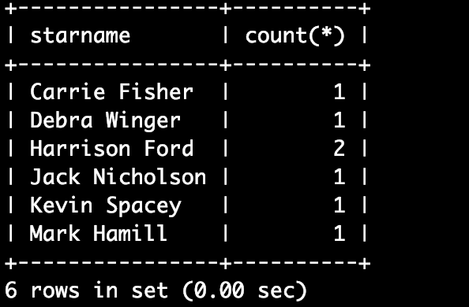
- Use relation movies, find those studios with total movie number no less than 2.
SQL ANSWER:
SELECT studioname,count(*)
FROM movies
GROUP BY studioname
HAVING count(*) >= 2;
RESULTING PICTURE:
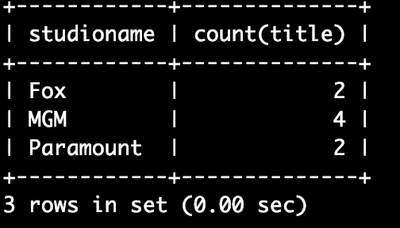

- For each movie that has more than one star, calculate the number of stars for each movie,and return the title ,year and the number of stars in each movie.
SQL ANSWER:
SELECT movietitle,movieyear,count(starname)
FROM starsin
GROUP BY movietitle,movieyear
HAVING count(starname) > 1;

RESULTING PICTURE:
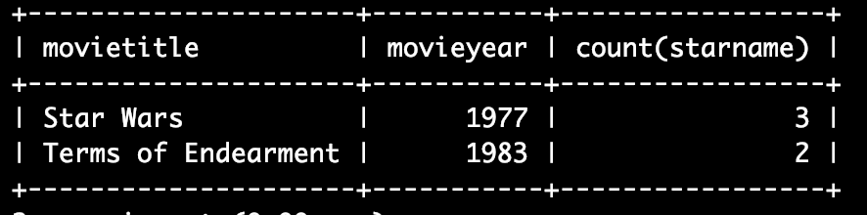

- devide movie stars by gender, then for each gender, return gender and number of member for each gender, order by gender
SQL ANSWER:
SELECT gender, count(*)
FROM moviestar
GROUP BY gender
ORDER BY gender;
RESULTING PICTURE:


- print the producers’ total film length for only those producers who made at least one film prior to 1980.
SQL ANSWER:
SELECT producerC, sum(length)
FROM movies
WHERE producerC in (SELECT producerC from movies where year<1980)
AND length is not null
GROUP BY producerC;

RESULTING PICTURE:
