《Introduction to Database System A*》Experiment report 2
contents：DML in SQL |  | lab：10-409/11.7/10
 |  | Instructor:liuli
Student ID:2017329621125 | Student Name:田野
Software Environment ：
Windows+Mysql+GUI
Purpose：
The exercise is to connect to a database, populate it with data, and run very
simple SQL statement to modify(insert/delete/update) and query data.

Guidance for the laboratory exercise：
refer to guidance_1.doc

manipulation statement in SQL:
Manipulation database include query data and modify data
1.to query from a relation
Select attributes list
From tablename
Where Condition
- to modify data in the database
1)To add a tuple by n number of values in a table
Insert Into tablename(A1,A2,…,An)
Values( v1,v2,…,vn);
2)To alter values in tuples which satisfy some conditions in a table
Update tablename
Set Attr = Expression
Where Condition
3)To delete a tuple which satisfies some conditions
Delete From tablename
Where Condition
- Tips for SQL statement in MySQL:
In SQL statement , value of data with the type of string , date or time should be surrounded by single quote (eg.’2007-01-01’ or ‘US.’)

Experiment background:
Based on our designing diagram on the movie system , we are to set up a database “my_movie_database” with the relations schema below:
Movies(title,year,length,genre, studioname, producerC)
movieStar(name,address,gender,birthdate)
starsIn(movietitle,movieyear,starname)
Studio(name,address,presC)
Movieexec(name,address,cert,networth)
Data in this tables represent the information about stars, movies,studios, presidents of studios and relationship between them.
For the experiment, we provide a sql file ‘movie_setup.sql’ to run to create tables and load data in each table. Since these tables are supposed to be in a database named ‘my_movie_database’, be sure to set up the database first in MySQL to allow these tables and data .
contents (refer to guidance_1.doc):
Step1: Access to the localhost in Mysql, Create new database;
Step 2:Import the tables and data from the given file ’movie_setup.sql’;
Step 3: (1)Write SQL statements and execute each statement under the MYSQL GUI for the following questions in pages 3-4 ;(2) After you have successfully execute the statement, copy this statement from MYSQL query editor to the document just after each questions ; paste the snapshot picture for each execution result of the SQL statement in the document; Handing your answer file using the file name as experiment _ID(ID should be replaced by your own student ID);
- The electronic version of your document should be handed in before you leave the lab.
Example tasks and answers:
Find all movies which is produced by studio ‘MGM’
SQL ANSWER:
Select * from movies where studioname='MGM'
RESULTING PICTURE:
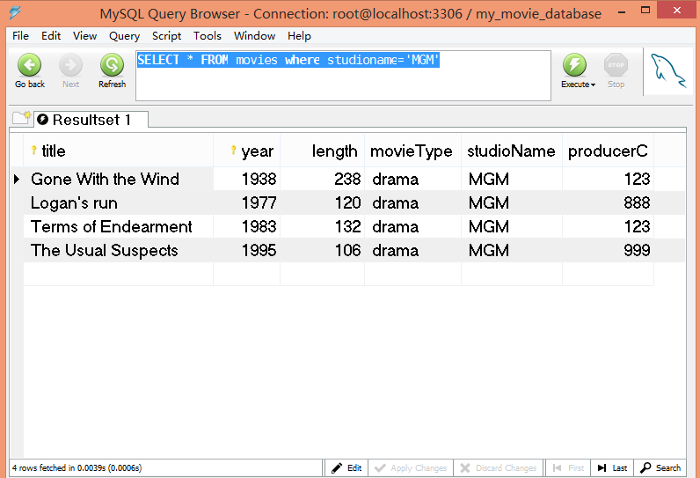
Experiment tasks:
Part 1 Subqueries
- Finding the producers of Ford’s movies using a subquery in the from clause
SQL ANSWER:
SELECT DISTINCT name
FROM movieexec, (SELECT producerC
FROM movies, starsin
WHERE starsin.movietitle=movies.title
AND starsin.movieyear=movies.year
AND starsin.starname LIKE '%Ford%') proc WHERE movieexec.cert = proc.producerC;

Part 2 set operation
- Find movies either in relation movies or in starsin
SQL ANSWER:
(SELECT title FROM movies)
UNION
(SELECT movietitle FROM starsin);

Part 3 Modification on database in SQL statement:
- Write SQL statement to insert a tuple with values(‘spiderman’,1997) on the first 2 attributes in the table ‘movies’;
SQL ANSWER:
INSERT INTO movies(title,year)
VALUES
('spiderman',1997);

RESULTING PICTURE:
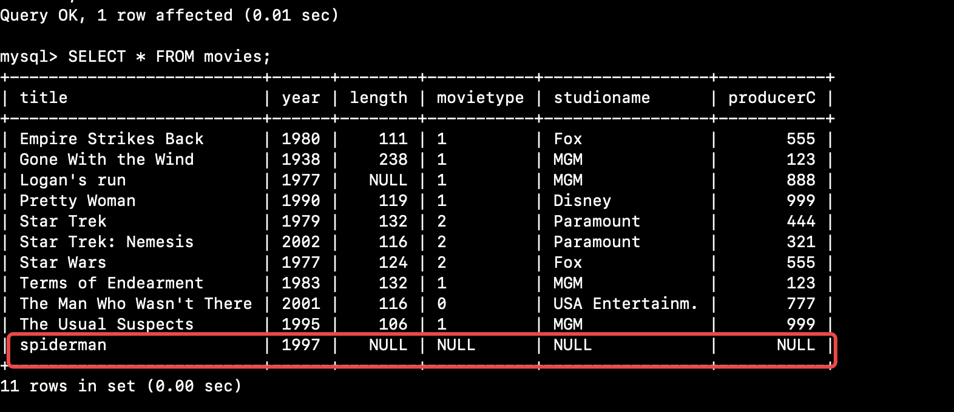

- Write SQL statement to insert a tuple with values('Kim Basinger','Baldwin Av.','F','1979-05-07')in the table ‘moviestar’;
SQL ANSWER:
INSERT INTO moviestar(name, address, gender, birthdate)
VALUES
('Kim Basinger','Baldwin Av.','F','1979-05-07')

RESULTING PICTURE:
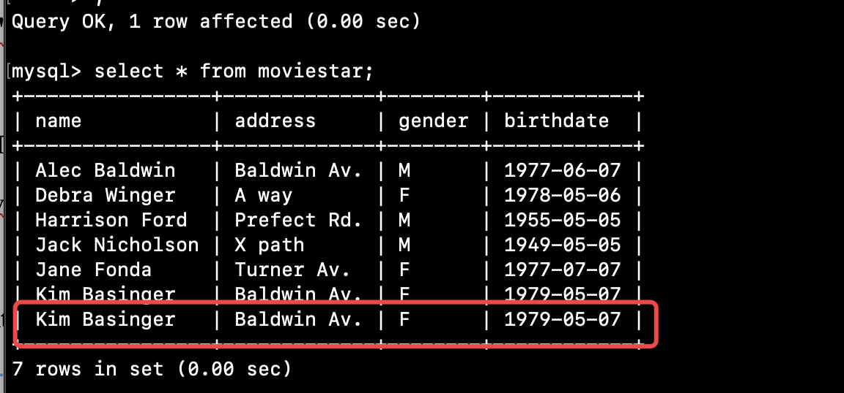

- Insert into table moviestar all the stars’ name that appear in starsin but not in moviestar
SQL ANSWER:
INSERT INTO moviestar(name)
SELECT starname
FROM starsin
WHERE starname NOT IN (SELECT name FROM moviestar);

RESULTING PICTURE:
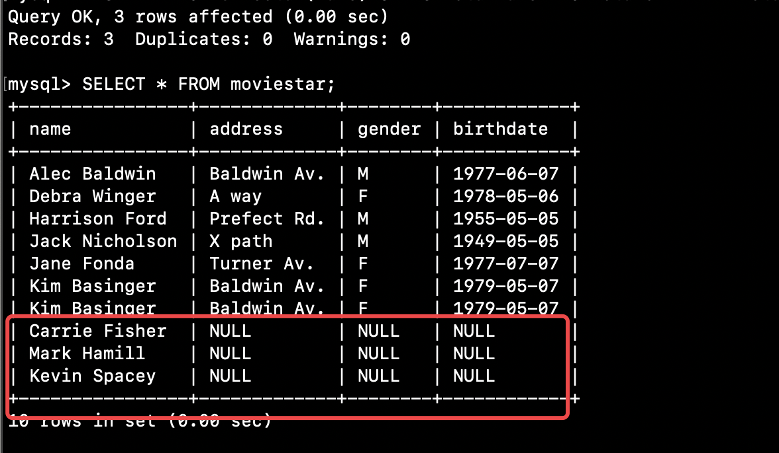

- Write SQL statement to update birthdate value by 1955-03-05 for star ‘Harrison Ford’ in the table moviestar ;
SQL ANSWER:
UPDATE moviestar SET birthdate='1955-03-05'
WHERE name='Harrison Ford';
RESULTING PICTURE:

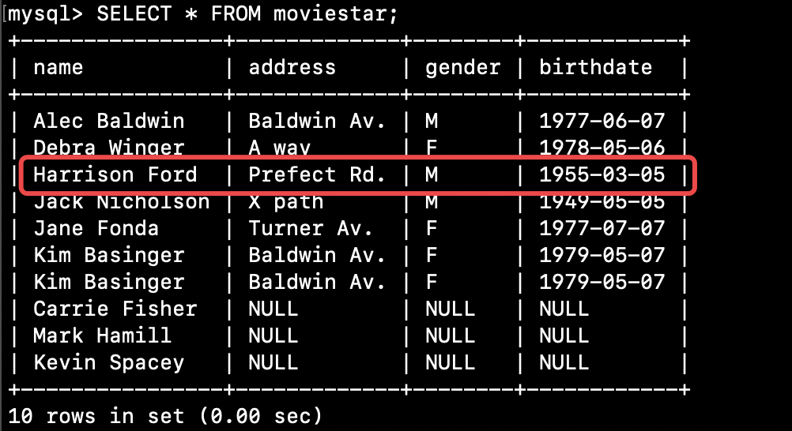

- Write SQL statement to update each networth value by dividing original networth by 1000000 in the table movieexec ;
SQL ANSWER:
UPDATE movieexec SET networth = networth / 1000000;

RESULTING PICTURE:
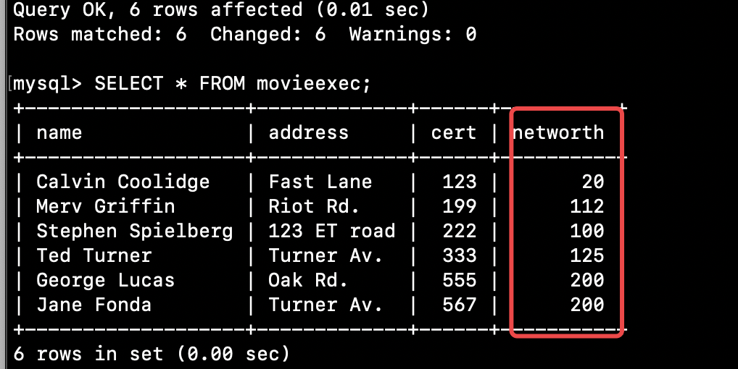

- Write SQL statement to delete those movies before 1977.
SQL ANSWER:
DELETE FROM movies
WHERE year < 1977;

RESULTING PICTURE:
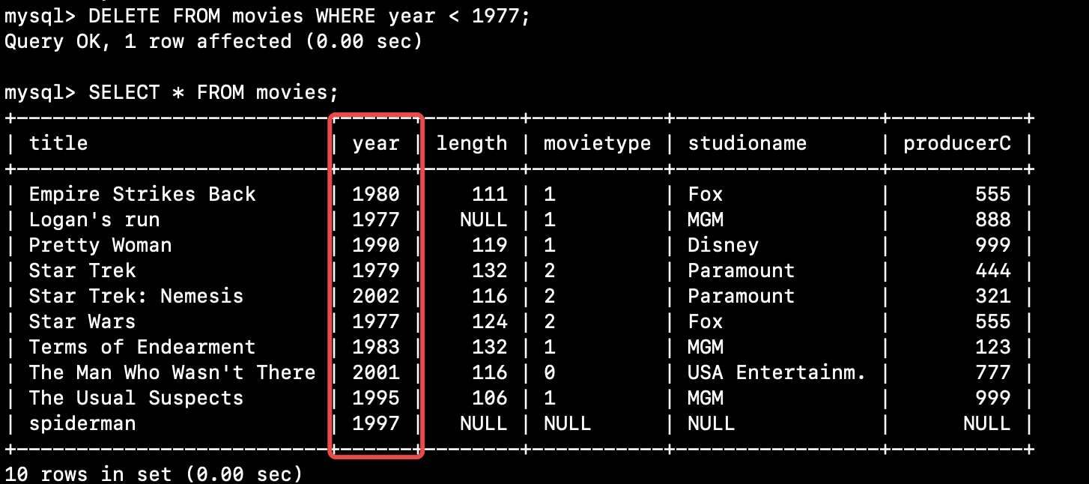

- write SQL statement to delete those executives with the certification numbers higher than 500 from movieexec table .
SQL ANSWER:
DELETE FROM movieexec
WHERE cert > 500;

RESULTING PICTURE:
