Homework2

田野 2017329621125

Mutation test

in mujava

in idea

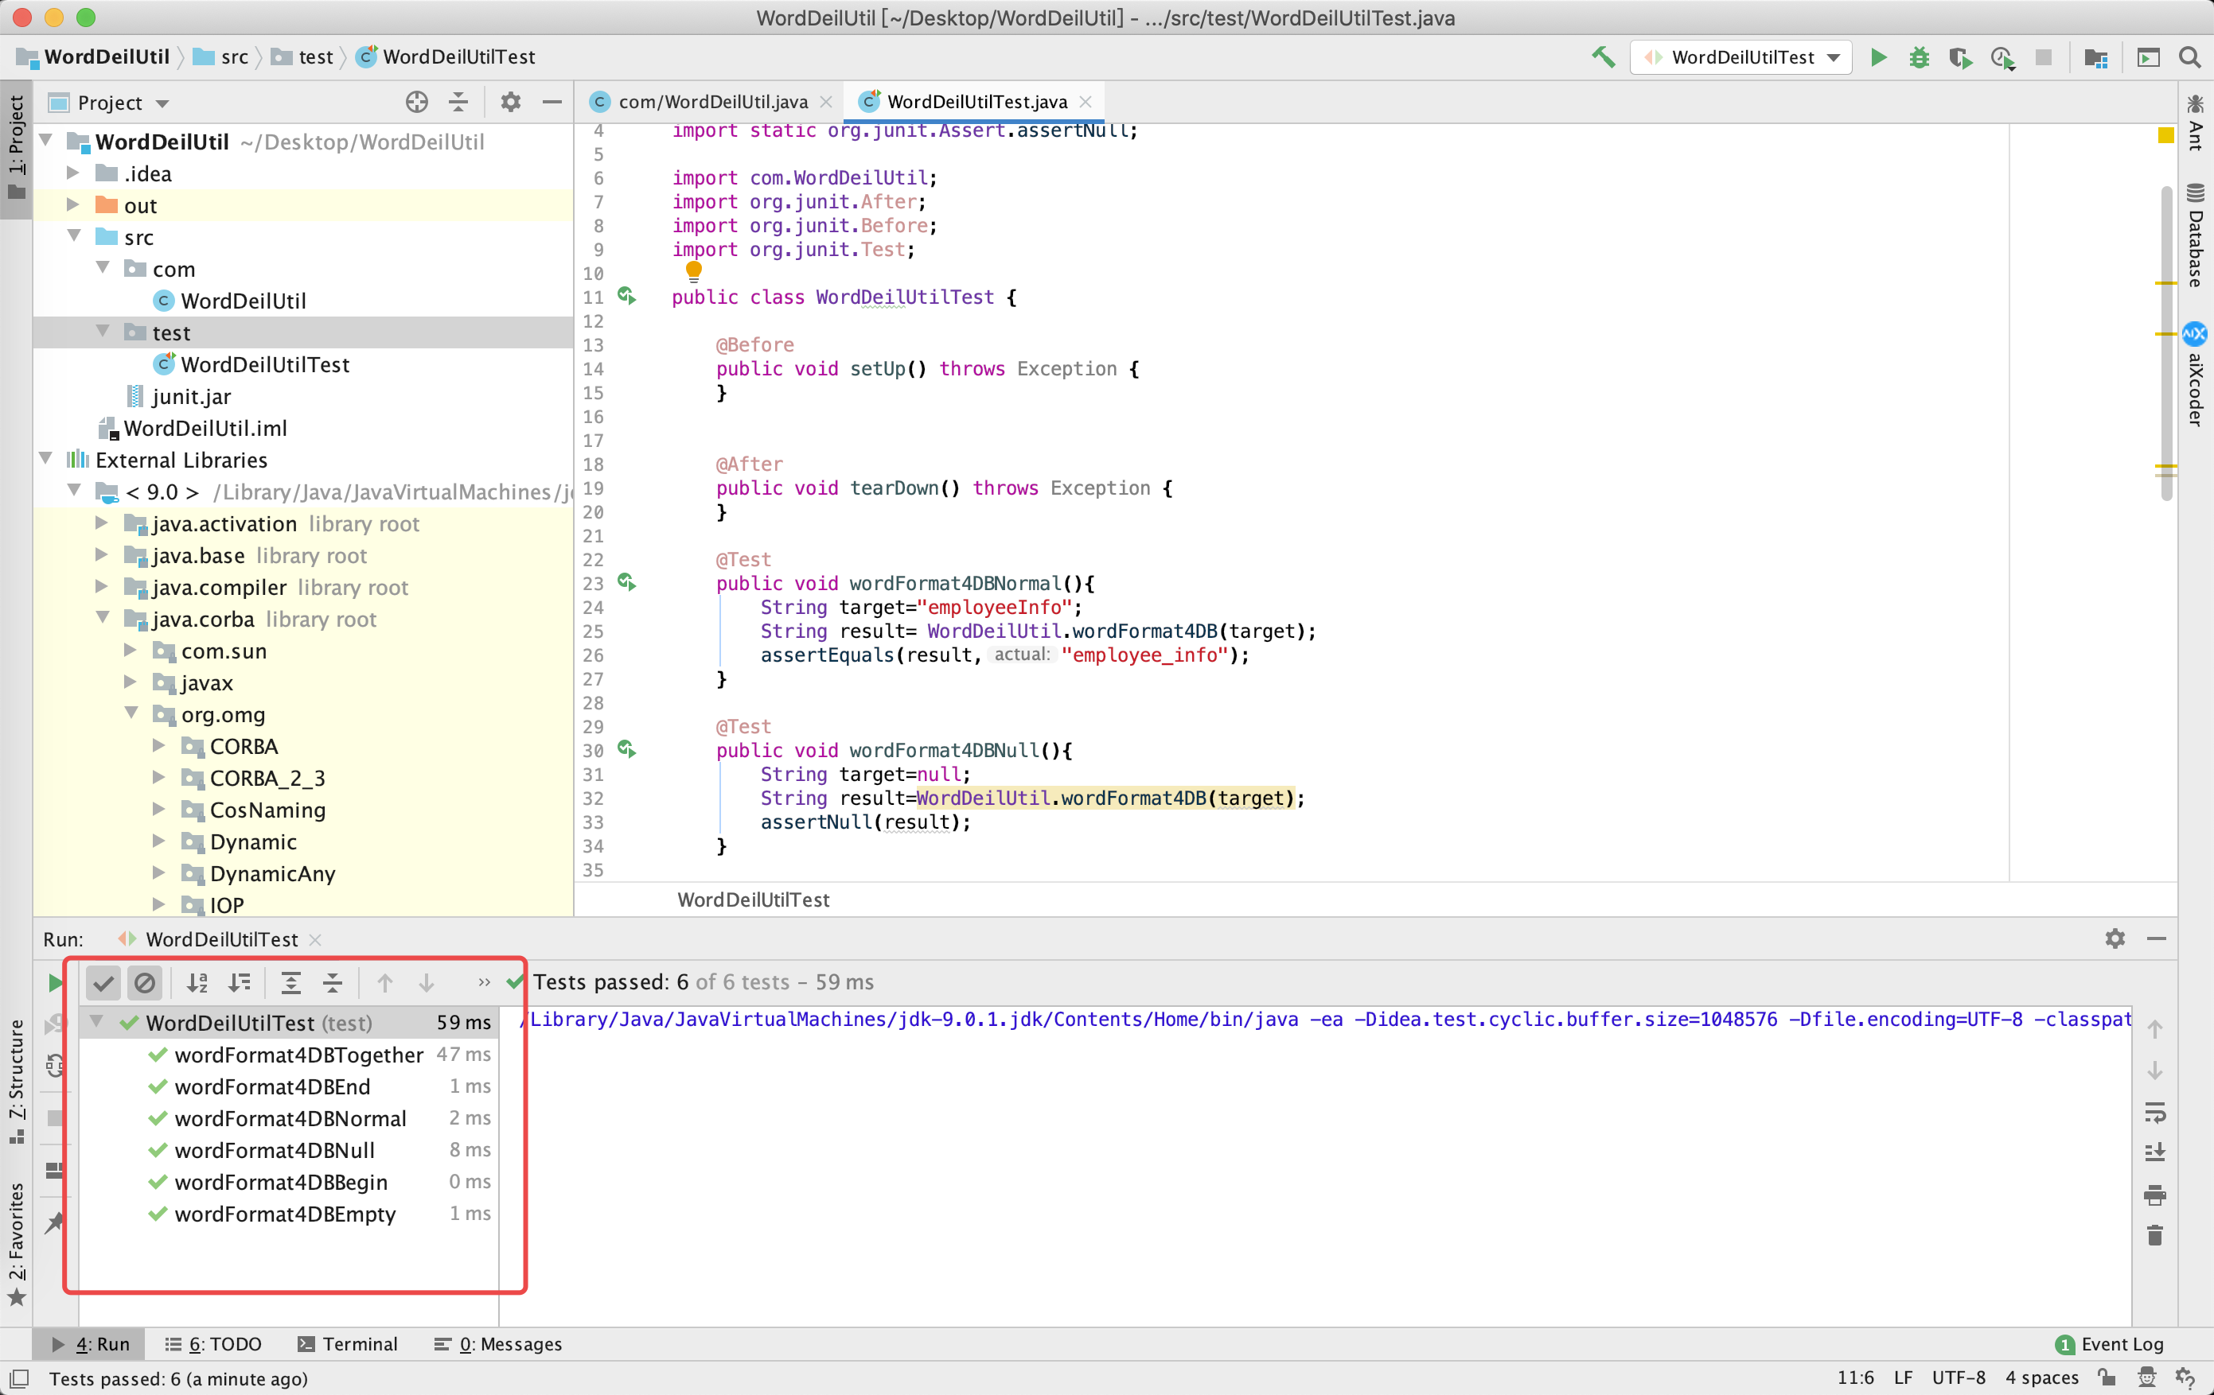

|  |  |  |  |  |
| --- | --- | --- | --- | --- |
| Mutation | Input | Origin result | New result | Equal? |
| If (name!=null) | “MyTest” | “my_test” | Null | No |
| Null | Null | Exception | No |
| “myTest” | “my_test” | Null | No |
| “myTEST” | “my_t_e_s_t” | Null | No |
| “hELlo” | “h_e_llo” | Null | No |
| If (m.start!=0) | “MyTest” | “my_test” | “_mytest” | No |
| While(!m.find) | “MyTest” | “my_test” | “mytest” | No |
| “MyTest” | “my_test | “mytest” | No |
| “MyTEST” | “my_t_e_s_t” | “mytest” | No |
| “mYTes” | “m_y_test” | “mytest” | No |

Solution 1.3

(a)

Yes, through the definition of subsumption, we can know that the because C1 subsumes coverage criterion C2 then every test set that satisfies criterion C1 also satisfies C2.

(b)

No, C2 does not subsume C1. So we can’t promise that T2 satisfy C1.

(c)

C1 subsume C2, but subsumption is only about criteria, not about test sets. So, there is no requirement that test set T2 be a subset of test set T1. So, it’s possible that T2 contains that one test that reveals the fault, but T1 doesn't.