2.7.2

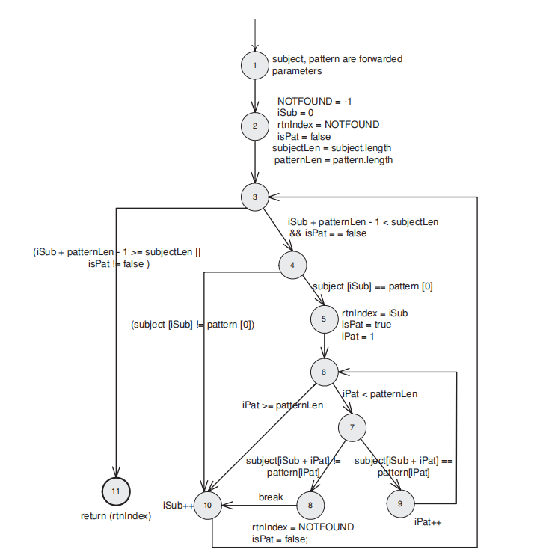

k

f

nl

ml

l

j

i

h

g

e

d

c

b

a

The path expression is listed as follows:

ab[ c(eg[ijk + (ilm)*jk + (ilm)*h] + f)n]*d

both of loops can be taken **0 to 2 times.**

The maximum number of paths can then be calculated by substituting the appropriate value for each edge label into the path expression.

1*1*[1*(1*1[1+(1)0-2 + (1)0-2*1] + 1)*1]0-2 * 1

= [1+10+11+12 +10+11+12 +1]+1]0-2

=(9)0-2

=(90+91+92)

=1+9+81=91

Minimum Number of Paths to Reach All Edges

Set the weight of the loop become **2**

1*1*[1*(1*1[1+(1)2 + (1)2*1] + 1)*1]2 * 1

=1*1*[1*(1*1[1+(2)+(2)]+1]+1)*1]2*1

=max(1,1,WA,1)

= 2