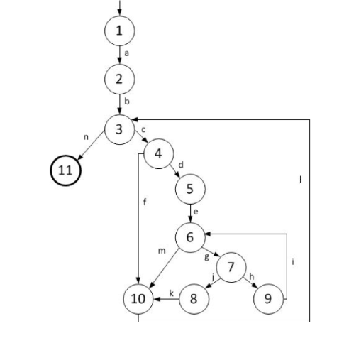

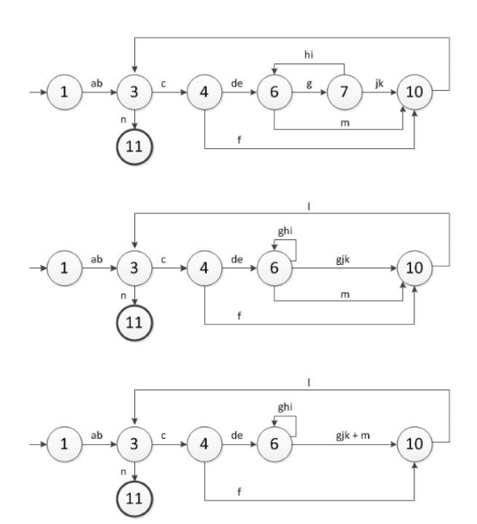

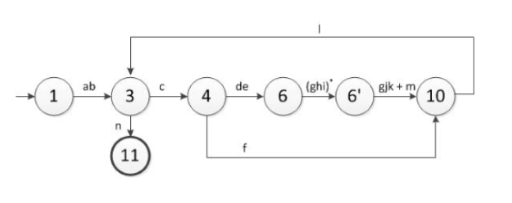

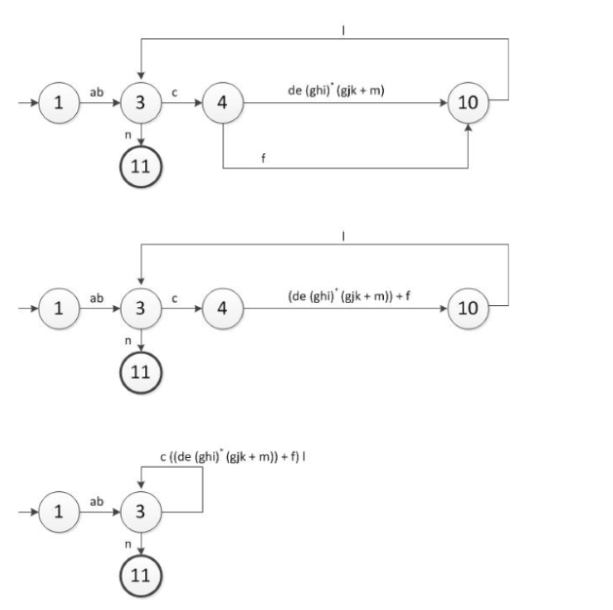

ab[c((de(ghi)\*(gkj+m))+f)l]\*n

so minimum is 6

maximum is ab[c((de(ghi)\*(gkj+m))+f)l]\*n