**Homework 8**

2017329621154 郑莉莉

Original graph :

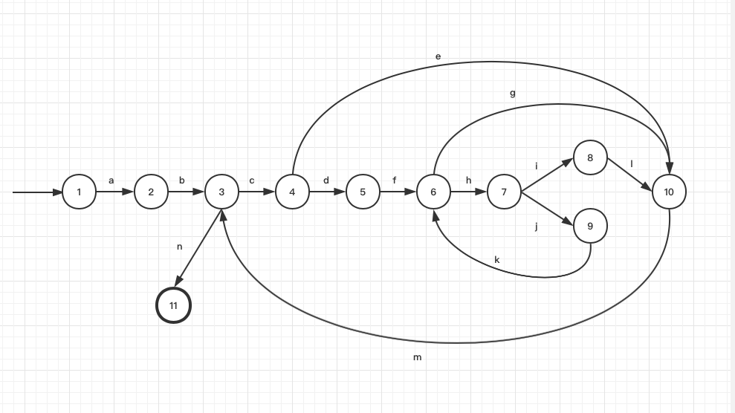

Simplified graph:

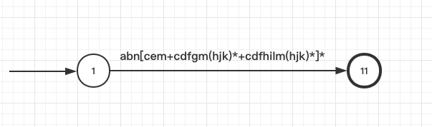

Maximum number of paths: 57

Minimum number of paths: 3