1. 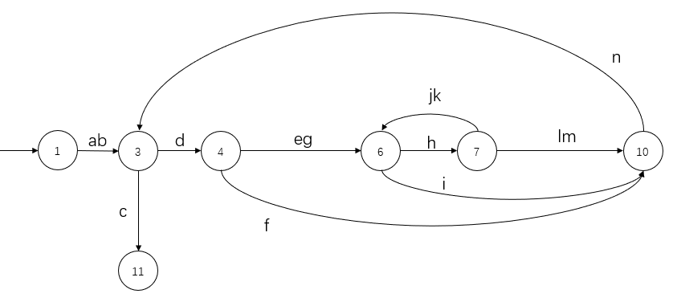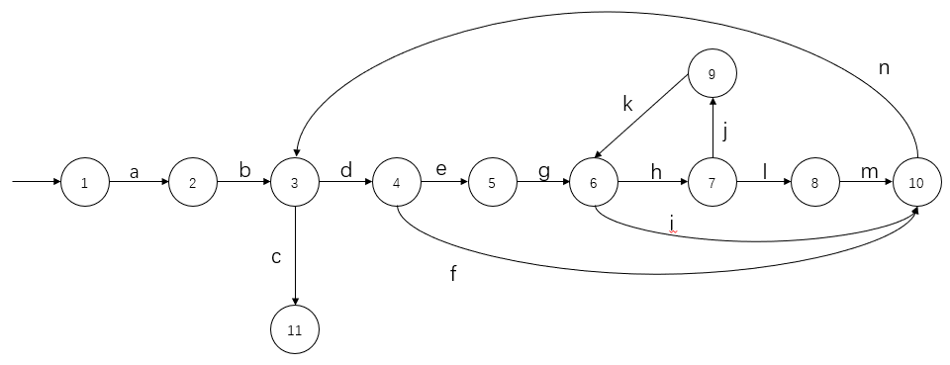Path expression

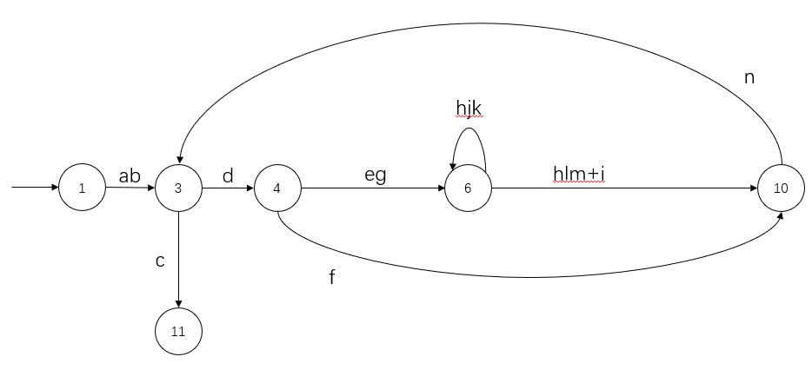

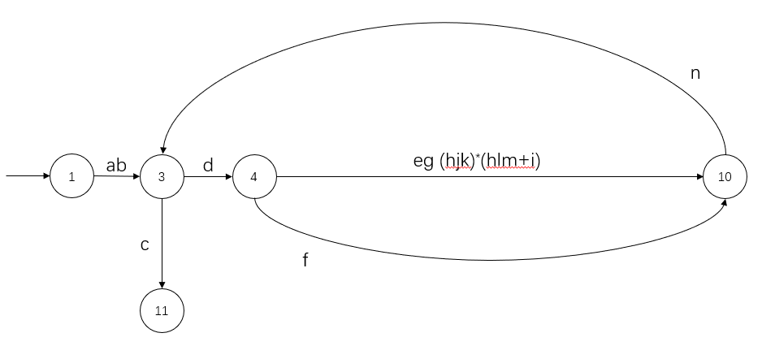

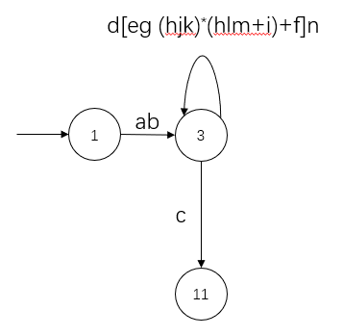

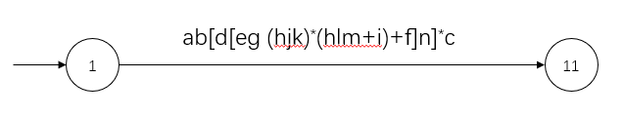

|  |
| --- |
| ab[d[eg (hjk)*(hlm+i)+f]n]*c |

1. Weights

For normal edge, its weight is 1.

For cycle edge, its weight is 2.

We assume that each loop can be executed at most 2 times.

|  |  |
| --- | --- |
| edge | weight |
| A | 1 |
| B | 1 |
| C | 1 |
| D | 1 |
| E | 1 |
| F | 2 |
| G | 1 |
| H | 1 |
| I | 2 |
| J | 1 |
| K | 2 |
| L | 1 |
| M | 1 |
| N | 2 |
|  |  |

1. Maximum number

$$1*1*\sum_{0}^{2}{\left\{1*\left[1*1*\left(\sum_{0}^{2}{1*1*2}\right)*\left(1*1*1+2\right)+2\right]*2\right\}}*1$$

= $1*1*\sum_{0}^{2}{46}*1$

= $46+46*46+1$

= $2163$

1. Minimum number

If we assume that not all paths through the loop can be taken in one test case, then

$$1*1*\sum_{0}^{2}{\left\{1*\left[1*1*\left(\sum_{0}^{2}{1*1*2}\right)*\left(1*1*1+2\right)+2\right]*2\right\}}*1$$

= $1*1*\sum_{0}^{2}{46}*1$

= $1*1*2163*1$

= $max⁡(1,1,2163,1)$

= $2163$

If we assume that all paths through the loop can be taken in one test case, then

$$1*1*\sum_{0}^{1}{\left\{1*\left[1*1*\left(\sum_{0}^{1}{1*1*2}\right)*\left(1*1*1+2\right)+2\right]*2\right\}}*1$$

= $1*1*\sum_{0}^{1}{22}*1$

= $1*1*23*1$

= $max⁡(1,1,23,1)$

= $23$