周学宜

2017329600180

Software Testing

8Th assignment

Section 2.7

2. Derive and simplify the path expressions for the three graphs in Figure 2.12. Assign reasonable cycle weights and compute the maximum number of paths in the graph and the minimum number of paths to reach all edges.

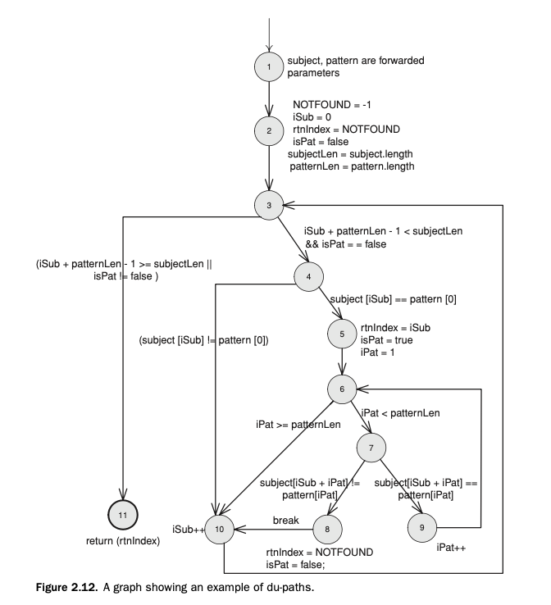

Solution:

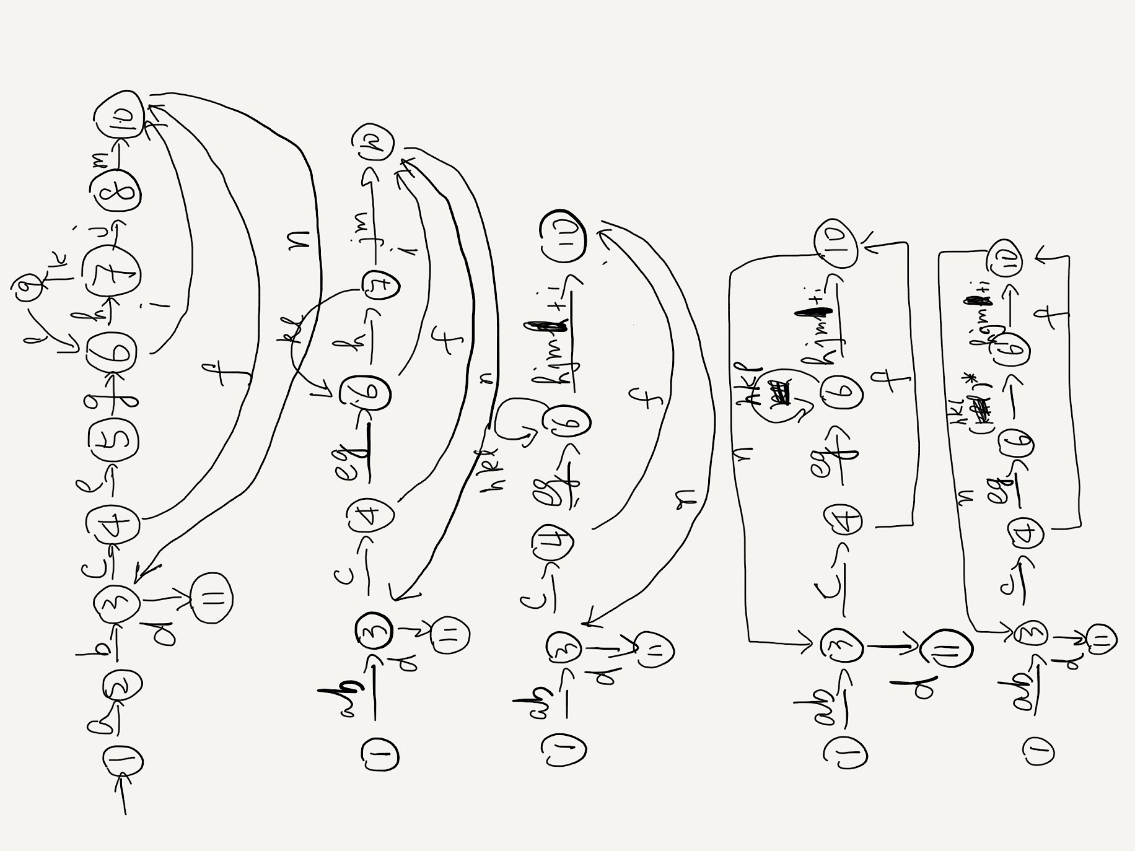

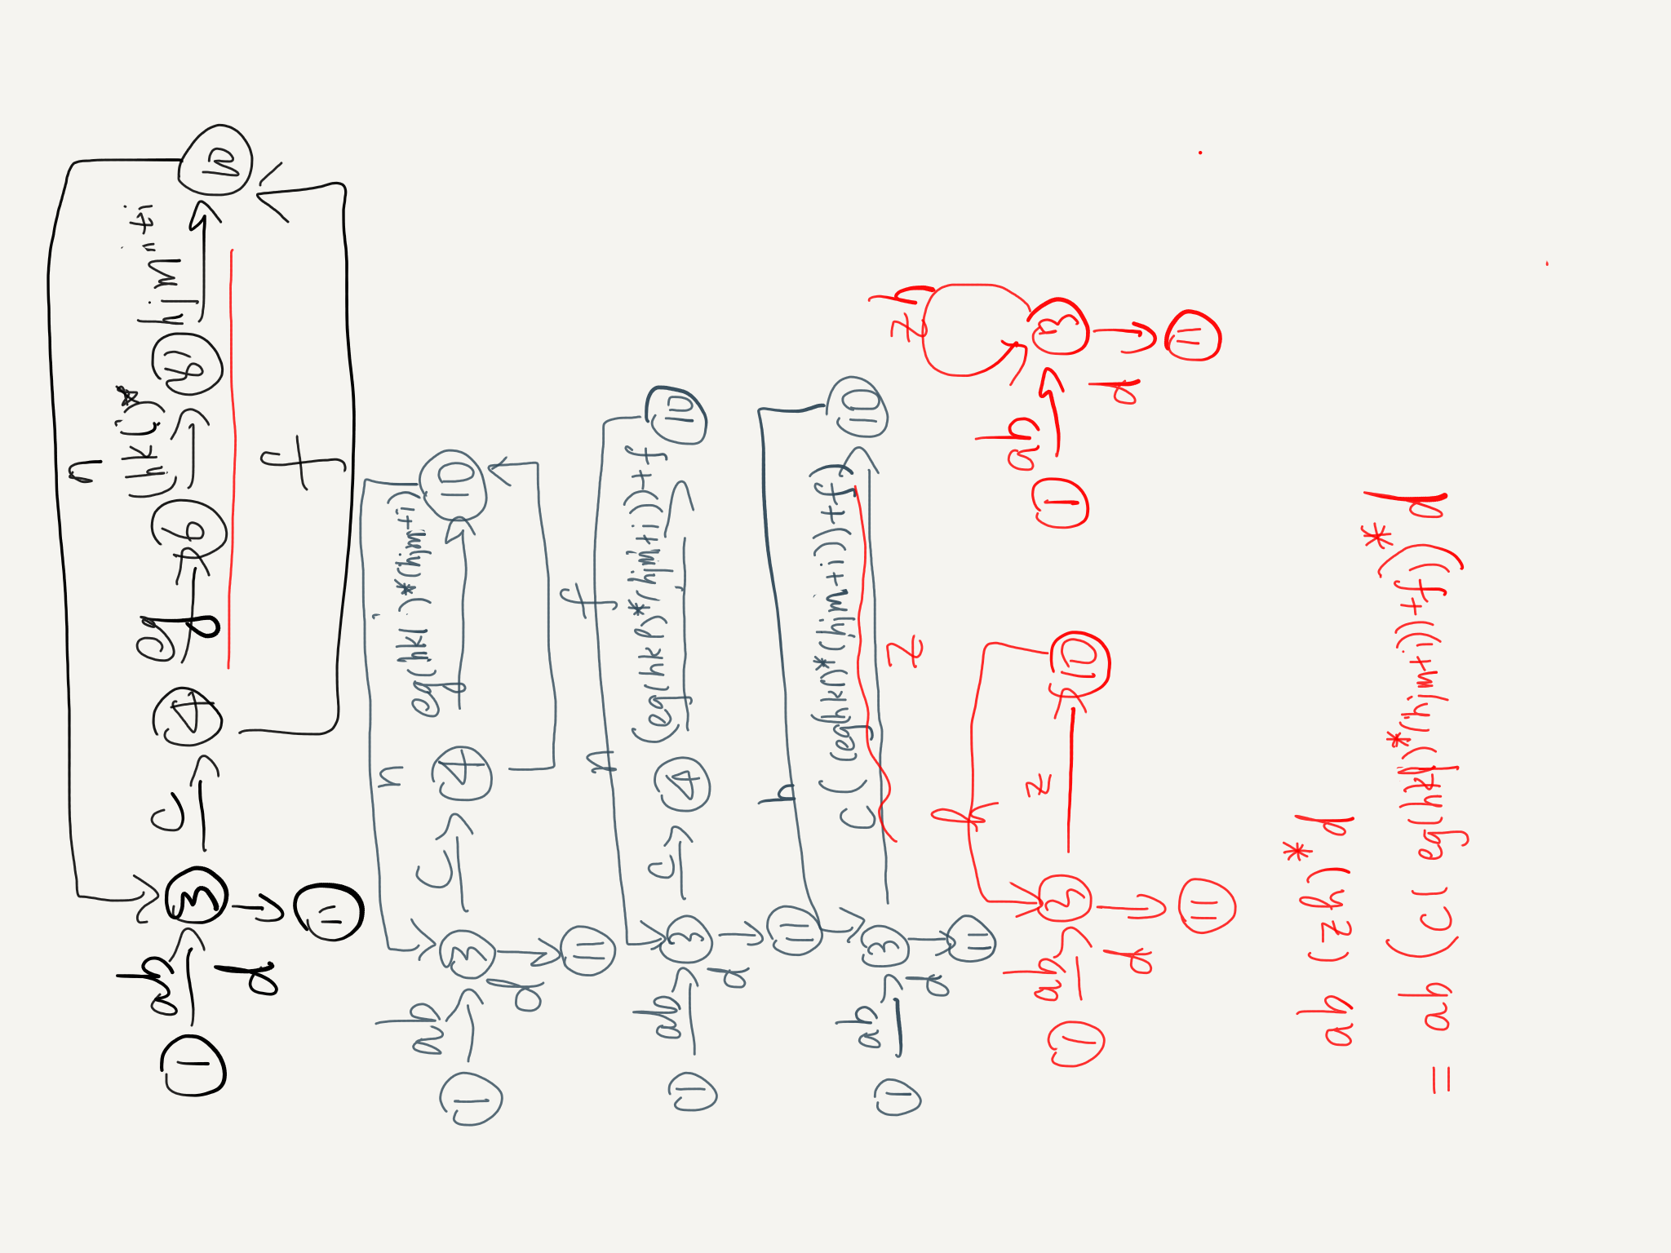

Assign a ~ n be 1.

a\*b\*(c\*(e\*g\*(h\*k\*l)^z\*(h\*j\*m+i))+f)^y\*d

= 1\*1\*(1\*(1\*1\*(1\*1\*1)^z\*(1\*1\*1+1))+1)^y\*1

= ((z\*2)+1)^y

Because the cumulation of 1^z is z\*1^z = z, we use z instead of 1^z.

Maximum: ∑∑((z\*2)+1)^i

If we set the inner circle is up to 2 time, and the outer circle is up to 2 time too. The Maximum will be 57.

Minimum: 6