Project Work Plan
Project: Online Shopping System
Team: Group 23
Duration: 14 Weeks

- INTRODUCTION

This document outlines the comprehensive work plan for the development of the Online Shopping System. The plan defines the project scope, establishes a detailed timeline and task breakdown, and specifies resource allocation, with the objective of guiding the team to deliver a fully functional, secure, and user-friendly e-commerce platform within the stipulated 12-week period. It serves as the foundational blueprint for systematic execution, monitoring, and successful project completion.

2.PROJECT SCOPE

Product Scope:
The system will include the following functional requirements as per System Specification:

Basic Requirements (Mandatory):
- Block A: Basic features to support minimal online shopping functions.

Customers do shopping in the storefront
- New Account registration
Customers may register a new account. They have to provide their full name, email address, password, and shipping address in registration.
- Product search
The product search is accessible to customers before login.
A customer can search products by product name (and optionally other product attributes).
- Product detail information
The product detail information is accessible to customers before login.
Customers may click/tap a product in the product list to view product detail information, which includes two more attributes in addition to the product name, price, and a thumbnail image.
- Shopping cart
Customers can add a product to their shopping carts.
After logging in, customers can manage their shopping carts and orders.
Customers can list the products in their shopping carts, showing the product name, price and quantity to buy.
The total order amount in a shopping cart is also shown.
A customer can click/tap an item in the shopping cart to review the product detail.
Customers can change the quantity to buy for a product in the shopping carts
Customers can remove a product from their shopping carts.
Customers can check out all items in the shopping cart. This action creates a purchase order and clears the content of the cart.
- View orders
Customers can list the purchase orders that they have placed.
The following is shown for each purchase order: the P.O. number, the purchase date, the total order amount and the purchase order status.
Customer can clicks/taps an entry in the list to see the detail of the purchase order.
The detail of a purchase order to show includes the P.O. number, the purchase date, the shipping address, the total order amount and the purchase order status. For each product in the purchase order, the product name, the quantity, the unit price and the subtotal are displayed.
- Pagination
Customers are provided suitable controls for navigating a long product list.
- Product browse
Customers may browse numerous products in a list (or grid, if appropriate). This product list shows basic information of products, including product name, price and a thumbnail image.

Vendors manage the product catalogue and process orders in the administration portal
- Browse the products
The vendor can browse the products in the product catalogue.
- Search the product
A system-generated unique product ID is also shown. The vendor can search products by entering a substring of the product ID.
The vendor can search products by product name (and optionally other product attributes).
- Add the product
The vendor may add a new product to the catalogue. The vendor enters detail information of the product, which includes, but is not limited to, the product name, price and a thumbnail image.
- List and view orders
The vendor can list the purchase orders placed by customers.
The vendor can click/tap a purchase order to show its details and line items.
(12) Edit products
The vendor can edit product detail information.
(13) Disable and enable the product
The vendor can disable a product to temporarily hide it from customers in the storefront. The vendor can later enable the product.

- Block B: Multiple photos per product & Basic order processing

- Multiple photos
The e-commerce system supports multiple photos per product. The store front displays the photos in product detail, and the administration portal allows adding and removing photos from a product.
- Order processing
The e-commerce system supports basic order processing. An order status is maintained for each purchase order to track the order processing workflow.
Users can define their own order status workflow, which contains at least four possible values for order status. The storefront and the administration portal allow the customers or vendors to carry out actions that trigger order status change.
Customers can filter the list of purchase orders by order status.
The system keeps a record of the date for some changes of order status, and displays these dates together with other order detail information.

- Block D: Configurable products & Preliminary inventory management

- Create and manage configurable products
Vendor can create configurable products with at least 1 option. Each option has a predefined set of values.
In the administration portal, the product catalogue keeps separate SKU (stock keeping unit) for different configurations of a configurable product. A simple product has only one SKU. The vendor can set the inventory status of each SKU as in-stock or out-of-stock.
A simple product or a certain configuration of a configurable product may be out-of stock. In this case, customers cannot add the product to the shopping cart.
- Customers’ interaction with configurable products
Customers must choose a value for each available option when they put a configurable product into shopping cart.
Customers can buy more than 1 items of a certain configuration of the product. In addition, they can buy several configurations of the product.
Further Requirements (Selected):
- Block T: User Generated Content (Product reviews and ratings).

A platform for customers to give feedback such as rating and/or writing a short review for a purchased product is available.
Customers can express and share their comments of the products. Customers who are interested in such product may view these comments to make the decision. Vendor can also judge their products with the feedback of customers, to make their products more market-oriented.

- Block V: Reports and analytics.

Sales reports is available to vendors. Sales reports show the daily, weekly, monthly or annual sales numbers to understand the pace of growth. From weekly sales volume to top-performing products.

- Block W: Accessibility

- Internationalization
The text translation into different languages, formatting date and time according to the set of regions.
- Friendly to people in special needs
- Speaker
A speaker can read out the text in the page for those who have visual impairment.
- Front enlargement
Enlarge the font size for those who have visual impairment.
- Color filters
Provide different color blindness model for people with color blindness.
They can choose red-green color blindness or blue-yellow color blindness model.
- Flash below the threshold
Do not design content that may trigger epileptic seizures or physical reactions.
Flash with 3 times or below the threshold will not cause epileptic seizures.

Process Scope:
The project will follow a development process with the following phases:

- Initiating: Project planning and setup.
1. Choose the group leader
2. Allocate the work
3. Business case chosen
4. Find related stakeholders
5. Target users
- Analysis: Requirements analysis and system design.
1. Customer requirement analysis.
Vendor requirement analysis.
2. System design
3. Technology choice
4. Marketing analysis

- Design: Architecture, database, and UI design.
1. User Interface design
2. System architecture design
3. Database design
4. API design
- Implementation: Coding, integration, and testing.
1. User system
User login/out
User registration
  - Customer
Shopping cart management
Order management
UGC functions
  - Vendor
Order management
Product management
Configurable products management, creation, and editing
Reports and analytics
2. User interface
Product browsing/ product detail browsing
Product searching
3. Database
4. Integration
5. Testing
- Deployment: System deployment and documentation.
- Closure: Final reporting and presentation.

- SCHEDULE PLAN(GANTT CHART)
Project Timeline: 14 Weeks
WBS
1. Initiating: Project planning and setup.
1.1 Choose the group leader
1.2. Allocate the work
1.3. Business case chosen
1.4. Find related stakeholders
1.5. Target users
2. Analysis: Requirements analysis and system design.
2.1 User requirement analysis
2.1.1 Customer requirement analysis.
2.1.2 Vendor requirement analysis.
2.2 System design
2.3. Technology choice
2.4. Marketing analysis

- Design: Architecture, database, and UI design.
3.1. User Interface design
3.2. System architecture design
3.3. API design
3.4. Database design
- Implementation: Coding, integration, and testing.
4.1 User login/out
  - User registration
  - Customer
4.3.1 Shopping cart management
4.3.2 Order management
    - UGC functions
  - Vendor
4.4.1 Product management
4.4.3 Configurable products management, creation, and editing
Reports and analytics
4.4.3 Order management
4.4.4 Reports and analytics
4.5 Product browsing/ product detail browsing
4.6 Product searching
4.7. Database
4.8. Integration
4.9. Testing
- Deployment: System deployment and documentation.
- Closure: Final reporting and presentation.

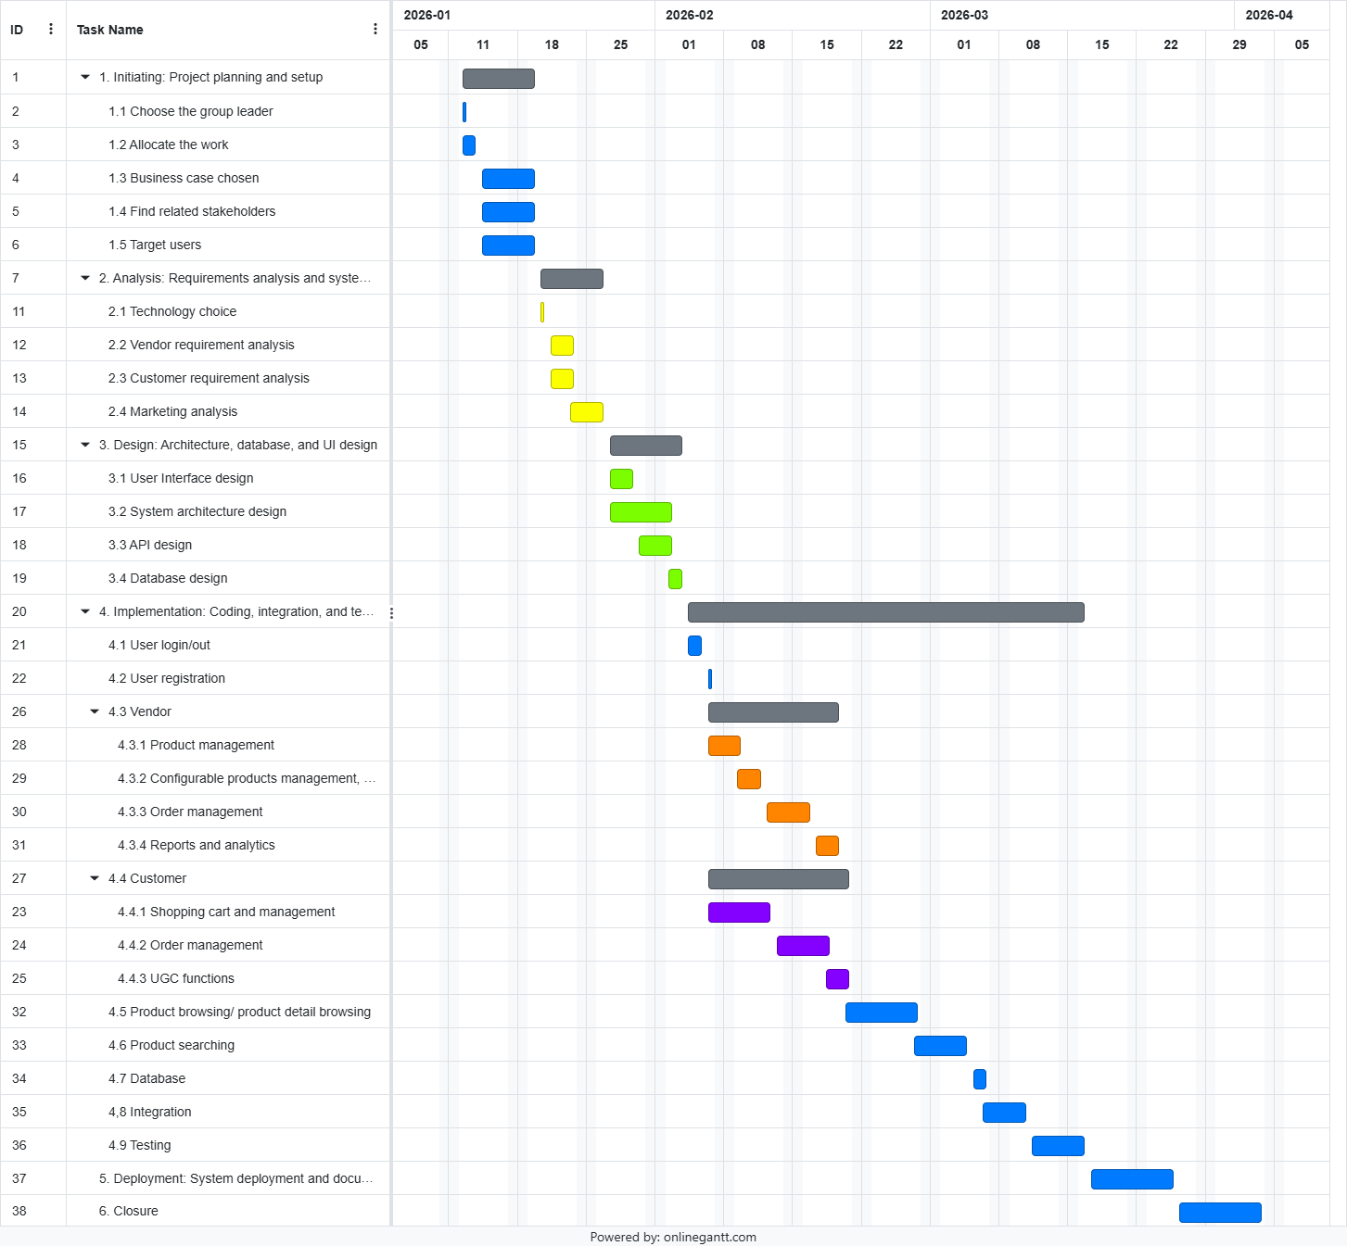

MILESTONES
M1: Project Plan Approved :milestone, m1, 2026-01-25, 0d
M2: Block A Complete :milestone, m2, 2026-02-15, 0d
M3: Core Features Complete :milestone, m3, 2026-02-29, 0d
M4: Testing Complete :milestone, m4, 2026-03-22, 0d
M5: System Deployed :milestone, m5, 2026-03-27, 0d
M6: Project Submitted :milestone, m6, 2026-04-06, 0d"
EXAMPLE GANNT CHART: BLOCK ABC, TUZ.

4.JOB ALLOCATION
Detailed Responsibility Matrix:

Task Category | Key Tasks | Primary Role | Supporting Role
Project Management | Timeline, Coordination, Docs | Group Leader | All Members
Backend Development | Server, DB, Core APIs | Group Leader | Backend Member
Frontend Development | UI/UX, Responsive Design | Frontend Lead | Frontend Members
Auth & Security | Login, Session, Security | Backend Member | Group Leader
Product Management | Product CRUD, Search, Admin | Backend Member | Group Leader
Order System | Cart, Checkout, Order Flow | Group Leader | Backend Member
UGC & Analytics | Reviews (T), Reports (V) | Backend Member | Frontend Lead
Testing & QA | Test Cases, Accessibility (W) | Frontend Member | All Members
Deployment | Server Config, Deployment | Group Leader | Backend Member
Phase 1 Docs | Plan, Charter, Gantt Chart | Frontend Lead & Members | Group Leader (Review)
Phase 2 Docs | Design, API Docs, Final Report | All Members | Group Leader (Merge)

