**SRS**

**Section 4 Functional Requirements**

**4.1 System Functions**

* The user can create an account.
* The user can sign in.
* The user can connect the device to the application using a QR-code.
* The user can view Contact Us page.
* The user can view Help page for any assistance with using the app.
* The user can view a page that has a list of the previously detected gases.
* The user can view profile.
* The user can edit profile.
* The model shall be trained and tested numerous times.

**4.2 Detailed Functional Specification**

|  |  |
| --- | --- |
| Name | Detect_gas |
| Code | O01 |
| Description | Detect gas using sensors that were installed on the hardware. |
| Input | Gas scent coming from database. |
| Output | Buzzing sounds and a text of the detected gas. |
| Pre-Condition | There must be a gas that could be detected by the sensors in the first place. |
| Post-Condition | The type of gas will be detected and it will be added to the previous detections list. |
| Risk | The sensor falsely detecting the gas. |

|  |  |
| --- | --- |
| Name | Sign_Up |
| Code | O02 |
| Description | Makes the user create an account. |
| Input | User’s required information to create an account. |
| Output | The account has been created. |
| Pre-Condition | The data inserted should be valid in order to create an account. |
| Post-Condition | The user will be directed to the homepage. |
| Risk | Account info might be already registered. |

|  |  |
| --- | --- |
| Name | Sign_In |
| Code | O03 |
| Description | Sign in to your registered account. |
| Input | User name and password |
| Output | The user signs into his previously registered account. |
| Pre-Condition | The account should be already existing. |
| Post-Condition | Redirects the user to the homepage. |
| Risk | Username or password could be incorrect, could sign in to a nonexistent account. |

|  |  |
| --- | --- |
| Name | View_Profile |
| Code | O04 |
| Description | Views the profile page. |
| Input | Click on profile page, user’s data. |
| Output | The user can view his previously detected gases. |
| Pre-Condition | The account must be signed in. |
| Post-Condition | Redirects the user to the profile page. |
| Risk | Page could freeze while loading. |

|  |  |
| --- | --- |
| Name | Edit_Profile |
| Code | O05 |
| Description | Edits the profile. |
| Input | Click edit on profile page, user’s data. |
| Output | The user can edit his data like the username, email, password and phone number. |
| Pre-Condition | The account must be signed in. |
| Post-Condition | Redirects the user to the profile page. |
| Risk | Page could freeze while updating the data. |

|  |  |
| --- | --- |
| Name | Model_Training |
| Code | O06 |
| Description | Using our ML algorithm we can train the model. |
| Input | Dataset to be trained. |
| Output | - |
| Pre-Condition | There must be a a dataset that could be trained and a ML algorithm to be implemented on this dataset. |
| Post-Condition | The model will be trained and ready for testing. |
| Risk | The model could fail in achieving the target it was trained for. |

**Section 5 Design Constraints**

**5.1 Standards Compliance**

* [**UL60950**](https://standardscatalog.ul.com/standards/en/standard_60950-1_2)**- Safety of Information Technology Equipment:**  
  Any products classified as information technology must adhere to this standard.
* [**AS3100**](https://infostore.saiglobal.com/en-us/Standards/AS-NZS-3100-2017-99695_SAIG_AS_AS_209576/)**- Approval and test specification - General requirements for electrical equipment:**  
  This is the primary specification governing the approval and test specification of electrical equipment. As such any electronic product must adhere to these basic rules governing safety.

**5.2Hardware Limitations**

* Sensor drift and the inability to give exact calibration are two limitations to their full potential: loss of sensitivity in the presence of water vapor or high concentrations of a particular component such as alcohol; and sensor drift.
* Some sensors have a short life span; method development is time-consuming for each application; and quantitative data for fragrance differences is difficult to come by.
* MQ2: This sensor works on 5V DC voltage. It can detect gases in the concentration of range 200 to 10000ppm.
* MQ3: The sensor can operate at temperatures from -10 to 50°C and consumes less than 150 mA at 5 V. The concentration sensing range of 0.04 mg/L to 4 mg/L.
* MQ4: The concentration sensing range of 300 ppm to 10,000 ppm is suitable for leak detection.
* MQ5: The concentration sensing range of 300 ppm to 10,000 ppm.
* MQ6: This sensor can detect gas concentrations anywhere from 200 to 10000ppm, and has a high sensitivity and fast response time.
* MQ7: This semiconductor gas sensor detects the presence of Carbon Monoxide at concentrations from 10 to 10,000 ppm.
* MQ8:  This sensor is very simple to use and detects hydrogen gas concentration in the range of 100-10000ppm anywhere.
* MQ9: This semiconductor gas sensor detects the presence of Carbon Monoxide at concentrations from 10 to 1,000 ppm and combustible gas from 100 to 10,000 ppm.
* MQ135: Semiconductor Sensor for Air Quality from 10～1000ppm.
* VOC: This robust fixed Continuous VOC Gas Detector has a selectable detection range of 0 – 10 ppm, 0 – 100 ppm or 0 – 1000 ppm and is ideal for use in manufacturing and process industries where VOCs are typically present.

**6 Non-Functional Requirements**

* 6.1 Reliability

The system shall detect life-threatening gases with high accuracy.

* 6.2 Safety

The system shall detect the harm that could occur because of the sensed gases and identifies what the harm could be.

Accordingly, miss-Classification shall be avoided to ensure their safety.

* 6.3 Availability

The sensors should be connected in a proper way onto the microcontroller in order to avoid any bugs that could happen.

* 6.4 Performance and Response Time

The system shall detect the harmful gases rapidly to avoid any complications.

* 6.5 Portability

As this system is developed mainly as a hardware device that will be coded in python, We also want to create a mobile application so that you can link with the hardware device for easier use.

**9 Operational Scenarios**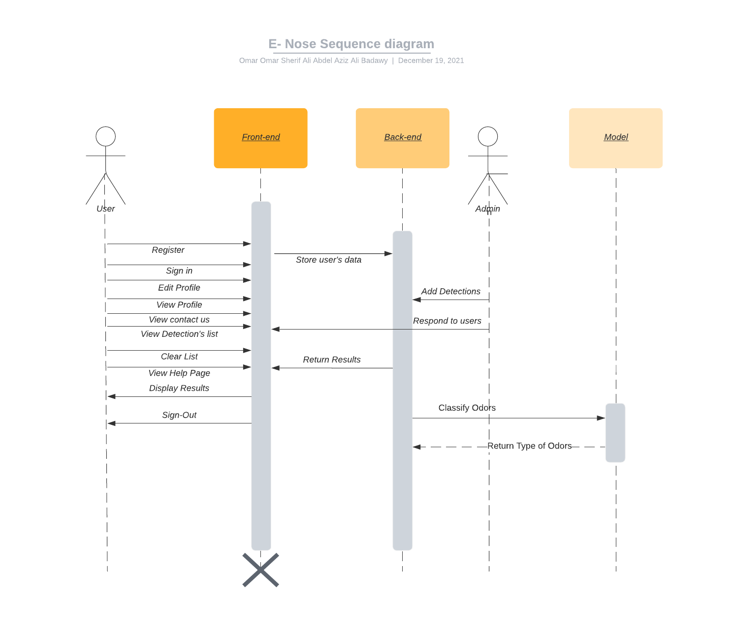

* User:
  + Users can Add/Delete Detections from detection’s list.
  + Users can view results coming from the model showing odors and their type and contact the admin for any questions they have.
* Admin:

– Admin can add a new user, view User’s information and detected odors, Edit, delete user’s data.

– Admin can add new detected odors for testing and managing the database, directly affecting the model’s classes, and responding to user’s messages.