MOTIVATION
Increasing trends towards adaptive, distributed, generative and pervasive software has made dynamic languages become increasingly popular. These languages facilitate the development of dynamic systems offering features such as reflection, meta-programming, dynamic code generation, and making nearly all entities first class objects. Examples are the successful use of Ruby on Rails in the Web 2.0 software development, the Java Scripting API included in Java SE 1.6, the DLR platform deployed in lasts versions of SilverLight and IronPython, and an extensive development of frameworks and applications in the Python programming language: Django, Zope, Pythius, MoinMoin wiki engine or BitTorrent.
When comparing dynamic languages with static ones, the lack of early error detection and a low runtime performance have prevented dynamic languages from being used in more scenarios of commercial software development. This project’s main aim is defining a high-level programming language and a platform that make possible the development of applications with both static (robust and fast) and dynamic (flexible and rapid-development) features using the same source code and computational model, following the Separation of Concerns principle. This will make possible to make more flexible specific parts of an application or convert a rapid prototyping program into a robust and efficient one, minimizing then changes in its source code.
In this section we will describe the outline of the project and its benefits. A brief description of the methodology will be specified in the following section.
Outline
A language is said to be safe if it produces no execution errors that go unnoticed and later cause arbitrary behaviour. Static languages ensure safety of programs by using type systems. However, this type systems do not compile some expressions that have a correct behaviour at runtime (e.g. to pass a message called “m” to an object, the reference of that object must implement an interface that declares this public method). This happens because their static type system requires ensuring that only good expressions are typable. Figure 1 illustrates this situation.
Compilable  Correct Behaviour  Compilable and wrong behaviour  Compilable and correct behaviour  Not compilable and correct behaviour  Not Compilable | Compilable and wrong behaviour  Compilable and correct behaviour  Not Compilable
Figure 1: Correct programs in a static language. | Figure 2: Correct programs in a dynamic language.
At the same time, static languages also permit the execution of programs that might cause the immediate stop of a running application, producing an execution error (e.g. array index out of bounds or null pointer exception).
The approach of dynamic languages is totally different. Instead of making sure that all correct expressions will be able to be executed, they make all syntactic correct programs compilable (Figure 2). This is a too optimistic approach that causes a lot of runtime errors that might be detected at compile time. Dynamic languages do not apply any type checking at compile type, causing too much wrong behaviour at runtime.
Our project defines a programming language that performs type inference at compile type, minimizing the “compilable and wrong behaviour” region of dynamic languages (Figure 2) and the “not compilable and correct behaviour” area of static languages (Figure 1). For both proposes we will use the same programming language and platform and let the programmer move form an optimistic, flexible and rapid development (dynamic) to a more robust and efficient (static) one. This will be done using the same source code, changing the compiling settings. We separate the concern of flexibility, robustness and performance, from functional requirements of the application.
To make this possible we identify two key issues:
- The Programming Language. There is a lot of theory on type systems and program analysis, but they have not been applied to a language created to develop commercial applications (not only research products) where runtime performance is an imperative issue. The Java 5 and C# 2.0 programming languages have added bounded polymorphism to improve its type system and runtime performance. However, the complexity of these languages has been seriously increased. As an example, the following code is the declaration of a simple “min” static method in the Collections class (java.util package) that returns the minimum element of the given collection:
public static <T extends Object & Comparable<? super T>>
T min(Collection<? extends T> coll)
This complexity might be reduced by using type inference (reconstruction) implemented by languages such as Haskell or ML.
- The Platform. There has been considerable research aimed at improving the performance of virtual machine’s application execution. Techniques like adaptive Just In Time (JIT) compilation or runtime adaptive optimization have reached such a point that Microsoft and Sun Microsystems distribute this kind of platforms as appropriate to implement commercial systems. In order to overcome the runtime performance drawback of dynamic languages, we will apply the same approach that made virtual machines a valid alternative to develop commercial software. We have extended the computational model of the SSCLI JIT-based virtual machine to support the reflective prototype-based computation model of dynamic languages. This will make possible the interoperation with existing .Net languages in a bidirectional way. This is one of the lacks of current implementations of dynamic languages over the .Net platform. Calling statically typed code from a dynamic language is easy, but this feature is limited in the opposite direction because types are only known are runtime. The use of Reflection implies a runtime performance and it is not type safe.
Objectives and Benefits
Our system has been created following the next objectives:
Runtime Performance.
Since once of the main advantages of static typing is runtime performance, we keep doing type reconstruction for dynamic languages. When types could be inferred at compile time (not always possible), runtime performance and safety will be increased in dynamic languages. Moreover, JIT compilation and adaptive hotspot optimization can be used in both scenarios at runtime.
Flexibility.
When the programmer wants to make parts of an application (or the whole program) more flexible –rapid prototyping of views, adaptive code, web engineering or interactive development– he or she will only need to specify it in separate files, without changing the source code. These parts of the application will use a more “optimistic” type checking scheme.
Type Safety.
As described in the previous point, the programmer may identify parts of an application as critical in performance and safety. In this case, static references will be used and the same code will be compiled in a “pessimistic” way. In case the programmer moves from dynamic to static, it will be common to obtain new compile-time errors. This behaviour is the one described in the “outline” section of this proposal.
Language and Platform Interoperability.
Since we do type inference both in dynamic and static compilation modes, it is possible to make dynamic and static code interoperate. Currently, IronPython and the Java Scripting API are two common examples that show how dynamic languages can interoperate with static ones, but not the other way round in a complete way. If the programmer creates a class instance in Python, the static code cannot directly retrieve its type. This lack is due to the fact that Python does not static type checking. Therefore, types created by the programmer in Python are not included in the type system of the static program.
This interoperability is also important at the platform level. Our modification of the SSCLI implements a reflective object-oriented prototype-based model. This computational model supports both the static class-based one and the reflective model supported by dynamic languages. This will facilitate the interoperation between our platform and other existing ones –e.g. C# or VB.
Separation of Concerns.
The language is created following the separation of two important concerns. One is the application functionality that is described with its source code. The other is safety and performance (contrary to flexibility and rapid development) that is described in separate files, used as compiler settings in specific parts of a program. This separation of concerns promotes the movement from agile and rapid-prototyping software development to robust, safe and efficient software. It also facilitates making more flexible specific parts of a system, without changing its source code.
Simplicity.
Our type reconstruction (inference) scheme uses parametric polymorphisms and detects type constraints by doing static program analysis. This implies that the programmer should not have to explicitly specify type variables (generics) and type constraints (bounded polymorphism). The compiler will extract all this information at compile time. As a syntactic example, the “min” method previously shown in Java 1.5 might be declared the following way:
public static var min(var coll)
This example shows that the programmer does not have to specify the set of type variables and the constraints that each type variable must satisfy. This information might be inferred by the type system.
Impact of the project
Software development has been extremely influenced by programming languages. High-level programming languages (Fortran vs. assembly), object-orientation (C++ vs. C or Pascal) and languages based on JIT-compiled virtual platforms (Java or .Net vs. C++) have previously changed the way software has been developed. Currently, dynamic languages seem to be the next step forward. This project might simplify and change the way software is developed, reducing its performance cost to the minimum. It could be a contribution in the evolution of programming languages and platforms.

THE PROGRAMMING LANGUAGE
The main aim of our project is to demonstrate that specific techniques of static program analysis and type systems can improve dynamic language performance, safety, interoperability with static languages, and SoC-based development mentioned in the motivation section. Therefore, instead of supporting a full-feature programming language such as Python or Ruby, we have extended the C# 3.0 specification. We have extended the semantics of the implicitly typed “var” references offering the behaviour of references in dynamic languages. Type checking is performed over these references in a safe and pessimistic way (static) or in a flexible and optimistic manner (dynamic). However, this separate concern is not described in the source file.
Type Inference
The technique we have used to make static and dynamic languages compliant is type inference. Since dynamic languages do not specify types of their references, static processing of these languages should implement a type reconstruction technique trying to infer types at compile time. Therefore, type inference of “var” references is used, independently if they are dynamic or static. However, its dynamism feature is taken into account for type checking (next section).
The following code is an example of type inference in our C# 3.0 extension:
class Test {
public static var element(var array, int index) {
return array[index];
}
public static void Main() {
var[] vector=new var[10];
for (int i=0;i<vector.Length;i++)
vector[i]=i;
int n = element(vector, vector.Length/2);
char c = element(vector, vector.Length / 2); // * Error
element(n, vector.Length / 2); // * Error
}
}
The “element” method takes an “array” and returns de “index” value. The first method call is valid –notice that the “vector” is another “var” reference whose type is also inferred– returning and integer value. However, the last two calls are erroneous. The compilation result of the previous program is shown the following figure (coloured text is produced by a testing tool we have developed):
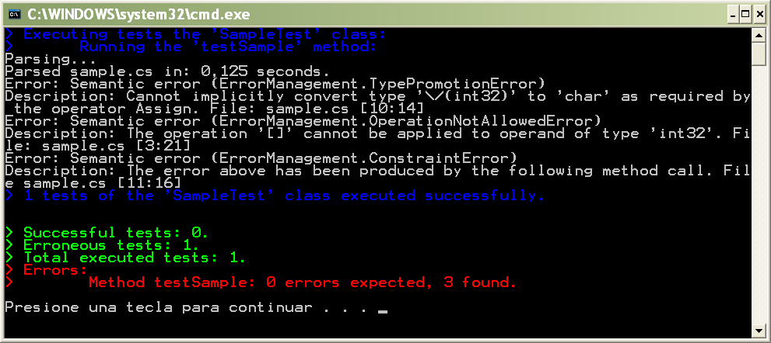
Knowing the type of a reference has three benefits:
- Runtime performance. The generated code does not use reflection.
- Type safety. Even in dynamic languages, there are semantic errors that can be detected at compile type. The early detection of these errors is a valuable tool. However, if we have declared “var” references as static, our code will be type safe.
- Abstraction and documentation. One of the lacks of typeless references are that they do not specify a kind of partial contract between implementers and users, nor an updated documentation of the parameters and return values.
In our previous example, the type of the first parameter of the “element” method is “an array of T” and the return value is “T”. However, this information is not supplied by the programmer; it is inferred by the compiler. This type information could be used to document the “element” method (this feature has not been implemented yet).
It is worth noting that knowing the type of dynamic references is important when we want to make a static program (e.g. C#) call dynamic code (e.g. Python) because, otherwise, introspection must be used, loosing type safety and runtime performance.
Separating the Dynamism Concern
One of the major objectives of our project is the SoC approach followed to convert agile, flexible and adaptable dynamic code into safe, efficient and robust static code, and vice versa, without modifying the application. This Separation of Concerns is achieved by assigning this responsibility to the compiler configuration; XML configuration files and command line options are used for this purpose.
Taking the following explicitly typed pair of classes:
namespace Figures {
class Rectangle {
private int x, y, width, height;
public Rectangle(int x, int y, int width, int height) {
this.x = x;
this.y = y;
this.width = width;
this.height = height;
}
public int getX() { return x; }
public int getY() { return y; }
public int getWidth() { return width; }
public int getHeight() { return height; }
}
class Circle {
private int x, y, radius;
public Circle(int x, int y, int radius) {
this.x = x;
this.y = y;
this.radius = radius;
}
public int getX() { return x; }
public int getY() { return y; }
public int getRadius() { return radius; }
}
}
We can write the following code:
using System;
using Figures;
namespace Testing.Sample {
class Test {
public static var getFigure(string name, int x, int y,
int radius, int width, int height) {
if (name.Equals("Circle"))
return new Circle(x, y, radius);
return new Rectangle(x,y,width,height);
}

public static void Main() {
string figureName = Console.ReadLine();
var myFigure = getFigure(figureName, 0, 0, 10, 20, 40);
int x = myFigure.getX(),
y = myFigure.getY();
// * The following statement is:
// - An error if "myFigure is static
// - Correct if "myFigure is dynamic
int radius = myFigure.getRadius();
}
}
}
The last line generates a semantic error because it is not safe to pass the “getRadius” message to both a circle and a rectangle. This is the default behaviour. However, if we want to set the “myFigure” reference as dynamic, we can use a command line option or write the following XML configuration file –the naming criterion is the same name of the “cs” file with a “dyn” extension.
<?xml version="1.0" encoding="utf-8"?>
<application name="sample">
<namespace name="Testing.Sample">
<class name="Test">
<method name="Main">
<dynvar name="myFigure" />
</method>
</class>
</namespace>
</application>
Using this configuration file, the last line of the previous code is not erroneous. We can be more optimistic and wait until runtime to see if some error occurs. In this case we are making our code more flexible, but we can also convert a rapidly developed prototype into a robust and efficient program. Obviously, in this scenario the source code might require modifications to correct type errors.
Union Types
The main feature that makes the SoC approach of our project possible is the use of union types. Union types denote the ordinary union of the set of values belonging to the set types they are composed of. Union types are inferred when using the return statement, in a control structure, when assigning elements to a “var” array, or when assigning or modifying objects in a non-sequential flow. The following is an example of a union type inference:
public static void unionTypes() {
bool condition;
var reference;
if (condition)
reference = 'h';
else
reference = 34.34;
double d = reference;
Char.IsDigit(reference); // * Correct only if referece is dynamic
}
Non-disjoint union types have long played an important role in program analysis. However, we used them to separate dynamic and static behavior with the same source code. In the previous example, the assignment “d=reference” is correct because the type “char” \/ “double” is a subtype of “double”: both values promote to a double. However, last statement is correct only if “reference” is dynamic because a “double” is not a subtype of “char” –the expected parameter.
Constraint-based Type System
The type inference mechanism implemented is a modification of the one described by Damas and Milner. Since this analysis algorithm requires that each method should be analyzed previously to its first invocation, we have implemented an abstract interpretation analysis algorithm. However, there are situations where we could not be able to infer the returned type because we don’t know types of the parameters. Here is an example:
public static var element(var array, var index) {
return array[index];
}
In this case, we do not know the type of the “array” parameter, nor the “index” type; so we cannot infer the resulting type. This is the scenario where we use constraint-based typing. We calculate a set of constraints –equations between type expressions– that must be satisfied by any actual parameter in future method calls –these constraints are added to the internal representation of method types. The previous method has two constraints: the “index” should promote to integer and “array” must be an indexer. The following are examples of correct and wrong method calls:
int[] vector=new var[10];
int n = element(vector, vector.Length/2); // * Correct
element(n, vector.Length / 2); // * Error
element(vector, 2.2); // * Error
Of course, constraints can be inherited when we call a constraint method with free variables, or they can be deleted when they are satisfied:
public static var add(var array, int index) {
return element(array,index)+index;
}
Of the two previous constraints, the promotion of the “index” type to integer has been satisfied. However, the “add” method inherits the constraint of requiring “array” to be an indexer. Additionally a new one is generated: the element of the array should be addable.
As we have previously said, constraints can be used by an IDE as a documentation and abstraction tool to overcome this drawback of implicitly typed references.
Multiple Types for a Single Reference
In dynamic languages, it is common to use the same reference with different types. However, in most statically typed languages it is not possible. The following code is a correct program in our language:
public static void testSequential() {
var reference;
reference = 3;
Console.Write(reference % 2);
reference = 3.3;
double d = reference;
reference = "3";
Console.Write(reference.Length);
reference = new int[10];
d = reference[3];
}
To make this possible, we have implemented different static program analysis algorithms. Specially, one of the most important ones was a modification of the SSA algorithm, customized for the analysis of high-level programs. This way, the AST representation of the “if”, “while”, “do”, “for” and “switch” statements is converted into an equivalent SSA AST. The following while statement is an example of this feature:

class While {
private var attribute;
public void setAttribute(var p) {
this.attribute = p;
}
public var getAttribute() {
return this.attribute;
}
/**************** testWhile ***************/
public void testWhile() {
Circle circle = new Circle(0, 0, 10);
Rectangle rectangle = new Rectangle(0, 0, 20, 40);
setAttribute(circle);
Console.WriteLine("Radius: {0}.", getAttribute().getRadius());
int i = 0;
while (i < 10) {
Console.WriteLine("X={0}, Y={1}.",
getAttribute().getX(), getAttribute().getY());
int radius = getAttribute().getRadius(); // * Error
if (i % 2 == 0)
setAttribute(rectangle);
else
setAttribute(circle);
int width = getAttribute().getWidth(); // * Error
i++;
}
this.attribute = Math.Sqrt(Math.Pow(attribute.getX(), 2) +
Math.Pow(attribute.getY(), 2));
}
public static void Main() {
While whileObject = new While();
whileObject.testWhile();
double distance = whileObject.getAttribute();
}
}
Inside the while statement, the two lines of code with the comment “Error” generate a semantic error when the “attribute” is a static reference –both are correct in case it is dynamic. In the first error, the “getRadius” message cannot be safely passed to the “attribute” reference because this line can be executed after the first iteration of the while loop. In this case, the reference holds a rectangle and this class does not implement that method.
Notice than SSA is not the only program analysis implemented to make possible the use of multiple types in a single reference –no deeper details will be given in this document. As an example, the invocation of the following method modifies the type of an object without using the assignment operator.
public void setAttribute(var p) {
this.attribute = p;
}
These messages are taken into account in the program analysis algorithms we have implemented.
Type-based Alias Analysis
Our type system has been designed to offer alias analysis. This is an essential feature of our system because, as it has been shown in previous examples, our implicit type system uses concrete types instead of abstract ones. This means that types of implicit references represent the type of the actual object. Therefore, the modification of field’s type produced when specific messages are sent to an object (e.g. “setAttribute”) should be reflected in the concrete type. This feature is also vital to implement a type system that supports structural reflection.
The implementation of alias analysis has not been performed using another different program analysis algorithm. It is the type system that, using unification of type variables, infers information regarding to alias references. The type system offers a context-sensitive inter-procedural alias analysis.
The following example uses a simple “VarWrap” class that wraps a var reference:
class VarWrap {
private var attribute;
public VarWrap(var param) {
this.attribute = param;
}
public VarWrap() {}
public var get() {
return attribute;
}
public void set(var param) {
attribute = param;
}
}
The alias analysis test uses this class in the following way:
class AliasAnalysisTest {
public static void modify(var theObject, var param) {
theObject.set(param);
}
public static void testInterProcLocalAlias() {
var obj1, obj2;
obj1 = obj2 = new VarWrap();// * Direct alias assignment
modify(obj1, "value");
// * Correct!
string s = obj2.get();// obj2 is an alias of obj1
// * Wrong!
int n = obj2.get(); // * Error
}

private var testField;
public void setField(var param) {
this.testField = param;
}
public var getField() {
return this.testField;
}
public static void testInterProcGlobalAlias() {
var boolObj = new VarWrap();
var test = new AliasAnalysisTest();
test.setField(boolObj);
boolObj.set(true);
// * Correct!
bool b = test.getField().get();// test.getField() of boolObj
// * Wrong!
string s = test.getField().get(); // * Error
}
}
In the “testInterProcLocalAlias” method, “obj1” and “obj2” are aliases. If we modify “obj1” in another “modify” method, the type of the “obj1.get()” expression returns is the type of “obj1.attribute”. In the second example, the method “testInterProcGlobalAlias” method, this alias relation is created without using the assignment operator. The alias relationship is created in other different method –even in a separate file– and the “bool” type is correctly inferred for the “test.getField().get()” expression.
Structural Reflection
Structural Reflection is the language feature that permits the programmer modifying the structure of objects, adding, modifying or removing fields and methods at runtime. Python (explicitly) and Ruby (implicitly) are languages that offer this characteristic. Although we have not implemented this feature yet –we plan to develop it after the Capstone Workshop– our system has been built taken to into account this future feature. It’s worth noting that:
- The type-based inter-procedural alias analysis and the use of concrete types are a really powerful tool to reflect the modifications of objects structures. The type system will reflect those changes in each single object, knowing, when possible, the members held by each object.
- Our reflective modification of the SSCLI (see the platform section) implements these structural reflective services in a native way, offering a fine runtime performance.
THE PLATFORM
Our system is being developed to be used in three platforms:
- The ЯRotor platform is a modification of the SSCLI where we have added structural reflective primitives offered by most dynamic languages. This is first platform we are using to generate code. It is efficient and, due to its services, it facilitates the implementation of the code generator.
- The CLR. In order to obtain performance comparisons with other dynamic languages such as visual basic, we are analyzing different strategies to generate code for the CLR.
- The DLR. After a brief evaluation of the DLR deployed in the IronPython 2.0alpha1, we have decided not to use the DLR as the target platform, at the moment.
We plan to generate executable files for the two first platforms in September 2007. In the future it will be really interesting to use the DLR and compare our system with IronPython or IronRuby. Since we all know the DLR, the rest of this section is a brief description of the ЯRotor platform.
Structural Reflection in ЯRotor
Runtime reflective features of Rotor are restricted to the introspection level: system’s structure can be dynamically consulted but not modified. However, the .Net platform offers the facility to dynamically generate CIL code at runtime in a limited way (it only permits to create new types, not adding new methods to the existing classes) by means of its “System.Reflection.Emit” namespace.
We have extended the introspective capabilities of.Net CLI at the abstract machine level, adding the structural reflective set of primitives offered by dynamic languages. A new namespace has also been added to the BCL: “System.Reflection.Structural”. Its functionality can be grouped into:
- Attributes manipulation. Besides modifying the structure of a class (altering the structure of all of its instances), we can also alter the composition of a single object. Attributes may be added, deleted or replaced.
- Methods manipulation. Methods of classes can be dynamically added and erased. Therefore, the set of messages accepted by an object could change at runtime depending on dynamic contexts. This dynamic typing scheme is also known as “duck typing”: if it walks like a duck and quacks like a duck, it must be a duck. It means that an object is interchangeable with any other object that implements the same dynamic interface, regardless of whether the objects have a related inheritance hierarchy or not.
A new method could also be placed in a sole object. The body of these new methods can be obtained from existing ones, or dynamically generated by means of the “System.Reflection.Emit” namespace.
The programmer could combine these facilities with the introspective services already offered by the .Net platform, making the CLI an appropriate platform to develop language neutral adaptive software.
Prototype-Based Object-Oriented Model
There exist some conceptual inconsistencies between the class-based object-oriented computational model and structural reflection. These inconsistencies were detected and partially solved in the field of object-oriented database management systems. In this area, objects are stored but their structure, or even their types (classes), could be altered afterwards as a result of software evolution.
The first scenario of modifying attributes of a class implies updating the structure of every object that is an instance of the modified class. This mechanism was defined as schema evolution in the database world. The modification of class’s instances could be performed as soon as the class is evolved (eager) or when the object is up to be used (lazy); it is only necessary to know at runtime the class an object is instance of. Dynamic evolution of class’s methods and attributes can produce situations such as accessing attributes or methods that do not exist in a specific execution point; these situations are checked by a dynamic type checking mechanism using exception handling, in order to make sure that no incorrect behavior is produced.
There is another situation that a structurally reflective computational model supports, but in this case is much more difficult to model it in a class-based language. How can an object’s structure be modified without altering the rest of its class’s instances? This problem was detected in the development of MetaXa, a reflective Java platform implementation. The approach they chose was the same as the adopted by some object-oriented database management systems: schema versioning. A new version of the class (called “shadow” class in MetaXa) is created when one of its instances is reflectively modified. This new class is the type of the recently customized object.
This model causes different problems such as maintaining the class data consistency, class identity, using class objects in the code, garbage collection, inheritance or memory consumption, involving a really complex implementation difficult to manage. One of the conclusions of the MetaXa research project was that the class-based object-oriented model does not fit well to structural reflective environments. They finally stated that the prototype-based model would express reflective features better than class-based ones.
In the prototype-based object-oriented computational model the main abstraction is the object, suppressing the existence of classes. Although this computational model is simpler than the one based on classes, there is no loss of expressiveness; i.e. any class-based program can be translated into the prototype-based model. A common translation from the class-based object-oriented model is the one performed as shown in the following figure:
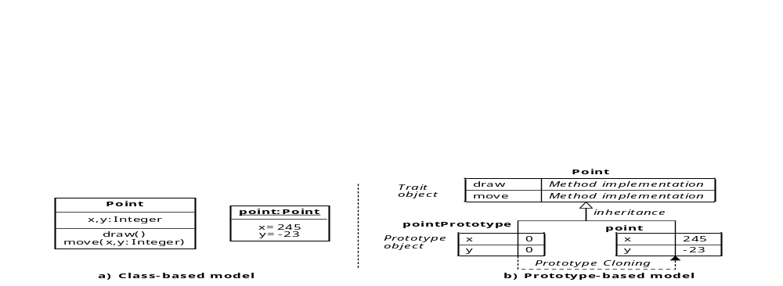
- Similar object’s behavior (methods of each class in the class-based model) can be represented by trait objects: objects whose members are only methods. Thus, their derived objects share the behavior they define.
- Similar object’s structure (attributes of each class in the class-based model) can be represented by prototype objects. This object has a set of initialized attributes that represent a common structure.
- Copying prototype objects (constructor invocation in the class-based model) is equivalent to the creation of a new instance of a class. A new object with a specific structure and behavior is created by cloning a prototype object.
In class-based languages, where classes are first class objects (Java, Smalltalk or C#), classes are represented by objects at runtime (e.g., in the .Net platform, instances of “System.Type” are objects that represent classes or another type). This demonstrates that, besides not existing loss of expressiveness, the translation of the model is intuitive and facilitates application interoperability. This is the reason why this model has been considered as a universal substrate for object-oriented languages.
For our platform, the most important feature of the prototype-based object-oriented computational model is that it models structural reflective primitives in a consistent way. Structural reflective languages such as Moostrap, Self or Kevo have successfully employed this model. The prototype-based object model overcomes the schema versioning problem stated in the previous section. Modifying the structure (attributes as well as methods) of a single object is performed directly, because any object maintains its own structure and even its specialized behavior. As shared behavior is placed in trait objects, its customization implies the adaptation of types (schema evolution).
Next figure shows an example scenario. The initial point and p2 objects are clones of the pointPrototype object and their shared behavior is placed in the Point trait object. A new coordinate attribute (z) has only been added only to point. Using the same approach, only the point object is capable to draw3D its three coordinates. Finally, all the derived objects from the Point trait object will be able to use the new getX method.
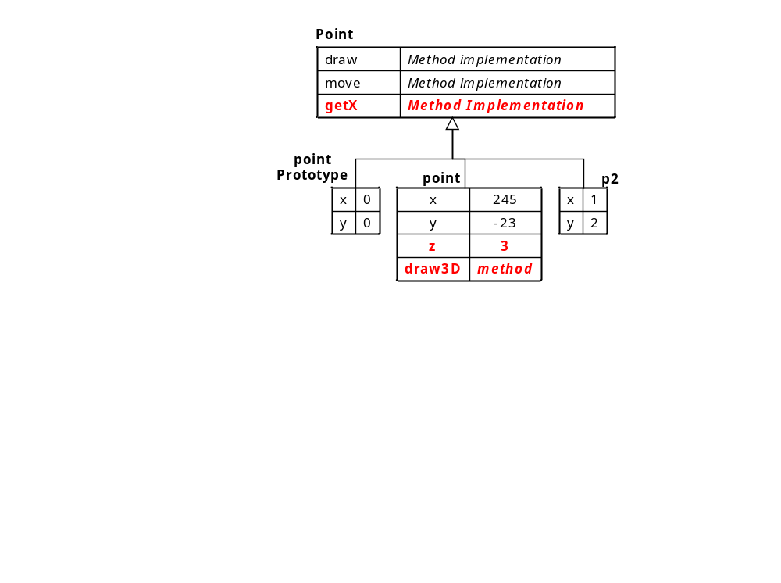
The addition of an attribute to a trait object represents a new field shared by all of the instances. This is what in the class-based object-oriented model is commonly known as static (class) attribute. Ruby follows this approach, whereas Python implements a schema evolution technique meaning that all the class’s instances should be involved. We will show how we have implemented both approaches.
Although computational models of dynamic languages are prototype based, most of them (Smalltalk, Python, Ruby, Groovy or Dylan) use the class reserved keyword. However, classes in these languages do not represent both shared behavior and structure as class-based languages do. They simply model trait objects –shared behavior. Objects are responsible for storing their own structure, and they can also contain specific behavior –methods.
Extending the SSCLI Computational Model
Dynamic languages use the prototype-based object-oriented model to be capable of offering structural reflection in a coherent way. However, although Common Language Infrastructure (CLI) tries to support a wide set of languages, the .Net platform offers a class-based object-oriented model optimized to execute “static” languages. Therefore, if we want dynamic languages to be interoperable with any existing .Net language or application, we should maintain the class-based model offering backward compatibility. Our reflective virtual machine should be capable of running any existing .Net application producing the same original behavior.
Taking into account that the CLI virtual machine is a low level platform for executing an ample set of high-level programming languages, both class-based and prototype-based object-oriented models will be supported: the former for running static class-based .Net applications; the latter for executing dynamic reflective programs. .Net compilers will select services of the appropriate model depending on the language being compiled.
The objective of our reflective extension of the .Net platform is supporting structural reflection with both class and prototype based computational models, implementing static and dynamic typing –performed by the compiler or the virtual machine, respectively.
As we have previously mentioned, we have maintained the use of classes for backward compatibility and to offer class-based structural reflection. Therefore, the structural manipulation of classes could imply:
- Schema evolution for class-based languages. Since classes are first class objects in the .Net platform, their structure is customized by means of “System.Type” instances. Altering their methods produces adaptation of objects’ behavior. In case we adapt attributes of “System.Type” objects (classes), what we obtain is the customization of all the existing instances of the adapted class. Looking for a good runtime performance, we have developed a lazy schema evolution mechanism. This adaptation of classes has been parameterized with a boolean argument indicating whether the new member is an instance slot or a class one (static in C++, Java and C#). Dynamic typing detects the use of a non-existing member, throwing the appropriate runtime exception.
- Traits customization in the prototype-based model. Modifying the interface of a trait object implies the customization of objects’ shared behavior –this is the same semantics as described above. However, the meaning of class structure (attributes) modification depends on the language. As we have seen in our example, Python interprets this modification as the adaptation of all the existing instances of the class being customized (lazy schema evolution); in Ruby, however, it simply implies the manipulation of class (static) members. Both functionalities are included in the paragraph above.
The scenario of modifying the structure of objects is only applicable to dynamic prototype-based languages because, in the class-based model, classes define the invariant behavior and structure of all their instances. In a reflective prototype-based model, however, it is possible to customize the specific behavior (methods) of a single object as well as customize its structure (attributes). These operations do not need to adjust the structure of classes because they only represent shared behavior (trait objects), overcoming the abovementioned schema versioning problem. Notice that compilers of statically type-checked .Net languages (e.g., C#) will never use these object reflective features because of its statically-typed class-based model.
Performance
Different benchmarks have been used to assess the efficiency of our implementation, measuring runtime performance and memory consumption. Three different sets of tests have been run to evaluate:
- Efficiency of structural reflective operations, measuring execution of micro-benchmarks that only use reflection.
- Runtime performance and memory consumption of non-reflective code execution.
- The cost of reflection, comparing the original implementation of the SSCLI with our reflective platform when programs do not use the new reflective services.
In order to compare our reflective SSCLI implementation with existing languages we have selected the Python programming language because it offers better runtime performance than its counterparts. Running the 18 tests of the Computer Language Shootout Benchmark, the two free implementations of Python and Ruby, Python is more than 4.6 times faster than Ruby, requiring 85.29% more memory. In the case of GNU Smalltalk, Python is 1.35 times faster, needing 12.3 times more memory resources.
So, we have used different well-known Python implementations in our tests:
- CPython 2.4 (commonly referred as simply Python): This is the most widely used Python interpreted implementation; it is called CPython because it has been developed in C.
- ActivePython 2.4.0. Another interpreted distribution of Python (from ActiveState) available for Linux, Solaris and Windows.
- Jython 2.1 (formerly called JPython): A 100% pure Java implementation of the Python programming language. It is seamlessly integrated with the Java 2 platform.
- IronPython 1.0 is a promising implementation of the Python language targeting the Common Language Runtime (CLR). It compiles Python programs into CIL bytecodes that run on either Microsoft's .Net or the open source Mono platform.
Structural Reflective Code.
We have measured execution time of all the reflective primitives described in this paper in loops of 10,000 iterations, removing any I/O and graphical routines. All tests were carried out on a lightly loaded 3.2 GHz iPIV hyper-threading system with 1 GB of RAM running WindowsXP. We measure the execution of these micro-benchmarks in our platform and in the four distributions of Python described above.
The following table shows the measurement of each primitive execution call expressed in milliseconds, and the Kbytes needed to execute them. As we can appreciate in this table, Jython and IronPython obtain the worst performance results in all the tests. The requirement to implement Jython as a 100% pure Java offers a great interoperability with any Java program, but it causes a significant performance penalty. The same happens to IronPython: generating CIL code that simulates the Python reflective model over a platform that does not support it involves low performance at runtime. This performance penalty is surely caused by the amount of extra code that must be generated to support the reflective model. Rotor was compiled in the free operation mode, without debug information and with highest degree of code optimization.
Reflective Primitive | Active  Python | CPython | ЯRotor | Jython | IronPython
1. Adding int attributes to an object | 590 ms | 541 ms | 75 ms | 20,679 ms | 102,327 ms
1. Adding int attributes to an object | 4,024 Kb | 4,040 Kb | 8,472 Kb | 18,116 Kb | 109,116 Kb
2. Adding object attributes to an object | 611 ms | 580 ms | 75 ms | 2,029 ms | 108,095 ms
2. Adding object attributes to an object | 5,876 Kb | 5,880 Kb | 7,768 Kb | 21,492 Kb | 110,912 Kb
3. Adding int attributes to a class | 551 ms | 591 ms | 75 ms | 20,063 ms | 104,169 ms
3. Adding int attributes to a class | 4,404 Kb | 4,392 Kb | 8,472 Kb | 18,556 Kb | 123,688 Kb
4. Adding object attributes to a class | 661 ms | 610 ms | 75 ms | 2,032 ms | 107,184 ms
4. Adding object attributes to a class | 6,256 Kb | 6,252 Kb | 7,768 Kb | 21,892 Kb | 124,828 Kb
5. Deleting int attributes from an object | 561 ms | 591 ms | 150 ms | 18,406 ms | 296,366 ms
5. Deleting int attributes from an object | 4,012 Kb | 4,004 Kb | 9,124 Kb | 18,856 Kb | 170,068 Kb
6. Deleting object attributes from an object | 611 ms | 601 ms | 150 ms | 19,028 ms | 295,344 ms
6. Deleting object attributes from an object | 5,872 Kb | 5,864 Kb | 8,548 Kb | 21,900 Kb | 176,132 Kb
7. Deleting int attributes from a class | 540 ms | 561 ms | 150 ms | 18,536 ms | 300,171 ms
7. Deleting int attributes from a class | 4,392 Kb | 4,384 Kb | 9,124 Kb | 19,196 Kb | 168,948 Kb
8. Deleting object attributes from a class | 581 ms | 560 ms | 150 ms | 18,896 ms | 304,758 ms
8. Deleting object attributes from a class | 6,252 Kb | 6,244 Kb | 8,556 Kb | 21,968 Kb | 177,404 Kb
9. Accessing added int attributes from an object | 521 ms | 530 ms | 75 ms | 18,607 ms | 293,782 ms
9. Accessing added int attributes from an object | 4,016 Kb | 4,004 Kb | 9,224 Kb | 18,564 Kb | 175,972 Kb
10. Accessing non-existing object attributes from an object | 641 ms | 601 ms | 506 ms | 20,019 ms | 105,451 ms
10. Accessing non-existing object attributes from an object | 4,440 Kb | 4,424 Kb | 9,224 Kb | 18,396 Kb | 204,003 Kb
11. Accessing attributes from a class | 511 ms | 481 ms | 75 ms | 18,577 ms | 297,327 ms
11. Accessing attributes from a class | 3,512 Kb | 3,504 Kb | 6,640 Kb | 16,892 Kb | 109,656 Kb
12. Accessing non-existing attributes from a class | 611 ms | 571 ms | 525 ms | 20,028 ms | 105,241 ms
12. Accessing non-existing attributes from a class | 3,512 Kb | 3,504 Kb | 6,640 Kb | 16,540 Kb | 109,352 Kb
13. Adding methods to an object | 171 ms | 181 ms | 169 ms | 5,859 ms | 9,500 ms
13. Adding methods to an object | 3,428 Kb | 3,428 Kb | 36,572 Kb | 16,620 Kb | 45,464 Kb
14. Adding methods to a class | 160 ms | 160 ms | 169 ms | 5,839 ms | 9,600 ms
14. Adding methods to a class | 3,564 Kb | 3,560 Kb | 36,572 Kb | 16,672 Kb | 43,948 Kb
15. Invoking methods that were added to an object | 160 ms | 170 ms | 75 ms | 5,087 ms | 21,050 ms
15. Invoking methods that were added to an object | 3,432 Kb | 3,432 Kb | 42,732 Kb | 16,784 Kb | 65,480 Kb
16. Invoking non-existing methods from an object | 190 ms | 210 ms | 131 ms | 6,339 ms | 10,400 ms
16. Invoking non-existing methods from an object | 3,440 Kb | 3,436 Kb | 6,224 Kb | 16,972 Kb | 46,268 Kb
17. Invoking methods that were added to a class | 181 ms | 180 ms | 75 ms | 5,238 ms | 21,430 ms
17. Invoking methods that were added to a class | 3,564 Kb | 3,564 Kb | 42,732 Kb | 16,932 Kb | 65,228 Kb
18. Deleting methods that were added to an object | 131 ms | 171 ms | 38 ms | 4,627 ms | 19,728 ms
18. Deleting methods that were added to an object | 3,432 Kb | 3,432 Kb | 42,032 Kb | 16,696 Kb | 64,368 Kb
19. Deleting methods that were added to a class | 160 ms | 140 ms | 38 ms | 4,697 ms | 20,018 ms
19. Deleting methods that were added to a class | 3,568 Kb | 3,560 Kb | 42,036 Kb | 16440 Kb | 64,148 Kb
Previous data shows that CPython, ActivePython and our implementation execute structural reflective primitives much faster than the two systems that generate intermediate code: Jython and IronPython. Average measurements of our platform are 113.24 and 1246.18 times faster than Jython and IronPython respectively. Regarding to memory consumption, Reflective Rotor requires 6% more memory than Jython, but IronPython uses 10.92 times the memory we make use of.
Running the reflection test suite with the new reflective prototype-based semantics added to the SSCLI runtime environment, we are 3.17 times faster than ActivePython and 3.14 times in the case of CPython. This better performance requires 3.9 and 3.91 times more memory than our counterparts. The only test where Reflective Rotor has been insignificantly slower is in the case we add method to a class. We think this difference might be caused by the way SSCLI manages methods. An object handle is the only way to access the members of an object (or class). This indirection is the mechanism used to implement references of a generational garbage collector and, in the case of methods, the process of creating their mangled name, obtaining its object handle, and finally accessing to the method implementation might be the reason of this performance fall.
The other three primitives that offer a lower benefit are those where the code try to access to non-existing members –primitives 10, 12 and 13. This cost is due to the complexity of the member searching algorithm (delegation) necessary in the dynamic reflective prototype-based model. This is a drawback produced by the design of the CLI that only takes static languages into account.
Non-Reflective Code.
The main advantage of dynamic languages is their capabilities (such as reflection) to model dynamically adaptive and adaptable software. Therefore, we think that it is really important to evaluate the efficiency of their dynamic features (previous point). However, there will be pieces of “static” code when developing an application in a dynamic language. This section is focused on assessing the efficiency of “static” programs that do not make use of reflection at all. Notice that, in this scenario, “static” languages (C#, Java or C++) would be more appropriate to develop this kind of software.
We have used a benchmark designed by Thomas Bruckschlegel to evaluate the characteristics of Java, C#, and C++ on Windows and Linux. This benchmark is a compounded of a set of 14 elementary tests that use fundamental data processing and arithmetic operations. The following figure shows the results of executing the benchmark in Reflective Rotor and in CPython. We translated the benchmark source code into Python.
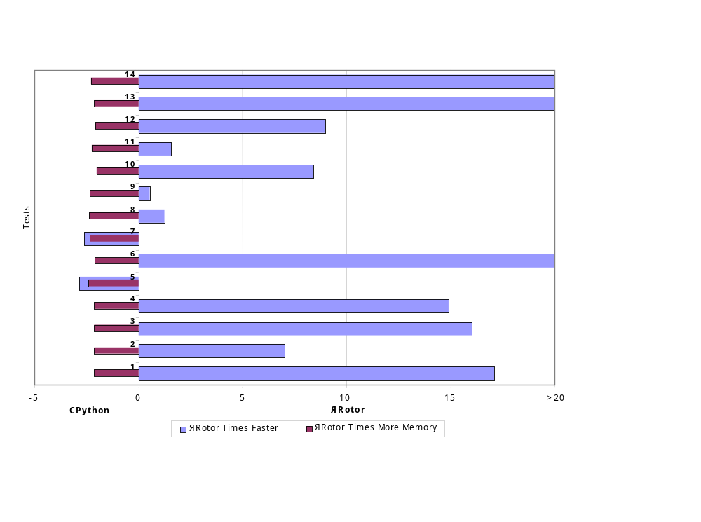
The execution of non-reflective code is much faster in Reflective Rotor than in CPython. The average time needed to execute non-reflective code in CPython is 12.15 times the time used by our implementation. This performance is achieved with only 28% more memory consumption. The figure above represents performance by memory utilization measurements. We can see how memory resources have been appropriately used to obtain a higher level of performance.
We have seen how the execution of programs that do not use reflection at all is much faster in our extension of the SSCLI than in CPython. As we have previously mentioned, dynamic languages are not as good as static ones when programs do not need runtime adaptation. Therefore, when a programmer chooses a dynamic language to implement a program, it is most likely motivated by the flexibility requirements of the application, which are best offered by dynamic languages. So, it is more important to measure reflective primitive’s performance rather than non-reflective code. Good performance results obtained in both scenarios implies that our reflective extension of the SSCLI is a really appropriate platform to support hybrid scenarios.
The Cost of Reflection.
The last variable to measure is the cost of adaptiveness. Runtime structural reflection is the main feature offered by dynamic languages to build adaptable and adaptive software. However, its implementation requires more memory and runtime performance to execute code that does not use reflection at all. What we assess is the non-reflective benchmark described in the previous section, comparing Reflective Rotor with the original SSCLI. The next figure shows the results.
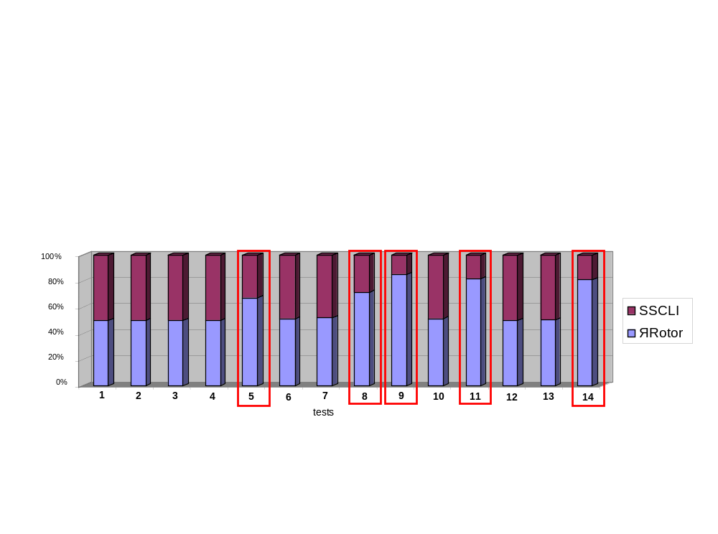
The average cost of memory utilization is 7%. The standard derivation of runtime performance penalty is 164.36%. This is due to the fact that some tests do not have performance costs, whereas others are significantly slower –tests inside a rectangle in the figure. Those tests are the ones that perform an important amount of (non-reflective) member accesses. So, we have evaluated the cost of accessing an instance field and invocating a method, discovering that in both cases the performance penalty was 60%.
In order to obtain an estimation of performance costs when executing real “static” programs over Reflective Rotor, we have assessed the benchmark of two real C# applications collected by Ben Zorn:
- LCSCBench. Based on the front end of a compiler for C#. Written in C# and uses a generalized LR (GLR) parsing algorithm. This benchmark is compute and memory intensive, requiring hundreds of megabytes of heap for the largest input file provided (a C# source file with 125,000 lines of code). The execution of this benchmark by Reflective Rotor is 81% slower than by the SSCLI, requiring 1.11% more memory.
- AHCBench: Based on compressing and uncompressing an input file using Adaptive Huffman Compression. It is written in C#. AHC bench is 1,267 lines of code compute-intensive, requiring a relatively small heap. Reflective Rotor needs 8% more memory than the SSCLI to run this test and is 2.14 times slower.

