# 1. Getting started

ALeP provides generated PDF files for DTC (DriveThruCards) so you can print out the packs as they are released. This is the simplest method of printing cards. All you need to do is: create and log into your DTC account, upload a desired PDF file, add the deck to your cart and you’re ready to checkout. The following will guide you through this process. Please note: if there are more than 130 cards in the pack, it consists of several PDF files.

If you want to customize the deck, please proceed to the next section (2. Customizing the deck). For example, you might want to combine several packs together, add additional copies of some player cards, etc.

* Open [**http://www.drivethrucards.com**](http://www.drivethrucards.com) and click **Log In**.

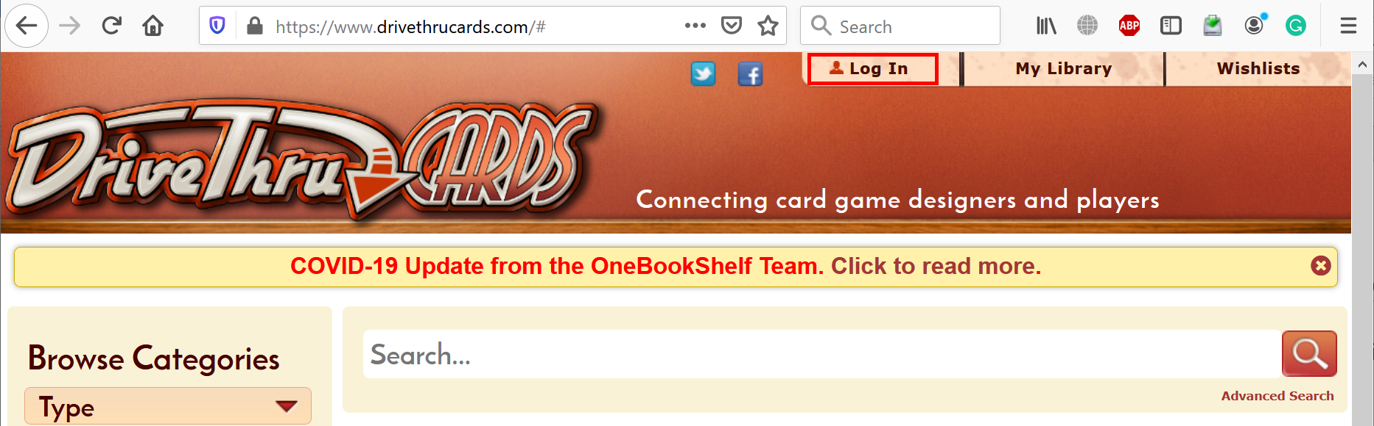

* If you already have an account, click **Log In**. If not, choose either **Create Account** or **Log In with Facebook**.

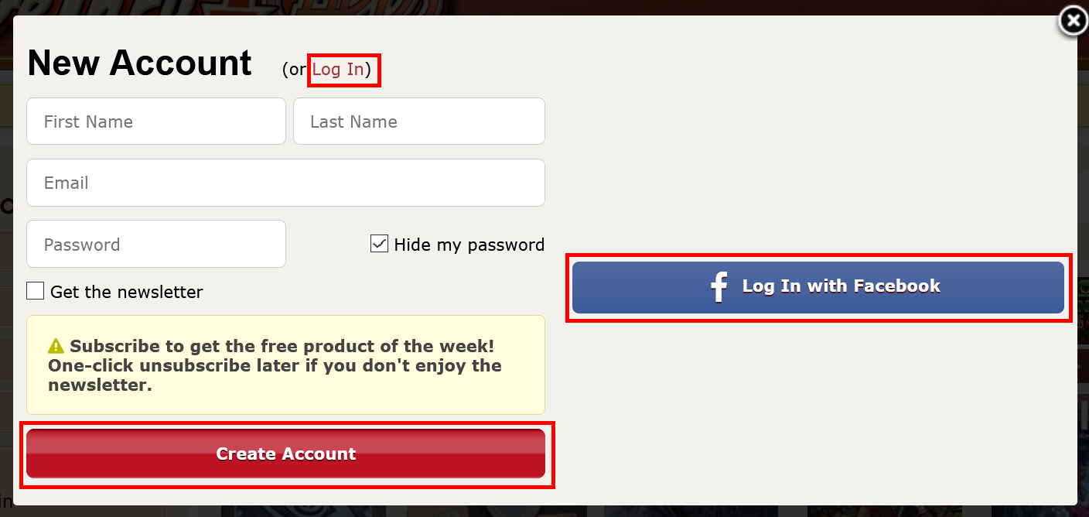

* Once you logged in, open this direct link: [**https://www.drivethrucards.com/joinchoice.php**](https://www.drivethrucards.com/joinchoice.php) and click **Create My Non-Exclusive Publisher Account** button (if you did not do that before).

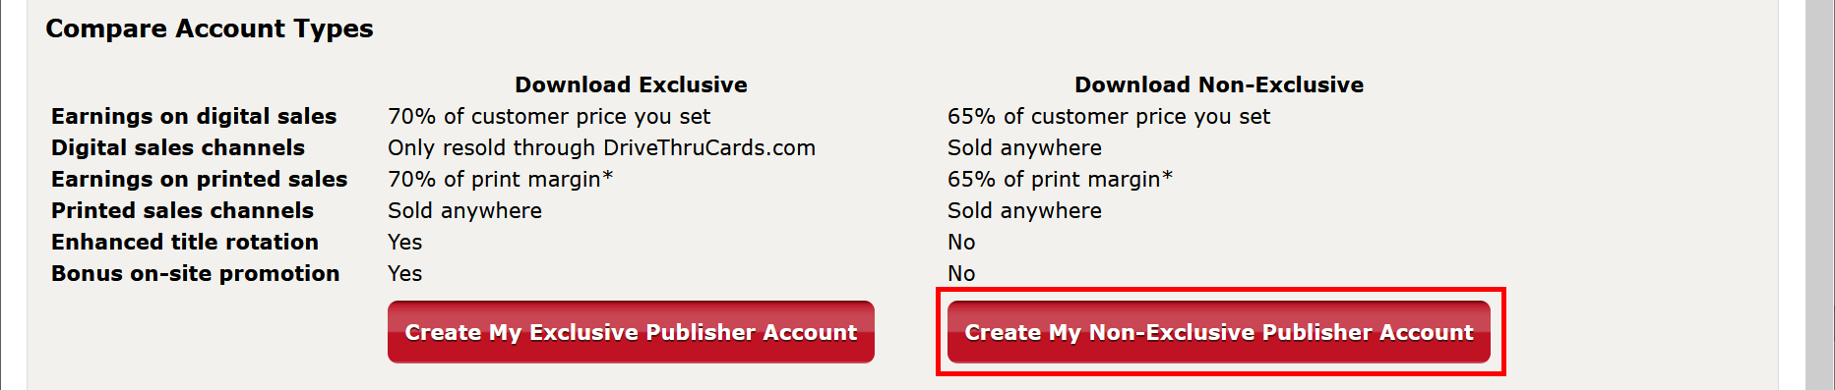

* Scroll to the bottom, check **I Agree**, enter **Publisher Account Name** (must be unique), and click **Set up My Publisher Account**.

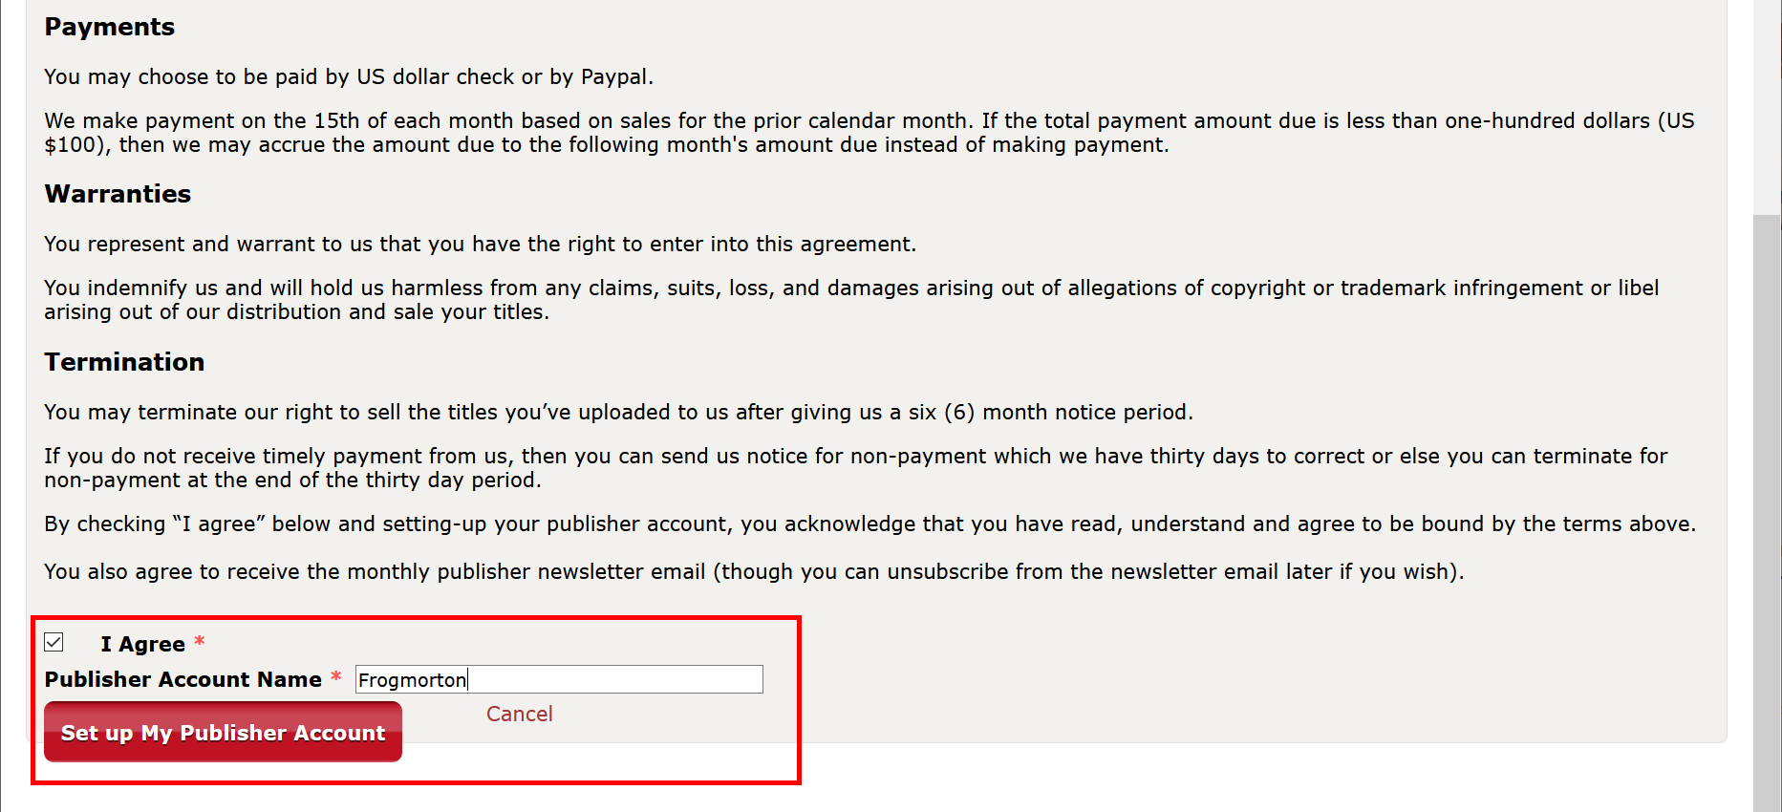

* Set the correct **PayPal Email** and click **Save** button.

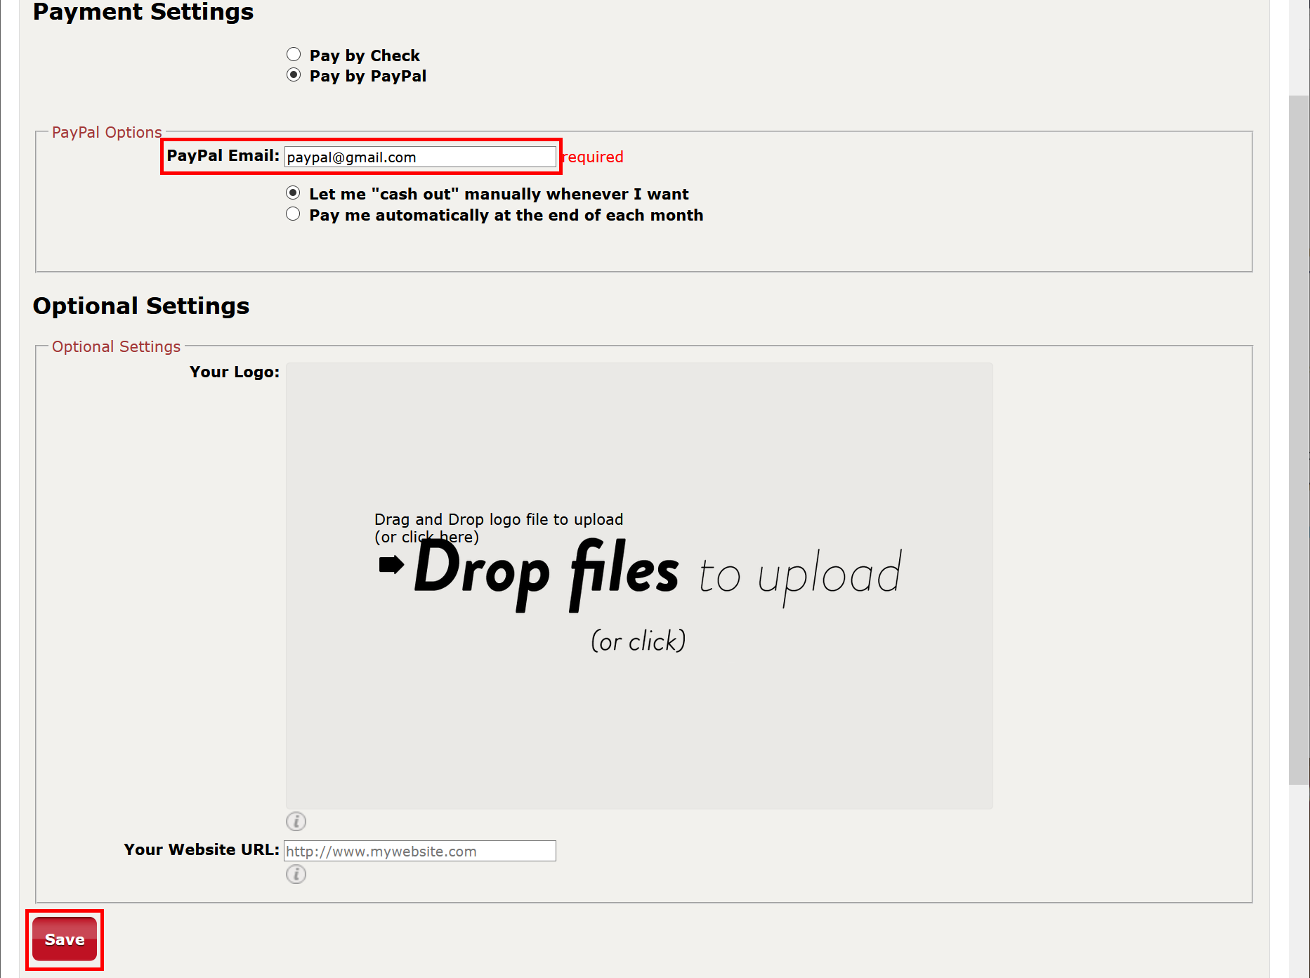

* Open this direct link: [**https://www.drivethrucards.com/pub_enter_product.php**](https://www.drivethrucards.com/pub_enter_product.php). Enter **Title** (any), set **Selling Price** to **$0**, and choose **Cover image** (any image file).

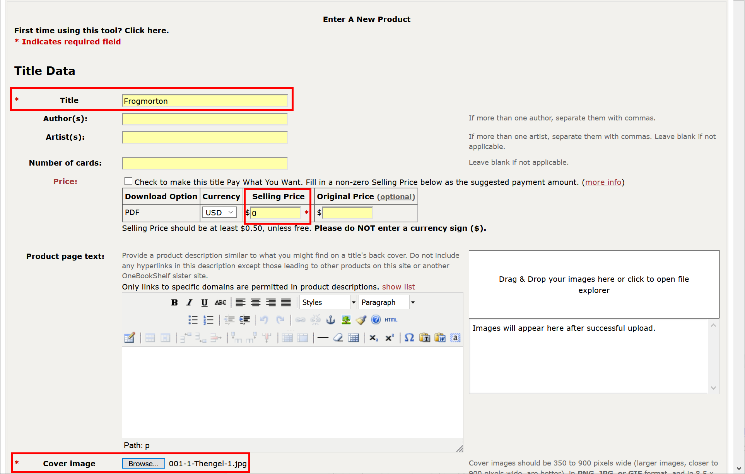

* Scroll to **Category Assignments** section and check one subcategory (any of them) under each main category: **Type**, **Theme**, **Age** and **Players**.

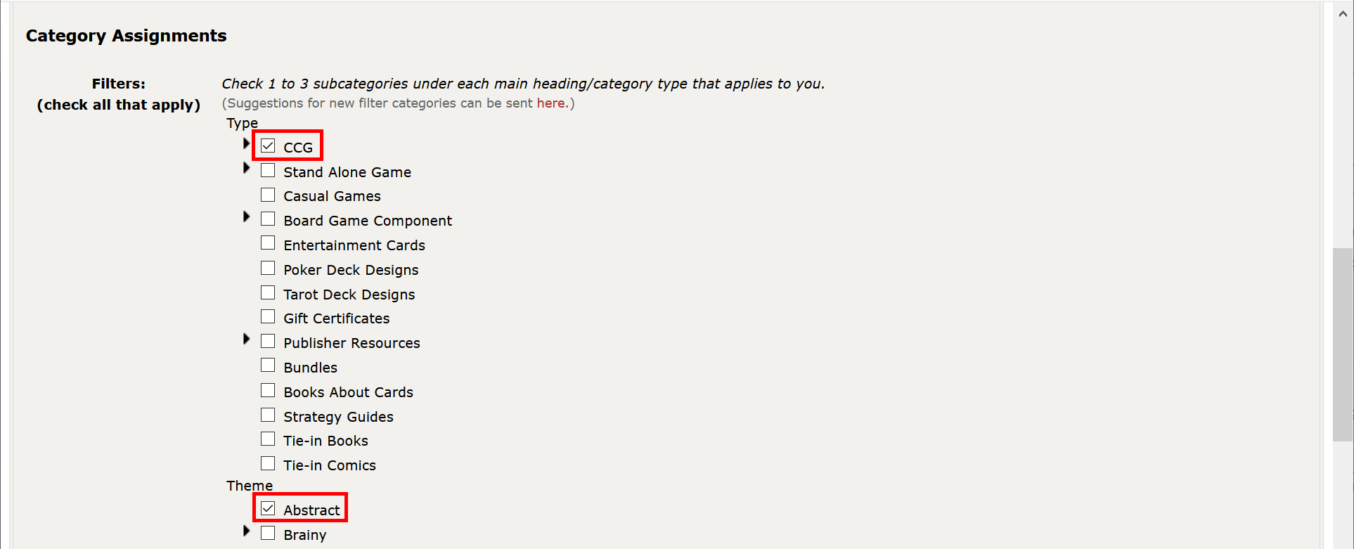

* Scroll to the bottom and click **Save Title Data and Continue to Preview Description**.

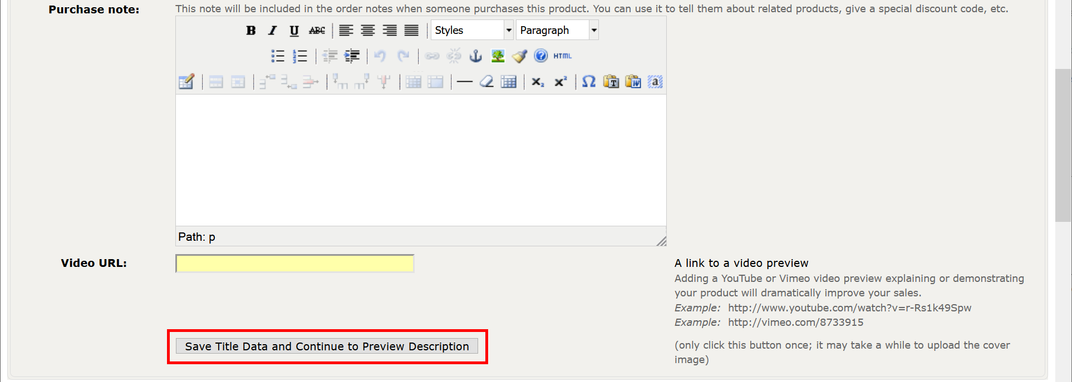

* Click Save and Continue button.

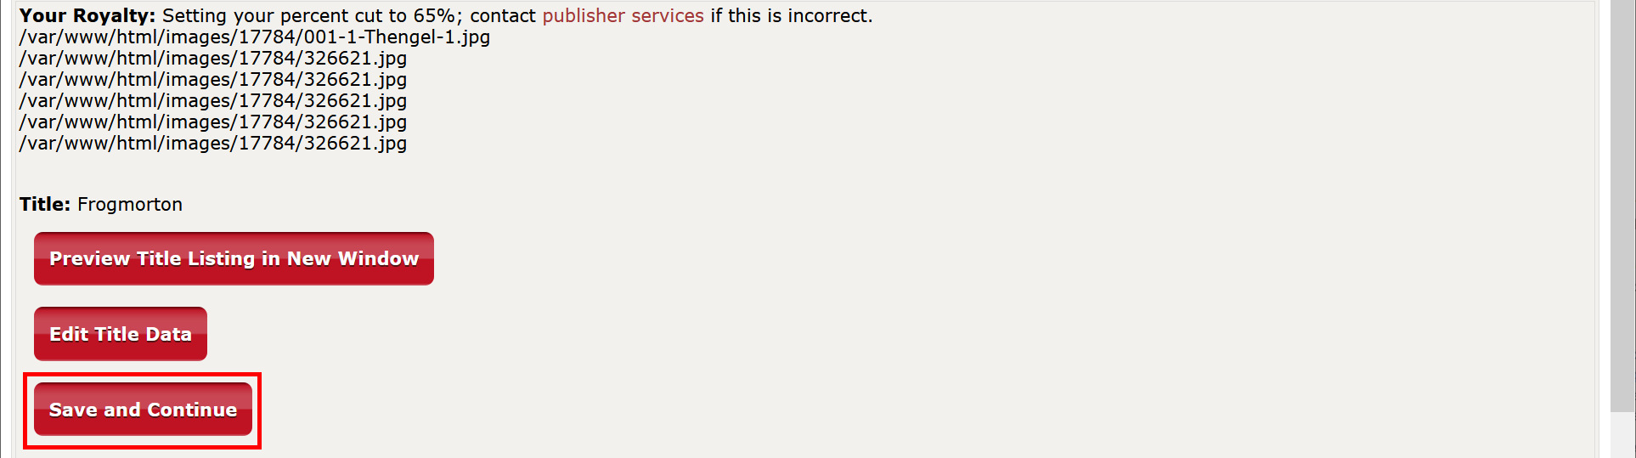

* Click **Upload print-ready file**.

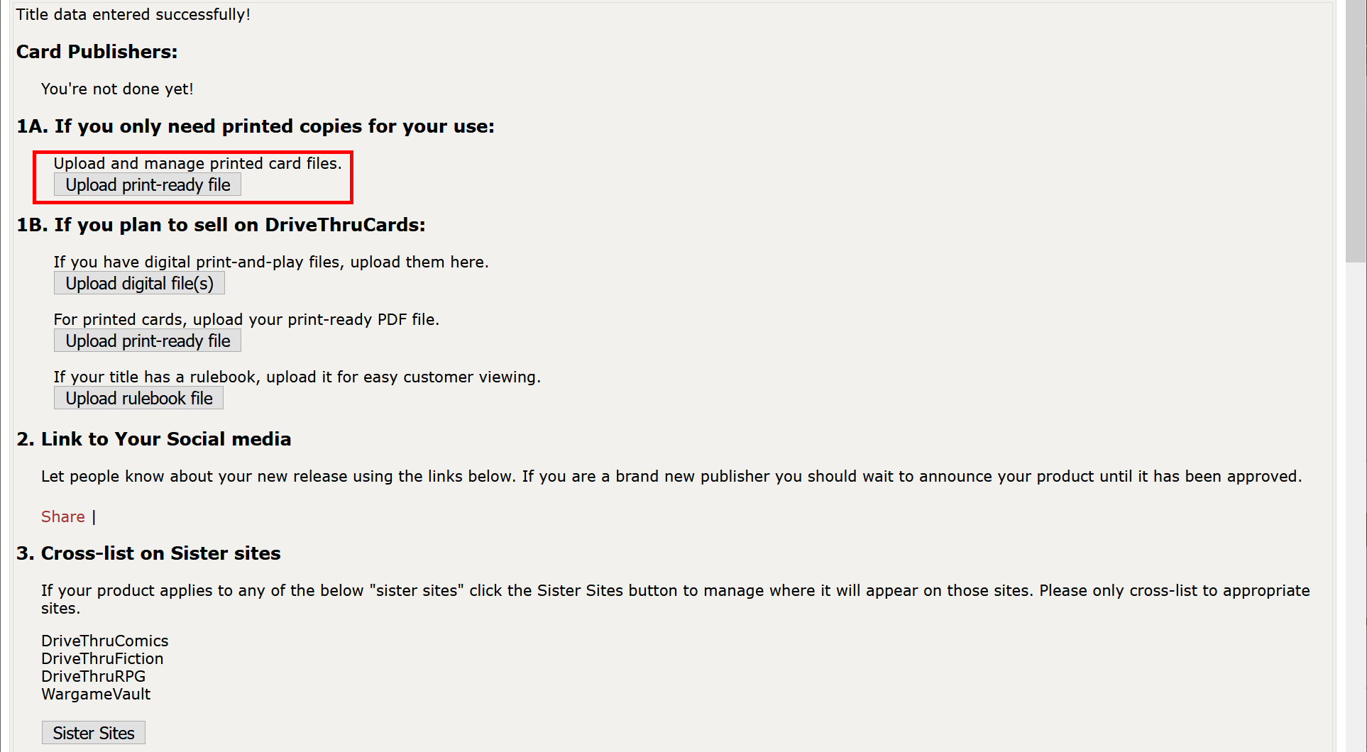

* Select **Premium US Poker Card(s)** in the dropdown, drag and drop the PDF file and click **Begin Card File Upload** button. Wait until the file has been uploaded (depending on your Internet connection speed, this may take a while).

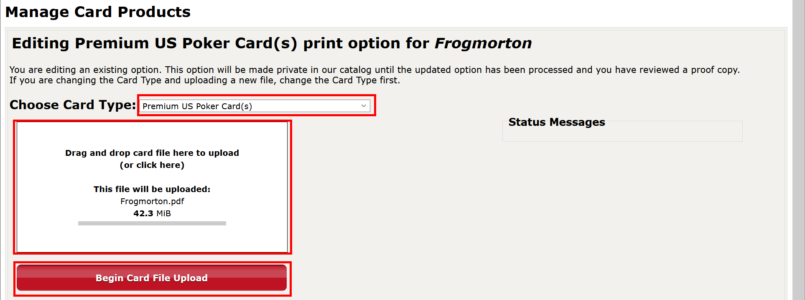

* Click **Click here after uploading your files** button.

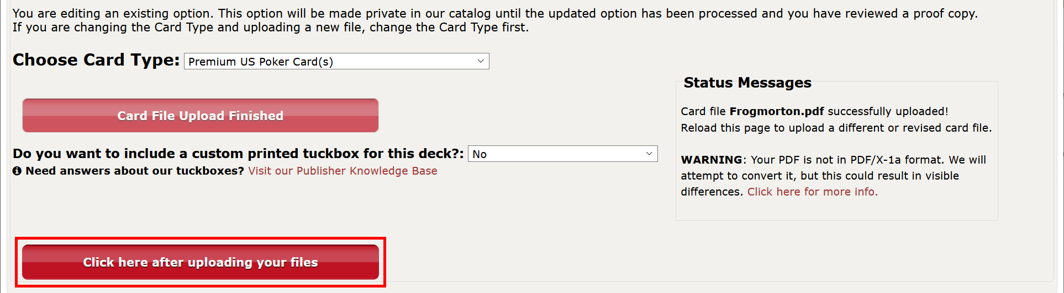

* Don’t change anything in the form, just click **Complete Setup** at the bottom.

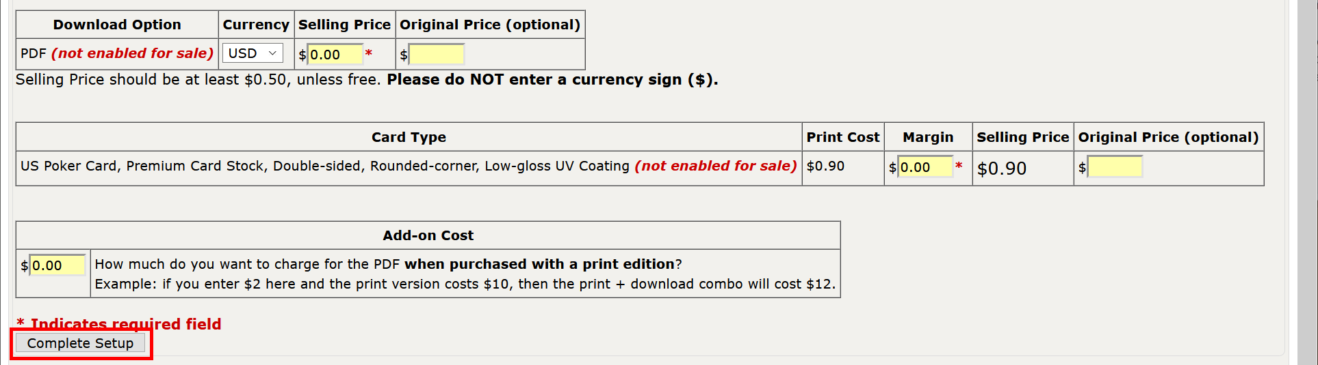

* Click the “**here**” link.



* If needed, update **Quantity** and click **Checkout** button.

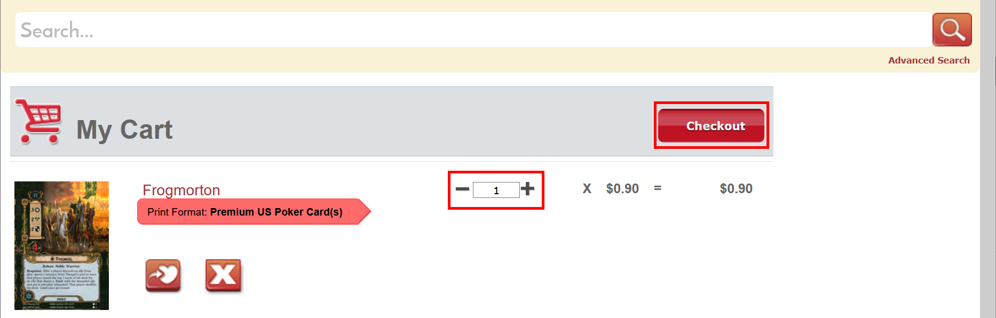

* Specify **Shipping Address**, **Shipping Method**, click **Next** button, and finish the order.
* If you want to print another deck, you don’t need to repeat all the steps related to creating a new product. Just proceed to this link: [**https://www.drivethrucards.com/pub_upload_podcard_files.php**](https://www.drivethrucards.com/pub_upload_podcard_files.php). Select an existing product from the dropdown, choose **Premium US Poker Card(s)**, and click **Enter New Print Option**.

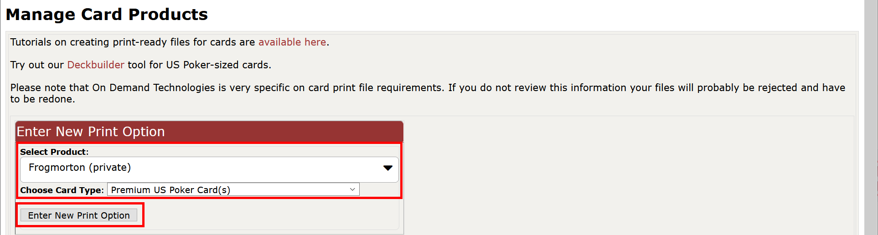

# 2. Customizing the deck

If you want to customize the deck, download either **7z** or **zip** archive for **DriveThruCards** from ALeP web-site (make sure that its name starts with **“DTC”**). Extract files from the archive. If there are no more than 130 cards in the pack, it contains just two folders: **front** and **back**. Otherwise, on the top level, there are folders **deck1**, **deck2**, etc. and each of them contains two subfolders: **front** and **back**. Do all the required customizations (add or remove cards, etc.)

* Open [**http://www.drivethrucards.com**](http://www.drivethrucards.com) and click **Log In**.



* If you already have an account, click **Log In**. If not, choose either **Create Account** or **Log In with Facebook**.



* Once you logged in, open this direct link: [**https://www.drivethrucards.com/joinchoice.php**](https://www.drivethrucards.com/joinchoice.php) and click **Create My Non-Exclusive Publisher Account** button (if you did not do that before).



* Scroll to the bottom, check **I Agree**, enter **Publisher Account Name** (must be unique), and click **Set up My Publisher Account**.



* Set the correct **PayPal Email** and click **Save** button.



* Open this direct link: [**https://www.drivethrucards.com/builder/deck/**](https://www.drivethrucards.com/builder/deck/). Choose **US Poker on Premium Stock** as **Card Type**, specify **Deck Name** (any) and click **Add New Deck** button.



* Drag and drop images from the **back** folder (from **deck1/back** folder if there are several decks) and wait until all images have been uploaded (depending on your Internet connection speed, this may take a while).

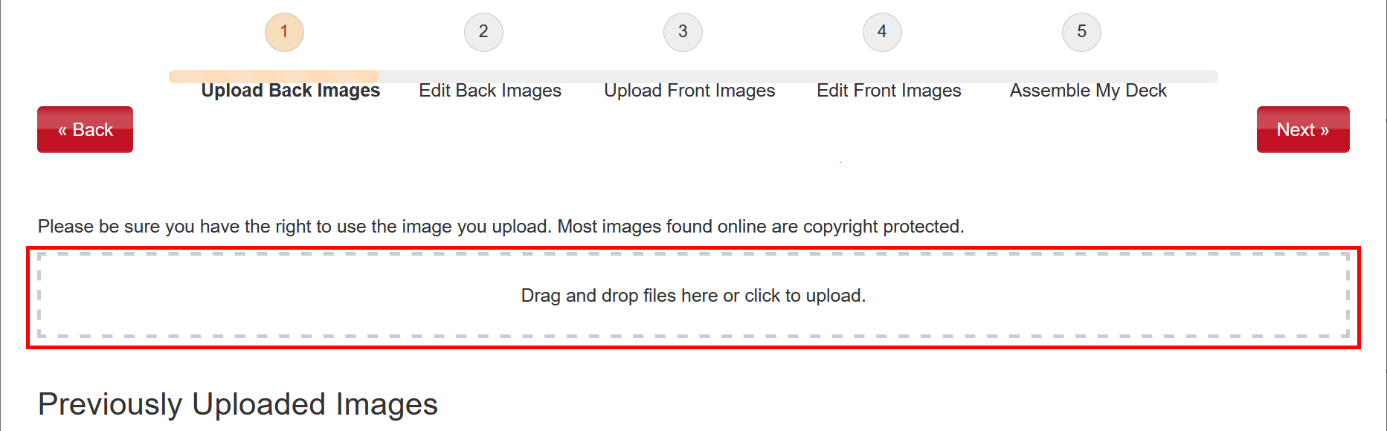

* Click **Next** button.

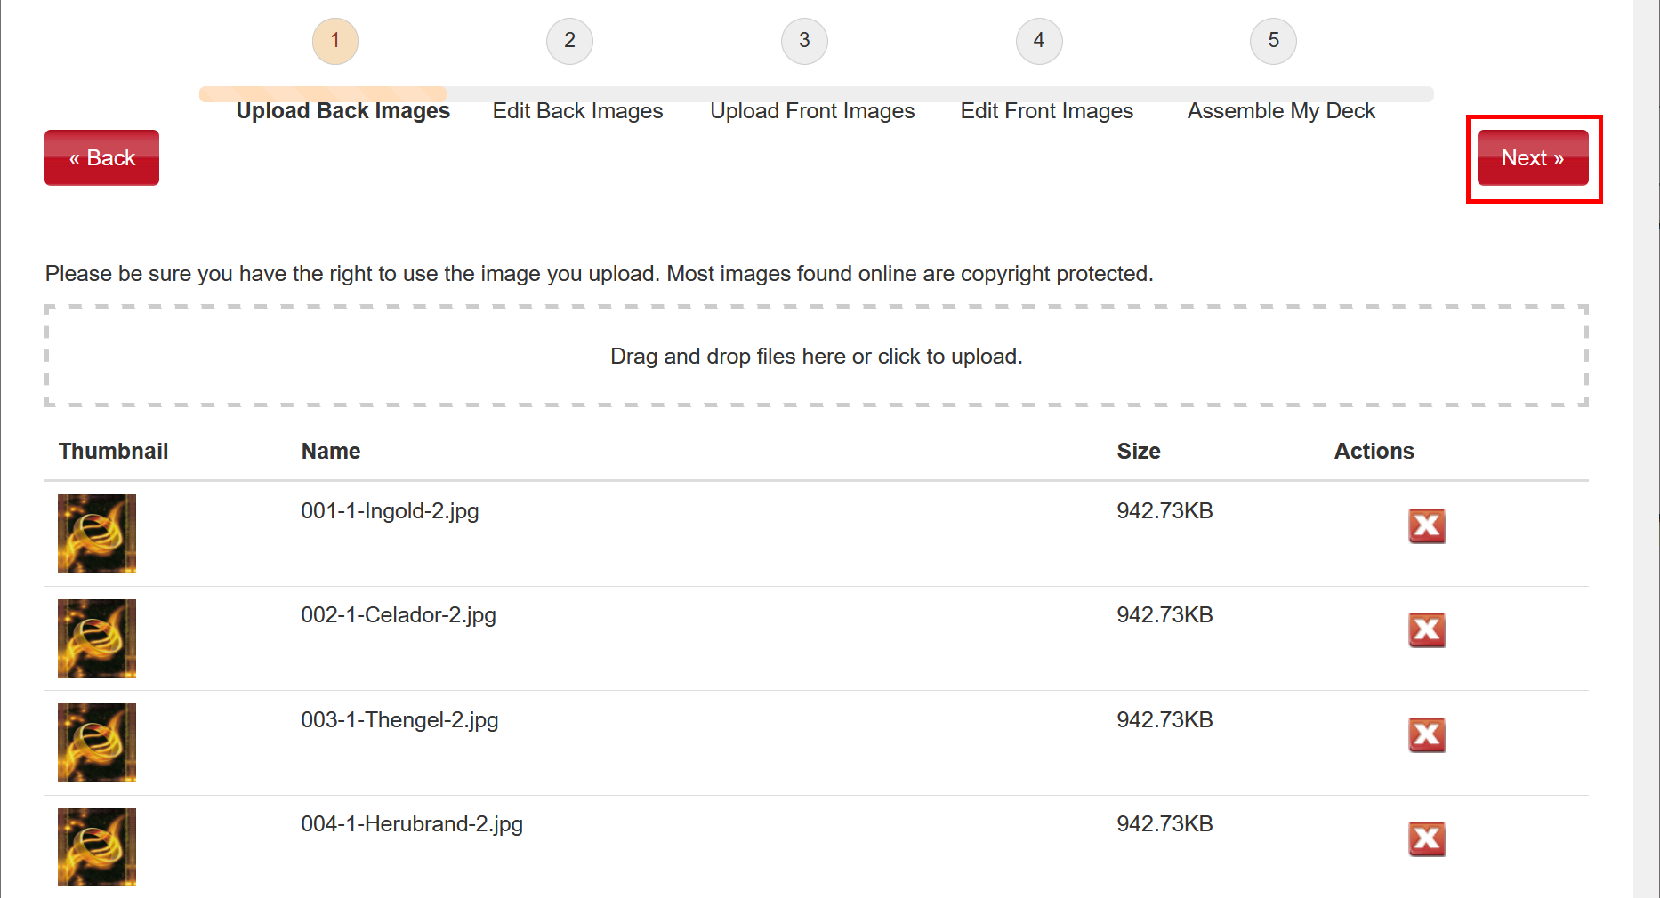

* Review all images and click **Next** button.

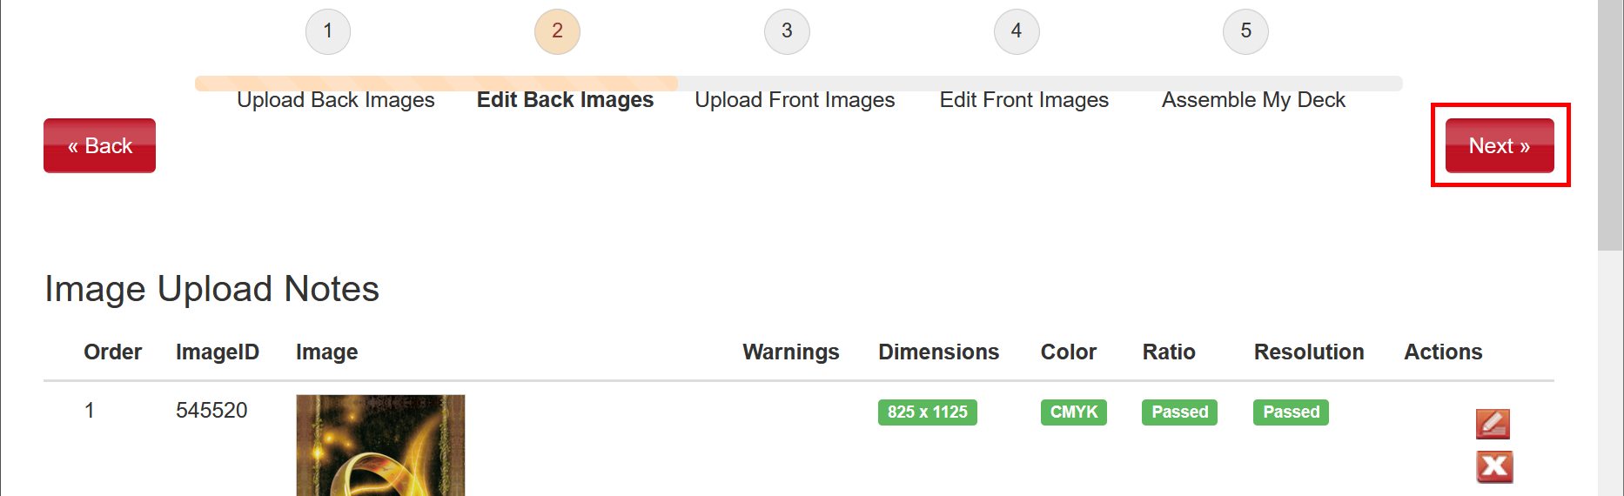

* Repeat for the front cards: drag and drop images from the **front** folder (from **deck1/front** folder if there are several decks) and wait until all images have been uploaded (depending on your Internet connection speed, this may take a while), then click **Next** button.

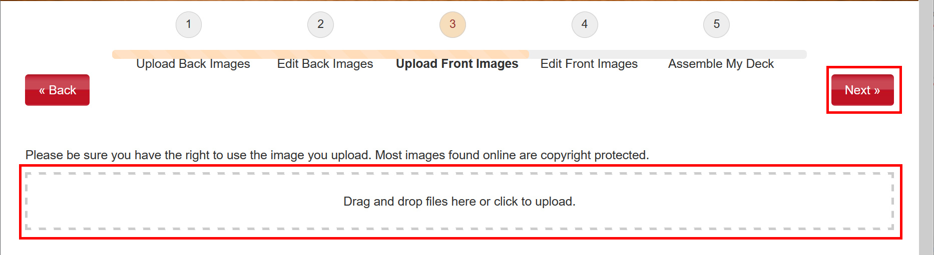

* Review all images and click **Next** button.

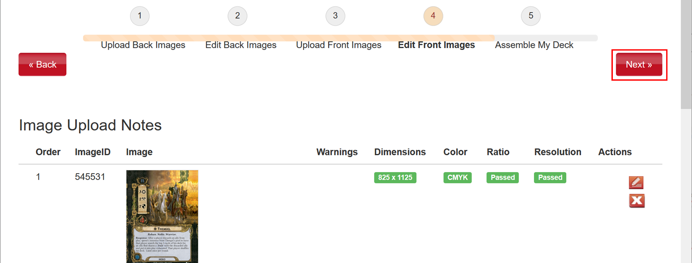

* Carefully review front and back sides of all cards. When finished, click **I’m finished** button.

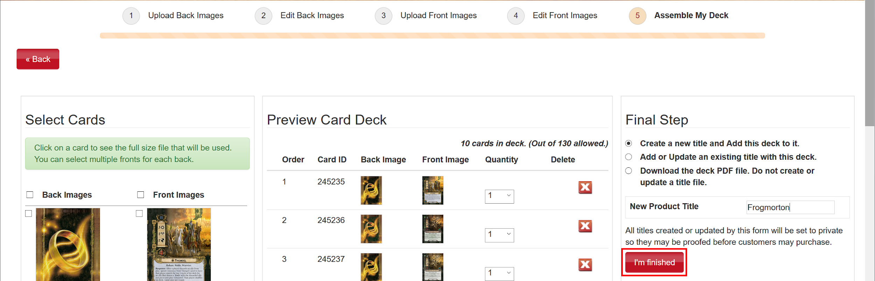

* Verify that the next screen says “**Your deck is complete!**”. Click “**you can order a print here**” link.

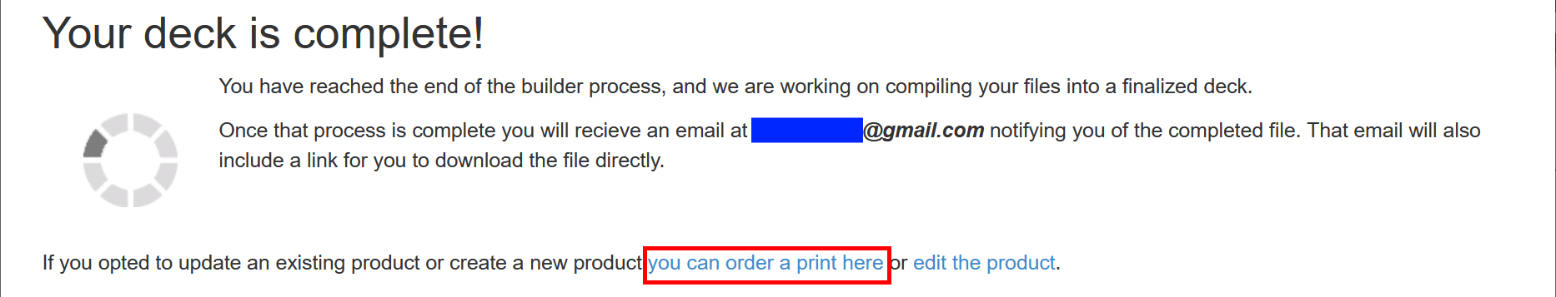

* If needed, update **Quantity** and click **Checkout** button.



* Specify **Shipping Address**, **Shipping Method**, click **Next** button, and finish the order.
* Also, in some time (up to an hour) you will receive a link to the final PDF file generated by DriveThruCards. You can share this file with somebody else.