Printing ALeP Packs using MBPrint

A Long-extended Party (ALeP) provides PDF and 7z files to print out the packs with official card backs as they are released using MBPrint. We recommend using the prepared PDF files that ALeP has created if you want to print a pack without any modifications, but it is possible to customize the pack manually using the provided 7z files to generate your own PDF files.

All PDF and 7z files can be found at [https://www.alongextendedparty.com](https://www.alongextendedparty.com/).

# Placing a MBPrint Order

You can order a pack using one of two ways: either by writing an email or sending a message through Facebook.

## Write an Email

1. Sign in to your email.
2. Create a new email.
   1. Note that this is based on how your email domain creates emails. For example, Gmail uses the **Compose** button to create a new email.
3. In the recipients field, type [**info@mbprint.pl**](mailto:info@mbprint.pl).
4. In the subject field, type something that indicates you would like to place an order.
5. In the body text, specify the following details:
   * Card size: 88.9 mm x 63.3 mm
   * 250 g paper
     + Instead of 250 g paper, you may ask for 350 g paper. This option is roughly 1.5 times more expensive, but the cards look very solid. However, they are much thicker than official FFG ones. **Note that by choosing 350 g paper, you might get more printing defects, especially along the cards’ edges.**
   * Round corners
   * Number of copies
   * Shipping address
   * Link to the PDF file
     + For example, you might have your PDF file on Google Drive, and you can copy and paste the file’s URL in your email (see step 7 in the Generate a PDF section for details).
     + **Note that this is the only way to share your PDF file with MBPrint as you will almost never have a PDF file that is less than 1GB, and most email domains will not allow you to attach large files to the email.**
6. Select **Send**.

Example of an email placing an order using MBPrint:

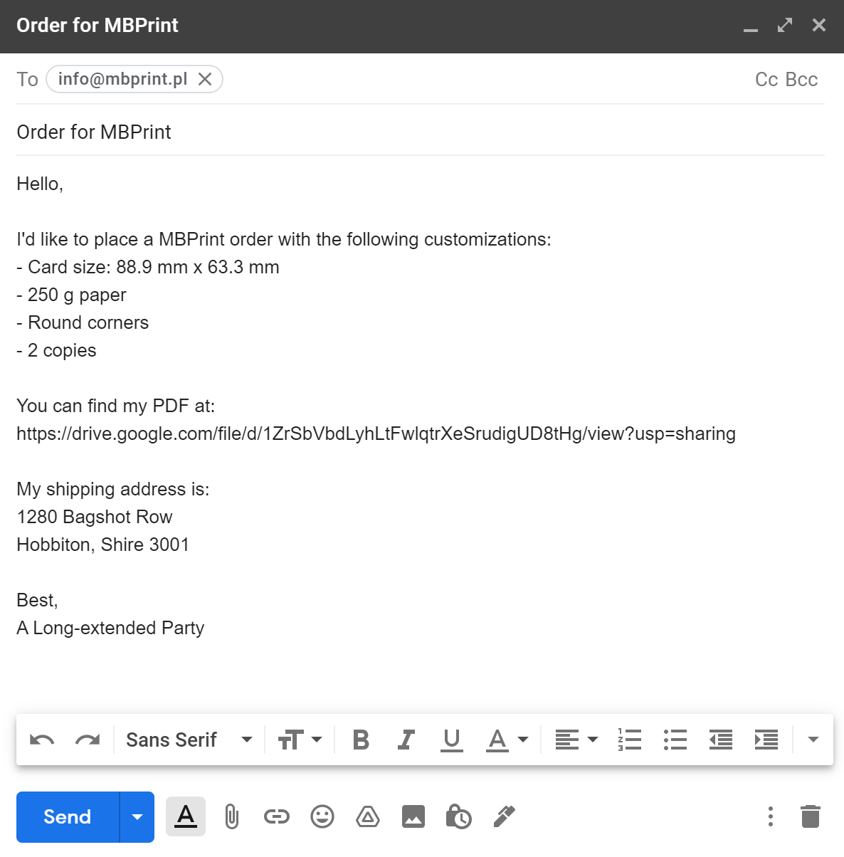

## Send a Facebook Message

1. Go to [https://www.facebook.com](https://www.facebook.com/).
2. Sign in to your Facebook account.
3. Go to MBPrint’s Facebook page: <https://www.facebook.com/MBprintPL/>
4. Select **Message**.

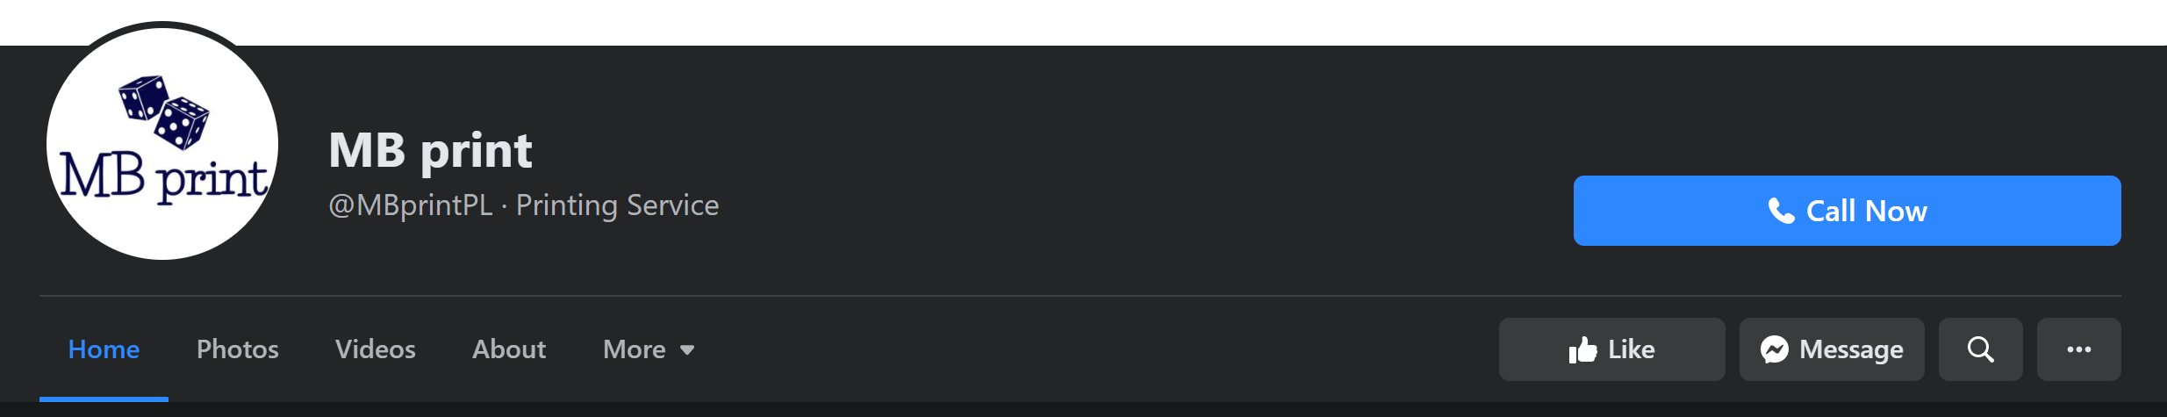

1. In your message, specify the following details:
   * Card size: 88.9 mm x 63.3 mm
   * 250 g paper
     + Instead of 250 g paper, you may ask for 350 g paper. This option is roughly 1.5 times more expensive, but the cards look very solid. However, they are much thicker than official FFG ones. **Note that by choosing 350 g paper, you might get more printing defects, especially along the cards’ edges.**
   * Round corners
   * Number of copies
   * Shipping address
   * Link to the PDF file
     + For example, you might have your PDF file on Google Drive, and you can copy and paste the file’s URL in your message (see step 7 in the Generate a PDF section for details).
     + **Note that this is the only way to share your PDF file with MBPrint as you will almost never have a PDF file that is less than 1GB, and Facebook will not allow you to attach large files to the message.**
2. Hit **Enter** to send the message.

Example of a Facebook message to MBPrint:

Hello,

I'd like to place a MBPrint order with the following customizations:   
- Card size: 88.9 mm x 63.3 mm

- 250 g paper

- Round corners

- 2 copies  
  
You can find my PDF at:   
https://drive.google.com/file/d/1ZrSbVbdLyhLtFwlqtrXeSrudigUD8tHg/view?usp=sharing

My shipping address is:

1280 Bagshot Row

Hobbiton, Shire 3001

Best,

A Long-extended Party

# Customizing the ALeP Pack

If you want to customize the ALeP pack, you can download the image files and modify the pack directly. For example, you may want to combine several packs together or add additional copies of player cards.

Note that in order to open an ALeP 7z archive, you will need to have a program installed on your computer that allows you to extract 7z files. If your computer does not have a program to extract 7z files, follow the steps provided in this link to install an open source freeware depending on your operating system (Windows, Mac, or Linux): <http://www.e7z.org/open-7z.htm>.

You will also need to download ImageMagick if it is not yet installed on your computer. To install ImageMagick, go to <https://imagemagick.org/script/download.php>. Then, download and run the binary release file that matches your operating system.

## Modify the MBPrint Archive

1. Download the MBPrint **7z** archive from the ALeP website.
   * **Make sure that the archive’s name starts with “MBPRINT”**.
2. Extract the files from the archive to a folder on your computer.
   * The archive should contain three folders: **front**, **back_official** and **back_unofficial**.
3. Modify the files in the **front**, **back_official** and **back_unofficial** folders as needed.
   * Note that you can use either official or unofficial card backs.
   * **When you modify the number of cards in any of the front**, **back_official** **or back_unofficial** **folders, make sure that the other folders’ images are also updated. The number of files in the front, back_official, and back_unofficial** **folders should all be the same. For example, if you add a player card, ensure that you add a front image, a back_official image, and a back_unofficial** **image.**
   * **When adding cards to your pack, ensure that all images are in CMYK JPG** **format and are 3.75 in x 2.75 in.**

## Generate a PDF

1. Create a new folder on your computer.
2. Copy the front and back images of the modified pack (see step 3 of Modify the MBPrint Archive for details) into the folder you created in step 1.
   * **Note that you only need to select the back images in either the back_official or back_unofficial folders. There is no need to copy all back images from both folders.**
3. Ensure that the back image of each card goes before its front image.
   * **Note that neglecting to do this might result in your cards being printed incorrectly.**
   * For example, the order of your images in your file explorer might look like this:

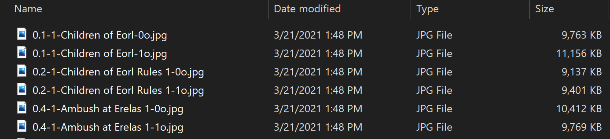

Note that in the above image, the *-0o.jpg files are the back images and *-1o files are the front images.

1. Open a command prompt.
   * Note that the process of opening a command prompt will depend on your operating system. Consult Google (or your preferred search engine) to determine how to open a command prompt on your OS.
2. Run the following command:

*"<path to magick.exe>" convert "<path to the images folder>\*.jpg" "<path to the output PDF file>"*

For example:

*"C:\Program Files\ImageMagick-7.0.10-Q16-HDRI\magick.exe" convert "C:\lotr\mbprint\*.jpg" "mbprint.pdf"*

1. Review the generated PDF to ensure that all of the images are present and in the correct order.
2. Upload it to your preferred website.
   * For example, you can upload the PDF file to Google Drive.
3. Follow the steps outline in Placing a MBPrint Order to place your order using your custom PDF file.