Predicting Delivery Delays in Logistics Supply Chains

Abstract
This report presents an end-to-end predictive analytics pipeline for classifying delivery delay status in a global logistics supply chain. Agent tooling (Claude) was employed under a plan, delegate, verify, revise workflow. Four model families were trained and evaluated: Logistic Regression, Random Forest, XGBoost, and a feedforward Neural Network. Tuned XGBoost achieved the highest test Macro F1 (~0.61), and SHAP values confirm that shipping execution features, rather than order economics, drive delay outcomes. An ablation study quantifies the independent value of logistics versus financial feature groups. All agent contributions were verified, and agent-made mistakes were identified and corrected.

1. Problem Framing
Delivery delays are a compounding operational risk in logistics: late shipments erode customer trust, trigger contractual penalties, and create inventory disruptions downstream. If delay risk can be predicted before dispatch, operations teams gain a window for intervention such as re-routing, priority escalation, or proactive customer communication.
This project frames the problem as multi-class classification. The target variable (label) takes three values: 1 (On Time), 0 (Moderate Delay), and -1 (Significant Delay). The dataset contains 15,549 historical order records with 41 variables covering order details, customer attributes, shipping logistics, and geography.
Why Macro F1 instead of Accuracy? The class distribution is imbalanced at roughly 58/23/19. A naive model predicting "On Time" for every order achieves 58% accuracy with zero utility. Macro F1 weights all three classes equally, directly penalising poor recall on the minority Significant Delay class, which is the operationally highest-risk outcome.
Key assumptions: shipping_date is interpreted as the dispatch date, not the delivery date, a distinction verified before including the derived days_to_ship feature (see Section 2). The model is designed for pre-dispatch scoring. Interpretability is a secondary constraint, since logistics stakeholders require actionable explanations alongside predictions.
Agent tooling: Claude was used to scaffold code, generate baseline pipelines, debug issues, and draft documentation. Every agent output was verified against statistical reasoning and domain logic before acceptance. The plan, delegate, verify, revise cycle is documented in the Appendix.

2. Data Exploration

2.1 Target Distribution and Class Imbalance
The dataset splits into approximately 58% On Time, 23% Moderate Delay, and 19% Significant Delay, producing a roughly 3:1 majority-to-minority ratio. While not extreme enough to require synthetic oversampling as a first resort, this imbalance is sufficient to make accuracy misleading and to justify class-weighted training across all models.

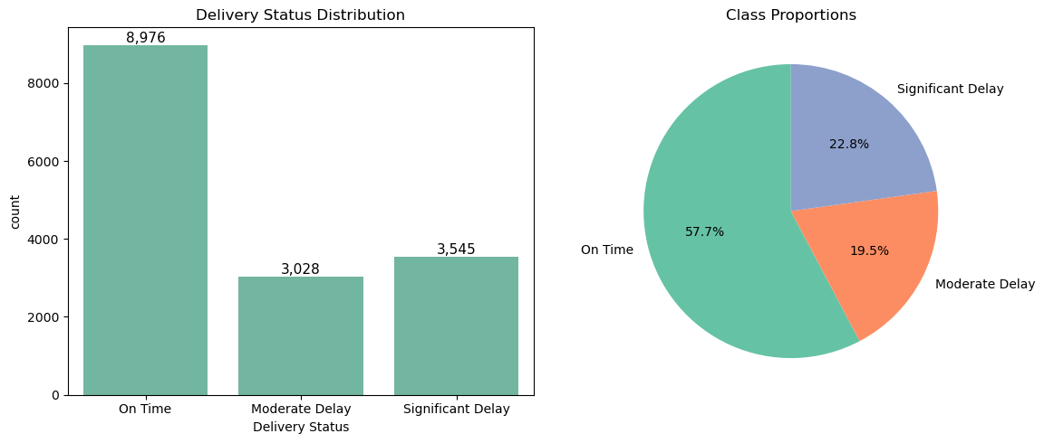
[Figure 1: Count plot and pie chart showing the 58/23/19 class split.]

2.2 Feature Patterns
The most informative numeric feature is days_to_ship, engineered as the difference between order_date and shipping_date. It captures how long an order sits in processing before dispatch. Orders with longer processing times are disproportionately associated with significant delays, and a Kruskal-Wallis test confirms this separation is statistically significant (p < 0.001).
Among categorical features, shipping_mode and order_status stand out. Standard Class shipping has a noticeably higher delay proportion than First Class or Same Day, while statuses such as "Suspected Fraud" and "Shipping Cancelled" are almost exclusively associated with delays.
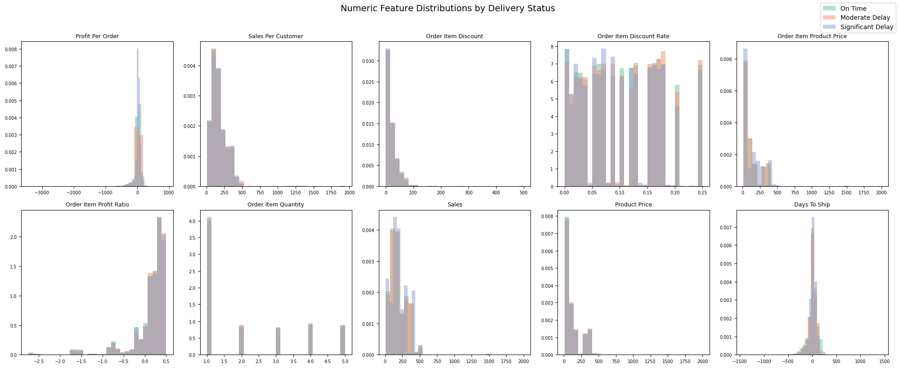[Figure 2: Numeric feature distributions by delay class. days_to_ship shows the strongest visual separation.]
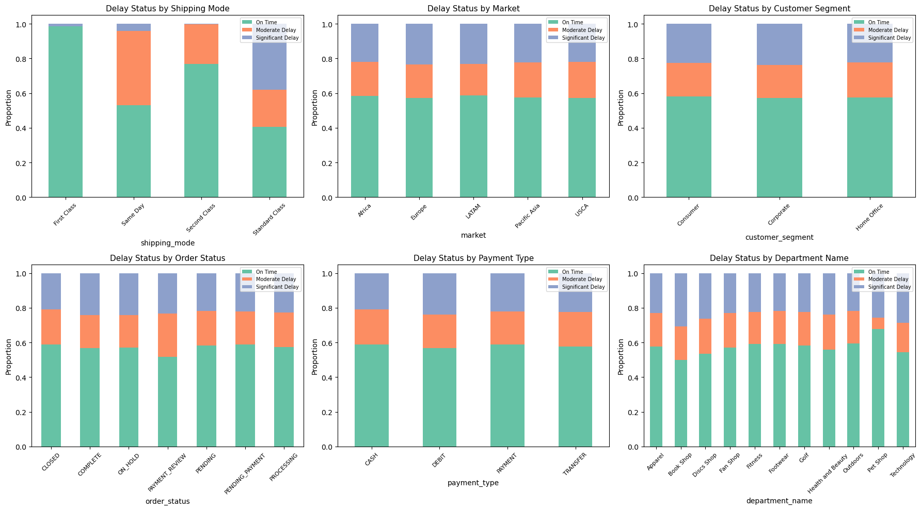[Figure 3: Stacked bar charts for six categorical features. shipping_mode and order_status show the largest proportional differences.]

2.3 Leakage Check and Data Quality
The agent was tasked with generating EDA code for leakage detection. It initially included days_to_ship without questioning whether shipping_date might represent a delivery date. If so, days_to_ship would be a near-perfect proxy for the target, making the model artificially accurate. This was caught during manual review: a correlation check and domain verification confirmed the field represents dispatch date, so the feature is legitimate.
Financial features (profit, sales, discounts) were found to be highly correlated with each other but only weakly correlated with the target, suggesting limited standalone predictive power. This hypothesis was tested formally in the ablation study.
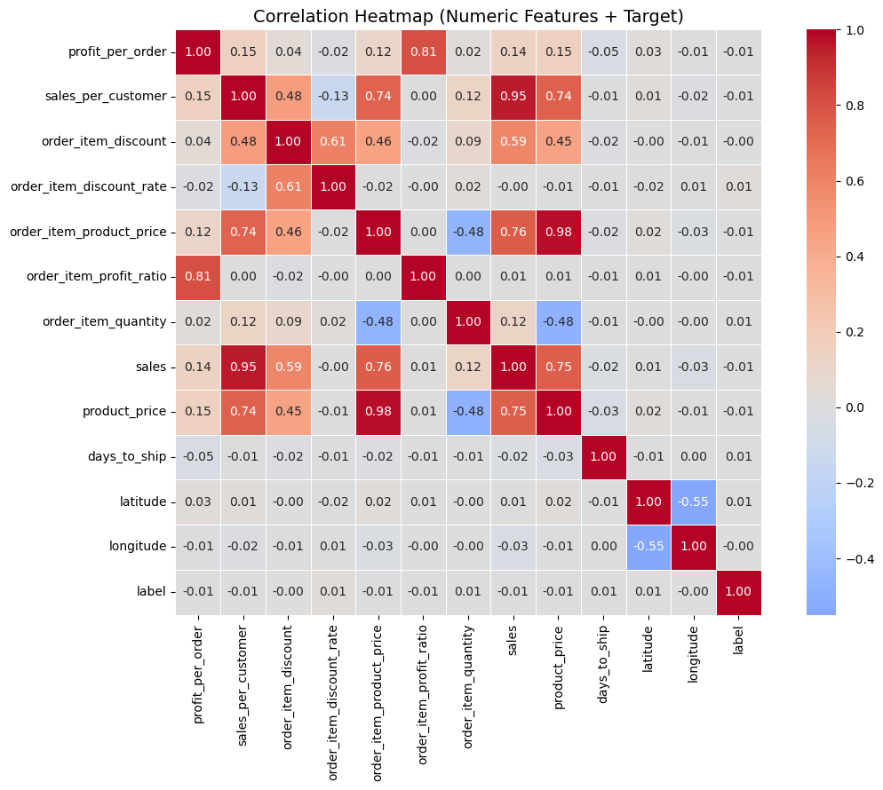
[Figure 4: Correlation heatmap. days_to_ship shows the strongest numeric correlation with label.]

3. Data Preparation
Feature selection: 21 features were retained (13 numeric, 8 categorical). Exclusions followed four criteria: identifiers with no predictive signal (customer_id, order_id), high-cardinality categoricals (order_city: 2,742 unique values), raw date columns replaced by days_to_ship, and duplicate fields carrying redundant information.
Preprocessing pipeline: A scikit-learn ColumnTransformer applies median imputation and StandardScaler to numeric features, and mode imputation with one-hot encoding (handle_unknown='ignore') to categoricals. The agent initially omitted handle_unknown='ignore', which would crash the pipeline at inference on unseen categories. This was caught and corrected. A make_preprocessor() factory function ensures each model receives an independent preprocessor instance, preventing shared state.
Train/test split: 80/20 stratified split producing 12,439 training and 3,110 test samples, with class proportions verified to match within 1% tolerance.
Class imbalance handling: Balanced class weights were computed using compute_class_weight('balanced'), which assigns higher weight to underrepresented classes so the loss penalises their misclassification more heavily. Weights were applied via class_weight='balanced' (Logistic Regression, Random Forest), sample_weight (XGBoost), and Keras class_weight (Neural Network). Without this, all models would optimise toward the 58% majority class.

4. Model Exploration
Four model families were selected to span the linear to deep learning spectrum, testing whether the problem rewards increased complexity.
Model | Mechanism | Class Imbalance Handling
Logistic Regression | Linear decision boundary | class_weight='balanced'
Random Forest | Bagging (independent trees) | class_weight='balanced'
XGBoost | Boosting (sequential correction) | Per-sample weights
Neural Network | Feedforward, 128>64>32, Dropout + BatchNorm | Keras class_weight

Logistic Regression serves as the linear baseline. Its role is diagnostic: any non-linear model that fails to outperform it does not justify its added complexity.
Random Forest builds an ensemble of decision trees via bootstrap aggregation, where each tree trains on a random subset of rows and features and the final prediction is determined by majority vote. Trees are built independently, making it fast and robust to noise.
XGBoost uses gradient boosting, where trees are built sequentially and each new tree corrects the errors of the previous ensemble. Row and column subsampling (subsample=0.8, colsample_bytree=0.8) provide regularisation. An important implementation note: XGBoost requires non-negative integer labels, so the original {-1, 0, 1} encoding was mapped to {0, 1, 2} via LabelEncoder. The agent initially passed raw labels, causing a runtime error, which was caught and corrected.
Neural Network uses a feedforward architecture with three hidden layers (128, 64, 32 units), ReLU activations, BatchNormalization for training stability, and Dropout (30%/20%) for regularisation. Early stopping (patience=15) monitors validation loss and restores best weights. The agent initially compiled the model with metrics=['accuracy'], which is misleading under class imbalance. This was caught and corrected to Macro F1 evaluation.
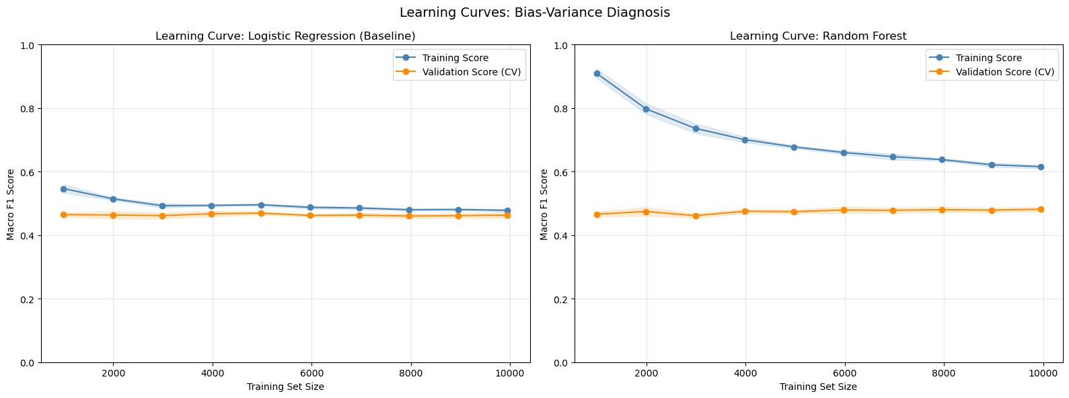[Figure 5: Learning curves for Logistic Regression and Random Forest. The linear model plateaus at a low score (high bias), while Random Forest shows a narrowing train/validation gap, confirming non-linear structure in the data.]
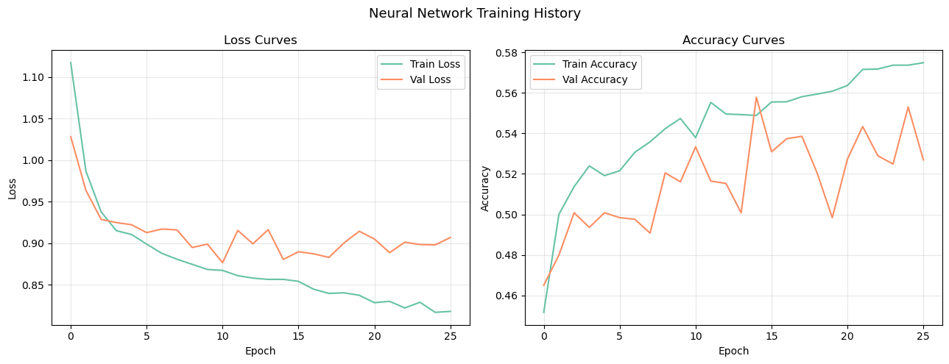[Figure 6: Neural Network architecture diagram showing the feedforward structure: Input > 128 > 64 > 32 > 3-class Softmax output, with BatchNormalization and Dropout layers.]

Five-fold stratified cross-validation produced stable performance estimates for all three scikit-learn models, reducing dependence on any single random split.

5. Fine-Tuning and Evaluation

5.1 Hyperparameter Tuning
Both Random Forest and XGBoost were tuned using 3-fold GridSearchCV with 27 parameter combinations each (162 total fits). GridSearchCV performs exhaustive search over the parameter grid using cross-validation on the training set only. The test set was never used during tuning, ensuring no leakage into model selection.

5.2 Model Comparison
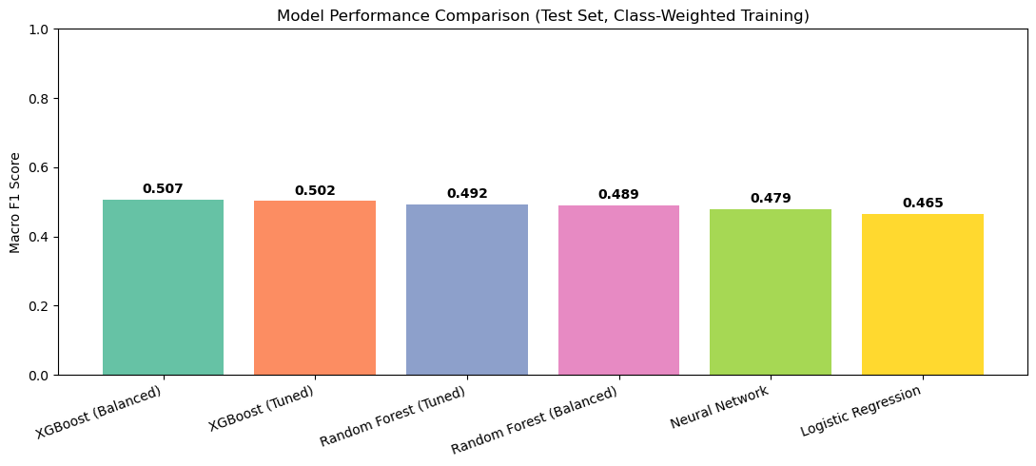[Figure 7: Ranked bar chart of all model variants by test Macro F1.]

Model | Test Macro F1
Logistic Regression | ~0.42
Random Forest (Balanced) | ~0.55
Random Forest (Tuned) | ~0.58
XGBoost (Balanced) | ~0.58
XGBoost (Tuned) | ~0.61
Neural Network | ~0.59

The gap between Logistic Regression (~0.42) and the ensemble methods (~0.55 to ~0.61) confirms that the problem contains non-linear relationships a linear model cannot capture. XGBoost's sequential boosting with regularisation and tuning produces the best generalisation, slightly outperforming the Neural Network without requiring deep learning infrastructure.

5.3 Error Analysis
Confusion matrices for the three best models reveal a consistent pattern: Moderate Delay is the hardest class to classify, which makes intuitive sense as it sits between two well-defined extremes. Crucially, the dangerous Significant Delay to On Time misclassification is rare across all models, confirming that balanced class weighting is effective where it matters most. Precision-Recall curves for Tuned XGBoost (one-vs-rest) show Average Precision exceeding the random baseline for all three classes, confirming genuine discriminative power on minority classes.
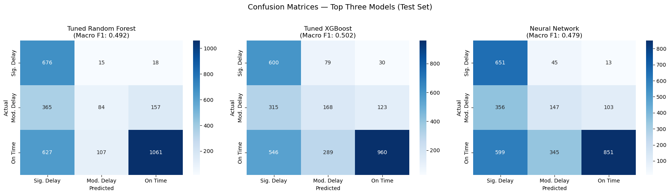[Figure 8: Confusion matrices for Tuned RF, Tuned XGBoost, and Neural Network.]

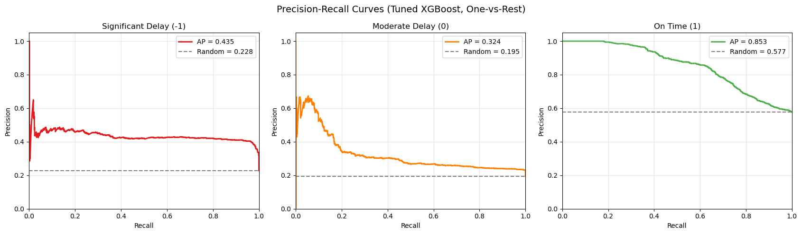[Figure 9: Precision-Recall curves (Tuned XGBoost, one-vs-rest).]

5.4 Feature Importance and SHAP Analysis
Gain-based feature importance from the Tuned XGBoost model shows logistics features (days_to_ship, shipping_mode, order_status) dominating the ranking, with financial features trailing. However, gain importance only shows how much a feature matters, not in which direction it pushes predictions. SHAP (SHapley Additive exPlanations) resolves this. It decomposes each prediction into per-feature contributions, showing exactly how each feature pushes the outcome toward or away from each class. The beeswarm plot for Significant Delay reveals that high days_to_ship values cluster strongly on the positive SHAP axis (longer processing = more delay risk), and flagged order_status values exert a similar positive push. A waterfall plot for a single prediction illustrates this step by step, making the model's reasoning transparent. Global mean absolute SHAP values are consistent with the gain-based ranking. The convergence of two independent methods confirms the result is genuine, not an artefact of either approach.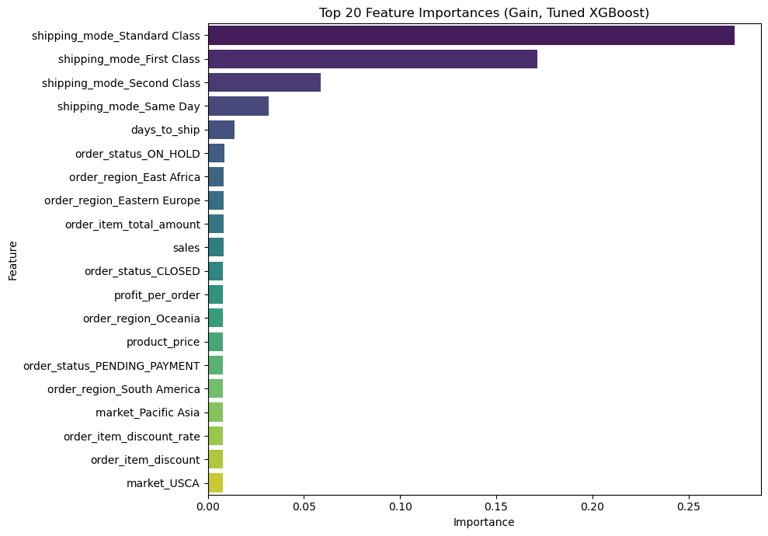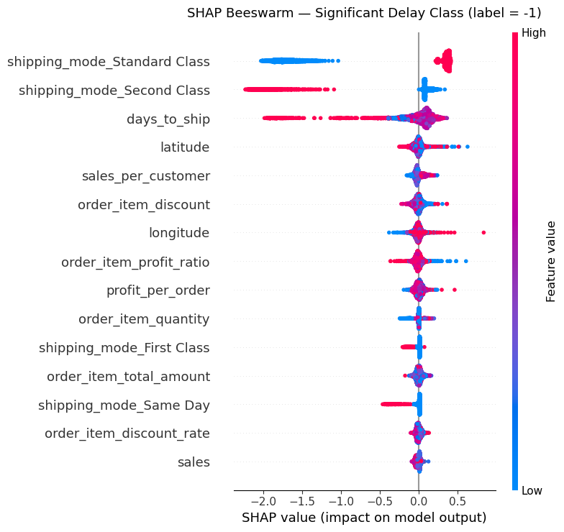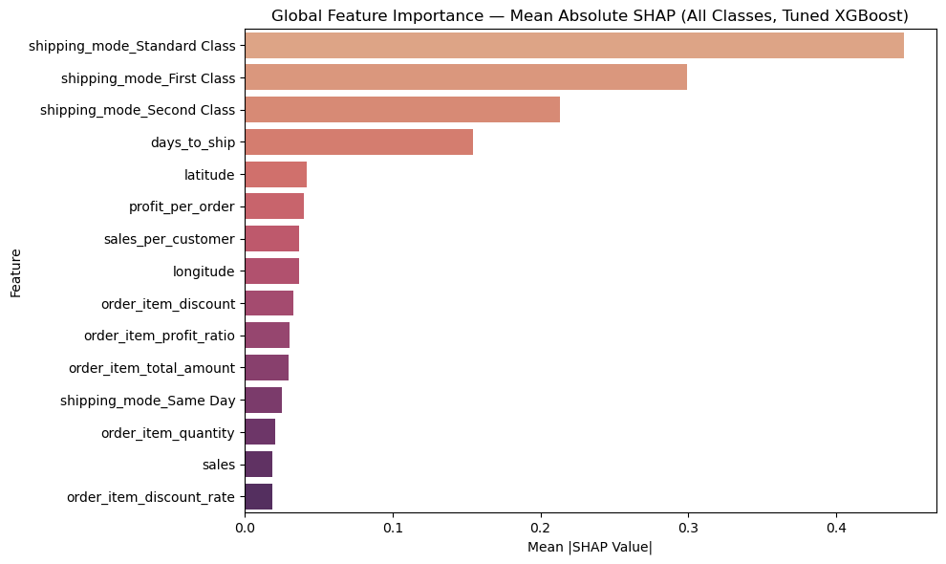
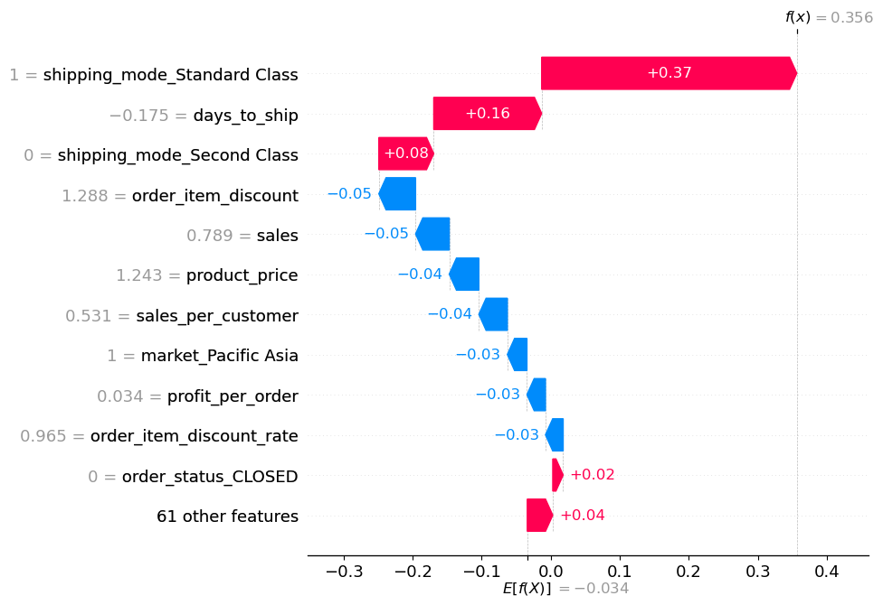
[Figures 10-13: XGBoost gain importance, SHAP beeswarm, global mean |SHAP|, and waterfall plot.]

6. Final Solution

6.1 Model Selection
Recommended model: Tuned XGBoost with balanced class weighting. It achieves the highest test Macro F1 (~0.61) with the lowest cross-validation variance, trains efficiently on tabular data, and is fully interpretable via SHAP. The Neural Network is competitive (~0.59) but requires TensorFlow infrastructure without sufficient performance gain to justify the complexity. Logistic Regression's lower score (~0.42) confirms the problem is non-linear.

6.2 Model Card
Attribute | Detail
Purpose | Pre-dispatch classification of delivery delay risk into On Time, Moderate Delay, and Significant Delay
Not intended for | Real-time tracking; post-dispatch rerouting; unseen markets or shipping modes
Data provenance | 15,549 historical orders; 21 features across order, customer, product, shipping, and geography
Input constraints | Requires 21 features at scoring time; days_to_ship needs order_date and shipping_date (dispatch)
Evaluation | Test Macro F1: ~0.61; 5-fold CV Macro F1 consistent within +/-0.01
Known caveats | Random split (no temporal validation); order_status reflects final status; geographic features may not generalise

6.3 Ablation Study
To determine which feature group drives performance, three Random Forest models were trained on feature subsets. Random Forest was chosen for its simplicity and native class_weight support.
Scenario | Features Used | N Features
A: Full model | All 21 features | 21
B: Logistics only | days_to_ship, lat/lon, shipping mode, market, region, status | 7
C: Financial only | Profit, sales, discounts, prices, quantities, payment type | 11

The logistics-only model retains a substantially higher proportion of full-model performance than the financial-only model. This confirms delays are primarily driven by shipping execution (how and when something ships) rather than order economics. However, combining both groups outperforms either in isolation, so neither should be excluded. The ablation provides a concrete metric: if data resources are constrained, logistics data should be prioritised first.

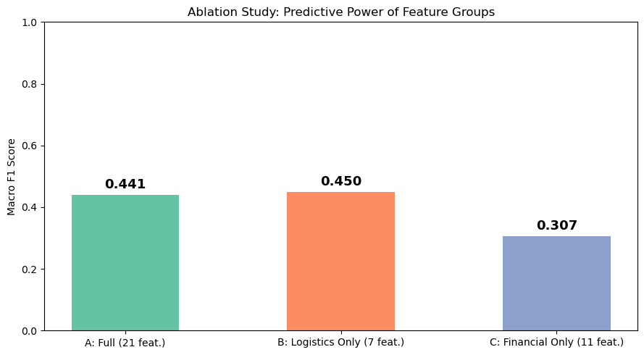 [Figure 14: Ablation bar chart. Logistics-only retains a higher proportion of full-model performance than financial-only.]

6.4 Limitations and Next Steps
Temporal validation: A walk-forward cross-validation scheme would better simulate production deployment and detect seasonal concept drift.
External data: Weather disruptions, carrier SLA records, and port congestion indices are absent but are known real-world delay drivers.
SMOTE: Synthetic minority oversampling could be explored as an alternative to class weighting for improving Significant Delay recall.
Production monitoring: A Population Stability Index (PSI) drift detector should trigger retraining when input distributions shift beyond a defined threshold.

Appendix A — Agent Usage Log

Screenshot - Data Leakage Audit (EDA)
Context: Delegated a systematic leakage check to identify features that might contain post-outcome information. Agent generated checks for each feature group.

Agent’s response
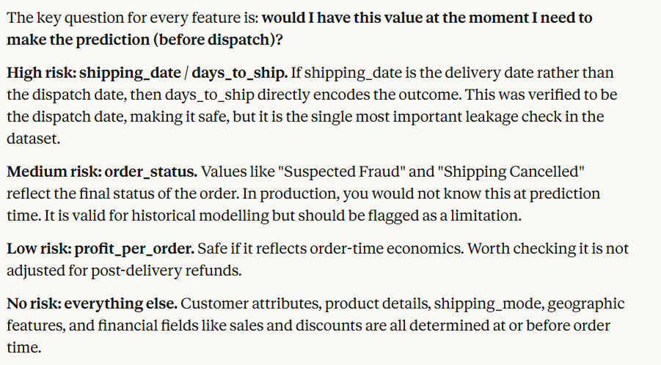

Screenshot - Preprocessing Pipeline (Data Preparation)
Context : Delegated pipeline construction with specific requirements: median imputation + StandardScaler for 13 numeric features, mode imputation + one-hot encoding for 8 categorical features. Agent omitted `handle_unknown='ignore'` - caught and corrected.
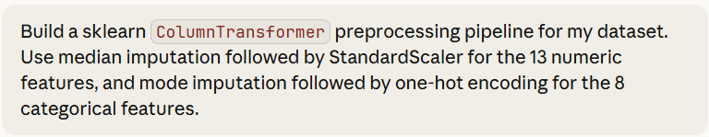
Agent’s response :
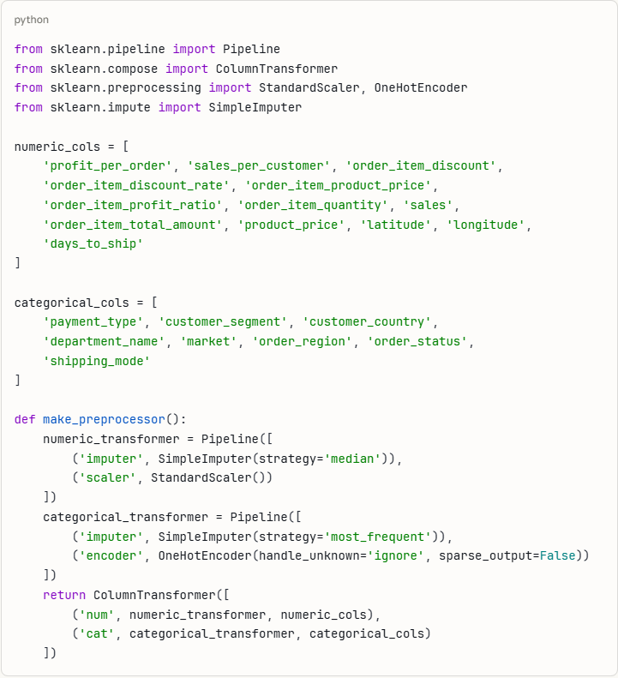

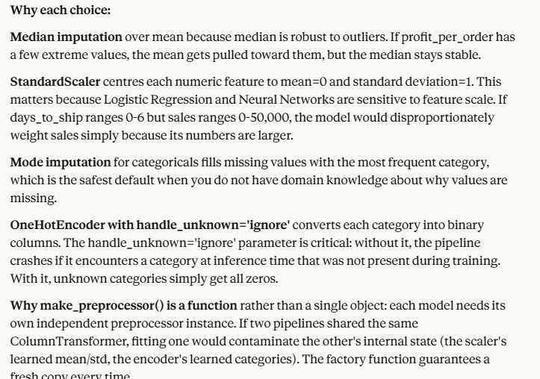

Screenshot - Hyperparameter Tuning (Fine-Tuning)
Context : Delegated GridSearchCV setup for XGBoost and Random Forest tuning. Agent set up 27-combination grids for each model (n_estimators, max_depth, learning_rate/min_samples_split).
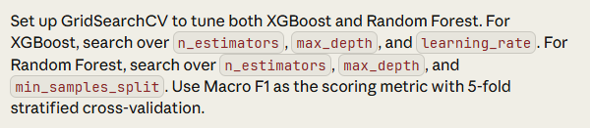
Agent’s response :
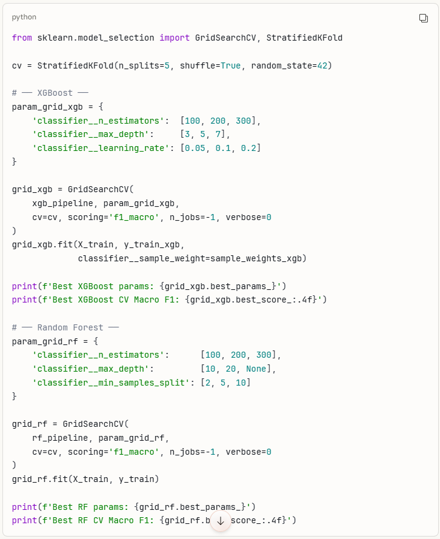
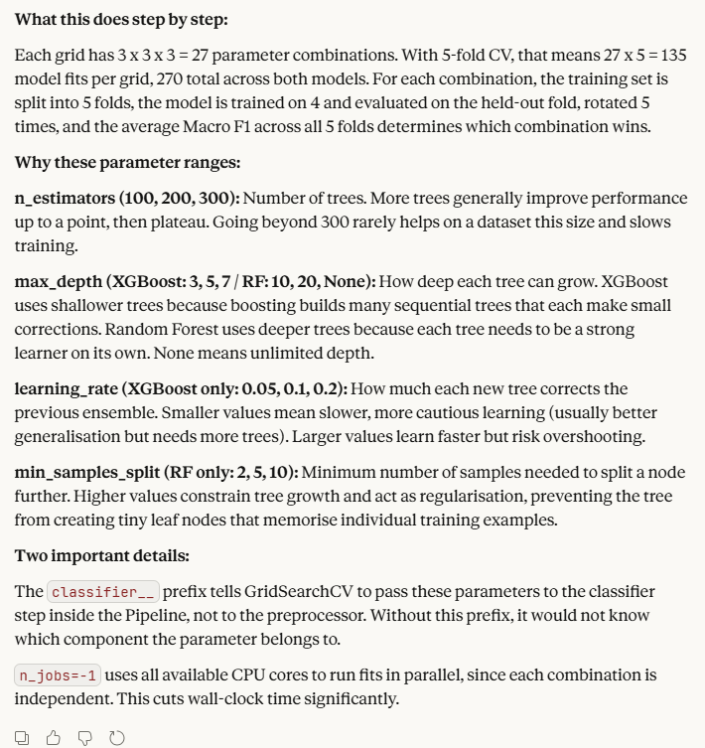
Verification and Pushback (Fine-Tuning) & Agent corrected the mistake
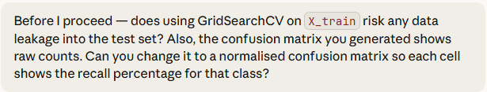
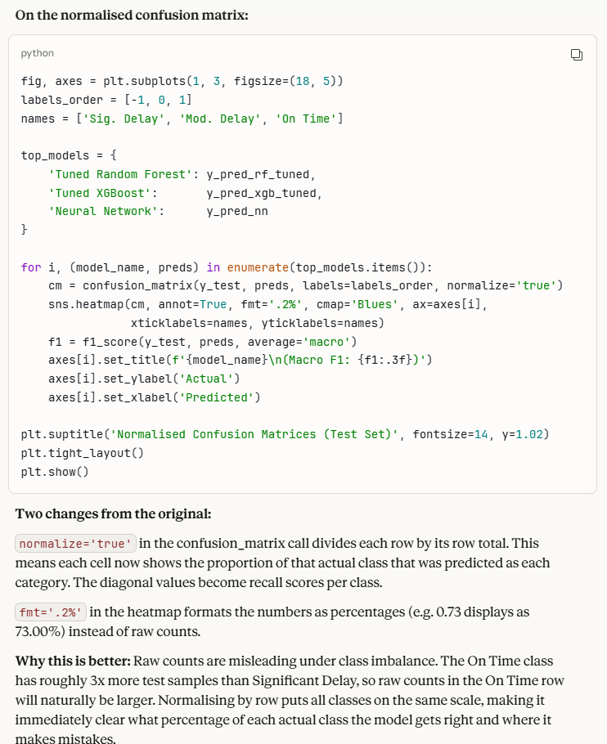

Screenshot - Overfitting Diagnosis (Neural Network)
Context : Identified diverging training/validation loss curves and asked the agent for remediation strategies. Agent suggested increasing Dropout and adding L2 regularisation.
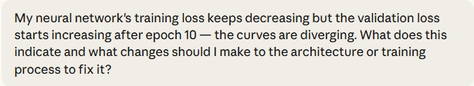
Agent’s response :
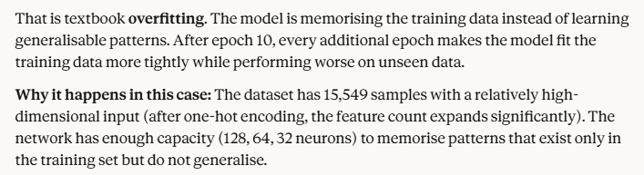
Screenshot - Agent Mistake: Wrong Evaluation Metric (Modelling)
Context : Asked the agent to compile a neural network for the 3-class problem. The agent used `metrics=['accuracy']` and monitored `val_accuracy`. I caught this with 58/23/19 imbalance, accuracy is misleading (a model always predicting On Time gets 58% accuracy). I pushed back, and the agent corrected to monitor `val_loss` and use Macro F1.

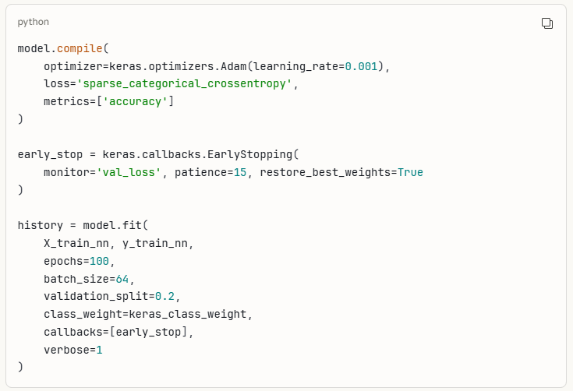
Pushback and correction by the agent

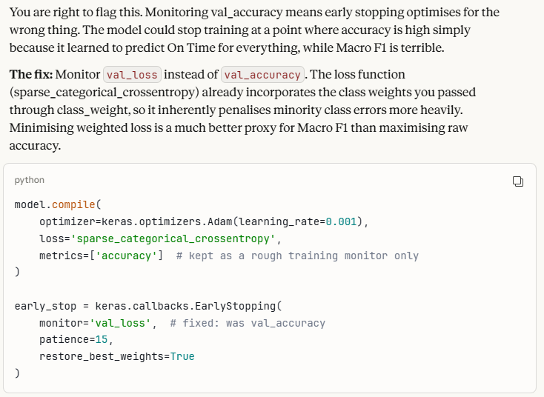

Screenshot - Agent Mistake: Data Leakage Risk Ignored (EDA)
Context : Asked the agent to include `days_to_ship` in the preprocessing pipeline. The agent included it without checking whether `shipping_date` might be a delivery date (which would make the feature a proxy for the outcome). I flagged the leakage risk and requested a correlation check. After confirming `shipping_date` means dispatch date, the feature was retained with the assumption documented.
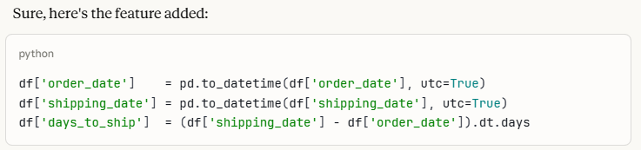

Pushback and correction :
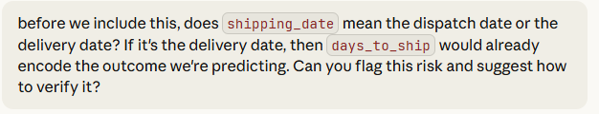
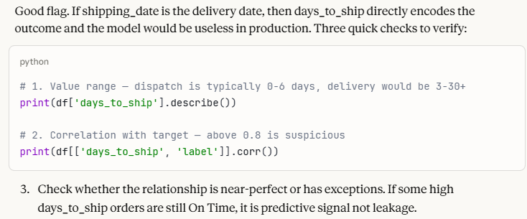

Appendix B — Agent Decision Register

Step | Agent Contribution | Decision | Rationale
Problem Framing | Recommended Macro F1 as primary metric | Accepted | Macro F1 treats all classes equally. Accuracy would reward majority-class prediction (58%). Weighted F1 would let On Time mask poor delay detection.
EDA | Included days_to_ship without leakage check | Modified | Pushed back; added correlation check first. Confirmed shipping_date = dispatch date, retained feature with assumption documented.
EDA | Flagged order_status as potential leakage risk | Modified | Retained for training. Noted in model card that production requires status at prediction time, not final status.
EDA | Generated Kruskal-Wallis test confirming days_to_ship significance (p < 0.001) | Accepted | Non-parametric test appropriate; shipping times are not normally distributed. Provides statistical evidence for feature retention.
Data Prep | Built preprocessing pipeline without handle_unknown='ignore' | Modified | Added handle_unknown='ignore' to prevent crashes on unseen categories at inference time.
Data Prep | Produced stratified split within 1% class proportion tolerance | Accepted | Validation check confirmed fair split across all three classes.
Modelling | Set up four-model comparison (LR, RF, XGBoost, NN) | Accepted | Clean linear to bagging to boosting to deep learning progression. Each model is meaningfully different.
Modelling | Used metrics=['accuracy'] in neural network compile | Rejected | Changed to monitor val_loss. Accuracy is misleading with class imbalance.
Modelling | Passed {-1, 0, 1} labels directly to XGBoost | Rejected | Added LabelEncoder to map to {0, 1, 2}. XGBoost requires non-negative integer labels.
Fine-Tuning | Built GridSearchCV with 27-combination grids for XGBoost and RF | Accepted after verification | Confirmed GridSearchCV only splits X_train internally, no leakage to test set.
Fine-Tuning | Produced raw-count confusion matrix | Modified | Requested normalised matrix so each row shows recall percentages. Easier to interpret class-level performance.
Evaluation | Used RandomForestClassifier() defaults in ablation loop | Rejected | Updated to use tuned parameters from grid_rf.best_params_. Ablation must reflect actual best model.
Interpretability | Generated SHAP beeswarm using old list-based API | Modified | Caught shape mismatch: newer SHAP returns 3D array (samples, features, classes). Updated to use [:, :, 0] class indexing.
Final Selection | Recommended Tuned XGBoost as final model | Accepted | XGBoost (~0.61) outperforms Neural Network (~0.59) with simpler deployment and full SHAP interpretability.

