Q1 - Design the student bio-data form using button, label, textbox, radio button, table and

checkbox using CSS.

<!DOCTYPE html>

<html lang="en">

<head>

<meta charset="UTF-8">

<meta name="viewport" content="width=device-width, initial-scale=1.0">

<title>Student Bio-Data Form</title>

<style>

body {

font-family: Arial, sans-serif;

background-color: #f4f4f9;

margin: 0;

padding: 0;

}

.form-container {

width: 80%;

max-width: 800px;

margin: 50px auto;

background-color: #ffffff;

padding: 20px;

border-radius: 8px;

box-shadow: 0 4px 8px rgba(0, 0, 0, 0.1);

}

h2 {

text-align: center;

color: #333;

}

.form-group {

margin-bottom: 15px;

display: flex;

flex-direction: column;

align-items: center; /\* Center vertically \*/

}

.form-group label {

display: block;

font-weight: bold;

color: #555;

}

.form-group input[type="text"],

.form-group input[type="email"],

.form-group input[type="date"] {

width: 100%;

max-width: 90%; /\* Optional: Adjust if necessary to ensure the fields don't extend too far \*/

padding: 8px;

margin-top: 5px;

border: 1px solid #ccc;

border-radius: 4px;

}

.form-group input[type="radio"] {

width: auto;

margin-right: 10px;

}

.radio-group {

display: flex;

justify-content: space-around;

align-items: center;

}

.radio-group label {

margin-right: 15px;

font-weight: normal;

}

.form-group input[type="checkbox"] {

width: auto;

margin-right: 15px;

}

/\* Style for checkbox to make them inline \*/

.checkbox-group {

display: flex;

justify-content: space-between;

flex-wrap: wrap;

}

.checkbox-group input[type="checkbox"] {

margin-right: 10px;

}

.form-group button {

background-color: #4CAF50;

color: white;

border: none;

padding: 10px 20px;

text-align: center;

border-radius: 5px;

cursor: pointer;

font-size: 16px;

width: 100%;

}

.form-group button:hover {

background-color: #45a049;

}

.table-container {

margin-top: 20px;

width: 100%;

text-align: center;

}

table {

width: 100%;

border-collapse: collapse;

margin-top: 10px;

}

table, th, td {

border: 1px solid #ddd;

}

th, td {

padding: 8px;

text-align: center;

}

th {

background-color: #f2f2f2;

}

/\* Ensuring the form is centered on smaller screens \*/

@media (max-width: 768px) {

.form-container {

width: 90%;

margin: 20px auto;

padding: 15px;

}

}

</style>

</head>

<body>

<div class="form-container">

<h2>Student Bio-Data Form</h2>

<form action="#">

<!-- Name Field -->

<div class="form-group">

<label for="name">Full Name</label>

<input type="text" id="name" name="name" placeholder="Enter full name" required>

</div>

<!-- Email Field -->

<div class="form-group">

<label for="email">Email Address</label>

<input type="email" id="email" name="email" placeholder="Enter email" required>

</div>

<!-- Date of Birth -->

<div class="form-group">

<label for="dob">Date of Birth</label>

<input type="date" id="dob" name="dob" required>

</div>

<!-- Gender Radio Buttons -->

<div class="form-group">

<label>Gender</label>

<div class="radio-group">

<div>

<input type="radio" id="male" name="gender" value="Male">

<label for="male">Male</label>

</div>

<div>

<input type="radio" id="female" name="gender" value="Female">

<label for="female">Female</label>

</div>

<div>

<input type="radio" id="other" name="gender" value="Other">

<label for="other">Other</label>

</div>

</div>

</div>

<!-- Hobbies Checkboxes -->

<div class="form-group">

<label>Hobbies</label>

<div class="checkbox-group">

<div>

<input type="checkbox" id="reading" name="hobbies" value="Reading">

<label for="reading">Reading</label>

</div>

<div>

<input type="checkbox" id="sports" name="hobbies" value="Sports">

<label for="sports">Sports</label>

</div>

<div>

<input type="checkbox" id="music" name="hobbies" value="Music">

<label for="music">Music</label>

</div>

</div>

</div>

<!-- Submit Button -->

<div class="form-group">

<button type="submit">Submit</button>

</div>

</form>

<!-- Table Displaying Student Information -->

<div class="table-container">

<h3>Student Information</h3>

<table>

<thead>

<tr>

<th>Name</th>

<th>Email</th>

<th>Date of Birth</th>

<th>Gender</th>

<th>Hobbies</th>

</tr>

</thead>

<tbody>

<tr>

<td>someone</td>

<td>sm@example.com</td>

<td>2000-01-01</td>

<td>Male</td>

<td>Reading, Sports</td>

</tr>

<tr>

<td>another one</td>

<td>ao@example.com</td>

<td>1999-05-15</td>

<td>Female</td>

<td>Music</td>

</tr>

</tbody>

</table>

</div>

</div>

</body>

</html>

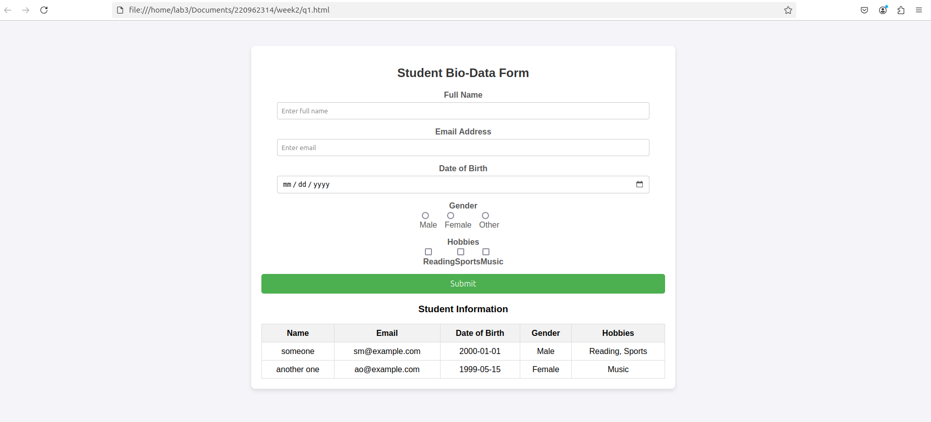

Q3. Create a web page using bootstrap as mentioned. Divide the page in to 2 parts top and

bottom, then divide the bottom into 3 parts and design each top and bottom part using

different input groups, input, badges, buttons and button groups. Make the design more

attractive using bootstrap.

<!DOCTYPE html>

<html lang="en">

<head>

<meta charset="UTF-8">

<meta name="viewport" content="width=device-width, initial-scale=1.0">

<title>Bootstrap Webpage</title>

<!-- Bootstrap CSS -->

<link rel="stylesheet" href="https://maxcdn.bootstrapcdn.com/bootstrap/3.4.1/css/bootstrap.min.css">

<style>

body {

padding-top: 50px;

padding-bottom: 50px;

}

.top-section {

background-color: #f8f9fa;

padding: 30px;

margin-bottom: 30px;

}

.bottom-section {

padding: 20px 0;

}

.col {

padding: 20px;

background-color: #e9ecef;

border-radius: 8px;

box-shadow: 0 4px 8px rgba(0, 0, 0, 0.1);

margin-bottom: 20px;

}

.input-group {

margin-bottom: 20px;

}

.badge {

background-color: #17a2b8;

}

.btn-group {

margin-top: 20px;

}

</style>

</head>

<body>

<!-- Top Section -->

<div class="container top-section">

<div class="row">

<div class="col-md-12 text-center">

<h2>Bootstrap Page Design</h2>

<p>Divided into top and bottom sections with different components</p>

<!-- Input Group Example -->

<div class="input-group input-group-lg">

<span class="input-group-addon" id="basic-addon1">@</span>

<input type="text" class="form-control" placeholder="Username" aria-describedby="basic-addon1">

</div>

<!-- Badge Example -->

<h4>

<span class="badge">New</span>

<span class="badge">Popular</span>

<span class="badge">Limited</span>

</h4>

<!-- Button Example -->

<button class="btn btn-primary btn-lg">Primary Button</button>

</div>

</div>

</div>

<!-- Bottom Section -->

<div class="container bottom-section">

<div class="row">

<!-- First Column (Sign Up) -->

<div class="col-md-4">

<h3>Sign Up</h3>

<!-- Sign Up Form Example -->

<div class="input-group">

<input type="text" class="form-control" placeholder="Enter Username">

</div>

<div class="input-group">

<input type="password" class="form-control" placeholder="Enter Password">

</div>

<div class="input-group">

<input type="password" class="form-control" placeholder="Confirm Password">

</div>

<button class="btn btn-success btn-lg">Sign In</button>

</div>

<!-- Second Column (Login & Password) -->

<div class="col-md-4">

<h3>Login & Password</h3>

<!-- Login Form with Password Example -->

<div class="input-group">

<span class="input-group-addon"><i class="glyphicon glyphicon-user"></i></span>

<input type="text" class="form-control" placeholder="Username">

</div>

<div class="input-group">

<span class="input-group-addon"><i class="glyphicon glyphicon-lock"></i></span>

<input type="password" class="form-control" placeholder="Password">

</div>

<button class="btn btn-primary btn-lg">Login</button>

</div>

<!-- Third Column (Option Buttons) -->

<div class="col-md-4">

<h3>Options</h3>

<!-- Button Group for Option 1, Option 2, and Option 3 -->

<div class="btn-group-vertical">

<button type="button" class="btn btn-info">Option 1</button>

<button type="button" class="btn btn-info">Option 2</button>

<button type="button" class="btn btn-info">Option 3</button>

</div>

</div>

</div>

</div>

<!-- Bootstrap JS (necessary for certain components like dropdowns) -->

<script src="https://ajax.googleapis.com/ajax/libs/jquery/3.5.1/jquery.min.js"></script>

<script src="https://maxcdn.bootstrapcdn.com/bootstrap/3.4.1/js/bootstrap.min.js"></script>

</body>

</html>

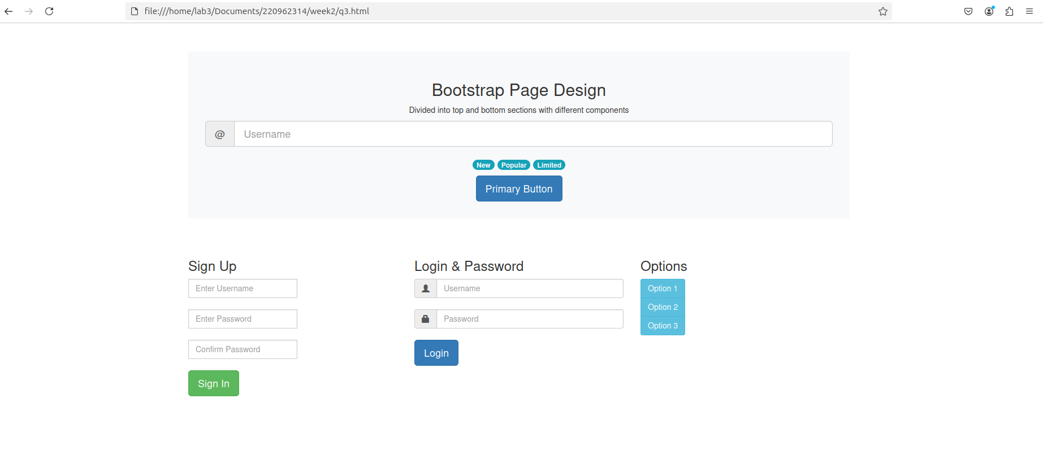

Q4. Design your class timetable using bootstrap table and carousel.

<!DOCTYPE html>

<html lang="en">

<head>

<meta charset="UTF-8">

<meta name="viewport" content="width=device-width, initial-scale=1.0">

<title>Class Timetable</title>

<!-- Bootstrap CSS -->

<link rel="stylesheet" href="https://maxcdn.bootstrapcdn.com/bootstrap/4.5.2/css/bootstrap.min.css">

<style>

body {

padding-top: 20px;

}

.carousel-inner {

text-align: center;

font-size: 18px;

}

/\* Change the arrow icon color to black \*/

.carousel-control-prev-icon,

.carousel-control-next-icon {

background-color: transparent; /\* Remove the background color \*/

border-color: transparent; /\* Remove the border color \*/

font-size: 30px; /\* Adjust size as needed \*/

color: black; /\* Set the color of the arrows to black \*/

}

.carousel-control-prev-icon::after,

.carousel-control-next-icon::after {

font-family: 'bootstrap-icons'; /\* Specify the icon font family \*/

content: '‹'; /\* Previous arrow \*/

}

.carousel-control-next-icon::after {

content: '›'; /\* Next arrow \*/

}

.carousel-inner table {

width: 100%;

}

.carousel-inner td {

padding: 10px;

text-align: left;

}

.carousel-inner th {

text-align: center;

background-color: #f8f9fa;

}

.carousel-inner tr:nth-child(even) {

background-color: #f1f1f1;

}

.carousel-inner .carousel-caption {

font-size: 24px;

}

h3 {

color: #000000;

}

.timetable-table {

margin-top: 20px;

}

</style>

</head>

<body>

<div class="container">

<!-- Carousel for timetable -->

<div id="carouselExampleIndicators" class="carousel slide" data-ride="carousel">

<!-- Indicators -->

<ol class="carousel-indicators">

<li data-target="#carouselExampleIndicators" data-slide-to="0" class="active"></li>

<li data-target="#carouselExampleIndicators" data-slide-to="1"></li>

<li data-target="#carouselExampleIndicators" data-slide-to="2"></li>

<li data-target="#carouselExampleIndicators" data-slide-to="3"></li>

<li data-target="#carouselExampleIndicators" data-slide-to="4"></li>

</ol>

<!-- Carousel items -->

<div class="carousel-inner">

<!-- Monday -->

<div class="carousel-item active">

<div class="carousel-caption">

<h3>Monday</h3>

</div>

<table class="table table-bordered timetable-table">

<thead>

<tr>

<th>Time</th>

<th>Subject</th>

</tr>

</thead>

<tbody>

<tr>

<td>8:00 - 9:00</td>

<td>WP</td>

</tr>

<tr>

<td>9:00 - 10:00</td>

<td>PE 1</td>

</tr>

<tr>

<td>10:30 - 11:30</td>

<td>EEFM</td>

</tr>

<tr>

<td>11:30 - 12:30</td>

<td>PE 2</td>

</tr>

</tbody>

</table>

</div>

<!-- Tuesday -->

<div class="carousel-item">

<div class="carousel-caption">

<h3>Tuesday</h3>

</div>

<table class="table table-bordered timetable-table">

<thead>

<tr>

<th>Time</th>

<th>Subject</th>

</tr>

</thead>

<tbody>

<tr>

<td>8:00 - 9:00</td>

<td>WP</td>

</tr>

<tr>

<td>9:00 - 10:00</td>

<td>PE 1</td>

</tr>

<tr>

<td>10:30 - 11:30</td>

<td>EEFM</td>

</tr>

<tr>

<td>11:30 - 12:30</td>

<td>PE 2</td>

</tr>

</tbody>

</table>

</div>

<!-- Wednesday -->

<div class="carousel-item">

<div class="carousel-caption">

<h3>Wednesday</h3>

</div>

<table class="table table-bordered timetable-table">

<thead>

<tr>

<th>Time</th>

<th>Subject</th>

</tr>

</thead>

<tbody>

<tr>

<td>8:00 - 9:00</td>

<td>WP</td>

</tr>

<tr>

<td>9:00 - 10:00</td>

<td>PE 1</td>

</tr>

<tr>

<td>10:30 - 11:30</td>

<td>EEFM</td>

</tr>

<tr>

<td>11:30 - 12:30</td>

<td>PE 2</td>

</tr>

</tbody>

</table>

</div>

<!-- Thursday -->

<div class="carousel-item">

<div class="carousel-caption">

<h3>Thursday</h3>

</div>

<table class="table table-bordered timetable-table">

<thead>

<tr>

<th>Time</th>

<th>Subject</th>

</tr>

</thead>

<tbody>

<tr>

<td>8:00 - 9:00</td>

<td>WP</td>

</tr>

<tr>

<td>9:00 - 10:00</td>

<td>PE 1</td>

</tr>

<tr>

<td>10:30 - 11:30</td>

<td>EEFM</td>

</tr>

<tr>

<td>11:30 - 12:30</td>

<td>PE 2</td>

</tr>

</tbody>

</table>

</div>

<!-- Friday -->

<div class="carousel-item">

<div class="carousel-caption">

<h3>Friday</h3>

</div>

<table class="table table-bordered timetable-table">

<thead>

<tr>

<th>Time</th>

<th>Subject</th>

</tr>

</thead>

<tbody>

<tr>

<td>8:00 - 9:00</td>

<td>WP</td>

</tr>

<tr>

<td>9:00 - 10:00</td>

<td>PE 1</td>

</tr>

<tr>

<td>10:30 - 11:30</td>

<td>EEFM</td>

</tr>

<tr>

<td>11:30 - 12:30</td>

<td>PE 2</td>

</tr>

</tbody>

</table>

</div>

</div>

<!-- Controls -->

<a class="carousel-control-prev" href="#carouselExampleIndicators" role="button" data-slide="prev">

<span class="carousel-control-prev-icon" aria-hidden="true"></span>

<span class="sr-only">Previous</span>

</a>

<a class="carousel-control-next" href="#carouselExampleIndicators" role="button" data-slide="next">

<span class="carousel-control-next-icon" aria-hidden="true"></span>

<span class="sr-only">Next</span>

</a>

</div>

</div>

<!-- Bootstrap JS and dependencies (necessary for carousel) -->

<script src="https://ajax.googleapis.com/ajax/libs/jquery/3.5.1/jquery.min.js"></script>

<script src="https://cdnjs.cloudflare.com/ajax/libs/popper.js/1.16.1/umd/popper.min.js"></script>

<script src="https://maxcdn.bootstrapcdn.com/bootstrap/4.5.2/js/bootstrap.min.js"></script>

</body>

</html>

