Q1 - Design the student bio-data form using button, label, textbox, radio button, table and
checkbox using CSS.

<!DOCTYPE html>
<html lang="en">
<head>
<meta charset="UTF-8">
<meta name="viewport" content="width=device-width, initial-scale=1.0">
<title>Student Bio-Data Form</title>
<style>
body {
font-family: Arial, sans-serif;
background-color: #f4f4f9;
margin: 0;
padding: 0;
}

.form-container {
width: 80%;
max-width: 800px;
margin: 50px auto;
background-color: #ffffff;
padding: 20px;
border-radius: 8px;
box-shadow: 0 4px 8px rgba(0, 0, 0, 0.1);
}

h2 {
text-align: center;
color: #333;
}

.form-group {
margin-bottom: 15px;
display: flex;
flex-direction: column;
align-items: center; /* Center vertically */
}

.form-group label {
display: block;
font-weight: bold;
color: #555;
}

.form-group input[type="text"],
.form-group input[type="email"],
.form-group input[type="date"] {
width: 100%;
max-width: 90%; /* Optional: Adjust if necessary to ensure the fields don't extend too far */
padding: 8px;
margin-top: 5px;
border: 1px solid #ccc;
border-radius: 4px;
}

.form-group input[type="radio"] {
width: auto;
margin-right: 10px;
}

.radio-group {
display: flex;
justify-content: space-around;
align-items: center;
}

.radio-group label {
margin-right: 15px;
font-weight: normal;
}

.form-group input[type="checkbox"] {
width: auto;
margin-right: 15px;
}

/* Style for checkbox to make them inline */
.checkbox-group {
display: flex;
justify-content: space-between;
flex-wrap: wrap;
}

.checkbox-group input[type="checkbox"] {
margin-right: 10px;
}

.form-group button {
background-color: #4CAF50;
color: white;
border: none;
padding: 10px 20px;
text-align: center;
border-radius: 5px;
cursor: pointer;
font-size: 16px;
width: 100%;
}

.form-group button:hover {
background-color: #45a049;
}

.table-container {
margin-top: 20px;
width: 100%;
text-align: center;
}

table {
width: 100%;
border-collapse: collapse;
margin-top: 10px;
}

table, th, td {
border: 1px solid #ddd;
}

th, td {
padding: 8px;
text-align: center;
}

th {
background-color: #f2f2f2;
}

/* Ensuring the form is centered on smaller screens */
@media (max-width: 768px) {
.form-container {
width: 90%;
margin: 20px auto;
padding: 15px;
}
}
</style>
</head>
<body>

<div class="form-container">
<h2>Student Bio-Data Form</h2>
<form action="#">
<!-- Name Field -->
<div class="form-group">
<label for="name">Full Name</label>
<input type="text" id="name" name="name" placeholder="Enter full name" required>
</div>

<!-- Email Field -->
<div class="form-group">
<label for="email">Email Address</label>
<input type="email" id="email" name="email" placeholder="Enter email" required>
</div>

<!-- Date of Birth -->
<div class="form-group">
<label for="dob">Date of Birth</label>
<input type="date" id="dob" name="dob" required>
</div>

<!-- Gender Radio Buttons -->
<div class="form-group">
<label>Gender</label>
<div class="radio-group">
<div>
<input type="radio" id="male" name="gender" value="Male">
<label for="male">Male</label>
</div>
<div>
<input type="radio" id="female" name="gender" value="Female">
<label for="female">Female</label>
</div>
<div>
<input type="radio" id="other" name="gender" value="Other">
<label for="other">Other</label>
</div>
</div>
</div>

<!-- Hobbies Checkboxes -->
<div class="form-group">
<label>Hobbies</label>
<div class="checkbox-group">
<div>
<input type="checkbox" id="reading" name="hobbies" value="Reading">
<label for="reading">Reading</label>
</div>
<div>
<input type="checkbox" id="sports" name="hobbies" value="Sports">
<label for="sports">Sports</label>
</div>
<div>
<input type="checkbox" id="music" name="hobbies" value="Music">
<label for="music">Music</label>
</div>
</div>
</div>

<!-- Submit Button -->
<div class="form-group">
<button type="submit">Submit</button>
</div>
</form>

<!-- Table Displaying Student Information -->
<div class="table-container">
<h3>Student Information</h3>
<table>
<thead>
<tr>
<th>Name</th>
<th>Email</th>
<th>Date of Birth</th>
<th>Gender</th>
<th>Hobbies</th>
</tr>
</thead>
<tbody>
<tr>
<td>someone</td>
<td>sm@example.com</td>
<td>2000-01-01</td>
<td>Male</td>
<td>Reading, Sports</td>
</tr>
<tr>
<td>another one</td>
<td>ao@example.com</td>
<td>1999-05-15</td>
<td>Female</td>
<td>Music</td>
</tr>
</tbody>
</table>
</div>
</div>

</body>
</html>

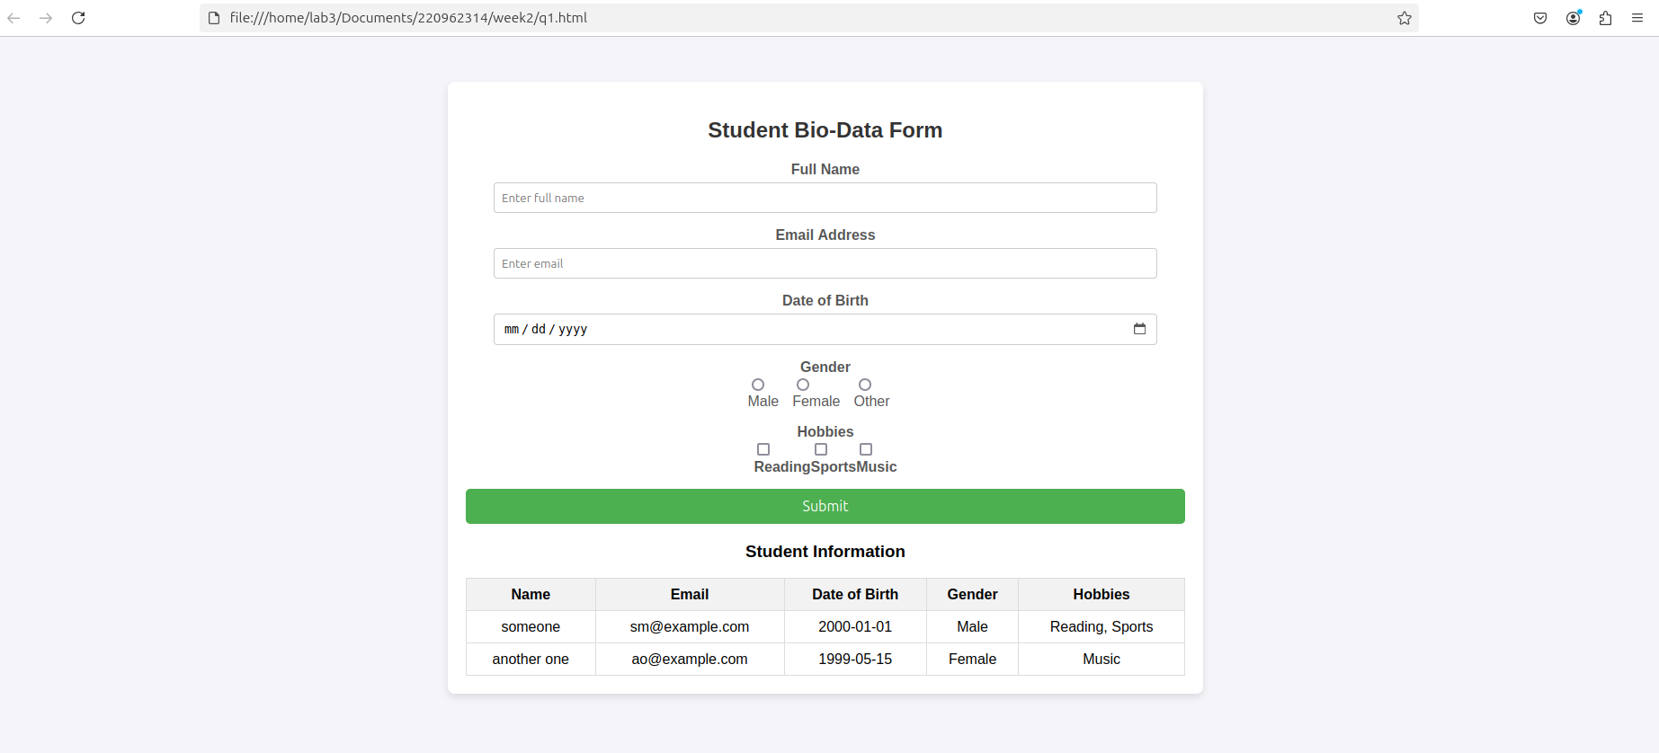

Q3. Create a web page using bootstrap as mentioned. Divide the page in to 2 parts top and
bottom, then divide the bottom into 3 parts and design each top and bottom part using
different input groups, input, badges, buttons and button groups. Make the design more
attractive using bootstrap.

<!DOCTYPE html>
<html lang="en">
<head>
<meta charset="UTF-8">
<meta name="viewport" content="width=device-width, initial-scale=1.0">
<title>Bootstrap Webpage</title>
<!-- Bootstrap CSS -->
<link rel="stylesheet" href="https://maxcdn.bootstrapcdn.com/bootstrap/3.4.1/css/bootstrap.min.css">
<style>
body {
padding-top: 50px;
padding-bottom: 50px;
}

.top-section {
background-color: #f8f9fa;
padding: 30px;
margin-bottom: 30px;
}

.bottom-section {
padding: 20px 0;
}

.col {
padding: 20px;
background-color: #e9ecef;
border-radius: 8px;
box-shadow: 0 4px 8px rgba(0, 0, 0, 0.1);
margin-bottom: 20px;
}

.input-group {
margin-bottom: 20px;
}

.badge {
background-color: #17a2b8;
}

.btn-group {
margin-top: 20px;
}
</style>
</head>
<body>

<!-- Top Section -->
<div class="container top-section">
<div class="row">
<div class="col-md-12 text-center">
<h2>Bootstrap Page Design</h2>
<p>Divided into top and bottom sections with different components</p>

<!-- Input Group Example -->
<div class="input-group input-group-lg">
<span class="input-group-addon" id="basic-addon1">@</span>
<input type="text" class="form-control" placeholder="Username" aria-describedby="basic-addon1">
</div>

<!-- Badge Example -->
<h4>
<span class="badge">New</span>
<span class="badge">Popular</span>
<span class="badge">Limited</span>
</h4>

<!-- Button Example -->
<button class="btn btn-primary btn-lg">Primary Button</button>
</div>
</div>
</div>

<!-- Bottom Section -->
<div class="container bottom-section">
<div class="row">
<!-- First Column (Sign Up) -->
<div class="col-md-4">
<h3>Sign Up</h3>
<!-- Sign Up Form Example -->
<div class="input-group">
<input type="text" class="form-control" placeholder="Enter Username">
</div>

<div class="input-group">
<input type="password" class="form-control" placeholder="Enter Password">
</div>

<div class="input-group">
<input type="password" class="form-control" placeholder="Confirm Password">
</div>

<button class="btn btn-success btn-lg">Sign In</button>
</div>

<!-- Second Column (Login & Password) -->
<div class="col-md-4">
<h3>Login & Password</h3>
<!-- Login Form with Password Example -->
<div class="input-group">
<span class="input-group-addon"><i class="glyphicon glyphicon-user"></i></span>
<input type="text" class="form-control" placeholder="Username">
</div>

<div class="input-group">
<span class="input-group-addon"><i class="glyphicon glyphicon-lock"></i></span>
<input type="password" class="form-control" placeholder="Password">
</div>

<button class="btn btn-primary btn-lg">Login</button>
</div>

<!-- Third Column (Option Buttons) -->
<div class="col-md-4">
<h3>Options</h3>
<!-- Button Group for Option 1, Option 2, and Option 3 -->
<div class="btn-group-vertical">
<button type="button" class="btn btn-info">Option 1</button>
<button type="button" class="btn btn-info">Option 2</button>
<button type="button" class="btn btn-info">Option 3</button>
</div>
</div>
</div>
</div>

<!-- Bootstrap JS (necessary for certain components like dropdowns) -->
<script src="https://ajax.googleapis.com/ajax/libs/jquery/3.5.1/jquery.min.js"></script>
<script src="https://maxcdn.bootstrapcdn.com/bootstrap/3.4.1/js/bootstrap.min.js"></script>
</body>
</html>

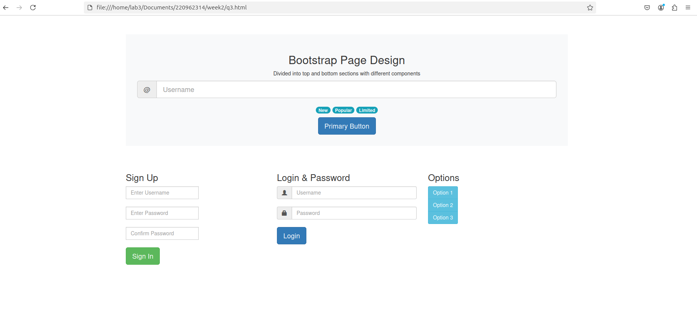

Q4. Design your class timetable using bootstrap table and carousel.

<!DOCTYPE html>
<html lang="en">
<head>
<meta charset="UTF-8">
<meta name="viewport" content="width=device-width, initial-scale=1.0">
<title>Class Timetable</title>
<!-- Bootstrap CSS -->
<link rel="stylesheet" href="https://maxcdn.bootstrapcdn.com/bootstrap/4.5.2/css/bootstrap.min.css">
<style>
body {
padding-top: 20px;
}

.carousel-inner {
text-align: center;
font-size: 18px;
}
/* Change the arrow icon color to black */
.carousel-control-prev-icon,
.carousel-control-next-icon {
background-color: transparent; /* Remove the background color */
border-color: transparent; /* Remove the border color */
font-size: 30px; /* Adjust size as needed */
color: black; /* Set the color of the arrows to black */
}

.carousel-control-prev-icon::after,
.carousel-control-next-icon::after {
font-family: 'bootstrap-icons'; /* Specify the icon font family */
content: '‹'; /* Previous arrow */
}

.carousel-control-next-icon::after {
content: '›'; /* Next arrow */
}
.carousel-inner table {
width: 100%;
}

.carousel-inner td {
padding: 10px;
text-align: left;
}

.carousel-inner th {
text-align: center;
background-color: #f8f9fa;
}

.carousel-inner tr:nth-child(even) {
background-color: #f1f1f1;
}

.carousel-inner .carousel-caption {
font-size: 24px;
}

h3 {
color: #000000;
}

.timetable-table {
margin-top: 20px;
}
</style>
</head>
<body>

<div class="container">
<!-- Carousel for timetable -->
<div id="carouselExampleIndicators" class="carousel slide" data-ride="carousel">
<!-- Indicators -->
<ol class="carousel-indicators">
<li data-target="#carouselExampleIndicators" data-slide-to="0" class="active"></li>
<li data-target="#carouselExampleIndicators" data-slide-to="1"></li>
<li data-target="#carouselExampleIndicators" data-slide-to="2"></li>
<li data-target="#carouselExampleIndicators" data-slide-to="3"></li>
<li data-target="#carouselExampleIndicators" data-slide-to="4"></li>
</ol>

<!-- Carousel items -->
<div class="carousel-inner">
<!-- Monday -->
<div class="carousel-item active">
<div class="carousel-caption">
<h3>Monday</h3>
</div>
<table class="table table-bordered timetable-table">
<thead>
<tr>
<th>Time</th>
<th>Subject</th>
</tr>
</thead>
<tbody>
<tr>
<td>8:00 - 9:00</td>
<td>WP</td>
</tr>
<tr>
<td>9:00 - 10:00</td>
<td>PE 1</td>
</tr>
<tr>
<td>10:30 - 11:30</td>
<td>EEFM</td>
</tr>
<tr>
<td>11:30 - 12:30</td>
<td>PE 2</td>
</tr>
</tbody>
</table>
</div>

<!-- Tuesday -->
<div class="carousel-item">
<div class="carousel-caption">
<h3>Tuesday</h3>
</div>
<table class="table table-bordered timetable-table">
<thead>
<tr>
<th>Time</th>
<th>Subject</th>
</tr>
</thead>
<tbody>
<tr>
<td>8:00 - 9:00</td>
<td>WP</td>
</tr>
<tr>
<td>9:00 - 10:00</td>
<td>PE 1</td>
</tr>
<tr>
<td>10:30 - 11:30</td>
<td>EEFM</td>
</tr>
<tr>
<td>11:30 - 12:30</td>
<td>PE 2</td>
</tr>
</tbody>
</table>
</div>

<!-- Wednesday -->
<div class="carousel-item">
<div class="carousel-caption">
<h3>Wednesday</h3>
</div>
<table class="table table-bordered timetable-table">
<thead>
<tr>
<th>Time</th>
<th>Subject</th>
</tr>
</thead>
<tbody>
<tr>
<td>8:00 - 9:00</td>
<td>WP</td>
</tr>
<tr>
<td>9:00 - 10:00</td>
<td>PE 1</td>
</tr>
<tr>
<td>10:30 - 11:30</td>
<td>EEFM</td>
</tr>
<tr>
<td>11:30 - 12:30</td>
<td>PE 2</td>
</tr>
</tbody>
</table>
</div>

<!-- Thursday -->
<div class="carousel-item">
<div class="carousel-caption">
<h3>Thursday</h3>
</div>
<table class="table table-bordered timetable-table">
<thead>
<tr>
<th>Time</th>
<th>Subject</th>
</tr>
</thead>
<tbody>
<tr>
<td>8:00 - 9:00</td>
<td>WP</td>
</tr>
<tr>
<td>9:00 - 10:00</td>
<td>PE 1</td>
</tr>
<tr>
<td>10:30 - 11:30</td>
<td>EEFM</td>
</tr>
<tr>
<td>11:30 - 12:30</td>
<td>PE 2</td>
</tr>
</tbody>
</table>
</div>

<!-- Friday -->
<div class="carousel-item">
<div class="carousel-caption">
<h3>Friday</h3>
</div>
<table class="table table-bordered timetable-table">
<thead>
<tr>
<th>Time</th>
<th>Subject</th>
</tr>
</thead>
<tbody>
<tr>
<td>8:00 - 9:00</td>
<td>WP</td>
</tr>
<tr>
<td>9:00 - 10:00</td>
<td>PE 1</td>
</tr>
<tr>
<td>10:30 - 11:30</td>
<td>EEFM</td>
</tr>
<tr>
<td>11:30 - 12:30</td>
<td>PE 2</td>
</tr>
</tbody>
</table>
</div>
</div>

<!-- Controls -->
<a class="carousel-control-prev" href="#carouselExampleIndicators" role="button" data-slide="prev">
<span class="carousel-control-prev-icon" aria-hidden="true"></span>
<span class="sr-only">Previous</span>
</a>
<a class="carousel-control-next" href="#carouselExampleIndicators" role="button" data-slide="next">
<span class="carousel-control-next-icon" aria-hidden="true"></span>
<span class="sr-only">Next</span>
</a>
</div>

</div>

<!-- Bootstrap JS and dependencies (necessary for carousel) -->
<script src="https://ajax.googleapis.com/ajax/libs/jquery/3.5.1/jquery.min.js"></script>
<script src="https://cdnjs.cloudflare.com/ajax/libs/popper.js/1.16.1/umd/popper.min.js"></script>
<script src="https://maxcdn.bootstrapcdn.com/bootstrap/4.5.2/js/bootstrap.min.js"></script>
</body>
</html>

