Task 2 Report
MOSTAFA SAEED 2021170522

Activation  Function | Train  Accuracy | Test  Accuracy | LR | Epochs | # Hidden  Layers | # Hidden  Nodes
Sigmoid | 100 | 100 | 0.01 | 500 | 1 | 10
Tanh | 100 | 100 | 0.01 | 400 | 2 | 5

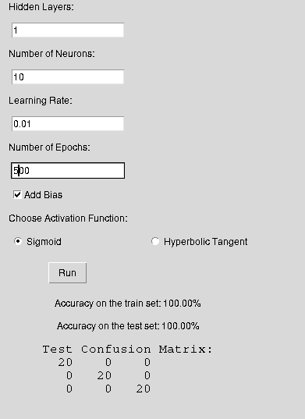
Sigmoid:

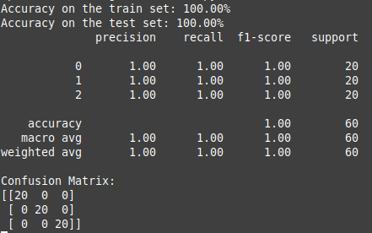

TanH:

