*Name : Mostafa Adel Abdallah Ali Behiry*

*ID : 1136*

*B.N : 3*

*Date : 12/6/2021*

*Topic : Operating Systems*

*Application Brief : I chose this topic because it is one of the important topics in the world of programming.. It is also important in our field, which is the field of engineering, especially mechanical engineering and the world of electronics, which will play an important role in the future in the digital operation of machines, and this system will be the best ever in the future, it will save time, money and effort, Therefore, I wrote in this important topic that I see that it will play an important role in the future. We must make our utmost efforts in this to search for an operating system that adapts to our world and the world of technology, which is progressing every day, so we must live with and coexist with this driver and lead it.*

*Screenshots :* 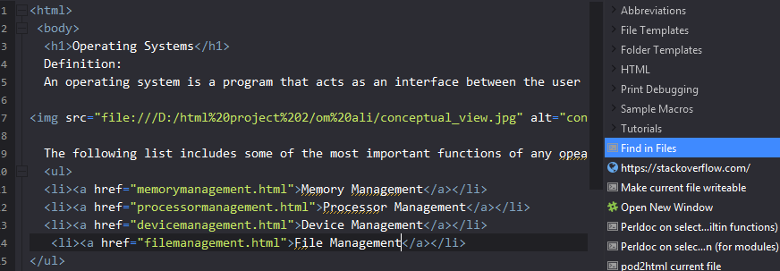

0