Task 3

VM Flask Screenshot: http://localhost:5000
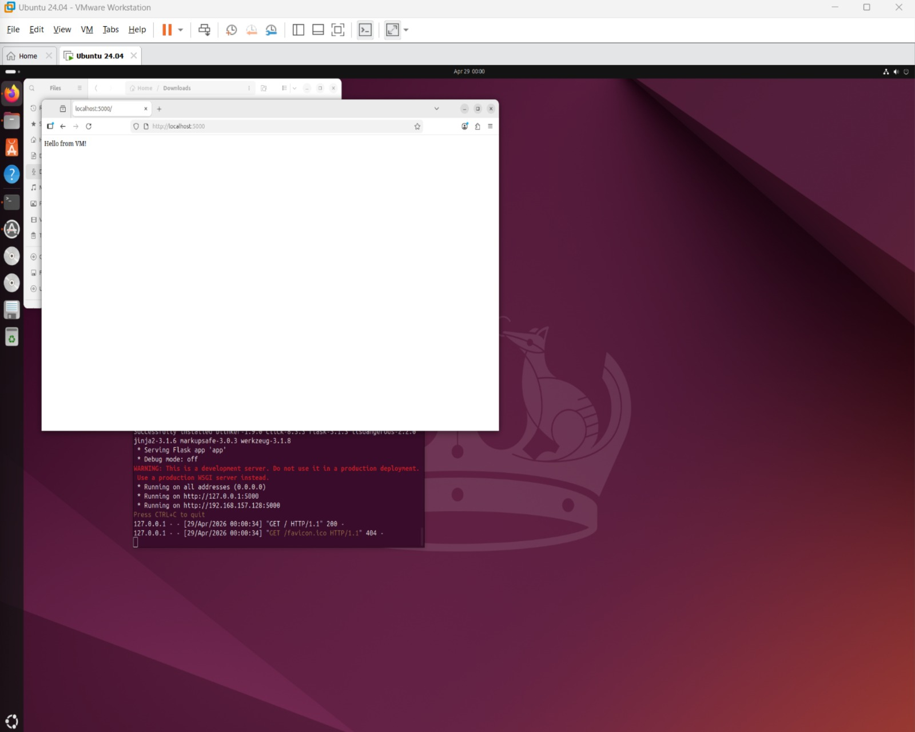

Docker Screenshot:
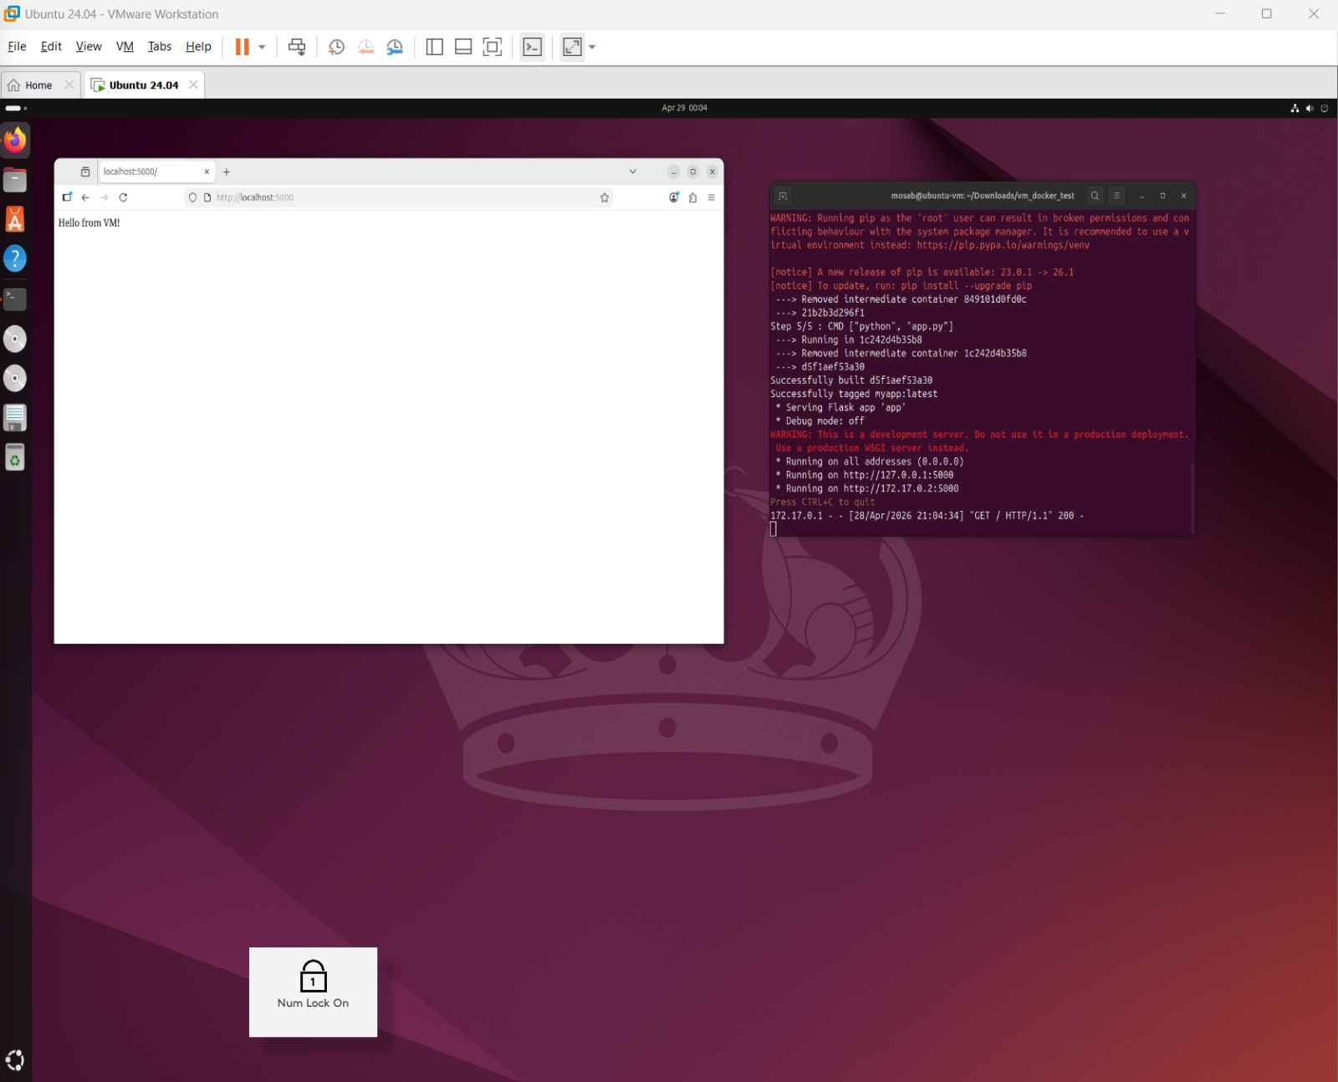

AWS EC2 Screenshot: http://54.87.79.79:5000
