Day2: Basics Linux command

Day 2 task completed

What is the Linux command to,

Check your present working directory, We use the below command

Pwd



The pwd command stands for "Print Working Directory". It prints the absolute path of the current working directory as above

2. List all the files or directories including hidden files, we use the below command

ls -a



The ls -a command in Ubuntu is used to list all files and directories, including hidden ones, in the current directory. The -a option stands for "all", and it instructs the ls command to show all files.

3. Create a nested directory A/B/C/D/E, we can use below command

mkdir -p A/B/C/D/E

This command will create the directory A in the current working directory, then the directory B inside A, and so on until the directory E is created inside D.The -p option instructs mkdir to create any missing intermediate directories along the given path.

To view the directories we can use below command to list

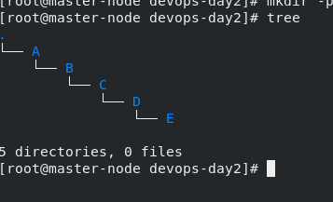

tree

The tree command in Ubuntu is used to display a recursive directory tree of the current directory or a specified directory. The command shows the directory structure in a graphical way, with each directory and its subdirectories listed in a hierarchical format.