# Name: Mosad Magdy Abdelnaby

# Group:7

# B/N:906

# Topic: Computer Engineer Role in Covid-19 pandemic

# Application Brief: I chose this application because many people are looking for this damn virus that spreads at a high speed.

# This repot contains the role of the computer in the corona crisis, as it publishes the numbers and developments of the virus in the world and how dangerous it is.

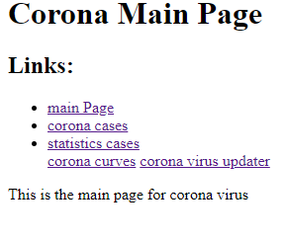

# Source code:

# 