Date: 12 June 2025
Full Name:
Student ID:

SDN Fundamentals & Techniques

Demo1: Mininet Fundamentals – as a SDN emulator

- Introduction

The main objective of this demonstration is to get familiar with Mininet as a SDN emulation environment. By doing this assignment, students will master both Mininet’s CLI and Python API. Besides, students will also learn to create fast prototyping topologies. Also instructions for the demo assignments are available in moodle. Please carefully read the ‘README.md’ under demo folder to familiarize yourself with the folder structure and instructions for usage.

- Setting things up

In this course, we will be using ONOS as a SDN controller along with some dependencies: Docker, OVS, Mininet, and Linux Machine. It is noted that networking knowledge, familiarity with Linux shell bash, and python languages are considered as prerequisites.

The following gives guidelines on how to set us these dependencies.
- ONOS is oﬃcially supported by the Open Networking Foundation (ONF) and runs on Linux machines and containers, i.e., LXC, LXD, and Docker. If you do not have any of them on your machine, you can either set up a virtual machine (using VirtualBox or VMWare). We used Ubuntu 22.04.5 LTS (Jammy Jellyfish) and 20.04.6 LTS (Focal Fossa) for testing, so it is recommended to use a stable version. Certain configurations are version-dependent and are detailed in the corresponding documentation. Please take care when setting up the environment and completing these assignments
- All files referred to in this assignment are available in moodle.
- We recommend using ONOS as a Docker image and we provide a simple shell script to instantly get ONOS ready. Please refer to the file under ‘Demo1/Task0_Env_setup’-“Install.md”.
- When using any downloaded script, please change the mode of the shell script to add execution, i.e., chmod +x your_file.sh.
- After successfully installing ONOS a link should appear in your terminal. To be able to access ONOS, the default ONOS credentials are – username: onos, password: rocks. You can also access to the ONOS UI to visualize the created topology.
- The next step is to start ONOS applications. For this purpose, you may refer to “Install.md” and follow the instructions therein. You can also consult the links included in the document for additional guidance. Those are activated as this assignment assumes that the application and the controller layers are out of the scope of this demonstration. To install Mininet, students are requested to follow the provided document. This document explains the steps for getting the Mininet emulator ready for work.

1

- Tasks

Task 1

- Create using the CLI interface and the OpenFlow Reference Controller:

  - A single-switch topology with 10 hosts. Note that a “single-switch topology” means one switch connected to all hosts.

  - A linear topology of 5 switches and 5 hosts.

  - A tree topology depth 3 fanout 2.

- Repeat the same operations using the remote SDN controller installed before, i.e., ONOS.

Note that for each question in Part 1 of Task 1, students are asked to provide the command used in addition to a brief explanation.

Task 2

Create using the Python API interface and the ONOS SDN Controller:

- A single-switch topology with 13 hosts. Note that a “single-switch topology” means one switch connected to all hosts.
- A linear topology of 10 switches and 10 hosts.
- A tree topology depth 3 fanout 2.

Note that you are free to mix API levels, i.e., low, middle, or high, or to use only one of them. Make sure that your code is well documented and follow python programming principles.

Task 3

Try to automate the precedent task, i.e., Task 2, to be able to create a topology given the type, i.e., tree or linear, and for each type its specifications. (Remember to clean out previous topology before executing automation task, otherwise error may come because of existing links.)

[Note: ONOS currently supports OpenFlow version 1.0 and 1.3. Remember to explicitly mention Openflow protocol version in every command and code for ONOS to receive topology information from Mininet.]

- How to submit?

The deadline to submit the solutions by email to tarik.taleb@rub.de and Yan.Chen-j3l@ruhr-uni-bochum.de is 20 Jun. 2025 at 23:55. Your submission should contain answers to the above-mentioned questions as well as the code with solutions used for the assignment.

Good luck!

- Appendices
  - Upon successful installation of ONOS

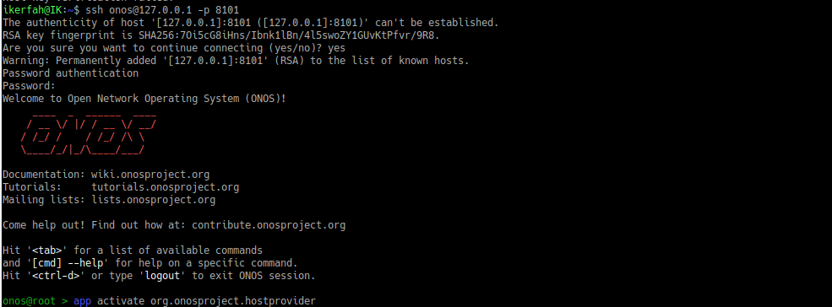

5.2 Snapshots of the Desired Topologies

- Single topology (10 switches)

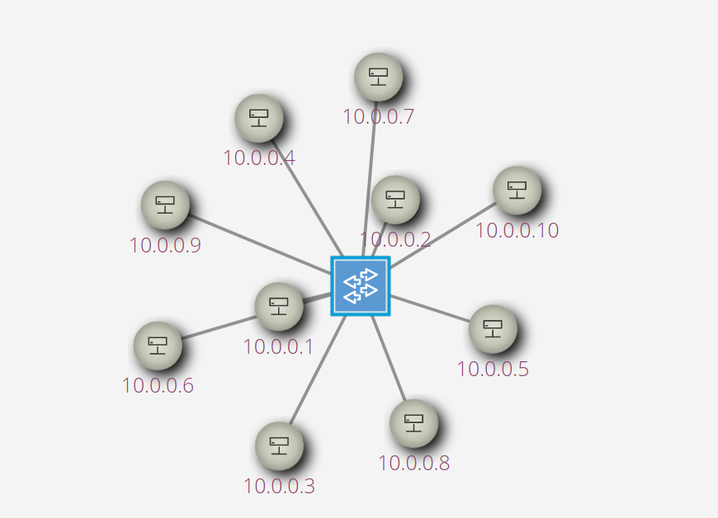

- Linear topology (5 switches, 5 hosts)
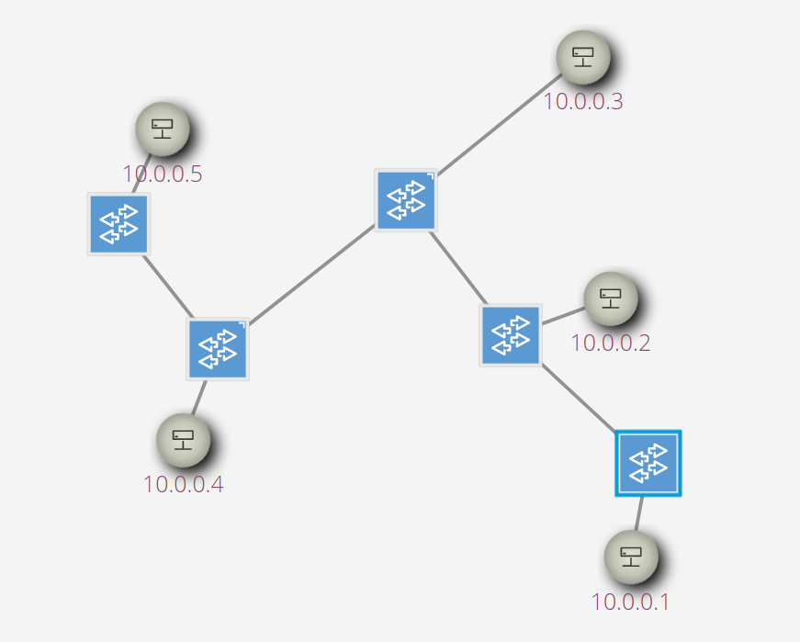

- Tree topology (Depth of 3 and fanout of 2)
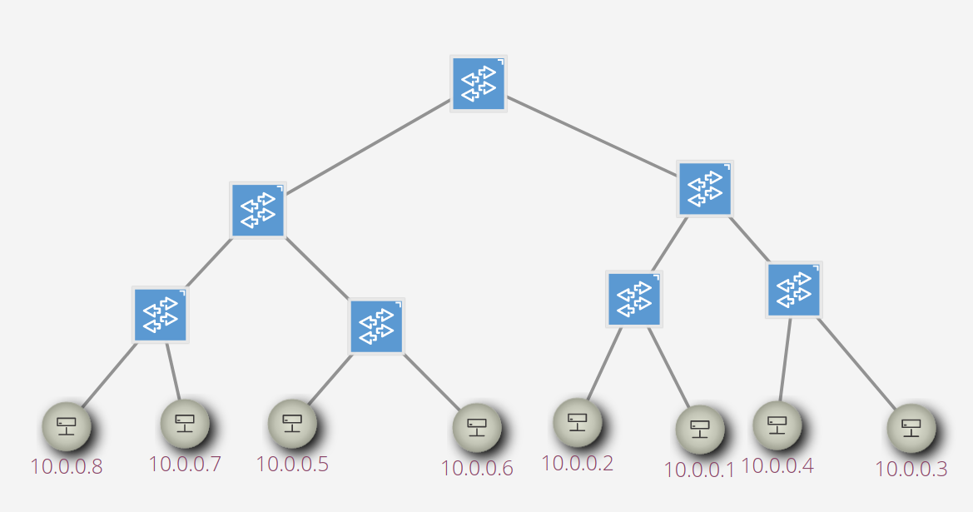
2

