SDN Fundamentals and Techniques
Demo 2: Virtualized Topologies

- Introduction

The main objective of this assignment is to get some intuition behind the basic infrastructure layer operations by creating topologies using Linux namespaces. Finalizing this assignment will allow the understanding of low-level components, i.e., namespaces, related to the infrastructure layer, their advantages and limitations, and their usage in well-known open-source projects, e.g., Kubernetes and Openstack.

- Setting things up

In this course, we will be using ONOS as an SDN controller along with some dependencies: Docker, OVS, and Linux Machine. It is noted that networking knowledge, familiarity with Linux shell bash, and python languages are considered as prerequisites. Let’s start by setting up everything.

ONOS is oﬃcially supported by the Open Networking Foundation (ONF) and runs on Linux machines and containers, i.e., LXC, LXD, and Docker. If you do not have any of them on your machine, you can set up a virtual machine (using VirtualBox or VMWare). We used Ubuntu 20.04.6 LTS (Focal Fossa) for testing, so it is recommended to use a stable version.

- All files referred to in this assignment are available at Moodle.
- We recommend using ONOS as a Docker image and we provide a simple shell script to instantly get ONOS ready. Please refer to the environment setup in Demo1.
- This Demo needs container tools, such as namespaces, LXC/LXD or docker-based topologies scripts, Please the Task.me and following instructions to ensure all these pre-requirements are properly installed and configured.

The next step is to start the ONOS applications and carry out the demo tasks. Please remember to use the cleaning scripts between tasks to ensure a clean environment for each task.

- Tasks

Task 1 - ONOS and Linux namespace

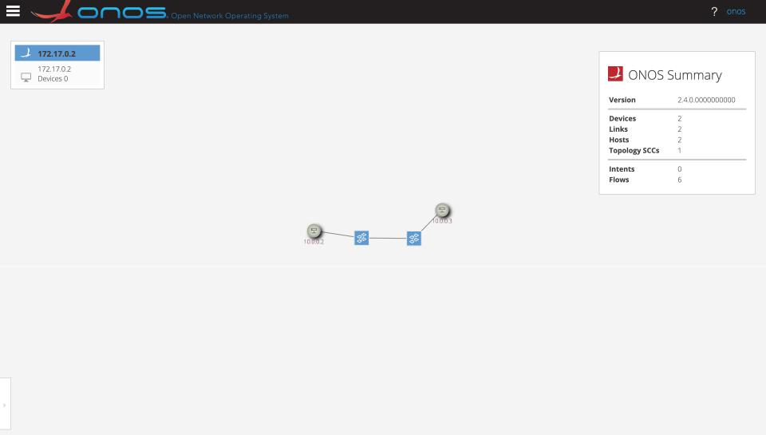
The shell script in Moodle. basic-net-ns.sh contains a set of shell functions to create a simple topology wherein two switches are connected together, each one of them is connected to one host, i.e., Fig. 1. In our assignment, a host is represented by a network namespace. This code is a simple manner of creating components of the infrastructure layer.

Figure 1: ONOS example.

In this assignment, you are requested to carry out the following tasks:

Task 1.1

Create a linear topology of 5 switches and 5 hosts. In a linear topology, each switch has two connections with other switches except the first and the last ones. To do that you may write a shell script or a python-based code, your code must be well-commented and following coding principles and naming convention (check the basic-net-ns.sh to get inspired).

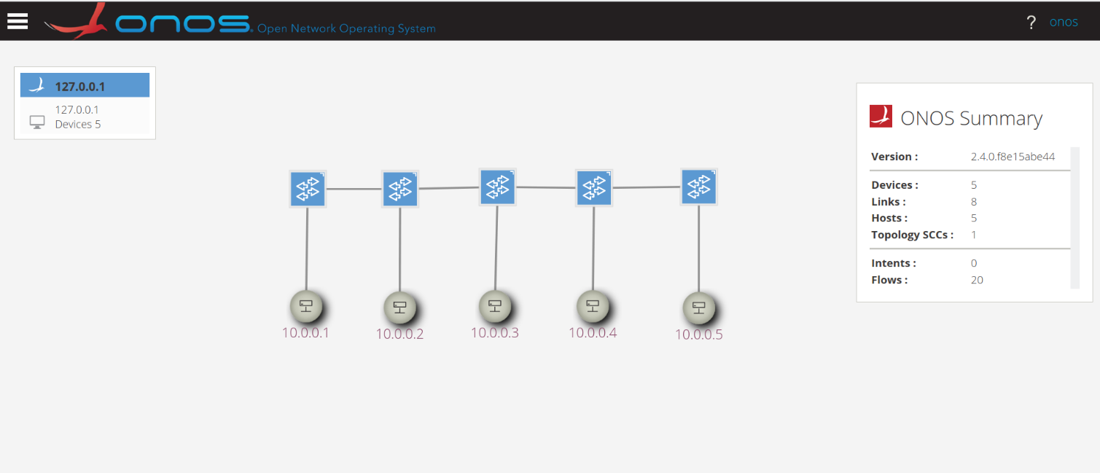

Figure 2: Example of a Linear topology with 5 switches and 5 hosts.

Task 1.2

Create a tree topology depth 3 fanout 2. In a tree topology, the depth refers to the number of layers in a tree and the fanout is the number of children each node has. For instance, in a tree where depth and fanout are equal to 2, the tree will have a node 0, i.e., switch 0, that has two other switches connected to it, switches 1 and 2.

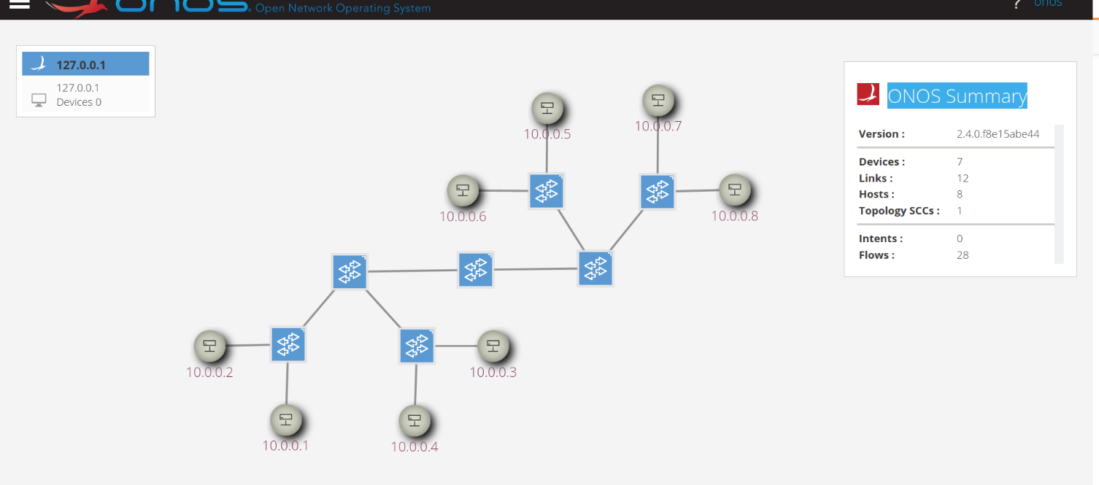
Figure 3: Example of a Tree topology with a depth of 3 and a fanout of 2.

Task 1.3

Try to automate the precedent tasks to be able to create a topology given the type, i.e., tree or linear, and for each type its specifications (i.e., depth and fanout for the tree and number of switches for linear). It is worth noticing that you can use Python as it is preferred because of the available tools that allow the exploitation of networking concepts.

(Note: Remember to clean up previous topology in the case of creating new topology to avoid overlapping error.)

Task 2 - ONOS and Linux Containers

This assignment contains two examples using two diﬀerent Linux Containers implementations, i.e., LXC and LXD, but resulting in the same outputs and results. The file related to LXC containers is stored in ONOS_LXC in Moodle while the file related to LXD is in ONOS_LXD.

Both python scripts create a simple topology wherein two switches are connected together, each one of them is connected to one host, i.e., Fig. 1. A host in the ONOS’s GUI is either an LXC or LXD container. This code is a simple manner of creating components of the infrastructure layer.

In this assignment, you are requested to carry out the following tasks:

Task 2.1

Create a leaf and spine topology in which the number of switches in the leaf layer is equal to eight, i.e., 8, and the number of switches in the spine is three, i.e., 3 (See Fig. 4). Each leaf node should contain two, i.e., 2, Linux Containers. It is noticed that a Leaf-spine topology is a two-layer network topology composed of leaf switches and spine switches. Each switch in the spine layer is connected to all the leaf switches. This topology is highly considered in data-centers. The task should be done using LXC when the leaf is an odd number and using LXD containers when a leaf node is an even number. For instance, if we have two leaf nodes, node one and two should attach to LXC containers while node three and four are linked with LXD containers.
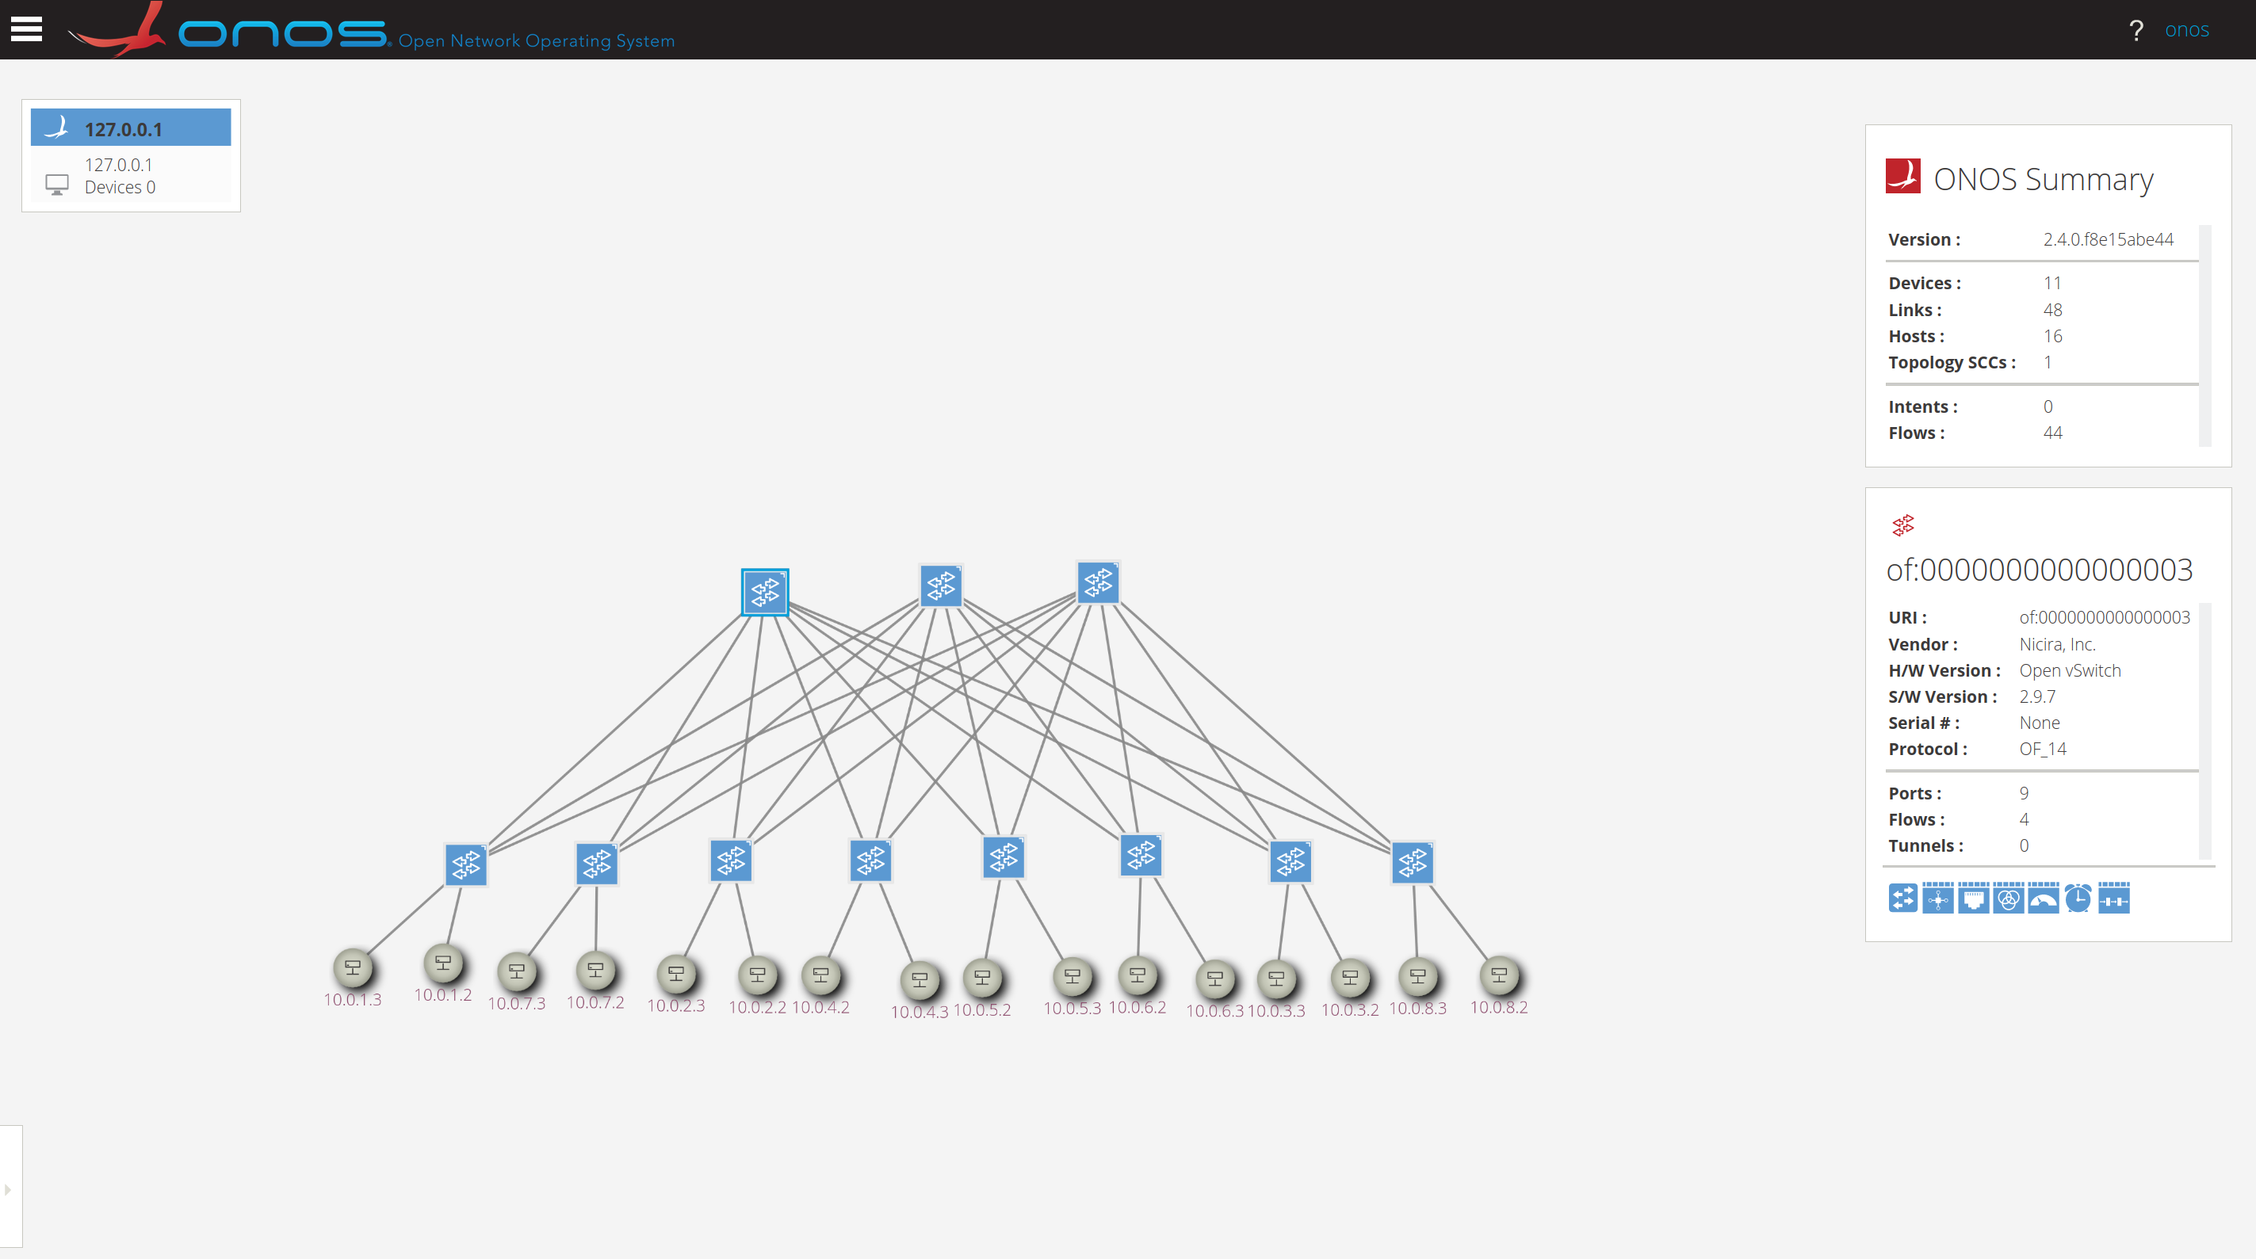
Figure 4: Example of a Leaf Spine topology with eight leaf and three spine switches.

Task 2.2

Work on the automation aspect of Task 2.1. The final results should be a code asking for the number of leaves, spine, and host nodes while the output must generate, in an automated way, the expected topology.

Task 2.3

Compared to namespaces (Demo 1), do you find manipulating low-level containers hard to implement and understand or not? Please elaborate why?

Task 2.4 (Optional)

Assuming you have understood well how Linux Containers work, repeat Tasks 2.1 and 2.2 using Docker containers instead of LXC. Note LXD must be used.

Task 3 - OpenFlow flow tables
This assignment is divided into two diﬀerent tasks. The first task is provided with a pre-defined topology wherein students are asked to create flow rules to achieve the defined objective. The second task requires the creation of a topology with restrictions imposed by flow rules.

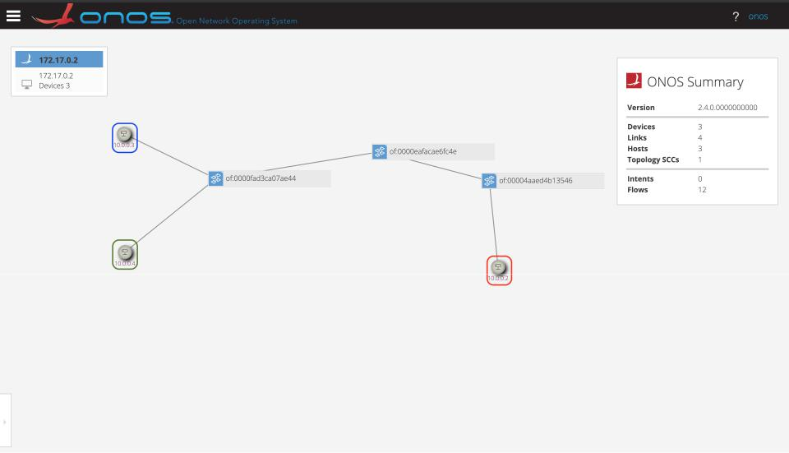

Figure 5: Task 3.1 Topology.

In this assignment, you are requested to carry out the following tasks:

Task 3.1

The file related to Task 3.1 is stored in “task1” in Moodle. This shell script creates a topology as depicted in Fig. 5. A host in the ONOS’s GUI is a namespace, however, LXC or LXD containers can be used. In this task you are asked to:

- Create the first flow rule to block the ICMP traﬃc from the “Blue" namespace to the “Red" namespace.

- Create the second flow rule to block the traﬃc to the “Red" namespace.

- Create the third flow rule to allow total access to the “Red" namespace from the “Green" and the “Blue" namespaces.

- Do you need to delete the second flow rule to activate the third flow rule?

- Create a flow rule to allow only Http and Https traﬃc to the “Red" namespace.

Note that for each flow rule, the student is asked to provide details on the entered rule and explanations. Use only the OVS command line to enter the flow rules.

Task 3.2

The objective of this task is to create a pseudo Network Slice based on namespaces and OVSs.

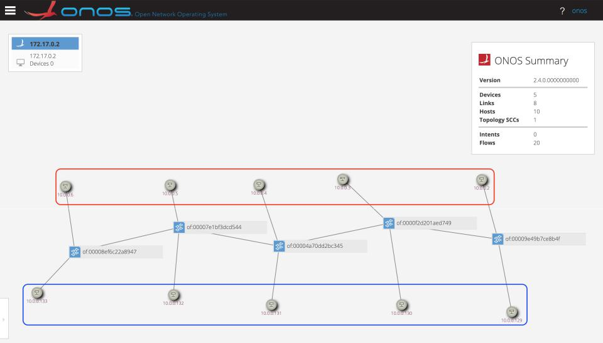
Figure 6: Task 3.2 Scenario.

- Create a linear topology of 5 switches and 10 hosts (as in Fig. 6). In a linear topology, each switch has two connections with other switches except the first and the last ones. Each switch contains two hosts, one for the “Red" slice and one for the “Blue" slice.
- After creating this topology, you are asked to create two slices, “Red" and “Blue", each slice is totally separated from the other without any toleration for shared access between them. To do that, you may write a shell script or a python-based code, your code must be well-commented and following coding principles and naming conventions. Your solution may leverage OVS’s CLI to create the necessary flow rules. Note that all hosts are in the same network range.

- Redo the isolation using another approach that diﬀers from the one you have used in the previous question.

Explore the usage of VLANs, this may help to solve one of the questions.
- Submission Guidelines

The deadline to submit the solutions through Moodle and by email is 10/07/2025. Your submission should contain answers to the above-mentioned questions as well as the code with solutions used for the assignment. Please email them to:
- yan.chen-j3l@ruhr-uni-bochum.de
- tarik.taleb@rub.de

Good luck!

