SDN Fundamentals and Techniques

Demo 4: Intents and Service Function Chaining (SFC)

- Setting things up

In this course, we will be using ONOS as an SDN controller along with some dependencies: Docker, OVS, and Linux Machine. It is noted that some networking knowledge, familiarity with Linux shell bash, and python languages are considered as prerequisites. Let’s start by setting up the environment.

ONOS is oﬃcially supported by the Open Networking Foundation (ONF) and runs on Linux machines and containers, i.e., LXC, LXD, and Docker. If you do not have any of them on your machine, you can either set up a virtual machine (using VirtualBox or VMWare). We used Ubuntu 20.04.6 LTS for testing, so it is recommended to use a stable version.

- All files referred to in this section are available in Moodle:
- We recommend using ONOS as a Docker image and we provide a simple shell script to instantly get ONOS ready. Please refer to the environment setting up.
- To access the ONOS API, access the following link: http://ONOS-IP:8181/onos/v1/docs/

- Tasks

Task 1: Using ONOS RESTful API, Linux containers, and Intent-based networking to orchestrate SFC

Introduction

This assignment aims to develop hands-on experience on Service Function Chaining (SFC) and SDN-based system orchestration, through the use of the ONOS RESTful API. This demonstration is part of the application layer as it introduces students to general orchestration methods and programmability in SDN-based environments. By completing this assignment, students will be familiar with the basics and operations of creating static SFC instances and their related networking traﬃc. Besides, students will develop technical knowledge to understand complex implementations used in well-known open-source projects such as Open-Stack.

Pre-Task

Please use the python code created in the previous demonstration to access ONOS RESTful API interface and activate the required ONOS applications. ONOS application list can be found in Moodle.

Tasks

All tasks are performed in a pre-defined topology in which students are asked to create various Intents to achieve the desired SFC communication. Fig. 1 shows a simple SFC made up of a source, i.e., RED container, a destination, i.e., GREEN container, and a simplified Service Function (SF) dubbed BLUE. The purpose of BLUE SF is to redirect traﬃc received from one interface to another. For example, if the BLUE container receives ingress traﬃc from interface “10.0.0.112”, it will output the same traﬃc from “10.0.0.111” and vice versa.

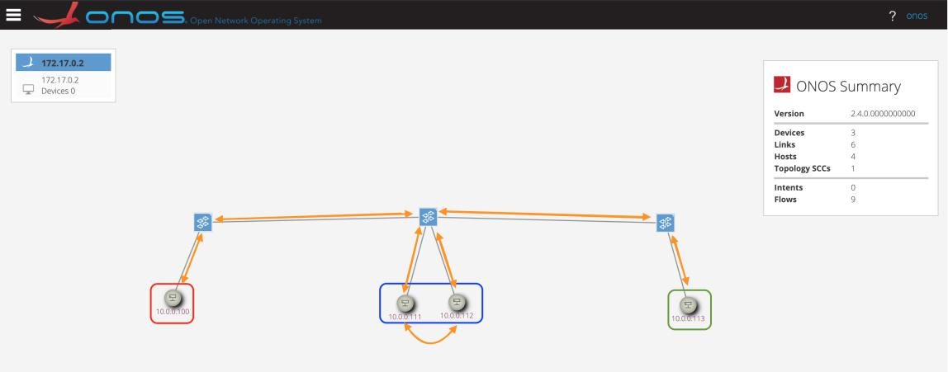

Figure 1: Task Topology.

Task 1

The file related to Task 1 is stored in the file “‘task.sh’” in Moodle. This shell script creates a topology as depicted in Fig. 1. Then, your task is using ONS RESTful API to Filter, Mirror, and Forwarding Networking Traffic based in INIS’s Intents Framework. In this task you are asked to:

- Create a Host-to-Host Intent to allow communication between the “RED" and “GREEN" containers.

- Using the TCPDUMP utility or other similar tool, try to identify the path taken by the traﬃc from the source, i.e., “RED”, to the destination, i.e., "GREEN" and report it. Note that TCPDUMP does not need to be installed inside containers. This utility can be used from the hosting machine by specifying the name of the interfaces used by the containers. Use the ICMP traﬃc generated by the ping command as an example.
- What do you observe?

- Do you think that Host-to-Host Intents can be useful in SFC deployments?

- Delete all the created Intents using Python-based code and ONOS RESTful API.

- What kind of Intents can be used to activate SFC communication in the current scenario?

- Using the right type of Intents, create a python-based code to steer the traﬃc as shown in Fig.3. Note that you do not need an Intent between interfaces 10.0.0.111 and 10.0.0.112.

- Explain the method used to create the end-to-end path.

Task 2

The file related to Task 2 is stored in the file “‘sfc.py’” in Moodle. This shell script also creates a topology as depicted in Fig. 1. Different from Task1, a host in the ONOS’s GUI is an LXC. Then, your task is using ONS RESTful API, Linux Containers, and Intent-Based Networking to Orchestrate SFC. In this task you are asked to complete the same tasks as Tasks 1.

Note that for each Intent, the student is asked to provide details and explanations. Please use only the ONOS RESTful API interface to enter the Intents and create the SFC traﬃc.

- Submission Guidelines

The deadline to submit the solutions through Moodle and by email is 17/07/2025. Your submission should contain answers to the above-mentioned questions as well as the code with solutions used for the assignment. Please email them to:
- yan.chen-j3l@ruhr-uni-bochum.de
- tarik.taleb@rub.de;

Good luck!

