**Sprint Plan + Backlog**

# Sprint 05

In Sprint 5, there were multiple modifications in the points allotted to certain user stories due to requiring more time than expected. We saw that some user stories needed to be divided into simpler tasks. With planning readjustments, the team had to re-assign the new stories to members and story points. Due to the challenges faced, story points were increased by extended research and development.

Another user story was added. The team decided to enhance the file comparison functionality by comparing files on a binary level. During the extraction process of files, we discovered that some files contained blocks of binary that could not be compared with other tags.

**Angelina – A [Sprint] – JC [Task Board]  
Dennis – D [Sprint] + [Task Board]  
Henry – H [Sprint] – HL [Task Board]  
Kelly – KM [Sprint] – K [Task Board]  
Kris – KL [Sprint] – KK [Task Board]**

**Before Sprint 05:**

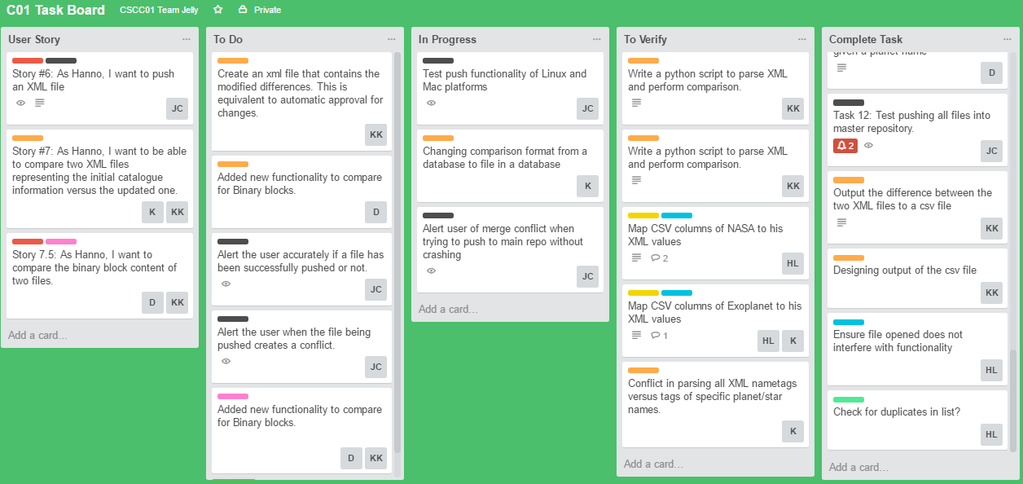

**After Sprint 05:**

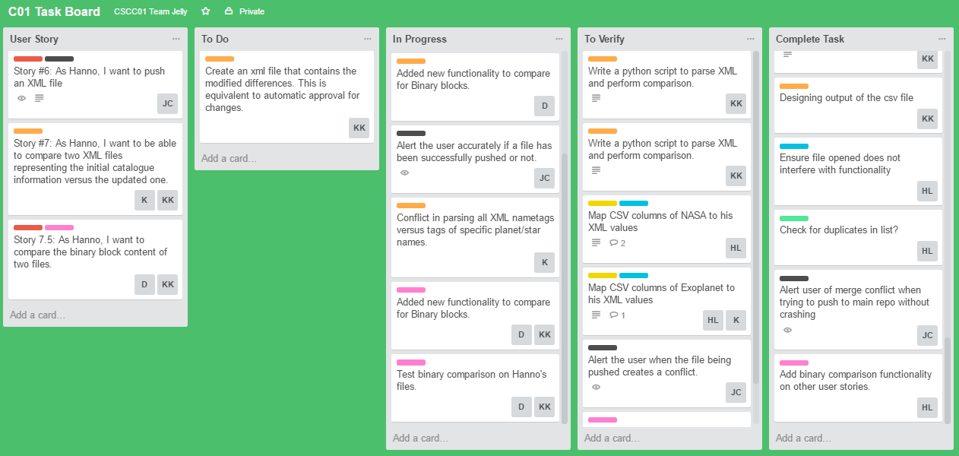

|  |  |  |  |  |  |  |
| --- | --- | --- | --- | --- | --- | --- |
| User Story | Tasks | Day 1 | Day 2 | Day 3 | Day 4 | Day 5 |
| Story #6: As Hanno, I want to push an XML file to the main repository.  Need to Fix: Crashes when a conflict is detected, along with inaccurate confirmations of file being pushed. | Test functionality on Linux and Mac platforms |  |  |  |  | A(1) |
| Alert the user accurately if a file has been successfully pushed. |  |  |  | A(1) | A(1) |
| Alert the user when the file being pushed creates a conflict. | A(1) | A(1) | A(1) |  |  |
| Story #7: As Hanno, I want to be able to compare two XML files representing the initial catalogue info vs the updated one.  *This has been pushed to this sprint due to unanticipated difficulties. | Changing comparison format from a database to file in a database | KM(1) | KM(1) |  |  | KM(1) |
| Conflict in parsing all XML nametags versus tags of specific planet/star names. |  |  | KM(2) | KM(2) |  |
| Output the difference between the two XML files to a csv file | KL(1) | KL(1) |  |  |  |
| New User Story #7.5: As Hanno, I want to compare the binary content of two files. | Added new functionality to compare for Binary blocks. |  | D(1) | KL(1) + D(1) | KL(1) + D(1) | KL(1) |
| Story #2: As Hanno, I want a command to list of all planetary systems that have been updated in other catalogues since the last commit. | Accommodate new user story’s functionality into existing user story | H(1) + D(1) | H(1) | H(1) | H(1) | H(1) + D(1) |

# Sprint 06

Sprint 6 was the merging of individual components into a single cohesive project. During the testing phase there were a great deal of bugs discovered. The team had to backtrack to ensure that the mandatory requirements of the program were functional. This was also the last sprint; therefore, it was crucial that the deliverable would be able to do the necessary functionalities. Most of the story points were spent on that rather than completing other user stories that were add-ons that would improve the deliverable but not absolutely essential.

Many of the user stories completed in previous sprints had to be modified to work with the new user story. Adding the additional feature to our existing code required more story points.

**Before Sprint 06:**

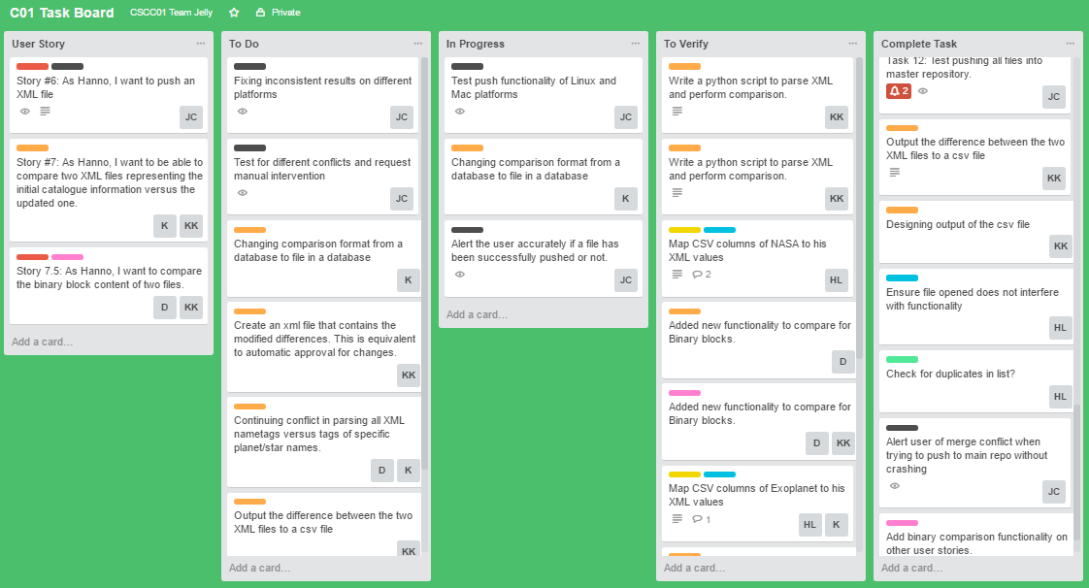

**After Sprint 06:**

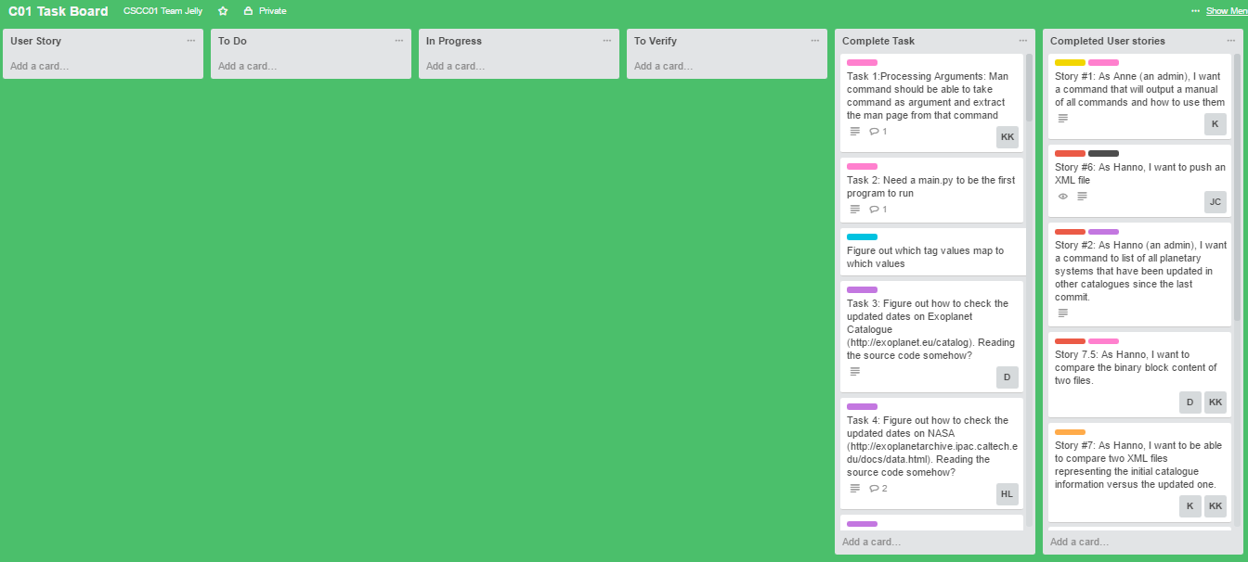

|  |  |  |  |  |  |  |
| --- | --- | --- | --- | --- | --- | --- |
| User Story | Tasks | Day 1 | Day 2 | Day 3 | Day 4 | Day 5 |
| Story #6: As Hanno, I want to push an XML file to the main repository | Fixing inconsistent results on different platforms | A(1) |  | A(1) |  |  |
| Test for different conflicts and request manual intervention |  | A(1) |  | A(1) | A(1) |
| Story #7: As Hanno, I want to be able to compare two XML files representing the initial catalogue info vs the updated one.  *Tasks from the previous sprint required attention during the merging process to ensure consistency. | Changing comparison format from a database to file in a database |  |  | KM(1) | KM(1) | KM(1) |
| Continuing conflict in parsing all XML nametags versus tags of specific planet/star names. | KM(1) | KM(1) |  |  |  |
| Output the difference between the two XML files to a csv file |  | KL(1) |  |  |  |
| Story #7.5: As Hanno, I want to compare the binary content of two files. | Modify binary block comparisons | KL(1) |  |  |  | KL(1) |
| Create an xml file that contains the modified differences. This is equivalent to automatic approval for changes. |  |  | KL(1) | KL(1) | D(1) |
| Story #3: As Hanno, I want to be able to manually push and commit updates from other catalogues to my git repository so that I can immediately add updated information to my catalogue | Add the binary comparison feature in pushing and committing updates. | H(1) + D(1) | H(1) |  |  |  |
| Test feature for bugs and fix accordingly |  | D(1) | H(1) + D(1) | H(1) + D(1) | H(1) |