SMART IRRIGATION
24-zone LoRa prototype: logic, crop adaptation, soil behavior, and file guide
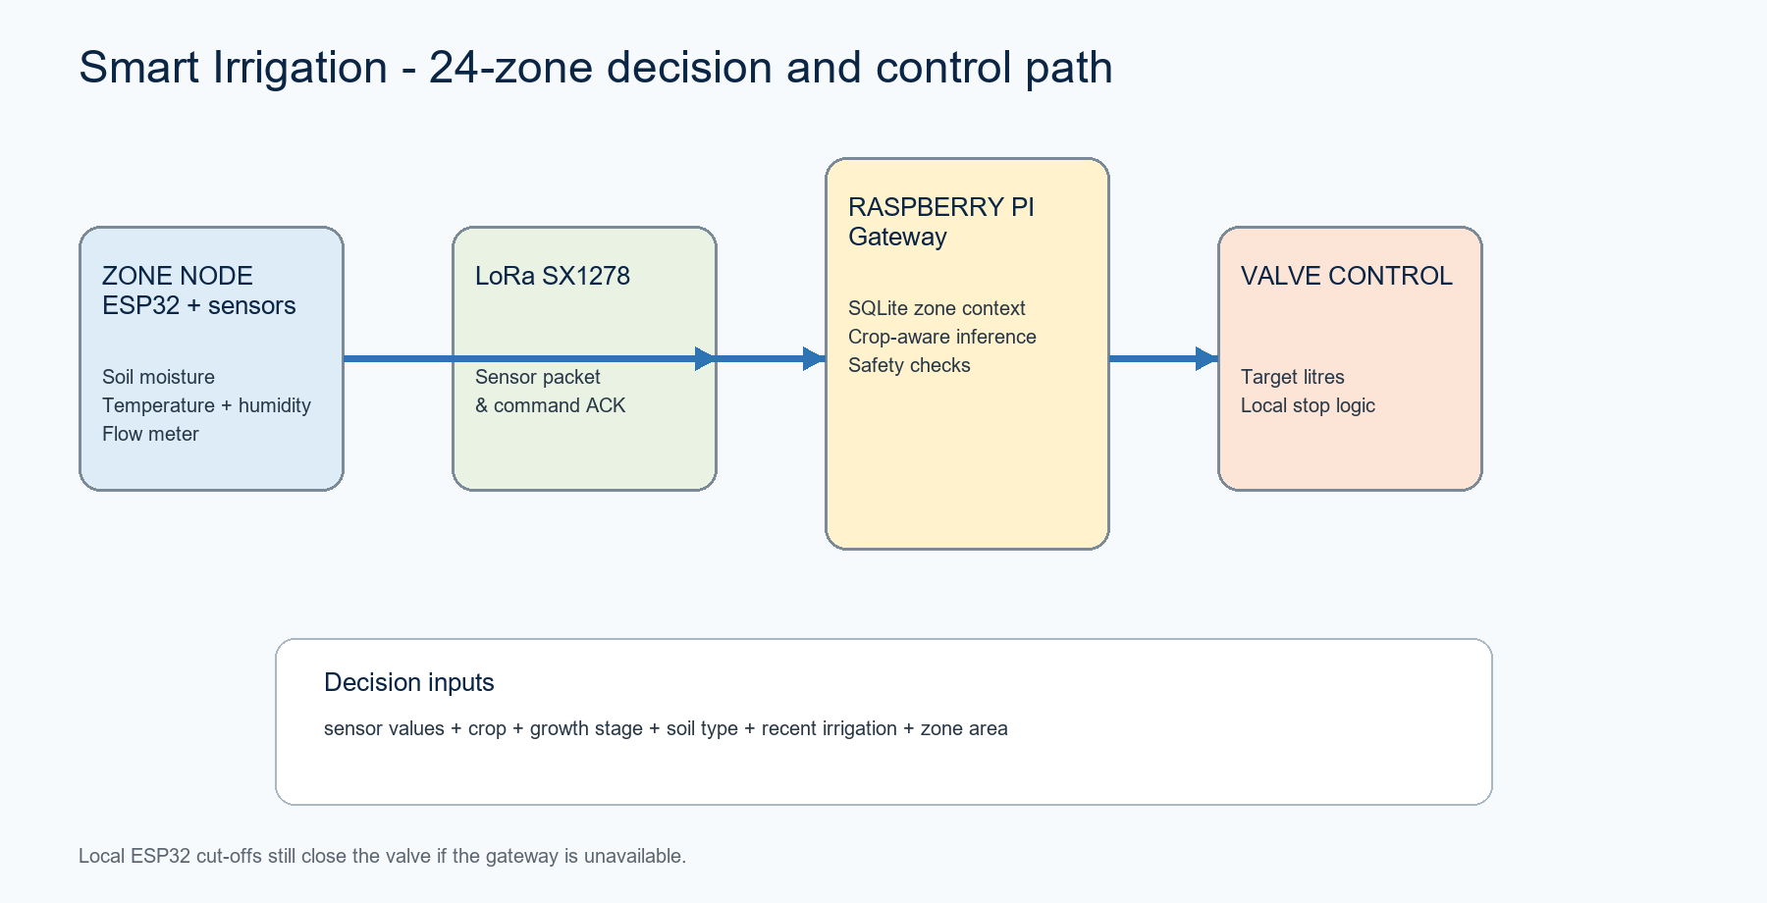
Figure 1. One-dimensional system path from field sensor to controlled irrigation.

1. What the application does
The application supervises 24 independent irrigation zones. Each zone measures soil moisture, temperature, humidity, and water flow; an ESP32 sends a compact JSON packet over SX1278 LoRa to a Raspberry Pi gateway. The gateway records the reading, combines it with zone context, selects a crop-specific ML model, and—only when irrigation is recommended and safety limits pass—commands the zone valve to deliver a calculated volume.
- Zone context is not a sensor: crop type, growth stage, soil type, area, and recent irrigation are stored/configured for each zone.
- The production target is a binary recommendation (irrigate / do not irrigate), then a transparent litres calculation determines the requested volume.
- The project explicitly labels its five models and data sets as synthetic prototypes, not field-validated agronomic schedules.

2. End-to-end decision logic
Step | Where it happens | Logic
1. Measure | ESP32 zone node | Read capacitive soil value, SHT31 temperature/humidity, flow rate, and pulse-derived total litres.
2. Report | ESP32 -> LoRa | Send sensor_data with zone_id at least every 60 seconds.
3. Enrich | Raspberry Pi / SQLite | Resolve zone crop, stage, soil type, area and recent water history.
4. Predict | raspberry/ml/inference.py | Build the seven features in metadata-defined order and call the selected crop model.
5. Size | irrigation/controller.py | Deficit = target moisture - measured moisture; convert deficit, area and demand index into litres.
6. Guard | Pi + ESP32 | Reject unsafe volume/flow/time; ESP32 independently stops for target, no-flow, high-flow, timeout or remote stop.
7. Record | SQLite + notifier | Write start/complete events and notify the configured channel.

3. Inputs and their meaning
Feature | Source | Role
soil_moisture_pct | ESP32 sensor | Primary depletion signal. It is compared against a soil-specific trigger in the synthetic label logic.
temperature_c, humidity_pct | SHT31 | Environmental demand modifiers; they affect the synthetic demand index and are ML features.
flow_rate_lpm | Flow meter | Water-delivery feedback and a safety signal; the label logic avoids irrigating while flow indicates recent activity.
growth_stage | Zone context | Selects the crop coefficient (Kc) for the crop's initial, development, mid-season, or late stage.
soil_type | Zone context | Selects depletion trigger and retention multiplier: sandy, loamy, or clay.
recent_irrigation_l | Database/context | Reduces an irrigation recommendation when recent water has already been applied.

4. Soil adaptation: why sandy differs from loamy and clay
The current prototype uses one transparent soil configuration in ml/research_config.py. It changes the synthetic training label through a moisture trigger and a retention multiplier. This is a modeling assumption to be calibrated for the actual farm.
Soil | Trigger | Retention | Effect in the current rule
Sandy | 60% | 0.85 | Higher trigger: recommend water earlier; lower retained-water term means recent irrigation offsets the need less.
Loamy | 52% | 1.00 | Baseline behavior.
Clay | 45% | 1.15 | Lower trigger: wait for lower moisture; retained-water term is larger, so recent irrigation more strongly suppresses a new event.
Synthetic label rule: irrigation is required when moisture < (soil trigger - 0.25 × recent irrigation litres), demand > 0.55, and flow rate < 0.35 L/min. The retention multiplier is used while synthesizing recent irrigation values; it does not directly modify the runtime water-volume formula.

5. Crop adaptation: tomato versus other plants
All crops share the same feature schema and soil rules. They differ in crop-stage coefficients (Kc) and in the temperature/humidity ranges used to create their own synthetic data. Separate data CSVs, trained joblib pipelines, metadata, results, and research notes exist for each crop. At runtime the selected crop name controls which model file is loaded.
Crop | Kc: initial / development / mid / late | Synthetic temperature (C) | Humidity (%) | Selected model
Tomato | 0.45 / 0.75 / 1.15 / 0.80 | 18-36 | 35-85 | Histogram Gradient Boosting
Potato | 0.45 / 0.75 / 1.15 / 0.85 | 12-30 | 40-90 | Histogram Gradient Boosting
Cucumber | 0.45 / 0.70 / 0.90 / 0.75 | 18-38 | 40-90 | Random Forest
Pepper | 0.35 / 0.70 / 1.05 / 0.90 | 18-36 | 35-85 | Histogram Gradient Boosting
Onion | 0.50 / 0.75 / 1.05 / 0.85 | 12-34 | 30-85 | Histogram Gradient Boosting

Tomato case study
Tomato is the reference example. Its mid-season Kc of 1.15 makes the synthetic demand index high when temperature rises or humidity falls. A tomato zone on sandy soil has the earliest moisture trigger (60%), while a tomato zone on clay can reach the lower 45% trigger before the same synthetic rule recommends irrigation. The choice is therefore not “tomato versus soil”; it is a combined crop-stage demand signal plus soil depletion/retention context.

How the five models are trained
- generate_synthetic_data.py creates 12,000 deterministic records per crop using the crop/soil configuration and stores data/<crop>_synthetic.csv.
- train_models.py splits each crop 70% / 15% / 15%, compares logistic regression, random forest and histogram gradient boosting by validation F1, and caches the winner.
- The saved pipeline one-hot encodes growth_stage and soil_type, standardizes numeric features, and preserves the required feature order in metadata.
- Metrics near 1.0 describe fit to synthetic labels, not expected field performance. Field calibration and measured ground truth are required before using irrigation decisions in production.

6. Volume and safety logic
After the model recommends irrigation, the controller calculates target litres as: area_m2 × moisture_deficit_pct × 0.06 × demand_index / application_efficiency. The default application efficiency is 0.80. The target moisture and demand index must come from the zone context; crop coefficients are intentionally not duplicated in the volume helper.
Protection | Location | Current default
Maximum target volume | Raspberry Pi safety.py | 250 L
Maximum irrigation time | Pi and ESP32 | 1,800 seconds on Pi; ESP32 MAX_IRRIGATION_MS
No-flow timeout | Pi and ESP32 | 60 seconds on Pi; ESP32 NO_FLOW_TIMEOUT_MS
High-flow stop | Pi and ESP32 | 60 L/min on Pi; ESP32 MAX_FLOW_LPM
Valve completion | ESP32 | Close on target reached, remote stop, no flow, high flow, or local timeout

7. File-by-file guide
Path | Responsibility | Crop / soil difference
ml/research_config.py | Single source for CROPS, SOIL and feature order. | The main place that defines each crop's Kc/ranges and sandy/loamy/clay behavior.
ml/generate_synthetic_data.py | Creates labelled data. | Reads the selected crop configuration and samples one soil type per record.
ml/train_models.py | Trains and selects a model for each crop. | Loops over crops; no different training code per crop.
models/<crop>_model.joblib + metadata.json | Cached per-crop pipeline and schema. | Different file is selected by crop; schema stays the same.
data/<crop>_synthetic.csv | Per-crop synthetic data. | Contains crop-specific distribution and labels.
research/<crop>.md | Human-readable Kc note. | Documents the crop's stage coefficients and caveats.
raspberry/ml/inference.py | Runtime adapter. | Builds seven features, then calls model_manager.predict(crop, features).
raspberry/irrigation/controller.py | Decision-to-command bridge. | Uses context target moisture/demand index after crop model decides yes/no.
raspberry/database/schema.sql | Zone persistence. | zones stores crop_type, growth_stage, soil_type and zone_area_m2.
esp32/zone_node/* | Field device firmware. | Crop-independent: it measures, receives command, drives valve and applies local safety.

8. Important repository split: current crop-aware path vs legacy path
The repository contains two partially overlapping gateway/model designs. The crop-aware pipeline is the newer documented design because README.md, ml/research_config.py, generated per-crop artifacts, and raspberry/ml/inference.py all agree on a seven-feature crop-specific interface. Some older files still assume a single three-feature model and do not match the current adapter signatures.
Area | Crop-aware current design | Legacy / incompatible design
Model artifact | models/<crop>_model.joblib, five valid crop files | model/model.joblib (README says supplied file was empty)
Inference call | predict_irrigation(crop, sensor, context) | tests and raspberry/main.py expect preprocess(...) and a different predict_irrigation(...) signature
Features | Seven: moisture, temperature, humidity, flow, stage, soil, recent litres | Three: capacitive moisture, SHT31 temperature, hall-effect flow
Water calculation | raspberry/irrigation/water_calculation.py: explicit area/deficit/demand/efficiency | raspberry/README.md and tests refer to utils.calculate_required_liters, which is a legacy interface
Integration recommendation: make raspberry/main.py and tests use the crop-aware adapter, load zone context from the zones table, and retire or isolate the single-model path. Do not combine both feature schemas without an explicit migration and new tests.

9. Practical deployment checklist
- Calibrate each capacitive soil sensor to report meaningful moisture percentage, not raw ADC values. The current ESP32 sensors.cpp sends raw analog output while the ML feature name is soil_moisture_pct; this conversion must be completed before field use.
- Measure the flow sensor's pulses per litre and set FLOW_PULSES_PER_LITER from a measured-volume test.
- Populate each zone record with correct crop_type, growth_stage, soil_type, area, target moisture, demand index, and recent irrigation history.
- Validate LoRa packet retries/ACKs and verify that target litres, local stop, and completion packets agree.
- Collect field observations and farmer-approved irrigation outcomes; retrain and calibrate thresholds/models before using autonomous control.

10. Source and limits
The crop coefficients are documented in the project as research-informed FAO crop-water inputs (see ml/research_config.py and research/*.md). This document describes implemented project logic; it does not claim that the prototype's synthetic accuracy metrics prove agronomic effectiveness. Soil thresholds, effective root-zone conversion, efficiency, safety limits, and all crop assumptions must be verified for the farm, irrigation hardware, and season.

