**ALBERT:**

Section 1: The Cosmic Prelude In this section, we embark on a journey through the vast expanse of the cosmos, akin to the birth of a star. We witness the inception of Albert Einstein's life as he enters the world in Ulm, Germany, in 1879. Just like a celestial body, his genius starts to take shape, fueled by the nurturing environment of his family and his early education.



Section 2: The Nebula of Curiosity As Einstein grows, his insatiable curiosity becomes the nebula from which his ideas form. Like a stellar nursery, his mind starts to churn with questions about the nature of the universe, the laws of physics, and the mysteries that lie beyond. We follow his journey through school and university, where his fascination with mathematics and physics sets the stage for future breakthroughs.

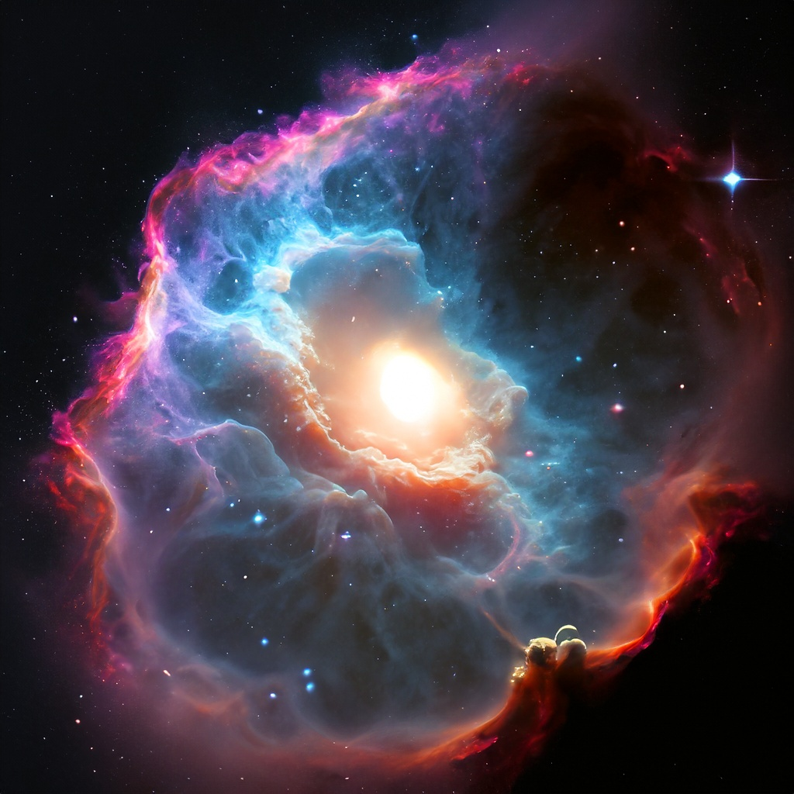

Section 3: The Stellar Fusion of Insight In this section, we witness the culmination of Einstein's intellectual fusion, comparable to the fusion of hydrogen atoms within a star's core. Through his "Miracle Year" in 1905, he publishes groundbreaking papers on the photoelectric effect, Brownian motion, and the theory of special relativity. These ideas collide and produce blinding insights, illuminating the scientific community and laying the foundation for modern physics. 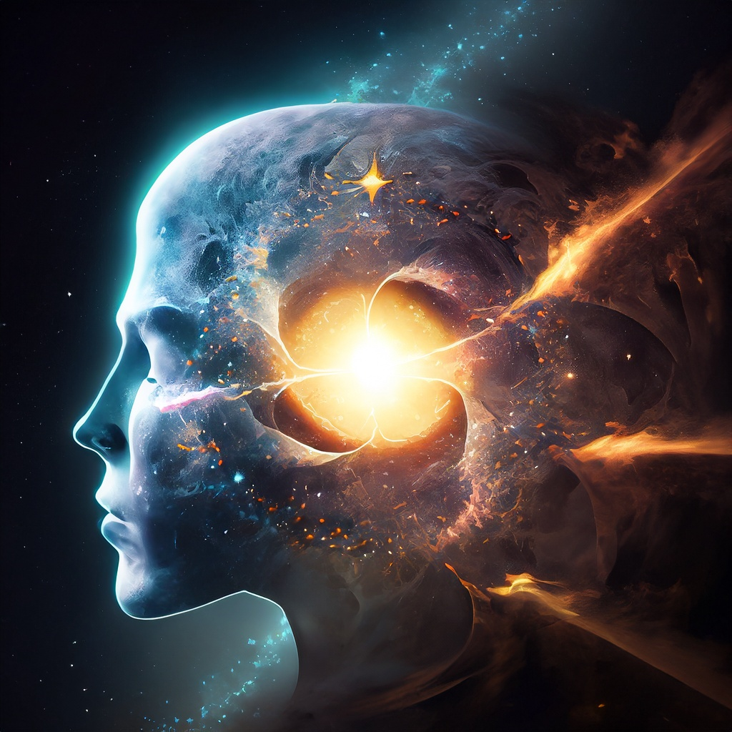

Section 4: The Black Hole of Adversity As in the life of any great visionary, Einstein's path was not without challenges. Like a star collapsing into a black hole, he faced personal and professional obstacles. The rise of the Nazi regime forced him to flee Germany, and his contributions were rejected by some scientists who could not comprehend the depths of his theories.

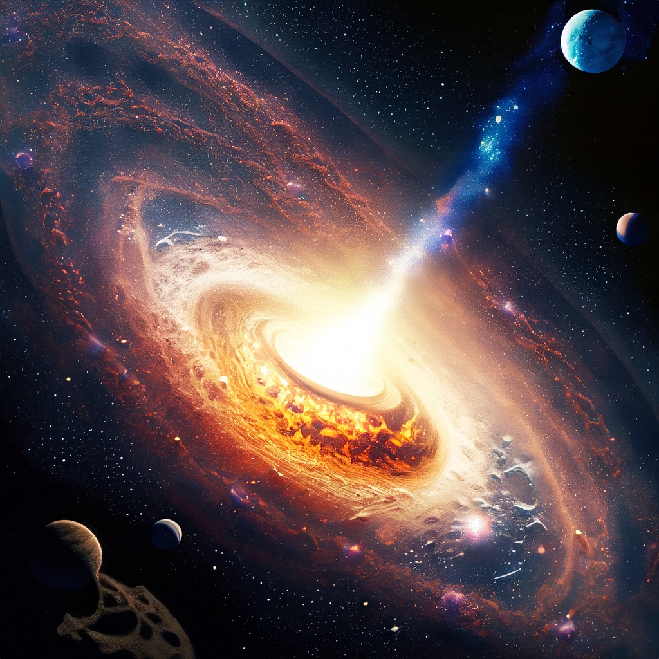

Section 5: The Cosmic Symphony of General Relativity This section explores the grand opus of Einstein's life, the development of the theory of general relativity. Here, we find a parallel to the gravitational waves that ripple through space-time, as his ideas reshaped our understanding of the universe. The eclipse experiment of 1919 provided empirical evidence, confirming the bending of light by gravity, and catapulted Einstein to global fame.

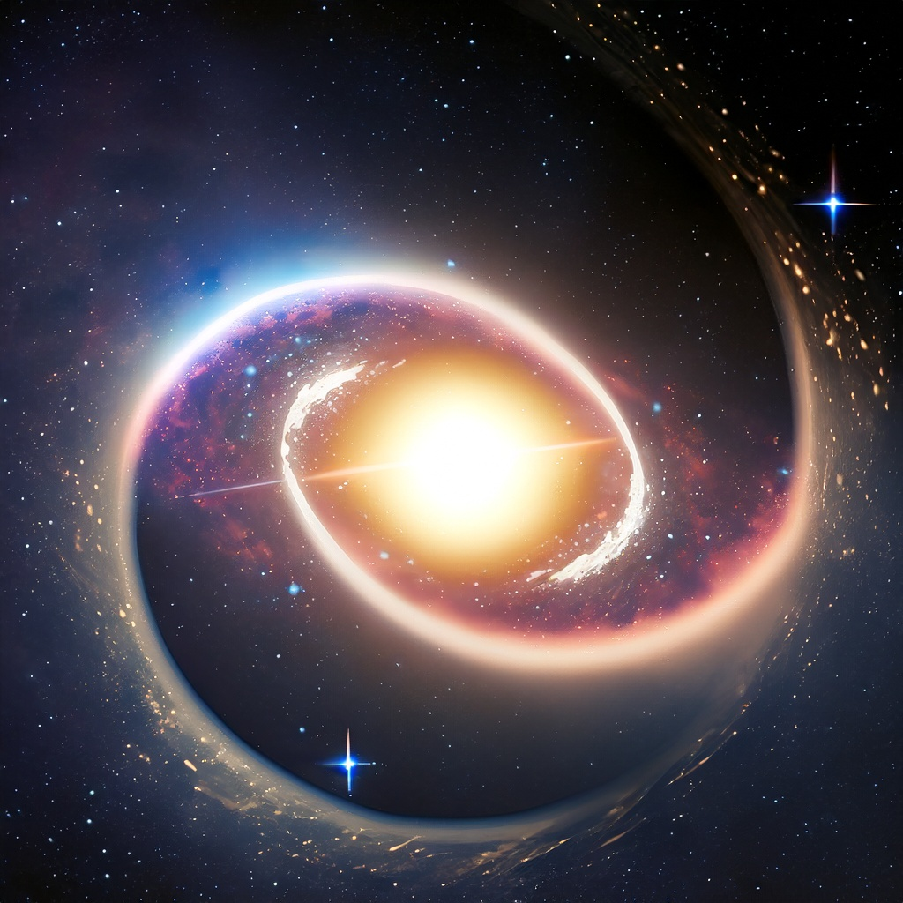

Section 6: The Expanding Universe of Legacy As the universe expands, so does the influence of Einstein's work. This section delves into how his ideas permeated various fields, from cosmology to quantum mechanics. The allegory of cosmic expansion mirrors how his legacy continues to grow, inspiring generations of scientists and shaping the course of modern physics.

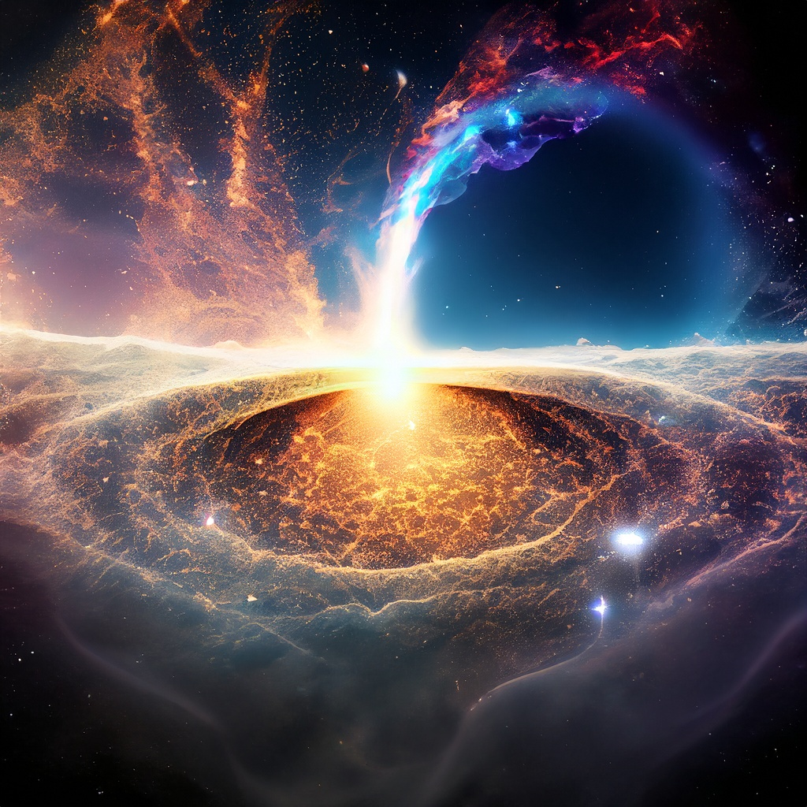

Section 7: The Quasar of Imagination Finally, we encounter the quasar of Einstein's imagination and creativity. Even after his passing, his ideas continue to radiate across the scientific landscape, illuminating new paths of exploration and understanding. Just as quasars emit immense energy, Einstein's contributions continue to energize the pursuit of knowledge, fueling future discoveries and innovations.

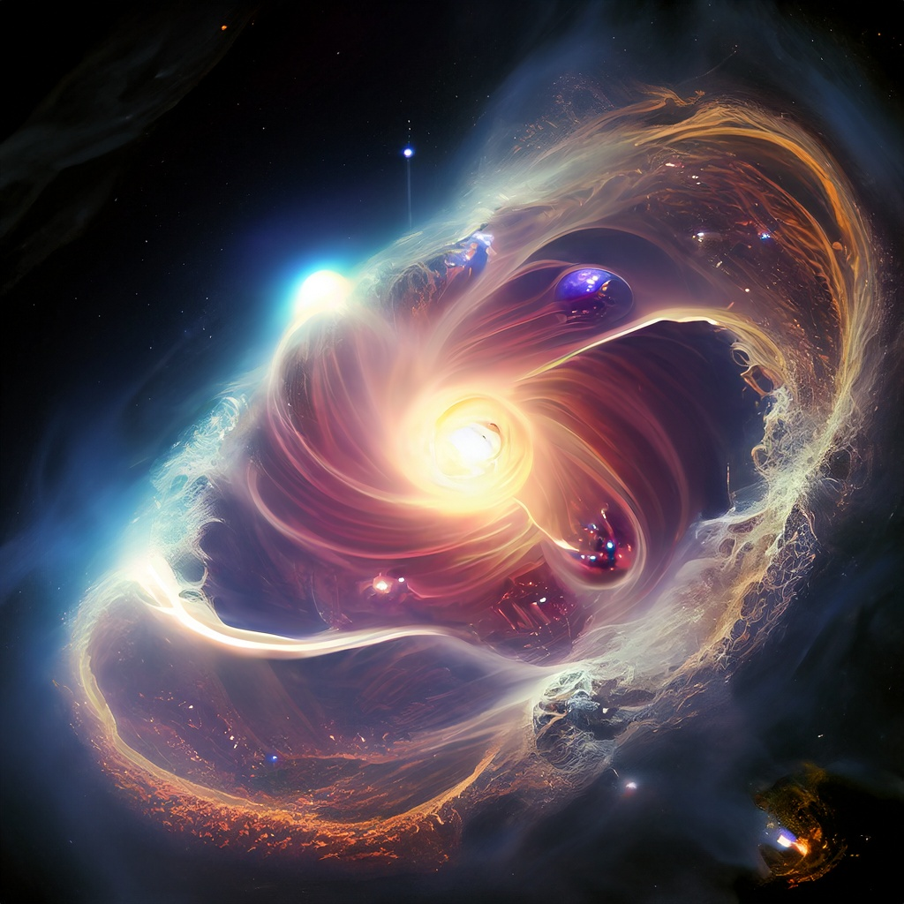

Epilogue: Dancing Among the Stars In this allegorical epilogue, we see Einstein's impact transcending the bounds of time and space. His name becomes synonymous with genius, his work an eternal dance among the stars of human achievement. As we look up at the night sky, we are reminded that like the stars themselves, Albert Einstein's legacy will forever shine bright in the firmament of history.

